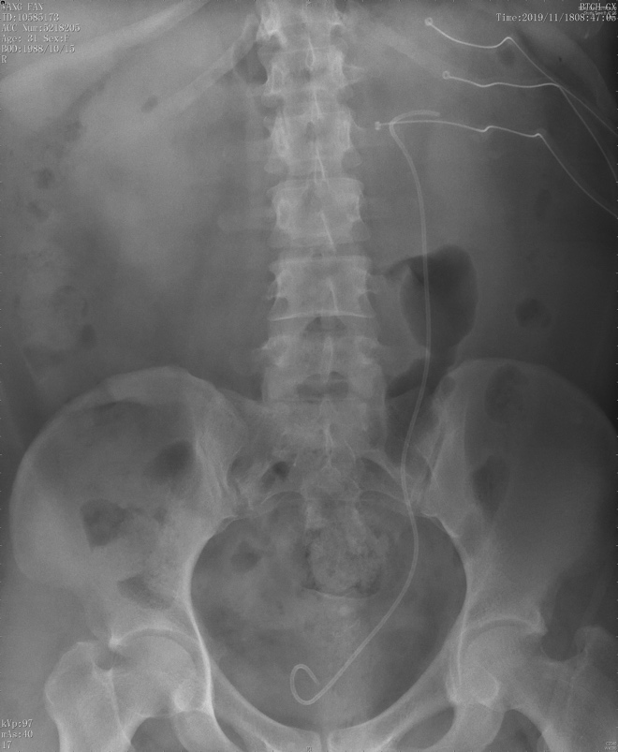
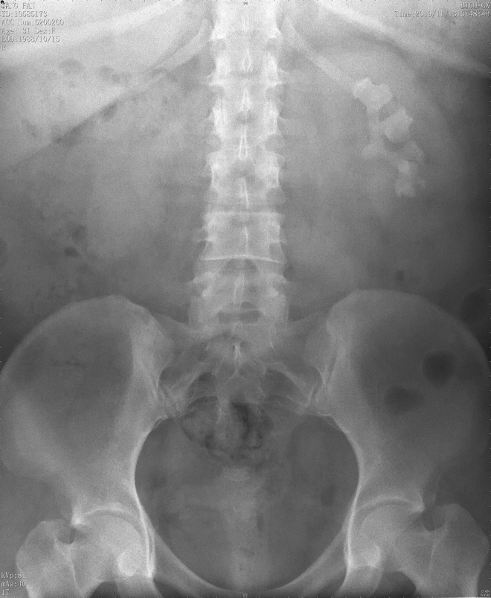
Supplementary Figure 1 (a) KUB before the surgery showed the renal stone
Supplementary Figure 1 (b) KUB after the surgery showed the renal stone

