Supporting Information

Imagination Materializes with Serendipity: Third Polymorph of N-Amino 1,8-Naphthalimide
Satyendra Verma, Jubaraj B. Baruah*

Content list:
Table S1 | The crystal and refinement parameters of the Polymoroh-3 and DTU
Figure 1S | ¹H-NMR of DTU. (DMSO-d₆, 600 MHz)
Figure 2S | High-resolution mass spectra of DTU
Figure 3S | Thermogram (blue) and differential thermogram of DTU (heating rate 10 °C/min, under nitrogen).
Figure 4S | ¹HNMR (CDCl₃, 400 MHz) of N-amino 1,8-naphthalimide.
Figure 5S | Experimental PXRD pattern of (a) concomitant polymorphs and the one generated from the CIF file of the (b) Polymorph-3 and (c) Polymorph-2.
Figure 6S | IR (neat, cm⁻¹) of the concomitant polymorphs.
Figure 7S | Thermogram of the concomitant Polymorph-2 and Polymorph-3 (Heating rate 10 °C/minute under nitrogen).
Figure 8S | POM image obtained for the Heating at 225 °C, 270 °C and 281 °C of the concomitant polymorph.  Figure 9S: Fluorescence microscopic images of the concomitant polymorphs (10 μM); a, b, c, and d are under visible-light, green light, UV light, and red light, respectively. (at room temperature)
Table S2 | Percentages (%) of interactions of all within the surface (All_{in}) with different atoms

Table S1: The crystal and refinement parameters of the Polymoroh-3 and DTU
 | Polymorph-3 |  | DTU
CCDC | 2423507 | 2484027
Formula | C₁₂H₈N₂O₂ | C₁₉H₁₁Cl₂N₃O₂S
Mol. wt. | 212.210 | 416.27
Space group | Pna2₁ | P2₁/n
A (Å) | 7.2036(18) | 10.6109(4)
B (Å) | 16.373(4) | 8.5478(3)
C (Å) | 7.9960(19) | 19.5788(8)
α (°) | 90 | 90
β (°) | 90 | 99.6690(10)
γ (°) | 90 | 90
V (Å³) | 943.1(4) | 1750.57(12)
Density, gcm⁻³ | 1.495 | 1.579
Abs. coeff., mm⁻¹ | 0.105 | 0.511
F(000) | 440.3 | 848.0
Total no. of reflections | 20727 | 38020
Reflections, I > 2σ(I) | 1666 | 3058
Max. θ/° | 25.38 | 25.00
Ranges (h, k, l) | -8 ≤ h ≤ 8,  -19 ≤ k ≤ 19,  -9 ≤ l ≤ 9 | -12 ≤ h ≤ 12,  -10 ≤ k ≤ 10,  -23 ≤ l ≤ 23
Complete to 2θ (%) | 99.8 | 99.1
Data/restraints/parameters | 1666/1/146 | 3058/0/244
GooF (F²) | 1.136 | 1.062
R indices [I > 2σ(I)] | 0.0443 | 0.0349
wR₂ [I > 2σ(I)] | 0.0933 | 0.0844
R indices (all data) | 0.0636 | 0.0384
wR₂ (all data) | 0.1073 | 0.0897

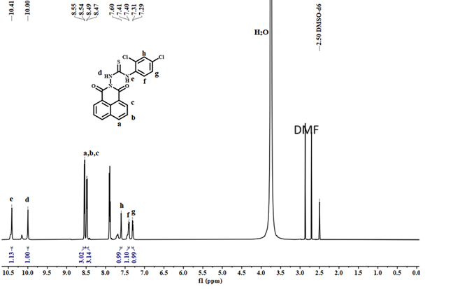
Figure 1S: ¹H-NMR of DTU. (DMSO-d₆, 600 MHz)

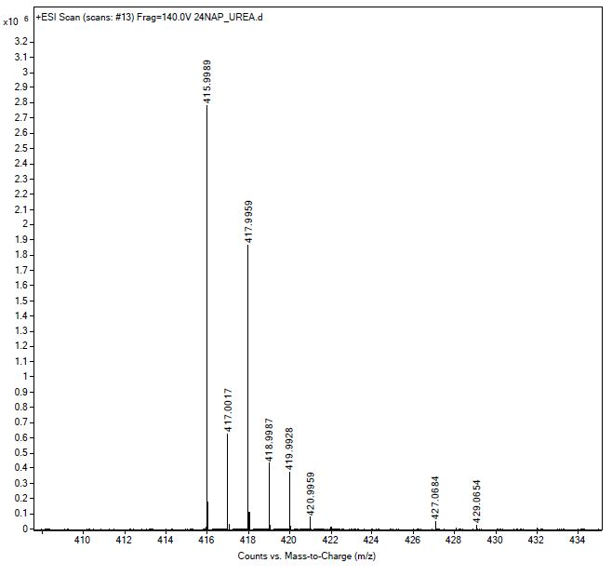
Figure 2S: High-resolution mass spectra of DTU

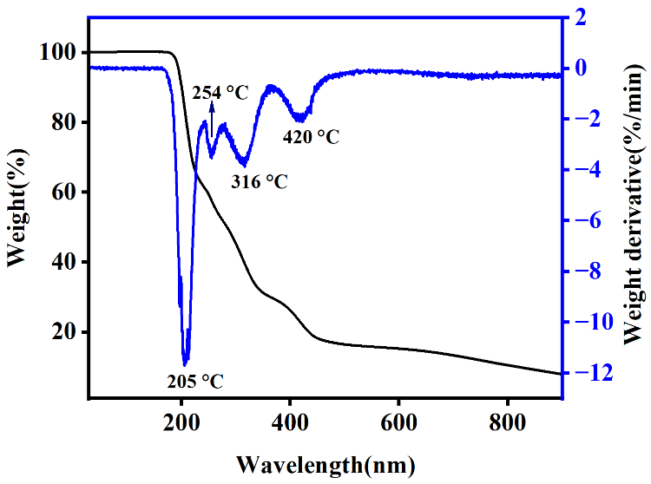
Figure 3S: Thermogram (blue) and differential thermogram of DTU (heating rate 10 °C/min, under nitrogen).
Figure 4S: ¹HNMR (CDCl₃, 400 MHz) of N-amino 1,8-naphthalimide.
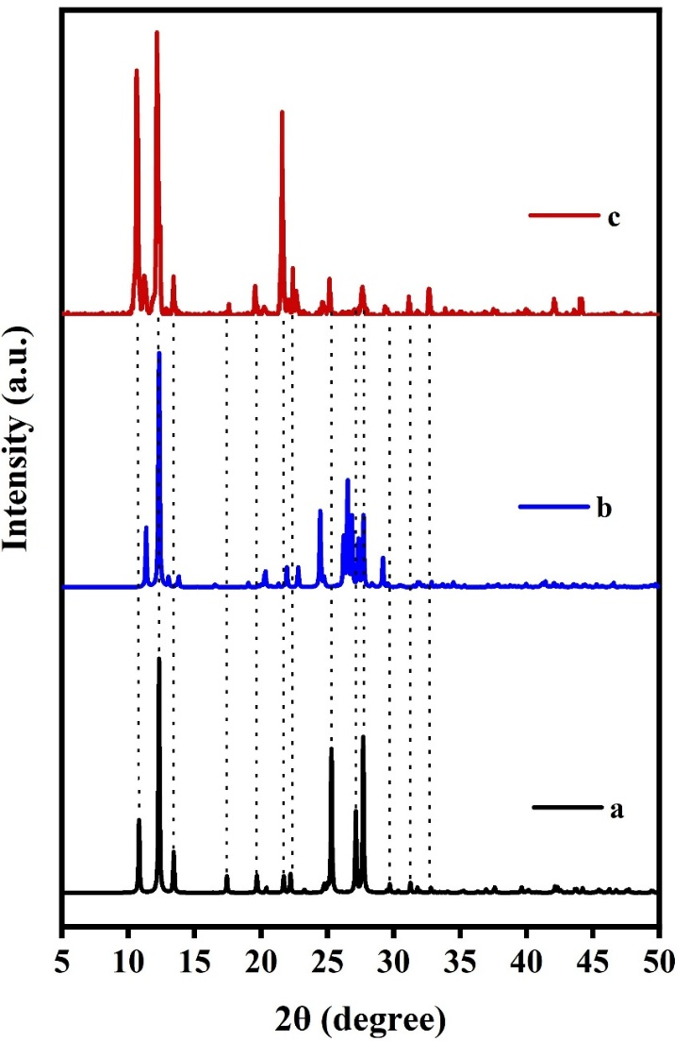
Figure 5S: Experimental PXRD pattern of (a) concomitant polymorphs and the one generated from the CIF file of the (b) Polymorph-3 and (c) Polymorph-2.

Figure 6S: IR (neat, cm⁻¹) of the concomitant polymorphs.
Figure 7S: Thermogram of the concomitant Polymorph-2 and Polymorph-3 (Heating rate 10 °C/minute under nitrogen).

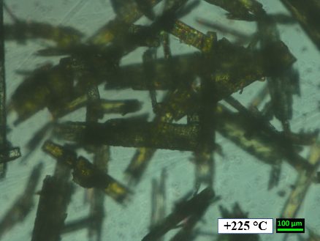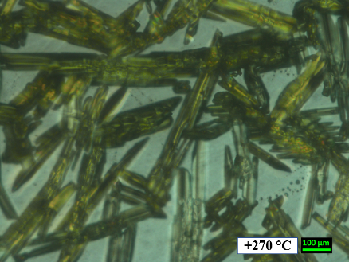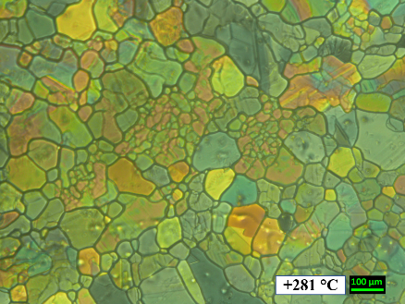
Figure 8S: POM image obtained for the Heating at 225 °C, 270 °C and 281 °C of the concomitant polymorph.

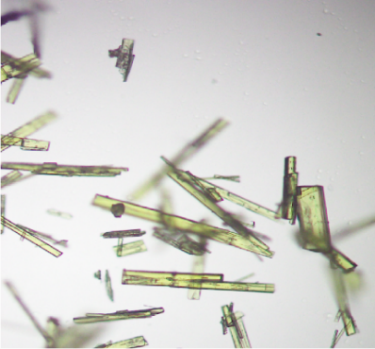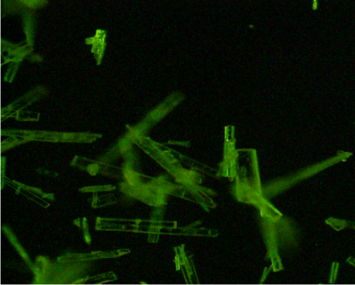
(a) (b)
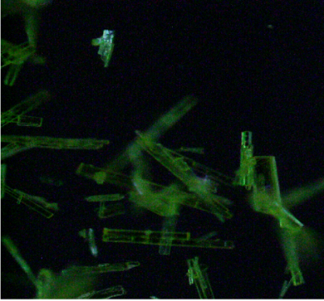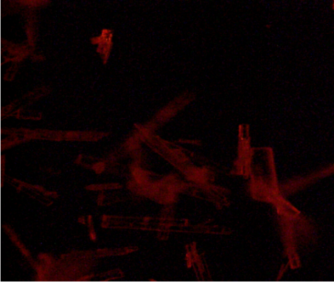
(c) (d)
Figure 9S: Fluorescence microscopic images of the concomitant polymorphs (10 μM); a, b, c, and d are under visible-light, green light, UV light, and red light, respectively. (at room temperature)

Table S2 : Percentages (%) of interactions of all within the surface (All_{in}) with different atoms
Polymorph | All_{in}-O | All_{in}-N | All_{in}-C | All_{in}-H
Polymorph-1 | 13.4 | 3.2 | 22.6 | 60.7
Polymorph-2 | 12.3 | 4.0 | 23.5 | 60.2
Polymorph-3 | 11.7 | 4.0 | 24.6 | 59.7

