Supporting Information for

Inverse-Designed Plasmonic Biosensors with LSPR-SPP-Wood Anomaly Coupling Enhenced for Biomolecular Analysis

Yihui Yang¹*, Youqian Chen¹*, Rui Li¹, Wen Li ¹, Mingqian Chen ¹, Wenjun Hu¹†, Gang Logan Liu¹†, Yanan Li²† and Liping Huang²†

Corresponding author: Wenjun Hu¹, Gang Logan Liu¹, Yanan Li² and Liping Huang²
Email: hu wenjun@hust.edu.cn(W. Hu) ; loganliu@hust.edu.cn(Gang L. Liu); liyanan@njnu.edu.cn (Y.L.); lphuang@nnu.edu.cn(L. Huang)

This PDF file includes:

Supporting text
Figures S1 to S26
Tables S1 to S2
SI References

S1. Principle for metasurface plasma excitation
The wave propagates along the metal dielectric interface, and its lateral extension gradually decays to both sides of the interface (rapidly decays away from the interface). Compared to the metal side, the attenuation wave has a longer penetration length in the dielectric.[1]
In addition, the dispersion relation is shown for the surface plasmon polaritons (SPPs) at an interface of two materials is:[2]
$$k_{spp}=\frac{ω}{c}\sqrt{\frac{ε_{m}ε_{d}}{ε_{m}+ε_{d}}}$$ | (S1)
Where $k_{spp}$ is the SPP momentum, ω is the frequency, and c is the velocity of light, $ε_{m}$ and $ε_{d}$ are the dielectric constants of the metal film and the medium (at the top or bottom surface of the nanostructures). For a given frequency, a free-space photon has less momentum than an SPP since they don’t intersect. Therefore, a coupling medium, like a prism, is necessary to increase the momentum of light to excite SPs because of its higher refractive index relative to free space. This alignment shifts the dispersion curve of the prism-coupled system, allowing the curves to intersect.[3]
However, when a periodic array of holes is perforated in the metal film, it acts as a grating. The additional degree of freedom associated with the grating momentum allows for coupling between the incident radiation and the SPP modes. The corresponding relation for conservation of momentum is then given by:[2] [4]

$$k_{spp}=k_{x}+i*G_{x}+j*G_{y}$$ | (S2)
where $k_{spp}$ is the wave vector associated with the SPP, $k_{x}$ is the transverse wave vector component of the incident radiation, $G_{x}$ and $G_{y}$ are the wave vector components associated with the two-dimensional array, for a square lattice, |$G_{x}$|=|$G_{y}$ |=2π/P. And $i$ and $j$ are integers.
We only consider the case of vertical incidence, which implies:
$$k_{spp}=\frac{2π}{P}\sqrt{i^{2}+j^{2}}$$ | (S3)
So, eqs. (S1) and (S2) reduce to:
$$λ_{sp}=\frac{P}{\sqrt{i^{2}+j^{2}}}\sqrt{\frac{ε_{m}ε_{d}}{ε_{m}+ε_{d}}}$$ | (S4)
where $P$ is the periodicity of nanostructures. In this condition, they thought as SPP-Bloch waves (SPP-BWs).[5] SPP-BWs were originally associated with light transmission maxima.[3] However, different interpretations have been suggested.[6–8]
If one conducts a similar analysis of the grating but replaces the surface plasmon polariton (SPP) wave vector with that of ordinary light, given by:
$$k_{w}=\frac{ω}{c}\sqrt{ε_{d}}$$ | (S5)
Eqs. (2) and (5) can expressed as:
$$λ_{w}=\frac{P}{\sqrt{i^{2}+j^{2}}}\sqrt{ε_{d}}$$ | (S6)
The result is the Wood’s anomalies condition. This represents the condition for light waves diffracted to be in the plane of the surface. Both surface plasmon polariton-Brillouin zones (SPP-BWs) and Wood's anomalies can coexist within the same scenario, and their proximity to each other can depend on the specifics of the system.

S2. Conversion from peak-shift modulation to intensity modulation
Both Wood's anomalies and surface plasmon (SP) excitation are highly sensitive to changes in surface refractive index, as demonstrated by Equations (1) and (2). When the surface refractive index increases (i.e., when $ε_{d}$ increases), the corresponding resonance wavelengths ($λ_{sp}$ and $λ_{w}$) undergo a red shift. As illustrated in Fig. S1a, we simulated the refractive index sensing response of nanopore metasurfaces with parameters P=450nm, d=120nm, and h=450nm. The simulation results are consistent with the theoretical predictions.
For example, the works of Yanik[9] and Palani[10] rely on detecting the position of resonance peaks to achieve detection. However, one disadvantage of this approach is that it requires precise measuring instruments, which increases the dependence of sensors on sophisticated equipment and the expertise of the personnel, thereby limiting their applicability. To address this, we propose a method to convert the information of peak shifts into intensity differences. By measuring the reference spectrum (${OD}_{ref}$) and the measurement spectrum (${OD}_{det}$), and calculating the differential optical density ($difOD$) between them, as shown in Equation (3), we can achieve this conversion, as illustrated in Fig. S1b.
$$difOD={OD}_{det}-{OD}_{ref}$$ | (S7)
Subsequently, we select the response between the two peaks (${difOD}_{650}$) and the valley (${difOD}_{637}$) of the differential OD response as the characteristic signal, which we refer to as the "endpoint method."
$${sig}_{RI}={difOD}_{peak}-{difOD}_{valley}$$ | (S8)
Fig. S1c and S1d present bar charts comparing the refractive index responses for both the peak-shift and differential OD methods, while Fig. S1e and S1f show the fitting results of these responses. The results indicate that both methods exhibit good linear responses, but the differential OD response demonstrates a superior correlation coefficient ($R^{2}$).

S3. Selection and simulation of multilayer metasurface material
Metals suitable for this purpose must possess conduction band electrons capable of resonating with incident light at specific wavelengths. Candidates include silver (Ag), gold (Au), copper (Cu) and so on.[11] However, copper's broad resonance light absorption in the visible spectral range limits its applicability. Consequently, silver and gold emerge as the most viable options for plasmonic materials due to their minimal loss in the visible and near-infrared (NIR) spectral ranges.[12] Silver, in particular, demonstrates superior performance Silver, in particular, demonstrates superior performance in the visible spectral rang.[12,13] Gold, on the other hand, is favored for its low chemical reactivity and excellent biocompatibility[12]. Despite these advantages, gold's adhesion to substrates is suboptimal, often resulting in issues such as delamination, peeling, and time-dependent performance degradation.[14] An ideal adhesive layer must not only bond well with the substrate and the desired thin film but also ensure the stability of the biosensor. As recommended by Matteo Todeschini for nano-optics applications, chromium (Cr) serves as an exemplary adhesive layer due to its low diffusion, temporal stability, and compatibility with lift-off procedures.[14]
To further investigate the influence of common plasmonic materials on the performance of the multilayer metasurface sensor, we employed the Finite-Difference Time-Domain (FDTD) algorithm to simulate the optical responses of four materials—silver (Ag), gold (Au), copper (Cu), and platinum (Pt)—on the metasurface nanohole array. The simulation parameters were set as follows: a period of 450 nm, a radius of 100 nm, a height of 500 nm, and a thickness of 100 nm.
Fig. S2a illustrates that, under these conditions, Ag, Au, and Cu exhibit strong absorption peaks around 650 nm, while Pt shows a strong absorption peak around 600 nm. As the refractive index increases, the wavelength of these absorption peaks redshifts. We subsequently calculated the differential optical density (OD) response, as shown in Fig. S2b. And the electric field distribution maps were shown in Fig. S2c.

S4. Particle Swarm Optimization Method
Particle swarm optimization (PSO)[15] algorithm is initialized as a group of random particles (random solutions). Particles only have two attributes: velocity and position, where velocity represents the speed of movement and position represents the direction of movement. Then find the optimal solution through iteration. In each iteration,as shown in Fig. S3, particles update themselves by tracking two "extreme values" (pbest, gbest). During the optimization process, the movement of each particle within the parameter space is influenced by three distinct forces:
(i) A frictional force proportional to the current velocity, given by ${αv}_{C}(n)$, where $α$ is the inertial weight that controls the impact of the particle's previous velocity on its current movement.
(ii) A cognitive force that drives the particle toward its individual best position, expressed as $c_{1}r_{1}[{x​}_{p}(n)-x(n)]$, where $c_{1}$​ is the cognitive factor representing the particle's self-awareness, and $r_{1}$​ is a random number uniformly distributed between 0 and 1.
(iii) A social force that guides the particle toward the global best position of the entire swarm, given by $c_{2}r_{2}[{x​}_{g}(n)-x(n)]$, where $c_{2}$​ is the social factor representing the influence of the swarm's collective experience, and $r$ ​ is another random number uniformly distributed between 0 and 1.
The velocity update equation for the particle in the next generation is derived from the summation of these forces:
$${{v_{C}(n+1)=αv}_{C}(n)+c}_{1}r_{1}[{x​}_{p}(n)-x(n)]{+c}_{2}r_{2}[{x​}_{g}(n)-x(n)]$$
In our implementation using the Lumerical solver, we adopted the default values of c1​=c2​=1.49, which are commonly used in the literature. The inertial weight α was linearly varied between 0.4 and 0.9 to ensure robust convergence, as verified in numerous optimization studies for photonic design problems. The position of the particle in the next generation is subsequently updated according to:
$${{x_{C}(n+1)=x}_{C}(n)+v}_{c}(n+1)$$
This approach effectively balances the exploration and exploitation capabilities of the PSO algorithm, facilitating efficient optimization within the complex parameter space.

S5. Manufacturing and processing of IDM-MetaSPR sensor
The development IDM-MetaSPR sensor is shown in Fig. S12, which encompasses various stages such as design (a) Design of Metasurface Structure and Parameters: The initial step involves the design of the metasurface structure and its parameters. This includes defining the geometry, periodicity, and other critical dimensions that will determine the optical properties of the sensor. (b) Fabrication of Imprint Templates: The next step is the creation of imprint templates. These templates are designed to transfer the metasurface patterns onto the target substrate. Typically, this involves high-precision lithography and etching processes to ensure the accuracy of the patterns. (c) Nanoimprint Transfer of Structural Parameters: The metasurface patterns are then transferred onto the substrate using nanoimprint lithography. This process involves pressing the imprint template against the substrate under controlled conditions to replicate the designed patterns with high fidelity. (d) Plasma Coating: After the patterns are transferred, plasma coating is applied. This step involves depositing thin layers of materials (such as metals or dielectrics) onto the nanostructured surface using plasma-enhanced techniques. This includes depositing multiple layers of materials (such as Cr, Ag, and Au) to achieve the desired plasmonic properties and improve the sensor's performance. (e) Quality Inspection and Storage of Multilayer Metasurface Sensors: The fabricated multilayer metasurface sensors undergo quality inspection to ensure they meet the required performance standards. After passing inspection, the sensors are stored under appropriate conditions to maintain their integrity and functionality. (f) Assembly with Standard Plates (e.g., 96-Well Plates): The final step involves assembling the fabricated metasurface sensors with standard detection devices, such as 96-well plates. This assembly allows for high-throughput detection and compatibility with existing microplate readers, making the sensor suitable for various applications.

S6. The mechanism and localization of SPP and Wood anomalies
Fig. S18 illustrates the transmission spectra of the nanocup metasurface array with a period of 475 nm immersed in water and various concentrations of sucrose. Due to the presence of multiple effects, as well as different orders of BW-SPP, Wood anomalies, and their mutual coupling, the optical behavior of metasurface nanocages will be more complex.
Within a water medium, the spectrum exhibits distinct transmission peaks and dips, which arise from the interactions of localized surface plasmon resonance (LSPR), Bloch wave surface plasmon polaritons (BW-SPPs), and Wood's anomalies. The LSPR within the nanocup induces a broad resonance peak in the transmission spectrum. The interplay between LSPR and either BW-SPPs or Wood's anomalies gives rise to a Fano-like resonance profile, characterized by a minimum and a neighboring maximum, nearly coincident with the position anticipated by Equation (S4) or Equation (S6).

S7. Simulation results of multilayer metasurface based on resonance peak shift
We calculated the effect of metasurface parameters on FoM based on resonance peak shift. The calculation of FoM can be expressed as follows:
$${FOM}_{shift}=\frac{{peak}_{det}-{peak}_{ref}}{δn*FWHM}$$ | (S9)

S8. Comparation of IDM-MetaSPR sensor’s sensitivity and FoM
To evaluate and demonstrate the performance of the developed IDM-MetaSPR sensor, we also compared it with relevant reported works. By definition in the “material and methods” section, we calculate the sensitivity and FoM of our IDM-MetaSPR sensor. Comparisons between the developed IDM-MetaSPR sensor and other similar sensors in visible wavelength regions published in the literature are performed. The characteristics of these structures are presented in Table S1. In this table, the comparison parameters include the structure type, metal type, resonance wavelength, sensitivity (S), and FoM. Although FoM and sensitivity were not our optimization goals, the sensors we ultimately determined still achieved 812 nm ⁄ RIU and 26.3 RIU ^ (-1), respectively. The sensitivity and FoM value of the biosensor we proposed are much higher than many similar sensors reported. Therefore, the proposed IDM-MetaSPR sensor can become an excellent candidate for biosensing applications.

S9. Establishment of the Molecular Interaction Analysis platform based on IDM-MetaSPR sensor
IgG is a monomeric immunoglobulin that participates in secondary immune reactions and is the most abundant immunoglobulin in serum.[16] Protein A is a surface protein of Staphylococcus aureus that can bind to immunoglobulin and has been widely used in research techniques such as immunoprecipitation and sensor development[17]. To exhibit the real-time monitoring ability of the developed IDM-MetaSPR biosensor, we selected Protein A and IgG as ligands and analytes models to build a high-throughput molecular interaction analysis method based on the IDM-MetaSPR sensor. To further confirm whether the response of different parameter IDM-MetaSPR sensors to biological samples is similar to the refractive index response, we also tested the response of Protein A and IgG. The response results of OD are shown in Fig. S23, which is similar to the response of different refractive indices. As shown in Fig. S23a-b, the excellent parameter IDM-MetaSPR chip is integrated with a 96-well microplate to produce a loading device and combines with XLement SPR We200 (the loading device is also suitable for almost all Microplate Readers) for high-throughput detecting molecular association and dissociation processes. Fig. S23c exhibits the establishment process of the high-throughput affinity measurement protocol, which mainly includes sensor cleaning, functionalization, adding analytes, and adding buffer solutions. With just a few simple steps, the entire affinity detection process can be completed at high throughput. After functionalization with equal amounts of Protein A and BSA in IDM-MetaSPR chip wells, different concentrations of IgG (0.125-8 μg/mL) were added to different chip wells to detect the real-time dual-wavelength OD changes using the XLement SPR200 instrument. After the association, the IgG solutions were replaced with buffer, and dissociation curves were measured.
Fig. S23d shows a typical SPR real-time detection process curve for biomolecule binding and dissociation, which mainly includes baseline, binding segment, and dissociation segment. The original signal curves collected at room temperature are demonstrated in Fig. S23e-f, in which the baselines are corrected to zero. This operation can usually effectively eliminate dissociation curve drift. The kinetic constants $K_{on}$ and $K_{off}$ were calculated by the fitting association and dissociation curves and the equilibrium affinity constant $K_{D}$ is the ratio of the two kinetic constants. We use the previously reported 1:1 binding stoichiometry Langmuir model to describe the kinetic association and dissociation processes based on the following equations:[17]
$$Y_{a}= A(1-e^{-B*X})$$ | (S9)
$Y_{d}$= $A$($e^{-K_{off}*X}$) | (S10)
$K_{on}$=$\frac{B-K_{off}}{[C]}$ | (S11)
$K_{D}$=$\frac{K_{off}}{K_{on}}$ | (S12)
In Equation (S9–12), $Y_{a}$ is the binding rate and $Y_{d}$ is the dissociation rate, corresponding to the response signal; A is the asymptote , which is the maximum binding signal at equilibrium; X is time; and B is the observed rate constant; $[C]$ is the concentration of the analyte. Equation (S9) describes the association stage, Equation (S10) describes the dissociation stage. Equation (S11) describe the relation of $K_{on}$, $K_{off}$ and $K_{D}$.
Fig. S23g shows the fitting curves of protein A and IgG binding dissociation at different concentrations. From the curves, we can see that protein A and IgG are ligand-analytes with strong binding and weak dissociation. The $K_{D}$ values of protein A and IgG ranged from 318 to 610 pM, which agrees with the literature[17]. The developed platform can simultaneously detect and create binding and dissociation curves in a high-throughput manner.

S10. Application of IDMM-SPR Sensor for Small Molecule Affinity Evaluation
The low molecular weight of small molecules results in minimal refractive index (RI) changes upon binding, making their detection challenging using conventional SPR techniques. [18] However, characterizing the binding affinity between small molecule ligands and target proteins is crucial for virtual drug screening and repurposing existing drugs. [19] To address this challenge, we developed a novel method for measuring small molecule affinity using the IDMM-SPR sensor chip, exemplified by the use of Quercetin. Quercetin, a bioflavonoid with anti-inflammatory and other therapeutic properties, [20] was chosen as a model small molecule. As shown in Fig. S26a, we functionalized the IDMM-SPR sensor chip surface with carboxyl groups using MUA to provide binding sites for Quercetin. The sensor surface was then activated under 365 nm UV irradiation to immobilize Quercetin. By adding various concentrations of human transforming growth factor-beta receptor 1 (TGFBR1) solutions and buffer solutions, we successfully monitored the association and dissociation processes between Quercetin and TGFBR1.
To validate the effectiveness of the inverse design, we compared the response signals of the optimized and unoptimized sensors. The optimized sensor exhibited significantly higher sensitivity and discrimination capability, especially at low concentrations (Fig. S26b-d). The dissociation constants ($K_{D}$) calculated from the kinetic data were 28.3 nM and 50.1 nM for the optimized sensor, indicating a strong binding affinity between Quercetin and TGFBR1. These values corroborate previous findings. [21] The unoptimized sensor showed slightly lower $K_{D}$ values, likely due to reduced precision in detecting low-concentration samples. However, the differences between the optimized and unoptimized sensors were smaller compared to ultra-high-affinity interactions, likely because the tested concentrations were close to the $K_{D}$ value.
These results highlight the exceptional performance of the inverse-designed IDMM-SPR sensor in small molecule affinity detection and quantitative analysis, demonstrating its potential for compound drug development and research.

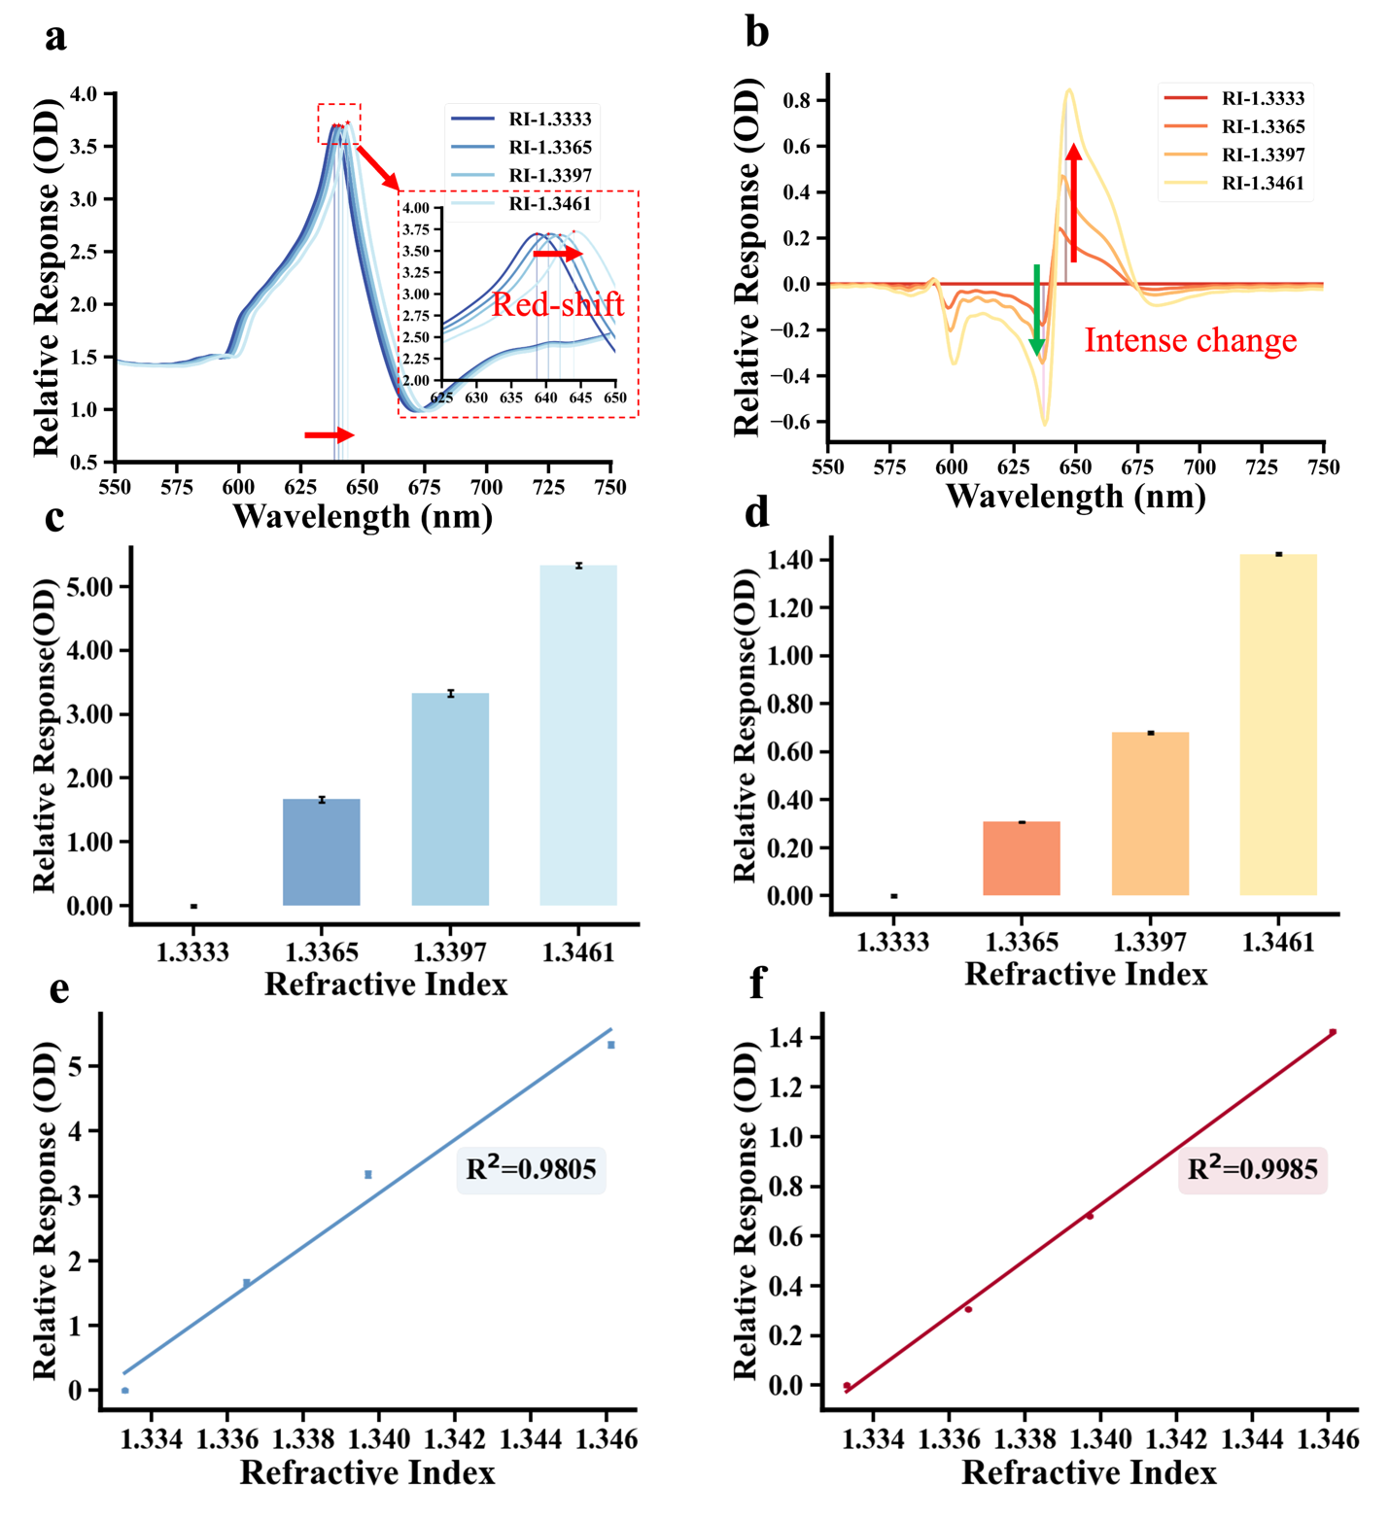
Fig. S1. Conversion from peak-shift modulation to intensity modulation. (a) Original OD spectrum under various refractive indices. (b) differential OD ($difOD$) under various refractive indices. (c) Bar graph of peak shift to refractive index variation. (d) Bar graph of $difOD$ to refractive index variation. (e) Fitting curve of peak shift to refractive index change. (f) Fitting curve of $difOD$ to refractive index change.

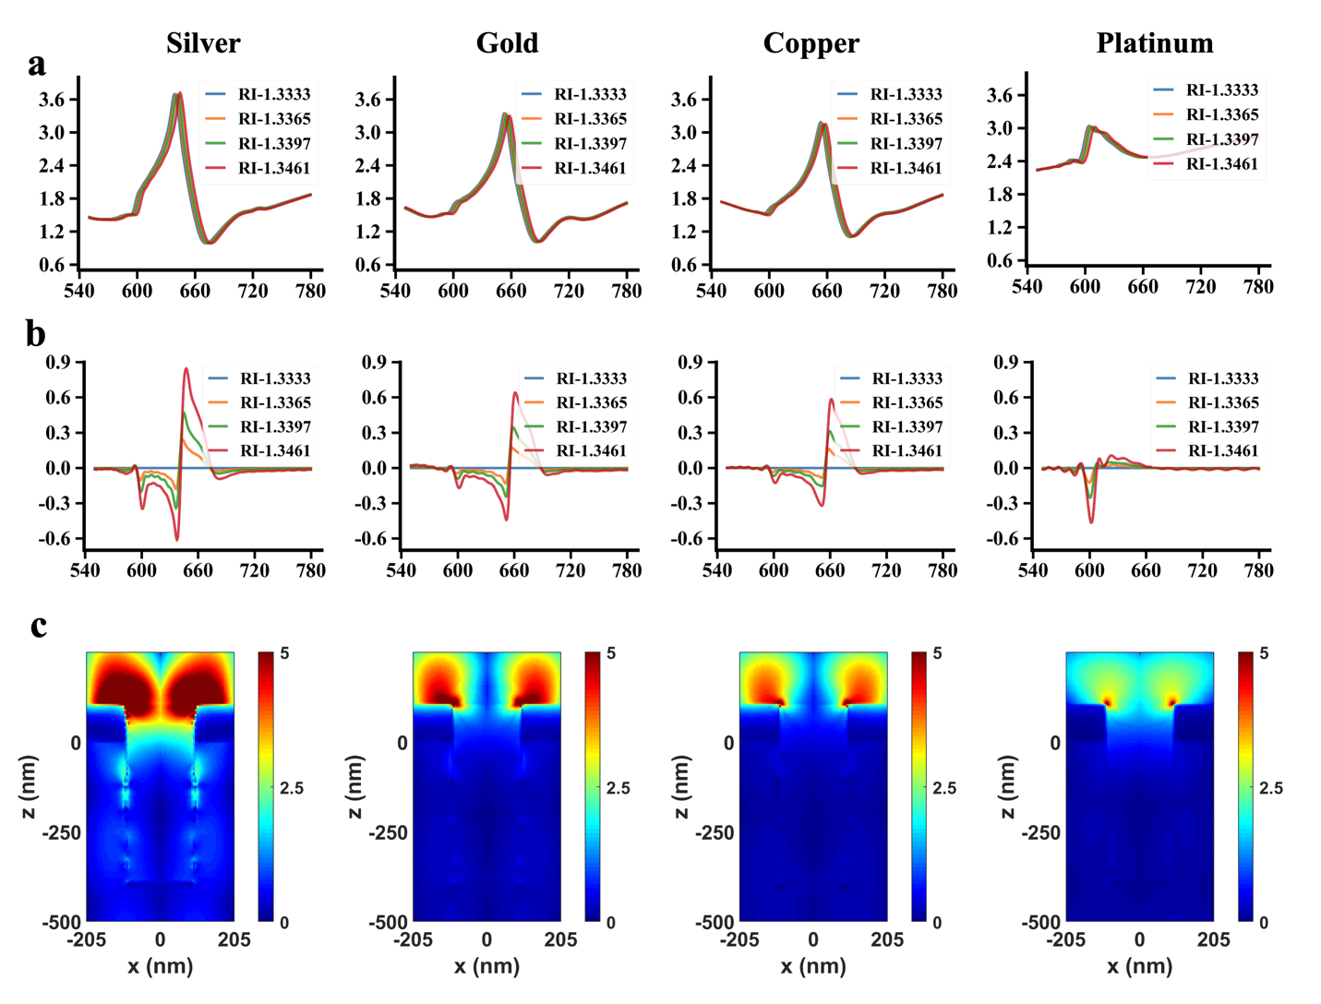
Fig. S2. Simulation results of normalized electric field intensity distributions and OD response. (a) The OD response of silver, gold, copper, and platinum as surface plasmon excitation materials on a nanohole array in varying refractive indices. (b) Differential OD response of the four metal materials at different refractive indices. (c) Normalized electric field distributions of the four materials at their absorption peaks based on the nanohole array.


Fig. S3. The update process of a single particle in particle swarm optimization algorithm.

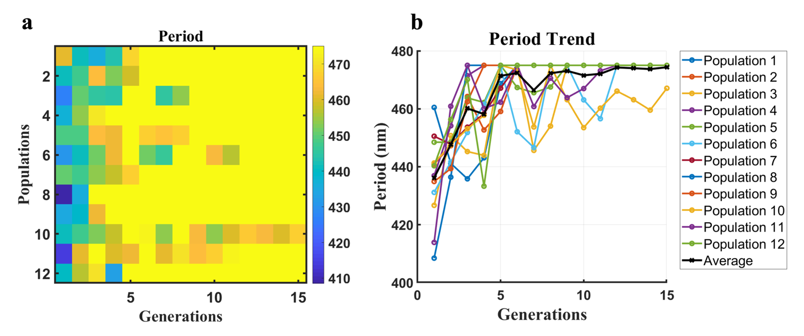
Fig. S4. The results of the period during the PSO inverse design.

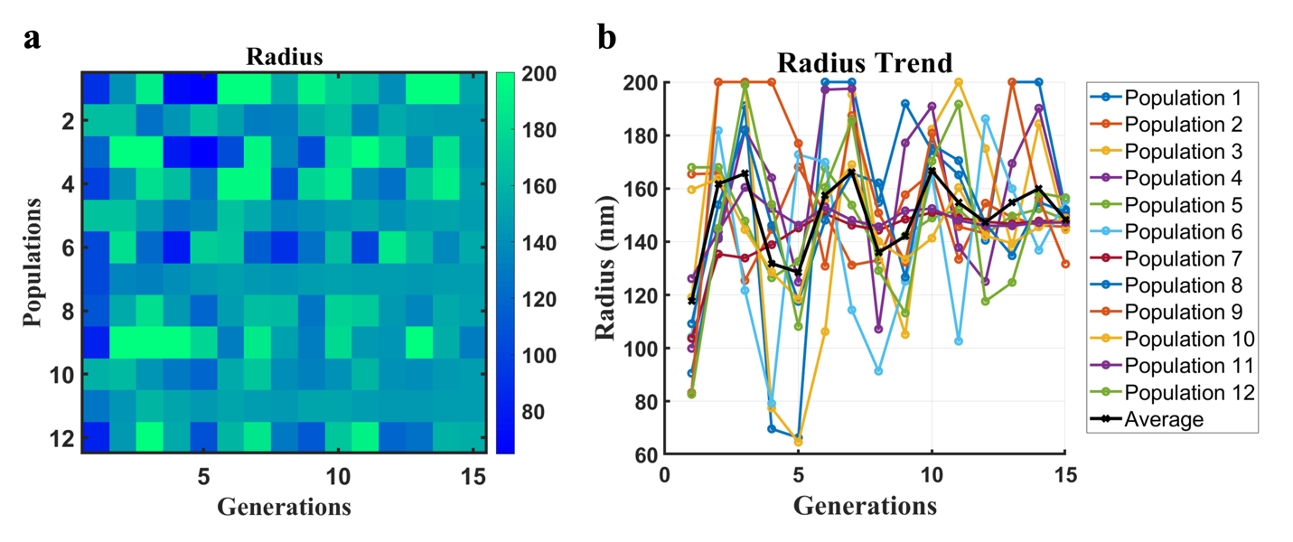
Fig. S5. The results of the radius during the PSO inverse design.


Fig. S6. The results of the height during the PSO inverse design.

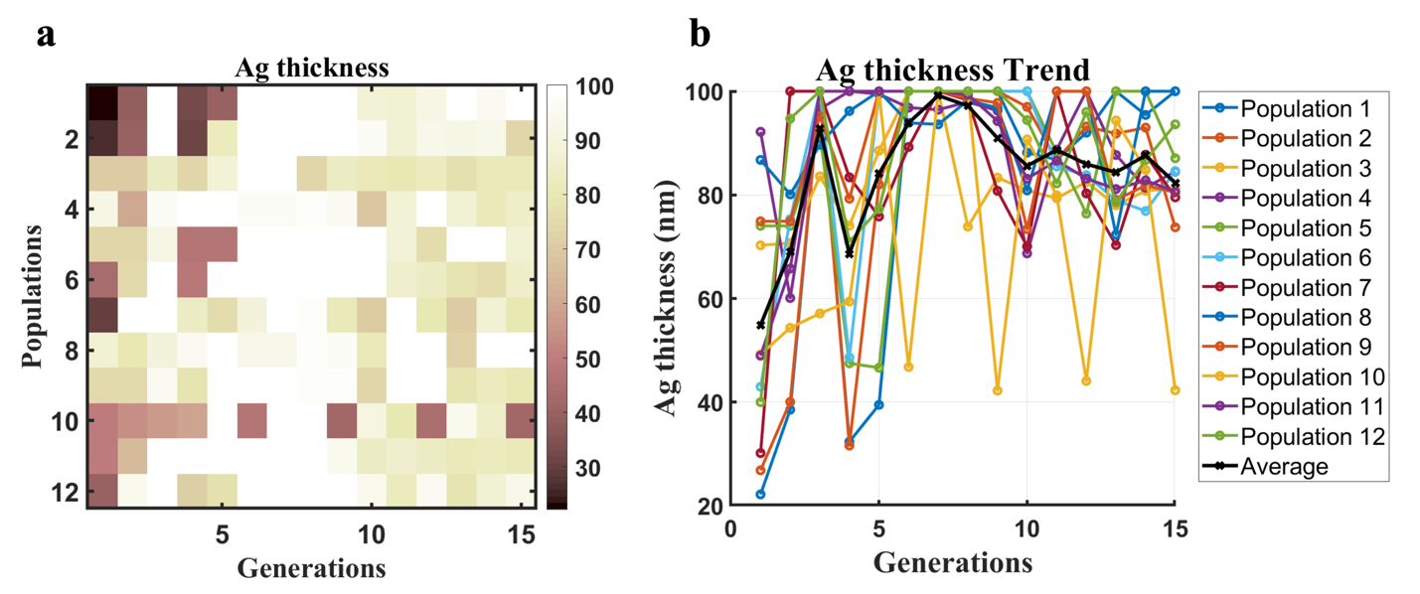
Fig. S7. The results of the Ag thickness during the PSO inverse design.

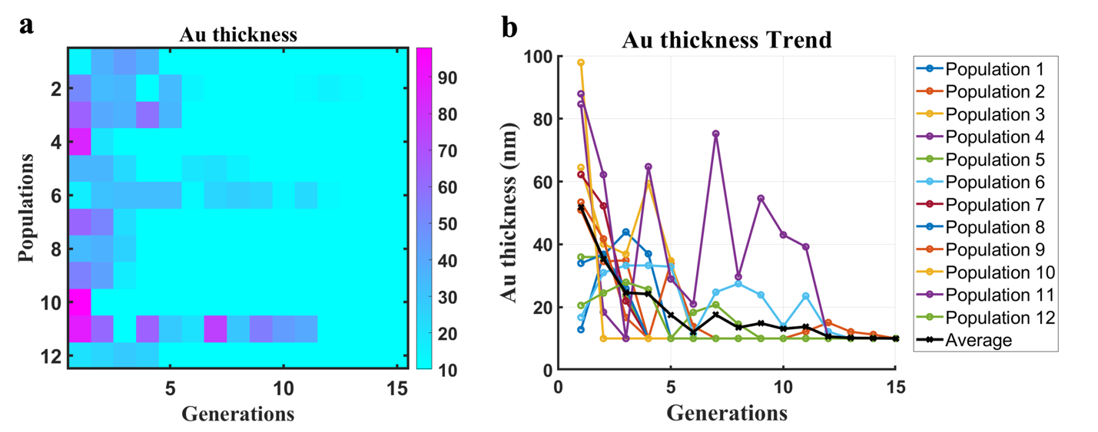
Fig. S8. The results of the Au thickness during the PSO inverse design.

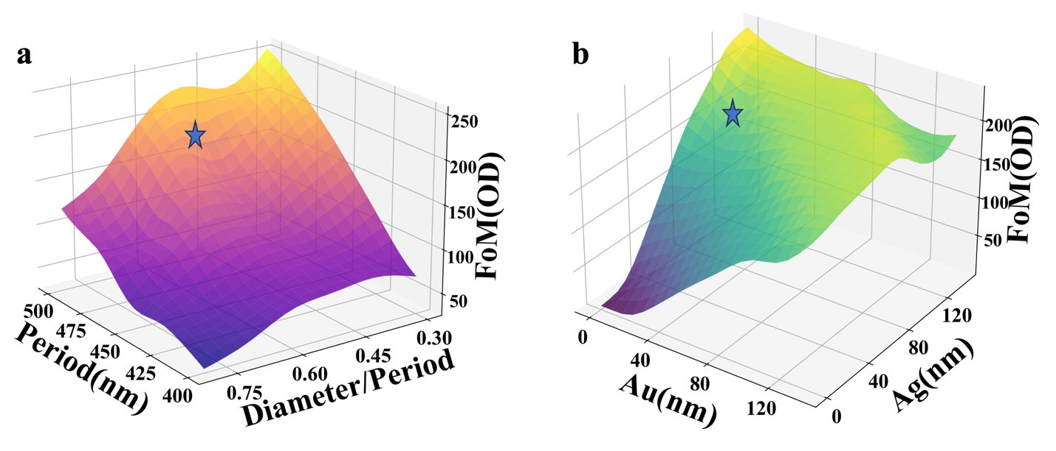

Fig. S9. The combined impact of main parameters on OD response. (a) Surface plot of ${FoM}_{OD}$ versus period and diameter-to-period ratio. (b) Surface plot of ${FoM}_{OD}$​ versus thickness variations of Au and Ag layers.

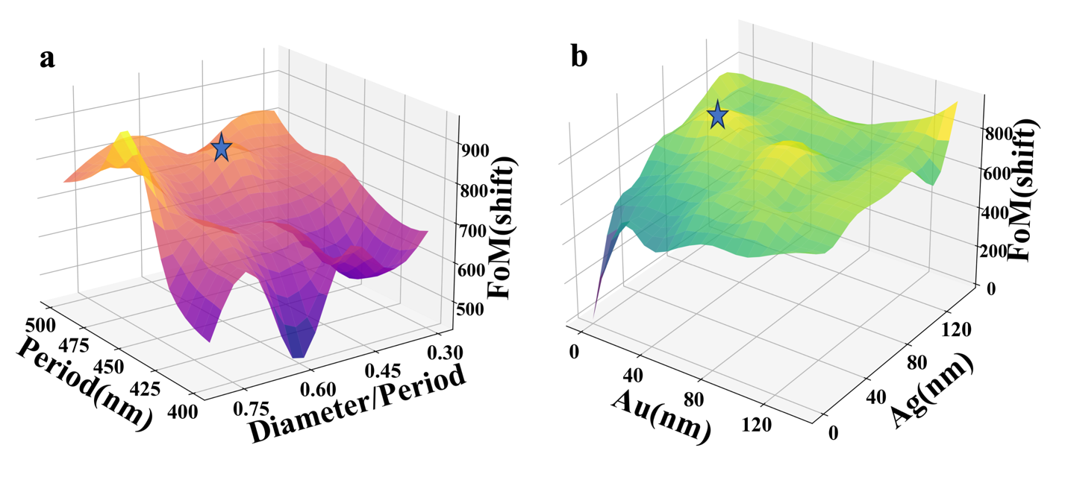
Fig. S10. The combined impact of main parameters on resonance peak shift response. (a) The result of period and diameter period ratio on Sensor's ${FOM}_{shift}$. (a) The result of Au and Ag thickness on Sensor's ${FOM}_{shift}$.

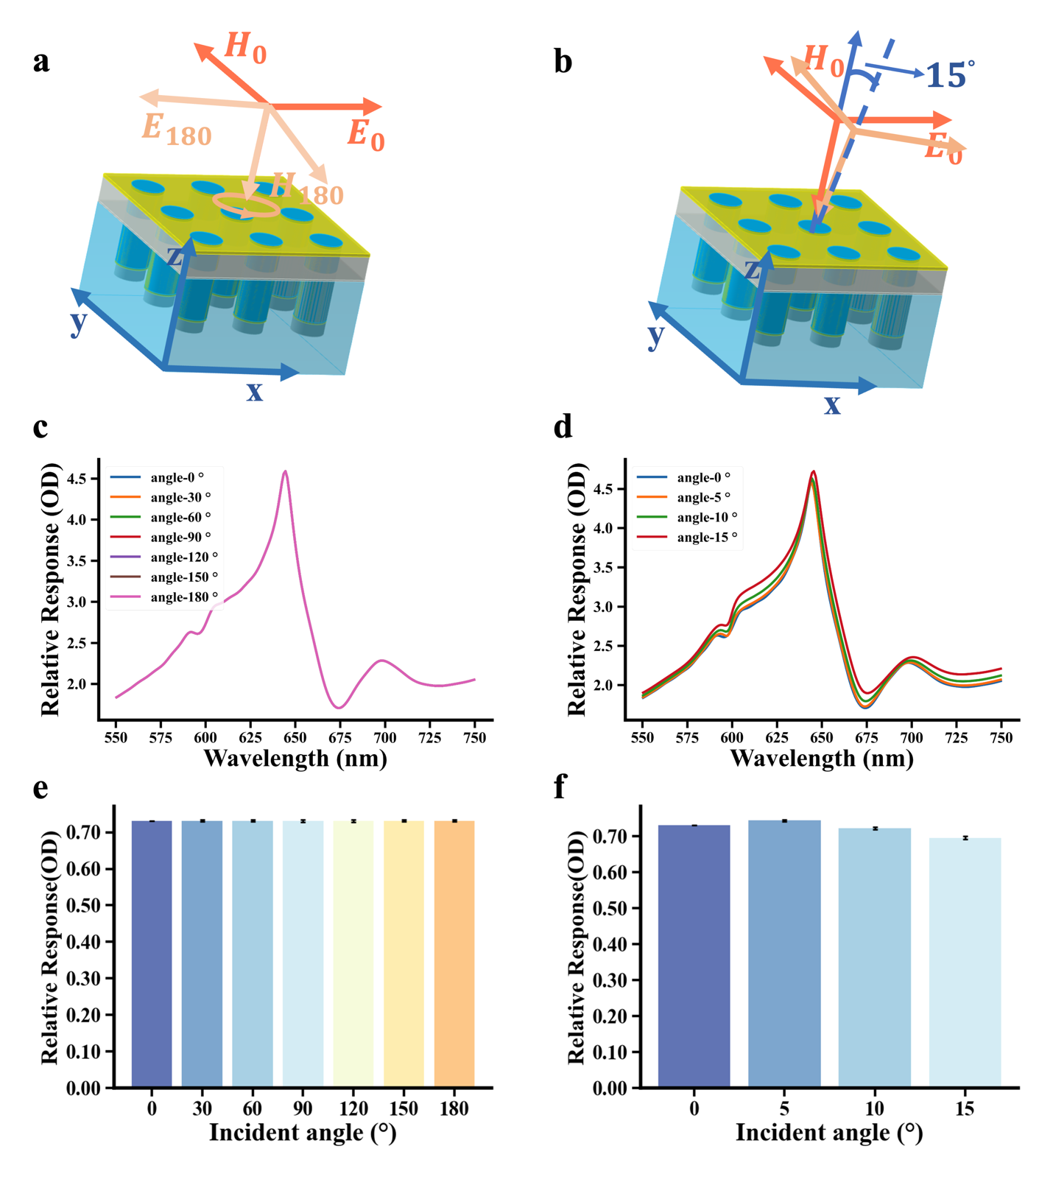
Fi. S11. The Influence of Polarization Angle and Incident Angle of Light Source on OD Response. (a-b) Schematic diagram of light source incidence conditions. (c-d) Origin OD spectrum of different incidence conditions. (e-f) the endpoint method results in different incidence conditions.

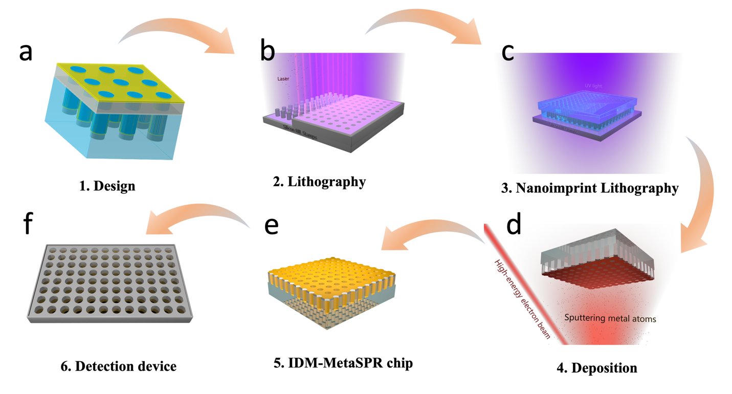
Fig. S12. Manufacturing and processing of IDM-MetaSPR sensor. (a) Design of Metasurface Structure and Parameters. (b) Fabrication of Imprint Templates. (c) Nanoimprint Transfer of Structural Parameters. (d) Plasma Coating on Metasurface Structure. (e) Quality Inspection and Storage of Multilayer Metasurface Sensor. (f) Assembly with Standard Plates (e.g., 96-Well Plates)

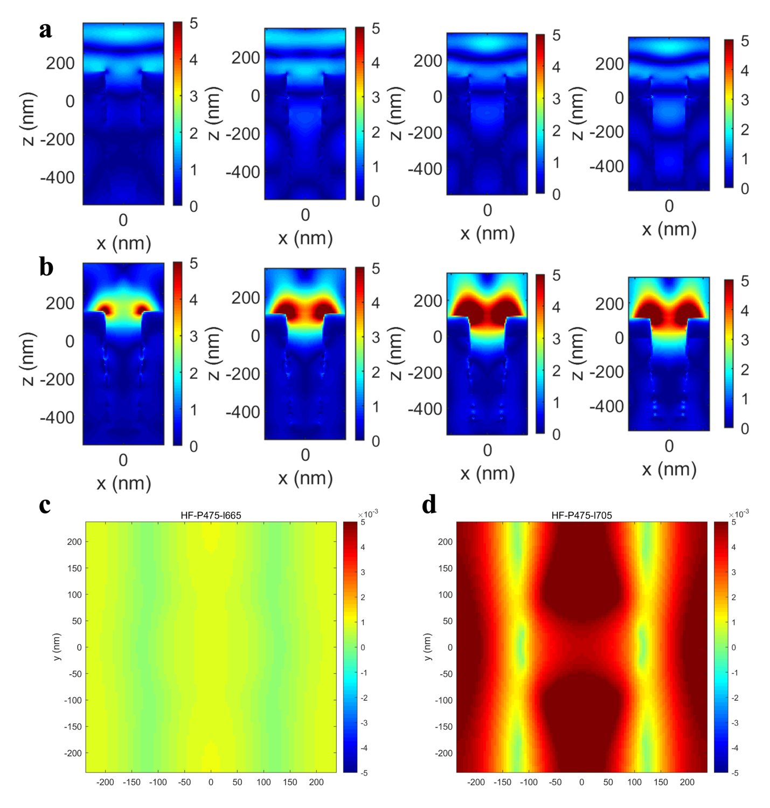
Fig. S13. Electronic and magnetic field profiles of IDM-MetaSPR sensor. (a) The electric field distribution for these structures at 400 nm under different strucuteres. (b) The electric field distribution for these structures at resonance wavelength under different structures. (c) The magnetic field distribution of Wood’s anomalies for the structure of p=475 nm under 665 nm . (d) The magnetic field distribution of Wood’s anomalies for the structure of p=475 nm under 705 nm .

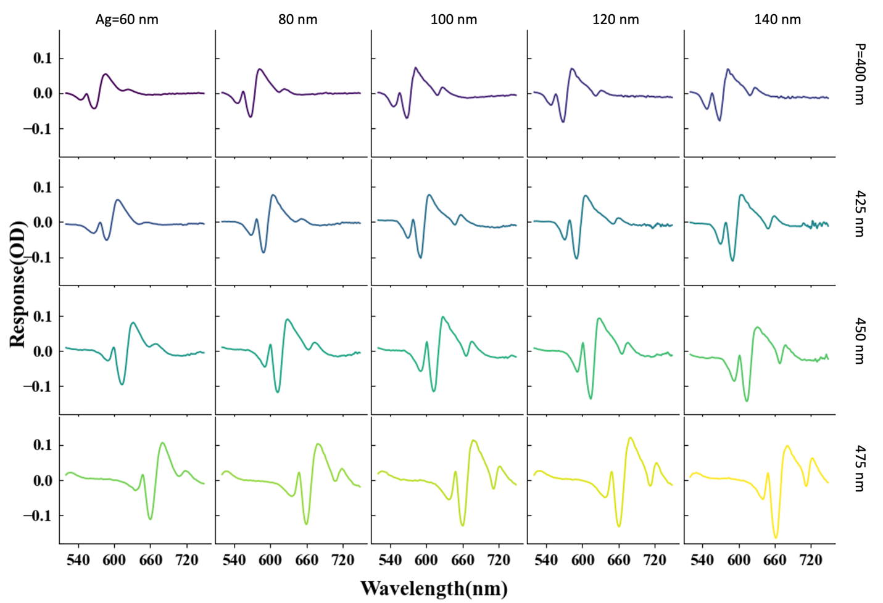
Fig. S14. Differential OD response of IgG binding to protein A based on IDM-MetaSPR sensor.

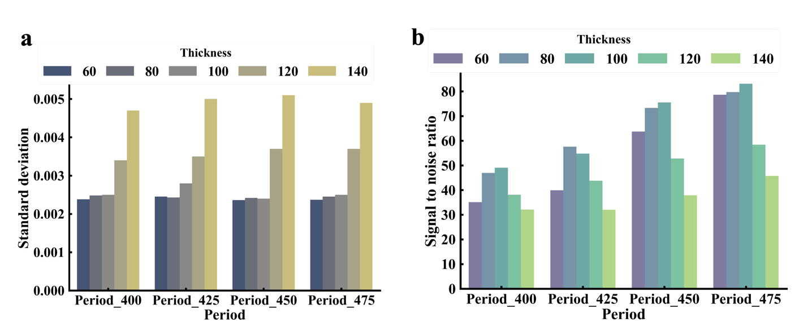
Fig. S15. Standard deviation and signal-to-noise ratio results of multilayer metasurface sensors with different parameters. (a) The standard deviation results of different period and thickness parameters at 4 μg/mL IgG differential OD (standard deviation data taken from three parallel experiments). (b) The signal-to-noise ratio results of 4 μg/mL IgG differential OD with different period and thickness parameters.

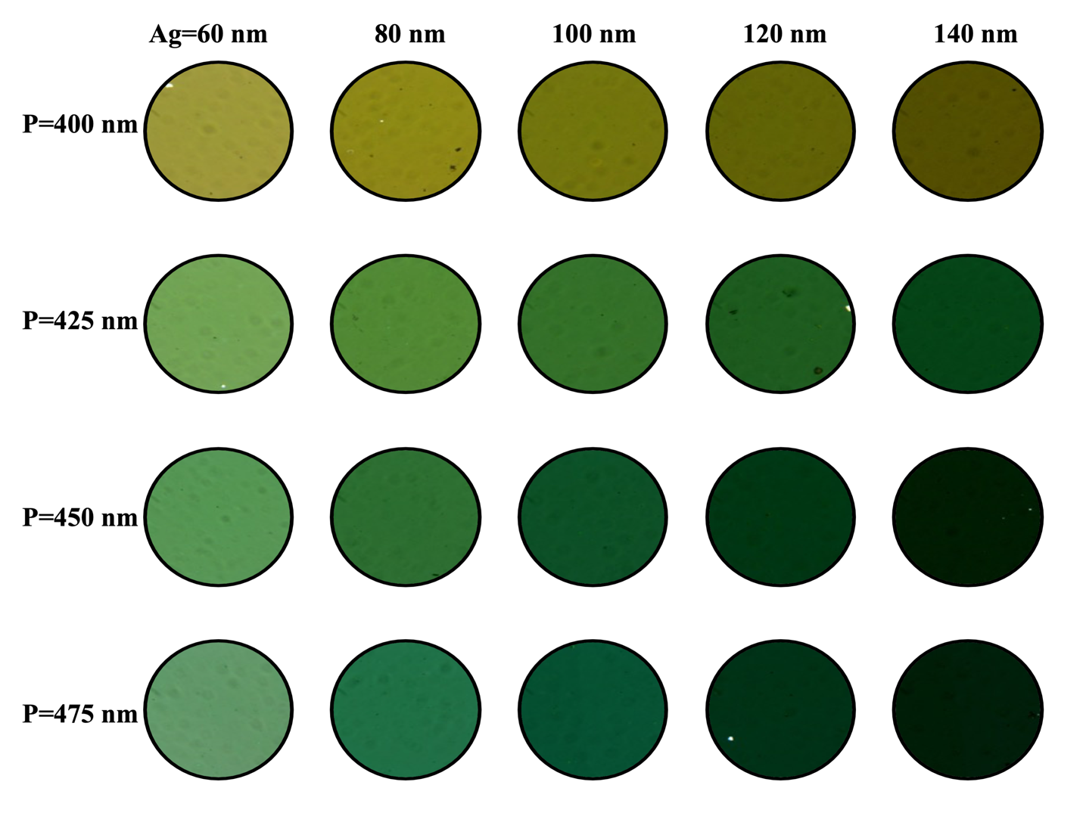
Fig. S16. Transmission microscopy images of chips with different parameters in air.

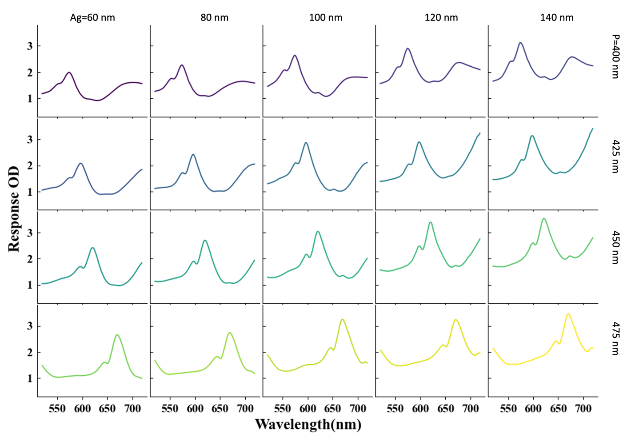
Fig. S17. The unprocessed OD spectrum of the sensors.

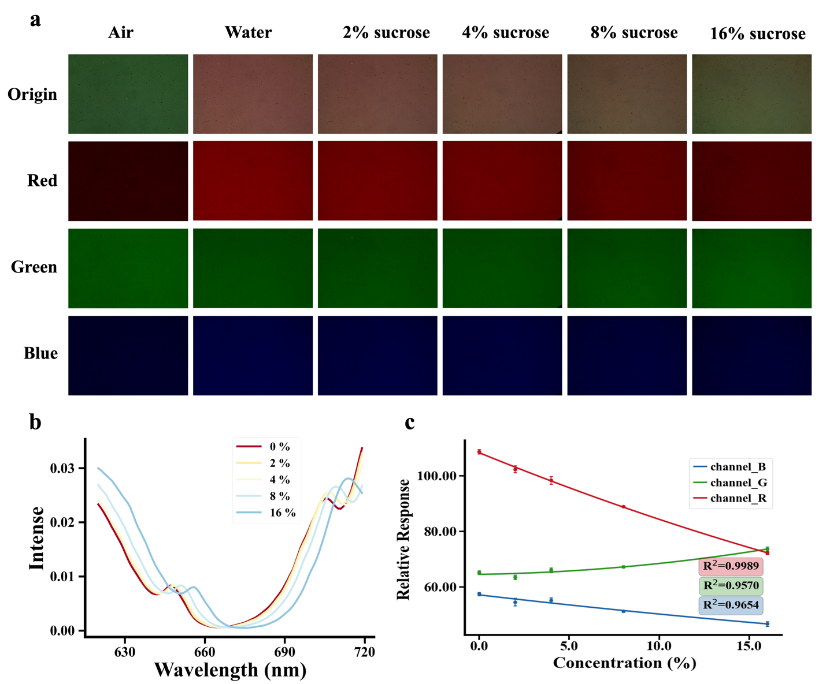
Fig. S18. Application of Peak-Shift-Based Optimization in SPR Imaging Sensing. (a) Color microscopic images of the metasurface sensor and the separated RGB channel images under different sucrose concentrations. (b) Resonance peak shift results under different sucrose concentrations. (c) Calibration curves of the mean values of the RGB channels against sucrose concentration under different sucrose concentrations (error bars represent data from three images taken at different times).

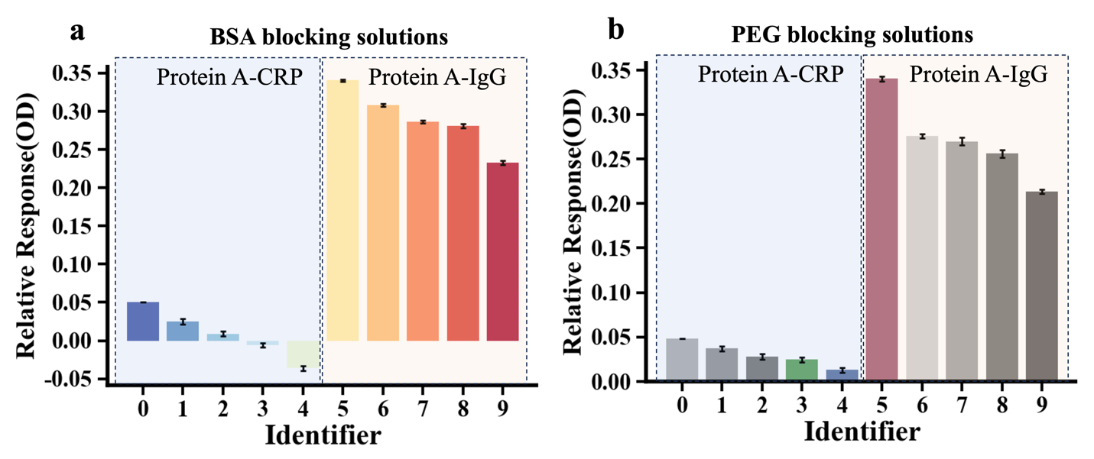
Fig. S19. Experimental study on the optimal parameter effect of blocking agent concentration. (a) The outcomes of detecting C-reactive protein (CRP) and immunoglobulin G (IgG) using bovine serum albumin (BSA) as a blocking agent at mass concentrations of 0% (Identifier 0,5), 0.1% (Identifier 1,6), 0.5% (Identifier 2,7), 1% (Identifier 3,8), and 5% (Identifier 4,9). (b) The outcomes of detecting C-reactive protein (CRP) and immunoglobulin G (IgG) using polyethylene glycol (PEG) 2000 as a blocking agent at mass concentrations of 0% (Identifier 0,5), 0.1% (Identifier 1,6), 0.5% (Identifier 2,7), 1% (Identifier 3,8), and 5% (Identifier 4,9).

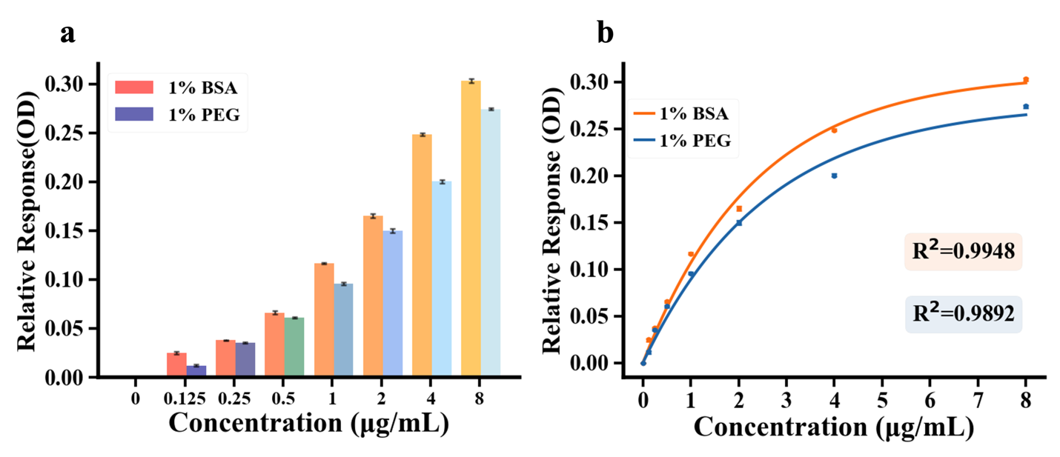
Fig. S20. Experimental study on PEG and BSA as blocking agent.

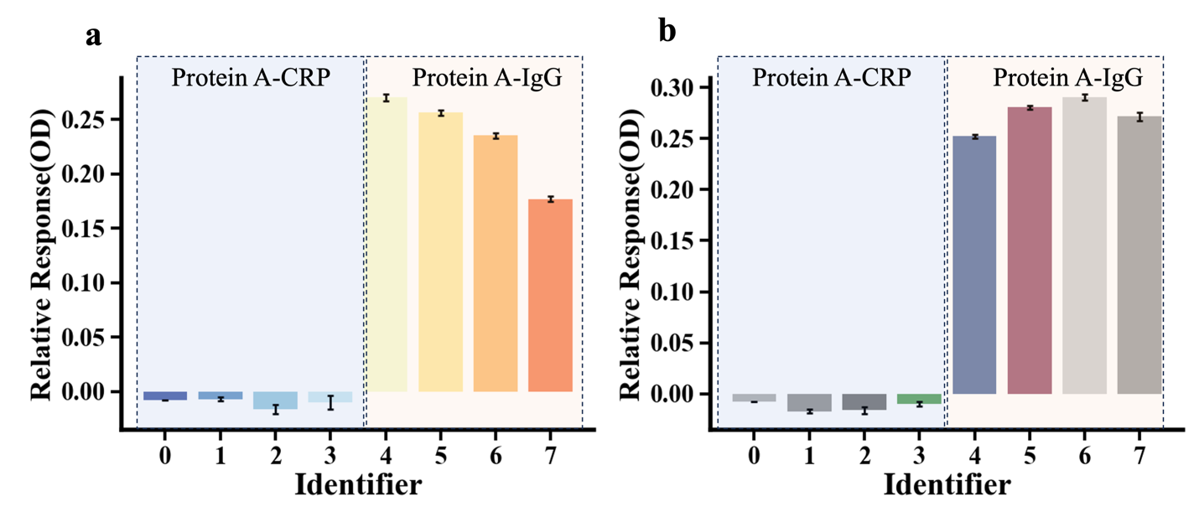
Fig. S21. Experimental study on the incubation buffer systems and detection buffer systems. (a) The results of CBS (Identifier 0,4), PBST (Identifier 1,5), HBS-ET (Identifier 2,6), and PBS (Identifier 3,7) as incubation buffer systems. (b) The results of CBS (Identifier 0,4), PBST (Identifier 1,5), HBS-ET (Identifier 2,6), and PBS (Identifier 3,7) as detection buffer systems.
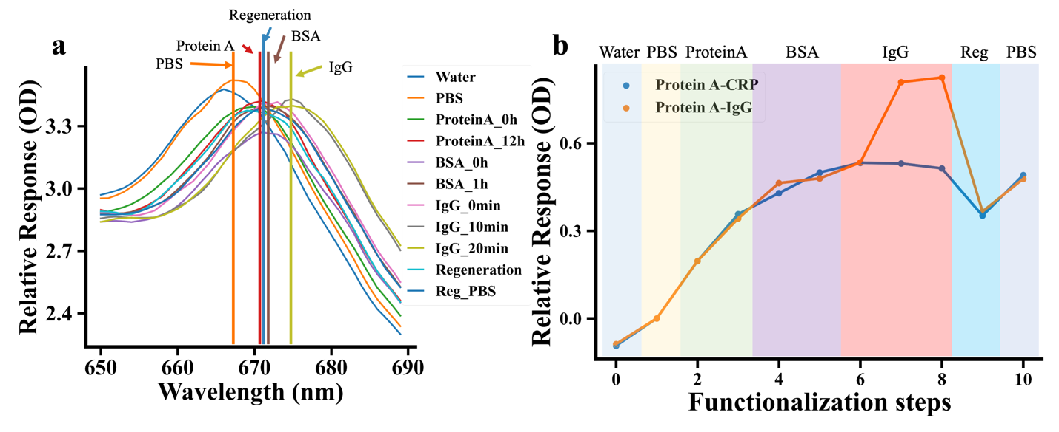
Fig. S22. Spectrum response for different detection steps. (a) Original OD spectrum of each detection steps. (b) The difOD results of each detection steps.

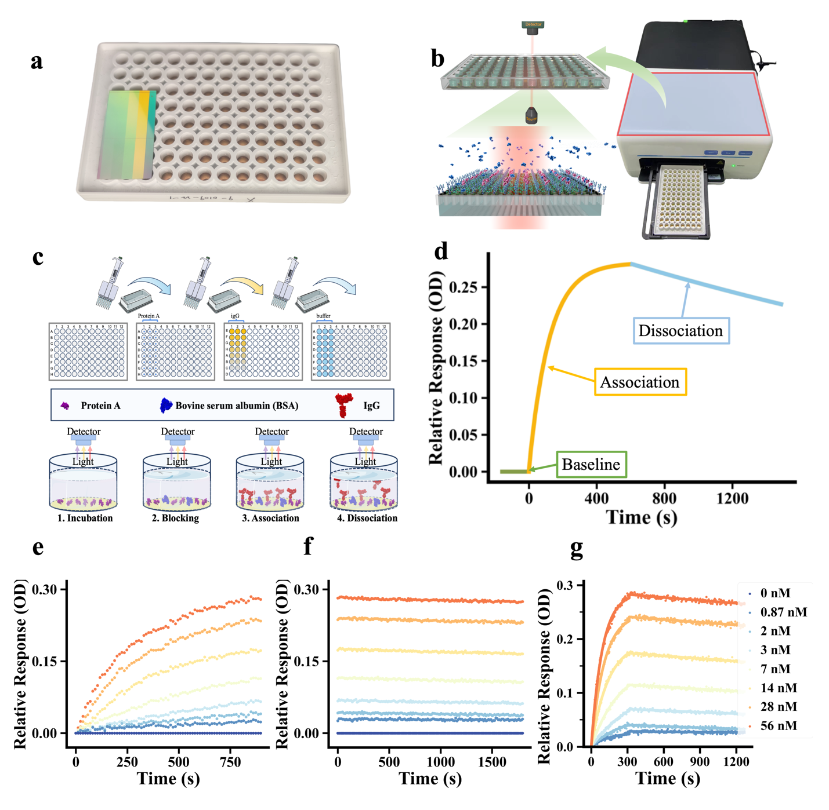
Fig. S23. Establishment of IDM-MetaSPR molecular interaction platform. (a) The physical image of four parameters IDM-MetaSPR chip and universal 96-well plate detection device. (b) Real-time detection schematic diagram based on a universal microplate reader. (c) Flowchart of high-throughput affinity detection based on IDM-MetaSPR biosensors. (d) A typical affinity response curve of a IDM-MetaSPR biosensor. (e-g) The association dissociation, and affinity fitting curves of protein A and IgG.

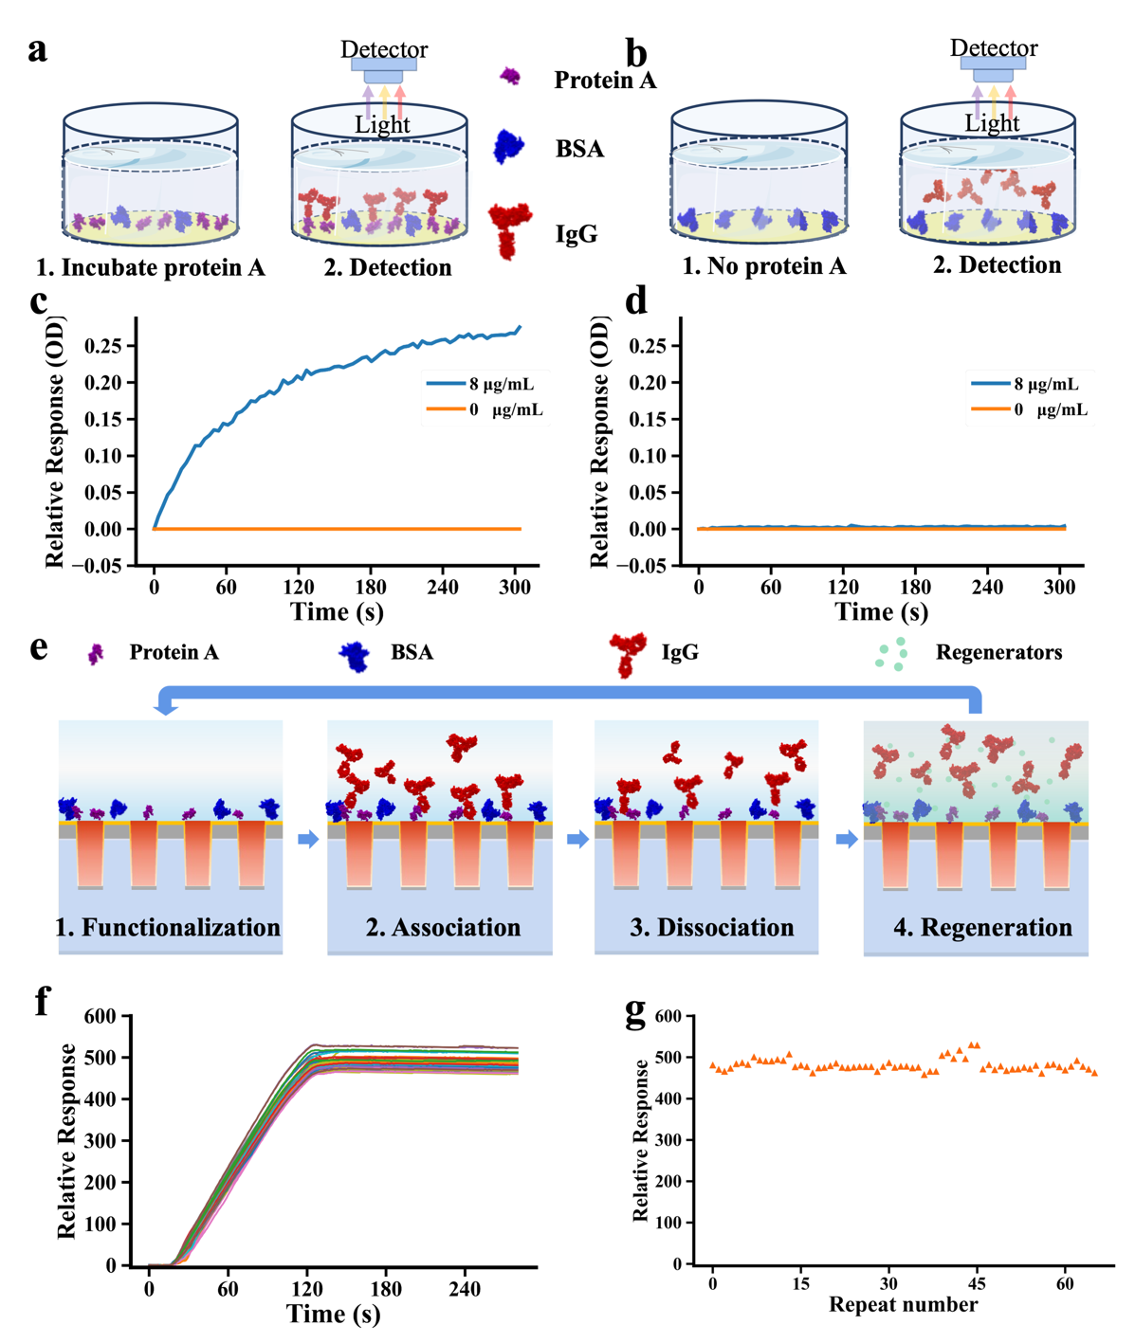
Fig. S24. Anti-non-specific adsorption and regeneration performance testing of IDM-MetaSPR sensors. (a) Schematic diagram of IgG detection with incubation of protein A (as a control group for anti-non-specific adsorption experiments). (b) Schematic diagram of IgG detection without incubation of protein A (as an experiment group for anti-non-specific adsorption experiments). (c-d) Real-time monitoring results of IgG binding process with and without incubation of protein A. (e) Schematic diagram of the main process of sensor regeneration experiment. (f) Real-time monitoring results of 65 regeneration experiments using protein A and IgG. (g) The maximum response value results of 65 regeneration experiments.

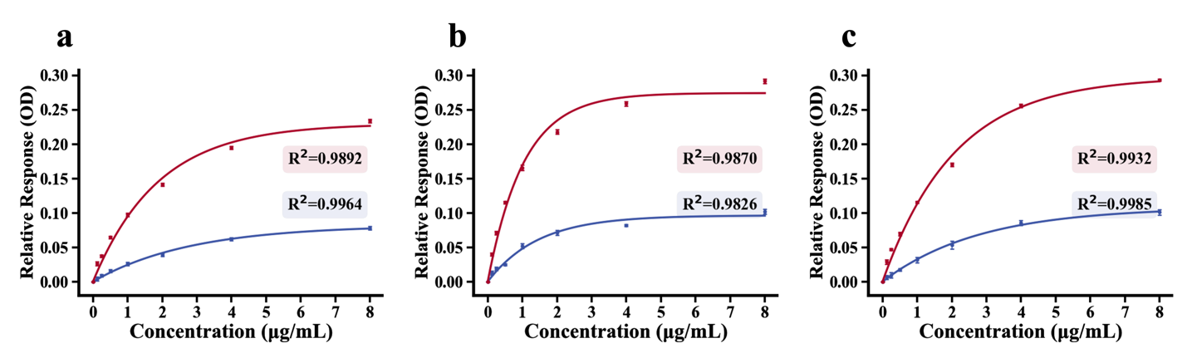
Fig. S25. Quantification Curves of Antibody Drugs Based on Endpoint Data from Dynamic Association Segments. (a) Quantification curve for Polatuzumab binding to CD79B, comparing the unoptimized sensor (blue) with the optimized IDM-MetaSPR sensor (red). (b) Quantification curve for Adalimumab binding to TNF-α, comparing the unoptimized sensor (blue) with the optimized IDM-MetaSPR sensor (red). (c) Quantification curve for Sacituzumab govitecan binding to TROP2, comparing the unoptimized sensor (blue) with the optimized IDM-MetaSPR sensor (red).
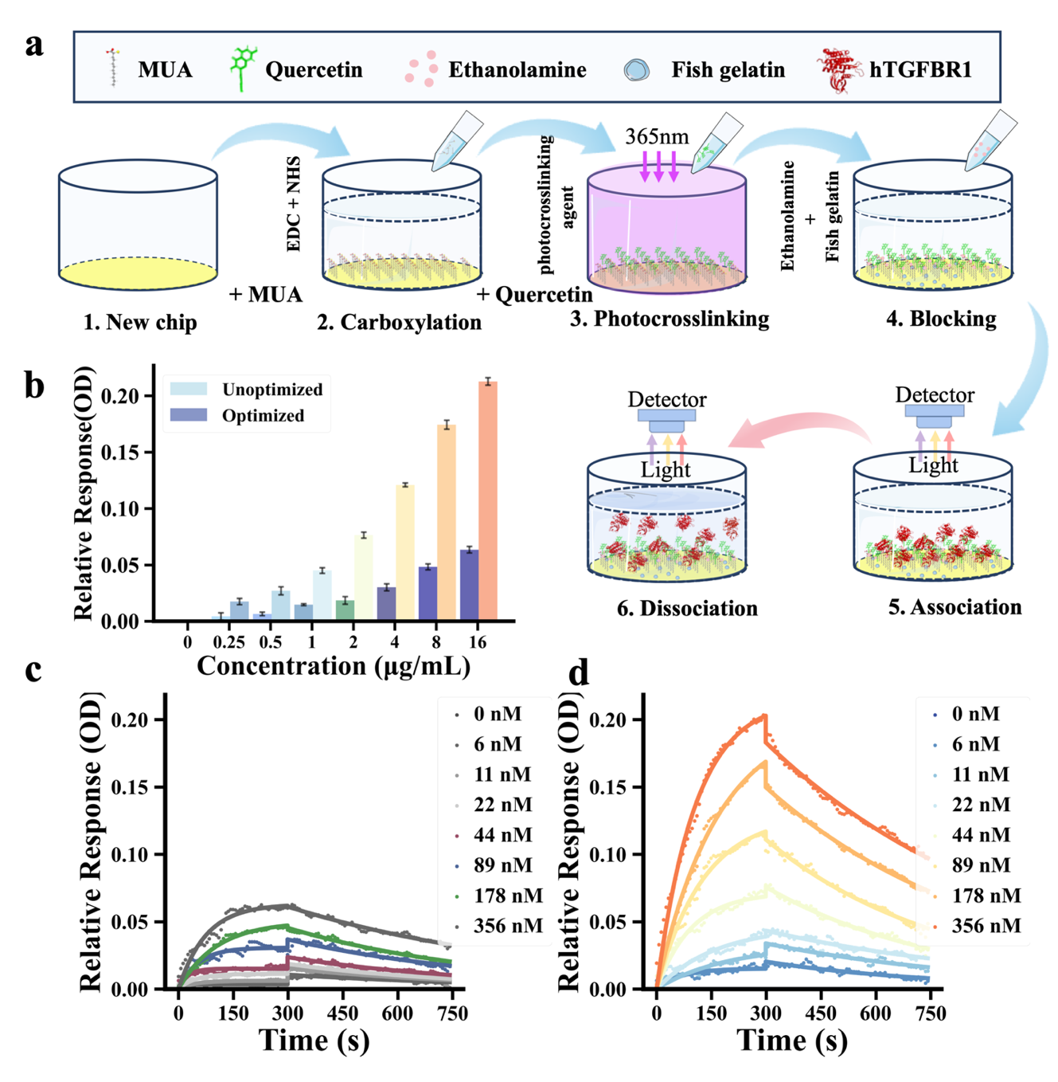
Figure S26. Small molecule affinity detection based on IDMM-SPR sensor. (a) Schematic diagram of the modification and detection process for small molecule affinity detection using the IDMM-SPR sensor. (b) Response signals from the unoptimized and optimized chips after kinetic binding. (c) The dynamic response curve of the Quercetin-modified sensor surface for detecting hTGFBR1 using the unoptimized sensor. (d) The dynamic response curve of the Quercetin-modified sensor surface for detecting hTGFBR1 using the optimized IDMM-SPR sensor.

Table S1.
Comparison of the characteristics of the proposed IDM-MetaSPR sensor with other structures reported in the literature.

NO. | year | Structure | Materials | Wavelength (nm) | Sensitivity  (nm/RIU) | FoM | Ref.
1 | 2018 | Nanodisk arrays | Au | 550-800 | 113 | / | [22]
2 | 2018 | Cross-shaped nanocup arrays | Ag | 400–800 | 477 | 12.9 | [23]
3 | 2019 | Nanocomposite arrays | Au, Ag | 674 | 322 | 10.07 | [24]
4 | 2021 | Periodic iso-Y NPs | Au | 825-975 | 428 | 1.90 | [25]
5 | 2021 | Mono-metallic nanocup arrays | Au, Ag | 691 | 387 | / | [26]
6 | 2023 | Nanocup arrays | Ti,Au,Ag | 400-800 | 759.5 | 22.01 | [27]
7 | 2024 | IDM-MetaSPR sensor | Cr,Ag,Au | 400-800 | 812 | 26.3 | This work

Table S2.
Comparison of LOD for Antibody Drugs Using Unoptimized and Optimized IDM-MetaSPR Sensors.

NO. | Name | LOD-unopt  (ng/mL) | $LOD$-opt  (ng/mL)
1 | Polatuzumab | 476.6 | 31.3
2 | Adalimumab | 193.4 | 18.4
3 | Sacituzumab govitecan | 332.5 | 23.2

References
1. A. Sohi P, Kahrizi M. Principles and Applications of Nanoplasmonics in Biological and Chemical Sensing: A Review. In: Kahrizi M, A. Sohi P, editors. Recent Advances in Nanophotonics - Fundamentals and Applications [Internet]. IntechOpen; 2020 [cited 2025 Jan 2]. Available from: https://www.intechopen.com/books/recent-advances-in-nanophotonics-fundamentals-and-applications/principles-and-applications-of-nanoplasmonics-in-biological-and-chemical-sensing-a-review
2. Raether H. Surface Plasmons on Smooth and Rough Surfaces and on Gratings [Internet]. Berlin, Heidelberg: Springer Berlin Heidelberg; 1988 [cited 2025 Jan 2]. Available from: http://link.springer.com/10.1007/BFb0048317
3. Ghaemi HF, Thio T, Grupp DE, Ebbesen TW, Lezec HJ. Surface plasmons enhance optical transmission through subwavelength holes. Phys Rev B. 1998;58:6779–82.
4. Thio T, Ghaemi HF, Lezec HJ, Wolff PA, Ebbesen TW. Surface-plasmon-enhanced transmission through hole arrays in Cr films. J Opt Soc Am B. 1999;16:1743.
5. Darmanyan SA, Zayats AV. Light tunneling via resonant surface plasmon polariton states and the enhanced transmission of periodically nanostructured metal films: An analytical study. Phys Rev B. 2003;67:035424.
6. Cao Q, Lalanne P. Negative Role of Surface Plasmons in the Transmission of Metallic Gratings with Very Narrow Slits. Phys Rev Lett. 2002;88:057403.
7. Treacy MMJ. Dynamical diffraction in metallic optical gratings. Applied Physics Letters. 1999;75:606–8.
8. Lezec HJ, Thio T. Diffracted evanescent wave model for enhanced and suppressed optical transmission through subwavelength hole arrays. Opt Express. 2004;12:3629.
9. Yanik AA, Cetin AE, Huang M, Artar A, Mousavi SH, Khanikaev A, et al. Seeing protein monolayers with naked eye through plasmonic Fano resonances. Proc Natl Acad Sci USA. 2011;108:11784–9.
10. Palani S, Kenison JP, Sabuncu S, Huang T, Civitci F, Esener S, et al. Multispectral Localized Surface Plasmon Resonance (msLSPR) Reveals and Overcomes Spectral and Sensing Heterogeneities of Single Gold Nanoparticles. ACS Nano. 2023;17:2266–78.
11. Hinman SS, McKeating KS, Cheng Q. Surface Plasmon Resonance: Material and Interface Design for Universal Accessibility. Anal Chem. 2018;90:19–39.
12. West PR, Ishii S, Naik GV, Emani NK, Shalaev VM, Boltasseva A. Searching for better plasmonic materials. Laser & Photon Rev. 2010;4:795–808.
13. Kim S, Kim J, Park J, Nam J. Nonnoble‐Metal‐Based Plasmonic Nanomaterials: Recent Advances and Future Perspectives. Advanced Materials. 2018;30:1704528.
14. Todeschini M, Bastos Da Silva Fanta A, Jensen F, Wagner JB, Han A. Influence of Ti and Cr Adhesion Layers on Ultrathin Au Films. ACS Appl Mater Interfaces. 2017;9:37374–85.
15. Kennedy J, Eberhart R. Particle swarm optimization. Proceedings of ICNN’95 - International Conference on Neural Networks [Internet]. Perth, WA, Australia: IEEE; 1995 [cited 2025 Jan 9]. p. 1942–8. Available from: http://ieeexplore.ieee.org/document/488968/
16. Vidarsson G, Dekkers G, Rispens T. IgG Subclasses and Allotypes: From Structure to Effector Functions. Front Immunol [Internet]. 2014 [cited 2024 Jul 23];5. Available from: http://www.frontiersin.org/Immunotherapies_and_Vaccines/10.3389/fimmu.2014.00520/abstract
17. Wilson JL, Scott IM, McMurry JL. Optical biosensing: Kinetics of protein A‐IGG binding using biolayer interferometry. Biochem Molecular Bio Educ. 2010;38:400–7.
18. Peltomaa R, Glahn-Martínez B, Benito-Peña E, Moreno-Bondi MC. Optical Biosensors for Label-Free Detection of Small Molecules. Sensors. 2018;18:4126.
19. Mofidifar S, Sohraby F, Bagheri M, Aryapour H. Repurposing existing drugs for new AMPK activators as a strategy to extend lifespan: a computer-aided drug discovery study. Biogerontology. 2018;19:133–43.
20. Anand David A, Arulmoli R, Parasuraman S. Overviews of biological importance of quercetin: A bioactive flavonoid. Phcog Rev. 2016;10:84.
21. Xu J, Zhang S, Wu T, Fang X, Zhao L. Discovery of TGFBR1 (ALK5) as a potential drug target of quercetin glycoside derivatives (QGDs) by reverse molecular docking and molecular dynamics simulation. Biophysical Chemistry. 2022;281:106731.
22. Khan Y, Li A, Chang L, Li L, Guo L. Gold nano disks arrays for localized surface plasmon resonance based detection of PSA cancer marker. Sensors and Actuators B: Chemical. 2018;255:1298–307.
23. Langley DP, Balaur E, Hwang Y, Sadatnajafi C, Abbey B. Optical Chemical Barcoding Based on Polarization Controlled Plasmonic Nanopixels. Adv Funct Materials. 2018;28:1704842.
24. Pinapati P, Cherukulappurath S. Hybrid Dielectric-Plasmonic Nanocomposite Arrays for Bulk and Local Refractive Index Sensing. Plasmonics. 2020;15:441–7.
25. Vestri A, Rippa M, Marchesano V, Sagnelli D, Margheri G, Zhou J, et al. LSPR immuno-sensing based on iso-Y nanopillars for highly sensitive and specific imidacloprid detection. J Mater Chem B. 2021;9:9153–61.
26. Hwang CSH, Ahn M, Jeong K-H. Extraordinary sensitivity enhancement of Ag-Au alloy nanohole arrays for label-free detection of Escherichia Coli. Biomed Opt Express. 2021;12:2734.
27. Li R, Zhao Y, Fan H, Zhou H, Yin S, Zhang Q, et al. Metasurface‐Driven and Nanomaterial‐Coupled Plasmonic Biosensor for the Rapid and Quantitative Clinical Identification of Neutralizing Antibodies against SARS‐CoV‐2 Variants. Adv Funct Materials. 2023;33:2306145.

