Supplementary Materials

Supplementary table 1: Sequencing counts in 49 samples (10 controls, 20 new TB patients and 19 TB patients on treatment) before (Reads in) and after (Reads out) trimming of low-quality reads, denoising (denoisedF/R), merging forward and reverse reads (merged), and after removing chimeras (nonchim).

Samples | Reads in | Reads out | denoisedF | denoisedR | merged | nonchim
GmCo_001_S1 | 247337 | 187950 | 187471 | 187581 | 185997 | 184632
GmCo_002_S2 | 357012 | 278570 | 278083 | 278114 | 274586 | 263478
GmCo_003_S3 | 256098 | 188572 | 187878 | 188019 | 185894 | 183473
GmCo_004_S4 | 241675 | 183332 | 182168 | 182606 | 178706 | 171147
GmCo_005_S5 | 96904 | 74824 | 74516 | 74528 | 73473 | 72760
GmCo_006_S6 | 252829 | 190408 | 189950 | 189994 | 188687 | 188236
GmCo_007_S7 | 340406 | 248028 | 246922 | 247141 | 242878 | 229213
GmCo_008_S8 | 310578 | 223168 | 222366 | 222478 | 219311 | 212007
GmCo_009_S9 | 314982 | 239253 | 238666 | 238733 | 235283 | 230443
GmCo_010_S10 | 337501 | 251057 | 250129 | 250291 | 247009 | 241340
GmTb_101_S11 | 311844 | 225618 | 224532 | 224536 | 220898 | 207629
GmTb_102_S12 | 137176 | 102524 | 102115 | 102069 | 100209 | 98268
GmTb_103_S13 | 163302 | 121221 | 120359 | 120466 | 118069 | 113515
GmTb_104_S14 | 215211 | 151210 | 150151 | 150416 | 147913 | 144436
GmTb_105_S15 | 144650 | 107683 | 107355 | 107413 | 106564 | 102564
GmTb_106_S16 | 329419 | 248463 | 247450 | 247753 | 244419 | 240356
GmTb_107_S17 | 359095 | 263680 | 262125 | 262398 | 257672 | 252191
GmTb_108_S18 | 359033 | 258825 | 257115 | 257414 | 252991 | 247932
GmTb_109_S19 | 247901 | 179429 | 178934 | 178913 | 177321 | 175917
GmTb_110_S20 | 372348 | 272163 | 270442 | 270435 | 264664 | 256546
GmTb_111_S21 | 229317 | 164347 | 164053 | 164032 | 162839 | 158456
GmTb_112_S22 | 277310 | 205571 | 204862 | 204763 | 201796 | 192873
GmTb_113_S23 | 188056 | 141536 | 141243 | 141244 | 140255 | 135404
GmTb_114_S24 | 233514 | 166441 | 166179 | 166232 | 165585 | 162331
GmTb_115_S25 | 238327 | 179658 | 179172 | 179196 | 177653 | 175762
GmTb_116_S26 | 241441 | 182008 | 181458 | 181561 | 179149 | 177406
GmTb_117_S27 | 251199 | 173255 | 172971 | 172979 | 171917 | 170198
GmTb_118_S28 | 277591 | 194580 | 194250 | 194302 | 193106 | 191113
GmTb_119_S29 | 233329 | 181183 | 180893 | 180865 | 179267 | 178092
GmTb_120_S30 | 235736 | 168323 | 168085 | 168138 | 167270 | 166042
GmTb_201_S31 | 195652 | 142772 | 141879 | 141897 | 137931 | 127405
GmTb_202_S32 | 250622 | 178959 | 178188 | 178107 | 174465 | 158886
GmTb_203_S33 | 197127 | 145418 | 144729 | 144834 | 142812 | 133033
GmTb_204_S34 | 250602 | 164253 | 163037 | 163575 | 160774 | 153107
GmTb_205_S35 | 261564 | 193865 | 193383 | 193450 | 191441 | 188479
GmTb_206_S36 | 228999 | 167563 | 167280 | 167346 | 166489 | 163378
GmTb_207_S37 | 184483 | 137369 | 137087 | 137156 | 135883 | 134103
GmTb_208_S38 | 183574 | 118456 | 118300 | 118350 | 117873 | 117487
GmTb_209_S39 | 190895 | 141913 | 141640 | 141588 | 140400 | 139239
GmTb_210_S40 | 226822 | 161979 | 161653 | 161736 | 160625 | 159222
GmTb_211_S41 | 235194 | 164464 | 164050 | 164125 | 162705 | 158552
GmTb_212_S42 | 225173 | 166795 | 166335 | 166474 | 164355 | 162625
GmTb_213_S43 | 222288 | 156971 | 155933 | 156241 | 153252 | 149023
GmTb_214_S44 | 197506 | 149995 | 149654 | 149770 | 148784 | 139849
GmTb_216_S46 | 261121 | 198956 | 198771 | 198797 | 198207 | 176390
GmTb_217_S47 | 239231 | 179007 | 178713 | 178810 | 177505 | 196393
GmTb_218_S48 | 263969 | 200581 | 200209 | 200323 | 199005 | 120850
GmTb_219_S49 | 181431 | 122223 | 122037 | 122027 | 121528 | 181437
GmTb_220_S50 | 262076 | 190517 | 190272 | 190221 | 189153 | 184632
Total | 12,059,450 | 8,834,936 | 8,805,043 | 8,809,437 | 8,704,568 | 8,467,850

Supplementary table 2: A list of significantly differentially abundant taxa between TB patient groups and controls.

Higher abundance in On_treatment patients vs Controls
 | baseMean | log2FoldChange | lfcSE | stat | p-value | padj
Phylum
Fusobacteria | 64.35 | 24.02 | 4.00 | 6.01 | 1.87e-09 | p = 1.87e-08
Tenericutes | 19.43 | 22.35 | 4.00 | 5.59 | 2.28e-08 | p = 1.14e-07
Genus
Fusobacterium | 25.94 | 23.78 | 4.00 | 5.95 | 2.73e-09 | p = 3.03e-08
Leuconostoc | 26.90 | 23.56 | 4.00 | 5.89 | 3.80e-09 | p = 3.95e-08
Coprobacillus | 7.18 | 21.93 | 4.00 | 5.48 | 4.18e-08 | p = 4.08e-07
Erysipelotrichaceae_UCG-006 | 40.36 | 21.37 | 4.00 | 5.34 | 9.19e-08 | p = 7.27e-07
Parvimonas | 10.84 | 18.32 | 4.01 | 4.57 | 4.80e-06 | p = 3.32e-05
Succinivibrio | 112.65 | 7.68 | 3.01 | 2.56 | 1.06e-02 | p = 4.00e-02
Tyzzerella_4 | 2863.87 | 7.46 | 2.70 | 2.76 | 5.71e-03 | p = 2.43e-02
Solobacterium | 140.09 | 6.52 | 2.49 | 2.61 | 8.94e-03 | p = 3.45e-02
Catenibacterium | 17992.97 | 5.20 | 1.76 | 2.95 | 3.13e-03 | p = 1.53e-02
Holdemanella | 7032.22 | 4.45 | 1.66 | 2.68 | 7.37e-03 | p = 2.91e-02
Lachnoclostridium | 5704.28 | 2.55 | 0.87 | 2.92 | 3.49e-03 | p = 1.66e-02
Lower abundance in On_treatment patients vs Controls
Genus
Turicibacter | 296.46 | -5.94 | 2.40 | -2.48 | 1.33e-02 | p = 4.91e-02
Higher abundance in On_treatment patients vs New_patients
Genus
Prevotellaceae_NK3B31_group | 3.44 | 21.64 | 4.00 | 5.41 | 6.31e-08 | p = 5.52e-07
Megasphaera | 598.44 | 10.75 | 3.97 | 2.71 | 6.71e-03 | p = 2.72e-02
Anaerostipes | 17814.68 | 3.06 | 1.09 | 2.81 | 4.96e-03 | p = 2.17e-02
Lower abundance in On_treatment patients vs New_patients
Phylum
Cyanobacteria | 16.64 | -16.67 | 4.03 | -4.14 | 3.46e-05 | p = 1.15e-04
Euryarchaeota | 41.08 | -11.93 | 4.03 | -2.96 | 3.05e-03 | p = 7.62e-03
Genus
Lachnospiraceae_AC2044_group | 892.78 | -29.45 | 2.04 | -14.47 | 2.01e-47 | p = 3.34e-45
Lachnospiraceae_UCG-008 | 45.59 | -26.54 | 2.61 | -10.16 | 3.10e-24 | p = 2.57e-22
Defluviitaleaceae_UCG-011 | 18.64 | -24.67 | 2.76 | -8.95 | 3.71e-19 | p = 2.05e-17
CAG-352 | 590.45 | -30.00 | 3.49 | -8.60 | 8.00e-18 | p = 3.32e-16
Enterobacter | 33.88 | -25.61 | 3.06 | -8.37 | 5.74e-17 | p = 1.91e-15
Sellimonas | 233.15 | -26.32 | 3.29 | -8.01 | 1.19e-15 | p = 3.31e-14
Lactonifactor | 38.36 | -25.22 | 3.68 | -6.85 | 7.44e-12 | p = 1.76e-10
Adlercreutzia | 22.49 | -26.16 | 3.97 | -6.58 | 4.57e-11 | p = 9.49e-10
Ruminococcaceae_UCG-004 | 101.27 | -24.78 | 3.97 | -6.24 | 4.47e-10 | p = 6.19e-09
Ruminococcaceae_UCG-009 | 224.70 | -24.83 | 3.89 | -6.39 | 1.71e-10 | p = 2.84e-09
Rikenellaceae_RC9_gut_group | 103.96 | -24.91 | 3.97 | -6.27 | 3.62e-10 | p = 5.46e-09
Eubacterium | 46.42 | -24.45 | 3.97 | -6.15 | 7.62e-10 | p = 9.73e-09
Ruminococcaceae_UCG-014 | 213.47 | -25.77 | 3.97 | -6.48 | 8.88e-11 | p = 1.64e-09
Weissella | 30.77 | -23.82 | 3.97 | -5.99 | 2.05e-09 | p = 2.44e-08
Eisenbergiella | 17.11 | -21.47 | 3.98 | -5.39 | 6.87e-08 | p = 5.70e-07
Butyricimonas | 10.36 | -21.51 | 3.94 | -5.46 | 4.65e-08 | p = 4.29e-07
DNF00809 | 12.00 | -18.76 | 4.03 | -4.66 | 3.17e-06 | p = 2.29e-05
Anaerotruncus | 16.64 | -19.03 | 4.01 | -4.75 | 2.02e-06 | p = 1.52e-05
Ruminococcaceae_UCG-002 | 11611.29 | -3.87 | 1.19 | -3.26 | 1.12e-03 | p = 6.42e-03
UBA1819 | 117.50 | -5.74 | 1.68 | -3.41 | 6.39e-04 | p = 4.20e-03
Oscillibacter | 525.57 | -6.53 | 1.92 | -3.41 | 6.57e-04 | p = 4.20e-03
Lachnospiraceae_UCG-001 | 42.24 | -9.81 | 2.99 | -3.28 | 1.03e-03 | p = 6.09e-03
Megamonas | 133.16 | -12.57 | 4.03 | -3.12 | 1.79e-03 | p = 9.91e-03
Negativibacillus | 72.59 | -13.54 | 4.03 | -3.36 | 7.66e-04 | p = 4.71e-03
Ruminococcaceae_NK4A214_group | 1880.20 | -4.42 | 1.53 | -2.89 | 3.91e-03 | p = 1.80e-02
Candidatus_Soleaferrea | 63.40 | -4.53 | 1.60 | -2.84 | 4.56e-03 | p = 2.04e-02
Clostridium_sensu_stricto_1 | 1461.31 | -4.86 | 1.62 | -3.01 | 2.64e-03 | p = 1.33e-02
Family_XIII_AD3011_group | 2672.89 | -4.93 | 1.61 | -3.07 | 2.15e-03 | p = 1.15e-02
GCA-900066225 | 22.11 | -5.63 | 2.06 | -2.73 | 6.37e-03 | p = 2.65e-02
Ruminococcaceae_UCG-010 | 2196.96 | -6.30 | 2.10 | -3.01 | 2.65e-03 | p = 1.33e-02
baseMean is the average normalized count of the taxon across all samples; log2foldchange is the log2-transformed fold change in abundance between two groups (e.g., treatment vs. control), with positive and negative values reflecting higher or lower abundance in the reference group respectively; IfcSE is the standard error of the log2 fold change; stat is the Wald test statistic (ratio of log2FoldChange / lfcSE) used to compute the p-value; and padj is the adjusted p-value using Benjamini-Hochberg FDR correction to account for multiple testing.

Supplementary figures

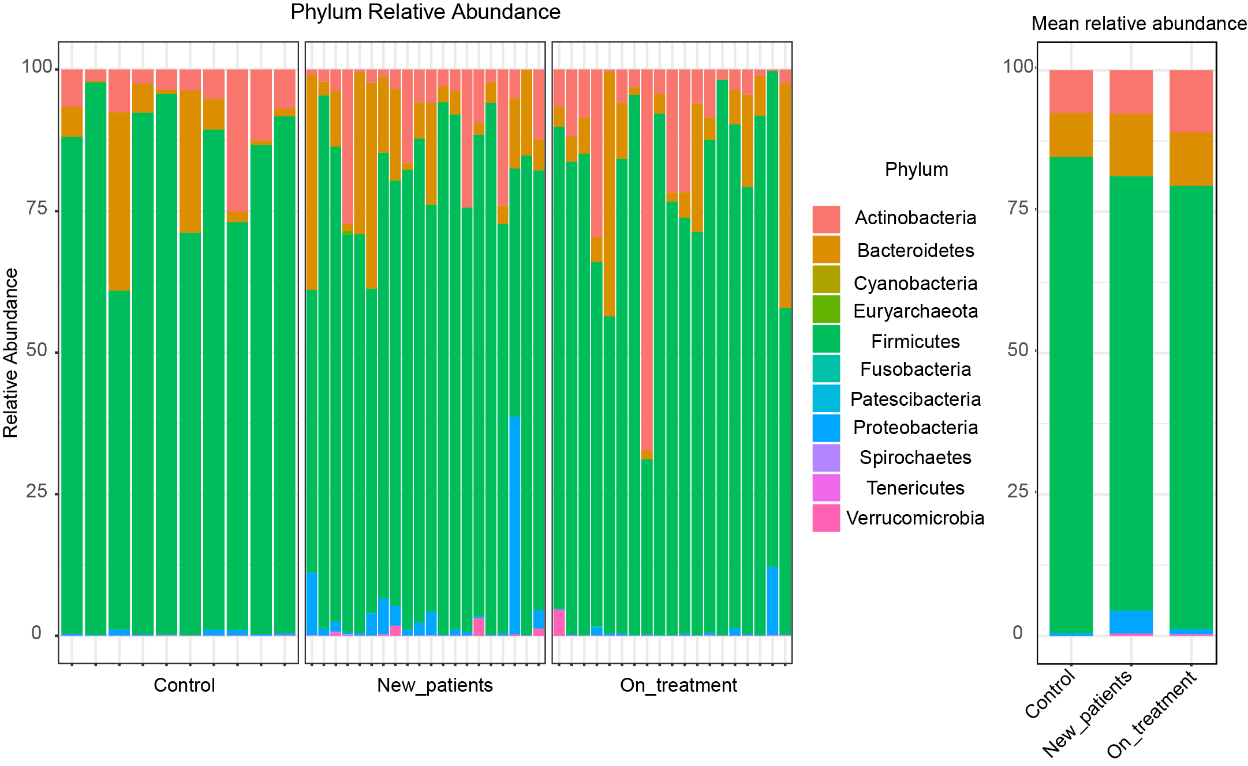
Supplementary figure 1: Relative abundance of phyla across TB patients and Controls. The left panel shows relative abundance in individual samples while the right panel shows the average relative abundance in each group.

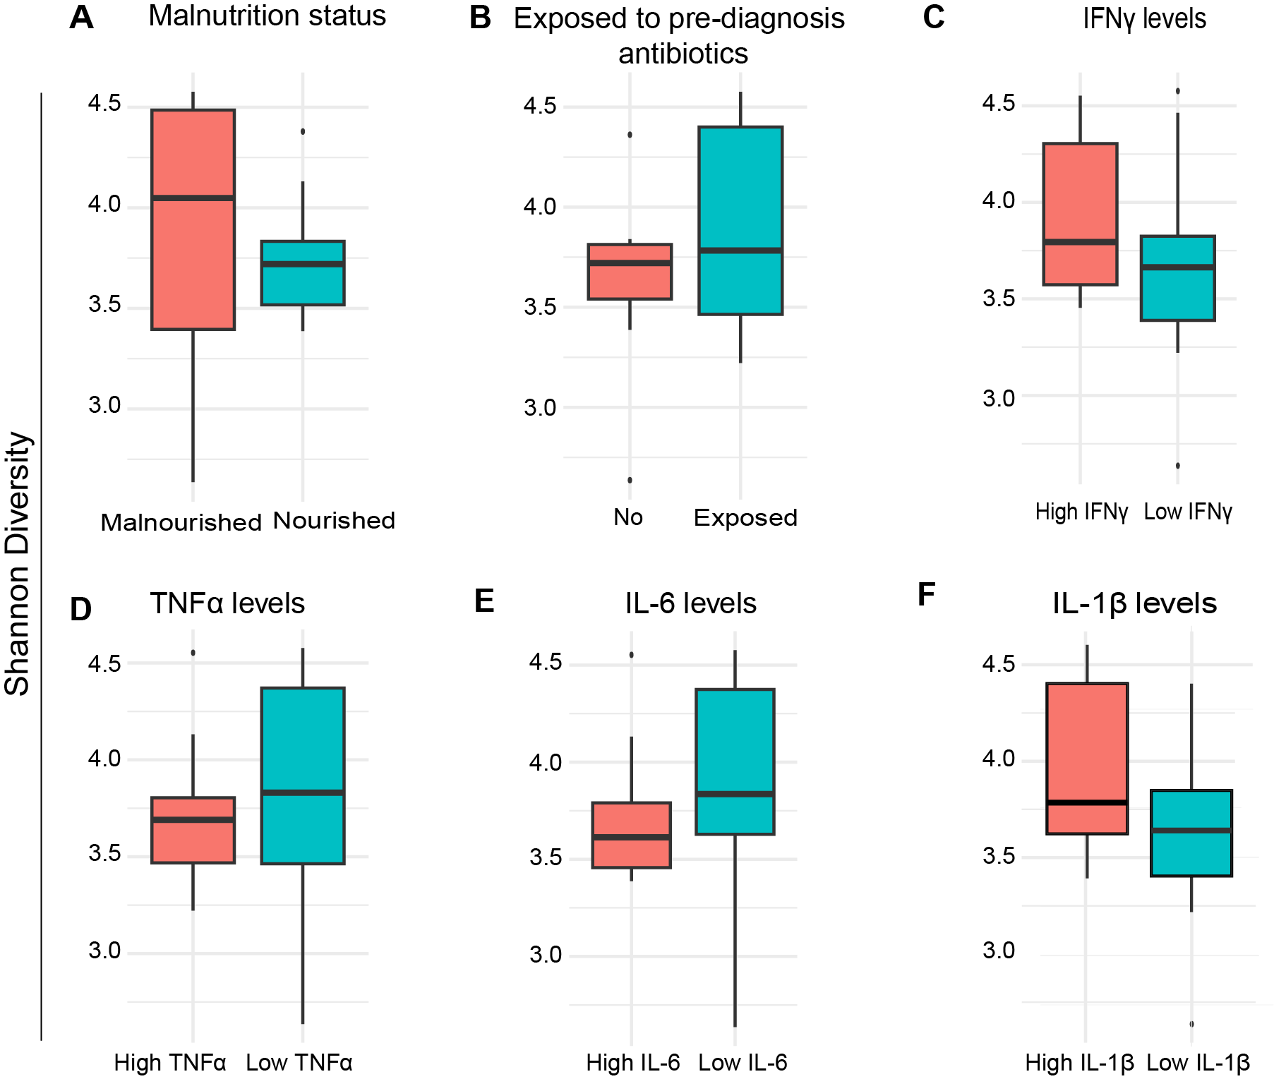
Supplementary figure 2. Alpha diversity across newly diagnosed TB patients with different clinical characteristics. (A-F) Box plots showing Shannon diversity indices across newly diagnosed TB patients with different characteristics including with and without malnutrition (A), with and without exposure to empirical antibiotics (B), and with high and low cytokine levels (C-F). The central line represents the median, the box indicates the interquartile range (IQR), and whiskers extend to 1.5 times the IQR. Outliers are shown as individual points. Differences in alpha diversity reflect variation in microbial richness and evenness between groups.

