Global hotspots of unprecedented tropical cyclone risk for targeted adaptation
Odériz I.¹, Losada, I.J.¹, Hinkel, J.^{2,3}
¹IHCantabria - Instituto de Hidráulica Ambiental de la Universidad de Cantabria, Santander, Spain
²Global Climate Forum, Berlin, Germany
³Research Economics Group, Thaer Institute, Humboldt University, Berlin

Itxaso Odériz (itxaso.oderiz@unican.es)

Table S 1. Names of the administration levels existing for each nation.
Level 1 | Sovereign Base Area, Sub-Region, Qark, Wilaya, District, Província, Island, Dependency, Parish, Provincia,  Distrito Federal, None, Territory, State, İqtisadi Rayonu , Muhafazah, Bibhag, Gewest, Département, Municipality , Caribisch openbaar lichaam, Entity, Estado, Daerah-Daerah , Oblast, Concelho, Khêt, Krong, Région, Province, Territoire, Región, Shěng, Zìzhìqu , Special Administrative Region, Zhíxiáshì, Departamento,  Autonomous Island, Island Council, District autonome, Županija, Eparchies, Region, Distrito, Zoba, Maakond,  Syssel, Division, Lääni, Arrondissement, Subdivisions administratives, Independent City , Avtonomiuri Respublika, Freie Hansestadt, Land, Apokentroménes dioikíseis, Kommuner, National Park, Região, Sector Autónomo, Landsvæði, Kaupstadir, Union Territor , Propinisi, Ostan, County, Parish District, Town District,  Village District, Mehoz, Regione, Ken, Do, Fu, To , Oblasy, Shabiyah, Apskritis, Negeri, Wilayah Persekutuan,  Reġjun, Atol, Wilayat|Région, Autonomous island , Chef-lieu canton, Préfecture de région, Sous-préfecture,  Opština, Yin, Pyine, Provincie, Water body , Group of islands, Región Autónoma, "Tŭkbyŏl Haengjeonggu",  Teukbyeolsi, Kaza, Fylke, Mintaqah, Comarca Indígena , Autonomous Region, Lalawigan, Województwo,  Regiões autônoma, Municipio, Municipio|Senatorial District , Baladiyah, Judet, Respublika, Avtonomnyy Okrug, Gorsovet , Kray, Paroisse, Administrative Area, Quarter, Commune , Itumalo, Minṭaqah, Outer Islands, Statisticna Regije , Capital Territory, Gobolka, Provinsie, Gwangyeoksi , Metropolitan City, Comunidad Autónoma, Ciudad Autónoma , Distrikkaya, Wilayat, Distrikt, Län, Muḥāfaẓah, Mkoa , Changwat, Atoll, Island Group, Borough, City, Il , Welayat, Town Council, Autonomous Republic, Oblas , Emirate, Reef, Tỉnh, Thành phố, Kingdom, Willaya , Constituent Country
Level 2 | None, Municipality, Commune-Cotiere, Commune , Chef-Lieu-Wilaya, County, Island, Município, Partido , Departamento, Distrito Federal, Territory, Area, City , Shire, Unincorporated Area, Region, Town , District Council, State reserve, Borough, Islands, Rayon , Sahar, Zila, Provincie, Županija, Ilha, Mukim , Obshtina, Srok, Département, Regional District , Census Division, District, Regional County Municipality , Municipalité Régionale de Comté, Provincia, Dìjíshì, Dìqu , Concelho|Distrito, Zhíxiáshì, Municipio , Corregimiento Departamental, Islas, Cantón , District autonome, Région, Općina, Grad, Territoire , Ville, Kommune, Distrito municipal, Canton, Markaz , Kism, Police-administered area, Districts, Vald, Linn , Kommunur, Province, Maakunta|landskap, Raioni, "Kalaki" , Kreisfreie Stadt, Landkreis, Kreis, Municipal District , Metropolitan District, Periféreia, Chef-lieu canton , Commune simple, Préfecture de région, Sous-préfecture , Water body, Sector, Préfecture , Neighbourhood Democratic Council, Not Classified , Arrondissement, Sveitarfélög, Kabupaten, Kota , Shahrestan, Unknown, Kaza, City Council , Borough District, Shi, Machi, Mura, Capital, Son , Special Ward, Shichō, Nahia, Maslikhat, Constituency , Aprinki|rajoni, Qadaa, Rajono Savivaldybe , Miesto Savivaldybe, Daerah, Wilayah Persekutuan , Kunsil lokal, Moughataas|Département, Atol, Reef , Prefecture, Distrito, Kayaing, Gemeente , Area Outside Territorial Authority, Local Authority, Si , Gun, Guyŏk, Kommuner, Wilayat, Division, Governorate , Comarca Indígena, Bayan|Munisipyo, Lungsod|Siyudad,  Miasto na prawach powiatu, Powiat, Concelho, Comune , Gorsovet, Ostrov, Raion, Gorod, AOk, Quartier , Administrative Area, Dependency, Muhafazah, Opcine, Ward , District Municipality, Gu, Ciudad Autónoma, Ressort , Mantika, Xiàn, Shì, Wilaya, Khet, Amphoe , King Amphoe, Subdistrito, Delegation, Uly etrap, Şäher , Etrap, "Miska Rada", Misto, Municipal Region, Emirate , Census Area, City And Borough, Parish, Independent City , Area council, Huyện, Thành phố, Thị xã, Quận , Subdistrict, Muderiah, Unitary Authority, NA , Administrative County, Unitary Authority (City) , Metropolitan Borough (City), Metropolitan Borough , Unitary District (City), Unitary District, Island area
Level 3 | None, Village, Commune, Upazilla, Arrondissement, Opčine , Distrito, Ilha, Khum, Réserve Indienne , Regional District Electoral Area, Cité , District Municipality, Town, Island Municipality , "Nisgaa Village", "Nisgaa Land", Indian Government District , Non Organisé, Établissemnet Indien, Parish , Rural Community, Subdivision of Unorganized, Indian Reserve , Region, Hamlet, Settlement, Chartered Community , Subdivision of County Municipality, Regional Municipality , Municipal District, Community, Township and Royalty, Ville , Municipalité, Municipalité De Paroisse , Municipalité De Canton, Terre Inuite, Village Nordique , Terres Réservées, Village Cri, Village Naskapi, Comuna , Xiànjíshì, Shìxiáqū, Xiàn, Zizhiqu, Zìzhìxiàn , Freguesia, Département, Cabecera Cantonal, Parroquia Rural , Küla, Alevik, Linn, Linnaosa , Seutukunta|Ekonomisk region, Gemeinschaftsfreie Gemeinde , Amtsfreie Gemeinde, Amt, Water Body, Einheitsgemeinde , Samtgemeinde, Dímos, Sub-prefecture, Taluk, Kecamatan , Distrik, Ward, Municipality, Clan, Cercle, Unknown , Localidad, Village|Township, District, Corregimiento , Barangay, Miasto na prawach powiatu, Gmina (urban) , Gmina (rural), Gmina (urban-rural), Arrondissment , Chiefdom, Local Municipality, Metropolitan Municipality , Comarca, Wodi, Tambon, Suco, Xã, Thị trấn, Phường , Đảo, Unitary authority, Administrative county district, NA , Unitary authority (city), Metropolitan borough (city) , Metropolitan borough, Unitary district (city) , Unitary district, Island area, Unitary authority (Wales)
Level 4 | None, Union, Gemeente, Phum, Sous-préfecture , Kunta|Kommun, Canton, Stadt, Gemeinde, Water Body , Gemeindefreies Gebiet, Sub-commune, Desa, Kelurahan , Commune Rural, Commune Urbaine, Commune, Parc National , Ward, Municipality, plazas de soberanía , Plazas de soberanía

Hazard
In many regions, the highest category in the baseline and projected climatology will be the same, represented in yellow in Figure S1. This includes the Caribbean, Gulf of Mexico, some regions in the Pacific coast of Mexico, Bangladesh, Mozambique and Madagascar.
However, other regions will transition to being affected by TCs of lower categories or even experience none at all. For instance, in Veracruz in the Gulf of Mexico, South India, North Sri Lanka and South Myanmar, the transition is from experiencing TCs to none tropical cyclones.
Regions that may be exposed to higher categories in the SSP5-8.5 scenario are found in the Northeast of USA, South of Mexico, Oman, Northeast Australia and Melanesia, China, South Japan, and Taiwan and Philippines, where the maximum category will increase from 4 to 5. In Southwest Europe, Northwest of Africa, and north of New Zealand the maximum category transitions from TC2 to TC3. Indonesia, Japan and the central region of China are projected to be affected by categories up 5.
Neoclimatic regions that may be affected to a TCs of any category for the first time are found in South of Australia and North California, which are projected to experience a transition from none to cyclones of category 1. Results also show neoclimatic regions in Arabic Peninsula (none to 1), Guinea (none to 2), Suriname (from none to 1) and Panama (from none to 1). However, there is a very high level of uncertainty in these regions, as only one of the four global climate models shows these results.
There are regions that will experience a decrease in frequency for all TC categories, such as East India and Bangladesh. Conversely, regions that will experience an increase in frequency for all TC categories include countries in the North Pacific (Mexico, Japan, China, Philippines, Taiwan), the majority of municipalities on the east coast of the USA, the Northeast of Australia, the islands of Melanesia and the majority of localities of Madagascar. Regions where lower categories (1 or 2) will remain unchanged in frequency, but major hurricanes (≥3) will increase in frequency are found in the Northwest Pacific (Philippines, Thailand, China and Japan) and some regions of the Caribbean countries (e.g., lesser Antilles and Dominican Republic). The converse trend, i.e., regions that experience a decrease in the lower categories (1 or 2) but an increase in major hurricane (≥3), can be found in the Arabian Sea (Pakistan, Yemen, West of India).
Specifically, for category 1, regions such as the Caribbean, Gulf of Mexico, East of the US, South Japan, Taiwan, South Korea, Southeast of India, North of the Philippines, and central China maintain similar RP for this category as the baseline climatology. However, areas where the frequency of these events may increase include South California (USA) (RP from ~525 to ~128), Belize (RP from ~737 to ~142) and Las Palmas of the Canary Islands (RP from ~228 to ~79 years).
Category 3 events are expected to increase in recurrence in the South China (RP from ~263 to ~63), South and Northwest Mexico (RP from ~334 to ~117), west of Madagascar and north of Mozambique (RP from ~380 to ~107). Additionally, the northeaster region of Australia may experience increased frequency, with a reduction of the RP varying from 300 to 40 years depending on the region. Nevertheless, the majority of municipalities in India, Pakistan, Bangladesh, and north of Sri Lanka may be affected by a reduction in the recurrence of these events (e.g., RP from ~ 213 to ~303).
Category 4 events are expected to become more recurrent in the North and South of Madagascar (e.g., RP from ~705 to ~190), East of Pakistan (RP from~180 to ~115), some regions in Australia (RP from ~720 to ~128), Papua New Guinea (RP from ~639 to ~164), some regions in China (RP from ~77 to ~27), central region of Japan (RP from ~62 to ~14), Korea (RP from ~322 to ~39), Florida (e.g., from ~61 to ~50), or Acapulco in Mexico (RP from ~164 to ~67).
Finally, category 5 events are expected to decrease in frequency in the east of India (RP from ~175 to ~529), Bangladesh (RP from ~105 to ~513), and Myanmar (RP from ~255 to ~1006). Hawaii (RP from ~339 to ~79) and the central west Pacific, central region in the Philippines (RP from ~667 to ~252), Melanesia, and central east of Madagascar (RP from ~897 to ~264) are expected to experience an increase in recurrence of events of this category.

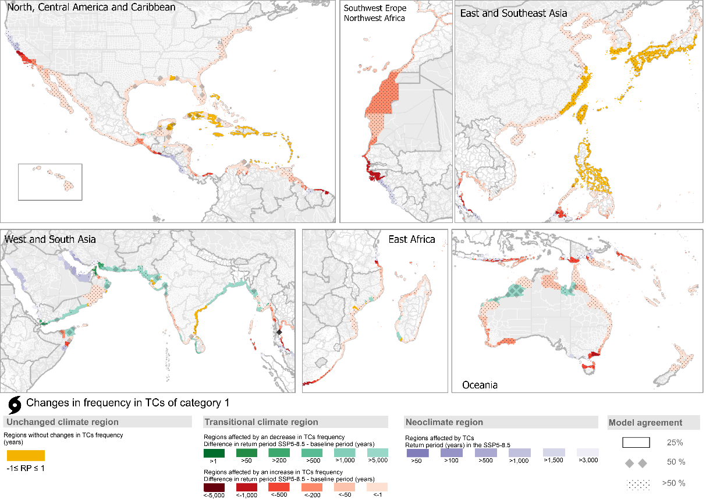
Figure S1. Changes in the frequency of tropical cyclones of category 1, comparing SSP5-8.5 (2015-2050) with the baseline climatology (1980-2017).

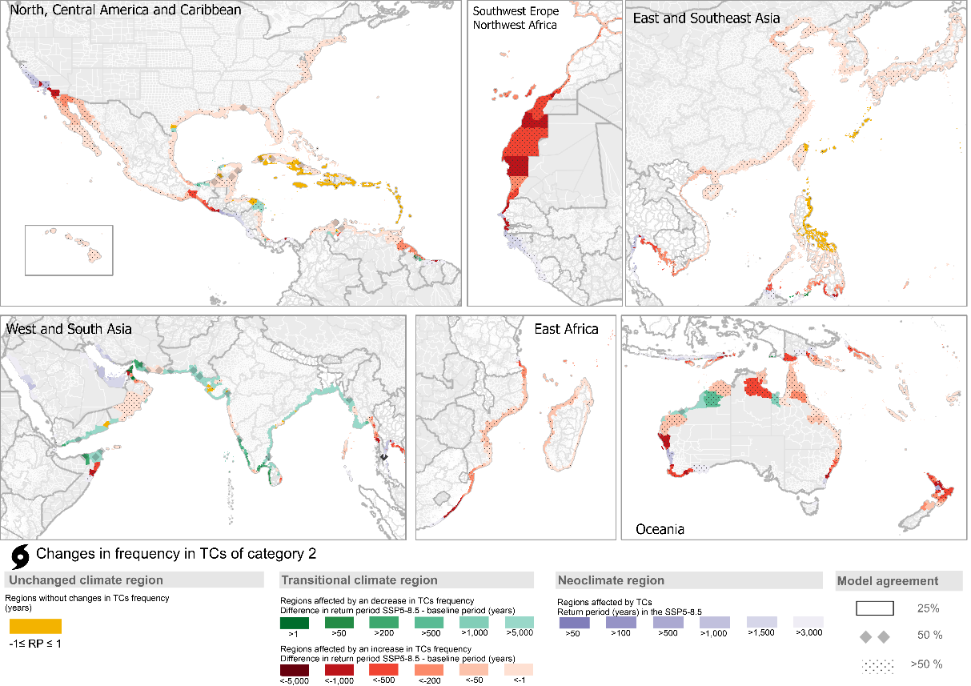
Figure S2. Changes in the frequency of tropical cyclones of category 2, comparing SSP5-8.5 (2015-2050) with the baseline climatology (1980-2017).
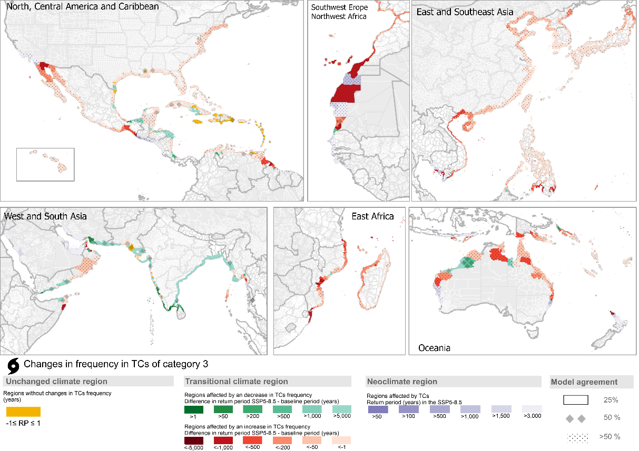
Figure S3. Changes in the frequency of tropical cyclones of category 3, comparing SSP5-8.5 (2015-2050) with the baseline climatology (1980-2017).
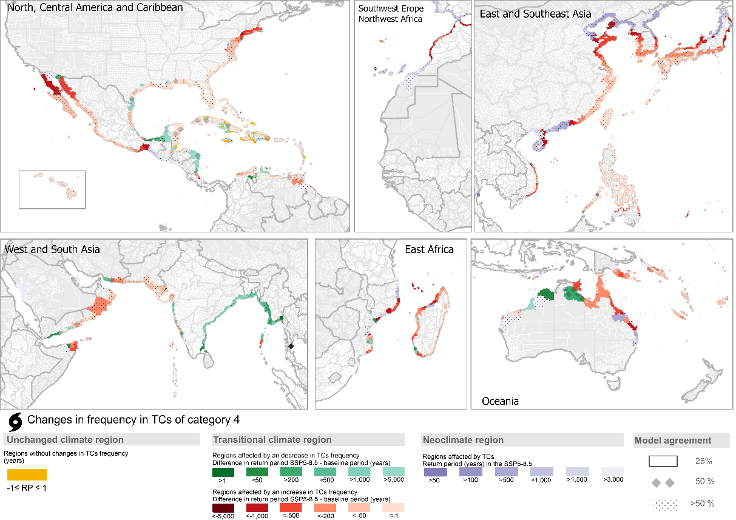
Figure S4. Changes in the frequency of tropical cyclones of category 4, comparing SSP5-8.5 (2015-2050) with the baseline climatology (1980-2017).
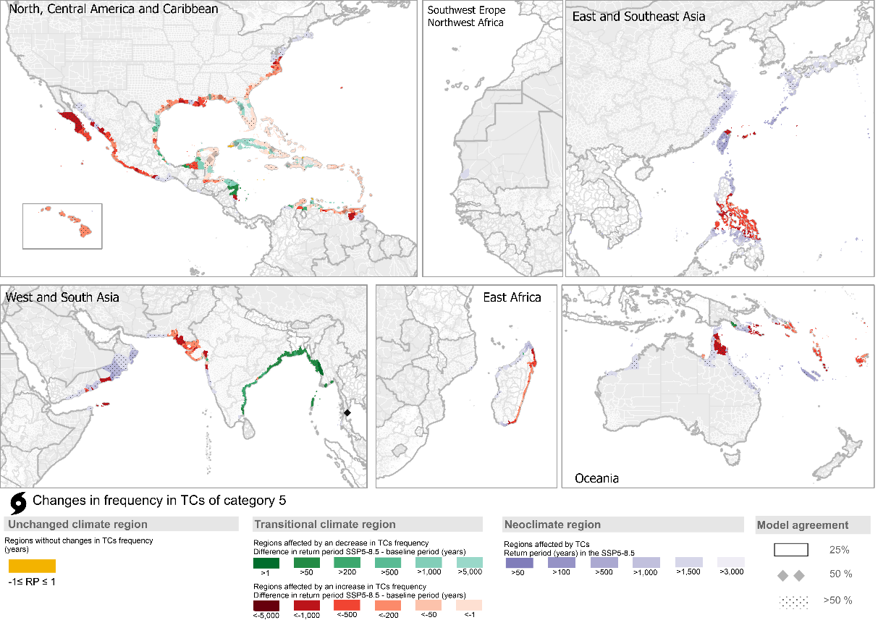
Figure S5. Changes in the frequency of tropical cyclones of category 5, comparing SSP5-8.5 (2015-2050) with the baseline climatology (1980-2017).

TC3-hazard index validation
Using the TC3-hazard index, we compared 1980–2000 and 2001–2021. Approximately 60% of administrative regions experienced an increase in the TC3-hazard index, resulting from combinations of changes in the intensity and frequency of both major and minor TCs. About 31% of coastal regions experienced the same TC category in both periods, while 47% showed an increase in intensity. Regarding frequency, 33% of regions exhibited an increase in major TCs and 30% an increase in minor TCs. Specifically, 15% of regions experienced increases in both major and minor TCs (22% experienced decreases in both), and 5% showed an increase in minor TCs but a decrease in major TCs (18% showed the opposite).
The analysis highlights clear intensification along the central coast of Japan during the second 20-year period, consistent with the well-documented poleward migration of lifetime maximum intensity (LMI) (Kossin et al., 2016; Choi et al., 2016; Song & Klotzbach, 2018; Zhan & Wang, 2017; Kossin, 2018). Similar poleward migrations were also detected in the SI and SP basins. In contrast, in the NA basin an equatorward migration trend has been observed (Kossin et al., 2016; Kossin, 2018). This equatorward shift is also evident in the TC3-hazard index and in the three hazard indicators, with clear increases across the Antilles and Nicaragua.
In the SI basin, while the southward trend in the TC3-hazard index is less pronounced, the maximum TC category increases toward the southeast, although frequency patterns are less clear. In Madagascar and southeastern Africa, the second period (2001–2021) shows an increase in maximum category, while the frequency of major TCs remained similar between periods.
Overall, nearshore intensification has been detected across most coastlines, except in the EP (Balaguru et al., 2024). This is consistent with observed increases in TC category. Globally, major TC activity has doubled in some regions, aligning with the increase seen in our TC3-hazard index. While Klotzbach et al. (2022) report a global decrease in overall TC frequency, with increases in the NA and decreases in the WP, our analysis does not show significant differences between the two periods, except in the Philippines and certain regions of the NA, where increases are evident.
The patterns identified by the TC3-hazard index across these two 20-year periods are broadly consistent with previous studies. We acknowledge, however, that the choice of time window strongly influences results due to natural variability (Knutson et al., 2022). For example, whereas the first period includes a balanced mix of El Niño and La Niña years, the second period is more strongly dominated by La Niña conditions, which tend to enhance TC activity in the NA relative to the WP.

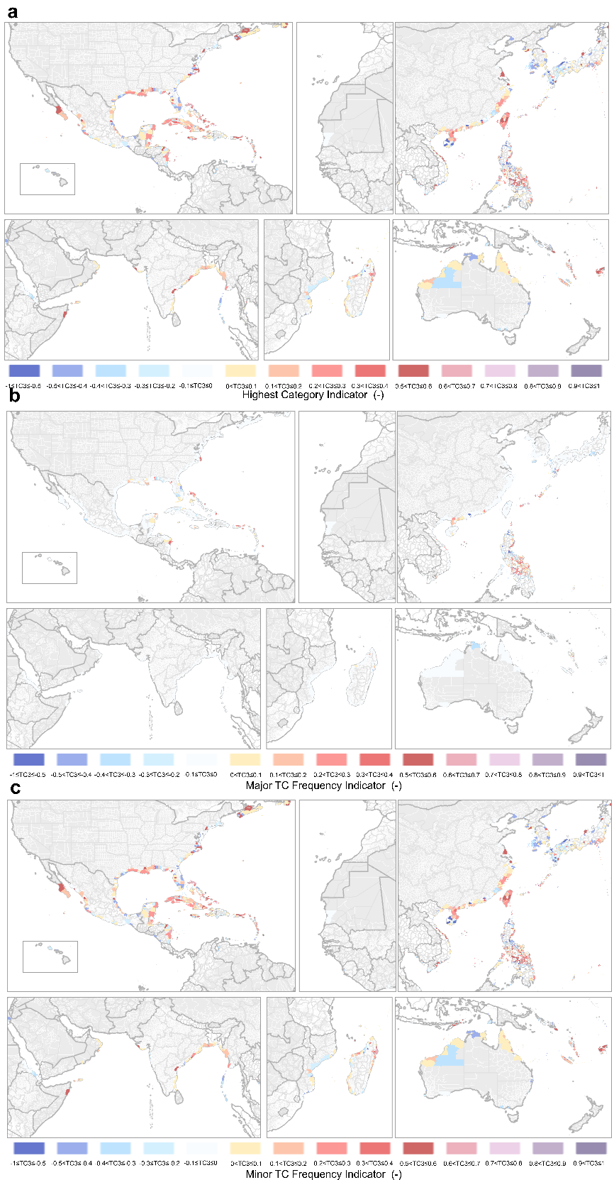
Figure S6. Validation of TC3hazard index, IBTrACS (1980-2000/2001-2021). Indicators that compose the TC-hazard index: (a) Highest category indicator, (b) Major TC frequency indicator, and (c) Minor TC frequency indicator.
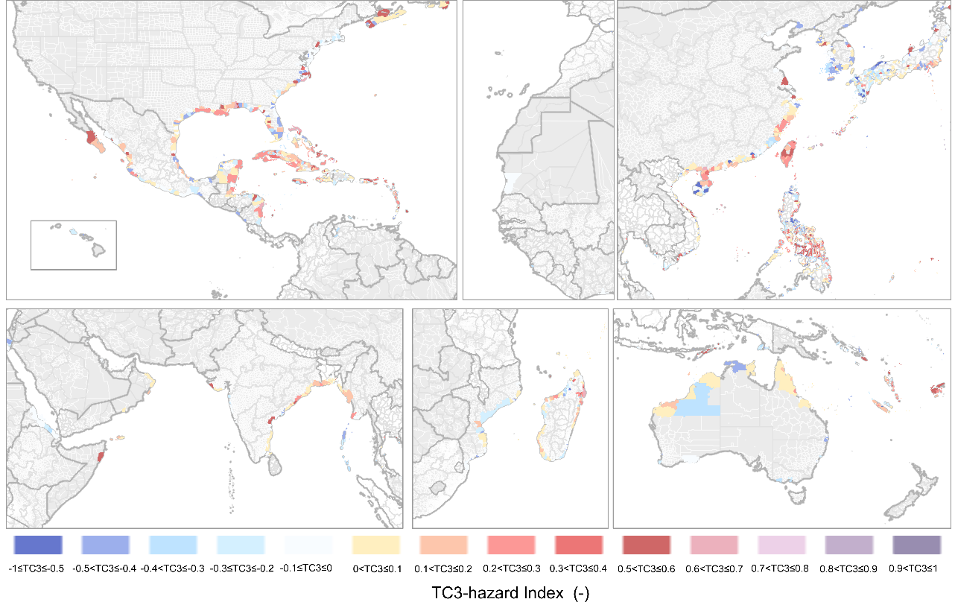
Figure S7. TC3-hazard index validation, IBTrACS (1980-2000/2001-2021).

TC3-hazard indicators

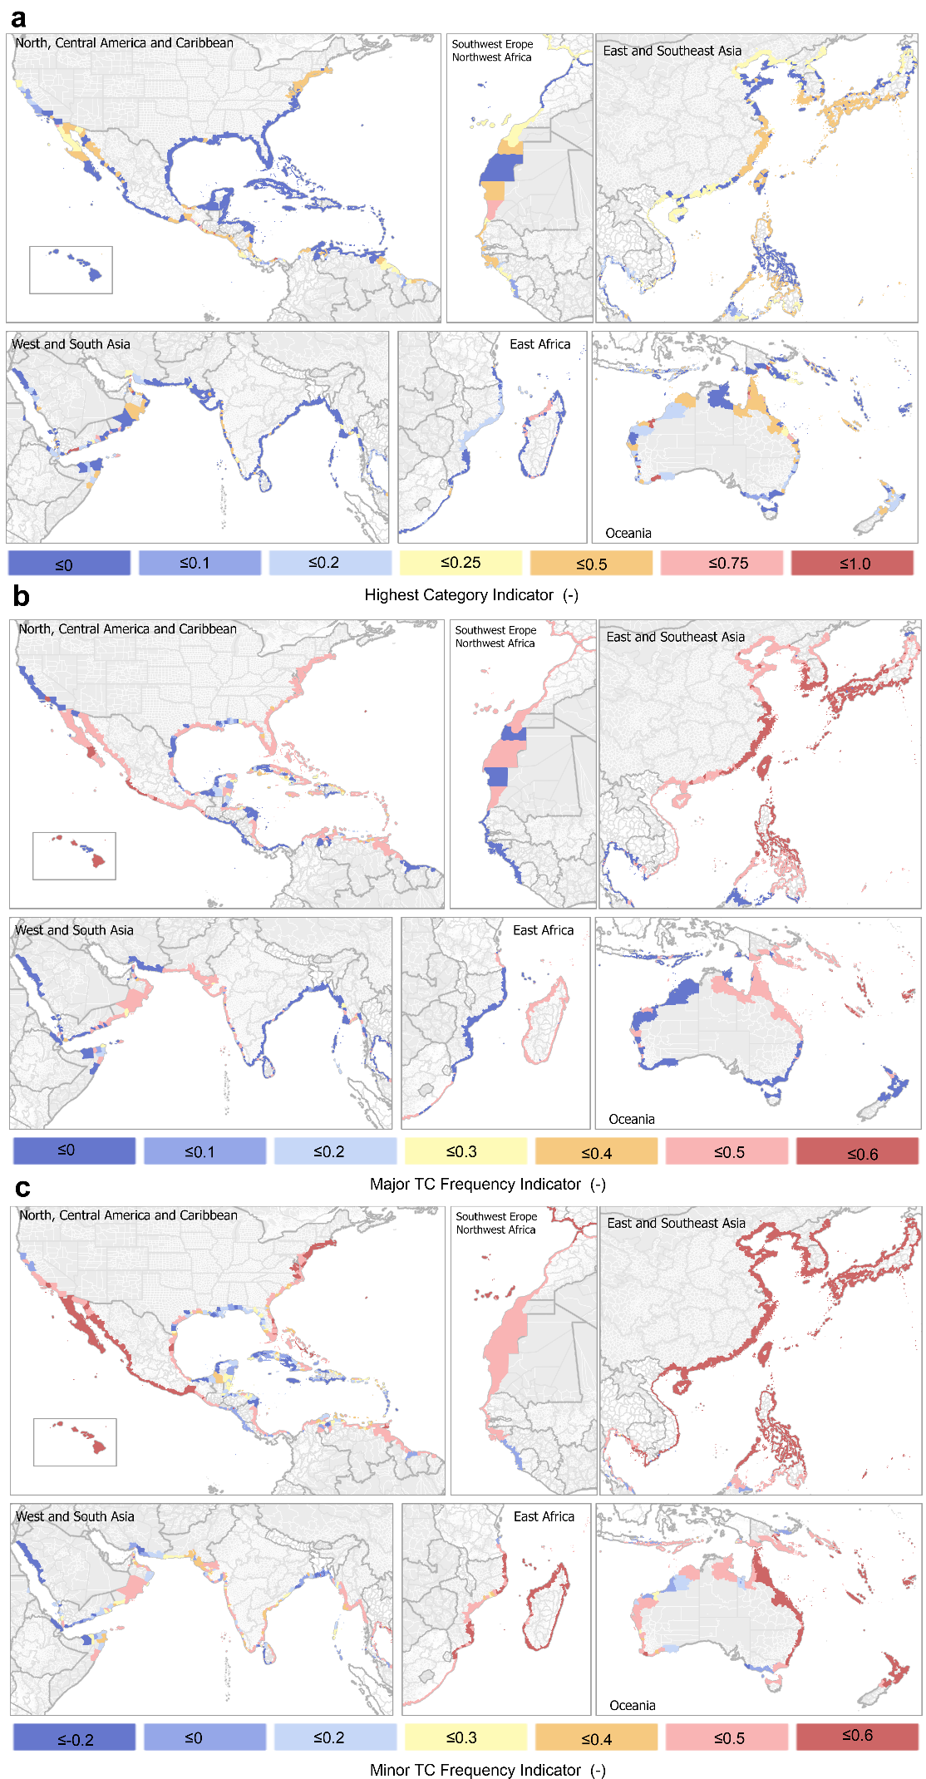
Figure S8. Indicators that compose the TC-hazard index: (a) Highest category indicator, (b) Major TC frequency indicator, and (c) Minor TC frequency indicator.
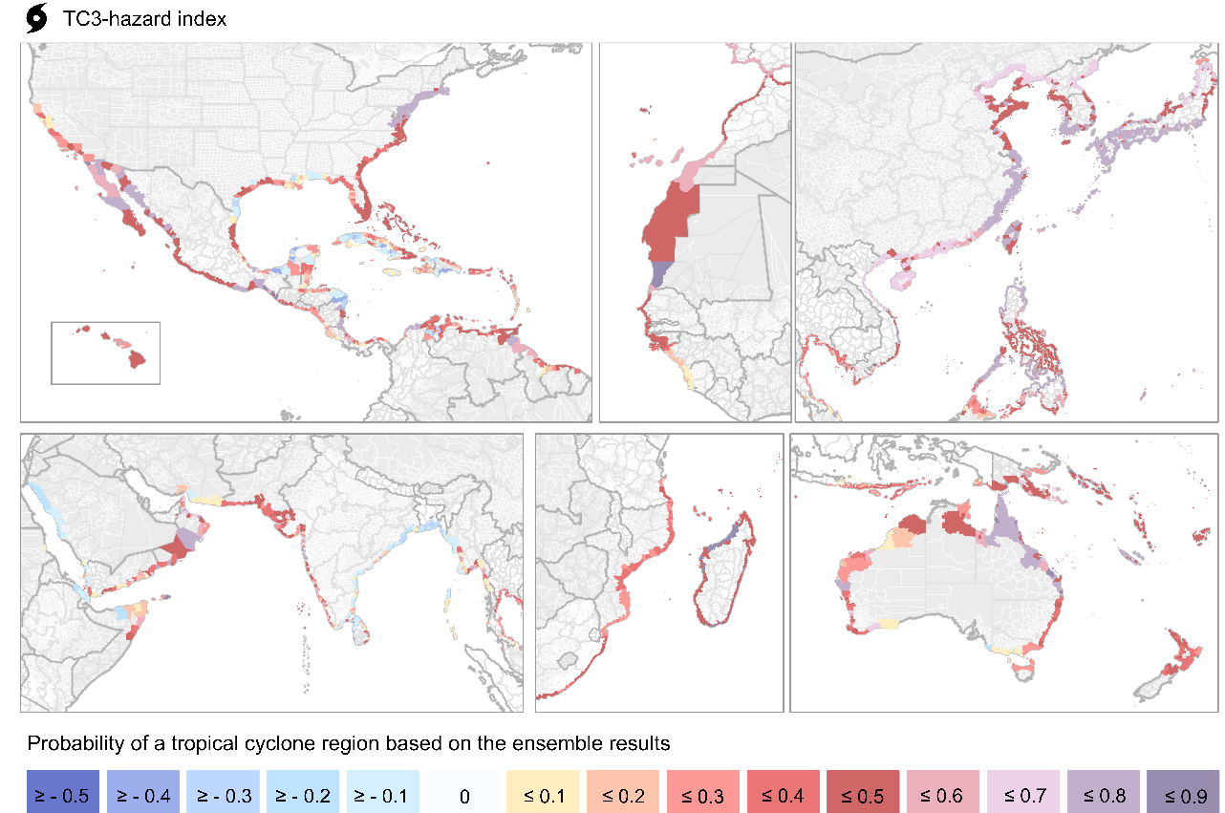
Figure S9. TC3-hazard index: mean of the ensemble.

Uncertainty
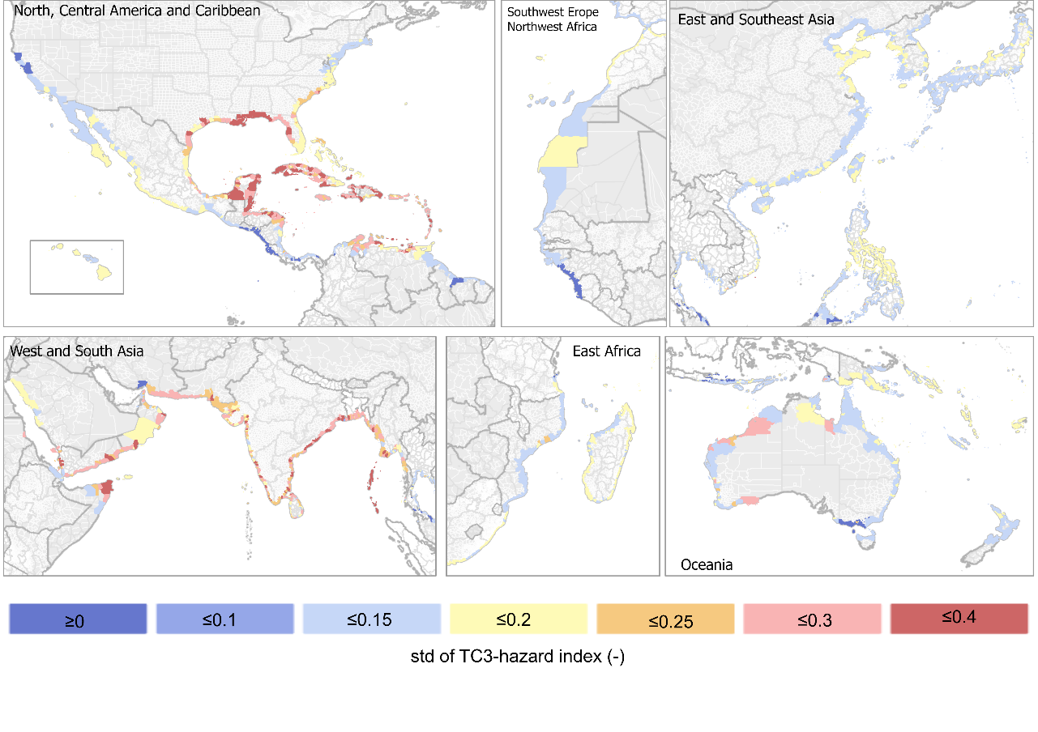
Figure S10. TC3-hazard index uncertainty: standard deviation of the ensemble.
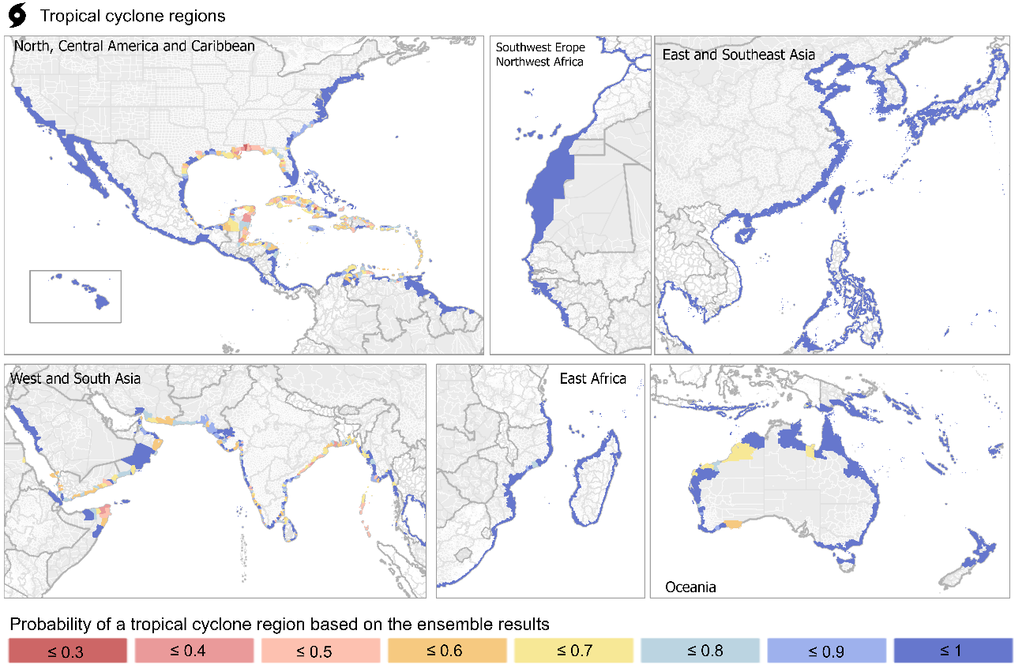
Figure S11. Probability of a TC region in the ensemble with the highest probability of occurrence.
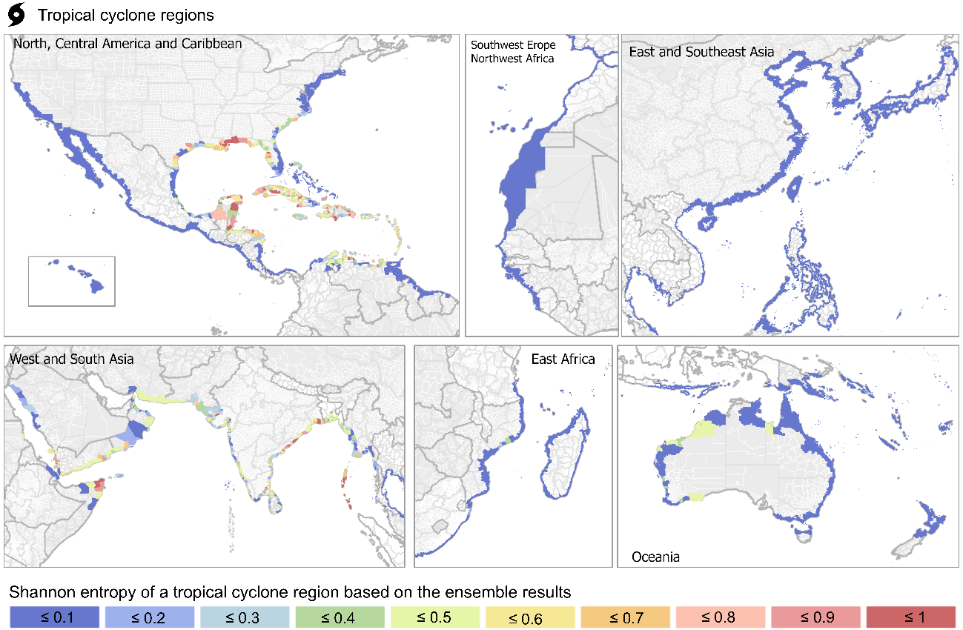
Figure S12. TC region uncertainty: Shannon entropy of a TC region in the ensemble.

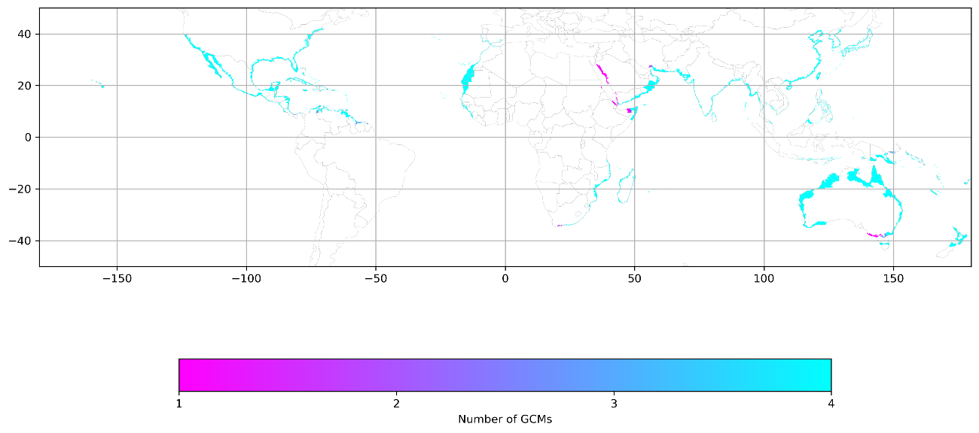
Figure S13. Spatial agreement of GCMs

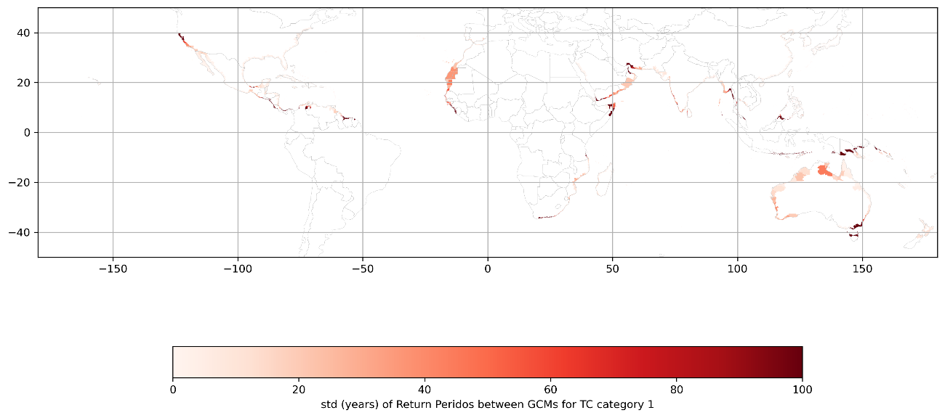
Figure S14. Standard deviation of the return period of Category 1 tropical cyclones from the ensemble.

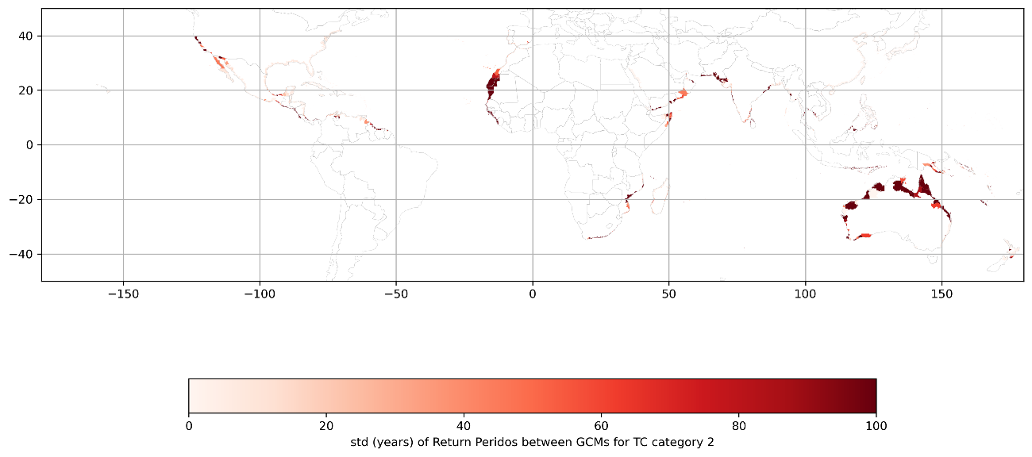
Figure S15. Standard deviation of the return period of Category 2 tropical cyclones from the ensemble.
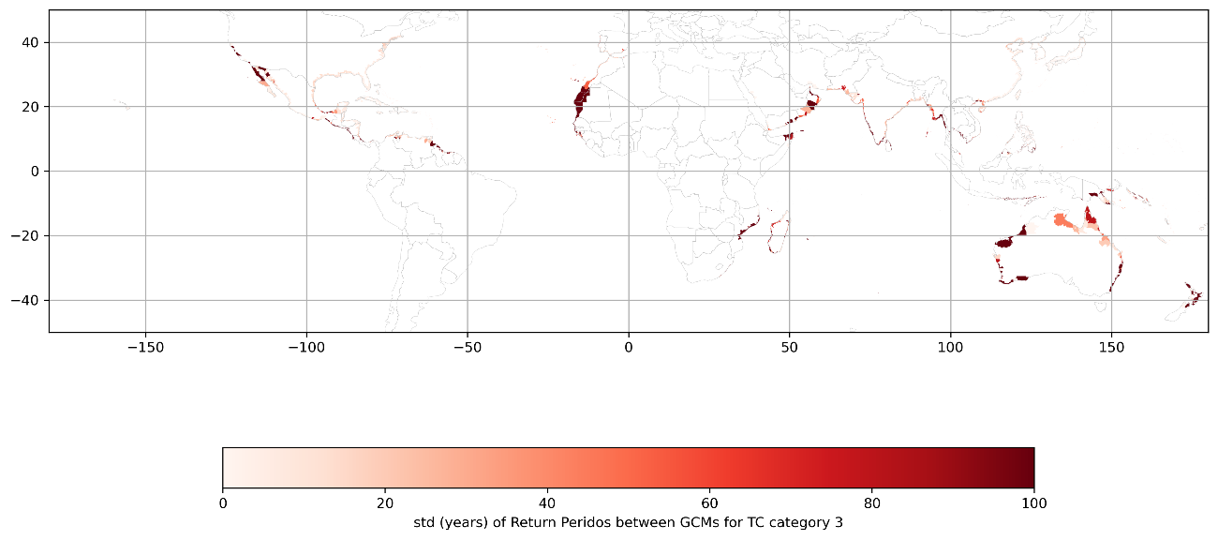
Figure S16. Standard deviation of the return period of Category 3 tropical cyclones from the ensemble.
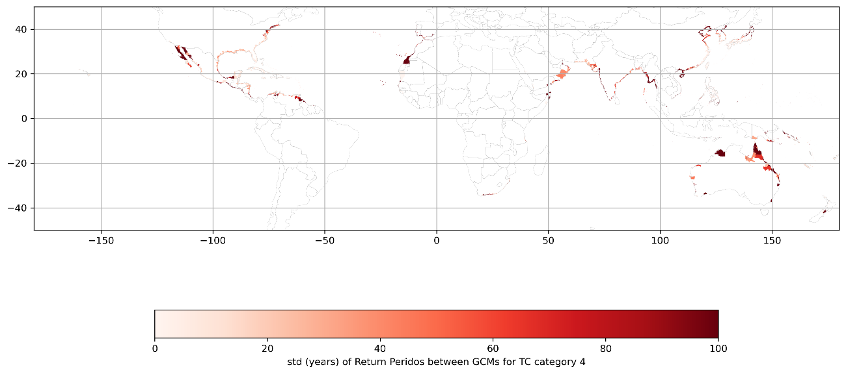
Figure S17. Standard deviation of the return period of Category 4 tropical cyclones from the ensemble.
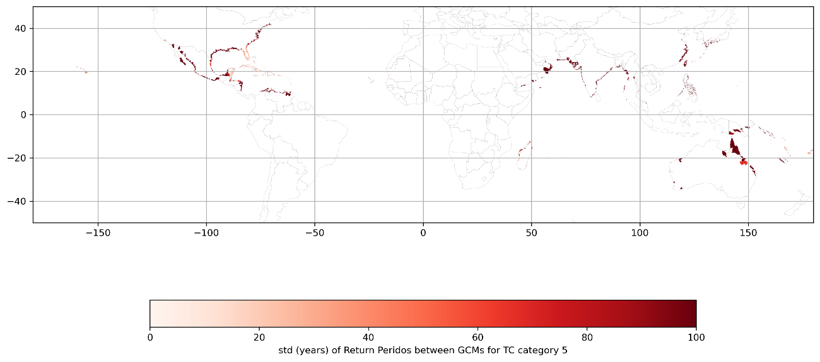
Figure S18. Standard deviation of the return period of Category 5 tropical cyclones from the ensemble.
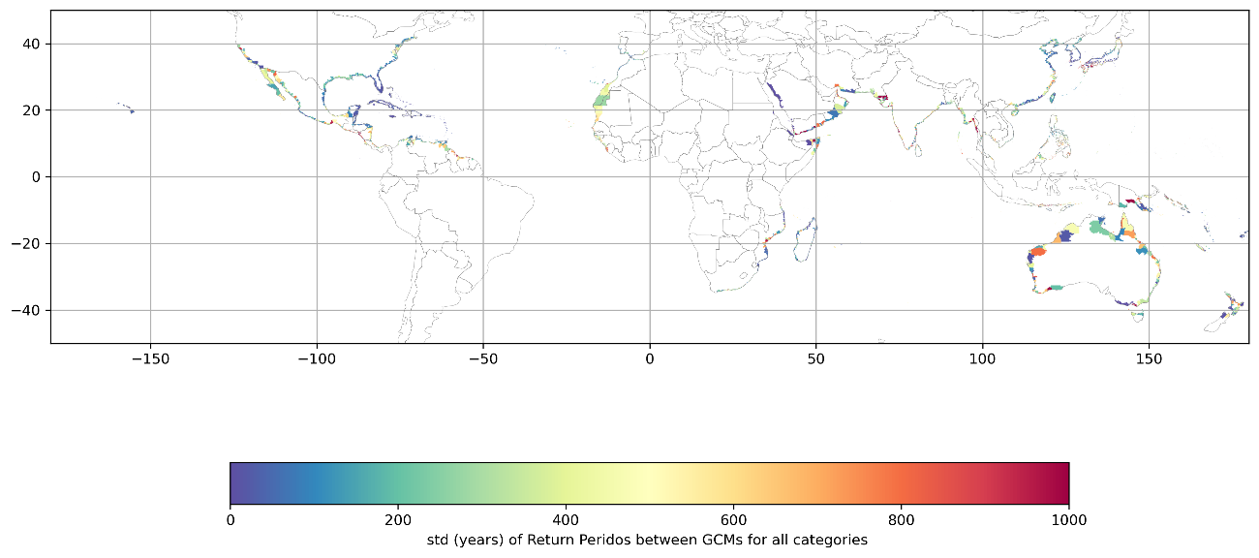
Figure S19. Standard deviation of the return period of all category’s tropical cyclones from the ensemble.
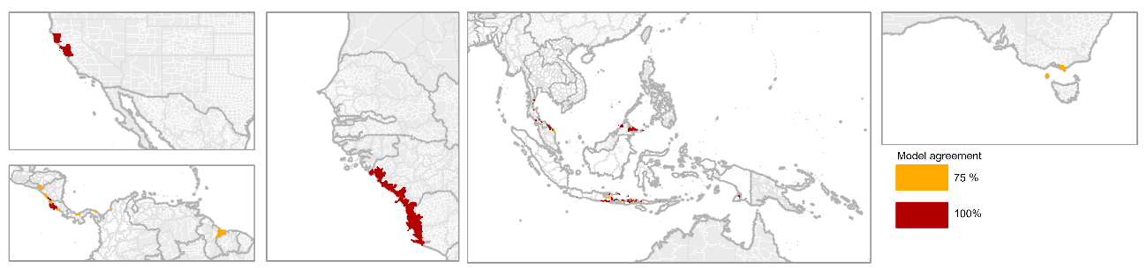
Figure S20. Model agreement for neoclimatic TC regions

Population
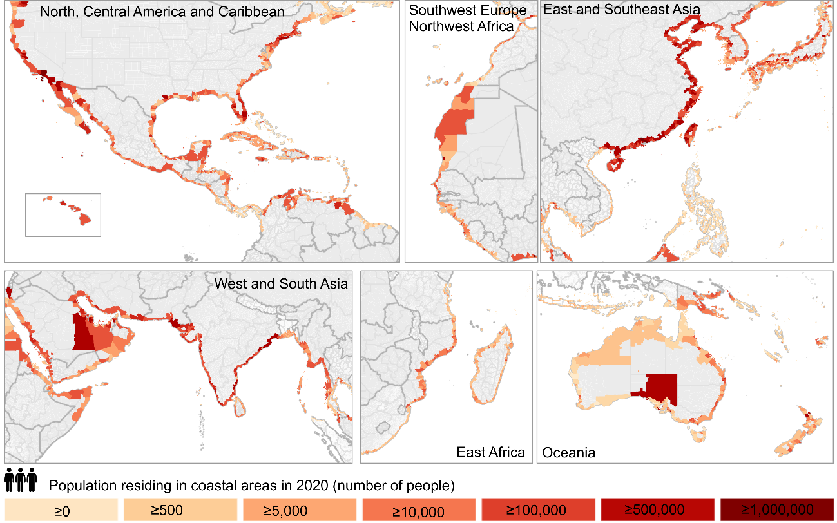
Figure S21. The 2020 population residing in coastal areas.
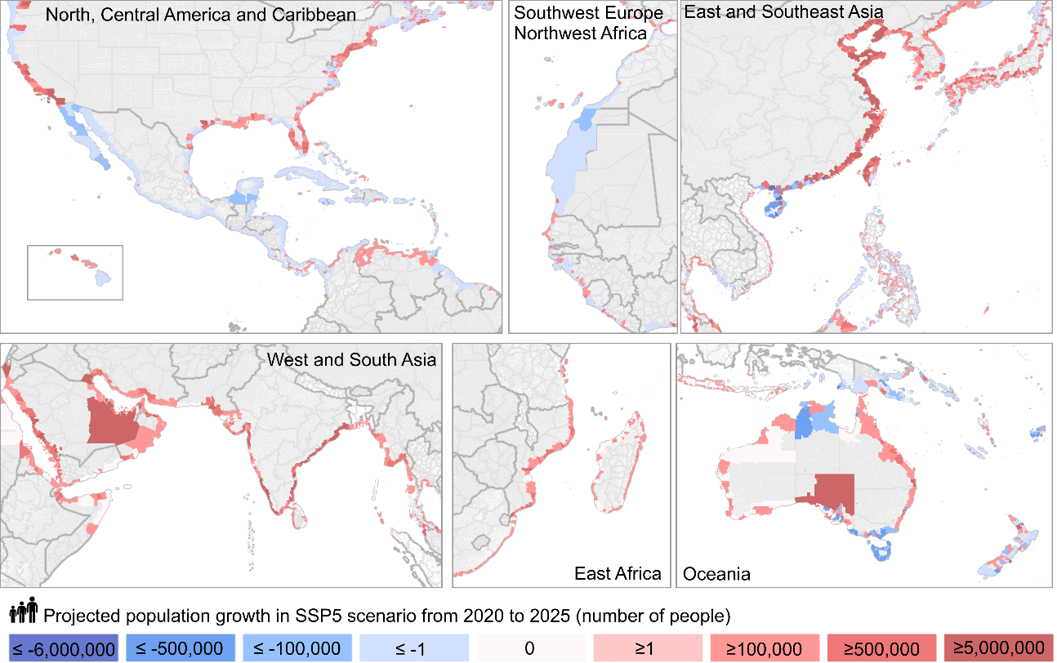
Figure S22. The projected population growth between 2020 and 2050 under the SSP5 scenario.

Adaptive Capacity
Countries with localities that have historically experienced TC include Australia, Madagascar, Mozambique, Vietnam, the Philippines, the USA, Mexico, Nicaragua, Belize, Honduras, Taiwan, South Korea, countries of Melanesia, Caribbean islands, some regions of North Korea, Thailand, the Philippines, and Papua New Guinea. Between 1980 and 2022, 83, 79, 76, 65, and 60 countries were impacted by TCs of categories 1, 2, 3, 4, and 5, respectively (see Supplementary Information Figure S20).
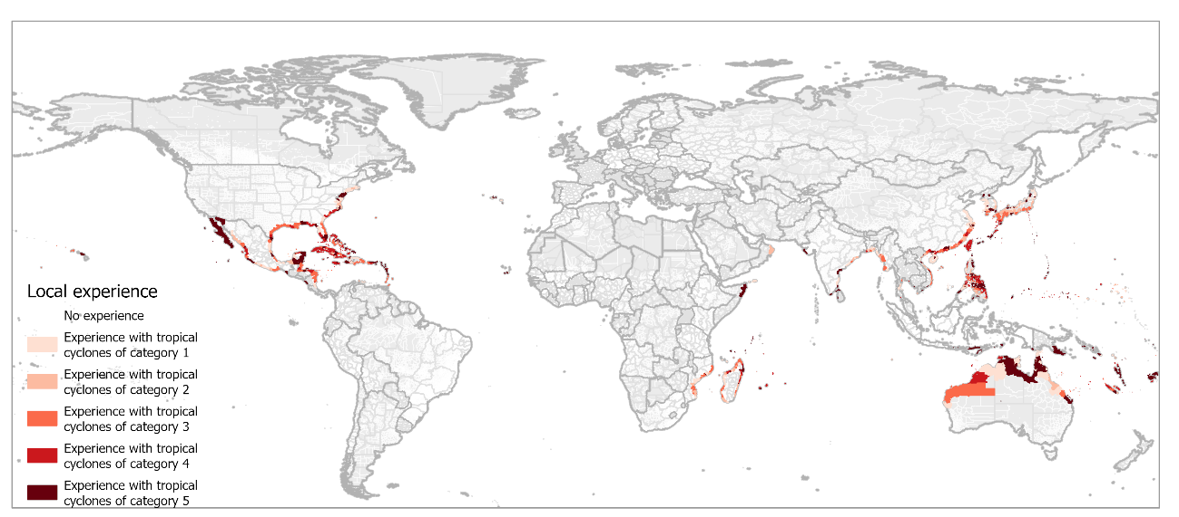
Figure S23. Local experience indicator, representing the maximum category of tropical cyclone that has affected the municipality between 1980 and 2023, based on IBTrACS.
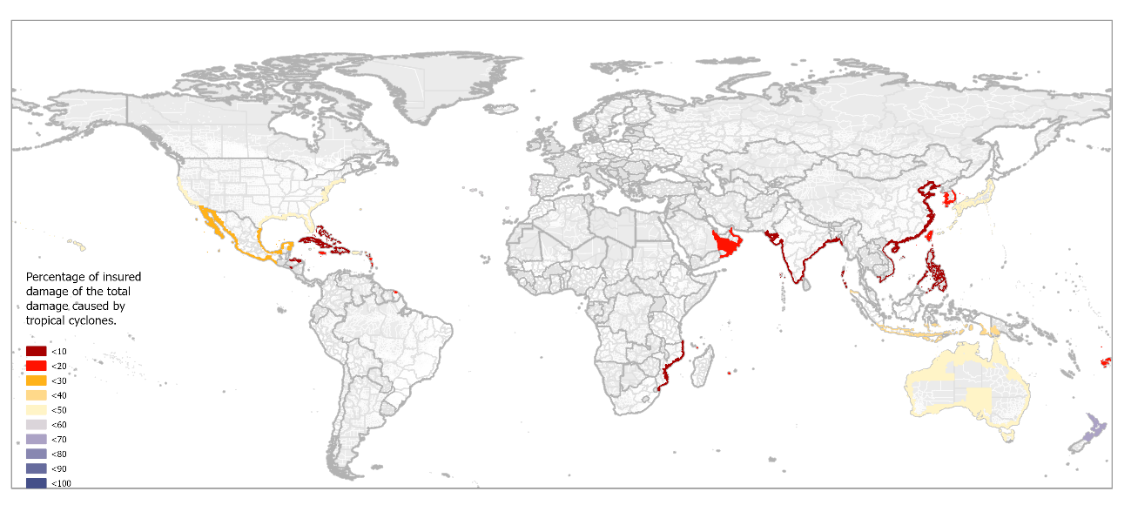
Figure S24. Insurance penetration for tropical cyclones indicator, representing the percentage of cyclone-induced damage covered by insurance between 1980 and 2023, based on EM-DATA.
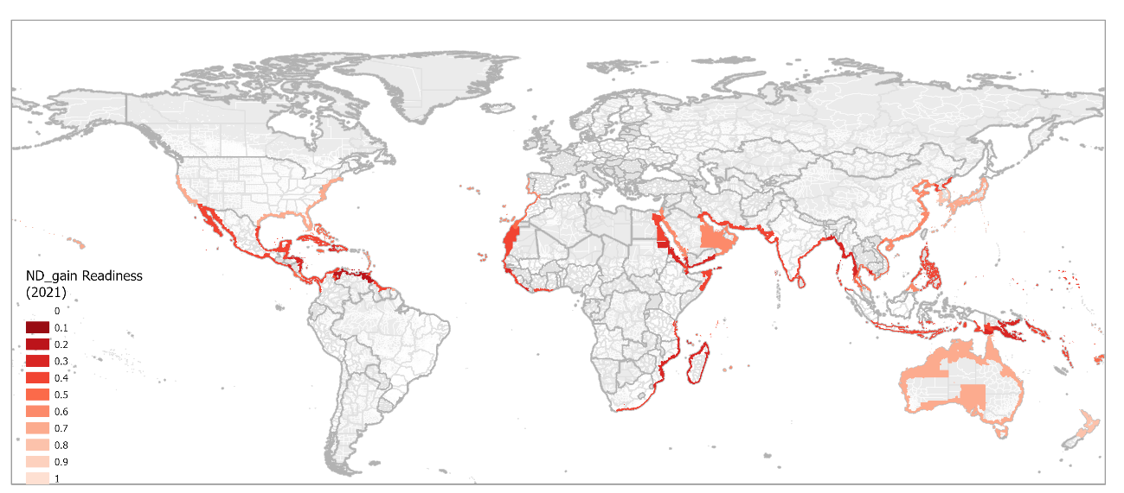
Figure S25. ND-GAIN readiness indicator based on social, economic and governance indicators.

Hotspots at risk in TC regions
Table S 2. Top 10 hotspots of transitional-decrease TC regions.
Name Administrative Level 2 | Name Administrative Level 3 | Name Administrative Level 4 | Continent | LAT (º) | LON (º) | Sovereign | TC region | TC3_riskn
Hà Tiên | My Duc | None | ASIA | 10.4121 | 104.46928 | Vietnam | C00_MD_mI | 0.10
Uttara Kannada | None | None | ASIA | 14.86866 | 74.28846 | India | C00_MD_mI | 0.10
Thiruvarur | None | None | ASIA | 10.58947 | 79.49392 | India | C00_MD_mI | 0.10
Pothuvil | None | None | ASIA | 6.94348 | 81.80064 | Sri Lanka | C00_MD_mI | 0.09
Uttara Kannada | None | None | ASIA | 14.47671 | 74.49639 | India | C00_MD_mI | 0.09
Eravur Town | None | None | ASIA | 7.73349 | 81.67631 | Sri Lanka | C00_MD_mI | 0.09
Kasaragod | None | None | ASIA | 12.57951 | 75.08141 | India | C00_MD_mI | 0.09
Dawei | None | None | ASIA | 13.70293 | 98.44104 | Myanmar | C00_MD_mI | 0.08
Dawei | None | None | ASIA | 13.70293 | 98.44104 | Myanmar | C00_MD_mI | 0.08
Long ?i?n | Phuoc Tinh | None | ASIA | 10.4121 | 107.18939 | Vietnam | C00_MD_mI | 0.08

Table S 3. Top 10 hotspots of transitional-increase TC regions.
Name Administrative Level 2 | Name Administrative Level 3 | Name Administrative Level 4 | Continent | LAT (º) | LON (º) | Sovereign | TC region | TC3_riskn
Tucupita | None | None | SOUTH AMERICA | 9.25334 | -61.67458 | Venezuela | C25_MI_mI | 1.00
La Cañada de Urdaneta | None | None | SOUTH AMERICA | 10.3829 | -71.94945 | Venezuela | C25_MI_mI | 0.89
Al Hali | None | None | ASIA | 14.81963 | 42.99834 | Yemen | C25_MI_mI | 0.88
Antonio Diaz | None | None | SOUTH AMERICA | 8.38948 | -60.89824 | Venezuela | C34_MI_mI | 0.86
Yangon-S | None | None | ASIA | 16.54107 | 96.09731 | Myanmar | C25_MI_mI | 0.79
Yangon-S | None | None | ASIA | 16.54107 | 96.09731 | Myanmar | C25_MI_mI | 0.79
Maracaibo | None | None | SOUTH AMERICA | 10.69631 | -71.6857 | Venezuela | C25_MI_mD | 0.79
Ad Durayhimi | None | None | ASIA | 14.61397 | 43.08049 | Yemen | C25_MI_mI | 0.78
Al Mina | None | None | ASIA | 14.85663 | 42.90516 | Yemen | C25_MI_mI | 0.78
Lagunillas | None | None | SOUTH AMERICA | 10.24288 | -71.11792 | Venezuela | C34_MI_mI | 0.77

Table S 4. Top 10 hotspots of neoclimatic TC regions.
Name Administrative Level 2 | Name Administrative Level 3 | Name Administrative Level 4 | Continent | LAT (º) | LON (º) | Sovereign | TC region | TC3_riskn
North Bougainville | None | None | OCEANIA | -5.62071 | 154.82288 | Papua New Guinea | CN5_ME_mE | 0.45
Bantul | None | Srigading | ASIA | -7.98783 | 110.27687 | Indonesia | CN5_ME_mE | 0.15
Bantul | None | Poncosari | ASIA | -7.97418 | 110.23358 | Indonesia | CN5_ME_mE | 0.14
Bantul | None | Gadingsari | ASIA | -7.98043 | 110.25294 | Indonesia | CN5_ME_mE | 0.14
Bantul | None | Parangtritis | ASIA | -8.00954 | 110.3143 | Indonesia | CN5_ME_mE | 0.14
Kulon Progo | None | Karang Sewu | ASIA | -7.95337 | 110.18776 | Indonesia | CN5_ME_mE | 0.14
Kulon Progo | None | Banaran | ASIA | -7.9685 | 110.20789 | Indonesia | CN5_ME_mE | 0.13
Gunung Kidul | None | Kanigoro | ASIA | -8.10026 | 110.51863 | Indonesia | CN5_ME_mE | 0.13
Gunung Kidul | None | Giripurwo | ASIA | -8.04123 | 110.39324 | Indonesia | CN5_ME_mE | 0.13
Kulon Progo | None | Bugel | ASIA | -7.94111 | 110.16268 | Indonesia | CN5_ME_mE | 0.13
Kulon Progo | None | Pleret | ASIA | -7.9362 | 110.14511 | Indonesia | CN5_ME_mE | 0.13

Table S 5. Potential responses for TC regions based on previous experiences, with illustrative hotspot case studies.
Notes:
• “TC Region” follow the manuscript categories (Windows of opportunity / Transitional‑decrease / Transitional‑increase / Neoclimatic).
• “Ambition” follows the taxonomy (Reactive / Incremental / Transformative).
• Illustrative hotspot case studies are drawn from the manuscript hotspot lists (Tables S2–S4).
# | Short name | Measure (what to do) | TC Region (where it fits) | Ambition (how far) | Illustrative hotspot case studies (from Tables S2–S4) | Key references
1 | Building standards | Revise/design TC‑adequate standards for critical infrastructure (hospitals, bridges, grids, wastewater, hazardous industries); update codes to reflect projected wind/surge. | Transitional‑increase; Neoclimatic; (maintain in Windows/ Transitional ‑decrease) | Incremental → Transformative | Yangon‑S, Myanmar (Trans‑increase): harden lifelines; North Bougainville, PNG (Neoclimatic): minimum cyclone design loads in new public works. | Paxton (2019)
3 | Health centres | Ensure surge capacity, backup power/water, redundancy and rapid triage protocols in hospitals/clinics. | Transitional‑increase; Neoclimatic | Incremental → Transformative | Tucupita, Venezuela (Trans‑increase): hospital backup systems; Bantul, Indonesia – Parangtritis/Gadingsari (Neoclimatic): basic emergency medical capacity. | Foerster et al. (2013)
4 | Housing costs | Pre‑plan financing for reconstruction/retrofit; deploy means‑tested grants and micro‑finance for resilient housing. | Transitional‑increase; Neoclimatic | Incremental → Transformative | La Cañada de Urdaneta, Venezuela (Trans‑increase): resilient self‑recovery support; North Bougainville, PNG: resilient core‑housing kits. | Keskitalo et al. (2019)
5 | Financial resources | Establish contingency funds/cat‑bonds; budget lines for rapid repair of public assets; align with adaptation finance windows. | All (priority in Transitional ‑increase & Neoclimatic) | Incremental → Transformative | Maracaibo, Venezuela (Trans‑increase): emergency works fund; Hà Tiên, Vietnam (Windows/Trans‑decrease): reallocate to multi‑hazard preparedness. | Adger et al. (2009)
6 | Resources for emergency services | Scale SAR, firefighters, EMS surge capacity; pre‑position equipment; mutual‑aid agreements. | Transitional‑increase; Neoclimatic | Reactive → Incremental | Al Hali & Al Mina, Yemen (Trans‑increase): equip coastal EMS; Bantul, Indonesia – Srigading/Poncosari (Neoclimatic): volunteer brigades + equipment. | Paxton (2019)
7 | Financial aid & insurance | Expand post‑disaster cash transfers; develop/scale micro‑insurance and sovereign risk pools; incentivize resilient retrofit. | Transitional‑increase; Neoclimatic | Incremental | Yangon‑S, Myanmar: pilot micro‑insurance; Tucupita, Venezuela: link cash‑assistance to resilient rebuilding. | Philp et al. (2019)
8 | Assess affected population needs | Rapid social needs assessments; map vulnerable groups; maintain registries for targeted aid. | All | Reactive → Incremental | Hà Tiên, Vietnam (Windows/Trans‑decrease): streamline assessments; North Bougainville, PNG: baseline needs registry before first event. | Keskitalo et al. (2019)
9 | Communicating risks | Co‑produce risk communications; plain‑language warnings; drills; trusted messengers; address naïve‑risk bias. | All (critical in Neoclimatic) | Reactive → Incremental | Bantul, Indonesia – Karang Sewu/Bugel (Neoclimatic): first‑time TC communications; Yangon‑S, Myanmar: major‑TC risk reframing. | Keskitalo et al. (2019)
10 | Disaster relief policies | Update relief eligibility/speed; reduce administrative frictions; pre‑authorize emergency procurement. | All | Incremental | La Cañada de Urdaneta, Venezuela; Yangon‑S, Myanmar: fast‑track debris clearance & shelter operations. | Keskitalo et al. (2019)
11 | Coastal development subsidies | Reform subsidies that incentivize high‑risk coastal settlement; redirect to safer siting/retrofits. | Transitional‑increase; Neoclimatic | Transformative | Maracaibo, Venezuela: shift incentives inland/elevated; North Bougainville, PNG: avoid new growth in exposed strips. | Keskitalo et al. (2019)
12 | Restrict high‑risk land use | Zoning/setbacks; managed retreat where cost‑effective; risk‑informed permitting. | Transitional‑increase; Neoclimatic | Incremental → Transformative | Yangon‑S, Myanmar: no‑build zones for surge corridors; Bantul, Indonesia – Parangtritis: dune‑belt setbacks. | Keskitalo et al. (2019)
13 | Statutory authority (local) | Grant local governments clear legal powers/resources for TC planning, evacuations, code enforcement. | Transitional‑increase; Neoclimatic | Transformative | North Bougainville, PNG: empower local DRM offices for first‑occurrence TC; Tucupita, Venezuela: enforcement capacity. | Keskitalo et al. (2019)
14 | Early warning systems | Integrate TC modules into DRM; last‑mile dissemination; multi‑channel redundancy; forecast‑based financing triggers. | All (especially Neoclimatic) | Reactive → Incremental | Bantul, Indonesia – Gadingsari/Srigading (Neoclimatic): install basic TC EWS; Yangon‑S, Myanmar: extend to major‑TC thresholds. | Kelder et al. (2005)
15 | Public alert mechanisms | Sirens/cell broadcast/radio; multilingual templates; periodic drills and performance audits. | All | Reactive → Incremental | Hà Tiên, Vietnam (Windows/Trans‑decrease): maintain drills; North Bougainville, PNG: first‑time protocols. | Kelder et al. (2005)
16 | Evacuation routes & shelters | Map/upgrade routes; design cyclone‑rated shelters; inclusive access; crowding/heat management plans. | Transitional‑increase; Neoclimatic | Reactive → Incremental | Yangon‑S, Myanmar: shelter hardening; North Bougainville, PNG: designate shelters + signage. | Paxton (2019)
17 | Coastal protection | Nature‑based + engineered: dunes/mangroves/reefs, floodwalls/berms; protect critical nodes first. | Transitional‑increase; Neoclimatic | Incremental → Transformative | Bantul, Indonesia – Karst/dune belt (Neoclimatic): dune rehabilitation; La Cañada de Urdaneta, Venezuela: urban surge defences. | Keskitalo et al. (2019)
18 | Ecosystem conservation | Protect/restore ecosystems providing winds, wave and surge attenuation; no‑net‑loss in TC‑exposed belts. | All (especially Neoclimatic) | Incremental and transformative | Bantul, Indonesia: conserve dune/vegetation buffers; Hà Tiên, Vietnam: maintain coastal wetlands. | (as per SM)
19 | Transfer TC risk instruments | Repurpose mature TC instruments to/from other hazards (e.g., SLR/flood); adapt to TC context. | Windows/ Transitional ‑decrease → Neoclimatic | Reactive → Incremental | Hà Tiên, Vietnam: reuse flood protocols for residual TC risk; North Bougainville, PNG: adapt flood SOPs for first TC. | (as per SM)
20 | Transfer national → local instruments | Cascade national DRM and financial instruments to local administrative regions lacking TC experience. | Neoclimatic; Transitional‑increase (low AC) | Incremental → Transformative | North Bougainville, PNG: localize national SOPs; Tucupita, Venezuela: subnational execution capacity. | (as per SM)

