TABLE 6: Molecular docking simulation information of active components and targets.

Target | Target (PDB ID) | Target Structure | Compound | Compound  (MOL ID) | Affinity  (Kcal/mol)
TNF | 5UUI | 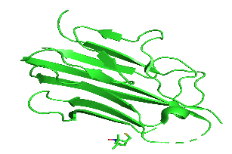 | Genkwanin  Rutaecarpine | MOL005573  MOL002662 | -6.21  -7.63
AKT1 | 1UNQ | 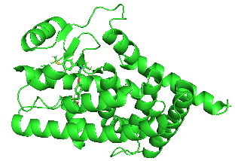 | Genkwanin  Rutaecarpine | MOL005573  MOL002662 | -6.21  -6.77
PPARG | 7E0A | 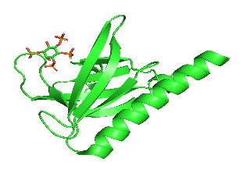 | Genkwanin  Rutaecarpine | MOL005573  MOL002662 | -7.36  -9.44
STAT3 | 6NJS | 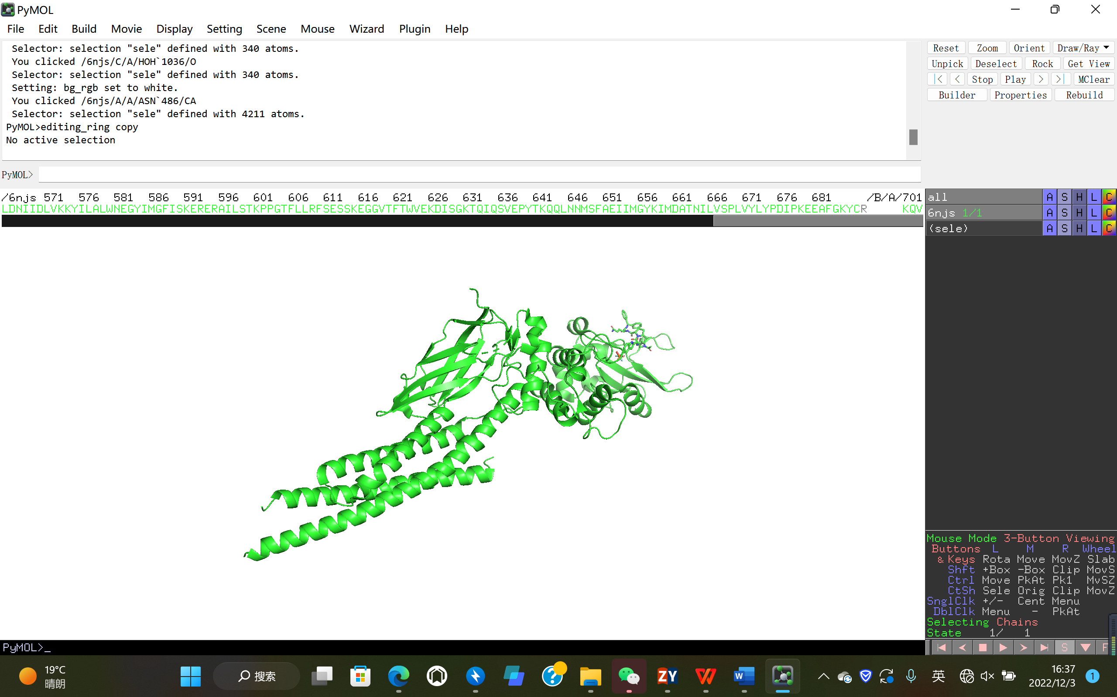 | Genkwanin  Rutaecarpine | MOL005573  MOL002662 | -5.03  -6.5
HSP90AA1 | 7S9H | 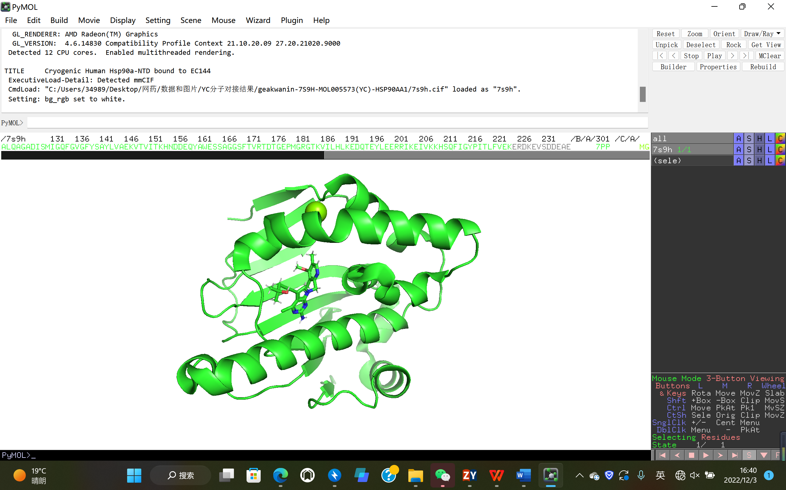 | Genkwanin  Rutaecarpine | MOL005573  MOL002662 | -7.68  -6.9

