TABLE 1: The active compounds information of Yinchen.
Mol ID | Molecule name | Structure（2D） | OB (%) | DL
MOL008047 | Artepillin A | 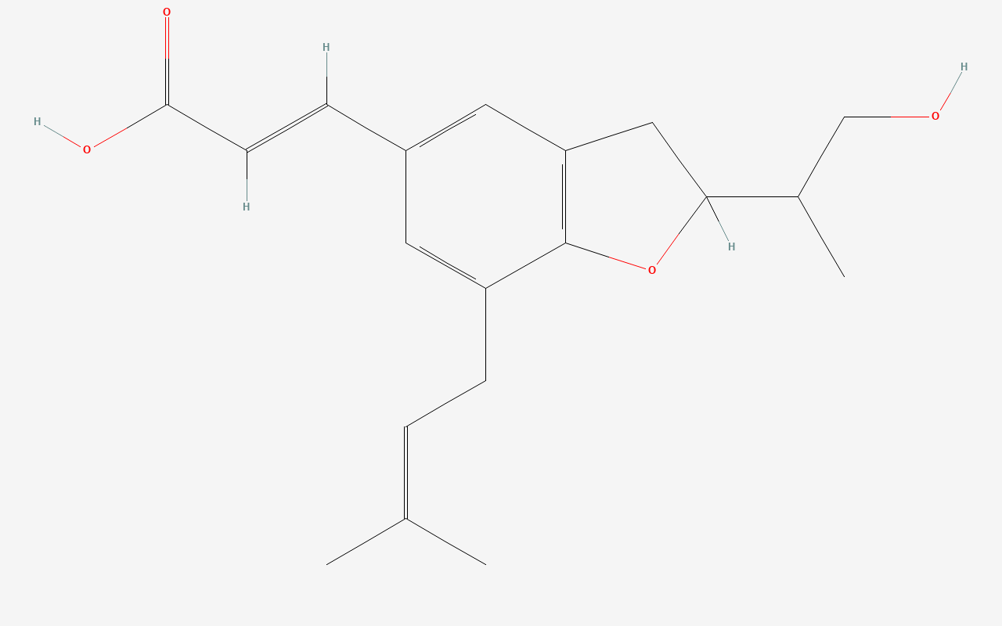 | 68.32 | 0.24
MOL005573 | Genkwanin | 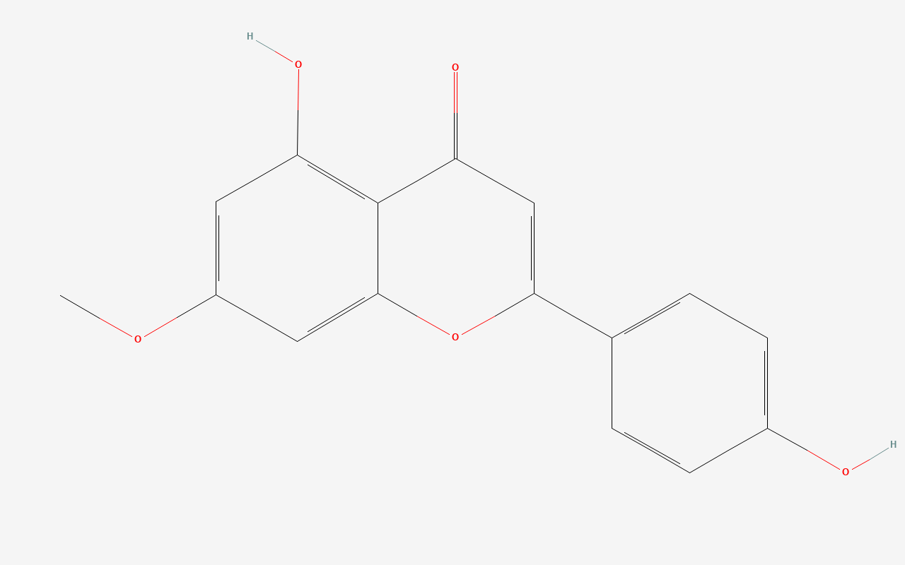 | 37.13 | 0.24
MOL008046 | Demethoxycapillarisin | 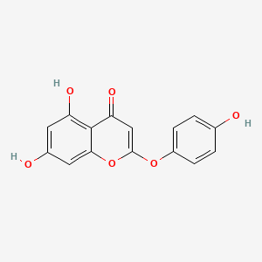 | 52.33 | 0.25
MOL000098 | quercetin | 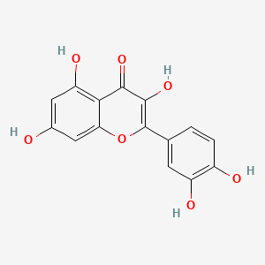 | 46.43 | 0.28
MOL007274 | Skrofulein | 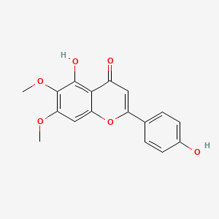 | 30.35 | 0.3
MOL000354 | isorhamnetin | 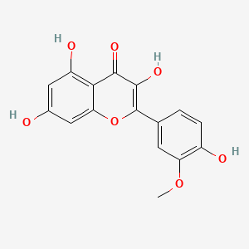 | 49.6 | 0.31
MOL008043 | capillarisin | 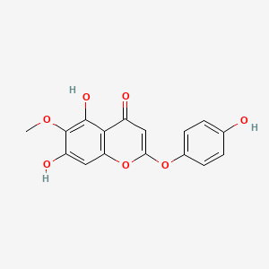 | 57.56 | 0.31
MOL008040 | Eupalitin | 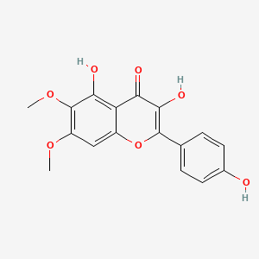 | 46.11 | 0.33
MOL008045 | 4'-Methylcapillarisin | 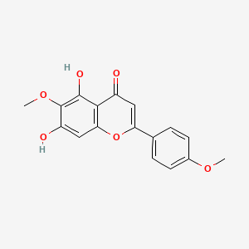 | 72.18 | 0.35
MOL008041 | Eupatolitin | 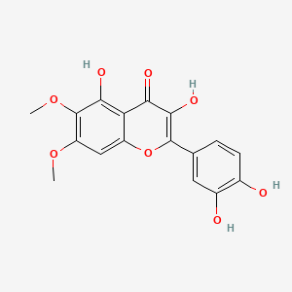 | 42.55 | 0.37
MOL008039 | Isoarcapillin | 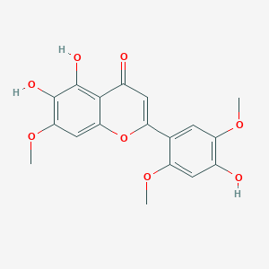 | 57.4 | 0.41
MOL000358 | beta-sitosterol | 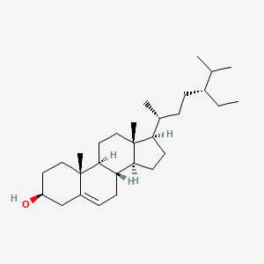 | 36.91 | 0.75

