TABLE 2: The active compounds information of Huangbai.
Mol ID | Molecule name | Structure（2D） | OB (%) | DL
MOL000622 | Magnograndiolide | 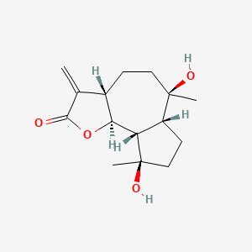 | 63.71 | 0.19
MOL002663 | Skimmianin | 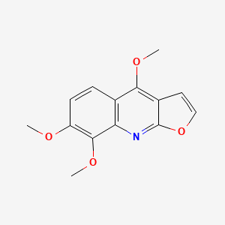 | 40.14 | 0.2
MOL000098 | quercetin | 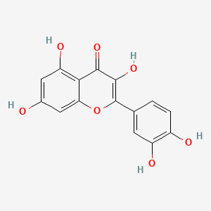 | 46.43 | 0.28
MOL002644 | Phellopterin | 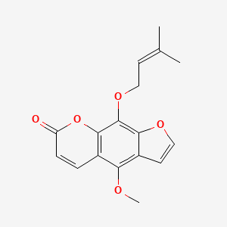 | 40.19 | 0.28
MOL001131 | phellamurin_qt | 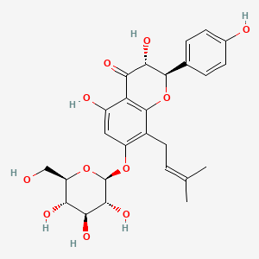 | 56.6 | 0.39
MOL002651 | Dehydrotanshinone II A | 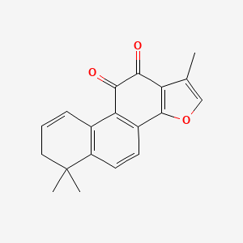 | 43.76 | 0.4
MOL002641 | Phellavin_qt | 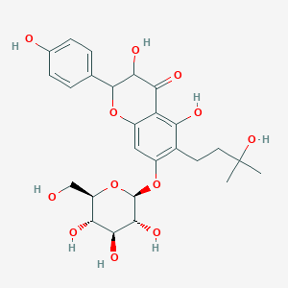 | 35.86 | 0.44
MOL000790 | Isocorypalmine | 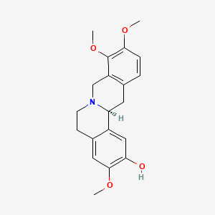 | 35.77 | 0.59
MOL002662 | rutaecarpine | 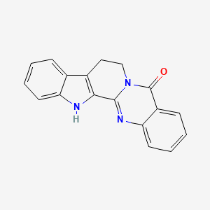 | 40.3 | 0.6
MOL002672 | Hericenone H | 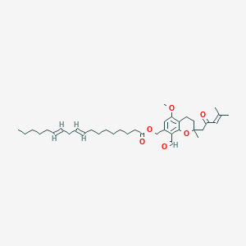 | 39 | 0.63
MOL000785 | palmatine | 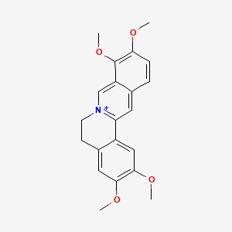 | 64.6 | 0.65
MOL000762 | Palmidin A | 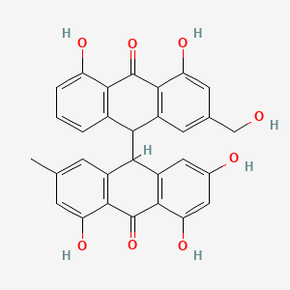 | 35.36 | 0.65
MOL002671 | Candletoxin A | 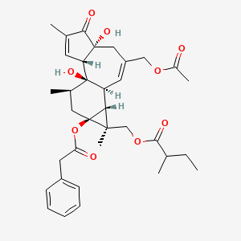 | 31.81 | 0.69
MOL002643 | delta 7-stigmastenol | 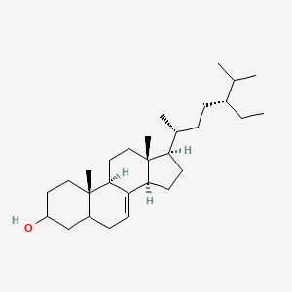 | 37.42 | 0.75
MOL002652 | delta7-Dehydrosophoramine | 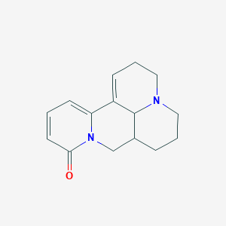 | 54.45 | 0.25
MOL002656 | dihydroniloticin | 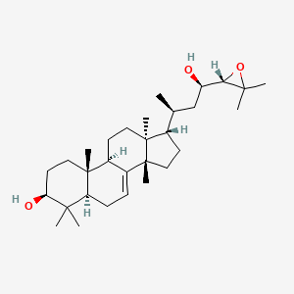 | 36.43 | 0.81
MOL002660 | niloticin | 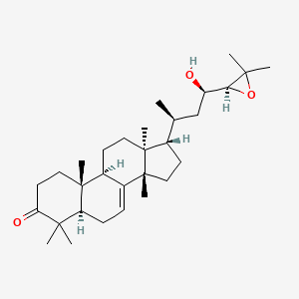 | 41.41 | 0.82
MOL002666 | Chelerythrine | 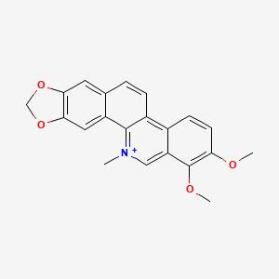 | 34.18 | 0.78
MOL002668 | Worenine | 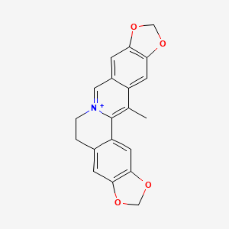 | 45.83 | 0.87
MOL002670 | Cavidine | 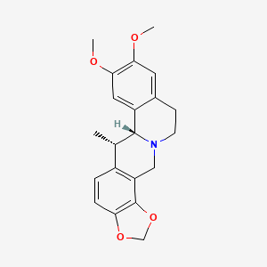 | 35.64 | 0.81
MOL002673 | Hispidone | 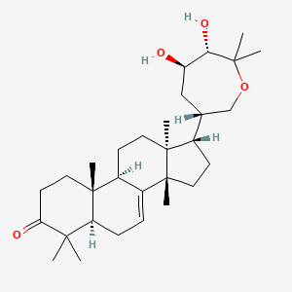 | 36.18 | 0.83
MOL005438 | campesterol | 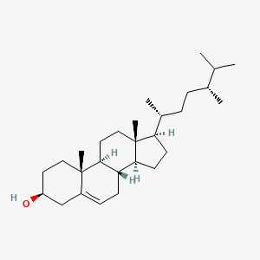 | 37.58 | 0.71
MOL006401 | melianone | 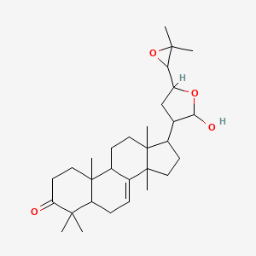 | 40.53 | 0.78
MOL006413 | phellochin | 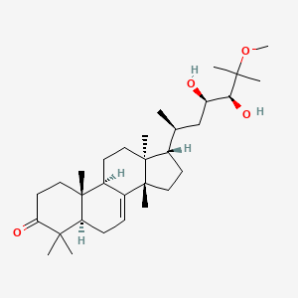 | 35.41 | 0.82
MOL006422 | thalifendine | 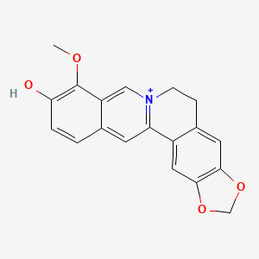 | 44.41 | 0.73
MOL013352 | Obacunone | 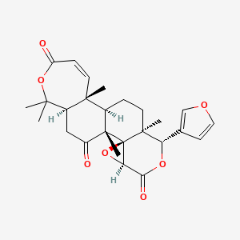 | 43.29 | 0.77

