Deprotonation Suppressing via Competitive Proton Transfer Control for Efficient Perovskite Solar Cells
Hang Dong^{a,b}, Jinsong Quª, Songya Wangª, Dazheng Chen^{a*}, Wenming Chaiª, Weidong Wang^{b}, Weidong Zhuª, He Xi^{c}, Long Zhou^{c}, Jincheng Zhangª, Pengfei Huang^{d*}, Yue Haoª and Chunfu Zhang^{a*}
- State Key Laboratory of Wide-Bandgap Semiconductor Devices and Integrated Technology, Faculty of Integrated Circuit, Xidian University, Xi’an 710071, People's Republic of China
- School of Mechano-Electronic Engineering, Xidian University, Xian 710071, People's Republic of China
- School of Advanced Materials and Nanotechnology, Xidian University, Xian 710071, People's Republic of China
- PetroChina Shenzhen New Energy Research Institute Co., Ltd., Shenzhen 518063, People's Republic of China

Corresponding authors: dzchen@xidian.edu.cn, hpf01@petrochina.com.cn, cfzhang@xidian.edu.cn
Electronic Supplementary Information (ESI) available: ¹H NMR spectra, pH test results of PPSs, Statistical results, J-V characteristics, Tables, etc.
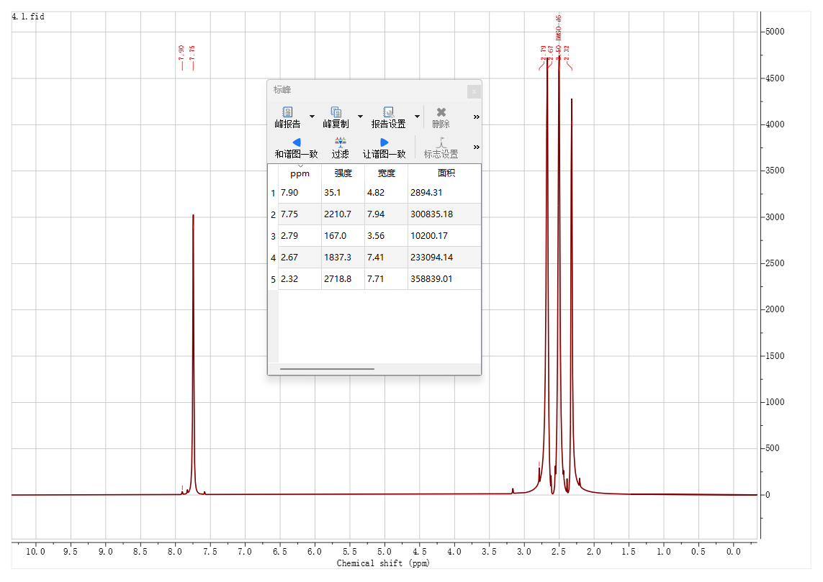
Figure S1. The ¹H NMR spectra of the fresh pristine PPS (DMSO-d₆).
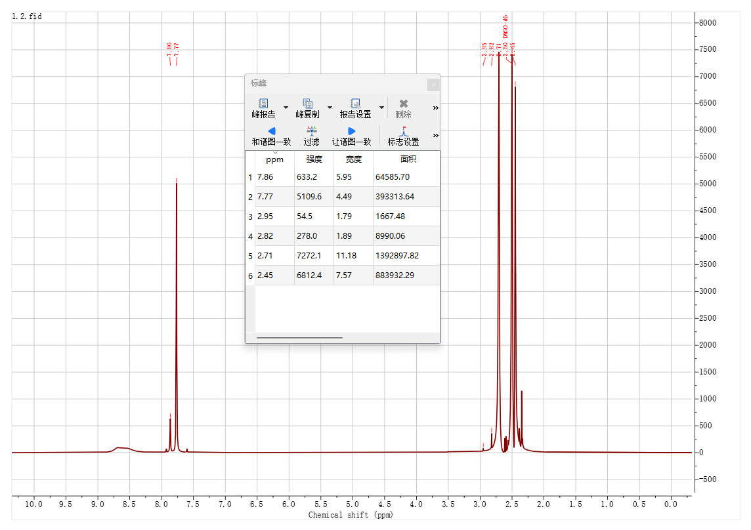
Figure S2. The ¹H NMR spectra of the aging pristine PPS (DMSO-d₆).
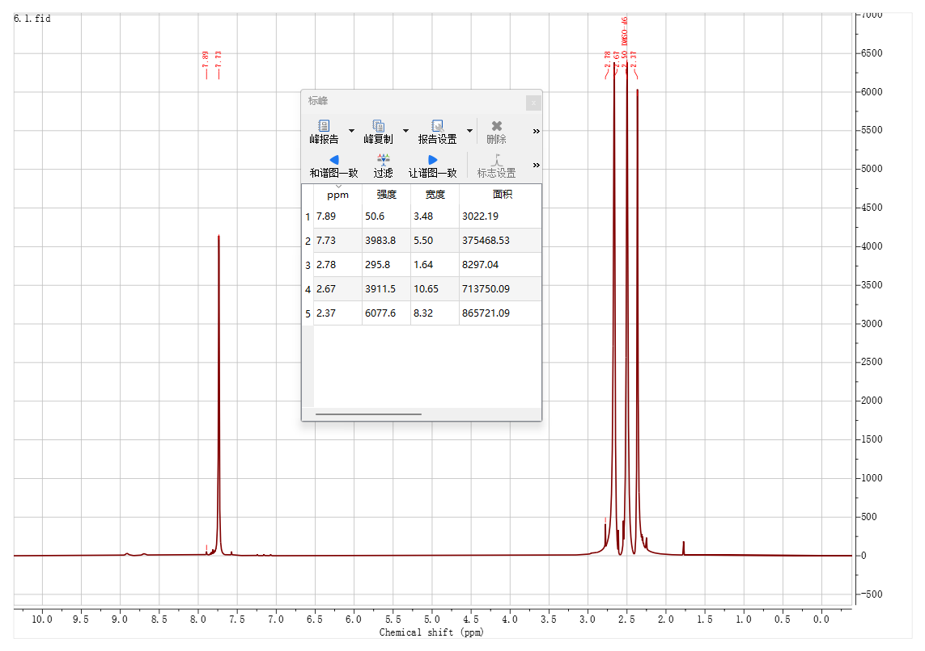
Figure S3. The ¹H NMR spectra of the fresh TFA-doped PPS (DMSO-d₆).
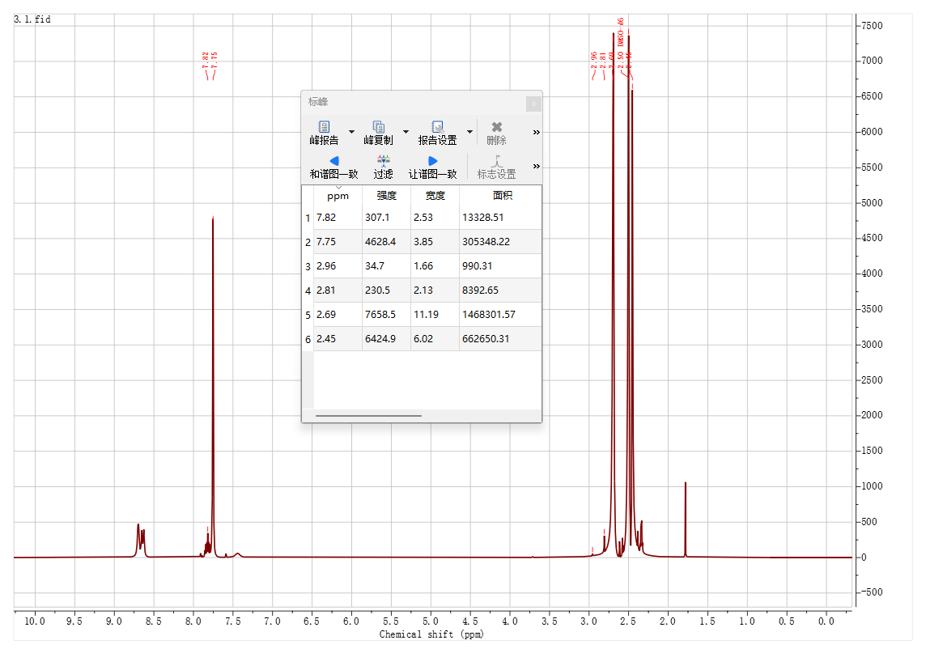
Figure S4. The ¹H NMR spectra of the aging TFA-doped PPS (DMSO-d₆).

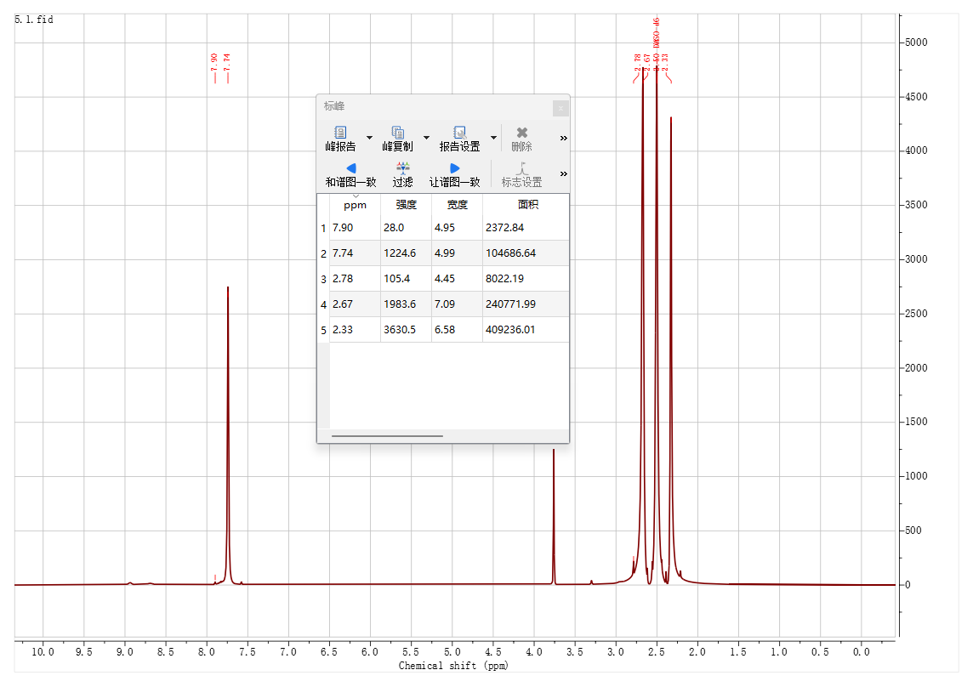
Figure S5. The ¹H NMR spectra of the fresh MTFA-doped PPS (DMSO-d₆).

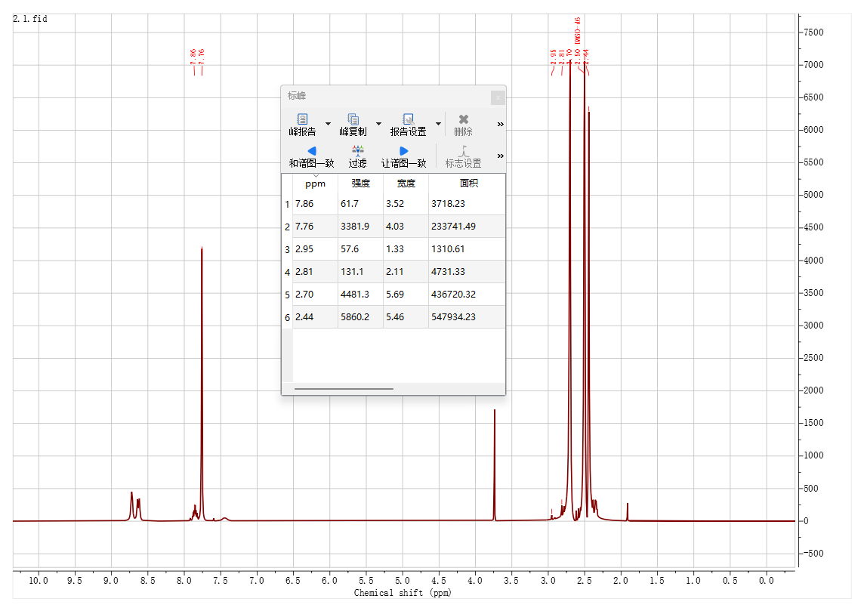
Figure S6. The ¹H NMR spectra of the aging MTFA-doped PPS (DMSO-d₆).
Figure S7. The pH tests of the (a) fresh and (b) aging pristine/TFA/MTFA-doped PPS
Figure S8. The partial enlarged ¹H NMR spectras indexed to the HI signal of the aging pristine/TFA/MTFA-doped PPS (DMSO-d₆).
Figure S9. The partial enlarged ¹H NMR spectra indexed to the CH₃OH of the aging pristine/TFA/MTFA-doped PPS (DMSO-d₆).
Figure S10. Electrostatic potential distribution (ESP) of HI.
Figure S11. The adsorption energy between TFA/MTFA and the Pb-I cluster structure or FA⁺ calculated from DFT results.
Figure S12. Integrated XPS spectra of perovskite films with various corrosion inhibitors.
Figure S13. In situ PL images of perovskite films during the (a) spin-coating and (b) thermal annealing process.
Figure S14. The 3D spatial distribution of PbI⁻ and Ni⁺ for the (a) pristine film, (b) TFA film and (c) MTFA film.
Figure S15. ToF-SIMS depth-profile analysis of PbI⁻, Ni⁺ and CF3COO⁻ species in the (a) pristine film, (b) TFA film and (c) MTFA film.
Figure S16. Contact angle measurements of water on the (a) pristine film, (b) TFA film and (c) MTFA film.
Figure S17. Partially enlarged (001) diffraction peaks for perovskite films with various corrosion inhibitors.
Figure S18. GIXRD spectra at varied ψ angles of the (a) pristine film, (b) TFA film and (c) MTFA film. Where the (012) crystal facet positioned at a higher diffraction peak of 31.68° was deliberately chosen to validate the reliability of the structure information owing to its high multiplicity, which is typically performed to acquire elaborate grain information while effectively mitigating the crystal orientation effect on the linear relationship of 2θ-sin²ψ in the GIXRD measurement.
Figure S19. Linear fit of 2θ-sin²ψ curves for the different perovskite films.
Figure S20. Tauc plots extracted from the absorption spectral of (a) the pristine film, (b) the TFA film and (c) the MTFA film.
Figure S21. (a) PL and (b) TRPL spectra of perovskite films with different corrosion inhibitors.
Figure S22. Histogram of PL intensity extracted from the PL mapping of perovskite films with different corrosion inhibitors.
Figure S23. Structure schematic diagram of the hole-only device for SCLC measurement.
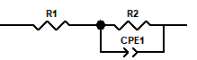
Figure S24. Equivalent circuit model of the complete solar cells for EIS analysis.
Figure S25. (a) J_{SC} and (b) FF statistic distributions of 12 independent PSCs.
Figure S26. MPP tracking test of unencapsulated PSCs under one sun irradiation in a ~25 ± 2 ℃ N² atmosphere.

Table S1. Peak-area ratio of DoD=(A_{MF}+A_{DM})/(A_{MF}+A_{DM} +A_{MA}+A_{FA}) in the fresh and aging PPS with and without TFA/MTFA. Where A_{MF}, A_{DM}, A_{MA} and A_{FA} are referred to the peak area of MFA⁺, DMFA⁺, MA⁺, and FA in NMR spectra respectively.
 | DoD of Pristine PPS (%) | DoD of TFA PPS (%) | DoD of MTFA PPS (%)
Fresh | 1.95 | 0.90 | 1.98
Aging | 5.56 | 2.29 | 1.23
Table S2. The k values of perovskite films extracted from their GIXRD spectral
 | Pristine | TFA | MTFA
k | -0.092 | 0.037 | -0.016
Table S3. TRPL analysis result of the pristine and corrosion inhibitor samples.
Cells | $τ_{1}$ (ns) | $τ_{2}$ (ns) | $τ_{avg}$ (ns)
Pristine | 9.68 | 205.44 | 191.17
TFA | 11.54 | 275.03 | 259.88
MTFA | 13.56 | 315.01 | 301.90
Table S4. Parameters derived from EIS measurements for the pristine and corrosion inhibitor samples.
 | Pristine | TFA | MTFA
R_{s} (Ω) | 38.78 | 36.81 | 30.85
R_{rec} (Ω) | 2491 | 3127 | 3304
Table S5. Photoelectric performance parameters extracted from the J-V curves.
Cells | J_{SC} (mA/cm²) | V_{OC} (V) | FF (%) | PCE (%)
Pristine | 25.27 | 1.20 | 82.47 | 24.95
TFA | 25.45 | 1.22 | 83.55 | 25.91
MTFA | 25.59 | 1.22 | 83.81 | 26.24

Table S6. Forward and reverse scanned photoelectric performance parameters extracted from the corresponding J-V curves for the champion pristine device and MTFA device.
Cells | J_{SC} (mA/cm²) | V_{OC} (V) | FF (%) | PCE (%)
Pristine-F | 25.14 | 1.20 | 81.81 | 24.58
Pristine-R | 25.27 | 1.20 | 82.47 | 24.95
MTFA-F | 25.53 | 1.23 | 83.56 | 26.23
MTFA -R | 25.59 | 1.22 | 83.81 | 26.24

