Supporting Information
One-tube nested PCR mediated CRISPR-Cas12a: A novel performance-enhanced approach for ultrasensitive fluorescent visual screening of Salmonella

Qingli Yang^{1,†}, Noor Fatima^{1,†}, Xiaofeng Yu², Yubo Peng¹, Qi Chen¹, Dexing Zeng², Zhaoran Chen², Guolin Wu^{3,*}, Wei Chen^{1,} ∗
¹Engineering Research Center of Bio-process, MOE, School of Food and Biological Engineering, Intelligent Manufacturing Institute, Hefei University of Technology, Hefei 230009, P. R. China
²Anhui Province Institute of Product Quality Supervision & Inspection, Hefei, 230051, P.R. China
³Devision of Life Sciences and Medicine, University of Science and Technology of China, Hefei, 230031, China

Table S1. DNA sequences used in this study.
DNA | Complete sequence (5’-3’)
188-F | CTACAAGCATGAAATGGCAGAACAGCGTCG
188-R | CAACCAGATAGGTAGGTAATGGAATGACGA
64-F | ACTGATTCTGGTACTAATGGTGATG
64-R | CAGATAGGTAGGTAATGGAATGACG
crRNA | UAAUUUCUACUAAGUGUAGAUUAUGUUCGUCAUUCCAUUAC
Report probe | FITC-TTATT-Biotin

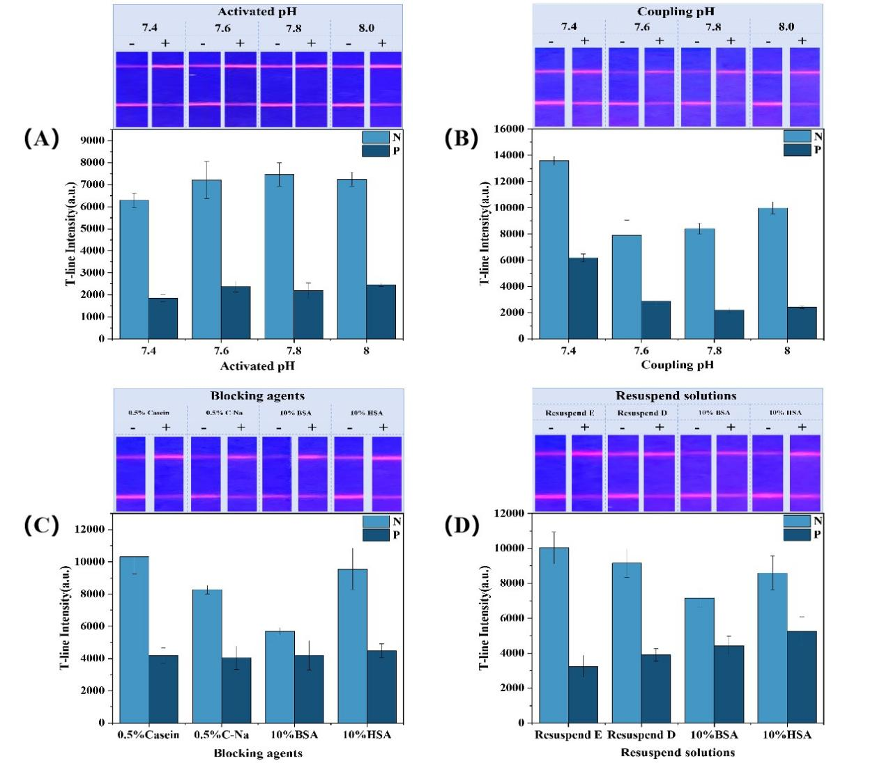

Figure S1. Optimization of conditions for fluorescent microsphere test strips. (A) Optimization of pH (pH7.4, pH7.6, pH7.8, pH8.0) of activated fluorescent microspheres; (B) Optimization of pH (pH7.4, pH7.6, pH7.8, pH8.0) for fluorescent microsphere-coupled antibodies; (C) Optimization of blocking agents for fluorescent microsphere-coupled antibodies; (D) Optimization of resuspend solutions.

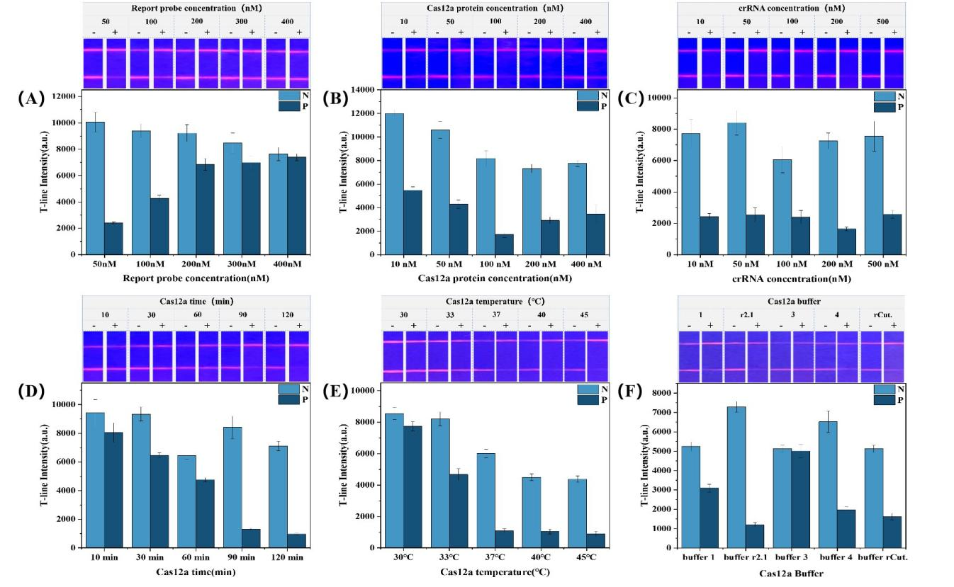
Figure S2. Optimization of different parameters of the CRISPR/Cas12a cleavage system. (A) Optimization of Cas12a concentration (10 nM, 50 nM, 100 nM, 200 nM, 400 nM); (B) Optimization of crRNA concentration (10 nM, 50 nM, 100 nM, 200 nM, 500 nM); (C) Optimization of temperature (30 ℃, 33 ℃, 37 ℃, 40 ℃, 45 ℃) for action of CRISPR-Cas12a protein; (D) Types of Cas reaction buffers (E) Time (90 min, 60 min, 50 min, 40 min, 30 min) optimization of Cas protein cleavage of ssDNA; (F) Concentration (50 nM, 25 nM, 10 nM, 5 nM, 2 nM) optimization of FITC-ssDNA-Biotin reporter probe.

