Supporting Information

Synthesis of aromatic and citrate-based quaternary ammonium salts for application as thermolatent bases
Matthias Udo Mayer-Kriehuber^{1,2} ● Evelyn Sattler¹ ● Johannes Krämer² ● David Reisinger^{1,2} ● Daniel Bautista-Anguís^{1,2} ● Johanna Uher^{1,3} ● Elvira Vidovic⁴ ● Sandra Schlögl^{1,2}

____
Sandra Schlögl
sandra.schloegl@pccl.at; sandra.schloegl@unileoben.ac.at
¹ Polymer Competence Center Leoben GmbH, Leoben, Austria
² Institute of Chemistry of Polymeric Materials, Technical University of Leoben, Leoben, Austria
³ Institute of Chemistry and Technology of Materials, Graz University of Technology, Graz, Austria
⁴ University of Zagreb Faculty of Chemical Engineering and Technology, Zagreb, Croatia

Results
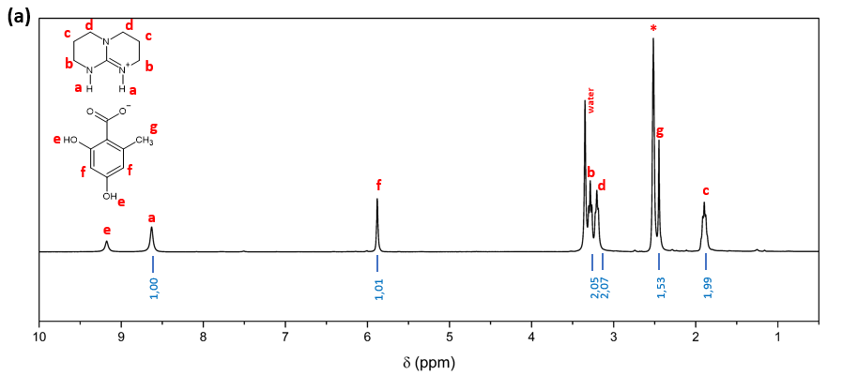
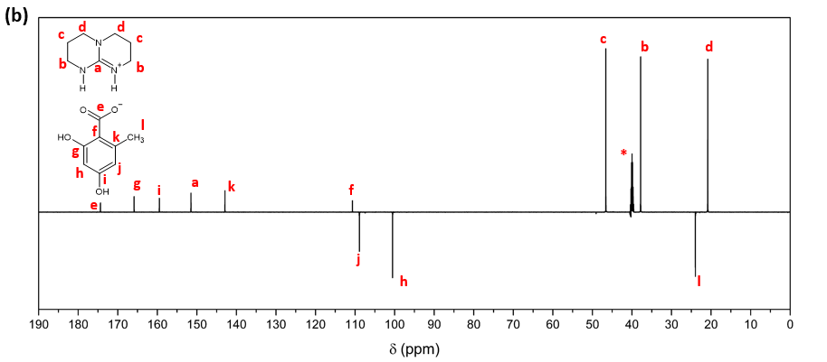
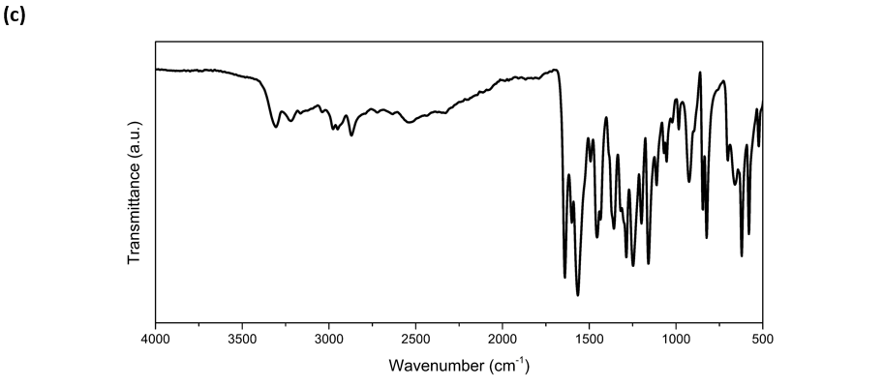
Figure S1: (a) ¹H NMR, (b) ¹³C NMR (600 MHz, DMSO-d₆) and (c) FTIR spectrum of 1-a.

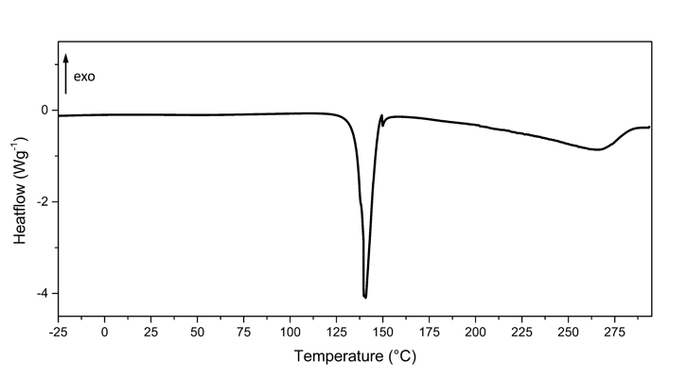

Figure S2: DSC curve of 1-a.

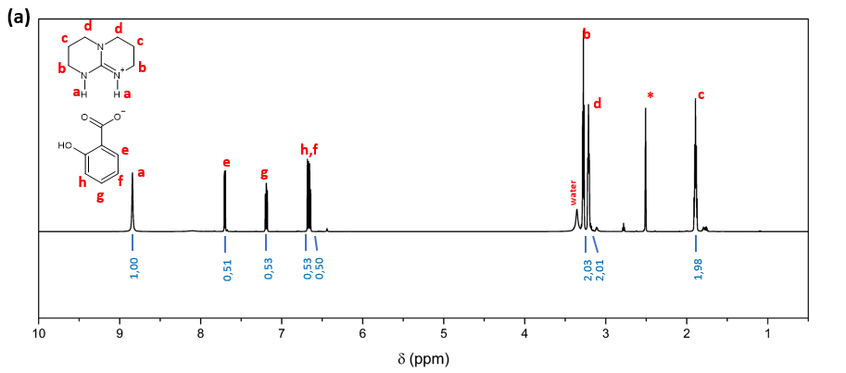
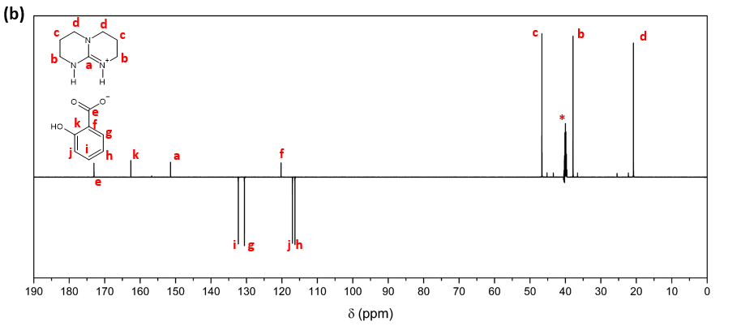
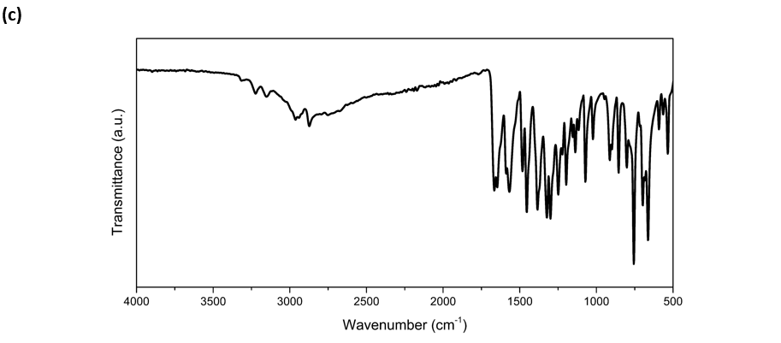
Figure S3: (a) ¹H NMR, (b) ¹³C NMR (600 MHz, DMSO-d₆) and (c) FTIR spectrum of 1-b.

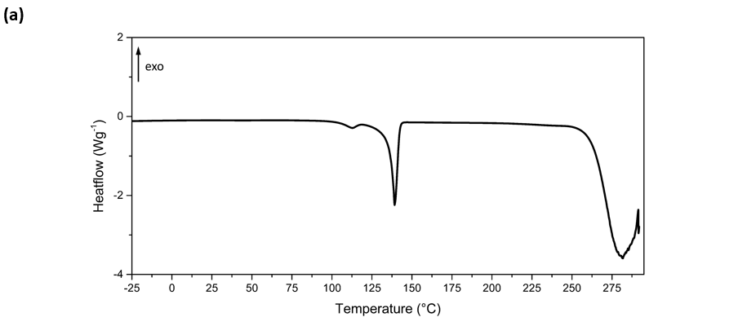

Figure S4: DSC curve of 1-b.

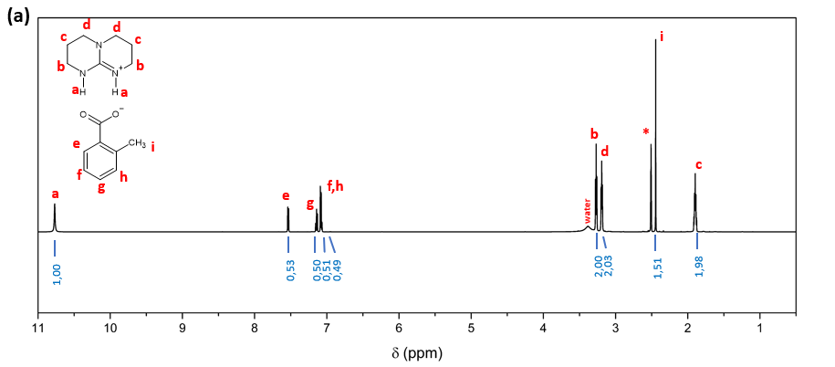
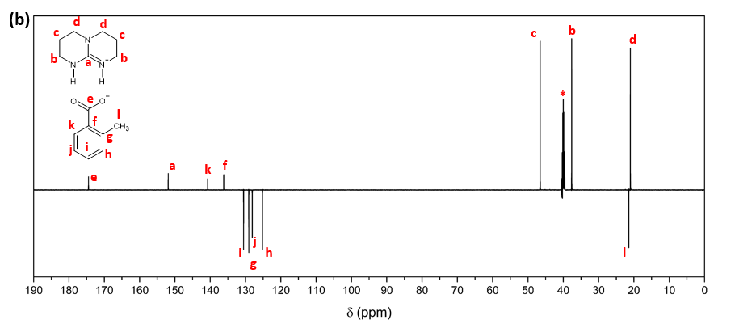
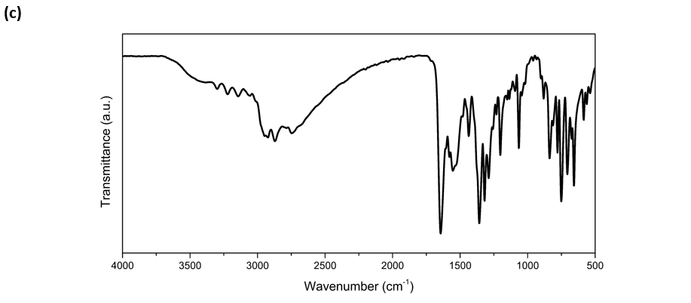
Figure S5: (a) ¹H NMR, (b) ¹³C NMR (600 MHz, DMSO-d₆) and (c) FTIR spectrum of 1-c.

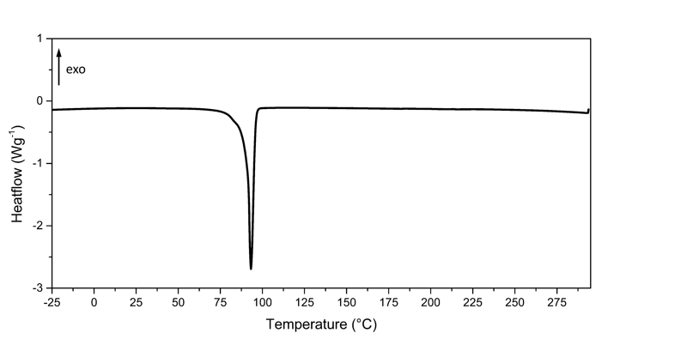
Figure S6: DSC curve of 1-c.

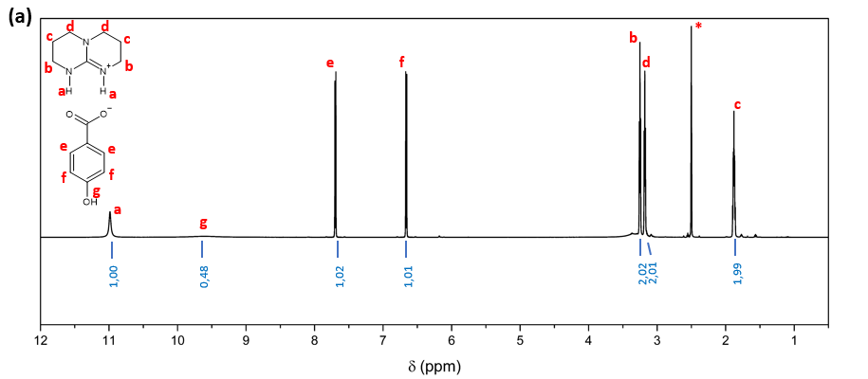
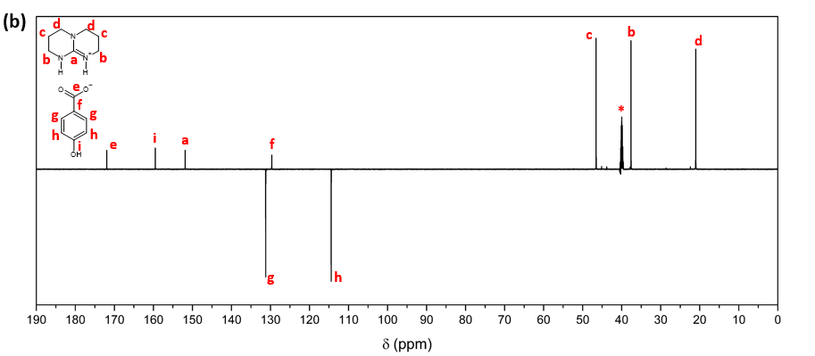
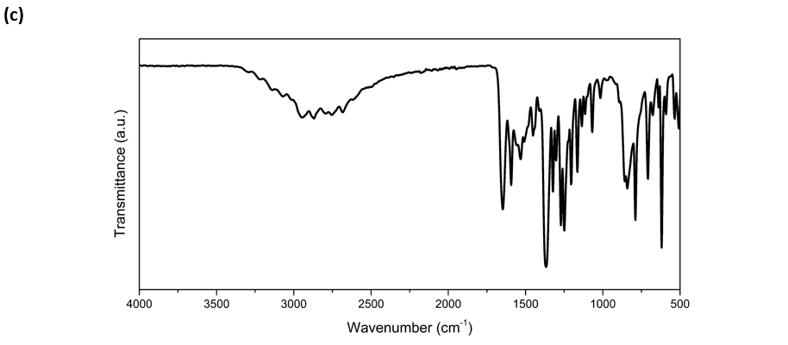
Figure S7: (a) ¹H NMR, (b) ¹³C NMR (600 MHz, DMSO-d₆) and (c) FTIR spectrum of 1-d.

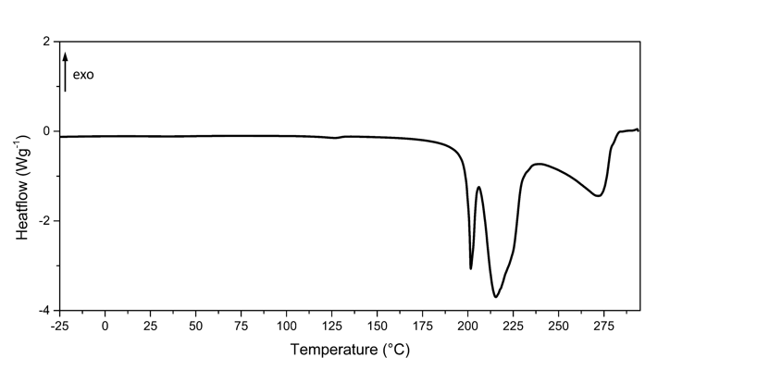

Figure S8: DSC curve of 1-d.

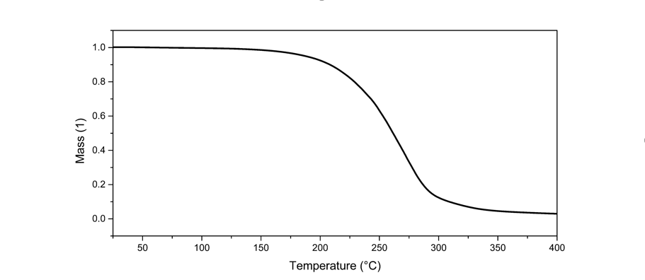
Figure S9: TGA curve of the pure base TBD.
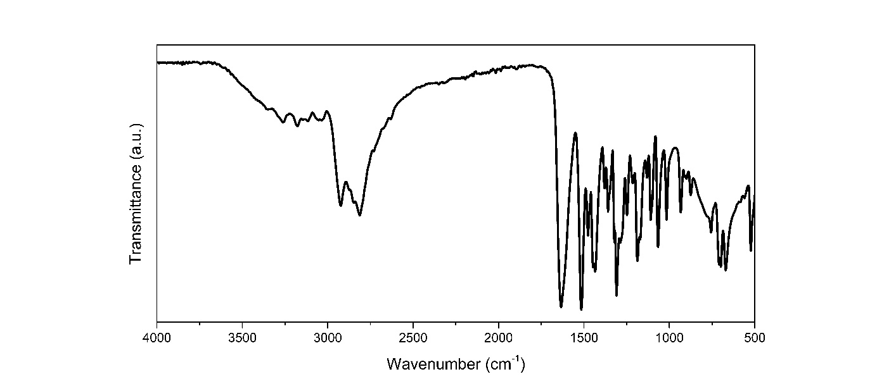
Figure S10: FTIR spectrum of the pure base TBD.
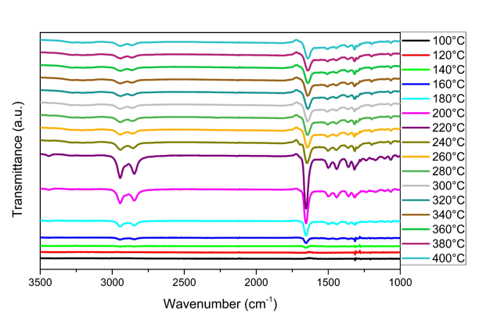
Figure S11: EGA analysis of the pure base TBD.

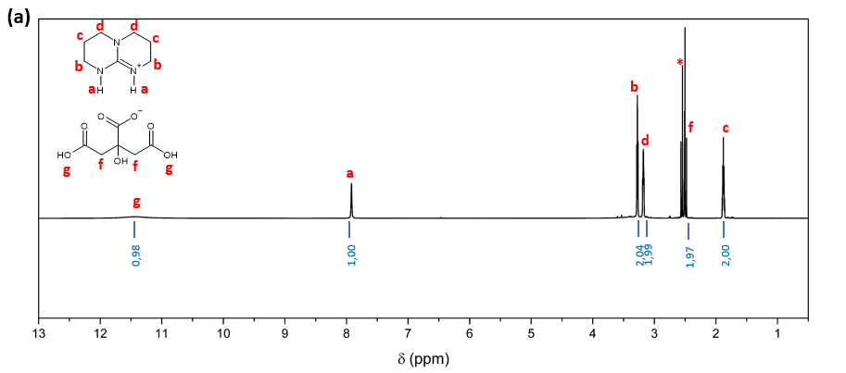
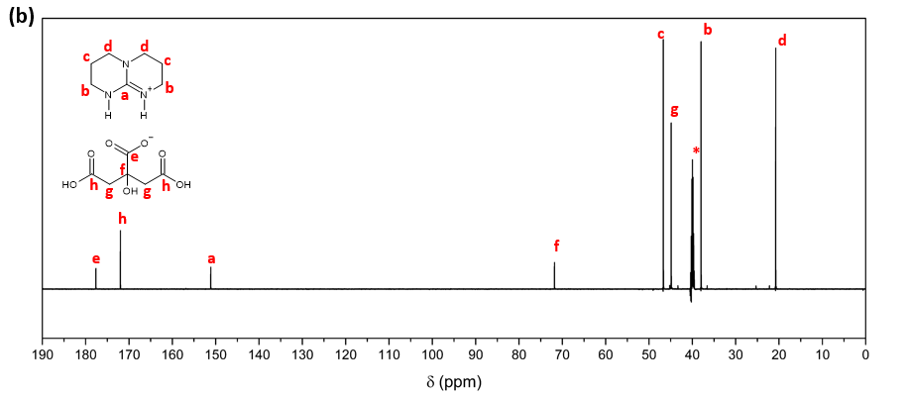
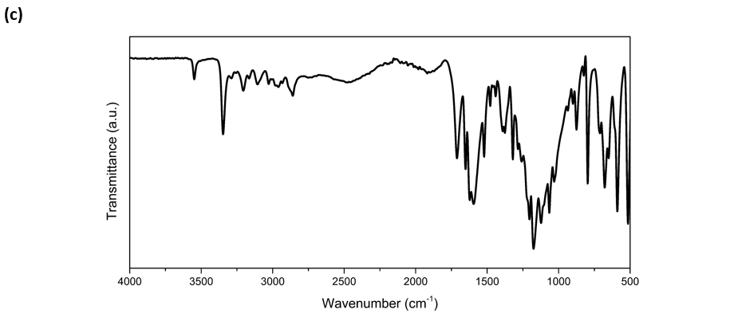
Figure S12: (a) ¹H NMR, (b) ¹³C NMR (600 MHz, DMSO-d₆) and (c) FTIR spectrum of 2-a.

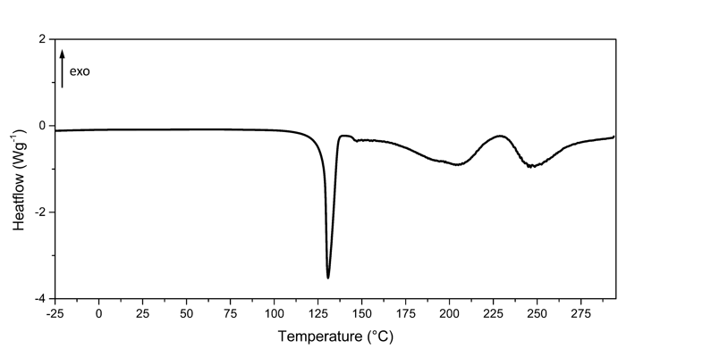

Figure S13: DSC curve of 2-a.

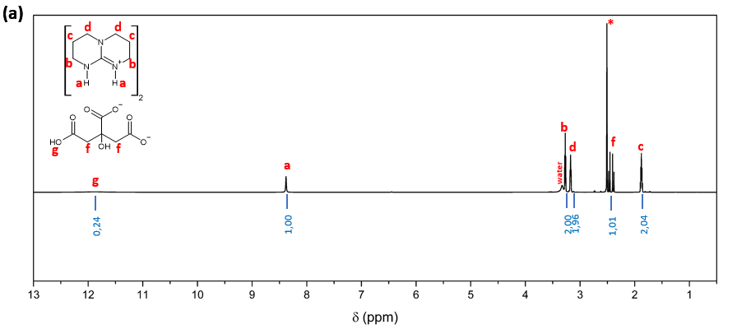
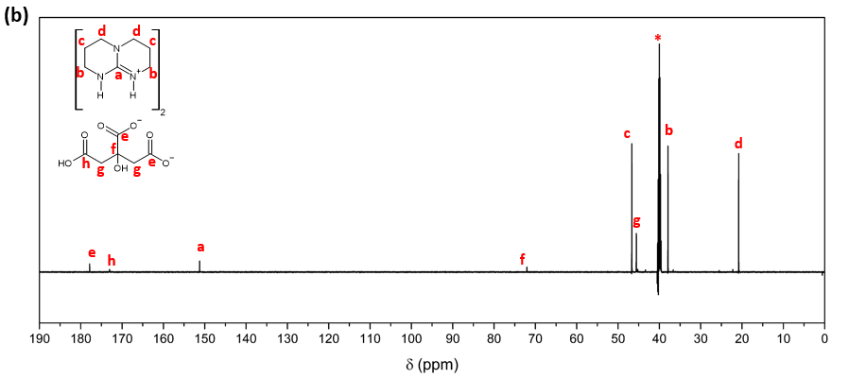
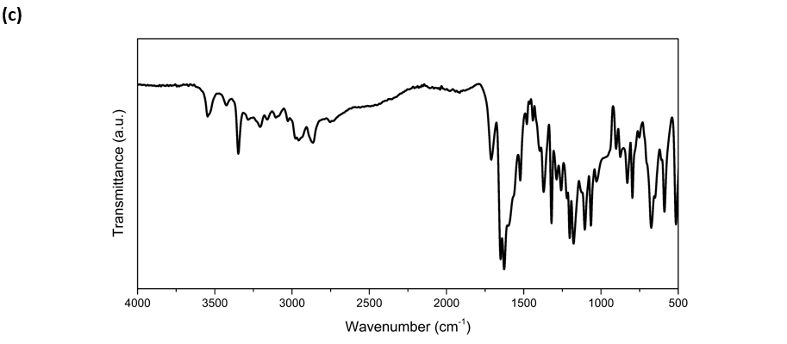
Figure S14: (a) ¹H NMR, (b) ¹³C NMR (600 MHz, DMSO-d₆) and (c) FTIR spectrum of 2-b.

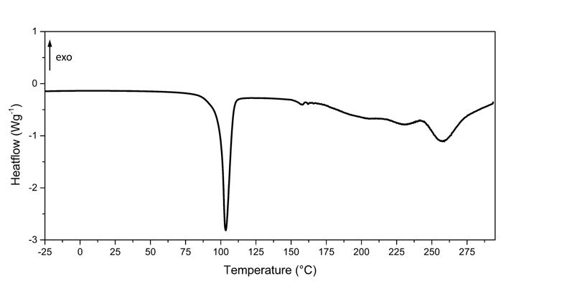

Figure S15: DSC curve of 2-b.

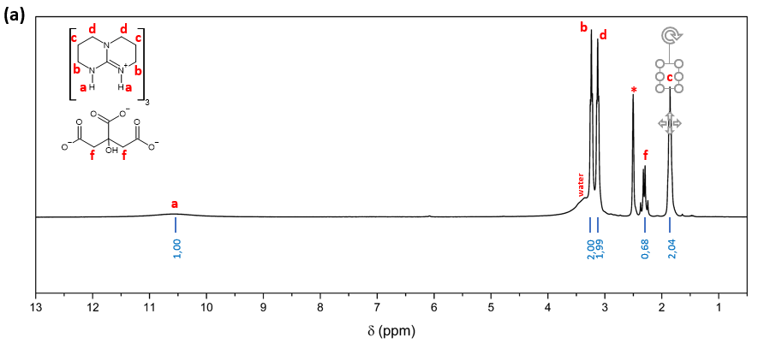
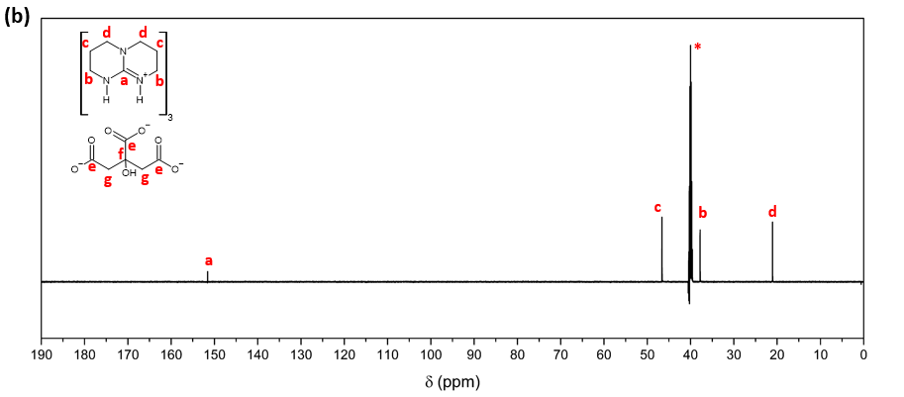
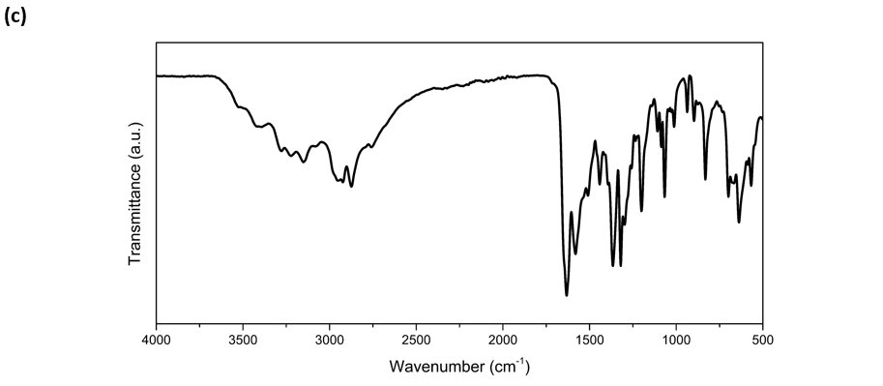
Figure S16: (a) ¹H NMR, (b) ¹³C NMR (600 MHz, DMSO-d₆) and (c) FTIR spectrum of 2-c.

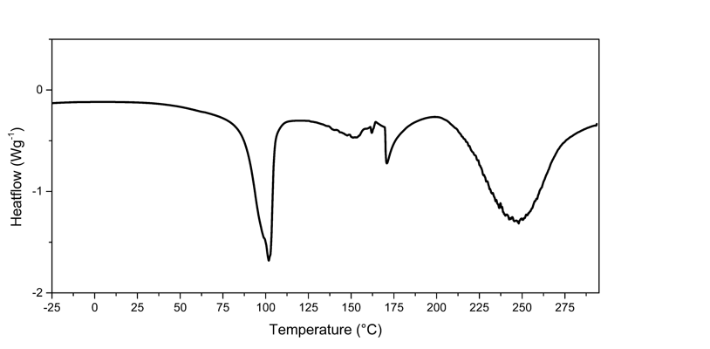

Figure S17: DSC curve of 2-c.

Table S1: pH Measurements of activated and not-activated 1-a.
Mass | Time | Temperature | pH_{NOT-ACT} | pH_{ACT} | ΔpH
mg | min | °C | 1 | 1 | 1
5.84 | 60.00 | 200.00 | 7.83 | 9.81 | 1.98
5.84 | 180.00 | 200.00 | 7.83 | 9.56 | 1.73
5.84 | 60.00 | 180.00 | 7.83 | 10.04 | 2.21
5.84 | 60.00 | 160.00 | 7.83 | 10.09 | 2.26
5.84 | 60.00 | 140.00 | 7.83 | 9.22 | 1.39
5.84 | 60.00 | 120.00 | 7.83 | 8.44 | 0.61
5.84 | 60.00 | 100.00 | 7.83 | 7.83 | 0.00
5.84 | 30.00 | 160.00 | 7.83 | 9.95 | 2.12
5.84 | 90.00 | 160.00 | 7.83 | 10.01 | 2.18
Highlighted row indicates the condition at which the highest ΔpH (2.26) was observed for 1-a at 160 °C after 60 min.

Table S2: pH Measurements of activated and not-activated 1-b.
Mass | Time | Temperature | pH_{NOT-ACT} | pH_{ACT} | ΔpH
mg | min | °C | 1 | 1 | 1
5.27 | 60.00 | 200.00 | 7.47 | 7.04 | -0.20
5.27 | 180.00 | 200.00 | 7.47 | 4.59 | -2.65
5.27 | 60.00 | 180.00 | 7.47 | 8.46 | 1.22
5.27 | 60.00 | 160.00 | 7.47 | 8.28 | 1.04
5.27 | 120.00 | 180.00 | 7.47 | 8.81 | 1.57
5.27 | 180.00 | 180.00 | 7.47 | 7.26 | 0.02
Highlighted row indicates the condition at which the highest ΔpH (1.57) was observed for 1-b at 180 °C after 120 min.

Table S3: pH Measurements of activated and not-activated 1-c.
Mass | Time | Temperature | pH_{NOT-ACT} | pH_{ACT} | ΔpH
mg | min | °C | 1 | 1 | 1
5.23 | 60.00 | 200.00 | 7.61 | 6.49 | -1.12
5.23 | 180.00 | 200.00 | 7.61 | 4.95 | -2.66
5.23 | 60.00 | 180.00 | 7.61 | 8.38 | 0.77
5.23 | 60.00 | 160.00 | 7.61 | 7.61 | 0.00
5.23 | 120.00 | 180.00 | 7.61 | 5.55 | -2.06
5.23 | 30.00 | 180.00 | 7.61 | 8.01 | 0.40
Highlighted row indicates the condition at which the highest ΔpH (0.77) was observed for 1-c at 180 °C after 60 min.

Table S4: pH Measurements of activated and not-activated 1-d.
Mass | Time | Temperature | pH_{NOT-ACT} | pH_{ACT} | ΔpH
mg | min | °C | 1 | 1 | 1
5.27 | 60.00 | 200.00 | 7.09 | 6.41 | -0.68
5.27 | 180.00 | 200.00 | 7.09 | 6.31 | -0.78
5.27 | 60.00 | 180.00 | 7.09 | 6.67 | -0.42
5.27 | 60.00 | 160.00 | 7.09 | 6.66 | -0.43
5.27 | 60.00 | 140.00 | 7.09 | 7.20 | 0.11
5.27 | 60.00 | 120.00 | 7.09 | 7.61 | 0.52
5.27 | 60.00 | 100.00 | 7.09 | 7.12 | 0.03
5.27 | 30.00 | 120.00 | 7.09 | 7.41 | 0.32
5.27 | 120.00 | 120.00 | 7.09 | 7.52 | 0.43
Highlighted row indicates the condition at which the highest ΔpH (0.52) was observed for 1-d at 120 °C after 60 min.

Table S5: pH Measurements of activated and not-activated 2-a.
Mass | Time | Temperature | pH_{NOT-ACT} | pH_{ACT} | ΔpH
mg | min | °C | 1 | 1 | 1
6.30 | 60.00 | 200.00 | 4.14 | 4.65 | 0.51
6.30 | 120.00 | 200.00 | 4.14 | 4.93 | 0.79
6.30 | 180.00 | 200.00 | 4.14 | 4.57 | 0.43
6.30 | 120.00 | 180.00 | 4.14 | 4.87 | 0.73
Highlighted row indicates the condition at which the highest ΔpH (0.79) was observed for 2-a at 200 °C after 120 min.

Table S6: pH Measurements of activated and not-activated 2-b.
Mass | Time | Temperature | pH_{NOT-ACT} | pH_{ACT} | ΔpH
mg | min | °C | 1 | 1 | 1
8.94 | 60.00 | 200.00 | 4.80 | 5.50 | 0.70
8.94 | 120.00 | 200.00 | 4.80 | 6.59 | 1.79
8.94 | 180.00 | 200.00 | 4.80 | 5.62 | 0.82
8.94 | 120.00 | 180.00 | 4.80 | 5.63 | 0.83
Highlighted row indicates the condition at which the highest ΔpH (1.79) was observed for 2-b at 200 °C after 120 min.

Table S7: pH Measurements of activated and notactivated 2-c.
Mass | Time | Temperature | pH_{NOT-ACT} | pH_{ACT} | ΔpH
mg | min | °C | 1 | 1 | 1
11.59 | 60.00 | 200.00 | 7.39 | 8.30 | 0.91
11.59 | 120.00 | 200.00 | 7.39 | 10.14 | 2.75
11.59 | 180.00 | 200.00 | 7.39 | 9.66 | 2.27
11.59 | 120.00 | 180.00 | 7.39 | 7.40 | 0.01
Highlighted row indicates the condition at which the highest ΔpH (2.75) was observed for 2-c at 200 °C after 120 min.

