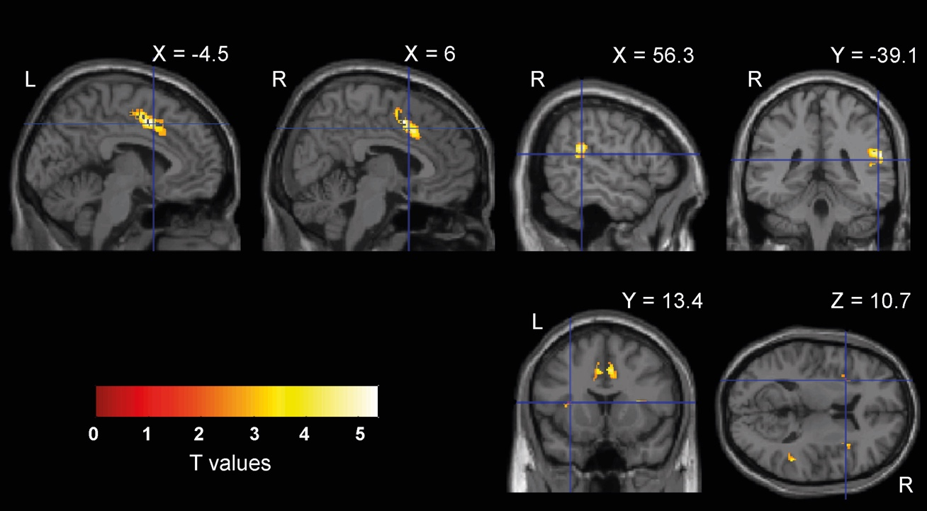

S-Fig. 1 fMRI group activations. Overlaid on the MNI template are the results of the group level analysis we ran on MNI spatially normalized images. For each subject, we estimated 12 t-contrasts, one for each duration and each response in the two temporal contexts, averaging across the 3 runs of each context. The resulted contrast images (t-statistics maps in MNI space) were then used in a second-level ANOVA where we contrasted all durations with all responses (6 durations – 6 responses). The statistical threshold was set to p < 0.05 FWE cluster-level corrected for multiple comparisons across the entire brain volume (cluster size estimated at a voxel level threshold p-uncorrected = 0.001).
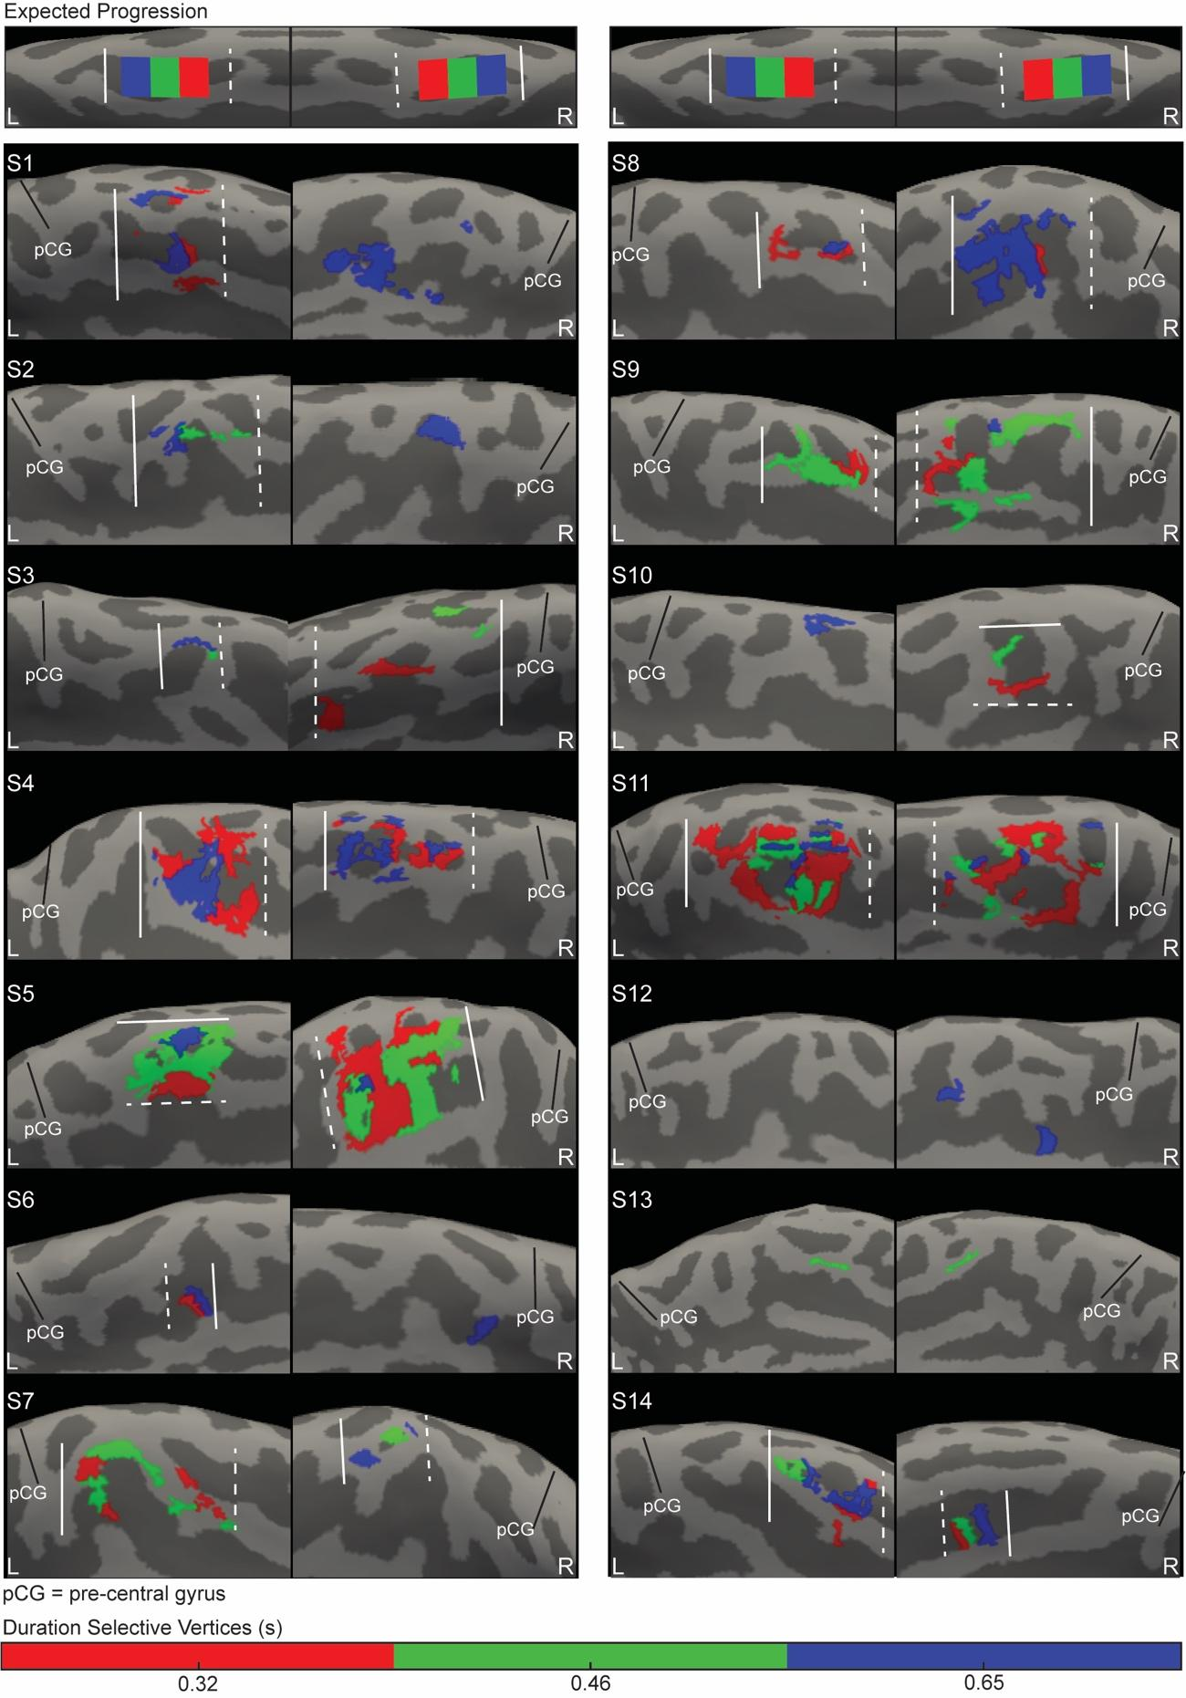

S-Fig. 2 Individual SMA chronomaps in the short context. Medial view of left (L) and right (R) hemispheres of the 14 tested subjects. Overlaid on the individual inflated cortical surface are clusters of vertices classified with a winner-take-all procedure as maximally responsive to the three durations in the short context (0.32, 0.46, and 0.65 s) The clusters are color coded according to duration preferences, 0.32 s is in red, 0.46 s is in green and 0.65 s is in blue. The white dashed line is the border at the shortest edge of the map (closest to the shortest duration), the solid line the border at the longest edge of the map (closest to the longest duration of the range). pCG is the precentral gyrus.

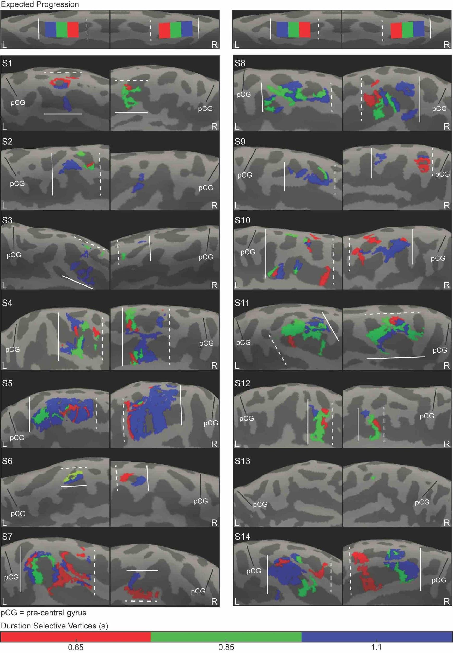

S-Fig. 3 Individual SMA chronomaps in the long context. Medial view of left (L) and right (R) hemispheres of the 14 tested subjects. Overlaid on the individual inflated cortical surface are clusters of vertices classified with a winner-take-all procedure as maximally responsive to the three durations in the long context (0.65, 0.85, and 1.1 s). The clusters are color coded according to duration preferences, 0.65 s is in red, 0.85 s is in green and 1.1 s is in blue. The white dashed line is the border at the shortest edge of the map (closest to the shortest duration), the solid line the border at the longest edge of the map (closest to the longest duration of the range). pCG is the precentral gyrus.

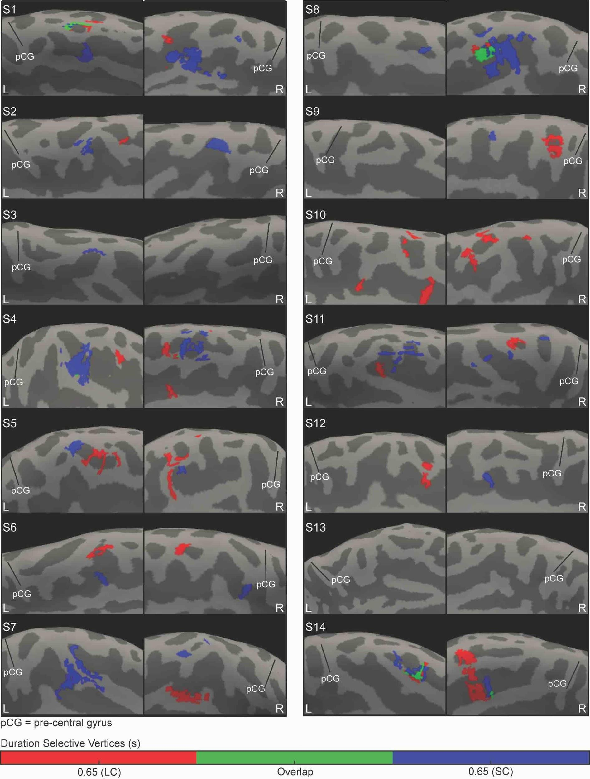

S-Fig. 4 Representation of the duration shared between contexts in SMA. Medial view of left (L) and right (R) hemispheres of the 14 tested subjects. Overlaid on the subject's inflated cortical surface are clusters of vertices classified with a winner-take-all procedure as maximally responsive to 0.65 s when presented in short (SC, blue) and long (LC, red) context. In green are the clusters responsive to 0.65 s in both the contexts. pCG is precentral gyrus.

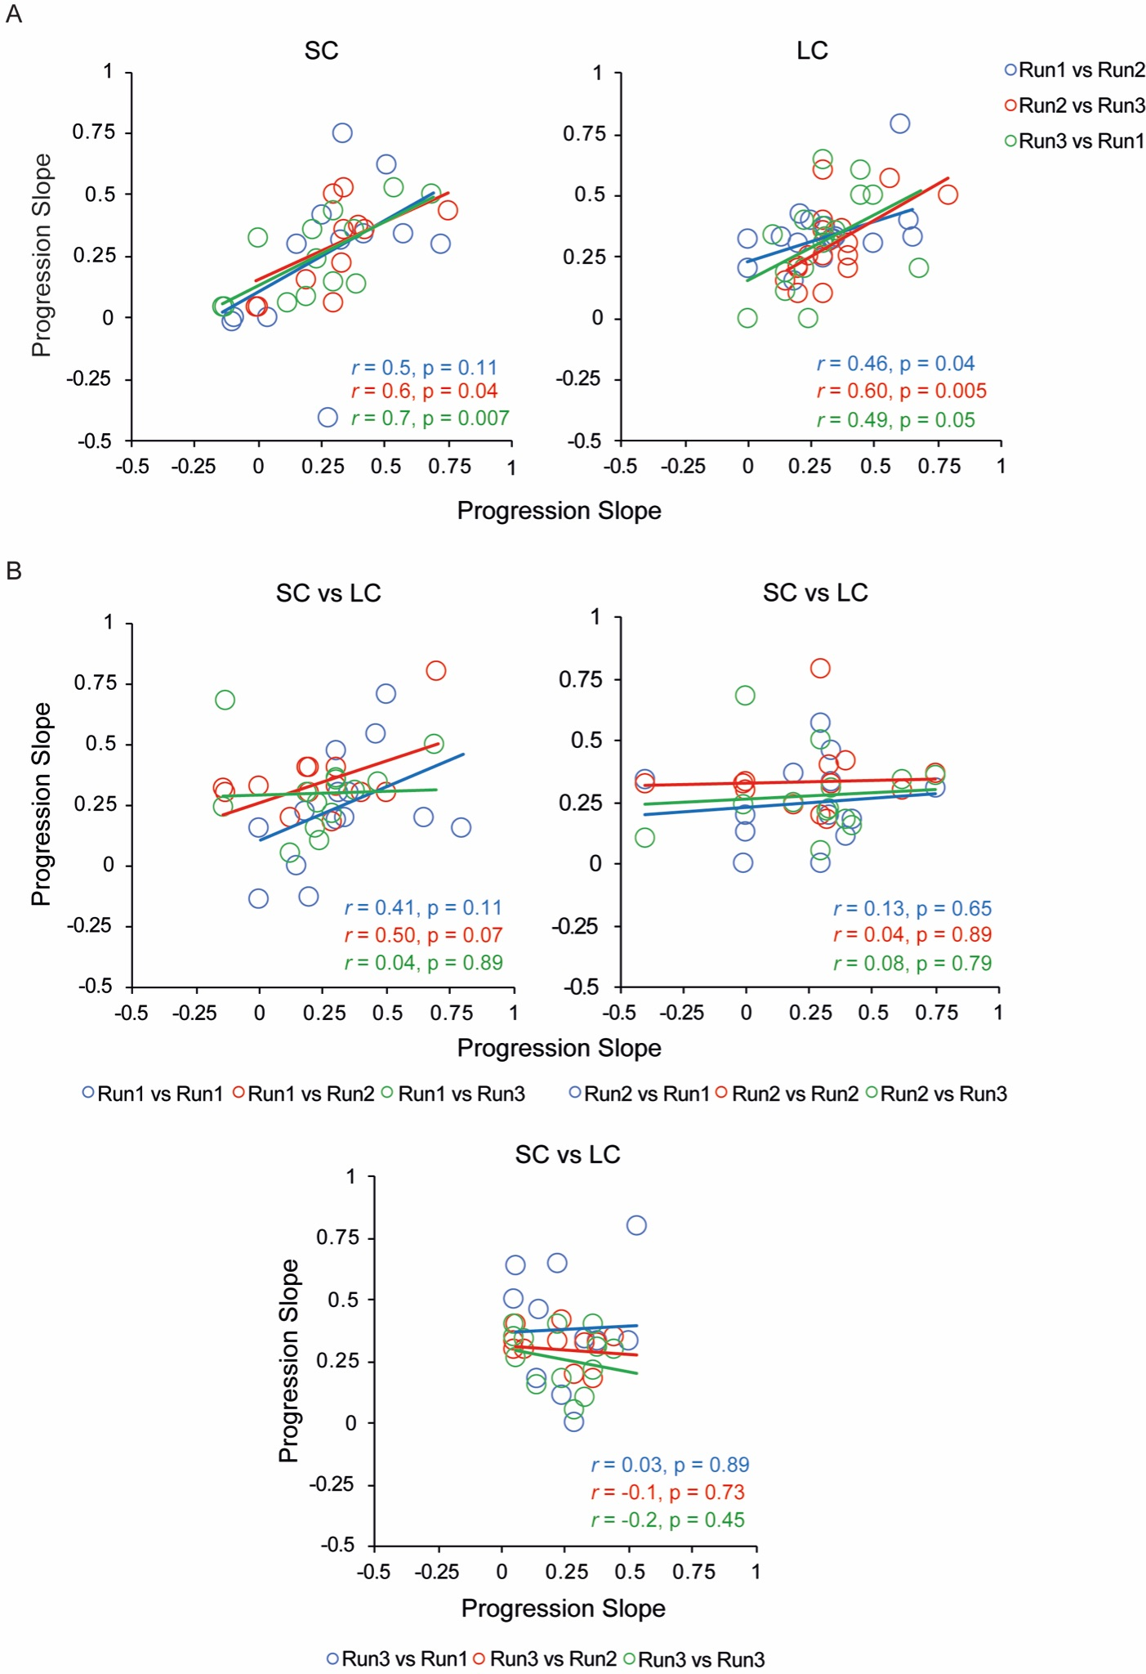

S-Fig. 5 Correlations between spatial progressions of the SMA chronomaps obtained within and across contexts. In each subject, we checked the correlation of the maps’ spatial progression (i.e., the individual slopes resulting from the computation of the distances of each duration selective cluster from the shortest edge of the map) between the different runs of the same (A) and of different contexts (B). SC = short context, LC =long context

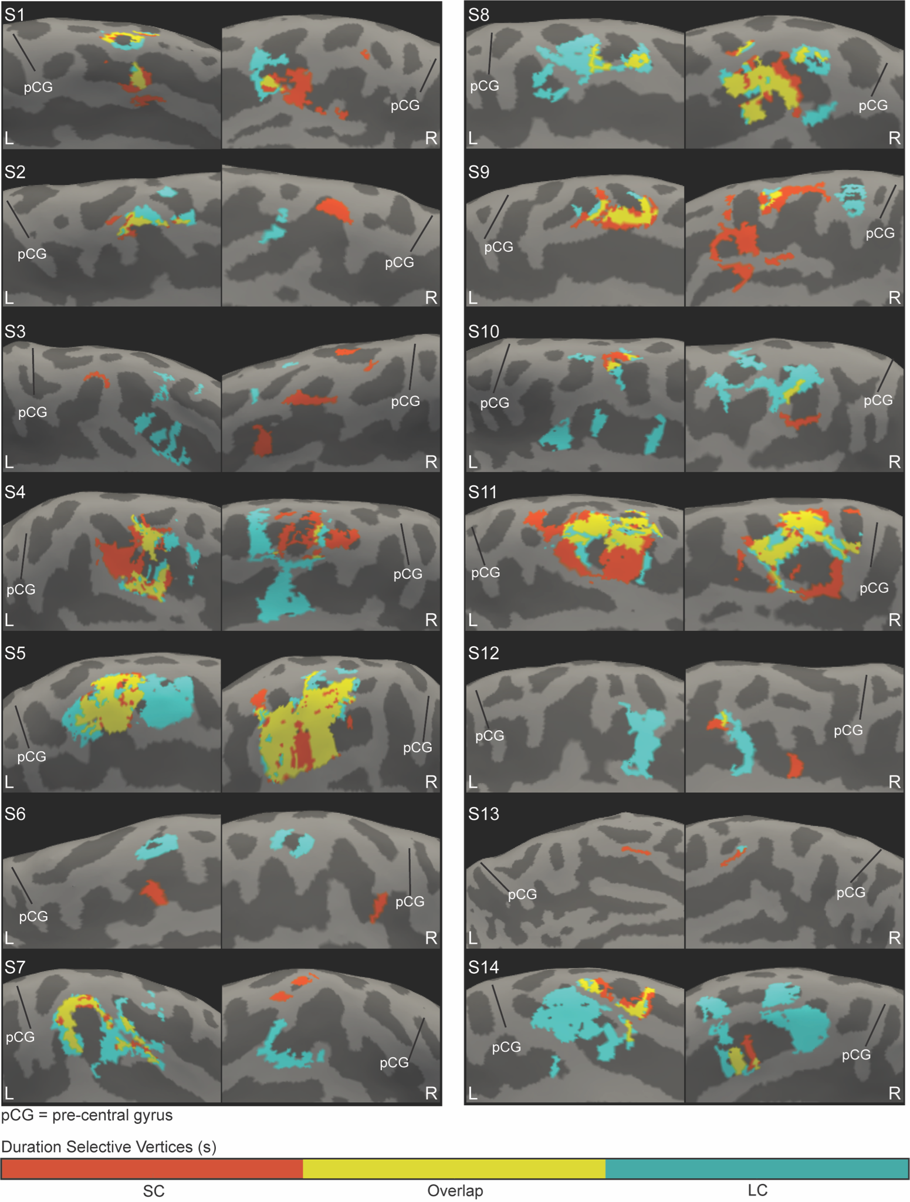

S-Fig. 6 Overlap between the maps of the two contexts in SMA. Medial view of left (L) and right (R) hemispheres of the 14 tested subjects, with the clusters corresponding to the short context in orange, those corresponding to the long context in pale blue and their overlap in yellow. pCG is precentral gyrus

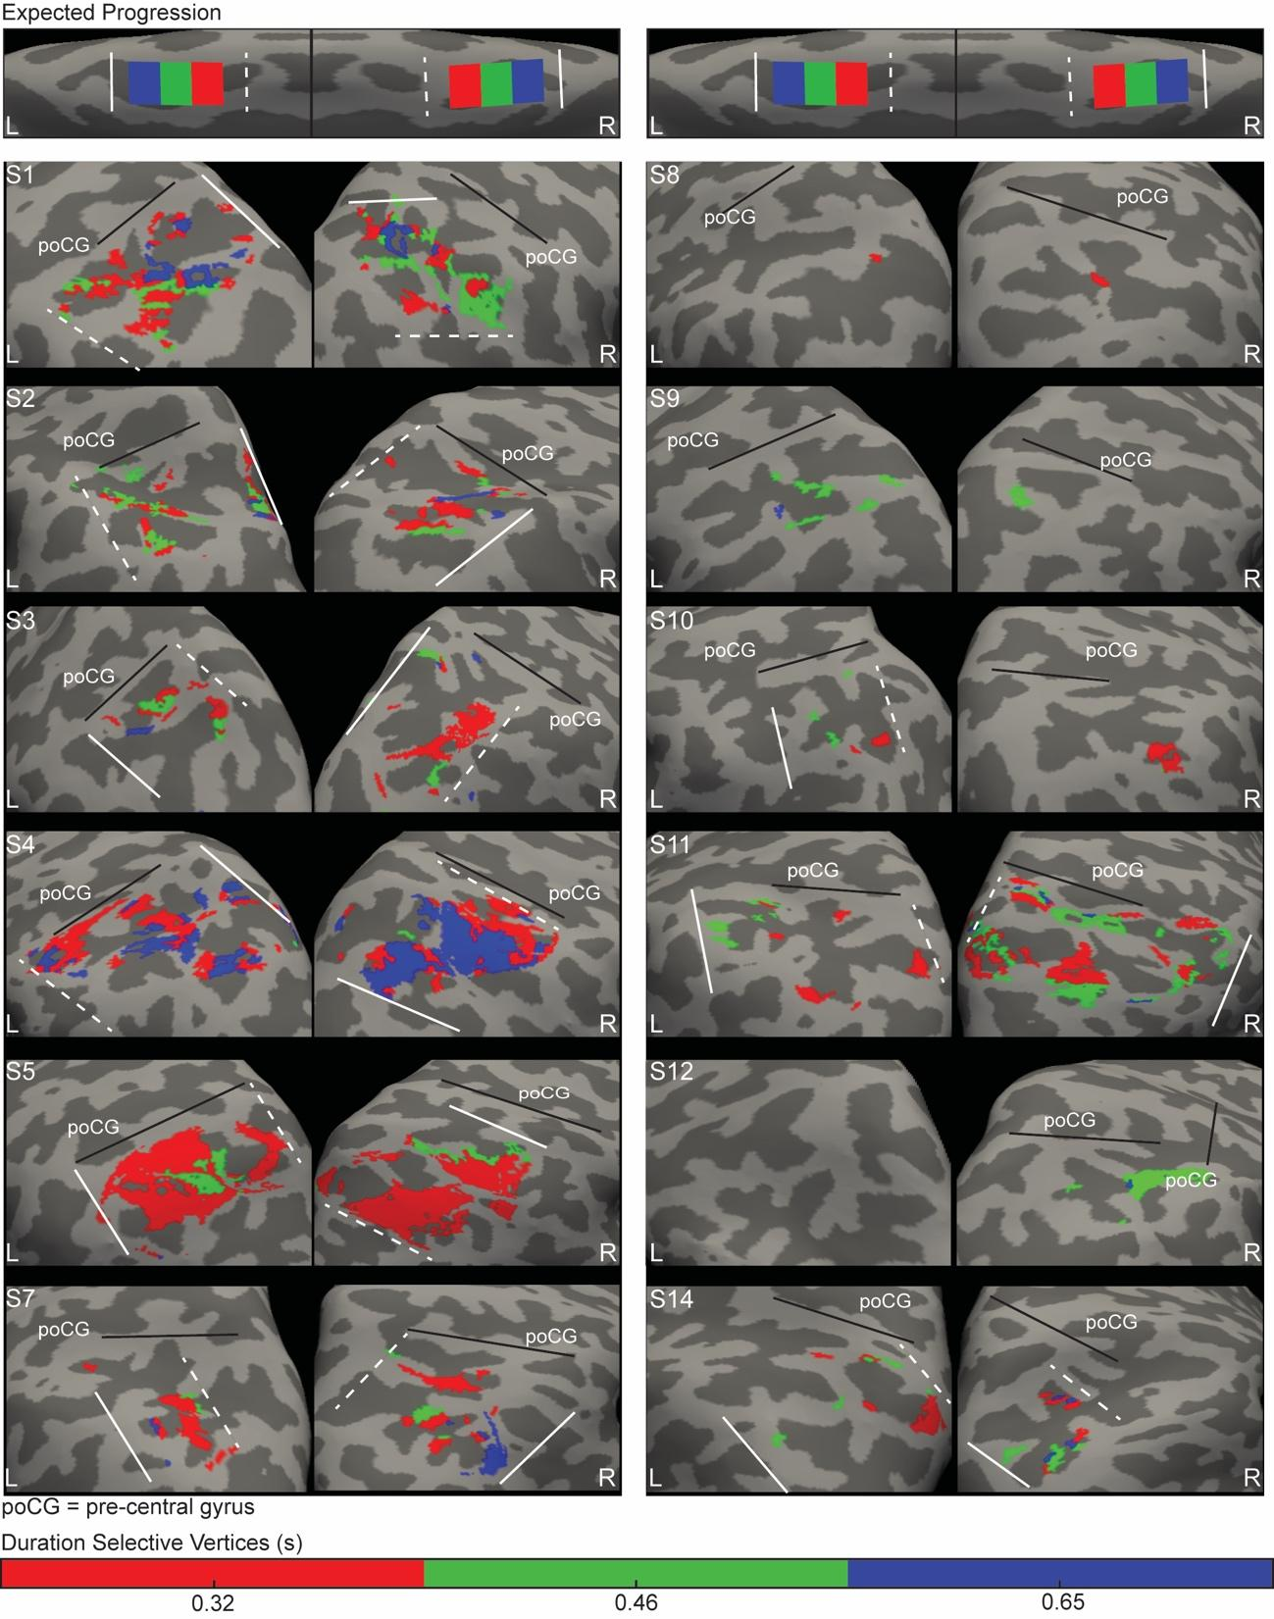
S-Fig. 7 Individual IPS chronomaps in the short context. Medial view of left (L) and right (R) hemispheres of the 14 tested subjects. Overlaid on the individual inflated cortical surface are clusters of vertices classified with a winner-take-all procedure as maximally responsive to the three durations in the short context (0.32, 0.46, and 0.65 s). The clusters are color coded according to duration preferences, 0.32s in red, 0.46s in green and 0.65 s in blue. The white dashed line is the border at the shortest edge of the map (closest to the shortest duration), the solid line the border at the longest edge of the map (closest to the longest duration of the range). poCG is the post-central gyrus.

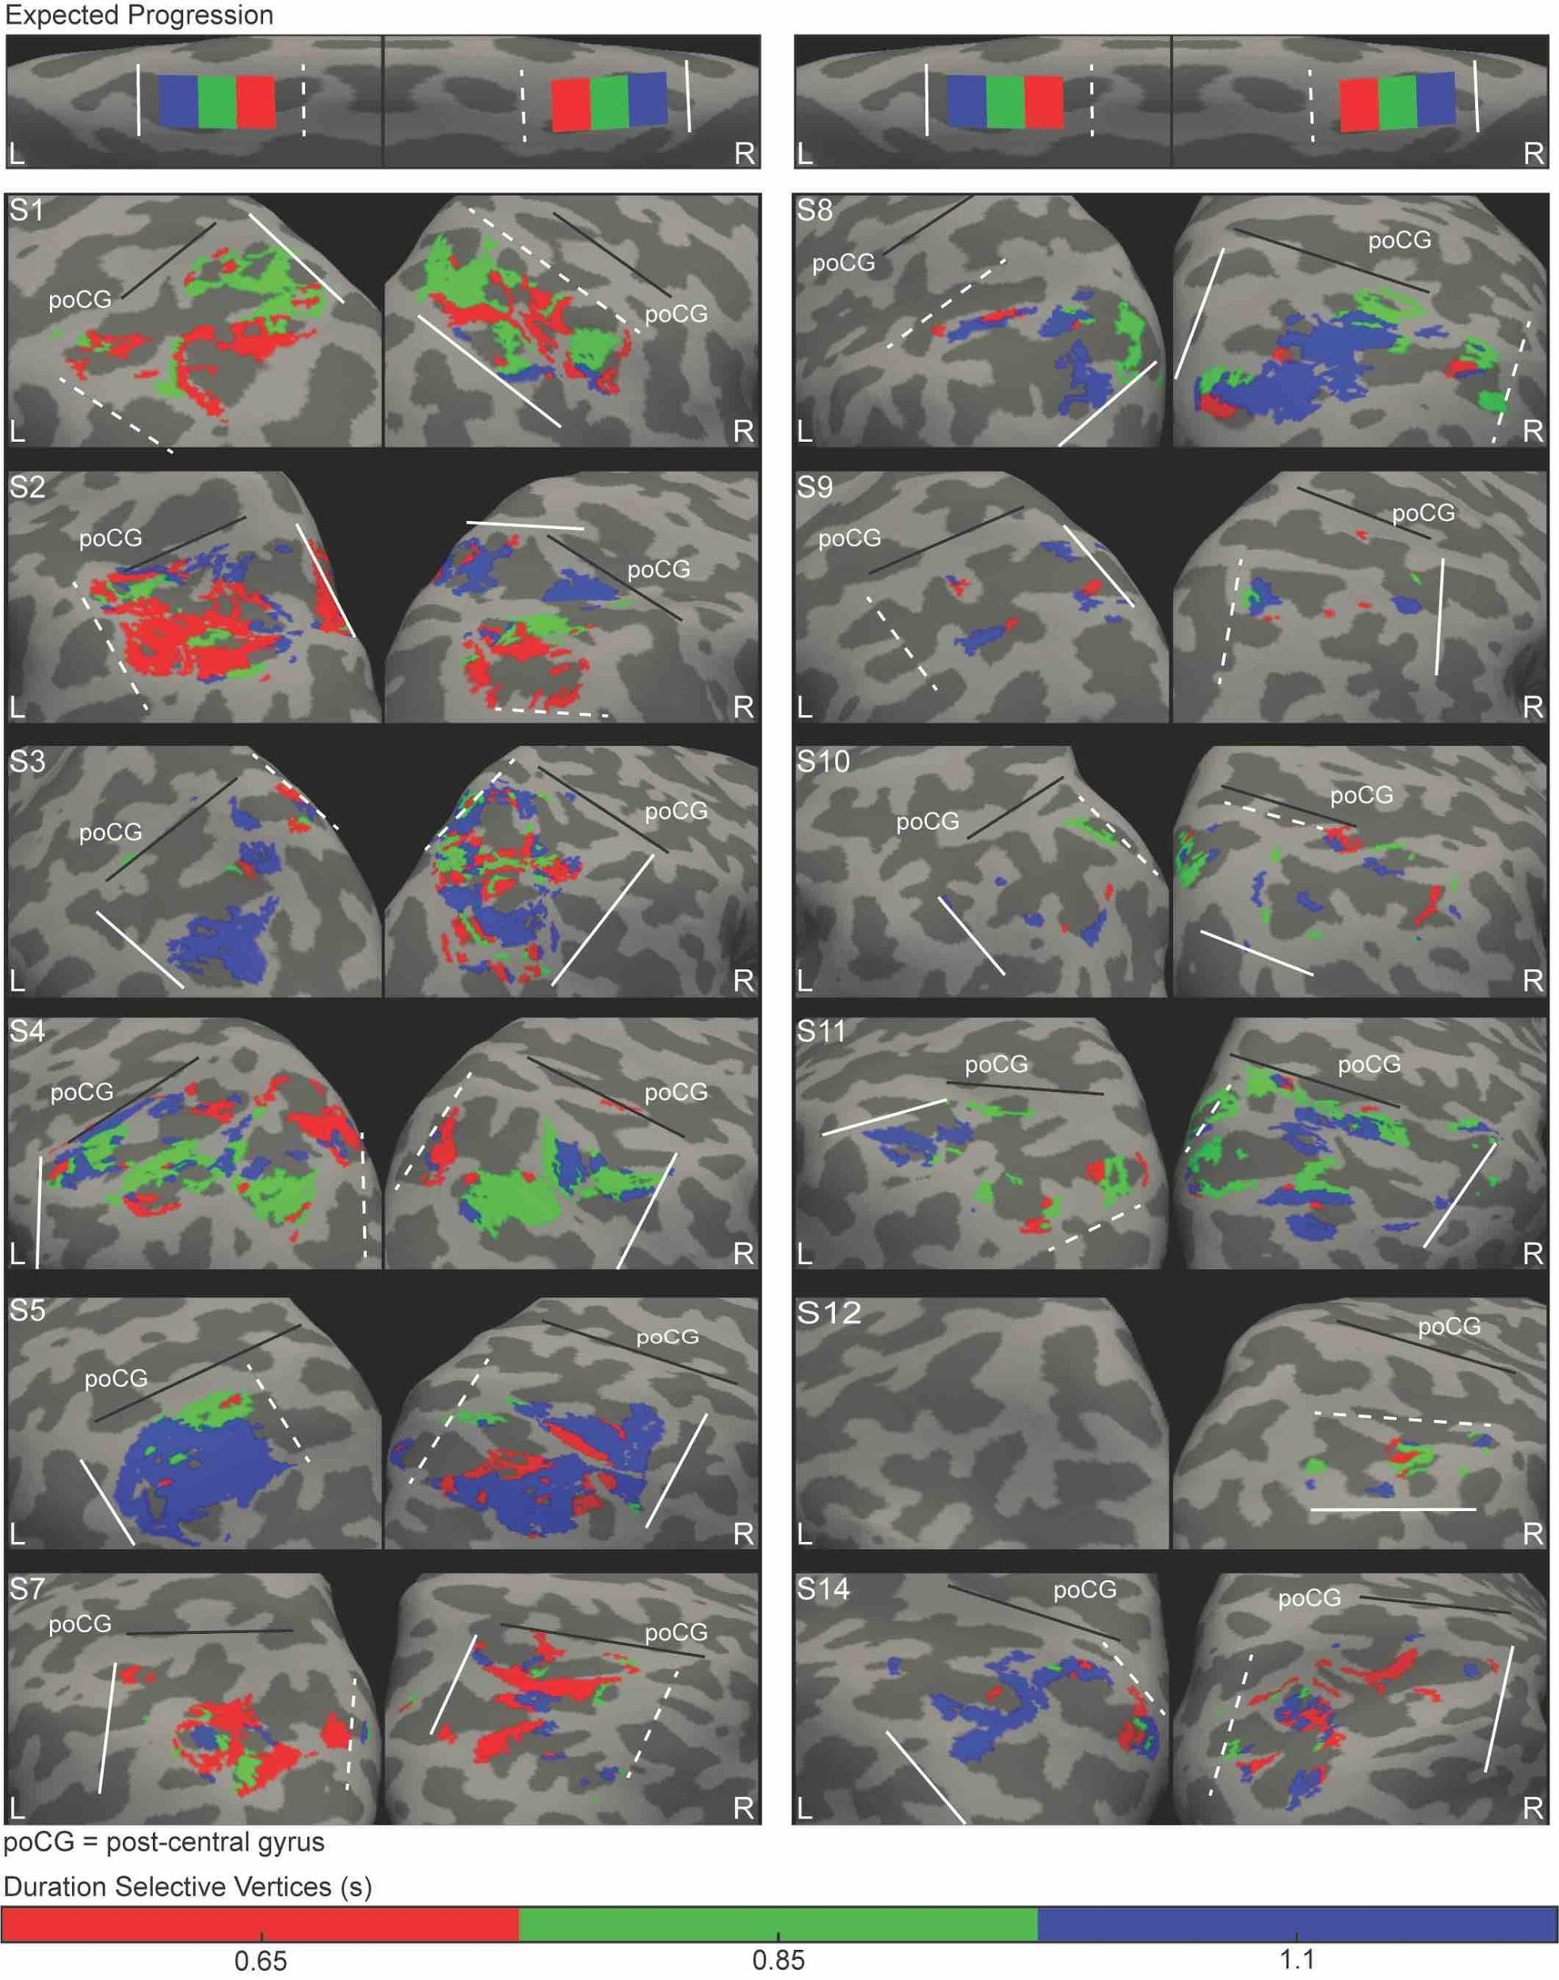

S-Fig. 8 Individual IPS chronomaps in the long context. Medial view of left (L) and right (R) hemispheres of the 14 tested subjects. Overlaid on the individual inflated cortical surface are clusters of vertices classified with a winner-take-all procedure as maximally responsive to the three durations in the long context (0.65, 0.85, and 1.1 s). The clusters are color coded according to duration preferences, 0.65 s in red, 0.85 s in green and 1.1 s in blue. The white dashed line is the border at the shortest edge of the map (closest to the shortest duration), the solid line the border at the longest edge of the map (closest to the longest duration of the range). poCG is the post-central gyrus.

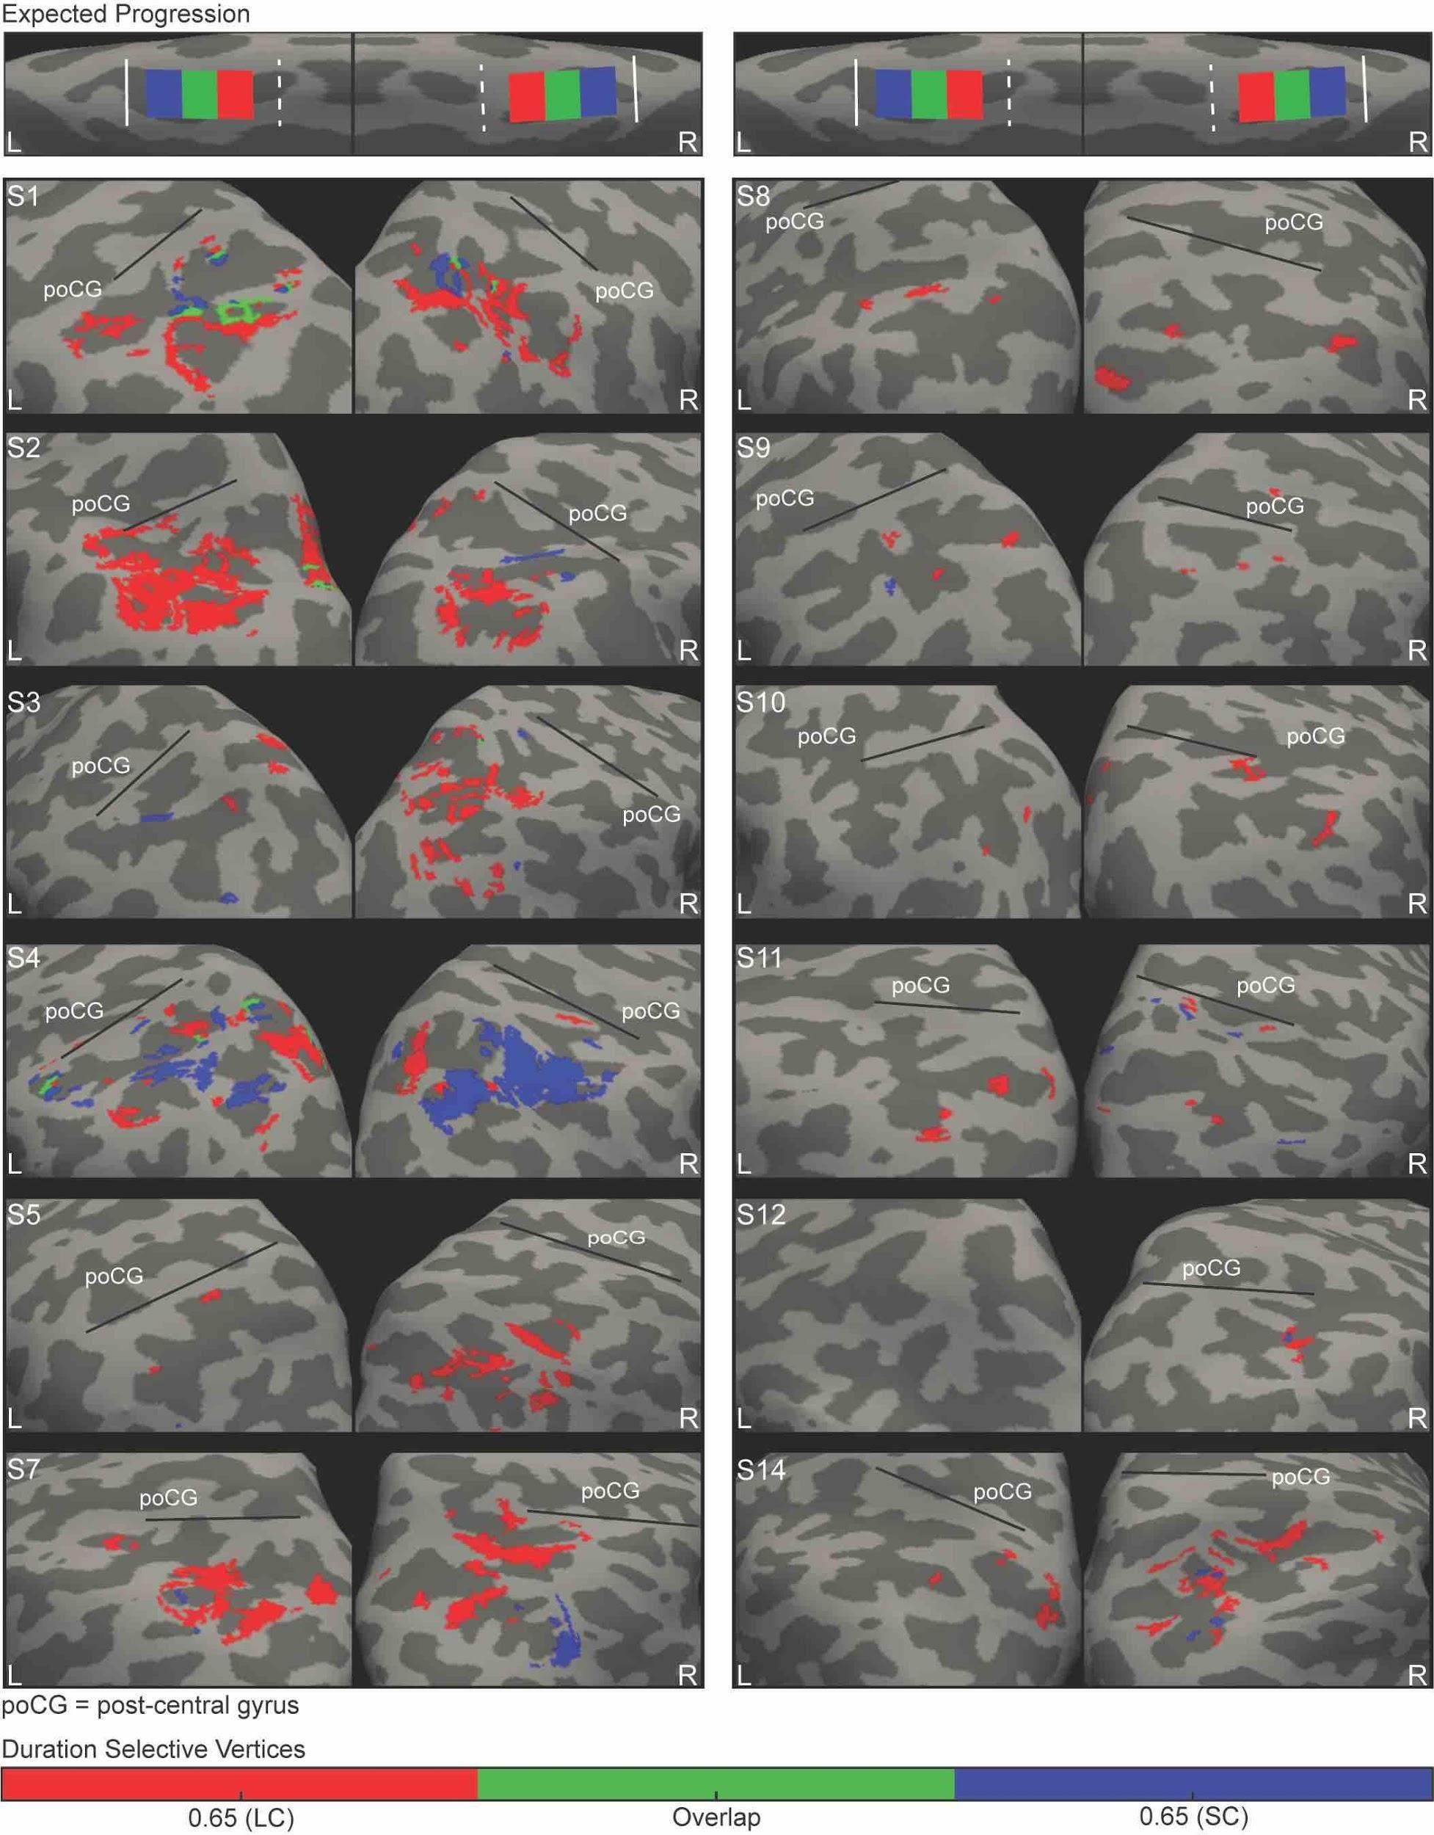

S-Fig. 9 Representation of the duration shared between contexts in IPS. Medial view of left (L) and right (R) hemispheres of the 14 tested subjects. Overlaid on the subject's inflated cortical surface are clusters of vertices classified with a winner-take-all procedure as maximally responsive to 0.65 s when presented in short context (SC, blue) and long context (LC, red). In green are the clusters responsive to 0.65 s in both the contexts. poCG is the post-central gyrus.

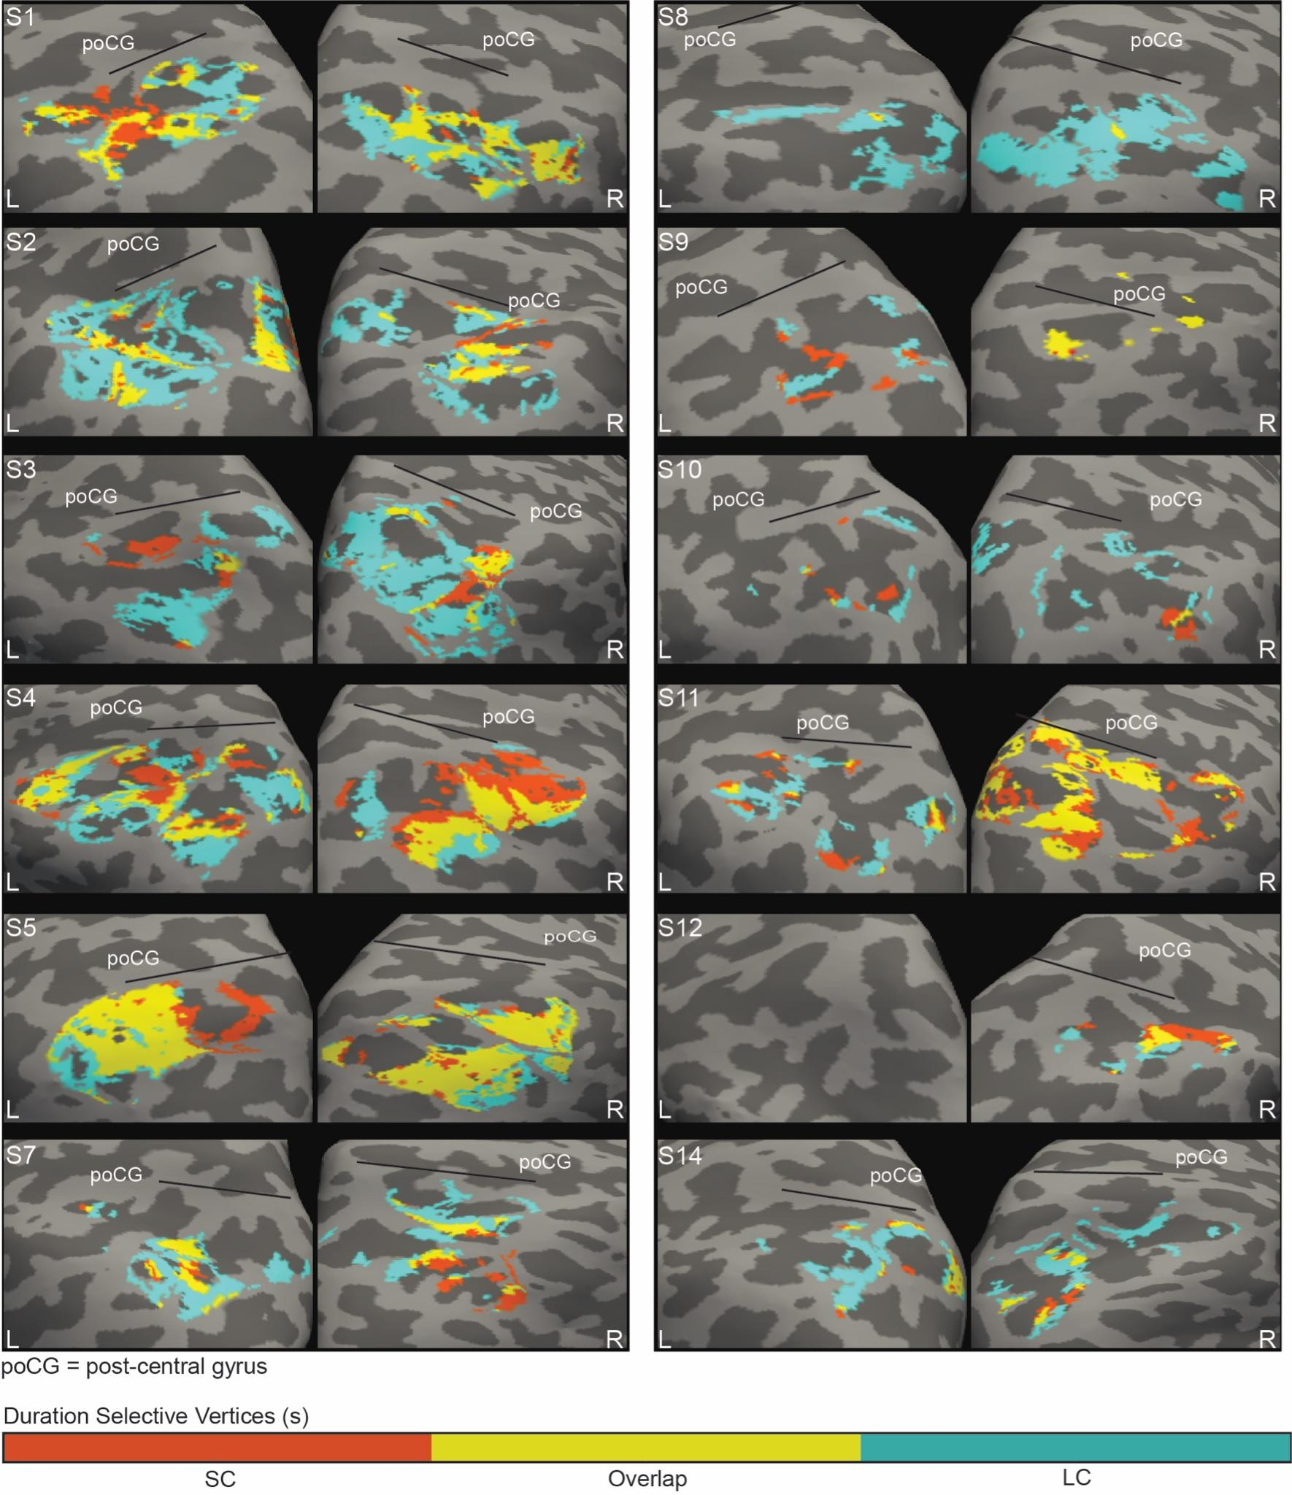

S-Fig. 10 Overlap between the maps of the two contexts in IPS. Medial view of left (L) and right (R) hemispheres of the 14 tested subjects, with the clusters corresponding to the short context in orange, those corresponding to the long context in pale blue and their overlap in yellow. poCG is the post-central gyrus
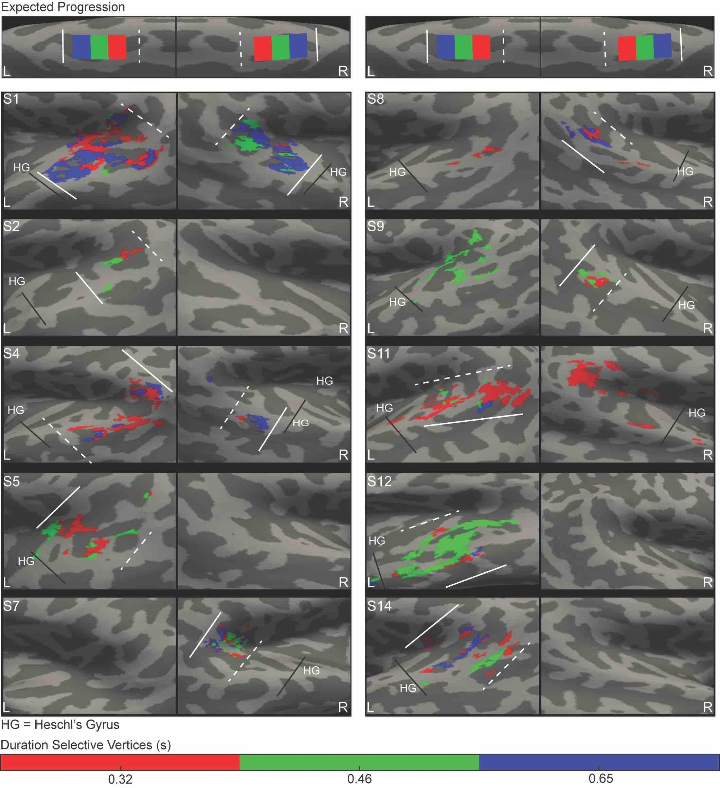

S-Fig. 11 Individual parabelt chronomaps in the short context. Medial view of left (L) and right (R) hemispheres of the 10 subjects where significant activation of the parabelt areas was found in short context. Overlaid on the individual inflated cortical surface are clusters of vertices classified with a winner-take-all procedure as maximally responsive to the three durations in the short context (0.32, 0.46, and 0.65 s). The clusters are color coded according to duration preferences, 0.32s in red, 0.46s in green and 0.65 s in blue. The white dashed line is the border at the shortest edge of the map (closest to the shortest duration), the solid line the border at the longest edge of the map (closest to the longest duration of the range). HG is the Heschl’s gyrus.

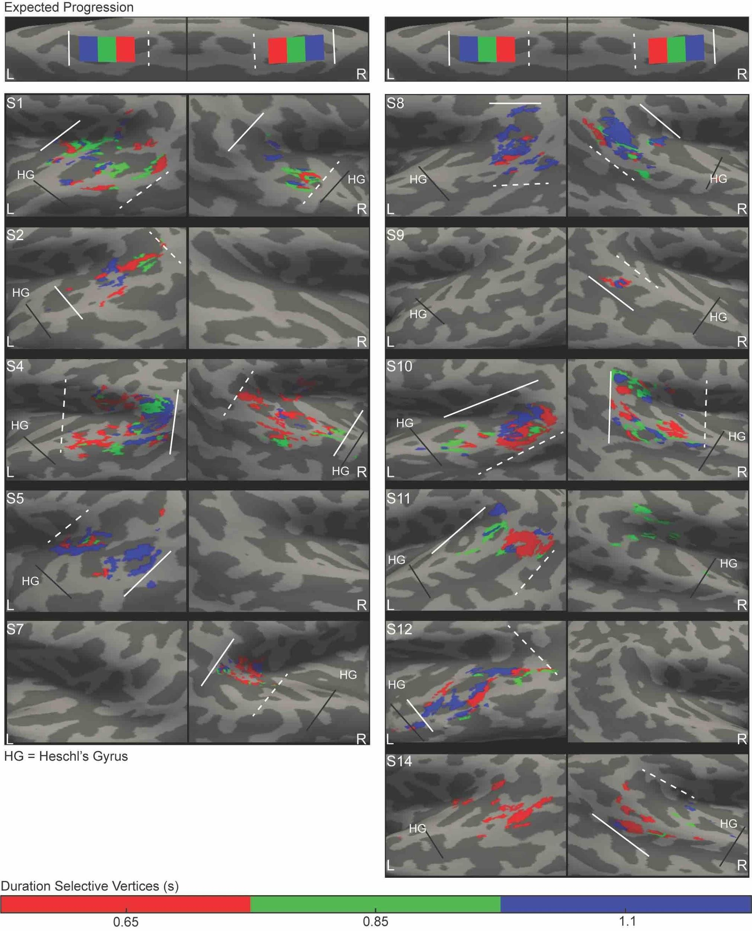

S-Fig. 12 Individual parabelt chronomaps in the long context. Medial view of left (L) and right (R) hemispheres of the 11 subjects where significant activation of the parabelt areas was found in long context. Overlaid on the individual inflated cortical surface are clusters of vertices classified with a winner-take-all procedure as maximally responsive to the three durations in the long context (0.65, 0.85, and 1.1 s). The clusters are color coded according to duration preferences, 0.65 s in red, 0.85 s in green and 1.1 s in blue. The white dashed line is the border at the shortest edge of the map (closest to the shortest duration), the solid line the border at the longest edge of the map (closest to the longest duration of the range). HG is the Heschl’s gyrus.

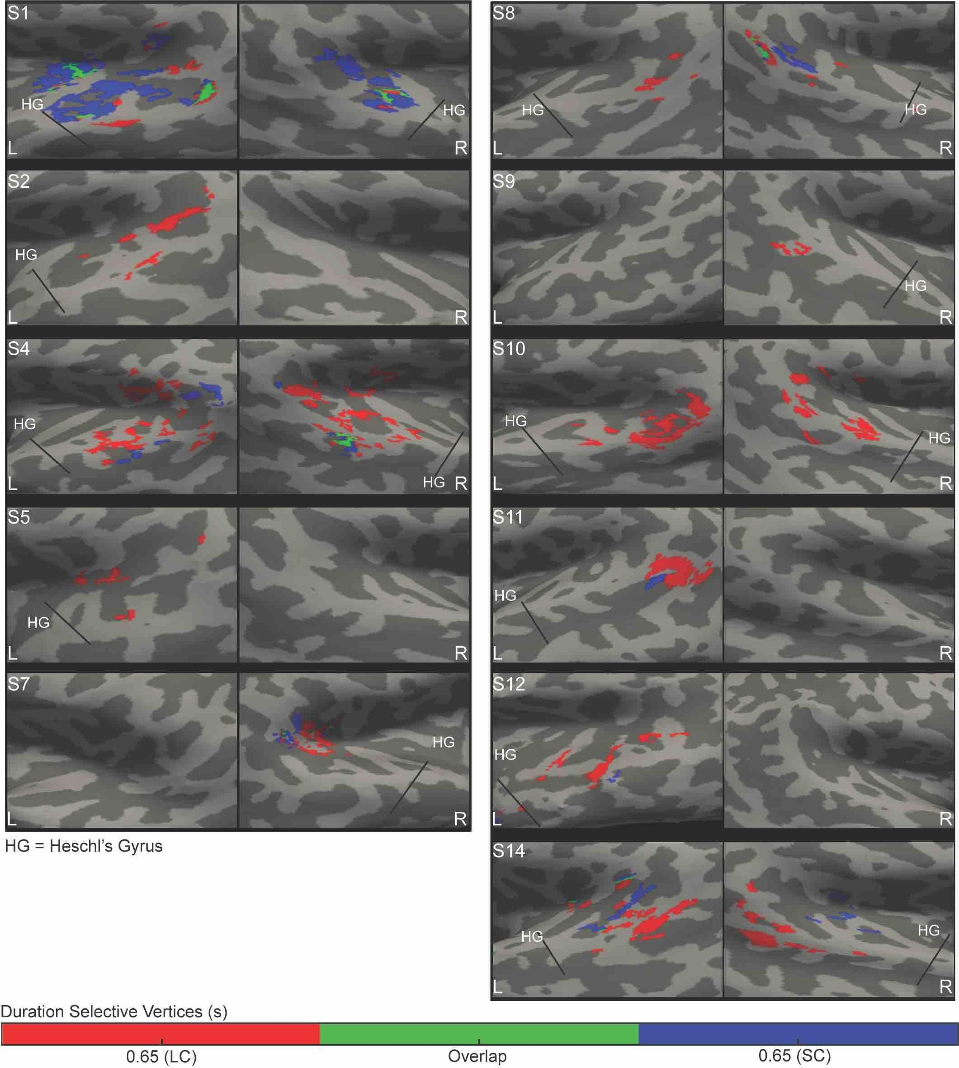

S-Fig. 13 Representation of the duration shared between contexts in parabelt. Medial view of left (L) and right (R) hemispheres of the 11 subjects that had the activation of the 0.65 s cluster in the two contexts. Overlaid on the subject's inflated cortical surface are clusters of vertices classified with a winner-take-all procedure as maximally responsive to 0.65 s when presented in short (SC, blue) and long (LC, red) contexts. In green are the clusters responsive to 0.65 s in both the contexts. HG is the Heschl’s Gyrus

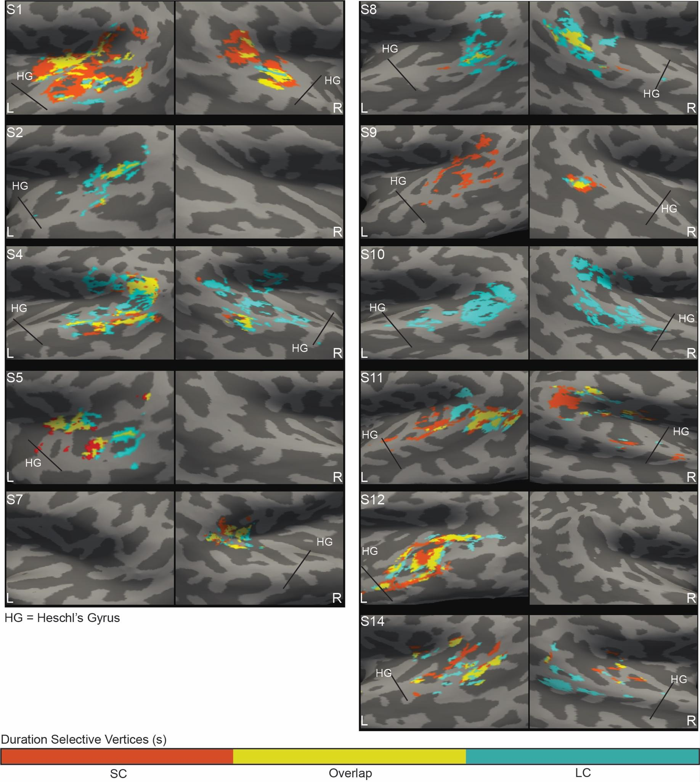

S-Fig. 14 Overlap between the maps of the two contexts in parabelt. Medial view of left (L) and right (R) hemispheres of the 11 subjects where activation in the two contexts was found. The clusters corresponding to the short context are in orange, those corresponding to the long context in pale blue and their overlap in yellow. HG is the Heschl’s gyrus

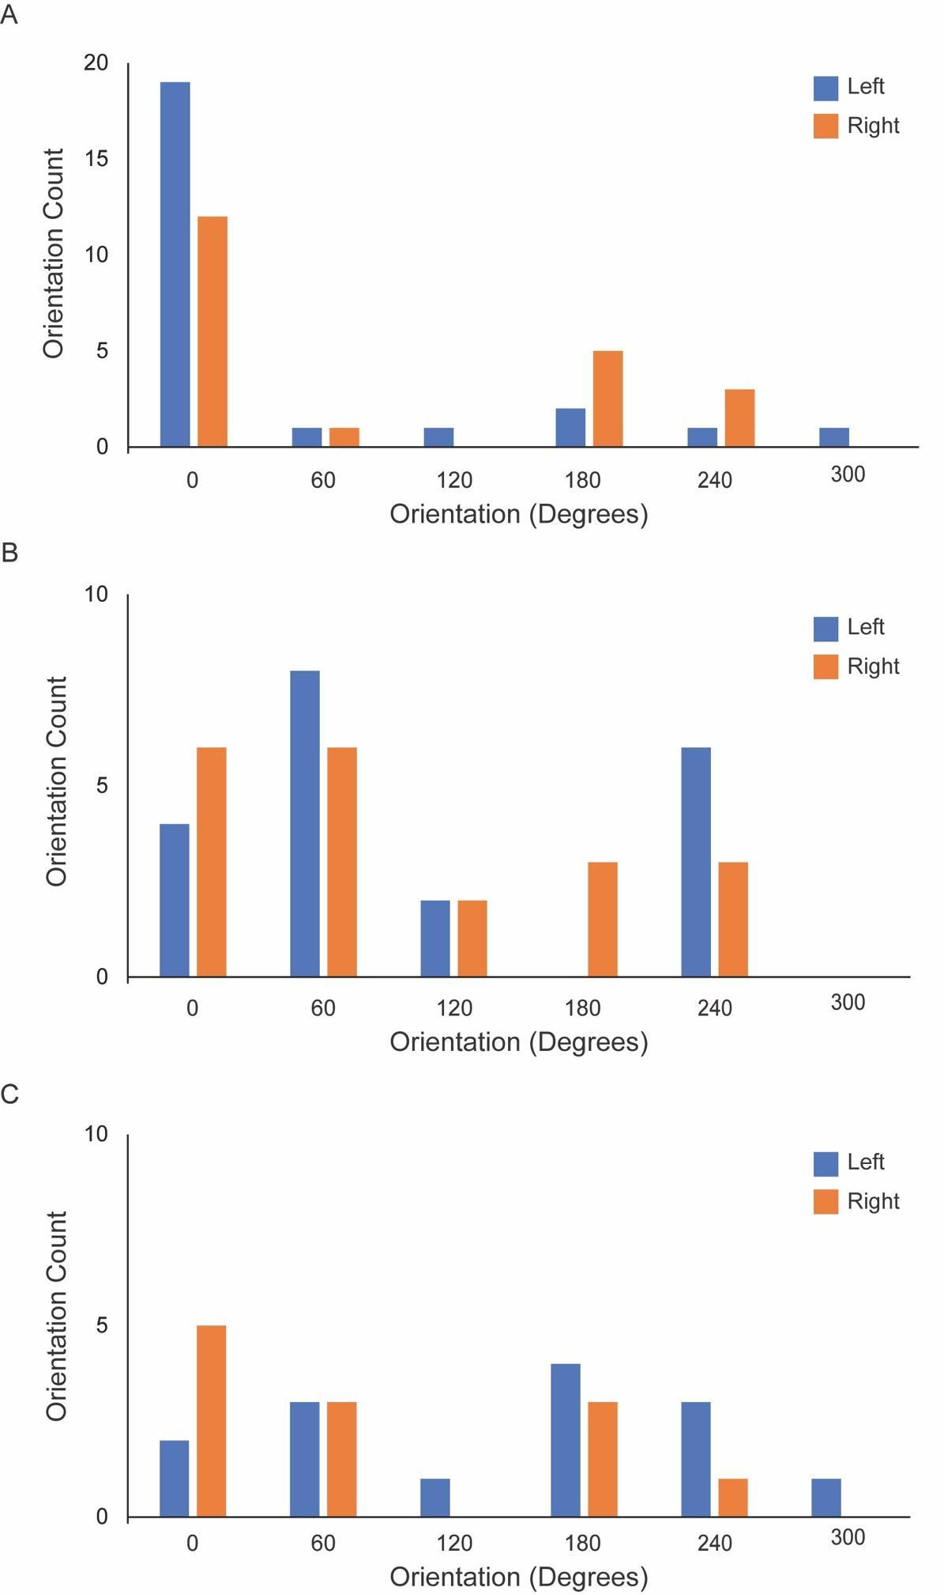

S-Fig. 15 Chronomaps’ orientations in SMA, IPS and parabelt. Histogram of the various chronomap orientations in SMA (A), IPS (B) and parabelt (C) for the short and long contexts together. The chronomap orientations of the left hemisphere are in blue and of the right hemisphere are in orange. In the y axis are the number of maps of a given orientation; on the x axis are the different orientations. In SMA (A) the orientation “0” corresponds to the anterior-posterior orientation. In IPS (B) “0” is the orientation orthogonal to the post-central gyrus. In parabelt (C) “0” is the orientation orthogonal to Heschl's gyrus.

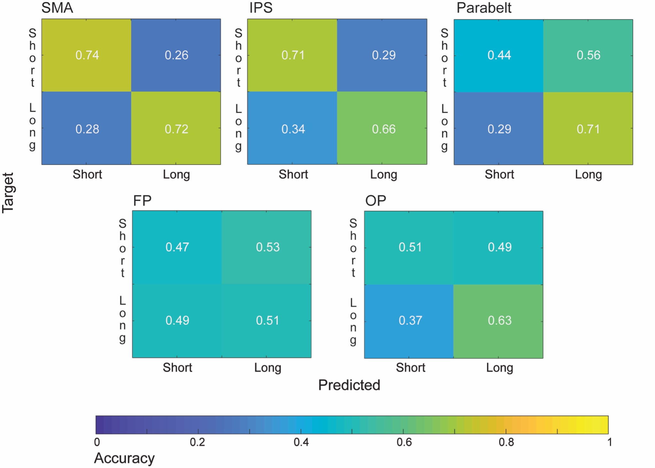

S-Fig. 16 Decoding accuracy of the MVPA analysis. The confusion matrices show the mean decoding accuracy of the two temporal contexts from SMA, IPS, parabelt, orbitofrontal cortex (FP) and occipital pole (OP) activity using an MVPA analysis with a leave one-run-out approach. For each subject and in each ROI, a support vector machine (SVM) classifier was trained to classify the pattern of activity associated with the two contexts (x-axis) from any two runs. The classifier was then tested using the activity pattern from the left out run (y-axis). The overall classification accuracy was then computed by averaging the resulting test accuracies from all iterations. A classification accuracy at chance was 0.5 (1/2).

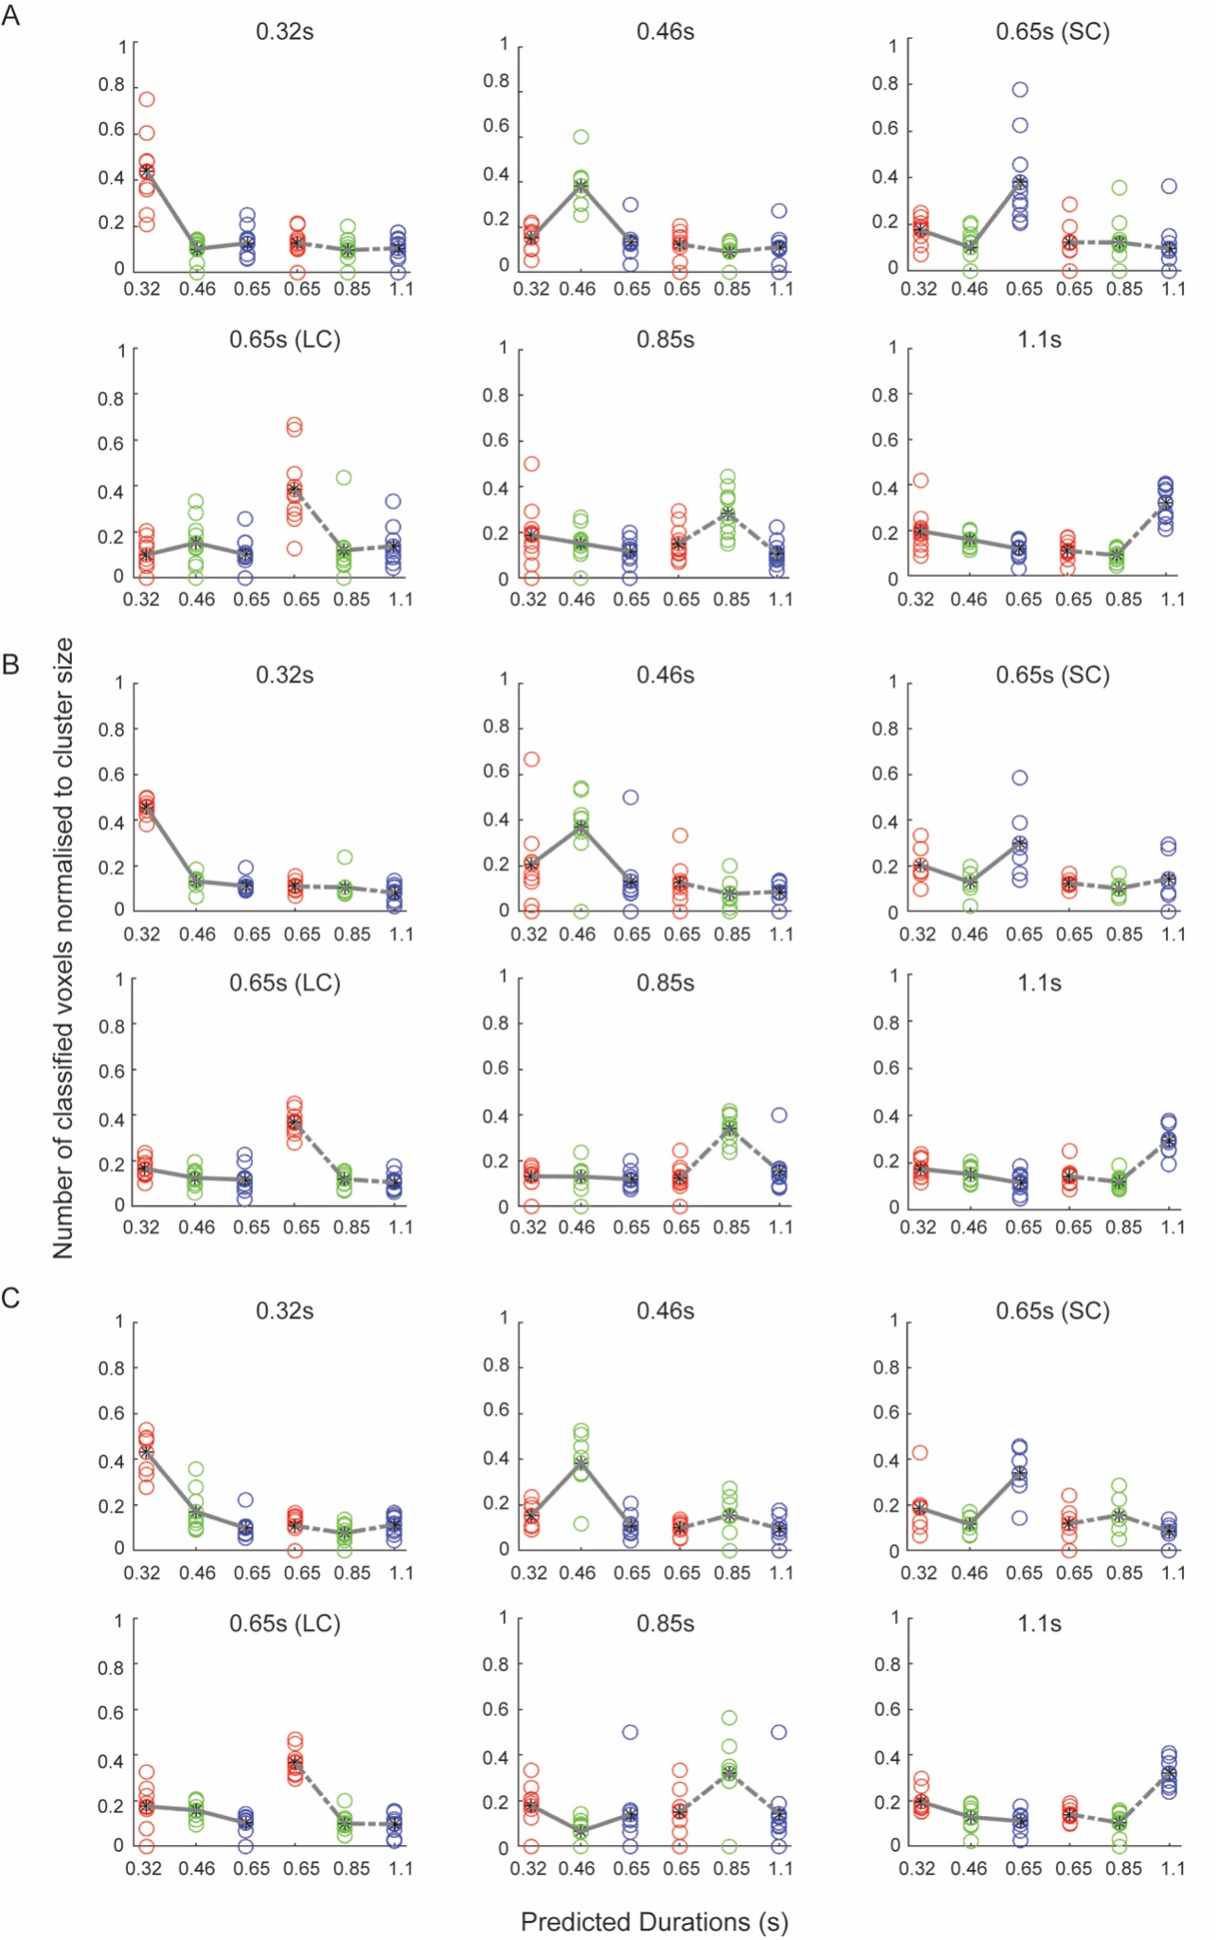

S-Fig. 17 Decoding the different durations from the activity of duration selective clusters. (A,B,C) show the results of the MVPA analysis ran on duration selective clusters of voxels in SMA(A), IPS (B) and parabelt areas (C). From the activity of each duration selective cluster of voxels (different subplot), as defined by the winner -take-all procedure based on t-maps, we tried to decode the different durations in the two contexts. For each subject and in each cluster of voxels, a support vector machine (SVM) classifier was trained to classify the pattern of activity associated with the six durations in two runs (x-axis). On the y-axis is the number of voxels classified over the total number of voxels in a cluster (i.e., cluster size). The different circles are the different subjects, the line is the average voxel count for short (continuous line) and long (dashed line) context. In each cluster, the number of accurately classified voxels is greater for the preferred duration of that cluster.
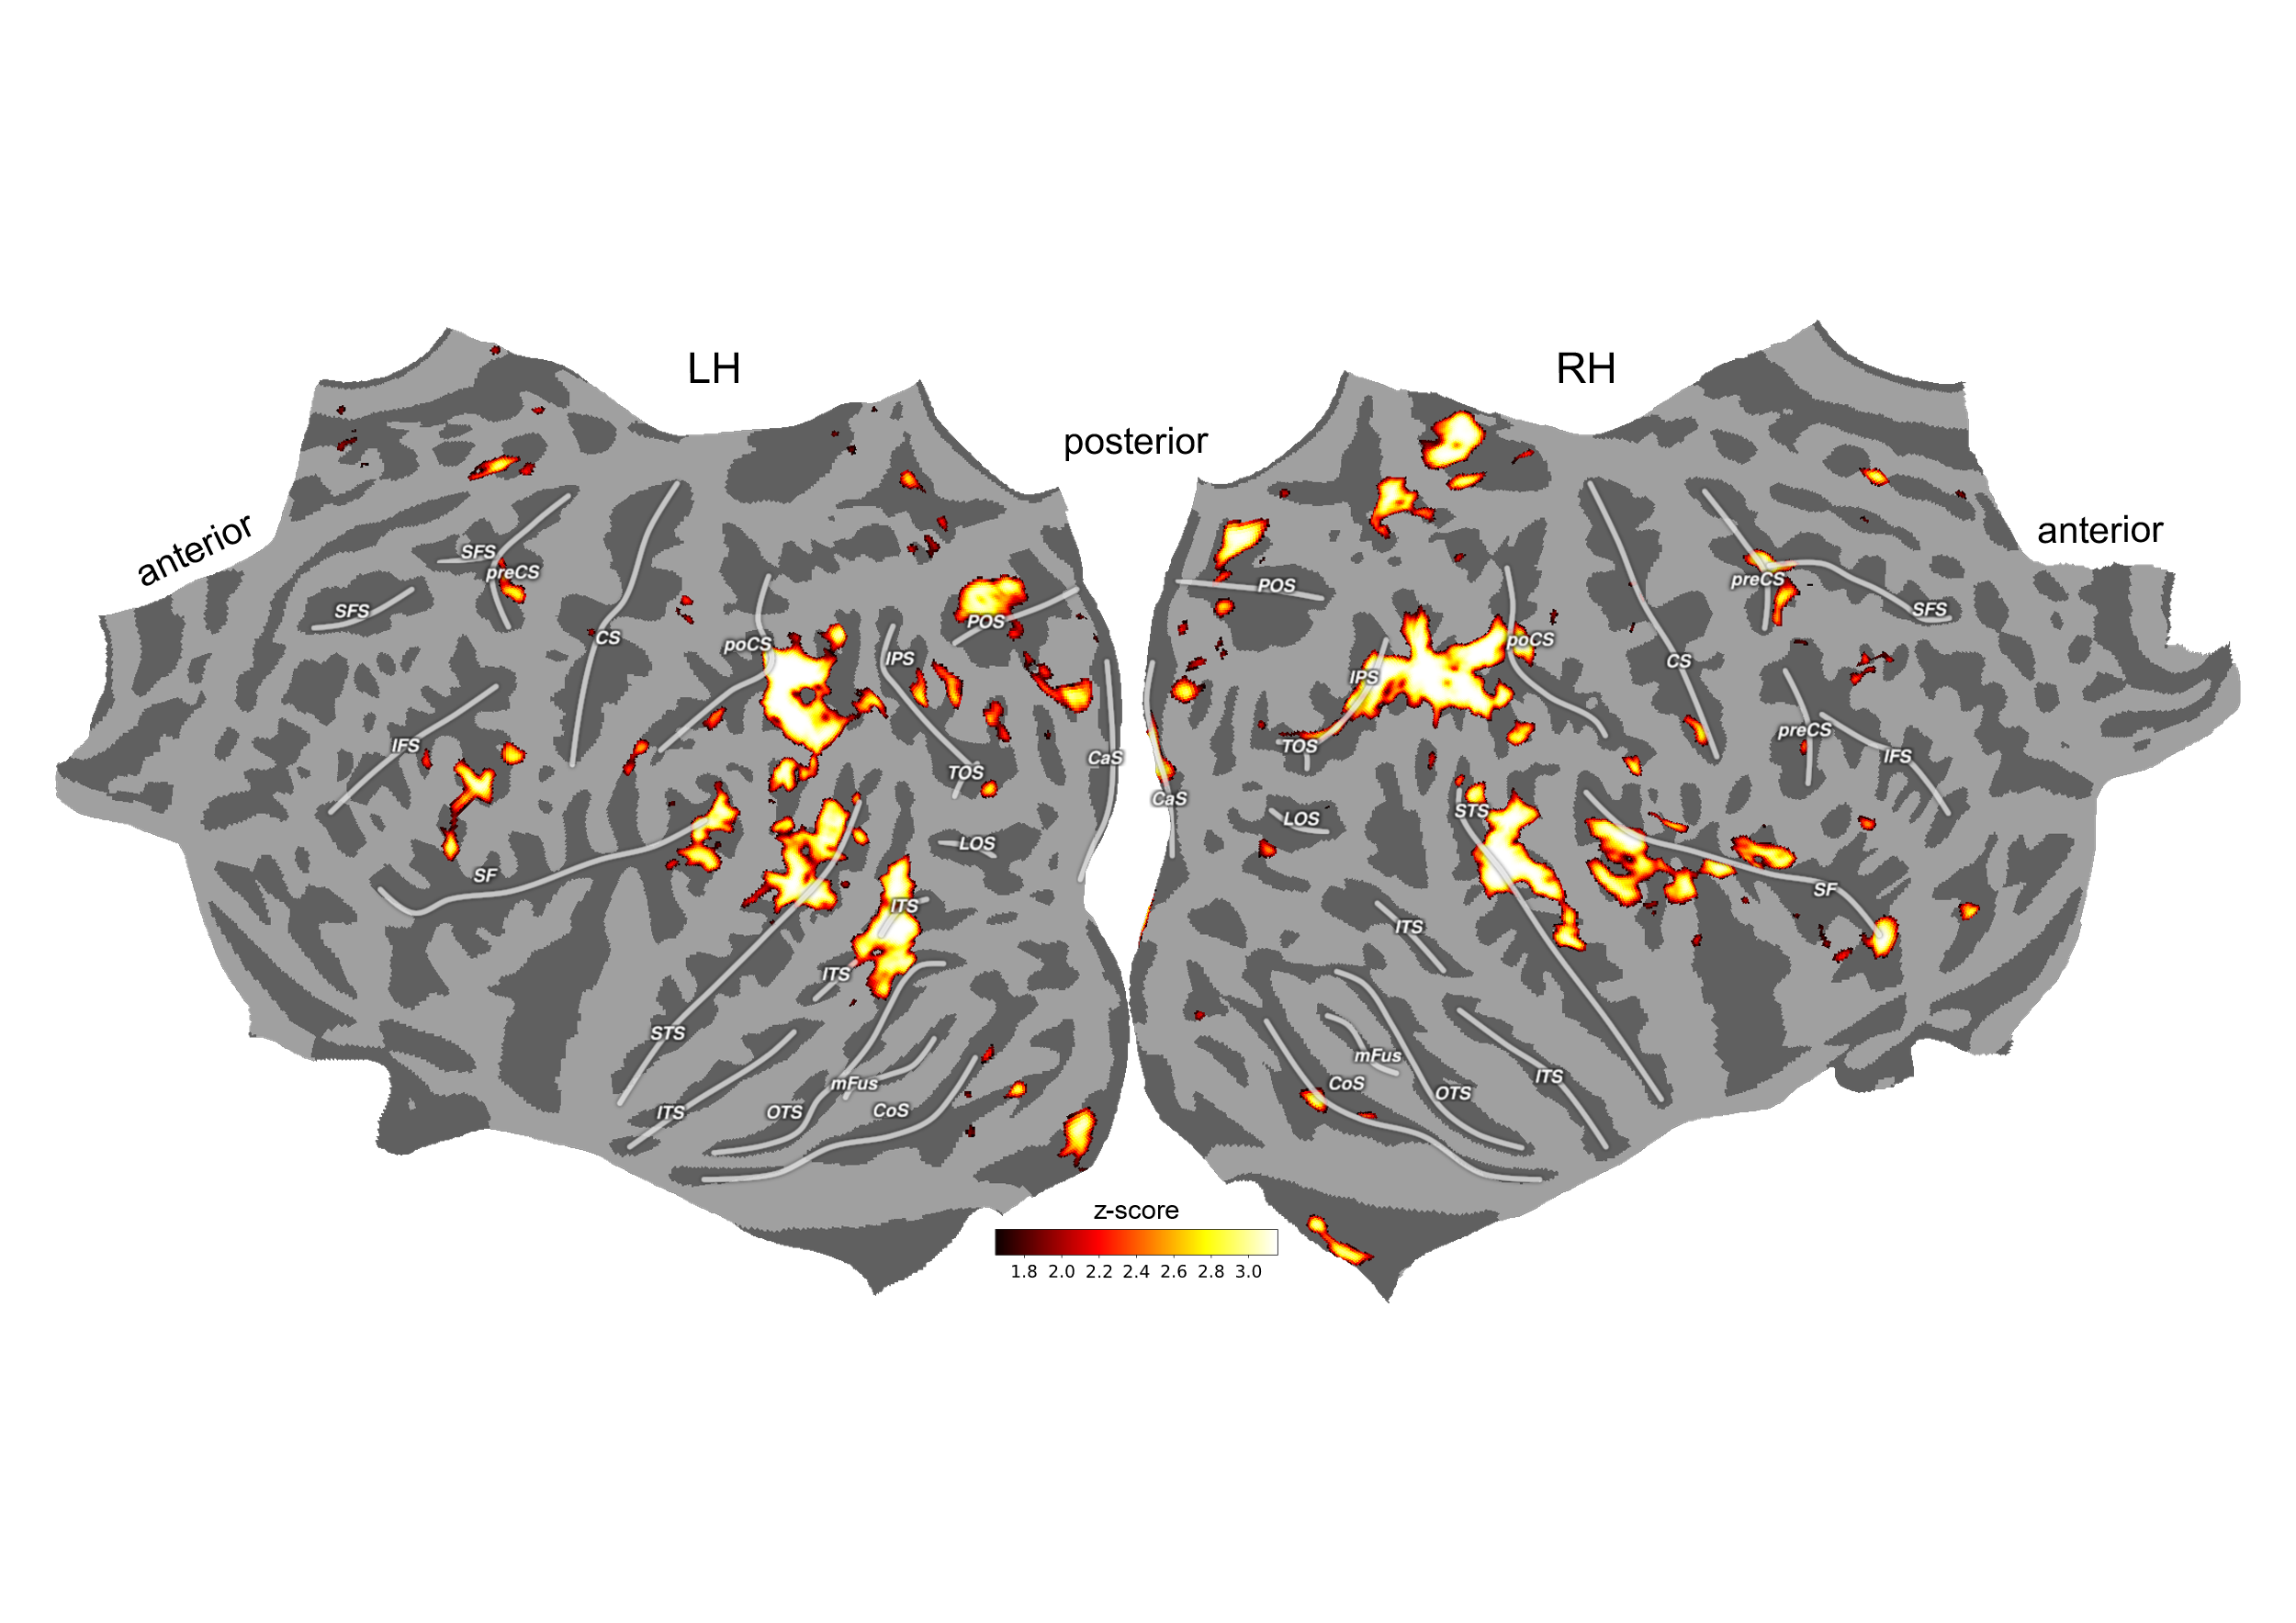

S-Fig. 18 Group-level context decoding. Z map of the whole-brain searchlight performed at group-level. Similar to S-Fig. 16 this figure show the result of the decoding accuracy of SVM classifier train to recognize the activity of the two context using the same leave one-run-out cross validation schema. This time the analysis was performed on the MNI space using searchlights (of 6 voxels of radius) throughout the brain. Z map represent the group-level and cluster-corrected (using cosmo_montecarlo_cluster_stat) results projected on the flatten representation of the fsaverage surface. Legend: CaS=calcarine sulcus, LOS=lateral-occipital sulcus, POS=pareto-occipital sulcus, TOS=transverse occipital sulcus, OTS=occipito-temporal sulcus, CoS=collateral sulcus, mFus=mid-fusiform sulcus, ITS=inferior temporal sulcus, STS=superior temporal sulcus, IPS=intra-parietal sulcus, poCS=post-central sulcus, SF=sylvian fissure, CS=central sulcus, preCS=pre-central sulcus, SFS=superior-frontal sulcus, IFS=inferior-frontal sulcus.

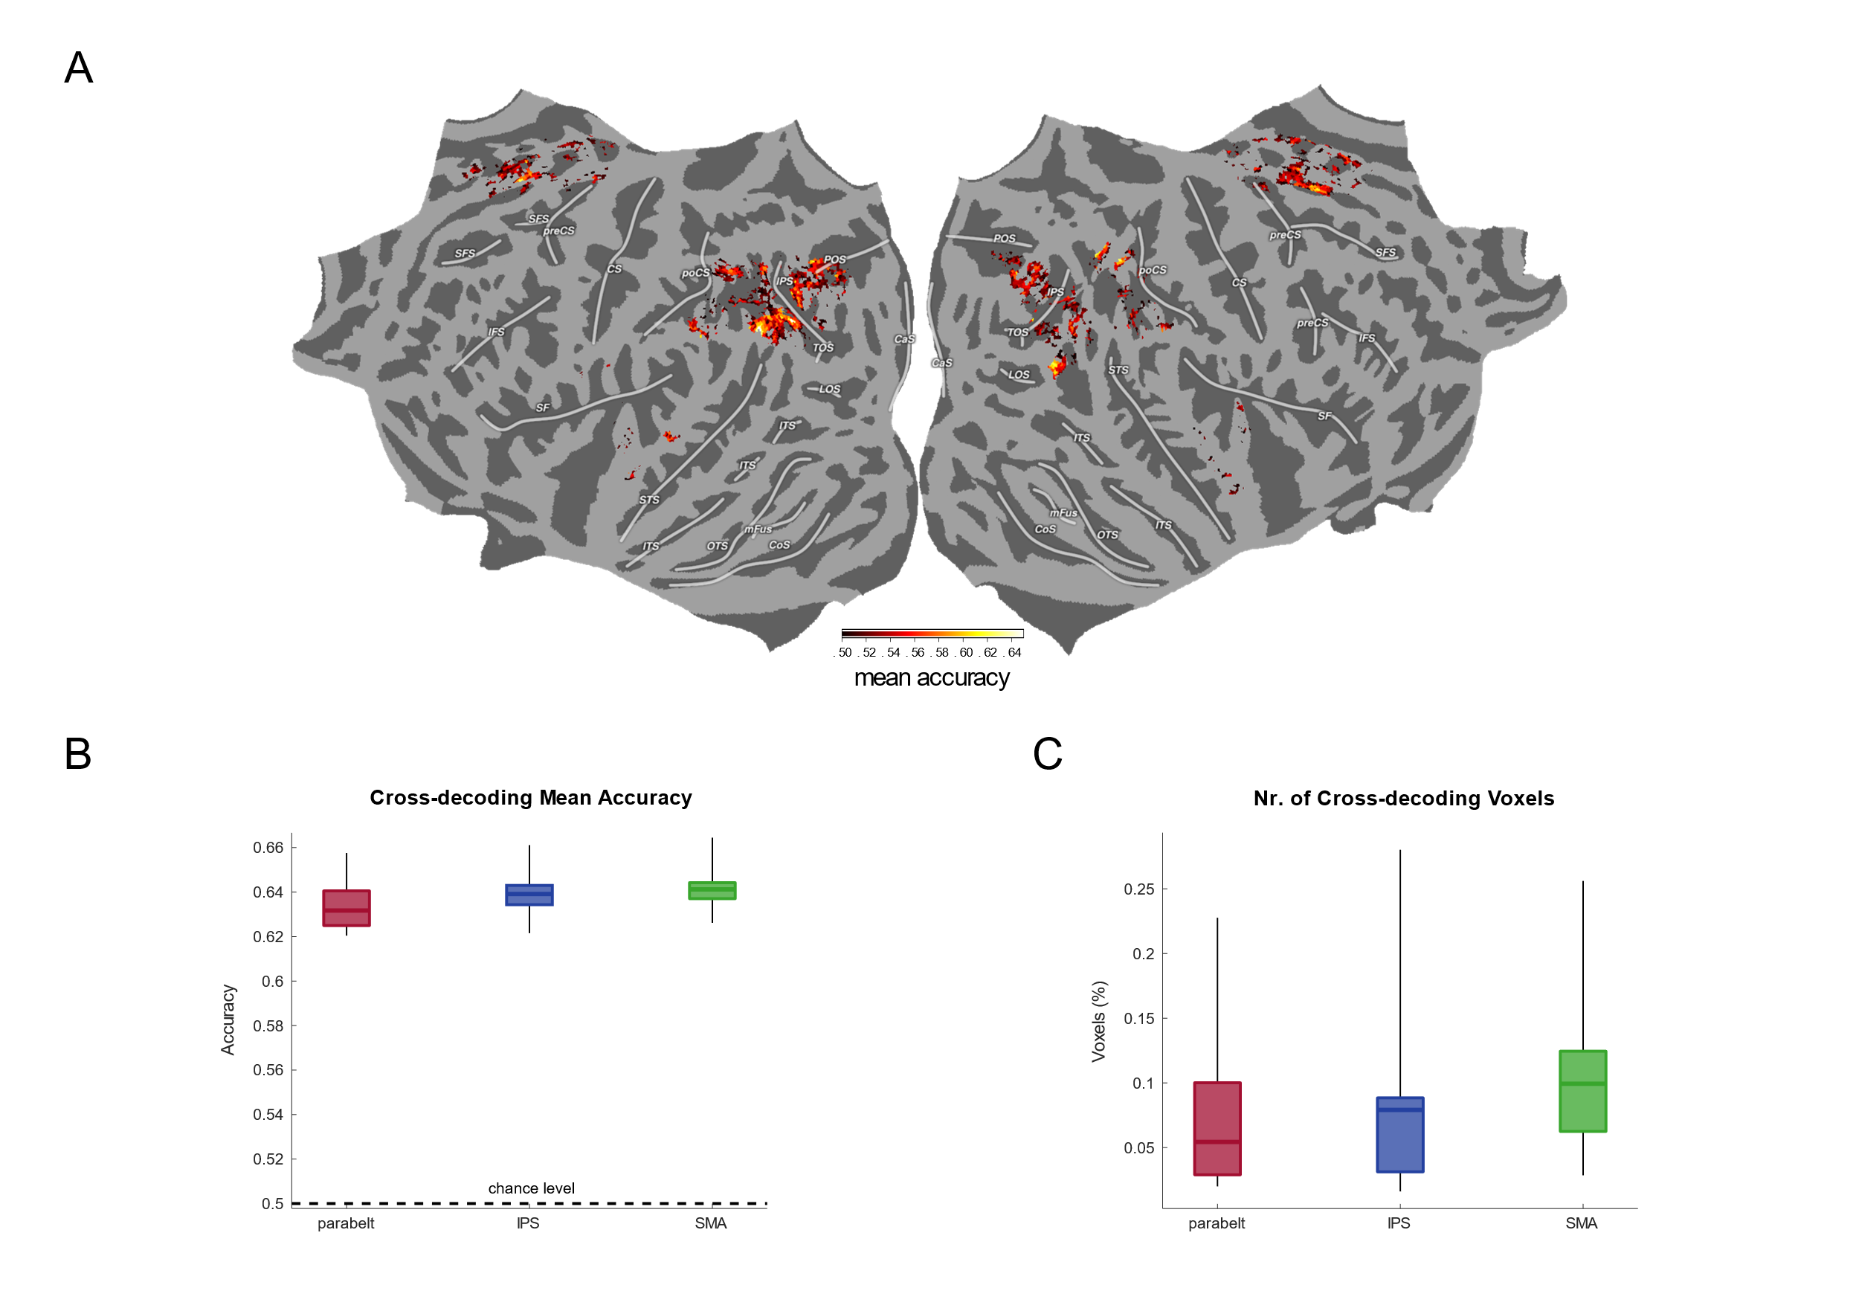

S-Fig. 19 Shared duration cross-decoding. Cross-decoding accuracy was computed by train a SVM classifier to identify the pattern of brain activity associated with the 0.65 s duration in the short context and then by testing its performance on the 0.65 s duration in the long context. Panel A show the average cross-decoding accuracy across subjects (chance level = 0.5) rendered on a flat representation of fsaverage surface.
Panel B show the distribution of significantly above chance accuracies across subjects. Panel C represent the percentage of voxels with each ROI displaying significantly above chance accuracy. The box plots, color coded according to the different ROIs (red is parabelt, blue is IPS, green is SMA), show the interquantile range and the median of the distributions, the whiskers represent its minimum and maximum values. Legend: CaS=calcarine sulcus, LOS=lateral-occipital sulcus, POS=pareto-occipital sulcus, TOS=transverse occipital sulcus, OTS=occipito-temporal sulcus, CoS=collateral sulcus, mFus=mid-fusiform sulcus, ITS=inferior temporal sulcus, STS=superior temporal sulcus, IPS=intra-parietal sulcus, poCS=post-central sulcus, SF=sylvian fissure, CS=central sulcus, preCS=pre-central sulcus, SFS=superior-frontal sulcus, IFS=inferior-frontal sulcus.

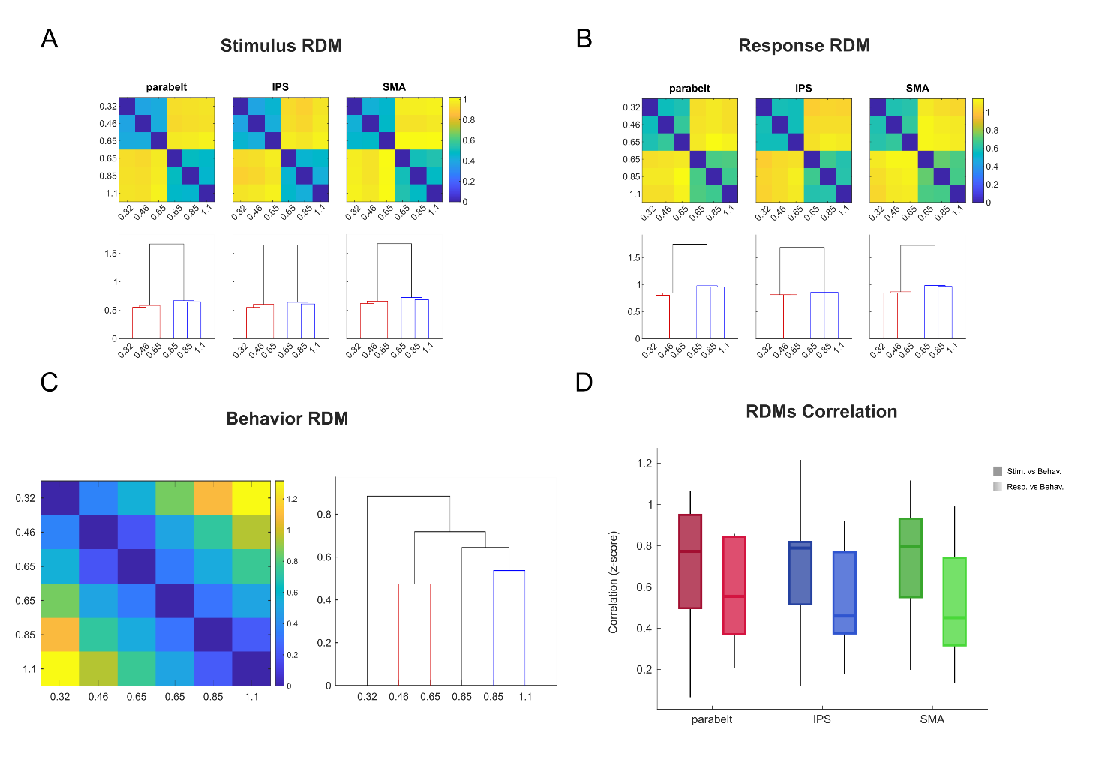
S-Fig. 20 Patterns of brain activity and their link with the behavior. A and B show the group-level representation dissimilarity matrices (RDM) computed at stimulus offset and response offset respectively, in auditory parabelt, IPS and SMA. Dissimilarities were computed using Euclidean distance. The color represent the DISTATIS metric which best summarize dissimilarities at group level. Dendrogram representation of the RDM is shown at the bottom of each matrix. C show RDM and dendrogram representation of participants behavior using the same metrics as in A and B. Panel D represent the distribution of the participants’ Fisher transformed correlation coefficients between stimulus RDMs and behavior RDMs in darker colors, and between response RDMs and behavior RDMs in lighter color, box plot represent the interquartile range of the distribution and its median, whiskers show the minimum and maximum. A significant difference in the correlation coefficients was found between stimulus RDMs and response RDMs (main effect of pattern type F(1,45)=17.01 p < 0.001, no effect of ROI F(2,45)=0.18, no interaction F(2,45)=0.30) with the former showing higher correlation coefficients with the behavior RDMs (marginal means difference: response – stimulus = -0.148 t(45) = -4.125 p < 0.001).
Anatomical Region | MNI Coordinates  (x,y,z) |  |  | Cluster Size | p_{FWE} | T
Left SMA | -4.5 | 6 | 45 | 176 | < 0.001 | 5.36
Right SMA | 6 | 7.5 | 46.5 | 177 | < 0.001 | 5.19
Right IPL | 58.5 | -39 | 21 | 225 | < 0.001 | 5.1
Right Insula | 31.5 | 15 | 12 | 21 | < 0.01 | 3.62
Left Insula | -34 | 12 | 9 | 24 | < 0.01 | 3.06

S-Table1 Stereotaxic MNI coordinates (mm) for regions exclusively active at the offset of the six durations and not during the onset of the reproduction phase. Voxels activated at p<0.05, FWE cluster-level corrected for multiple comparisons across the entire brain volume.

