This document includes Supplementary Figure S1, Supplementary Figure Legend and Supplementary Table S1

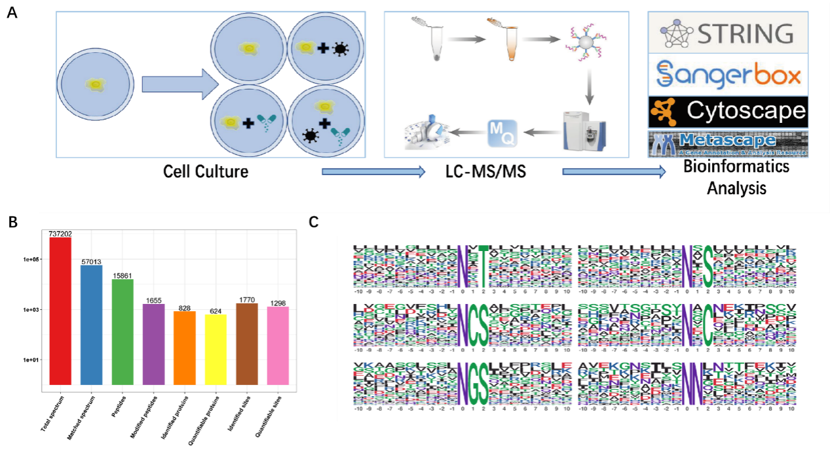
Supplementary Figure S1. Overview of the N-glycoproteomic profiling in SARS-CoV-2 cellular model and CEP drug intervention. A. Workflow of N-glycoproteomics analysis process. Vero E6 were treated with (/or without) GX_P2V at presence or absence of CEP. Proteins were extracted from cell cultures and digested using trypsin. LC-MS/MS was carried out to analyze the enriched glycopeptides and global proteins which were used for N-glycoproteion normalization. Bioinformatics analysis was performed by using the software listed. B. Basic statistics of mass spectrometry data. C. The motif analysis of protein glycosylation modifications sites reveals the characteristic sequences around glycosylation modifications sites.
Supplementary Table S1 . Key glycoproteins affected by CEP treatment against GX_P2V infestation
Protein name | Sites | Regulation type | V_P/V ratio | V_P/V ratio | Key nodes | location | Function
MRC2 | N69 | up | 3.61 | 1.444 | no | CM | Urokinase type plasminogen activator receptor-associated Protein,
MRC2* | N1134 | up | 2.616 | 0.497 | no | CM
ASPH | N64 | up | 2.156 | 1.202 | no | ER | Aspartyl beta-hydroxylase, calcium homeostasis.
TGFB2 | N241 | up | 2.284 | 1.043 | no | ECM | Protein homodimerization activity and signaling receptor binding
GBA | N309 | up | 2,443 | 0.744 | no | Lyso. | Lysosomal membrane protein related to glycolipid metabolism
GNS | N111 | down | 0.385 | 0.768 | no | Lyso. | Glycosaminoglycan degradation
GNS | N117 | down | 0.384 | 0.713 | no | Lyso. | Glycosaminoglycan degradation
FN1 | N430 | down | 0.131 | 0.731 | yes | ECM | Bind to cell surfaces and various compounds (collagen, fibrin, Heparin and protease.), involved in cell adhesion, cell motility.
ATP1B1 | N158 | down | 0.43 | 0.714 | no | CM | cAMP signaling
LAMB1 | N1343 | down | 0.492 | 0.706 | yes | ECM | Enzyme binding and integrin binding, mediate the attachment, migration of cell to tissue.
PTK7 | N567 | down | 0.068 | 0.673 | no | CM | Wnt pathway-related tyrosine kinase
LAMP1 | N83 | down | 0.468 | 1.099 | no | CM | lysosome-associated membrane Protein 1
NCSTN | N530 | down | 0.367 | 0.851 | no | CM | Essential subunit of gamma-secretase complex
MYORG | N240 | down | 0.477 | 0.683 | no | Nuc. | Myogenesis regulating glycosidase
MYORG | N250 | down | 0.477 | 0.683 | no | Nuc. | Myogenesis regulating glycosidase
PLAUR* | N183 | down | 0.297 | 2.448 | no | CM | Plasminogen activator, urokinase receptor
GRN* | N277 | up | 3.029 | 0.545 | no | Lyso. | Regulates protein trafficking to lysosomes
Note: CM, cell membrane; Lyso., Lysosome; Nuc., Nucleus; ECM, extracellular matrix; ER, endoplasmic reticulum.
* indicate the over-corrected protein glycosylation in GX_P2V treated cells in presence of CEP.

