Table S1. Quantitative characteristics of different soil types bacterial communities at various taxonomic levels.
Group | Kingdom | Phylum | Class | Order | Family | Genus | Specise | OTUs
SRS | 2 | 42 | 141 | 359 | 581 | 1116 | 1736 | 20706
SSS | 2 | 44 | 146 | 365 | 576 | 1091 | 1673 | 20799
ARS | 2 | 46 | 143 | 367 | 575 | 1102 | 1680 | 19895
ASS | 2 | 45 | 148 | 374 | 579 | 1098 | 1673 | 21808
CK | 2 | 46 | 147 | 373 | 578 | 1092 | 1653 | 19295
Total | 2 | 54 | 164 | 412 | 654 | 1272 | 2002 | 31172

Figure S1. Growth curves of ST1-4 strain under different conditions.(a)ST-1; (b)ST-2; (c)ST-3; (d)ST-4.

Figure S2 Plate morphology of strain ST1-4 and phylogenetic analysis based on 16S rDNA

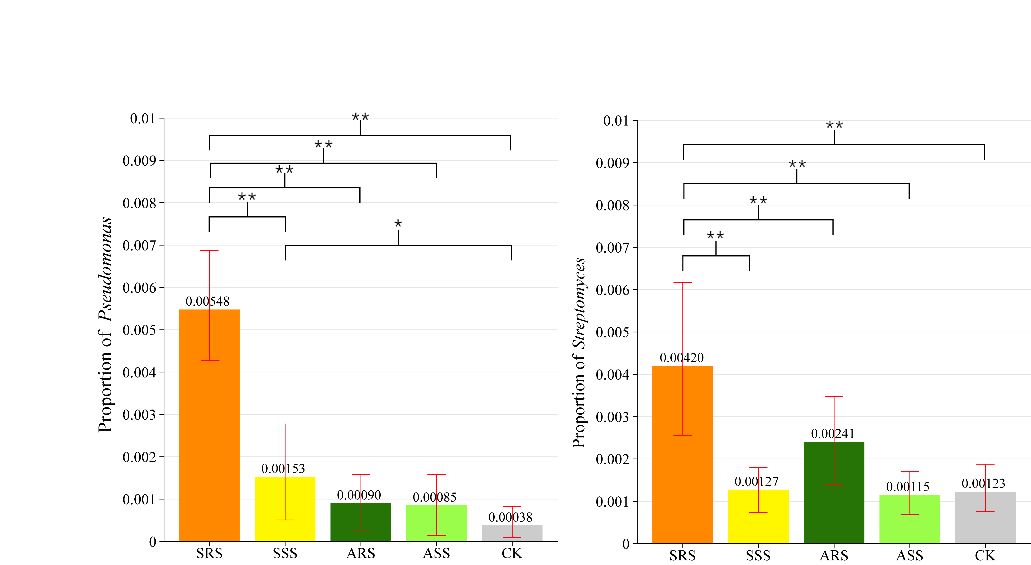
Figure S3. The proportion of Pseudomonas and Streptomyces in different soil samples.
Figure S4. Realistic photos of different soil types. (a) S. trilobata; (b) A. compressus; (c) adjacent bulk soil.

