Breathe Well, Be well: Development and Validation of the Perceived Breath Mastery Scale (PBM-S)
Journal of Happiness Studies: Supplementary Information

Expert panel members

Tania Clifton-Smith has 30 years of experience in the field of breathing assessment and treatment, both as a physiotherapist and educator. She is the co-founder of the Bradcliff breathing method and Breathing Works clinics, which have treated over 30,000 individuals. She has published four books as well as peer-reviewed research and textbook chapters on breathing pattern disorders. In 2021, Tania received the New Zealand Physiotherapy Honorary Fellow award for her contribution to breathing.

Nick Heath, Ph.D is a breath educator based in Miami, USA. In 2019, Nick founded The Breathing Diabetic, a public education newsletter and training course that synthesises the latest breathing research into simple and actionable insights and strategies to improve health and well-being. As someone living with Type 1 diabetes, Nick discovered that breathing was a tool he could utilise to help regulate his blood sugars and the stresses that come with being a diabetic. His mission is to share science-based information on breathing principles that can help people to thrive despite these health challenges. Nick frequently collaborates on breathing research and education with global breathwork companies, such as The Oxygen Advantage and Breathwrk.

Prof Joseph Ciarrochi is a professor of psychology at Australian Catholic University. Joseph is one of the top 1% of scientists in the world and has published hundreds of peer-reviewed articles on acceptance and commitment therapy (ACT), mindfulness, emotional intelligence, well-being, psychological flexibility, self-esteem, and related topics to do with human flourishing. Joseph is the author or co-author of over 10 books.

Dr. Baljinder Sahdra is a senior lecturer at the Institute for Positive Psychology and Education at Australian Catholic University. Her research spans fields ranging from psychological assessment, mindfulness, nonattachment, and personality psychology. Dr. Sahdra is perhaps best known for her work in conceptualising and creating an assessment of the Buddhist concept of nonattachment. This depth of understanding of contemplative traditions, practices, and mechanisms by which they work is highly relevant to our attempt to do the same for optimal breathing. Dr. Sahdra also brings deep expertise in advanced statistics and computational methods for psychometrics, such as machine learning.

Eloise Wellings is a 2 x Olympian and 5 x Commonwealth Games representative for Australia, competing in the 5000m, 10,000m and Marathon events. This level of endurance performance challenges breathing. Eloise has publicly credited her breathing training in helping her to perform to her potential and regulate her state prior to competition.

Dr George Dallam is a professor in the School of Health Science and Human Movement at Colorado State University – Pueblo. Dr. Dallam’s primary research interest is in the capacity of human beings to adapt to nasal only breathing during exercising as a means of improving health and performance. Dr. Dallam has published extensively on topics relating to breathing health and performance and teaches classes on physiology, biomechanics, psychology and exercise assessment. Dr. Dallam is a competitive triathlete and served as the inaugural USA national team coach, advisor, and consultant. Through his coaching, Dr. Dallam has guided national, Olympic and world champion level athletes.

Dr. Matt Dewar is an educator, author and breathing practitioner who teaches research-based mindfulness and breathwork practices. Dr. Dewar designs school mindfulness programs and is completing a master’s degree in breathing retraining. Dr. Dewar provides a unique interdisciplinary perspective with his background in mindfulness, training in breathing physiological and behavioural assessment and Ph.D. in the phenomenology of well-being. Dr. Dewar authored ‘The Mindful Workbook for teens’, which teaches breathing skills from mindfulness-based stress reduction to help teens stay grounded, find calm and shift their mood, ultimately leaving them feeling more empowered and in control of their stress.

Patrick McKeown is one of the most renowned experts on breathing. He is the founder, CEO and Director of Education and Training at Oxygen Advantage, Director of Education and Training at Buteyko Clinic International and President of Buteyko Professionals International. Patrick has authored several bestselling books on the science and practice of breathing, including ‘The Oxygen Advantage’, ‘The Breathing Cure’, and ‘Close Your Mouth’. Patrick has taught tens of thousands of students and accredited hundreds of breathing coaches through his ‘Oxygen Advantage’ program. Patrick is a Fellow of The Royal Society of Biology (UK) and a Fellow of the International Academy of Breathing and Health.

Table S1
Items Included the Perceived Breath Mastery Scale (PBM-S) After Expert Panel Review
Dimension | Item
Perceived efficacy in using breathing | 1. When I feel high stress or strong emotions, I can use my breathing to slow myself down and not overreact
 | 2. I can use my breathing to stay composed when working out near my physical limit
 | 3. I can quickly return to easy breathing after hard physical activity
 | 4. I can use my breathing to stay composed when I need to perform under pressure
 | 5. I can use breathing to quickly wind down and fall asleep even when my mind is busy
 | 6. I can use breathing to re-focus on a task when there are distractions
 | 7. I can use my breathing to give me energy when I am tired or lethargic
 | 8. I can use my breathing to help me manage or cope with pain
 | 9. I can use my breathing to reduce physical tension when that’s helpful
 | 10. I can effectively control my breathing when that's helpful
 | 11. I can count on my ability to breathe well in any situation
 | 12. I can use my breathing to connect with my best/wisest self
 | 13. I can use my breathing to be fully in the moment, regardless of what is happening
 | 14. I can use my breathing to ground myself in the present moment
Perceived efficiency | 15. My breathing is always efficient
 | 16. At any given moment in the day, my breathing will feel rhythmic
 | 17. My breathing is generally quiet (almost silent)
 | 18. My breathing is usually effortless
 | 19. At rest, my abdomen moves in and out as I breathe
 | 20. At rest, my chest remains still as I breathe
 | 21. At rest, I can comfortably breathe through my nose
 | 22. I primarily breathe through my nose in everyday life
 | 23. I primarily breathe through my nose during physical activity/exercise
 | 24. I primarily breathe through my nose during sleep
 | 25. I believe that breathing is a powerful tool
 | 26. Effective breathing benefits my life
 | 27. I notice a brief pause after my exhale
 | 28. My breathing never feels rushed
 | 29. My ribcage feels free and can expand easily when I breathe
 | 30. I trust my body’s natural ability to breathe well
 | 31. I believe that my breathing is optimal
Positive breath awareness | 32. I am very in tune with my breathing
 | 33. I easily notice the small changes in my breathing, such as when it speeds up or slows down
 | 34. Noticing my breath helps me to tune into my feelings
 | 35. My breath is a safe and reliable place to come back to in any situation
 | 36. My breathing helps me to connect more deeply with life
 | 37. I bring awareness to my breath many times throughout the day
 | 38. I can be aware of my breathing without controlling it
 | 39. I am good at letting my breathing happen naturally
 | 40. Being aware of my breath benefits my life
Note. Items 1-14 were scored 1-100 and preceded by the prompt “Please rate your degree of confidence for each of the following statements using the scale below. There are no right or wrong answers”. Items 15-40 were scored 1-100 and preceded by the prompt “Please mark on the line how much you agree with each statement. Remember, there are no right or wrong answers”.

Table S2
Inter-factor correlations for the Perceived Breath Mastery Scale (PBM-S)
 | F1 | F2 | F3
F1 Breath efficacy | 1
F2 Breath efficiency | .41 | 1
F3 Breath awareness | .73 | .41 | 1
Note. N = 1000.

Table S3
Goodness of fit for models in the testing sample
Model | N Parms | CHI | df | RMSEA | CFI | TLI | Description
CFA:  PBM-S | 49 | 0.00 | 227 | 0.05 | 0.945 | 0.938 | CFA using long-form measure. Test sample (N = 298)
ESEM: PBM-S | 112 | 300.681* | 187 | 0.045 | 0.965 | 0.953 | ESEM Test sample (N = 298)
Note. N = 298. Results of confirmatory factor analysis (CFA) and exploratory structural equation modelling (ESEM) on the PBM-S. N Parms = number of parameters. df = degrees of freedom.

Table S4
Perceived Breath Mastery Scale (PBM-S)

Please rate your degree of confidence for each of the following statements using the scale below. There are no right or wrong answers.

Moderately confident
Extremely confident
Not at all
confident

0 10 20 30 40 50 60 70 80 90 100
- When I feel high stress or strong emotions, I can use my breathing to slow myself down and not overreact
- I can use my breathing to stay composed when working out near my physical limit
- I can quickly return to easy breathing after hard physical activity
- I can use my breathing to stay composed when I need to perform under pressure
- I can use breathing to quickly wind down and fall asleep even when my mind is busy
- I can use breathing to re-focus on a task when there are distractions
- I can use my breathing to give me energy when I am tired or lethargic
- I can use my breathing to help me manage or cope with pain
- I can use my breathing to reduce physical tension when that’s helpful
- I can effectively control my breathing when that’s helpful
- I can count on my ability to breathe well in any situation
- I can use my breathing to connect with my best/wisest self
- I can use my breathing to be fully in the moment, regardless of what is happening
- I can use my breathing to ground myself in the present moment

Please mark on the line how much you agree with each statement. Remember, there are no right or wrong answers.
Strongly Disagree
Strongly Agree

0 10 20 30 40 50 60 70 80 90 100
- My breathing is generally quiet (almost silent)
- My breathing is usually effortless
- At rest, I can comfortably breathe through my nose
- I primarily breathe through my nose in everyday life
- My ribcage feels free and can expand easily when I breathe
- I trust my body’s natural ability to breathe well
- Noticing my breath helps me to tune into my feelings
- My breathing helps me to connect more deeply with life
- Being aware of my breath benefits my life

Q1-14: Factor 1: Perceived efficacy in using breathing
Q15-20: Factor 2: Perceived efficiency of breathing
Q21-23: Factor 3: Positive breath awareness

Table S5
Perceived Breath Mastery Scale (Short form)
Please rate your degree of confidence for each of the following statements using the scale below. There are no right or wrong answers.
Not at all
confident
Extremely confident
Moderately confident

0 10 20 30 40 50 60 70 80 90 100
- I can use my breathing to give me energy when I am tired or lethargic
- I can effectively control my breathing when that’s helpful
- I can use my breathing to be fully in the moment, regardless of what is happening

Please mark on the line how much you agree with each statement. Remember, there are no right or wrong answers.
Strongly Disagree
Strongly Agree

0 10 20 30 40 50 60 70 80 90 100
- My breathing is usually effortless
- At rest, I can comfortably breathe through my nose
- I trust my body’s natural ability to breathe well
- Noticing my breath helps me to tune into my feelings
- My breathing helps me to connect more deeply with life
- Being aware of my breath benefits my life

Q1-3: Factor 1 Perceived efficacy in using breathing
Q4-6: Factor 2 Perceived efficiency of breathing
Q7-9: Factor 3 Positive breath awareness

Table S6
Suggested Short-form items from ‘The Self Evaluation of Breathing Questionnaire’ (SEBQ)

Please rate how true each statement is for you using the scale below.
 | Never/not true at all | Occasionally/a bit true | Frequently/  mostly true | Very frequently/ very true
- I notice that I am breathing irregularly | 0 | 1 | 2 | 3
- I can’t catch my breath | 0 | 1 | 2 | 3
- My breath feels like it does not go in all the way | 0 | 1 | 2 | 3
Note. These are the three highest-ranking dysfunctional breathing items from the Self Evaluation of Breathing Questionnaire (SEQB; Courtney & Greenwood, 2009) and are negatively scored. These items were added to the 9-item PBM-S to create a 12-item scale with dysfunctional breathing as a fourth factor.

Genetic algorithm procedure for developing short-form scales
Traditionally, short-form scale development has involved manually balancing various recommended criteria for which items to retain and which to exclude. For example, retaining the highest loading items is recommended but so too is reducing redundancies by removing highly correlated items. If one item loads higher than another but is also more highly correlated with other items, it is left to the discretion of the researcher to decide which to retain and which to remove. Then there are other considerations too, such as cross-loadings, correlated uniqueness, and coefficient alpha. More recently, genetic algorithms (GAs) have emerged as an alternative and equally effective approach to scale abbreviation (Yarkoni, 2010). GAs bring the advantage of being completely automated, making the process of determining the optimal abbreviated scale significantly faster and less subjective.
GAs use principles of Darwinian evolution to find the ‘fittest’ short-form solution that explains the maximal variance in the long-form data. These principles include selection, mutation, and crossover. Selection refers to whether a particular item is selected in a particular iteration that the GA is testing; Mutation refers to the possibility of an item switching from selected to unselected (or vice versa) in a particular generation; whilst crossover involves switching items such that an item that is selected in one generation is unselected in the next, and vice versa. In essence, this results in the GA testing all possible combinations of items to determine the optimal combination of items. To do this in the most efficient and rigorous manner, we used a freely available R package, ‘GAabbreviate’ (Sahdra et al., 2016), which implements a validated genetic algorithm method for scale reduction (Sandy et al., 2014; Yarkoni, 2010). In line with best practice in using GAs (Sahdra et al., 2016), we ran GA procedure on our training sample (N = 702). The stochastic nature of GAs means that they do not necessarily produce the same results each time. We therefore ran the GA 30 times, tallying the items that were selected at the end of each run (Table 8 and 9). Items that were most frequently selected in the 30 runs were included in the final scale. To avoid overfitting, we systematically adjusted either the item cost or population size in the following way for each run:
- item cost = beginning at 0.01 and increasing by 0.05 every run until it reaches 0.055 (10 runs)
- population size = 50 for first 10 runs, then 150 for next 10 runs, then 300 for last 10 runs
We held the other GA parameters constant and in line with recommendations.
- maximum number of iterations per generation = 300
- maximum number of items per subscale = 3

Figure 1
Example Run of the Genetic Algorithm Procedure for Shortening the PBM-S to Three Items per Subscale
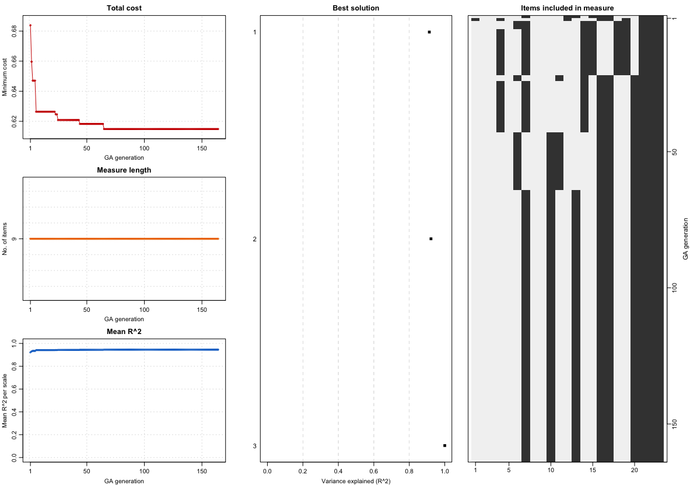
Note. The left panel shows the reduction in the cost, number of items retained and mean explained variance of the selected measure across the 300 generations. The middle panel shows the variance explained by the best solution for each of the three subscales. The right panel shows the selected (black squares) and excluded (white squares) items from the first (top) to last (bottom) run.

Table S7
Goodness of Fit for Models in the Testing Sample
Model | N Parms | CHI | df | RMSEA | CFI | TLI | Description
CFA1-LF Breath Mastery | 49 | 0.00 | 227 | 0.05 | 0.95 | 0.94 | CFA Test using short form measure. Sample (N = 298)
CFA2-SF Breath Mastery | 21 | 0.00 | 36 | 0.06 | 0.97 | 0.96 | CFA Test using short form measure. Sample (N = 298)
CFA3-SF  Breath Mastery/  Dysfunctional | 30 | 0.00 | 48 | 0.05 | 0.97 | 0.96 | CFA Test using the combined breath mastery and dysfunctional breathing scale
Note. Results from CFA of Perceived Breath Mastery Long Form (LF) and Short Form (SF) scales and the combined Short Form Breath Mastery/Dysfunctional Breathing Scale. N Parms = Number of parameters. CHI = Chi-Square value. df = Degrees of freedom. RMSEA = Root Mean Square Error of Approximation. CFI = Comparative Fit Index. TLI = Tucker-Lewis Index.

