Supplement information

Photosensitive gel vaccines with enzyme-like properties for modulating tissue microenvironment with STING activation for tumor synergistic therapy

Ji Pang,¹ Jing Yang,¹ Xinyu Cao,¹ Yiming Geng,¹ Zhihui Yan²

- Department of Clinical Laboratory, The Affiliated People’s Hospital of Jiangsu University, Zhenjiang 212002, Jiangsu, China.
- The Affiliated Huai’an Hospital of Xuzhou Medical University and The Second People’s Hospital of Huai’an, No. 62, Huaihai Road (S.), Huai’an 223002, China.

Experimental section
Materials
Oleic acid (technical grade, 90%), 1, 3-diphenylisobenzofuran (DPBF), doxorubicin (DOX), 2, 7’-dichlorofluorescein diacetate (DCFH-DA), reduced glutathione (GSH), [Ru(dpp)₃]Cl₂ (RDPP), 4’,6-diamidino-2-phenylindole (DAPI) and cell counting kit-8 (CCK-8) were purchased from Shanghai Aladdin (Shanghai, China). Potassium permanganate (KMnO₄) and hydrogen peroxide (H₂O₂, 30%) were purchased from Beijing Chemical Reagent Company. Dulbecco’s modified Eagle’s medium (DMEM), trypsin, penicillin-streptomycin and fetal bovine serum (FBS) were acquired from Sigma-Aldrich Chemicals (Madison, USA). CD11c, CD80, CD86, CD3, CD8a, CD44, CD62L, STING and TKB1 were procured from Hyclone (Logan, UT, USA). Nattokinase was obtained from Yangtze River Delta Health Research Institute (Zhengjiang China). Deionized water was used in the experiments. All chemicals were used without further purification.

Apparatus and procedures
X-ray photoelectron spectroscopy (XPS) of all samples was performed by XPS spectrometer (Thermo Kalpha). The morphological characteristics were monitored by scanning electron microscopy (SEM) images (Germany). Fourier transform infrared (FTIR) spectra were preformed through a NicoletNexus 470 spectrometer (USA). Fluorescence emission measurements were acquired from a NicoletNexus 470 spectrometer (USA). Rheological measurement was executed by rheometer (Anton Paar, MCR 302) perform the with a parallel plate geometry. UV-vis absorption spectra were obtained from a Cary100 UV-vis spectrophotometer (USA). Irradiation laser (808 nm) was performed by a fiber-coupled NIR laser (MDL-N-808 nm-10W, Beijing Laserwave OptoElectronics Technology Co., Ltd., Beijing, China). The infrared thermal camera (HT-19, Guangzhou, China) was utilized to take the infrared thermal photos and record the temperature changes. A dissolved oxygen meter (JPBJ-608, INESA, China) was used to detected the extracellular oxygen content.

Synthesis of KMO
KMO system was produced through a typical reduction process with little modified.¹⁻² KMnO₄ (50 mg) was dissolved in ultrapure water (50 mL) and the solution was stirred at 28℃ for 1 h. Then, oleic acid (0.5 mL) was added to form a steady emulsion, which was subsequently stirred at 500 rpm for 8 h until the formation of a dark KMO system.

Cell culture
Anthropogenic gastric mucosa epithelial cells (GES-1 cells), and murine breast cancer cells (4T1 cells) were obtained from Zhenjiang Kemei Biotechnology Co., LTD. DC cells, CD8⁺ T cells and memory T cells were derived from tumor tissues and lymph nodes. All cell lines were incubated with fresh DMEM media containing 10% heat-inactivated FBS. All the cell lines were approved by Jiangsu University.

Animal welfare
All animal studies were complied with the protocol approved by the Animal Management Rules of the Ministry of Health of the People’s Republic of China and the Institutional Animal Care and Use Committee of Jiangsu University. (No.20200327004). 6-week-old BALB/c mice were purchased from Yangzhou University (Yangzhou, China) and fed in specific pathogen-free-conditions. All efforts were made to minimize the animals’ suffering and reduce the frequency of animal use.

Safety Evaluation
The potential biosafety of KMO/DOX&NA in vivo was performed on BALB/c mice subjected to a subcutaneous injection of 50 µL KMO/DOX&NA into dorsal region. After 15 days, mice were sacrificed from all groups to collect vital organs (heart, liver, spleen, lung and kidney) and stained with H&E to assess the morphological feature of these tissues. Moreover, the blood was collected from orbital venous plexus at day of 0, 7, and 15 days after post-injection. The major blood index was evaluated by hematology analyzer (SYSMEX-XN1000, Mindray, China).
Statistical analysis
Graphpad Prism version 6 software and originPro 17 were utilized to analyze all the experimental data. All experimental data were recorded with the mean value standard deviation (mean ± SD). The student’s t-test was used for statistical analysis. The p value of < 0.05 was considered statistically significant. *p < 0.05, **p < 0.01, ***p < 0.001.

Results
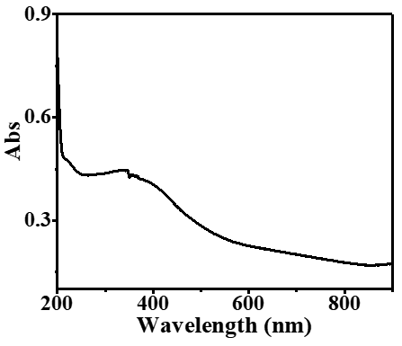
Figure 1. Uv–Vis absorption spectra of KMO system.

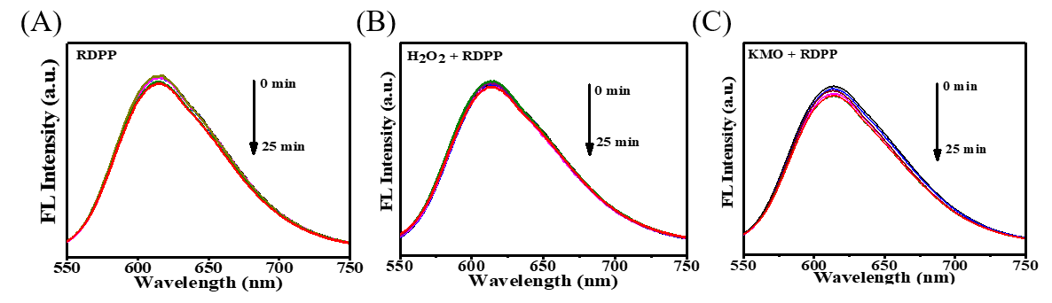
Figure 2. Fluorescence spectra of (A) RDPP, (B) H₂O₂ + RDPP solution, and (C) KMO + RDPP solution.
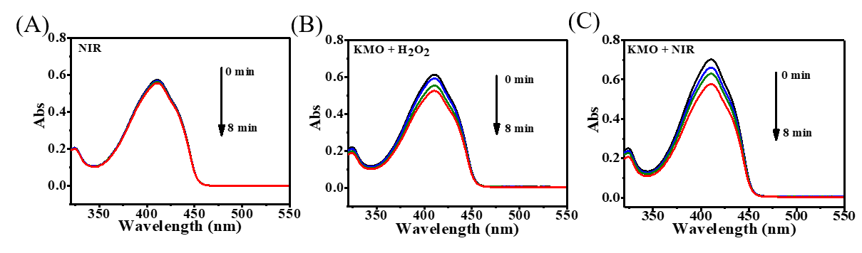
Figure 3. (A) UV–vis absorption of DPBF after (A) NIR, (B) KMO + H₂O₂, and (C) KMO + NIR treatment.

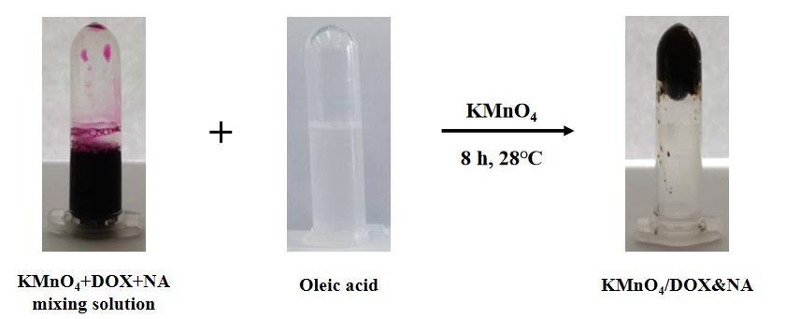

Figure 4. Photographs of KMnO₄ + DOX + NA mixing solution, OA, and KMO/DOX&NA at room temperature.

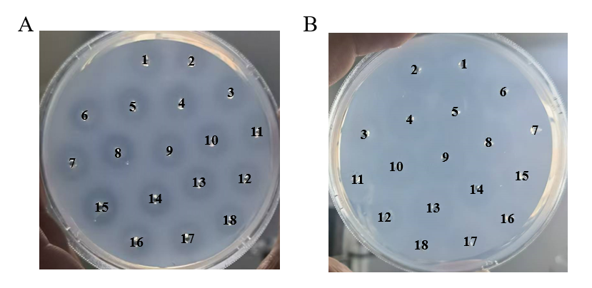
Figure 5. (A) The activity of NA in fibrous plates after different time treatments for 8 min (30 °C: 1-3, 35 °C: 4-6, 40 °C: 7-9, 45 °C: 10-12, 50°C: 13-15, and 55 °C: 16-18). (F) The activity of in fibrous plates after different treatments for 8 min (PBS: 1-3, H₂O₂: 4-6, GSH: 7-9, pH = 6.5: 10-12, TME: 13-15, and TME + NIR: 16-18).

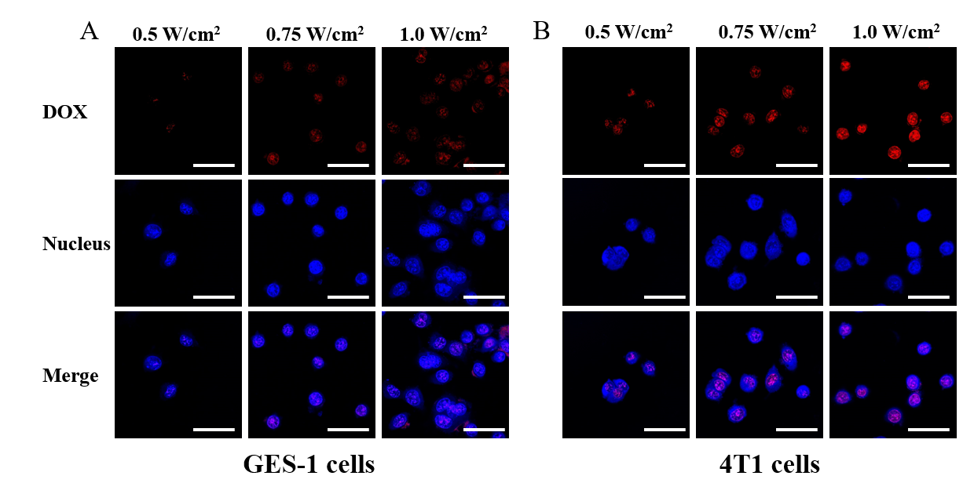
Figure 6. CLSM images of (A) GES-1 cells and (B) 4T1 cells incubated with KMO/DOX&NA for 4 h with different NIR power. Images show cell nuclei stained by DAPI (blue), DOX fluorescence in cells (red), and the merged overlap of the two images. Scale bars: 30 μm.

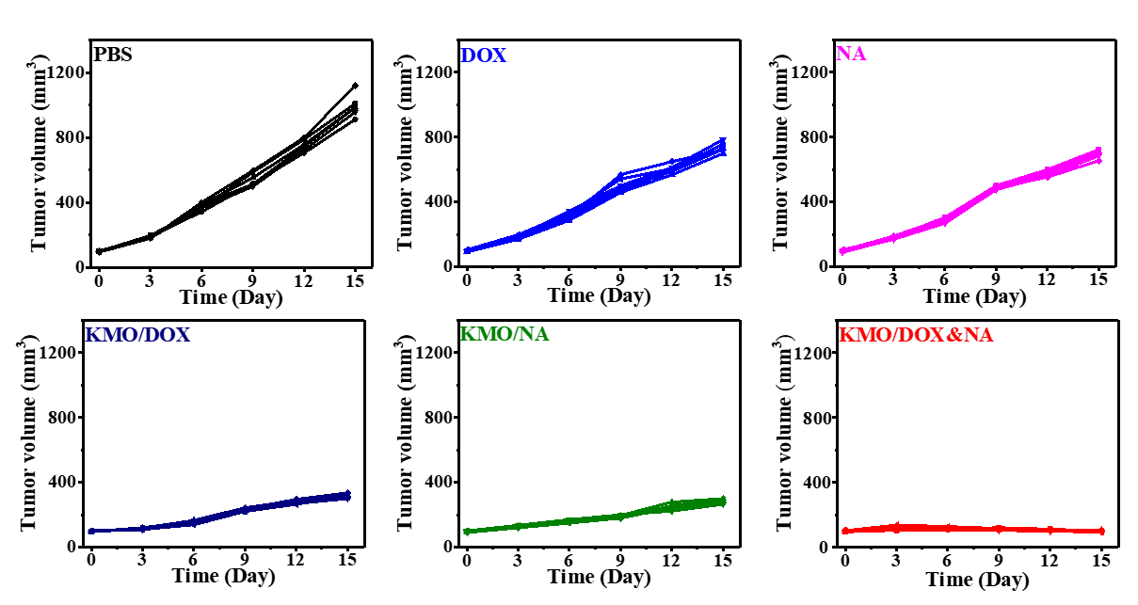
Figure 7. Individual tumor volume curves of 4T1 tumor-bearing mice after 15 days of different treatments (n=6/group).

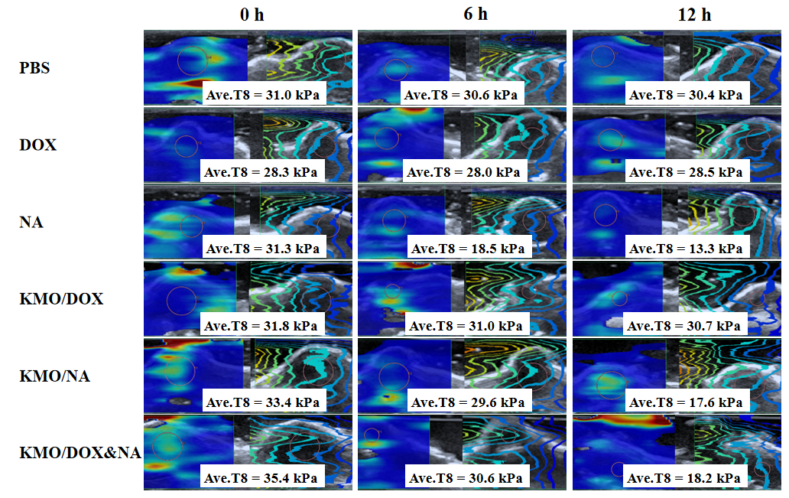
Figure 8. Ultrasound images showed the stiffness of tumor tissue after different treatment at different time points.

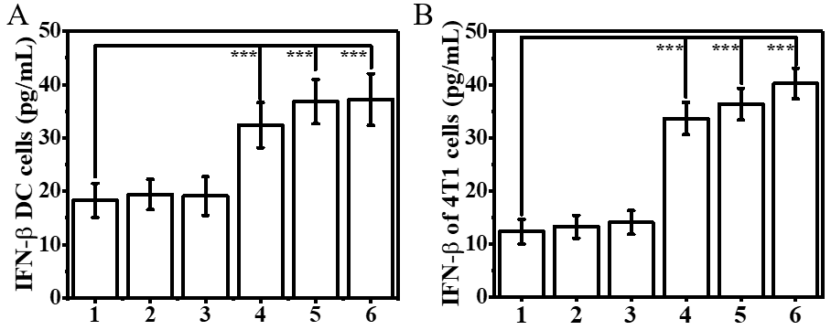
Figure 9. IFN-β secretion of (A) DC cells and (B) 4T1 cells incubated with different treatment groups for 24 h. 1: PBS + NIR, 2: DOX + NIR, 3: NA + NIR, 4: KMO/DOX + NIR, 5: KMO/NA + NIR, 6: KMO/DOX&NA + NIR.
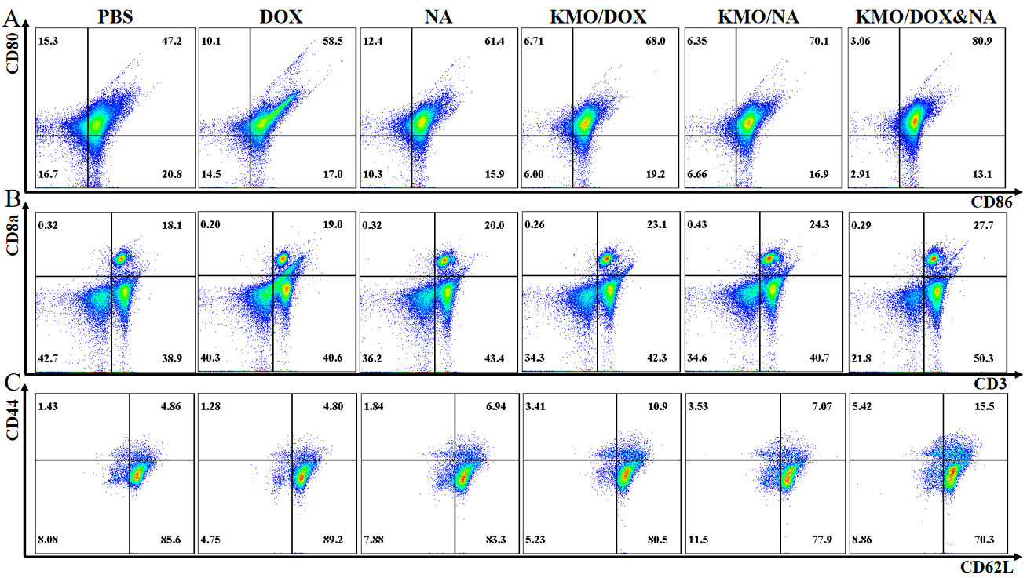
Figure 10. Flow cytometry plots showing (A) the maturation of DC cells (CD11c⁺CD80⁺CD86⁺) and (B) CD8⁺ T cells (CD3⁺CD4⁺CD8a⁺), extracted from tumor tissues following different treatments. (C) Flow cytometry plots of memory T cells (CD44⁺CD62L⁻CD3⁺CD8a⁺ T cells) extracted from lymph nodes after various treatments.
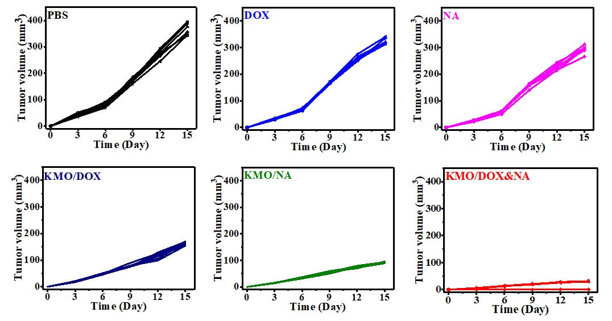
Figure 11. Individual distant tumor growth curves of 4T1 tumor-bearing mice after different treatments.
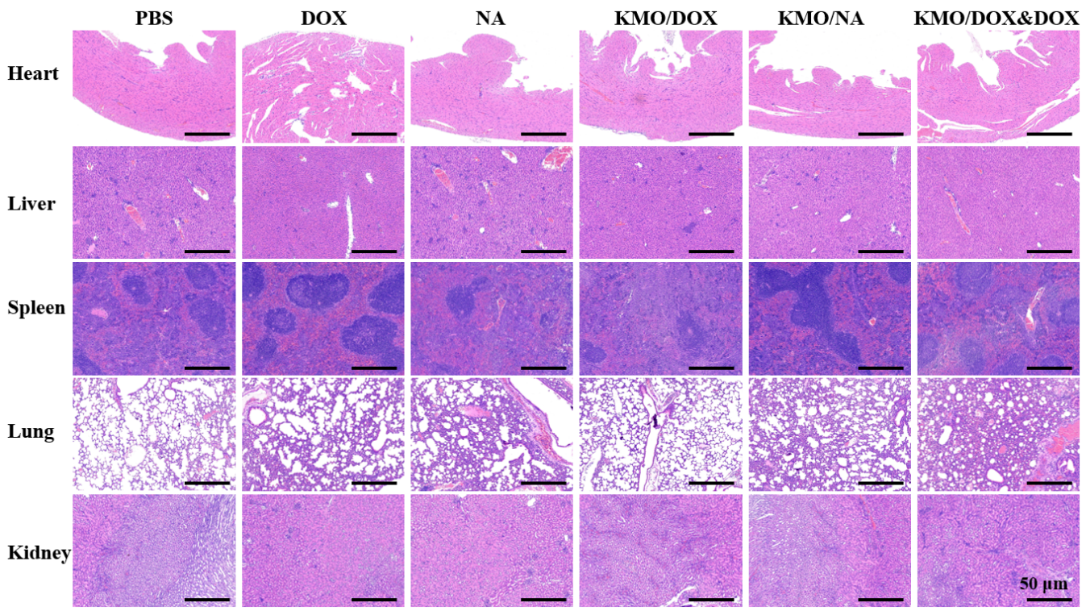
Figure 12. H&E-stained images of the major organs in the different groups. Scale bar: 50 μm.

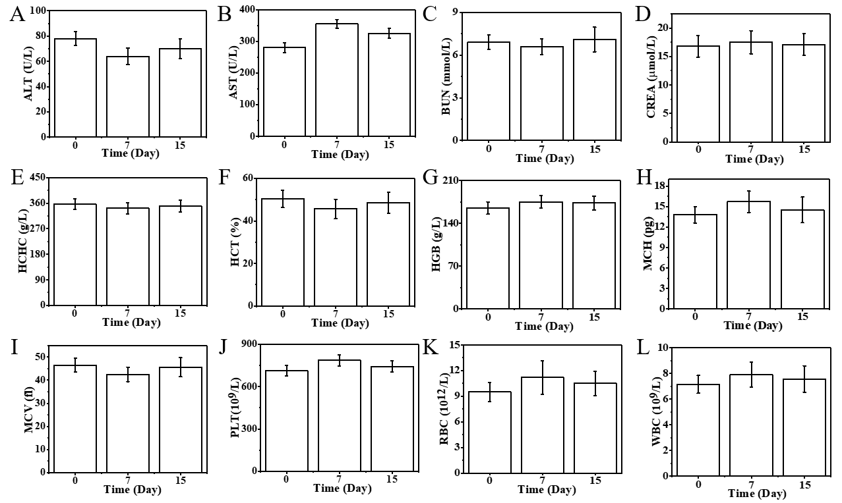
Figure 13. The serum biochemistry index (A-D) and the blood tests (E-L) of the mice on the 0 st, 1st, 7th, and 15th day after the treatment of KMO/DOX&NA + NIR.

Reference:
- Kiky Corneliasari Sembiring, Asif Aunillah, Eiji Minami, et al. Renewable gasoline production from oleic acid by oxidative cleavage followed by decarboxylation. Renewable Energy, 2018. 122: 602-607.
- Arno Behr, Nils Tenhumberg and Andreas Wintzer. Efficient ruthenium-catalysed oxidative cleavage of methyl oleate with hydrogen peroxide as oxidant. RSC, 2013. 3: 172.

