Supplementary Table S1. Clinical and pathological characteristics between training set and validation set.
Characteristic |  | Total (n=1029) | training set (n=720) | validation set (n=309) | P value
VTE, n (%) | Yes / No | 130 (12.6) / 899 (87.4) | 92 (12.8) / 628 (87.2) | 38 (12.3) / 271 (87.7) | 0.832
Sex, n (%) | Male / Female | 797 (77.5) / 232 (22.5) | 556 (77.2) / 164 (22.8) | 241 (78.0) / 68 (22.0) | 0.786
Age (years), n (%) | ≤ 65 / > 65 | 513 (49.9) / 516 (50.1) | 358 (49.7) / 362 (50.3) | 155 (50.2) / 154 (49.8) | 0.897
BMI (kg/m²), n (%) | <18.5  18.5-24.9  ≥ 25 | 147 (14.3)  570 (55.4)  312 (30.3) | 96 (13.3)  407 (56.5)  217 (30.1) | 51 (16.5)  163 (52.8)  95 (30.7) | 0.349
Smoking, n (%) | Yes / No | 553 (53.7) / 476 (46.3) | 378 (52.5) / 342 (47.5) | 175 (56.6) / 134 (43.4) | 0.223
Alcohol, n (%) | Yes / No | 397 (38.6) / 632 (61.4) | 276 (38.3) / 444 (61.7) | 121 (39.2) / 188 (60.8) | 0.803
NRS-2002, n (%) | < 3 / ≥ 3 | 343 (33.3) / 686 (66.7) | 248 (34.4) / 472 (65.6) | 95 (30.7) / 214 (69.3) | 0.248
Hypertension, n (%) | Yes / No | 325 (31.6) / 704 (68.4) | 233 (32.4) / 487 (67.6) | 92 (29.8) / 217 (70.2) | 0.413
Diabetes, n (%) | Yes / No | 136 (13.2) / 893 (86.8) | 90 (12.5) / 630 (87.5) | 46 (14.9) / 263 (85.1) | 0.300
CCVD, n (%) | Yes / No | 327 (31.8) / 702 (68.2) | 221 (30.7) / 499 (69.3) | 106 (34.3) / 203 (65.7) | 0.254
Respiratory disease, n (% | Yes / No | 275 (26.7) / 754 (73.3) | 188 (26.1) / 532 (73.9) | 87 (28.2) / 222 (71.8) | 0.497
Neoadjuvant chemotherapy, n (%) | Yes / No | 196 (19.0) / 833 (81.0) | 132 (18.3) / 588 (81.7) | 64 (20.7) / 245 (79.3) | 0.373
Preoperative ASA score, n (%) | I–II / III | 716 (69.6) / 313 (30.4) | 503 (69.9) / 217 (30.1) | 213 (68.9) / 96 (31.1) | 0.767
Cycle of p-HIPEC, n (%) | 2 / 3 | 649 (63.1) / 380 (36.9) | 452 (62.8) / 268 (37.2) | 197 (63.8) / 112 (36.2) | 0.766
Operative approach, n (%) | Open  Laparoscopic  Robotic | 107 (10.4)  793 (77.1)  129 (12.5) | 84 (11.7)  544 (75.6)  92 (12.8) | 23 (7.4)  249 (80.6)  37 (12.0) | 0.104
Operative duration (min), n (%) | < 200 / ≥ 200 | 430 (41.8) / 599 (58.2) | 305 (42.4) / 415 (57.6) | 125 (40.5) / 184 (59.5) | 0.569
Intraoperative blood loss (ml), n (%) | < 120 / ≥ 120 | 744 (72.3) / 285 (27.7) | 524 (72.8) / 196 (27.2) | 220 (71.2) / 89 (28.8) | 0.604
Postoperative ICU admission, n (%) | Yes / No | 186 (18.1) / 843 (81.9) | 121 (16.8) / 599 (83.2) | 65 (21.0) / 244 (79.0) | 0.106
Tumor location, n (%) | Upper  Middle  Lower  Multiple parts | 40 (3.9)  200 (19.4)  681 (66.2)  108 (10.5) | 25 (3.5)  138 (19.2)  479 (66.5)  78 (10.8) | 15 (4.9)  62 (20.1)  202 (65.4)  30 (9.7) | 0.692
Tumor size (cm), n (%) | < 6.45 / ≥ 6.45 | 694 (67.4) / 335 (32.6) | 491 (68.2) / 229 (31.8) | 203 (65.7) / 106 (34.3) | 0.433
T stage, n (%) | T3 / T4 | 316 (30.7) / 713 (69.3) | 226 (31.4) / 494 (68.6) | 90 (29.1) / 219 (70.9) | 0.471
N stage, n (%) | N0  N1  N2  N3 | 40 (3.9)  201 (19.5)  321 (31.2)  467 (45.4) | 30 (4.2)  143 (19.9)  226 (31.4)  321 (44.6) | 10 (3.2)  58 (18.8)  95 (30.7)  146 (47.2) | 0.806
LVI, n (%) | Yes / No | 737 (71.6) / 292 (28.4) | 524 (72.8) / 196 (27.2) | 213 (68.9) / 96 (31.1) | 0.210
Nerve invasion, n (%) | Yes / No | 856 (83.2) /173 (16.8) | 607 (84.3) / 113 (15.7) | 249 (80.6) / 60 (19.4) | 0.143
CEA (ng/ml), n (%) | < 4.00 / ≥ 4.00 | 767 (74.5) / 262 (25.5) | 530 (73.6) / 190 (26.4) | 237 (76.7) / 72 (23.3) | 0.297
AFP (ng/ml), n (%) | < 1.80 / ≥ 1.80 | 158 (15.4) / 871 (84.6) | 113 (15.7) / 607 (84.3) | 45 (14.6) / 264 (85.4) | 0.644
CA199 (U/ml), n (%) | < 6.25 / ≥ 6.25 | 263 (25.6) / 766 (74.4) | 190 (26.4) / 530 (73.6) | 73 (23.6) / 236 (76.4) | 0.351
Caprini score, median (Q25, Q75) |  | 8.0 (7.0, 9.0) | 8.0 (7.0, 9.0) | 8.0 (7.0, 10.0) | 0.227
CVC | Yes / No | 416 (40.4) / 613 (59.6) | 296 (41.1) / 424 (58.9) | 120 (38.8) / 189 (61.2) | 0.495
LEVVs | Yes / No | 95 (9.2) / 934 (90.8) | 67 (9.3) / 653 (90.7) | 28 (9.1) / 281 (90.9) | 0.901
High-APTT (sec) | Yes / No | 699 (67.9) / 330 (32.1) | 492 (68.3) / 228 (31.7) | 207 (67.0) / 102 (33.0) | 0.672
High-PT (sec) | Yes / No | 231 (22.4) / 798 (77.6) | 152 (21.1) / 568 (78.9) | 79 (25.6) / 230 (74.4) | 0.116
High-FIB (g/L) | Yes / No | 412 (40.0) / 617 (60.0) | 291 (40.4) / 429 (59.6) | 121 (39.2) / 188 (60.8) | 0.706
High-D-dimer (ng/ml) | Yes / No | 357 (34.7) / 672 (65.3) | 252 (35.0) / 468 (65.0) | 105 (34.0) / 204 (66.0) | 0.753
Y, Yes; N, No; APTT, activated partial thromboplastin time; AFP, alpha fetoprotein; ASA, American society of Aneshesiologists, BMI, body mass index; CA199, Carbohydrate antigen199; CCVD, cardio-cerebral vascular disease; CEA, carcinoembryonic antigen; CVC, central venous catheter; FIB, fibrinogen; ICU, intensive care unit; LEVVs, lower extremity varicose veins; LVI, lymphovascular invasion; NRS-2002, nutrition risk screening 2002; NED, neuroendocrine differentiation; PT, prothrombin time; p-HIPEC, prophylactic hyperthermic intraperitoneal chemotherapy; T2-DM, Diabetes mellitus type 2; VTE, venous thromboembolism.
* P<0.05 was considered significant.

Supplementary Table S2. Comparison of the inflammatory nutrition indicators and body composition parameters between training set and validation set.
Variables |  | Total  (n=1029) | training set  (n=720) | validation set  (n=309) | P value
High-PLR | Y / N | 734 (71.3) / 295 (28.7) | 508 (70.6) / 212 (29.4) | 226 (73.1) / 83 (26.9) | 0.401
High-NLR | Y / N | 544 (52.9) / 485 (47.1) | 385 (53.5) / 335 (46.5) | 159 (51.5) / 150 (48.5) | 0.553
High-CAR | Y / N | 155 (15.1) / 874 (84.9) | 105 (14.6) / 615 (85.4) | 50 (16.2) / 259 (83.8) | 0.511
High-IBI | Y / N | 372 (36.2) / 657 (63.8) | 273 (37.9) / 447 (62.1) | 99 (32.0) / 210 (68.0) | 0.072
High-SIRI | Y / N | 472 (45.9) / 557 (54.1) | 334 (46.4) / 386 (53.6) | 138 (44.7) / 171 (55.3) | 0.610
High-SII | Y / N | 330 (32.1) / 699 (67.9) | 236 (32.8) / 484 (67.2) | 94 (30.4) / 215 (69.6) | 0.458
High-PNI | Y / N | 560 (54.4) / 469 (45.6) | 402 (55.8) / 318 (44.2) | 158 (51.1) / 151 (48.9) | 0.165
High-NHR | Y / N | 335 (32.6) / 694 (67.4) | 235 (32.6) / 485 (67.4) | 100 (32.4) / 209 (67.6) | 0.931
High-FAR | Y / N | 470 (45.7) / 559 (54.3) | 326 (45.3) / 394 (54.7) | 144 (46.6) / 165 (53.4) | 0.696
Low-SMI | Y / N | 427 (41.5) / 602 (58.5) | 308 (42.8) / 412 (57.2) | 119 (38.5) / 190 (61.5) | 0.203
Low-VATI | Y / N | 587 (57.0) / 442 (43.0) | 408 (56.7) / 312 (43.3) | 179 (57.9) / 130 (42.1) | 0.708
Low-SATI | Y / N | 612 (59.5) / 417 (40.5) | 421 (58.5) / 299 (41.5) | 191 (61.8) / 118 (38.2) | 0.317
Low-TATI | Y / N | 775 (75.3) / 254 (24.7) | 534 (74.2) / 186 (25.8) | 241 (78.0) / 68 (22.0) | 0.192
Low-SMD | Y / N | 356 (34.6) / 673 (65.4) | 252 (35.0) / 468 (65.0) | 104 (33.7) / 205 (66.3) | 0.678
Low-SD | Y / N | 555 (53.9) / 474 (46.1) | 396 (55.0) / 324 (45.0) | 159 (51.5) / 150 (48.5) | 0.296
Low-VD | Y / N | 322 (31.3) / 707 (68.7) | 230 (31.9) / 490 (68.1) | 92 (29.8) / 217 (70.2) | 0.491
High-IMAC | Y / N | 523 (50.8) / 506 (49.2) | 371 (51.5) / 349 (48.5) | 152 (49.2) / 157 (50.8) | 0.492
High-VSR | Y / N | 562 (54.6) / 467 (45.4) | 388 (53.9) / 332 (46.1) | 174 (56.3) / 135 (43.7) | 0.474
Y, Yes; N, No; PLR, platelet-to-lymphocyte ratio; NLR, neutrophil-to-lymphocyte ratio; IBI, inflammatory burden index; SIRI, systemic inflammation response index; SII，systemic immune-inflammation index; PNI，prognostic nutritional index; SMI, skeletal muscle index; VATI, visceral adipose tissue index；SATI, subcutaneous adipose tissue index；TATI, total adipose tissue index； SMD, skeletal muscle density; SD, subcutaneous adipose density; VD, visceral adipose density；IMAC, intramuscular adipose tissue content; VSR, visceral to subcutaneous adipose tissue area ratio.
* P<0.05 was considered significant.

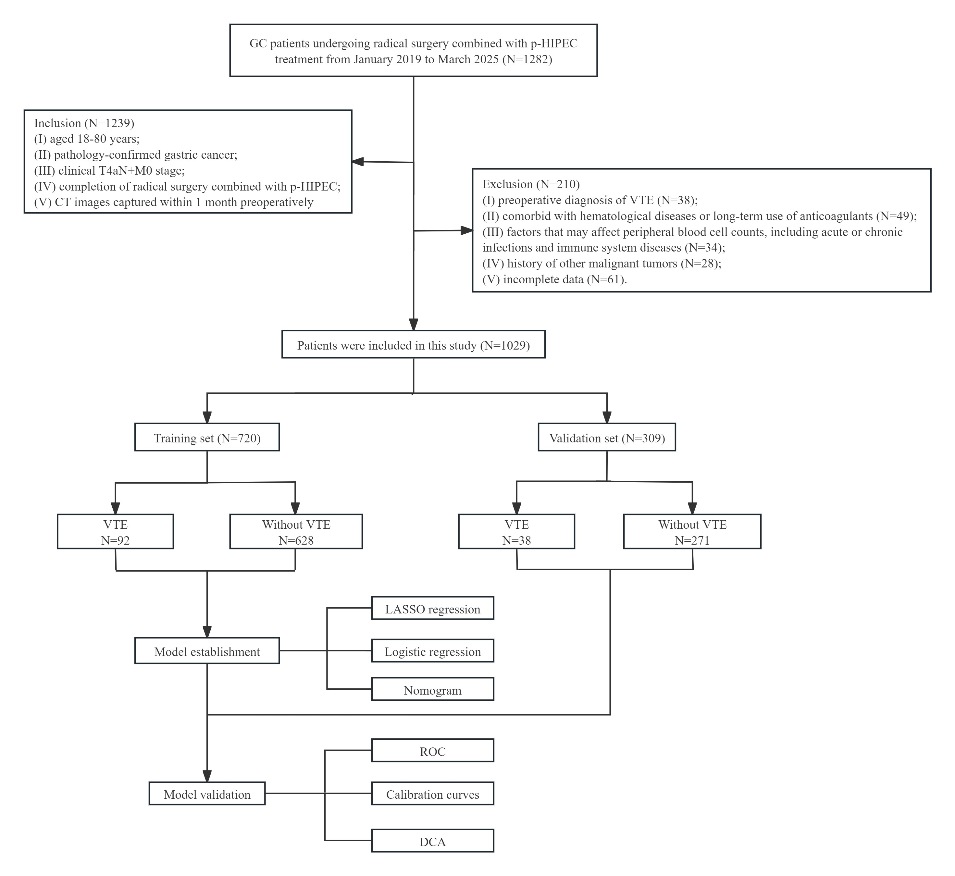
Supplementary Figure S1. Flow diagram of study design. ASA, American Society of Anesthesiologists; RS, radical surgery; CT, computed tomography; GC, gastric cancer; LAGC, locally advanced gastric cancer; LASSO, least absolute shrinkage and selection operator; p-HIPEC, prophylactic hyperthermic intraperitoneal chemotherapy; ROC, receiver operating characteristic curve; DCA, decision curve analysis.

Supplementary Figure S2. Cross-sectional computed tomography images of the third lumbar vertebra used to quantify body composition parameters. The red, yellow, blue, and green shaded regions show the skeletal muscle area (SMA), visceral adipose tissue area (VATA), subcutaneous adipose tissue area (SATA) and intramuscular adipose tissue area (IMATA), respectively.

