Figure S1 LASSO Feature Selection for the Whole Tumor Region
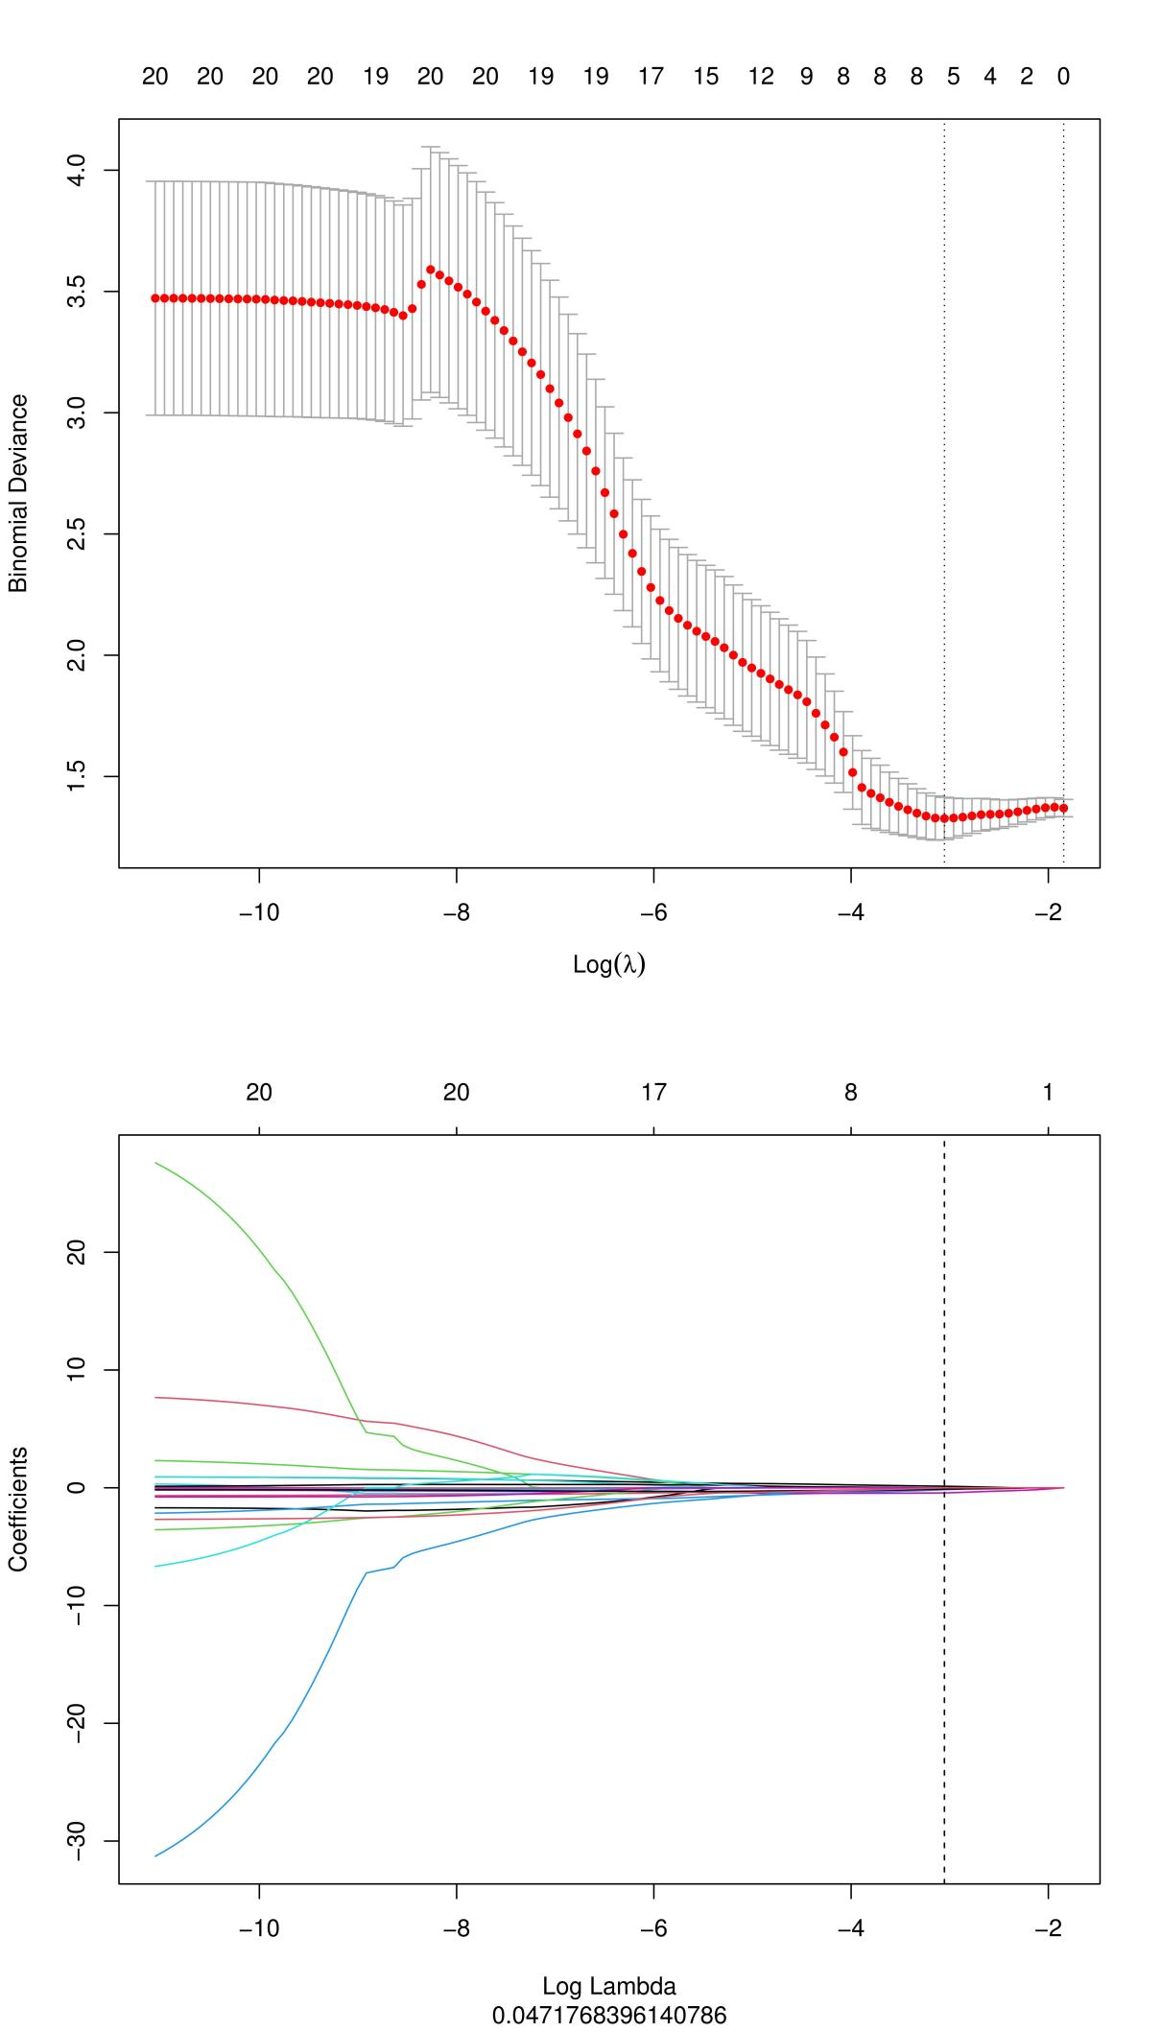
Figure S2 LASSO Feature Selection for the Tumor Margin Region
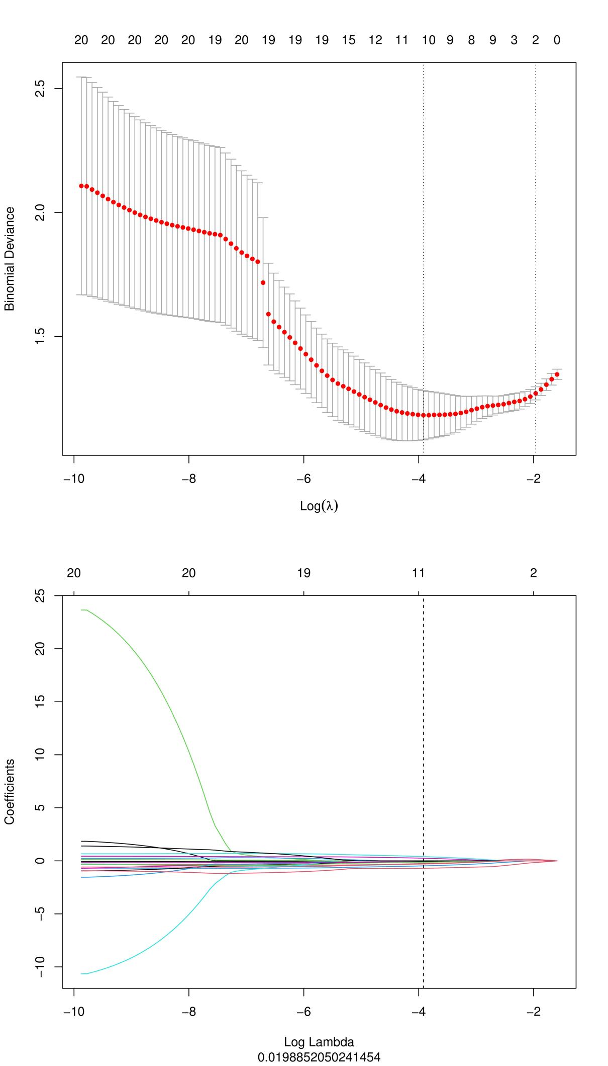
Formula for Intratumoral Radiomics Score
Rad-score=0.132564828842256*wavelet_HHH_glrlm_LongRunHighGrayLevelEmphasis+-0.00462411596096455*wavelet_HLL_glszm_LargeAreaHighGrayLevelEmphasis+-0.110074251401751*wavelet_HHH_glszm_SmallAreaLowGrayLevelEmphasis+-0.112394694809825*exponential_glcm_ClusterProminence+-0.165067053123905*exponential_glszm_ZoneVariance+-0.435037128334255*wavelet_HLL_glcm_Correlation+-0.443163932474384*(Intercept)

Formula for Tumor Marginal Radiomics Score
Rad-score=0.397423917721302*wavelet_LLH_firstorder_Skewness+0.247407565937007*wavelet_HHH_firstorder_Median+-0.0310479386957947*wavelet_HHH_glszm_LargeAreaHighGrayLevelEmphasis+-0.0664884842339231*exponential_glszm_ZoneEntropy+-0.129152856590973*squareroot_glszm_ZoneVariance+-0.250925833838904*lbp_2D_glrlm_RunEntropy+-0.291859978565058*exponential_glszm_ZoneVariance+-0.296122631859518*wavelet_HLH_glszm_LargeAreaHighGrayLevelEmphasis+-0.473276076545078*square_glszm_ZoneEntropy+-0.531155233674298*(Intercept)+-0.703817008575888*lbp_2D_firstorder_Kurtosis

