Anti-inflammatory potential of Herbal gel containing Urtica dioica extract against Arthritis
Supplementary file
3.6: In vivo drug release – Preparation of membrane- Egg membrane was prepared which was used as dialysis membrane in fabricated Franz diffusion cell. Whole egg was immersed in water Hcl solution and conc. Hcl was added until egg shell starts melting. The membrane remains intact with the internal egg yolk which was removed by picking a small hole in the membrane. Washed membrane neatly with water and kept in Glycerin solution until used.
The study was performed by modified Franz diffusion cell using dialysis membrane. Before carrying out the study, membrane was kept in buffer pH 7.4 for 48 hour and it was mounted carefully between the donor and receptor chamber. 500mg of gel was weighed and was spread on the dialysis membrane. 50 mL of phosphate buffer (pH 7.4) was placed in receptor medium as dissolution medium both donor and receptor compartment were kept in contact with each other and whole assembly was maintained at constant temperature of 32± 0.5˚ C, magnetic bead was used to stir the solution of receptor chamber. 1 ml of sample withdrawn after specific time intervals and equal amount was replaced with fresh dissolution media. Sample absorption was calculated spectrophotometrically at 741 nm and % cumulative drug permeation was calculated. The dilutions were done as per folin coicateu method as described in tannic acid equivalent and assay.
4.1 Extract characterization:
Urtica dioica aerial part extract organoleptic properties were determined and the results were given.
Table 1: Organoleptic characters of Urtica dioica aerial part methanolic extract. The extracts obtained by successive extraction in soxhlet apparatus.
S.NO | CHARACTER | PET ETHER | CHLOROFORM | METHANOLIC EXTRACT
1 | Physical state | Semisolid | Semisolid | Semisolid
2 | Odor | Characteristic similar to Henna | Characteristic similar to Henna | Characteristic similar to Henna
3 | Color | Yellowish brown | Dark Green | Brownish green

4.2 Phytochemical screening methods:
Table 2: Phytochemical screening of Urtica dioica aerial part methanolic extract.
TEST | INFERENCE | RESULT
1.Shinoda Test  To test solution added magnesium turnings and conc. Hcl. | Pink, Blue, Green scarlet should appear. | Slight pink scarlet appeared at the junction.
2.Ammonia Test  To the test solution added ammonia solution and conc. H2So4 from the sides of the test tube. | Yellow coloration should appear. | Yellow color appeared which indicates the presence of flavonoids.
3.Lead Acetate Test  To the test solution added few drops of lead acetate solution. | Yellow precipitate should form. | Yellow color precipitate developed shows the presence of flavonoids.
4.Sodium Hydroxide test  To the test solution added NaOH. | Yellow color should appear after adding NaOH which disappears on addition of acid. | Yellow color appeared which disappeared on addition of an acid.

4.4 Detection of λmax Urtica dioica
The λmax was found to be 741 nm.
4.4.1 Standard Calibration Curve for Tannic acid equivalent

Table: 3 Calibration curve data of UD extract in phosphate buffer 7.4 at λmax 741 nm.

CONCENTRATION | ABSORBANCE
2μL | 0.305
5μL | 0.720
7μL | 0.820
10μL | 1.163

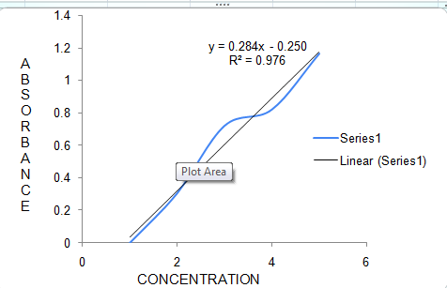
Fig.1– Standard calibration curve of Tannic acid by using Folin Ciocateu method.
4.4 Calculation of Percentage mg of tannic acid equivalent present in extract which is required to calculate the assay and dissolution.
Y=mx+c -----------eq
x=1.6232 mcg/ml
Convert it into mg/ml = 1.6232/1000=0.00162 mg/ml
Total phenolic content – C = x (v/m)
where v is the dilution factor, m amount of drug i.e., 1000mg extract dissolved in 100ml so, 1ml = 0.01gm
=32.4mgTAE/g of drug extract

4.6.1: Table 4: General appearance test of each formulation.
Formulation | Color | Texture | Odor
Extract | Dark green | Semi solid | Characteristic
Gum Kaitra Gel | Brown | Not smooth | Characteristic
Carbopol Gel | Light Brown | Smooth, no phase separation | Characteristic
Sodium Alginate Gel | Dark Brown | Smooth, no phase separation | Characteristic
Polyherbal Gel | Light Brown | Smooth, no phase separation | Aromatic
Phytosomal Gel | Light Brown | Smooth, no phase separation | Characteristic

4.6.3: The viscosity of the gels were calculated by using Brookfield viscometer in triplicate and the results are mentioned in the table.
Table 5- Viscosity of the different gels
Formulation | Viscosity ( Mili Pascal per second)
1)Carbopol gel | 25243
2)Sodium alginate gel | 7895
3)Polyherbal gel | 6854
4)Phytosomal gel | 10227

4.7 Percentage drug content – The assay of different gels was calculated using Folin ciocalteu method which was used to calculate the tannic acid equivalent also as described under method section.
Table 6- Assay values of different gels.
Formulation | Percent Drug Content (%)
Carbopol Gel | 89.4%
Sodium Alginate Gel | 68.8%
Polyherbal Gel | 98.2%
Phytosomal Gel | 95.2%
Note- To compare the gels prepared and marketed voveran gel was used. For that first we calculated the standard calibration curve of diclofenac and then calculated the assay and in vitro drug release.
Standard calibration curve of diclofenac
Table 7- Standard calibration curve reading of diclofenac.
CONCENTRATION | ABSORBANCE
1μl | 0.074
2μl | 0.123
3μl | 0.195
4μl | 0.278
5μl | 0.324
6μl | 0.391

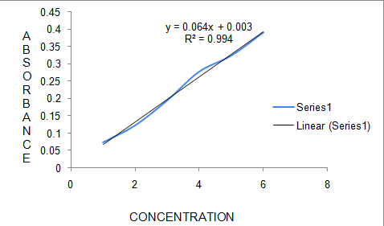
Fig.2- Standard calibration curve reading of diclofenac.

4.8 In vitro drug release profile of each formulation
Table 8: Comparison Study Of invito drug release of formulated Gels and marketed gel Voveran (containing diclofenac).

TIME IN MINS | % DRUG RELEASE
TIME IN MINS | Carbopol Gel | Sodium Alginate Gel | Polyherbal Gel | Phytosomal Gel | Marketed voveran Gel
30 | 18.42 | 42.87 | 21.24 | 16.09 | 55.28
60 | 25.65 | 53.17 | 72.45 | 17.37 | 74.73
120 | 53.15 | 71. | 88.88 | 24.18 | 89.36
180 | 78.2 | 78.98 | 98.2 | 25.24 | 95.28
240 | 81.3 | 80.68 |  | 27.89 | 97.33
300 | 88.5 | 86.11 |  | 30.80 | 99.37
360 | 95.2 | 95.44 |  | 28.9 | 99.86
420 |  |  |  | 28.86
480 |  |  |  | 31.96
1440(24hr) |  |  |  | 59.35
2880(48hr) |  |  |  | 96.89

Note- Assay of marketed diclofenac gel was found to be 98.9%.
4.9 Release kinetics
For analyzing the mechanism of drug release kinetics of the phytosomal gel, data obtained were fitted to various kinetic equations of zero order, first order, Higuchi model, and Korsmeyer Peppas model .The n value and regression coefficient are summarized in the table below.

Table 9. Data of regression coefficient of different kinetic models
Gel Formulation | Zero order (R² ) | First order (R² ) | Higuchi (R² ) | Korsmeyer Peppas (R² ) | Hixon crowell plot (R² )
Phytosomal gel | 0.990 | 0.888 | 0.959 | 0.915 | 0.004
The phytosomal gel follows the zero order drug release as shown in Fig no.4.It showed slow release in controlled manner. The drug released upto 48 hrs.
5.1 Stability Studies
1) Assay readings were recorded for three months .The assay values for phytosomal gel and polyherbal gel were similar to the initial readings as shown table
Table 10: Assay values obtained in stability studies.
Formulation | % Drug Content  Initial | 1st month | 2nd month | 3rd month
Carbopol Gel | 89.4% | 87% | 85% | 76%
Sodium Alginate Gel | 68.8% | 67% | 68% | 58%
Polyherbal Gel | 98.2% | 98.6% | 97.2% | 97.9%
Phytosomal Gel | 95.2% | 95.65% | 94.3% | 94.5%

2) In vitro drug release –
Table 11: Percentage cumulative drug release of the prepared formulations kept for stability studies.
Formulation | Time in min | Initial month | 1st month | 2nd month | 3rd month
- Carbopol gel | 30 | 18.07 | 18.94 | 19.29 | 24.60
 | 60 | 20.02 | 39.72 | 38.24 | 33.38
 | 120 | 25.54 | 61.62 | 62.77 | 37.17
 | 180 | 25.60 | 54.77 | 55.79 | 50.14
 | 240 | 26.98 | 69.40 | 70.70 | 55.19
 | 300 | 35.63 | 76.76 | 78.20 | 64.49
 | 360 | 34.56 | 84.86 | 86.45 | 74.5
- Sodium alginate gel | 30 | 42.87 | 40.45 | 50.81 | 50.81
 | 60 | 53.17 | 53.60 | 55.20 | 62.89
 | 120 | 71.98 | 70.30 | 62.89 | 66.23
 | 180 | 77.44 | 75.58 | 66.23 | 67.53
 | 240 | 99.80 | 80.06 | 67.53 | 70.88
 | 300 | 99.82 | 90.78 | 70.88 | 75.86
 | 360 | 99.90 | 91.13 | 85.20 | 86.23
- Polyherbal gel | 30 | 21.24 | 32.17 | 55.45 | 32.16
 | 60 | 72.45 | 65.23 | 88.60 | 60.23
 | 120 | 88.88 | 89.96 | 88.90 | 80.65
 | 180 | 92.80 | 90.88 | 92.56 | 91.25
- Phytosomal gel | 30 | 16.09 | 19.86 | 12.5 | 15.2
 | 60 | 17.37 | 14.60 | 14.6 | 17.2
 | 120 | 24.18 | 25.44 | 28.09 | 24.12
 | 180 | 25.24 | 26.52 | 31.21 | 27.69
 | 240 | 27.89 | 26.59 | 31.76 | 27.98
 | 300 | 30.8 | 30.82 | 32.87 | 31.30
 | 360 | 28.86 | 30.61 | 33.11 | 32.61
 | 420 | 28.89 | 31.39 | 34.37 | 38.22
 | 480 | 31.96 | 36.42 | 42.31 | 38.26
 | 1440(24hr) | 59.35 | 40.23 | 47.90 | 60.87
 | 2880(48hr) | 96.89 | 81.55 | 83.0 | 82.74
The most stable and best formulation was the phytosomal gel.

5.2.1 Animal Studies:- . Fig.3 acute skin irritation results
 | Extract | Carbopol gel | Sodium alginate gel | Polyherbal gel | Phytosomal gel
Initial | 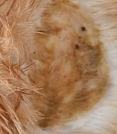 | 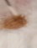 | 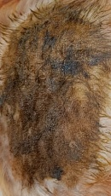 | 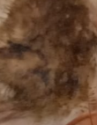 | 
After 3 hr | 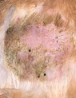 | 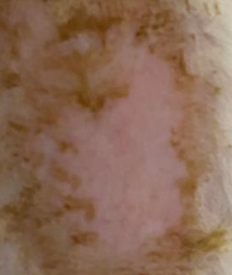 | 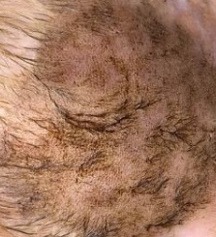 | 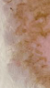 | 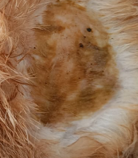
24hr | 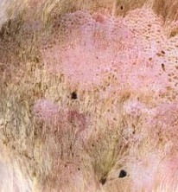 | 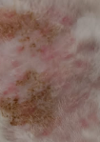 | 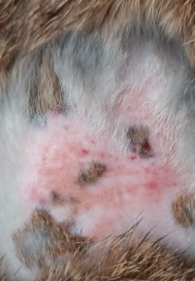 | 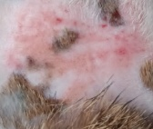 | 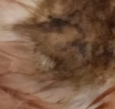
3rd day | 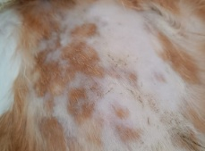 | 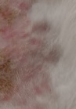 | 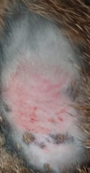 | 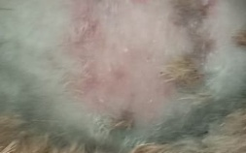 | 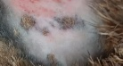
10th day | 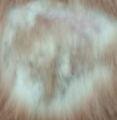 | 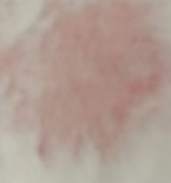 | 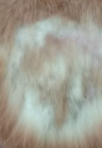 | 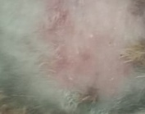 | 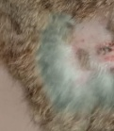
14th day | 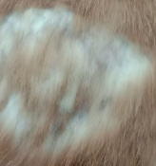 | 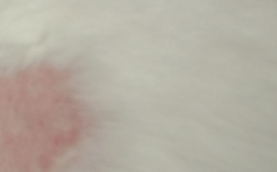 | 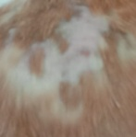 |  | 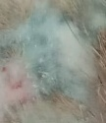
 | % Inhibition of edema
Time | Extract | Carbopol gel | Sodium alginate gel | Polyherbal gel | Phytosomal gel | Standard drug
 | 25 | 25 | 25 | 50 | 50 | 50
  1HR
24HR | 50 | 25 | 25 | 50 | 50 | 75
72HR | 50 | 25 | 25 | 50 | 75 | 75
96HR | 75 | 50 | 50 | 75 | 75 | 66
120HR | 66.6 | 33.3 | 33.3 | 66 | 66 | 66
144HR | 66.6 | 33.3 | 33.3 | 66 | 66 | 83
168HR | 66.6 | 66.6 | 66.6 | 83 | 83 | 62
192HR | 50 | 50 | 50 | 57 | 54 | 66
5.2.2 Carragenan induced rat paw edema method for anti-inflammatory activity

Table.no:15 –Percentage inhibition of carrageenan induced rat paw edema.

