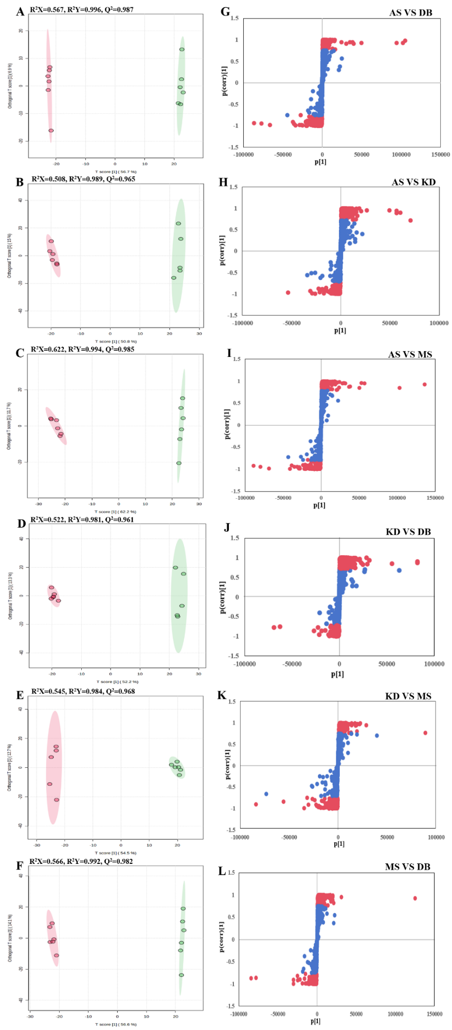
Figure S1 The OPLS-DA score plots of four mulberry fruit varieties. A-F, OPLS-DA model plots for the comparison groups AS vs. DB, AS vs. KD, AS vs. MS, KD vs. DB, KD vs. MS, MS vs. DB

Figure S2 Statistical map of DAMs. The classification and percentage of the DAM_{S} of the selected HMDB hierarchy (Class) are displayed in a high to low order, with different colours in each pie plot in the figure, whose area represents the relative proportion of the DAMs in that classification. (A) AS VS DB, (B) KD VS DB, (C) MS VS DB, (D) AS VS MS, (E) AS VS KD, (F) KD VS MS.

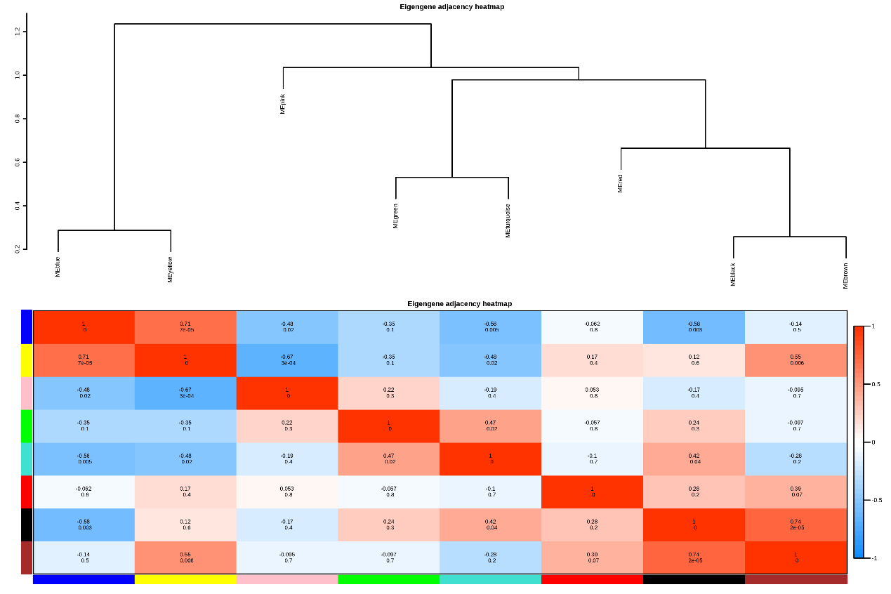
Figure S3 Heat map of inter-module correlations.

