Supplementary files:
1. Obesity-Related CVD Mortality by 2013 Urban–Rural Classification, US, 1999–2020
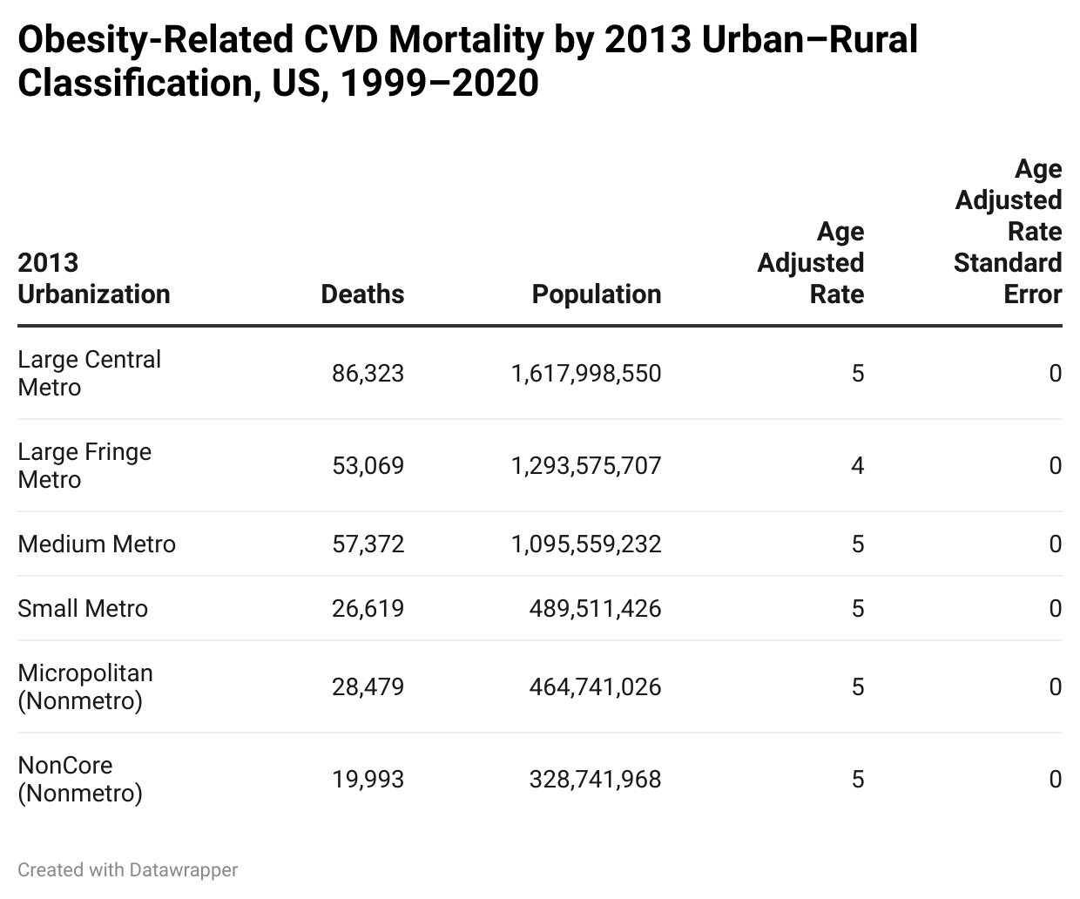

2. Obesity-Related CVD Mortality by Age Group, US, 1999–2020
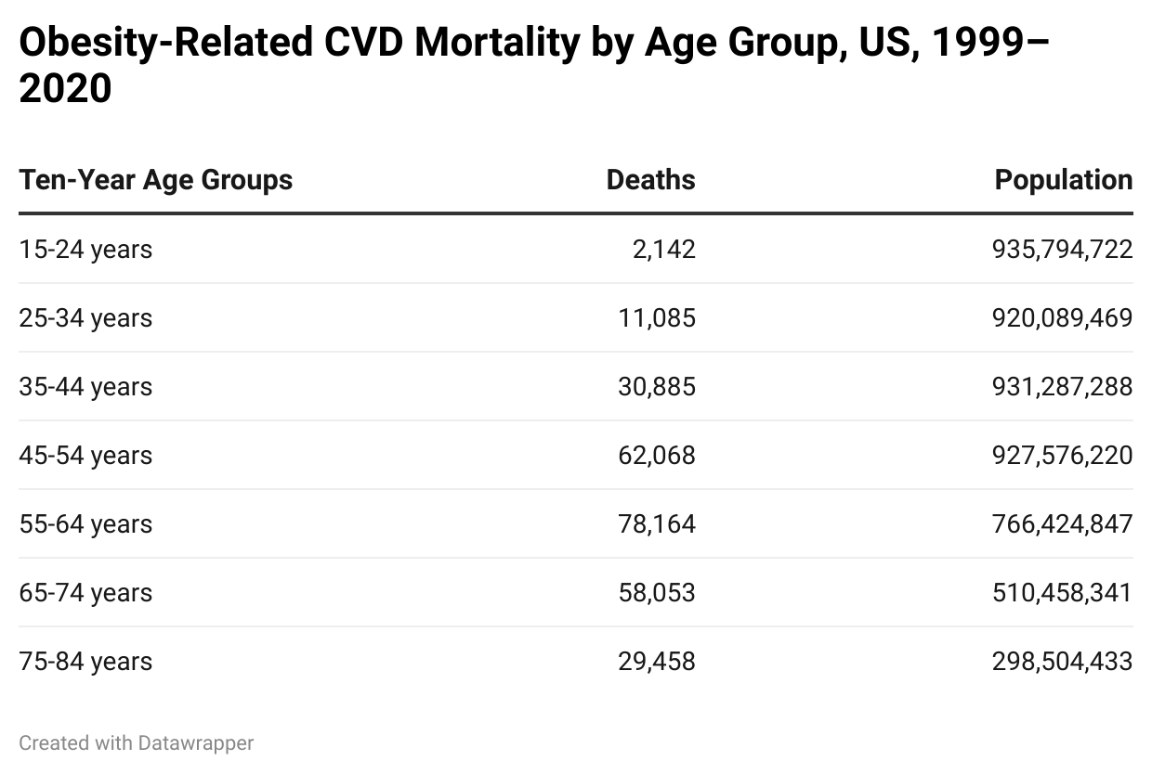

3. Obesity-Related CVD Mortality by Race, US, 1999–2020
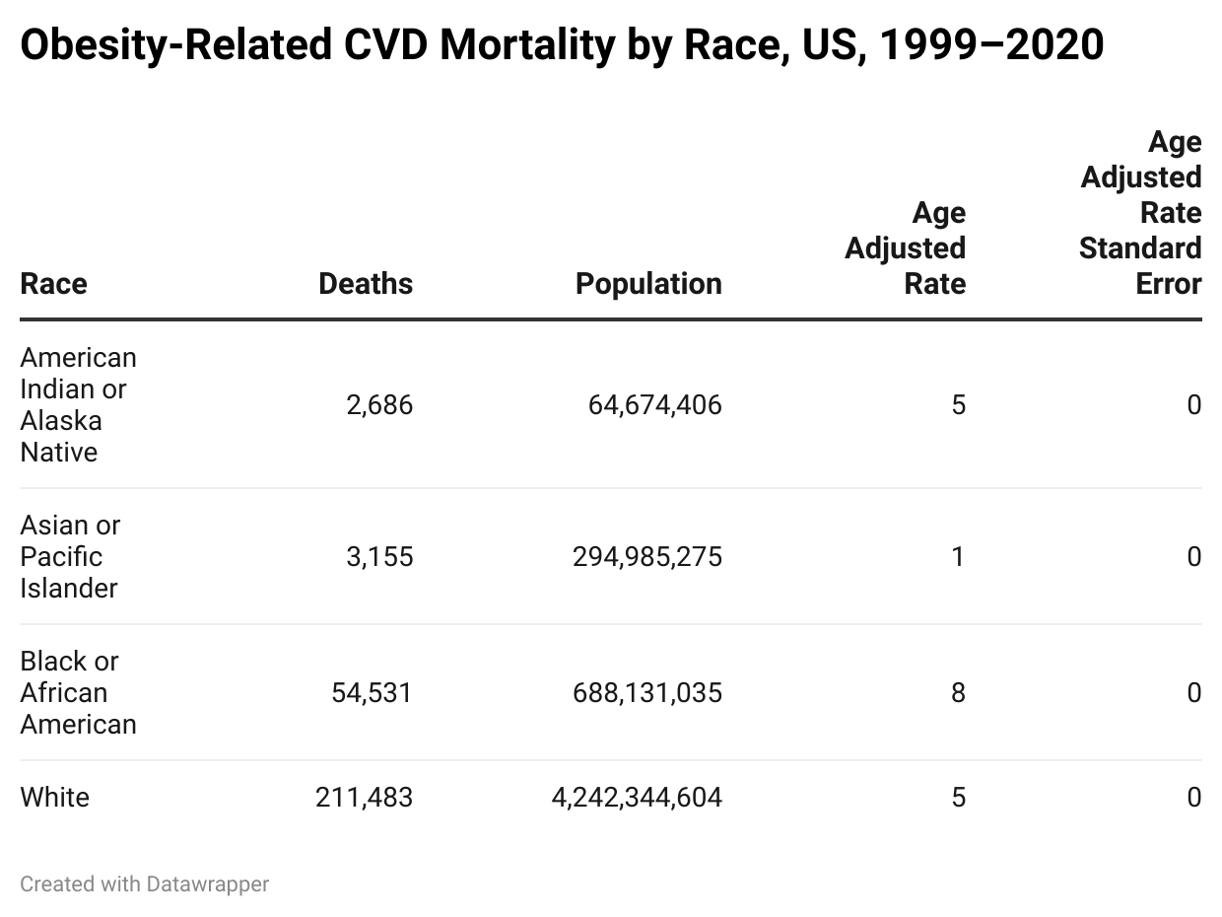

4. Obesity-Related CVD Mortality by Sex, US, 1999–2020
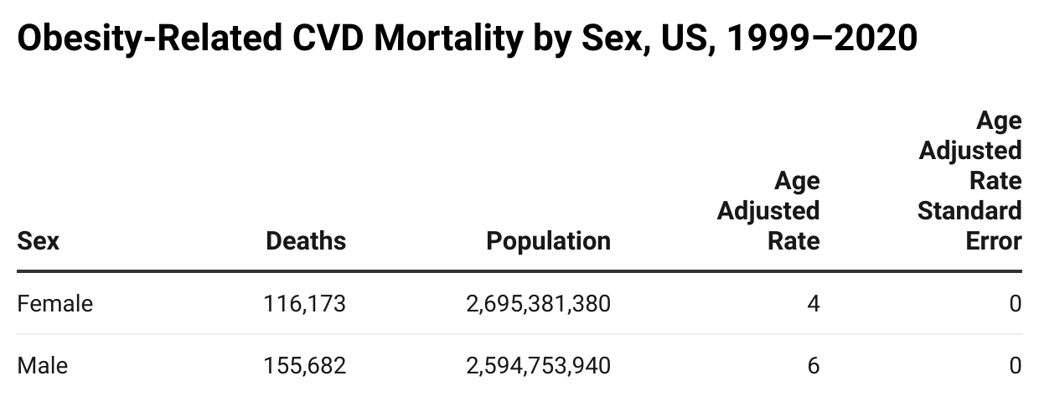

5. APCs
