Supplementary material
Figure S1: CONSORT diagram of the study
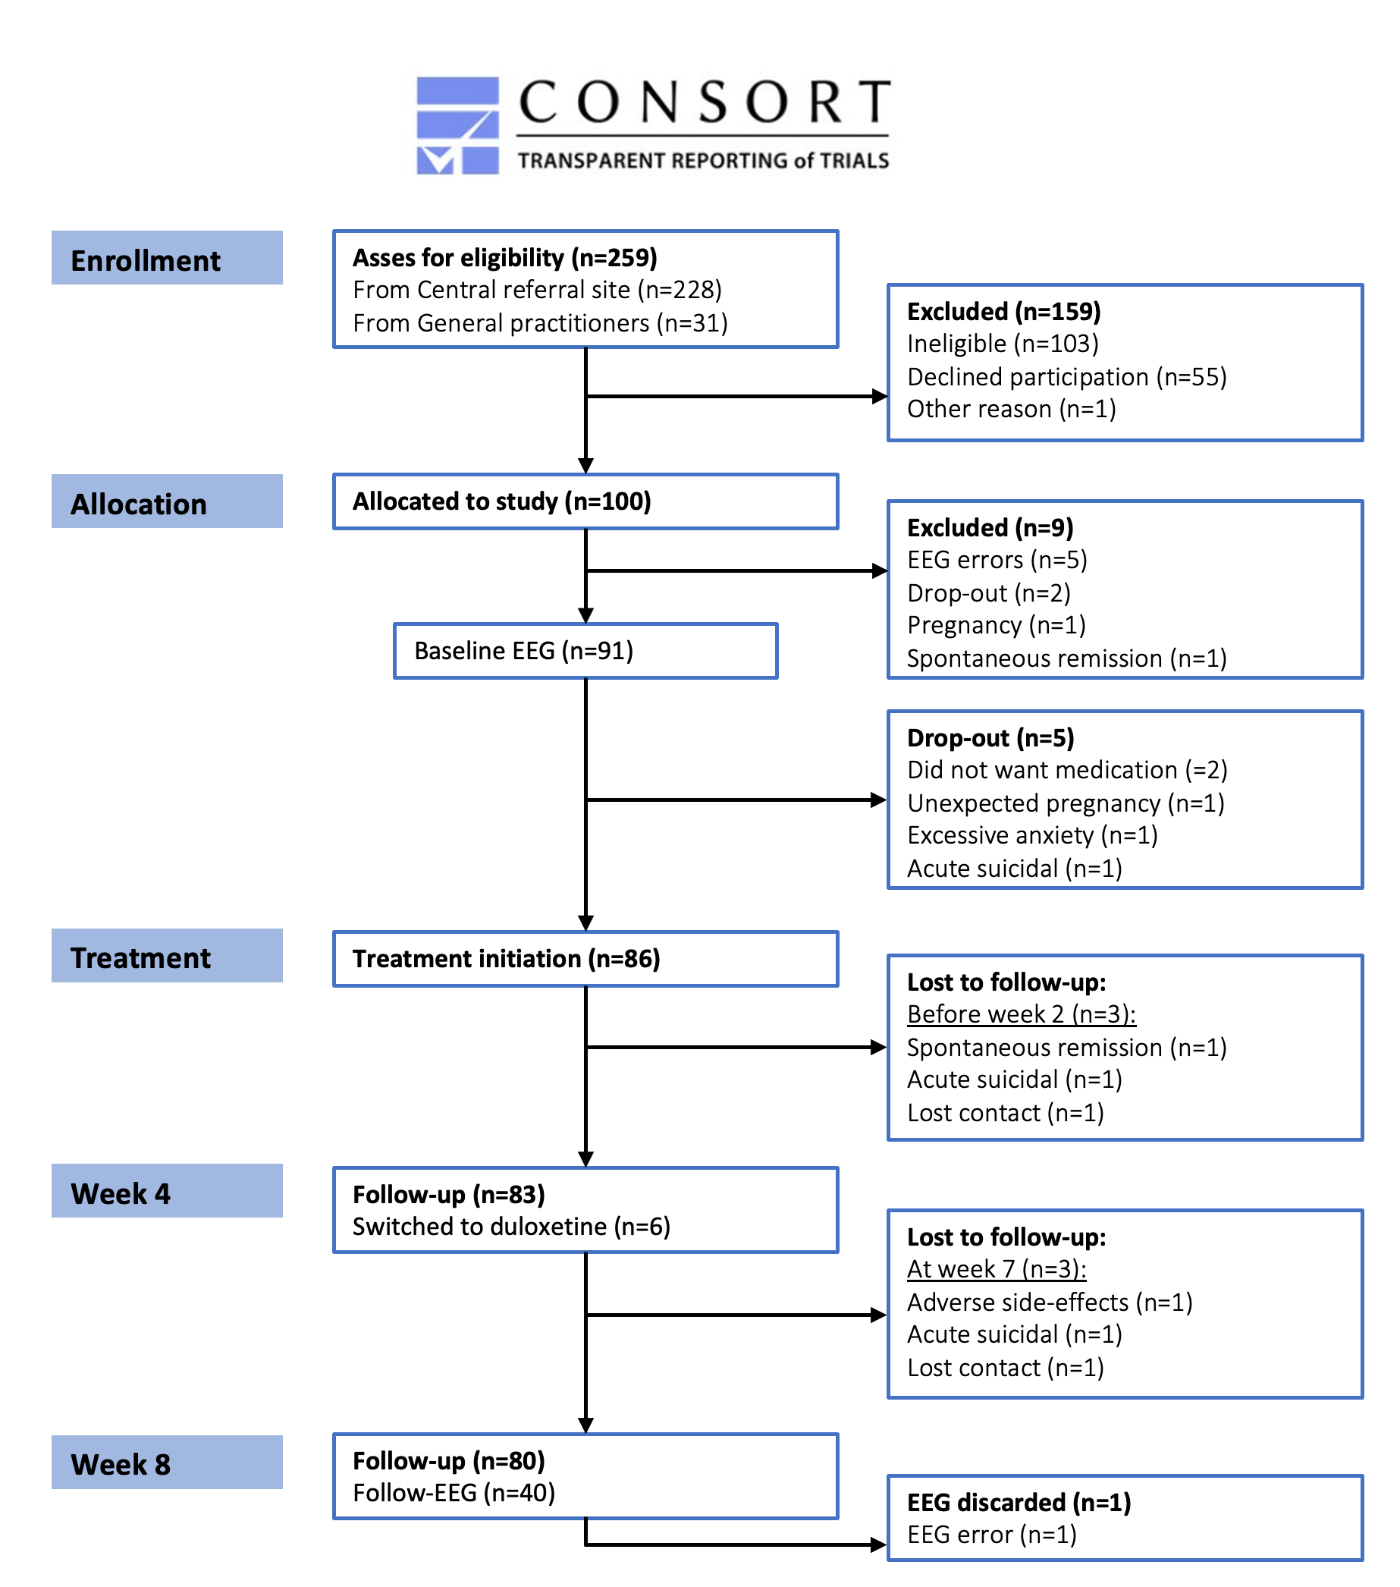

Figure S2: Regional sex differences in the aperiodic exponent
Sex-stratified: females above, males below. A) Mean aperiodic exponents with CI for the frontal, temporal, parietal and occipital cortical regions in MDD patients and HC. B) Topoplot of aperiodic exponents in MDD patients and HC, and C) group differences. 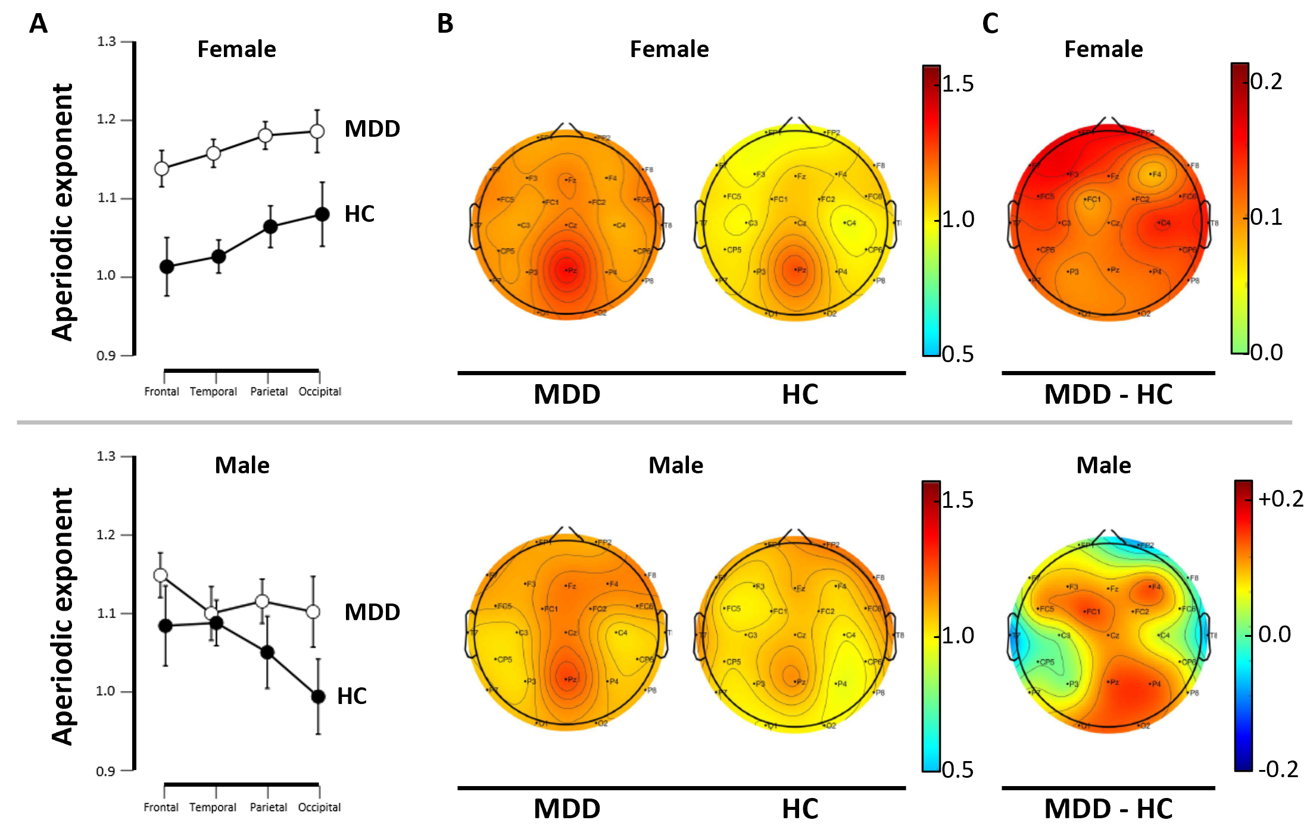

Figure S3: Hormonal contraceptive and frontal aperiodic exponent
Information on hormonal contraceptive use was available from 71 premenopausal women 18-50 years of age (median 24.5), not using hormonal contraceptives, using Combination oral contraceptives (COC) or levonorgestrel-releasing intrauterine devices (LNG-IUD).
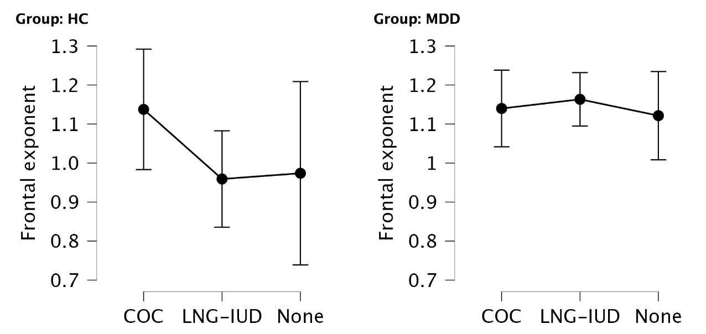

Figure S4: Frontal aperiodic exponent during treatment
Frontal aperiodic exponent from patients (treatment adherent) measures before treatment and at week 8 (n=39) with mean and SD. Change: -0.015, [-0.06; 0.03], Cohen’s d = 0.11[-0.43; 0.22], p = 0.501.

Table S1: Group comparisons of the aperiodic exponent
ANCOVA with age and sex as covariates. Correlations between regions were high (r=0.80-0.92).
1/f EEG | MDD (n=91) |  |  | HC (n=35) |  |  | Group-difference
Region | Mean (SD) | Range |  | Mean (SD) | Range |  | partial-ω2 | Cohen’s d | p
Frontal | 1.14 (0.21) | 0.65-1.66 |  | 1.03 (0.20) | 0.57-1.43 |  | 0.030 [0.000; 0.110] | 0.44 [0.04; 0.84] | 0.030
Temporal | 1.14 (0.22) | 0.61-1.63 |  | 1.04 (0.22) | 0.45-1.36 |  | 0.017 [0.000; 0.087] | 0.36 [-0.04, 0.76] | 0.078
Parietal | 1.16 (0.25) | 0.41-1.72 |  | 1.06 (0.23) | 0.48-1.42 |  | 0.013 [0.000; 0.079] | 0.33 [-0.07; 0.73] | 0.106
Occipital | 1.16 (0.26) | 0.40-1.82 |  | 1.05 (0.25) | 0.43-1.45 |  | 0.014 [0.000; 0.084] | 0.33 [-0.07; 0.73] | 0.099

Table S2: Hormonal contraceptive use
Information on hormonal contraceptive use was available from premenopausal women 18-50 years of age (median 24). Combination oral contraceptives (COC), Progestin-only oral contraceptives (POC), and levonorgestrel-releasing intrauterine devices (LNG-IUD).
Group | No use | COC | POC | LNG-IUD | Total (without POC)
HC | 7 | 4 | 0 | 7 | 18 (18)
MDD | 22 | 20 | 5 | 11 | 58 (53)
Total | 29 | 24 | 5 | 18 | 76 (71)

Table S3: Linear Regression Models Predicting Frontal Exponent
*Significant group (i.e. MDD) effect (p ≤ 0.010). All models were adjusted for age and sex. CATS = Childhood Trauma Questionnaire total score; SHAPS = Snaith-Hamilton Pleasure Scale; BDI-II = Beck Depression Inventory-II total score; B = unstandardized coefficient; SE = standard error; β = standardized coefficient. The analysis of CATS subscales was post hoc.
Predictor | Model | B [95% CI] | SE | β | Adj. R² | p | p_{FDR}
Depression | - group | 0.003 [0.0003; 0.005] | 0.001 | 0.182 | 0.228 | 0.030 | 0.059
(BDI-II) | + group | 0.002 [-0.004; 0.007] | 0.003 | 0.110 | 0.222 | 0.555 | 0.672
Anhedonia | - group | 0.013 [0.004; 0.022] | 0.004 | 0.251 | 0.219 | 0.005 | 0.019
(SHAPS) | + group | 0.009 [-0.003; 0.022] | 0.006 | 0.183 | 0.216 | 0.142 | 0.227
Familial | - group | 0.012 [-0.065; 0.088] | 0.038 |  | 0.205 | 0.762 | 0.762
Predisposition | + group* | -0.022 [-0.101; 0.057] | 0.040 |  | 0.243 | 0.588 | 0.672
Childhood | - group | -0.081 [-0.155; -0.007] | 0.037 | -0.182 | 0.259 | 0.028 | 0.059
Trauma (CATS) | + group* | -0.132 [-0.207; -0.057] | 0.038 | -0.296 | 0.347 | <0.001 | 0.003
- sexual abuse |  | 0.078 [-0.101, 0.256] | 0.090 | 0.072 |  | 0.390
- punishment | + group* | -0.013 [-0.073, 0.047] | 0.030 | -0.041 | 0.320 | 0.663
- neglect |  | -0.093 [-0.156, -0.030] | 0.032 |  |  | 0.004

Table S4: Linear Regression Models Predicting Frontal Exponent from Parental Bonding
The Parental Bonding Instrument (PBI) assesses recalled parental care and overprotection for each parent separately, with parent-specific cut-offs, and is traditionally analysed separately. However, cohabiting or separated, both parents impact the child possibly synergistically, and a combined model is also provided below. All models included age, sex, and diagnostic group (MDD vs. controls) as covariates. Collinearity was assessed using tolerance values and variance inflation factors (VIF), which were ≤1.3 in the separate models and ≤1.6 for the combined model. The models are not corrected for multiple comparisons due to their post hoc nature as replications. B = unstandardized coefficient; SE = standard error; β = standardized coefficient
Parent | Domain | B [95% CI] | SE | β | Adj. R² | p
Maternal | Care | 0.003 [-0.003; 0.009] | 0.003 | 0.108 | 0.283 | 0.269
Maternal | Overprotection | -0.007 [-0.013; -0.001] | 0.003 | -0.215 | 0.283 | 0.031
Paternal | Care | 0.008 [0.003; 0.012] | 0.002 | 0.326 | 0.300 | 0.002
Paternal | Overprotection | -0.0001 [-0.007; 0.007] | 0.003 | 0.005 | 0.300 | 0.995
Maternal | Care | 0.001 [-0.006; 0.007] | 0.003 | 0.019 | 0.305 | 0.859
Maternal | Overprotection | -0.006 [-0.013; 0.001] | 0.004 | -0.183 | 0.305 | 0.102
Paternal | Care | 0.006 [0.001; 0.012] | 0.003 | 0.273 | 0.305 | 0.016
Paternal | Overprotection | 0.003 [-0.005; 0.010] | 0.004 | 0.073 | 0.305 | 0.486

