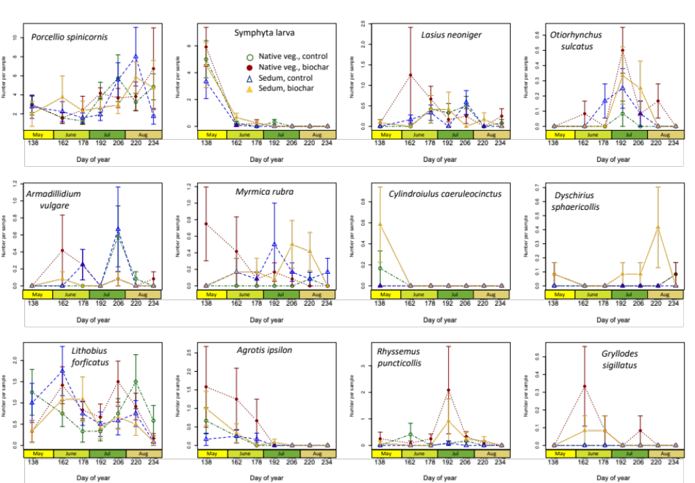

Figure S1: Average number of individuals per sample for 12 most commonly encountered arthropods in green roof samples by treatment. Means are plotted ± SE. Corresponding statistical analyses are shown in Table 3.

