Appendix S3
Rarefaction curves for Chao1, Shannon and observed species metrics

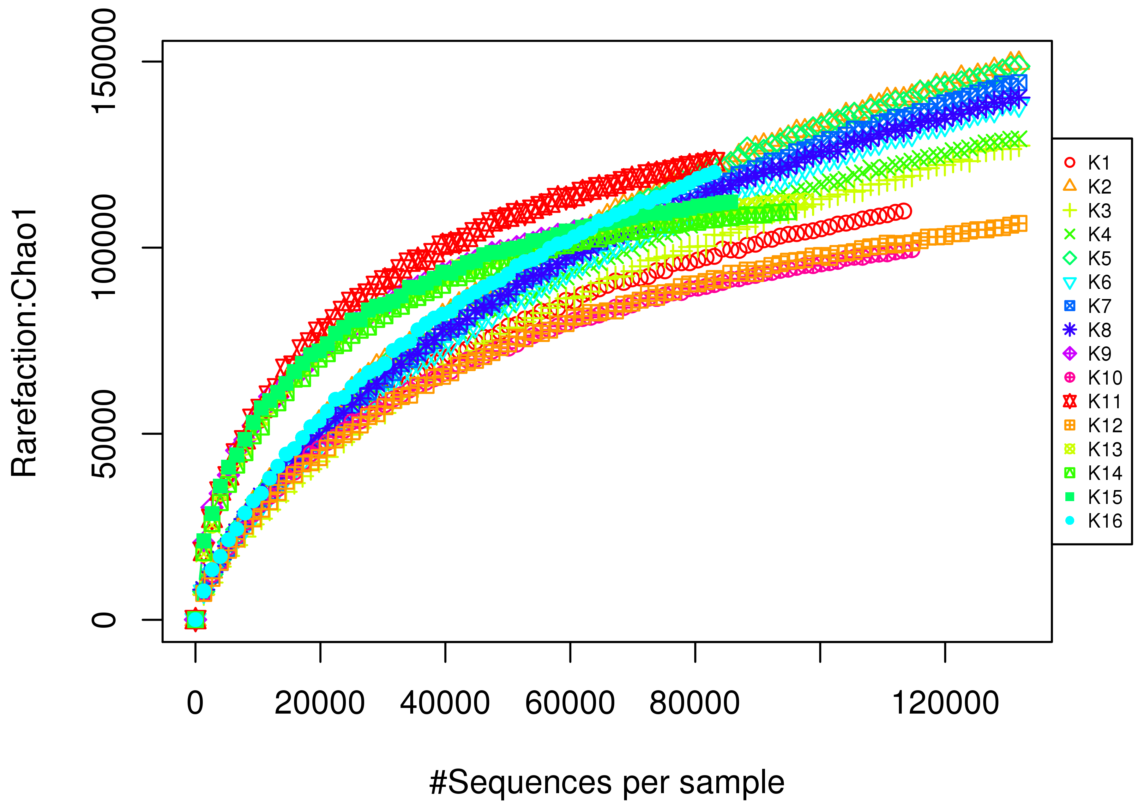
Chao1 curve obtained for the samples

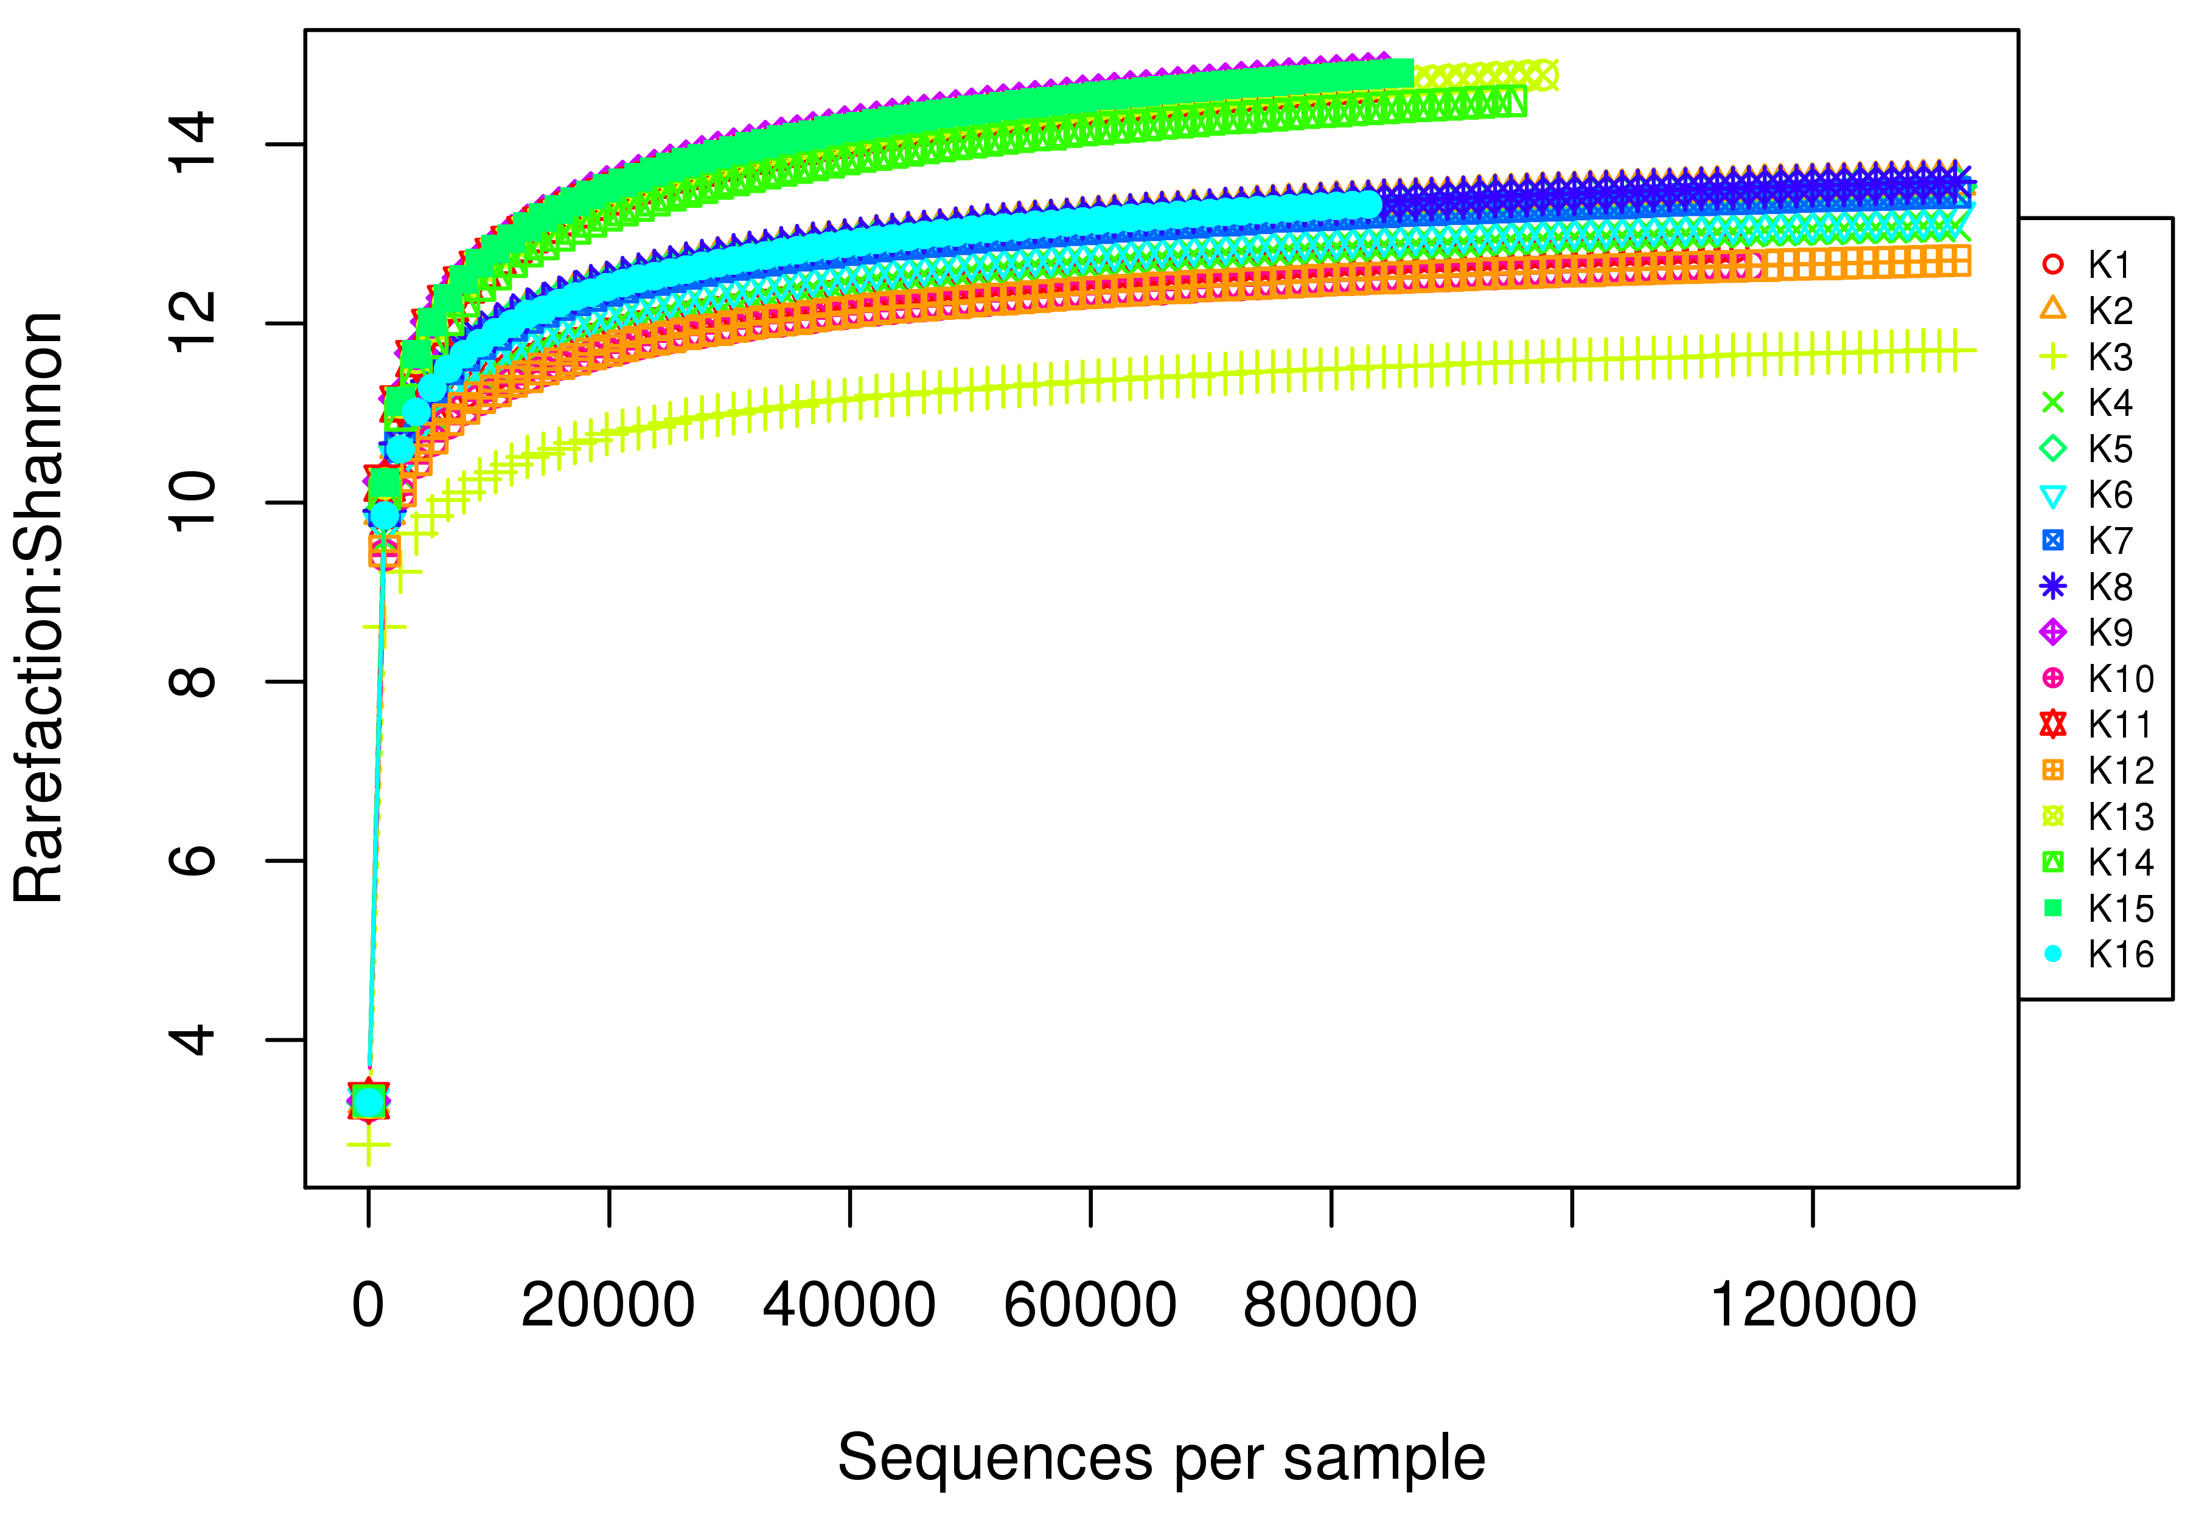
Shannon curve obtained for the samples

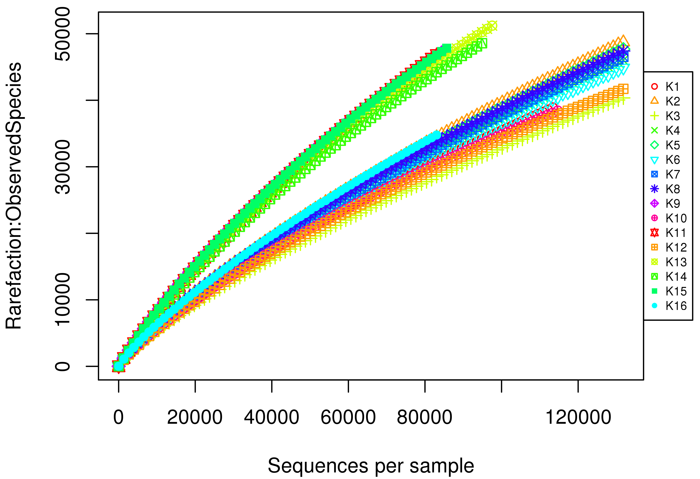
Observed species curve obtained for the samples

