Appendix S2
Heat maps
The taxa other than top 10 are categorized as “Others” and the sequences do not have any alignment against taxonomic database were categorized as “Unknown”.
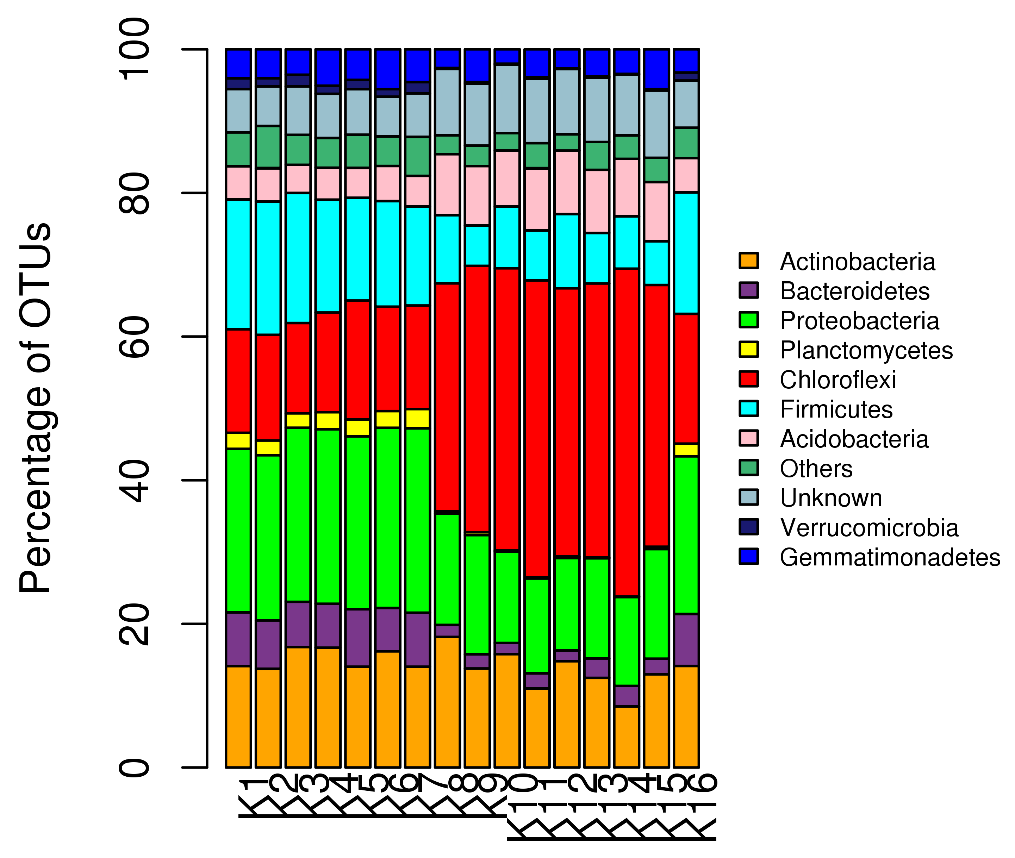
Phylum level classification for the samples

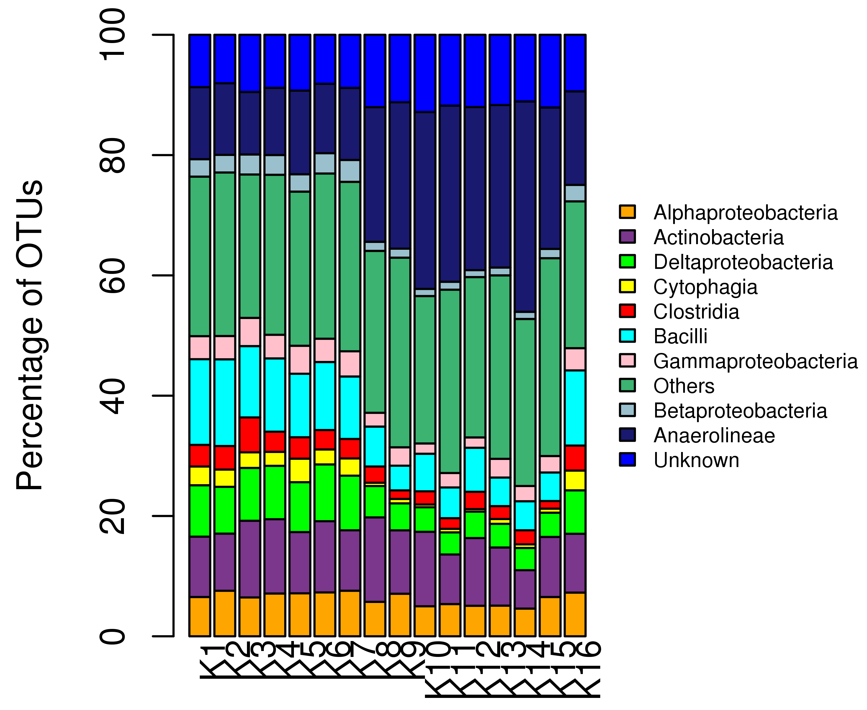
Class level classification for the samples

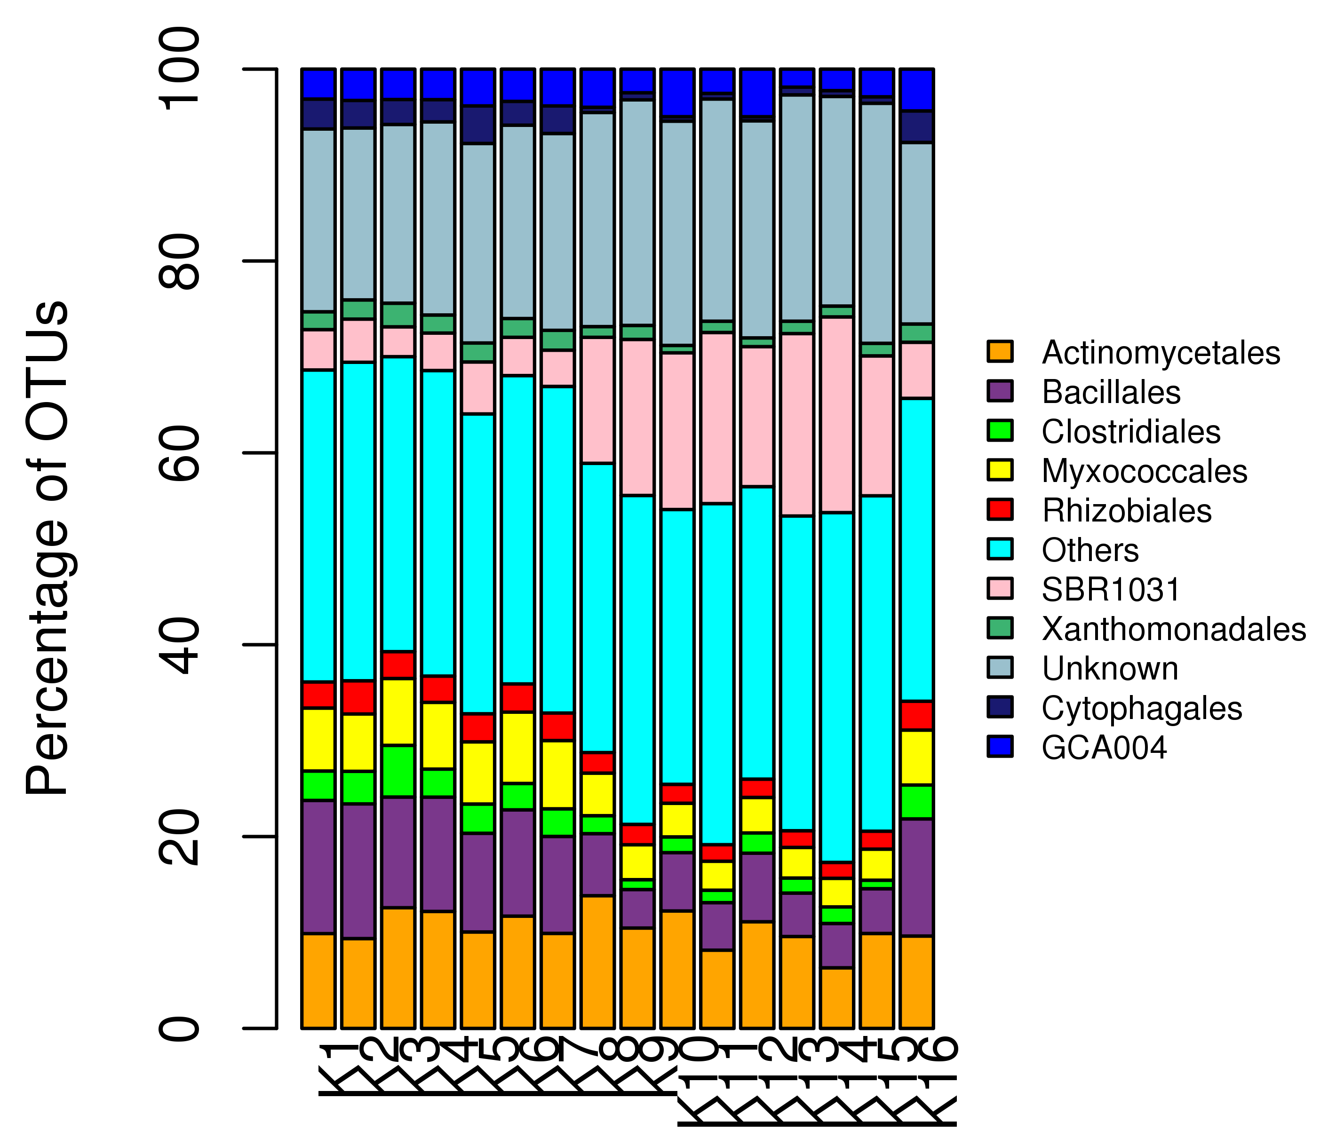
Order level classification for the samples

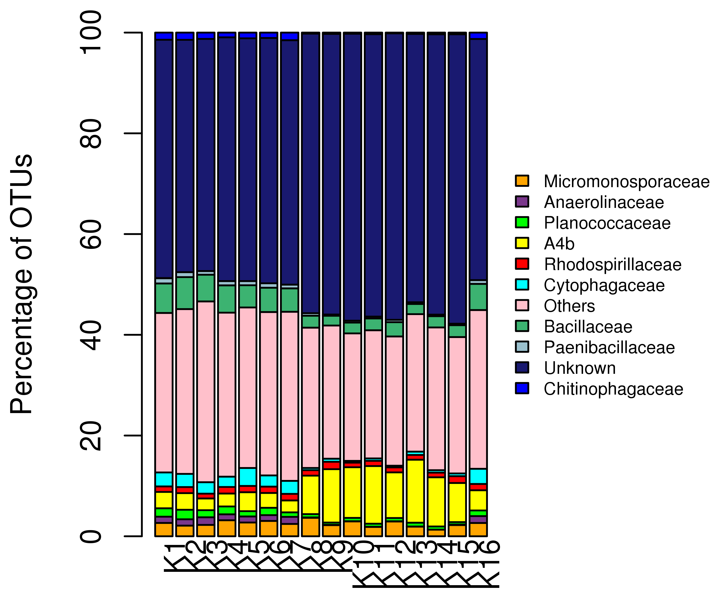
Family level classification for the samples

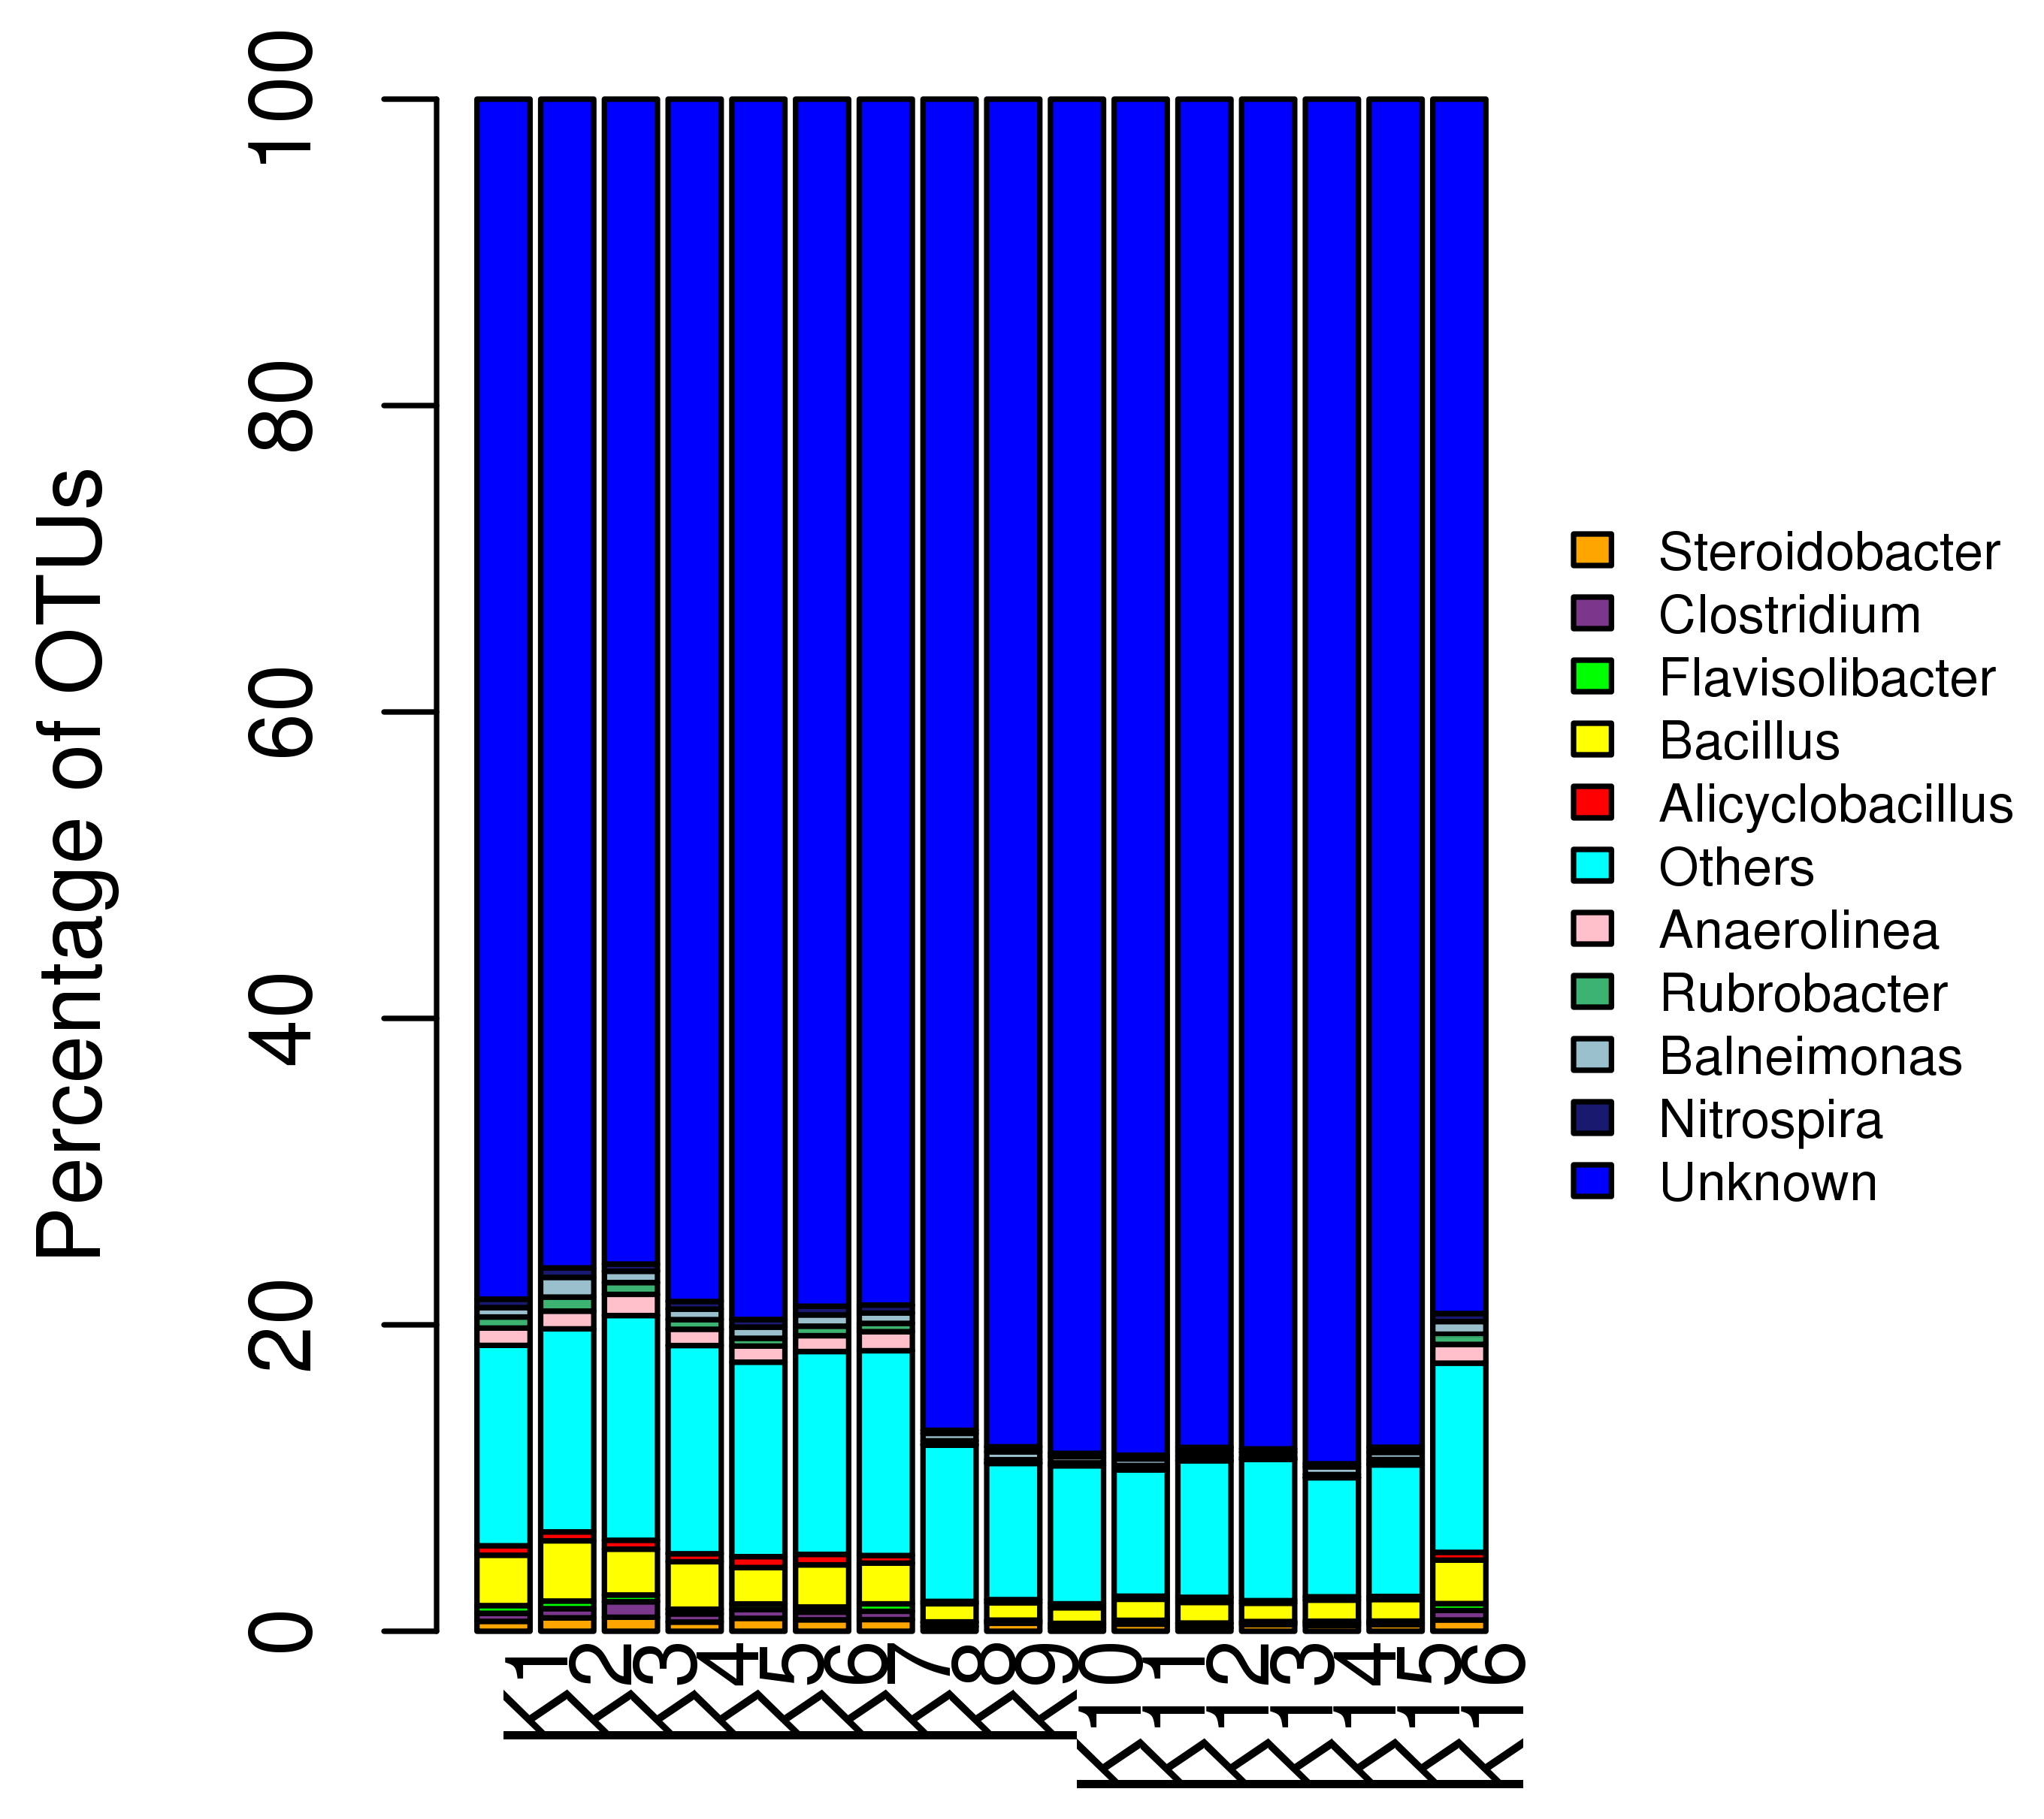
Genus level classification for the samples

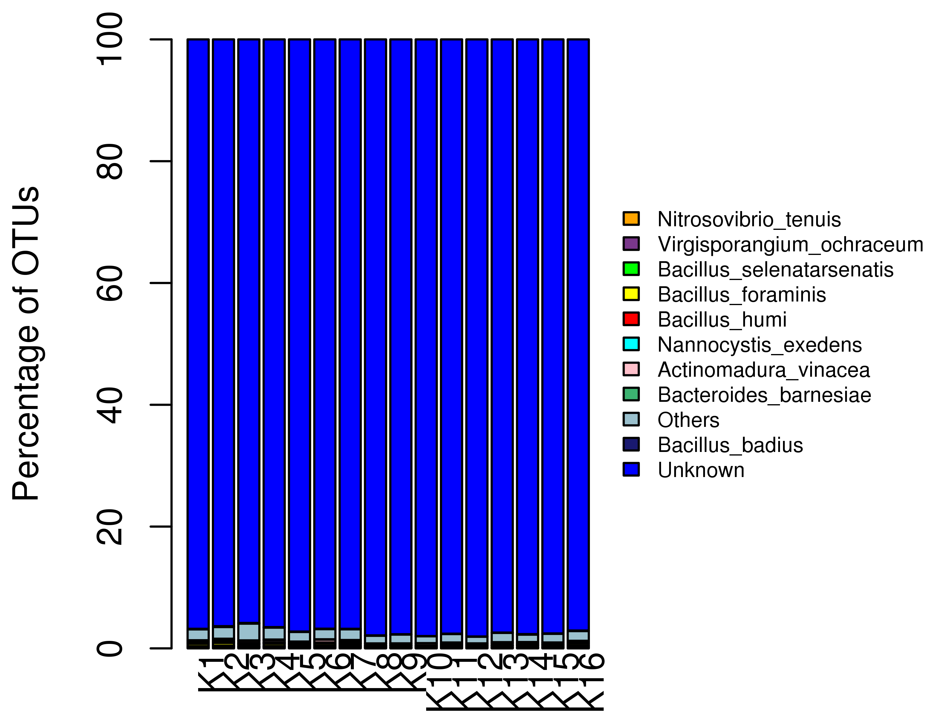
Species level classification for the samples

