GRAPHIC ABSTRACT

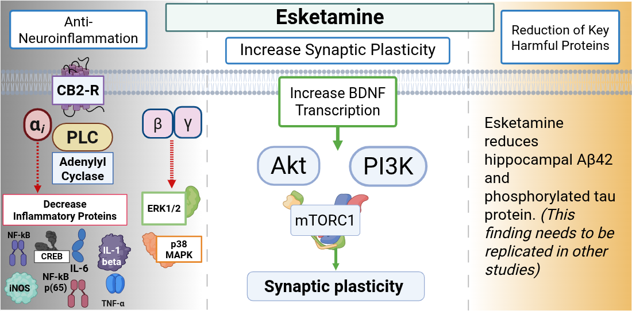
Figure legend: Adenylyl Cyclase enzyme (isoforms 5 or 6), BDNF (Brain-Derived Neurotrophic Factor), CB2-R (Cannabinoid 2 receptor), CREB (cAMP Response Element-Binding Protein), ERK1/2 (Extracellular signal-Regulated Kinase 1/2), IL-1 (Interleukin-1), IL-6 (Interleukin-6), iNOS (inducible nitric oxide synthase), mTORC1 (Mechanistic Target of Rapamycin Complex 1), NF-κB (Nuclear factor kappa light chain enhancer of activated B cells), NF-kB (p65) (Nuclear factor kappa light chain enhancer of activated B cells protein 65), p38 MAPK (mitogen-activated protein kinase p38 protein), PI3K-Akt (Phosphoinositide 3-Kinase/ Protein Kinase B), PLC (Phospholipase C), TNF-α (Tumor Necrosis Factor-α). Light green arrows indicate direct activation. Red dashed arrow: the pathway leads to inhibition downstream.
Created in https://BioRender.com

