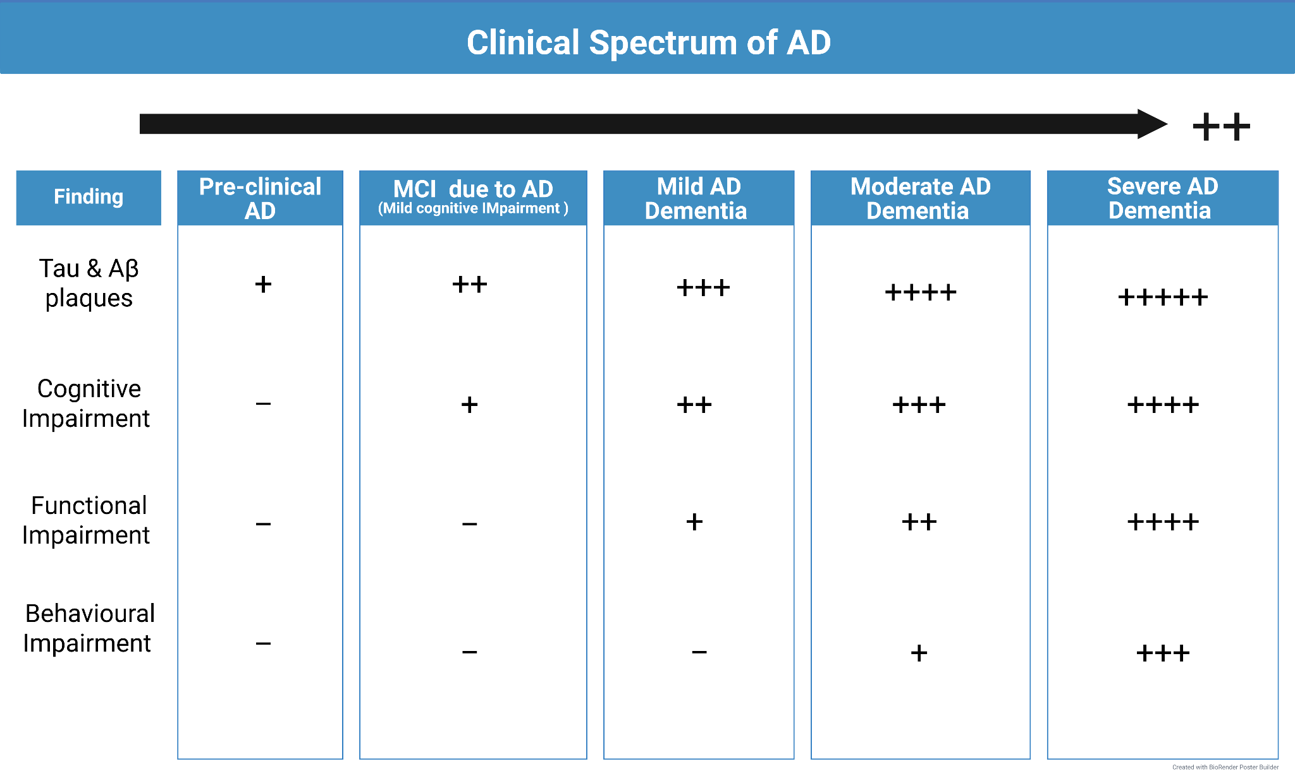
Table 1: Clinical Spectrum of AD. The clinical spectrum of Alzheimer’s disease (AD) ranges from the pre-clinical stage (with minimal cognitive, functional, and behavioral symptoms) to severe AD Dementia. The accumulation of tau and Aβ proteins is proportional to the stage of the illness. Tau & amyloid-β (Aβ) plaques begin accumulating early, even in the preclinical phase, and progressively worsen throughout the disease. Functional impairment, e.g., difficulty with daily activities, emerges in mild AD dementia and significantly worsens as the disease advances. Behavioral impairment, e.g., agitation and mood changes, tends to appear later, becoming more prominent in moderate to severe AD.
Created in BioRender. ElSayed, M. (2025) https://BioRender.com/9n4kmgd (4)

