Table 1 Recent findings related to packed-bed thermal energy storage system.
Author(s) | Geometry configuration | PCM | Significant outcomes
Huang et al. [24] | 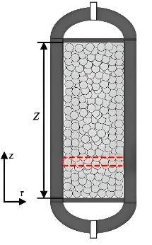 | Air/  nitrogen | - Optimized CESPB using the RSV approach.  - Larger aspect ratios improved efficiency but raised pressure drop.  - Peak performance: 63.72% exergy, 81.12% thermal, 81.13% discharging..
Guo et al. [25] | 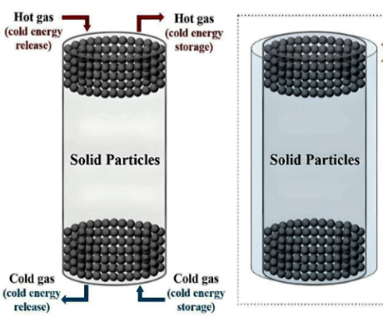 | Compressed air and diathermic oil | - Study analyzed two-stage packed beds in CES for LAES systems.  - Round-trip efficiency dropped 16.8% due to intermittent periods and cold energy loss.  - Axial heat conduction and temperature gradients worsened over cycles.  - Future work: minimize cold energy loss and improve efficiency through packed bed integration.
Xuan Dong a et al. [18] | 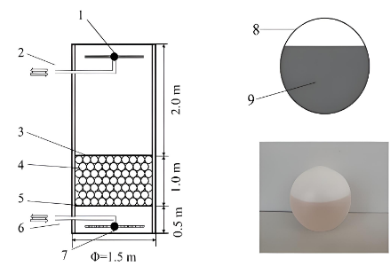 | DI water | - Study explores PCM balls for cold energy storage in air-conditioning systems.  - Smaller PCM balls (60 mm) and faster flow rates improve freezing rate.  - Optimal sizes (90 mm and 60 mm) achieve 100% freezing in 8 hours.  - Future work: refine ball diameter and flow rate for better efficiency and cost reduction.
Bowen Chi et al. [26] | 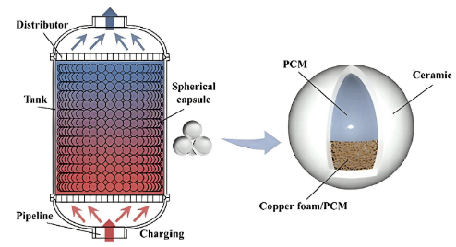 | Paraffin wax | - Study investigates copper foam in spherical capsules for PCM heat transfer.  - High cone shape optimizes heat transfer via convection and conduction.  - Case F2 reduces copper foam by 24.48% and speeds melting by 22.93%.
[27] Narasimha et al. | 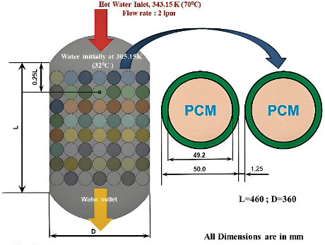 | Paraffin wax | - Study examines PBLHTES using EPCMs and MWCNT for improved heat transfer.  - Inclining EPCMs reduces efficiency; larger angles keep the system ideal.  - 3% MWCNT improves melting rate by 13.16%, with minimal gains beyond.
Sebbar  et al. [28] | 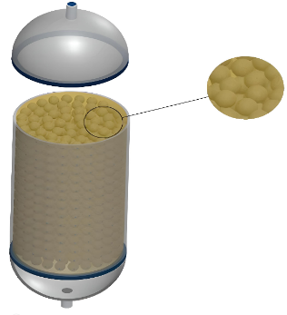 | DI water | - Model analyzes thermal storage with water as PCM in a cylindrical container.  - Results show supercooling impacts energy performance and matches experiments.  - Lower crystallization temperature or higher HTF flow shortens storage time.
Wu et al. [29] | 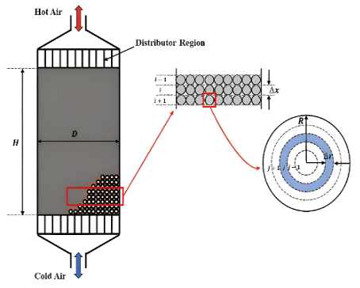 | DI water | - Density (40.8%) and latent heat (32.8%) boosted heat storage.  - Melting temperature (45.7%) and thermal conductivity (22.4%) improved residual heat.  - Density (31.9%) and melting temperature (24.4%) enhanced CAES efficiency.
Shao et al. [30] | 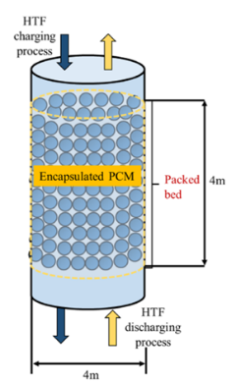 | DI water | - Max Efficiency: 42% PCM-1 & 18% PCM-2 improve exergy & volume but increase costs.  - Lower Cost: 18% PCM-1 & 42% PCM-2 cut costs by 6.8%, reducing discharge efficiency by 14.1%.  - Balanced Performance: PCM-1 struggles in charging, PCM-2 in discharging; cascaded setup optimizes both.  - Better Heat Transfer: Placing PCM-1 below & PCM-2 above enhances central tank efficiency.
Al-Shannaq et al. [17] | 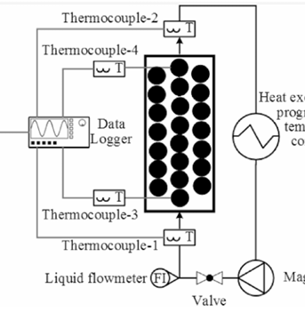 | DI water | - 12x Conductivity Boost: Graphite encapsulation slashes freezing/melting times.  - Efficient Freezing: Composite spheres enhance nucleation and freezing performance.  - Faster Freezing: At 3.5°C, 1000 mL/min, 5.3h freeze time; 45% faster at 5.5°C, 65% at 7.5°C.

