Supplementary Information – Marine heatwaves disrupt culling of Crown-of-Thorns-Starfish on the Great Barrier Reef
Contents
Section S1: Extra details of CoTS Control Methodology 2
Section S2: Variable Descriptions 3
Section 3.0: GLMM to investigate how heat stress affect CoTS detectability on manta tows? 5
Section S4: Hurdle model to investigate feeding scar reliability and effects of heat stress on culled CoTS 12
Section S5: GAM to investigate increasing annual heat stress severity alter the seasonal trajectory of CPUE? 17

Figures
Figure S1. …………..…………………………………………………………………………2
Figure S2..……………………………………………………………………………………..6
Figure S3.1. ……..…………………………………………………………………………….7 Figure S3.2. ……..…………………………………………………………………………….8
Figure S3.3. ………..………………………………………………………………………….9
Figure S3.4. ………..………………………………………………………………………...10
Figure S3.5. ………..………………………………………………………………………...11
Figure S3.6. ………..………………………………………………………………………...12
Figure S4.1. ………..………………………………………………………………………...14
Figure S4.2. ………..………………………………………………………………………...15
Figure S4.3. ………..………………………………………………………………………...16
Figure S5. ………..………...………………………………………………………………...18
Tables
Table S1 ……………………………………………………………………………………….2
Table S2 …………………………………………………………………...………………3 - 4
Table S3 ……………………………………………………………………………………….5
Table S4 ……………………………………………………………………………………...13
Table S5 ……………………………………………………………………………………...17

Each research question is referred to as:
- How does heat stress affect COTS detectability on manta tows?
- Are feeding scars a reliable indicator of COTS presence?
- How does heat stress affect the number and size distribution of COTS culled?
- How does increasing annual heat stress severity alter the seasonal trajectory of CPUE?
- How does the seasonal relationship between COTS abundance and coral cover vary under heat stress?

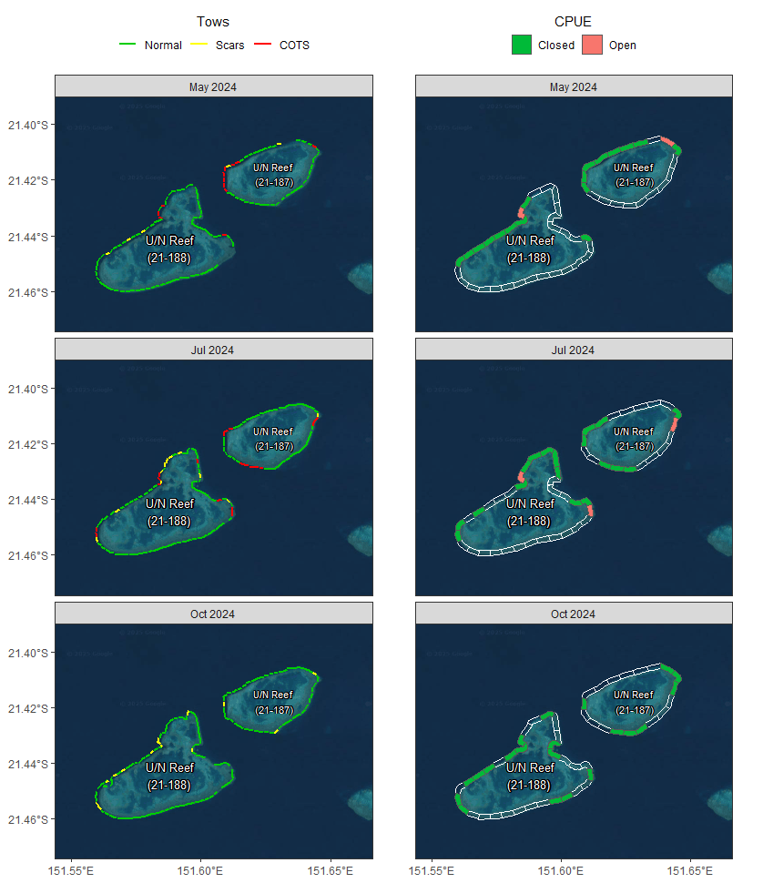
Section S1: Extra details of CoTS Control Methodology
Fig. S1. Example of manta tow surveillance (left) and subsequent culling activity (right) in the Swain Reefs National Park (Southern GBR), conducted in July 2024. Areas where CoTS presence was detected on manta tows (yellow and red tows) were the areas where culling was performed and CoTS-per-unit-effort (CPUE) was assessed against the ecological threshold (ET). Sites where CPUE was below the ET were closed (green) and sites where it was above remained open for further culling (red).
0
2 km
Table S1. Categories of hard coral cover (%) used in manta tow surveys to quantify reef coral cover. Each category represents a coral cover range bracket used for estimating percent cover during surveys.
Category | Coral Cover Estimate (%)
0 | 0
1− | >0–5%
1+ | >5–10%
2− | >10–20%
2+ | >20–30%
3− | >30–40%
3+ | >40–50%
4− | >50–62.5%
4+ | >62.5–75%
5− | >75–87.5%
5+ | >87.5–100%

Section S1.1: The Use of Hard Coral as a Covariate
Coral cover was a useful covariate to explain variance in CoTS detections (likely due to lack of coral being a good reason for few CoTS to be present). RQ2-4 all use culling records as their response variable while coral cover was only recorded in manta tows. As such, manta tow records were spatiotemporally joined to their closest cull record along with the variable ‘Tow_Cull_Time_Diff’ representing how far apart the coral cover was recorded from the actual cull event.

Section S2: Variable Descriptions
Table S2. Descriptions of all variables used in every analysis
Variable | Description | Used In Models | RQs
COTS Observed/Scar Presence | Presence or count of COTS or scars from manta tow surveys | GLMM | 1
COTS Culled/Presence | Count or presence of COTS individuals culled by size class | Hurdle Model | 2,3
CPUE | Catch per unit effort; COTS culled per Bottomtime | Tweedie GAM | 4
ΔHCC | Change in hard coral cover (%) | GAMM | 5
Heat Stress Metric | SST, DHW, BAA, or Bleaching Presence | GLMM, Hurdle, Tweedie GAM | 1-4
Heat Stress Metric × Size | Interaction between heat stress and COTS size cohort | Hurdle Model (Count) | 3
ΔCOTS × max DHW | Smooth interaction between change in COTS and max DHW | GAMM | 5
Region | GBR region to capture spatial structure | All models | 1-5
Season | Summer (Nov–Apr) vs Winter (May–Oct) | All models | 1-5
Latitude | Models southward shift or gradient in COTS/outbreak patterns | GLMM, Hurdle | 1-3
HCC (Hard Coral Cover) | Binned coral cover percentage | All models | 1-5
Reef | Unique reef identity | All models | 1-5
Session (nested in Reef) | Time-based survey sessions within reefs | GLMM | 1
Cull Site (nested in Reef) | Nested random intercept to group cull sites within reefs | Hurdle Model | 2-3
Dive (nested in Cull Site) | Groups observations by dive event, nested in cull site | Hurdle Model | 2-3
Size (COTS Cohort) | COTS size classes used in culling records | Hurdle Model (Zero) | 2
COTS Detection | Type of detection that initiated cull (COTS, scar, other) | Hurdle Model (Zero) | 2
Bottomtime | Time spent surveying per cull dive (survey effort) | Hurdle Model, Tweedie GAM | 2-3
TowCullTimeDiff | Time between manta tow and associated cull event | Hurdle Model, Tweedie GAM | 2-4
PRevious CPUE | Weighted CPUE from earlier culls (exponential decay, 10 day half-life) | Tweedie GAM | 4
Day of Year | Seasonal position of survey (1–365), cyclic spline for annual cycle | Tweedie GAM | 4
SST | Sea surface temperature (absolute) | Tweedie GAM | 4
DHW (Degree Heating Weeks) | Cumulative thermal stress | Tweedie GAM, GAMM | 4
BAA (Bleaching Alert Area) | NOAA bleaching alert category | Tweedie GAM | 4
HCC Summer | Starting coral cover in summer season | GAMM | 5
COTS Summer | Starting COTS abundance in summer season | GAMM | 5
Seasonal Year | Random intercept for annual cycle (e.g., Summer 2017) | GAMM | 5

Section S3: GLMM to investigate how heat stress affect CoTS detectability on manta tows?
Model structure for the predicting CoTS Observations:
COTS Observed ~ Heat Stress Metric + Region + Season + (1 | Hard Coral) +
Latitude + (1 | Reef/Session), family = nbinom1
And feeding scar presence:
Scar Presence ~ Heat Stress Metric + Region + Season + (1 | Hard Coral) +
Latitude + (1 | Reef/Session), family = binomial
See Table S2 for variable details
Table S3. Sample size of the nested structures (Session within Reef) for each year of manta tow surveillance data.
Year | Sessions | Reefs
1991 | 84 | 84
1992 | 60 | 57
1993 | 76 | 71
1994 | 107 | 96
1995 | 95 | 95
1996 | 79 | 79
1997 | 88 | 88
1998 | 107 | 107
1999 | 93 | 93
2000 | 103 | 101
2001 | 136 | 120
2002 | 103 | 100
2003 | 69 | 69
2004 | 92 | 92
2005 | 102 | 88
2006 | 88 | 79
2007 | 90 | 82
2008 | 76 | 74
2009 | 79 | 74
2010 | 64 | 61
2011 | 37 | 37
2012 | 102 | 90
2013 | 195 | 164
2014 | 124 | 108
2015 | 186 | 148
2016 | 141 | 114
2017 | 198 | 150
2018 | 337 | 210
2019 | 503 | 276
2020 | 498 | 283
2021 | 431 | 270
2022 | 358 | 215
2023 | 329 | 211
2024 | 402 | 272
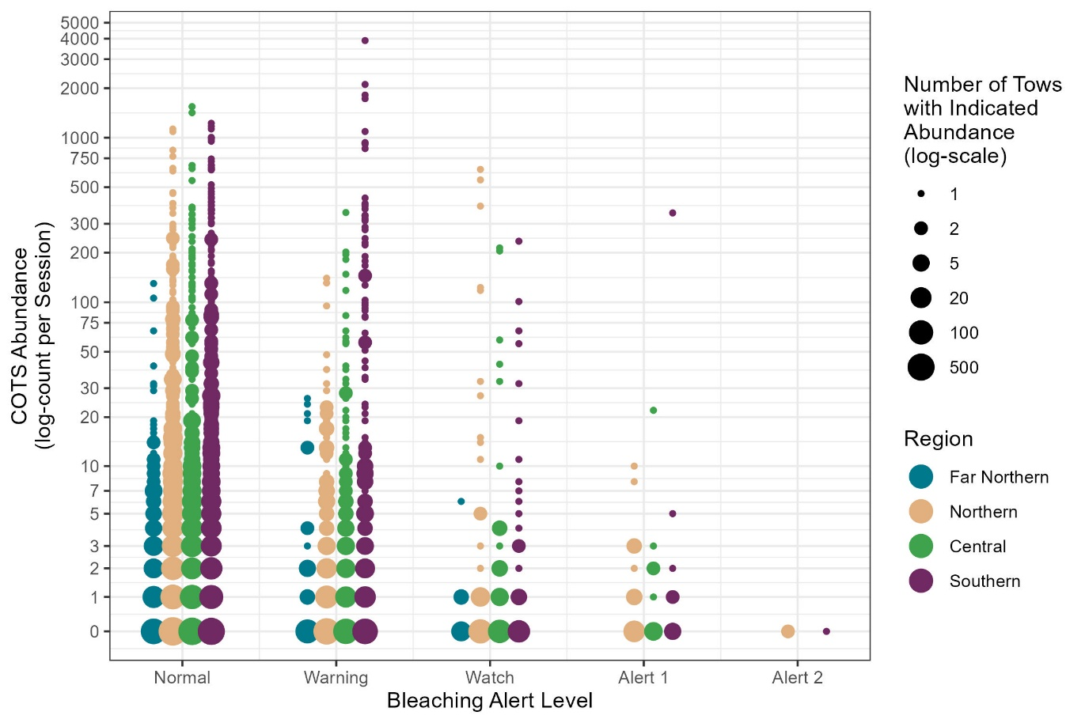
Figure S2: Relationship between CoTS observations, bleaching alert level, and region of the GBR. Point size shows the number of sessions recorded at that specific plot point (how many points are stacked on top of each other) in log scale so the change in size between 1 to 5 is the same as 20 to 500.

Section 3.1: Model Validation
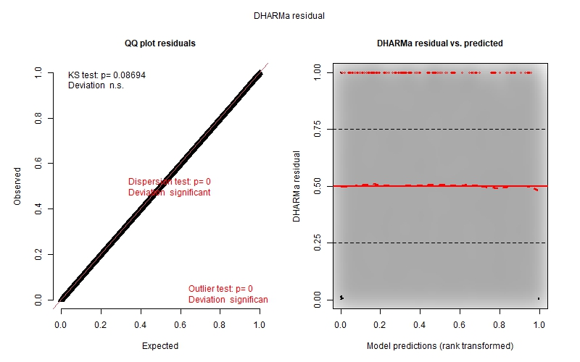
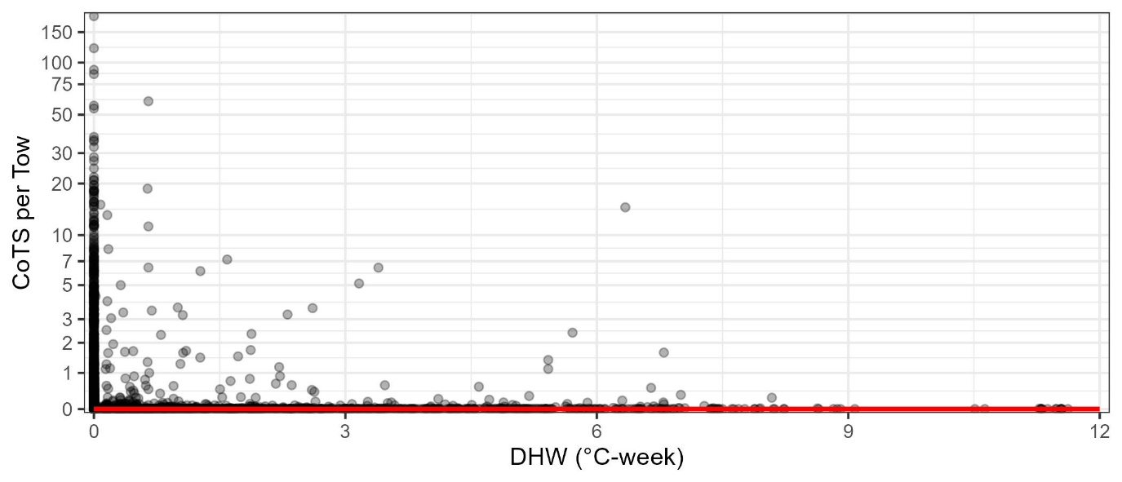
No major violations of normality and homoscedasticity assumptions were observed for any of the 8 models generated to answer this question (Fig S3.1 - 3.8).
Figure S3.1: Model estimates (red line) with original data (black points) aggregated to session on a log axis (top). DHARMa Residual analysis of normality (left) and homoscedasticity (right) for the negative binomial GLMM predicting COTS observations using DHW as the heat stress metric.
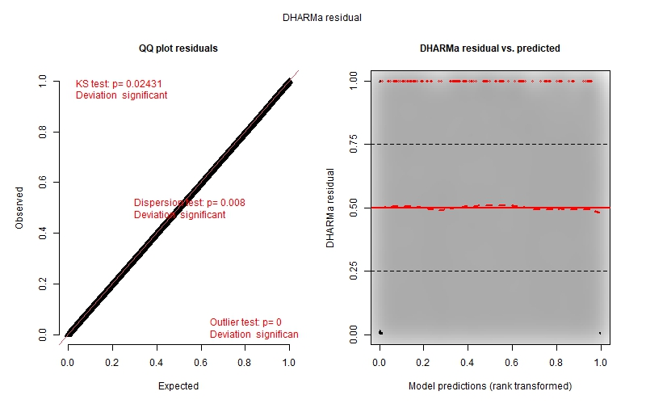
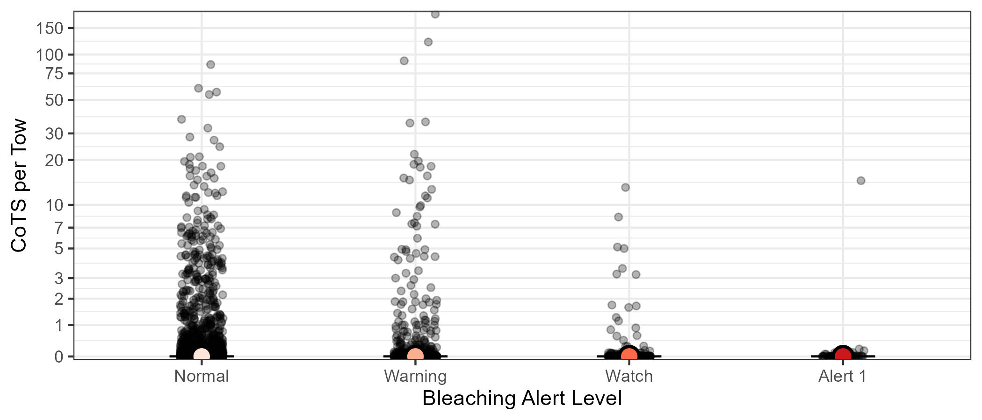
Figure S3.2: Model estimates (filled dots) with original data (black points) aggregated to session on a log axis (top). DHARMa Residual analysis of normality (left) and homoscedasticity (right) for the negative binomial GLMM predicting COTS observations using BAA as the heat stress metric.
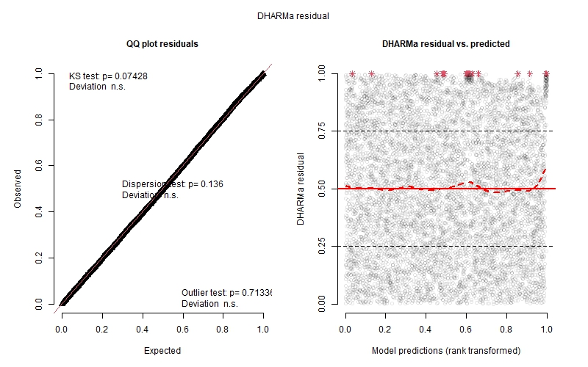
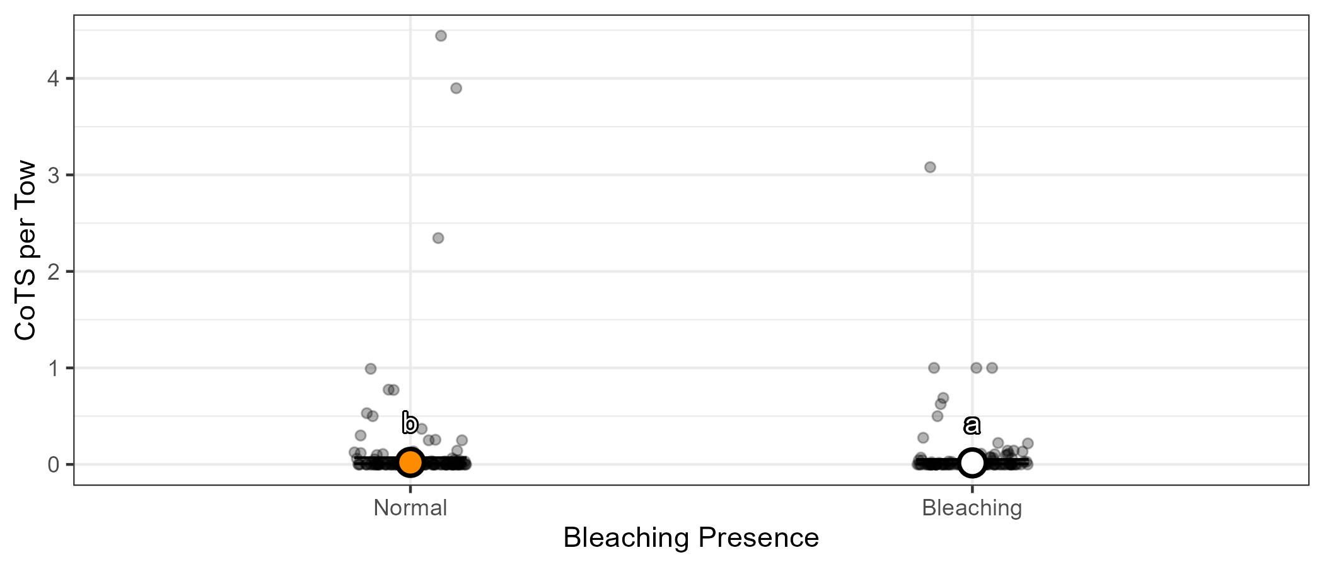
Figure S3.3: Model estimates (filled dots) with original data (black points) aggregated to session (top). DHARMa Residual analysis of normality (left) and homoscedasticity (right) for the negative binomial GLMM predicting COTS observations using Bleaching Presence as the heat stress metric.

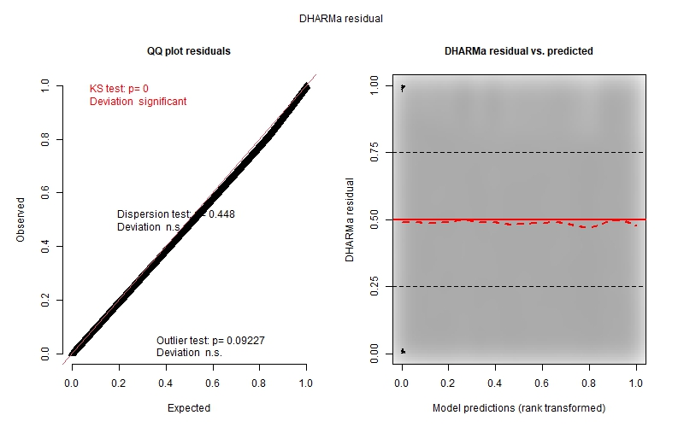
Figure S3.4: Model estimates (filled dots) with original data (black points) aggregated to session (top). DHARMa Residual analysis of normality (left) and homoscedasticity (right) for the binomial GLMM predicting COTS feeding scar presence using DHW as the heat stress metric.
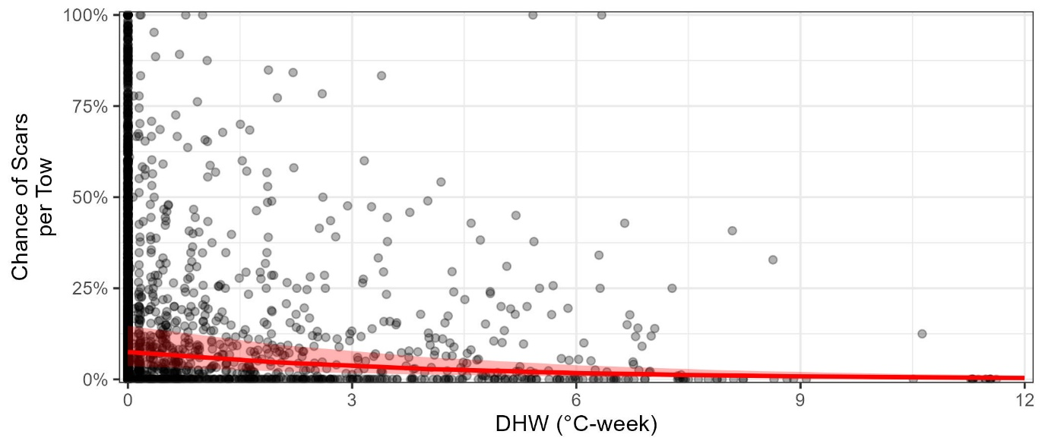
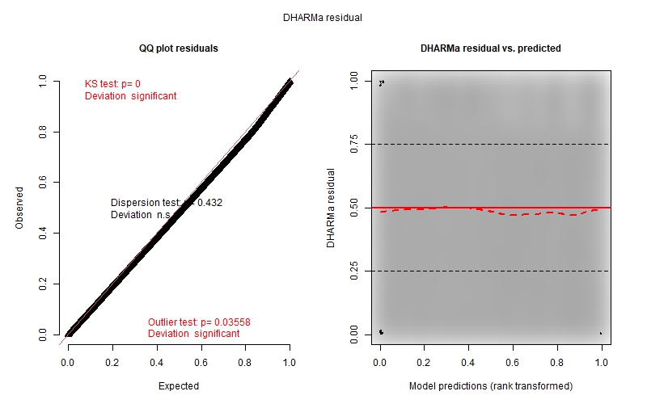
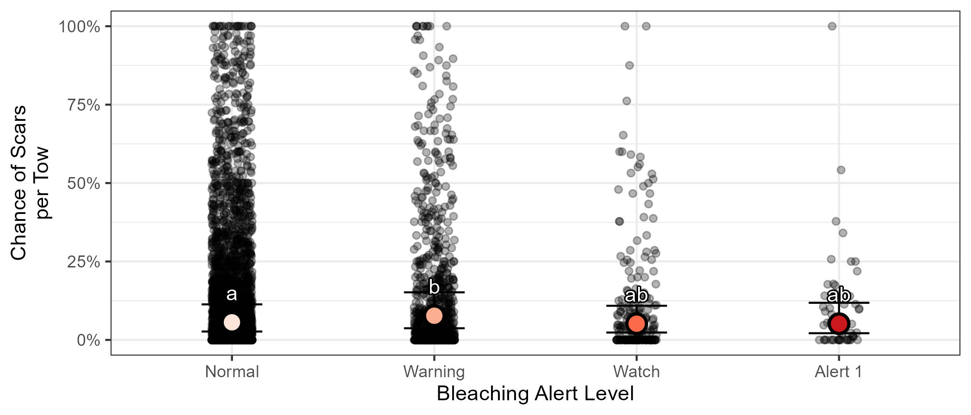
Figure S3.5: Model estimates (filled dots) with original data (black points) aggregated to session (top). DHARMa Residual analysis of normality (left) and homoscedasticity (right) for the binomial GLMM predicting COTS feeding scar presence using BAA as the heat stress metric.

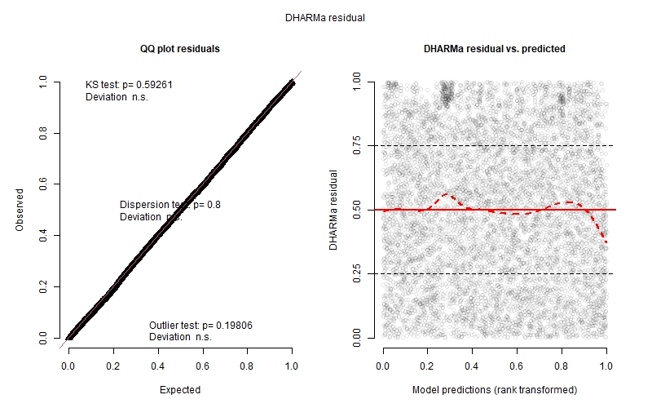
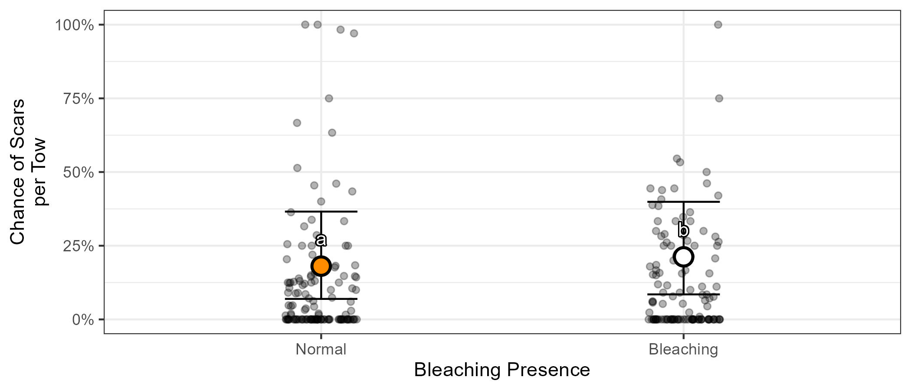
Figure S3.6: Model estimates (filled dots) with original data (black points) aggregated to session (top). DHARMa Residual analysis of normality (left) and homoscedasticity (right) for the binomial GLMM predicting COTS feeding scar presence using Bleaching Presence as the heat stress metric.

Section S4: Hurdle model to investigate feeding scar reliability and effects of heat stress on culled CoTS
Model structure for the predicting CoTS Culled:
`COTS Culled` ~ Heat Stress Metric* Size + (1 | `Hard Coral`) +
Latitude + Region + Bottomtime + Tow_Cull_Time_Diff +
Previous CPUE + (1 | `Reef ID`/`Cull Site`/Dive_ID),
family = truncated_nbinom2
Zero inflation:
~Size + (1 | `Hard Coral`) + Latitude + Region + `COTS Detection` +
Bottomtime + Tow_Cull_Time_Diff + (1 | `Reef ID`/`Cull Site`/Dive_ID)
See Table S2 for variable details
Table S4. Sample size of the nested structures (Dive within Cull Site within Reef) for each year of culling data.
Year | Dives | Cull Sites | Reefs
2018 | 190 | 107 | 16
2019 | 2066 | 578 | 58
2020 | 1569 | 690 | 82
2021 | 2108 | 919 | 80
2022 | 2008 | 1100 | 111
2023 | 2167 | 1184 | 115
2024 | 2161 | 1182 | 144

Section S4.1: Model Validation
To assess the adequacy of the hurdle model, we examined residual patterns using DHARMa (Fig. S4.1, S4.3). The QQ plots showed systematic curvature away from the 1:1 line, indicating that the model does not fully capture the shape of the empirical distribution, particularly at high counts. Compared with alternative models (Poisson, negative binomial, zero-inflated), the hurdle model substantially reduced, but did not eliminate, these deviations and provided the most contextually appropriate representation of the data. The residuals vs. predicted plots revealed increased spread and an upward bias at the highest fitted values, driven by large outbreak events with catches well above the median range. Such extreme values are characteristic of CoTS population dynamics on the GBR and inherently difficult to represent with standard count distributions, especially when estimates are further stratified by size class, which magnifies the variance structure. Importantly, the hurdle structure remains contextually appropriate, separating the process of cull initiation from the subsequent counts, and aligning with operational realities of CoTS control. Independent analyses that removed the size class facet of the model structure and included nonlinearity (GAM), as well as parallel GLMMs fitted to manta tow survey data yielded qualitatively similar effect estimates, indicating that our main conclusions are robust to model choice and data source. Overall, while the hurdle model does not fully capture extreme outbreak events, it provides a transparent, biologically grounded, and operationally relevant framework for interpreting CoTS culling dynamics across size classes.
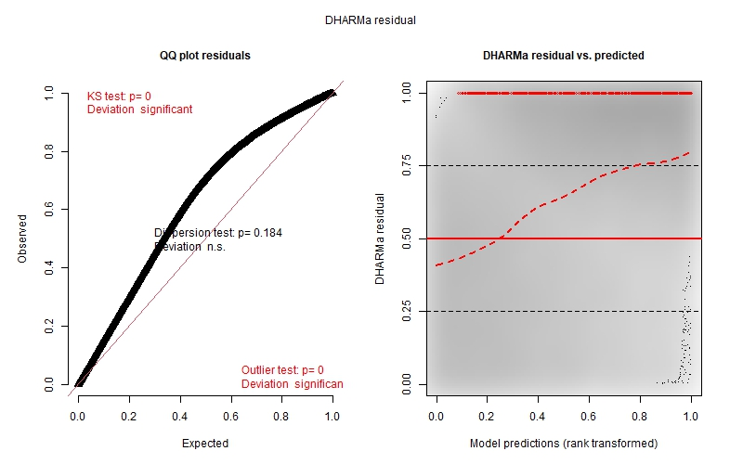
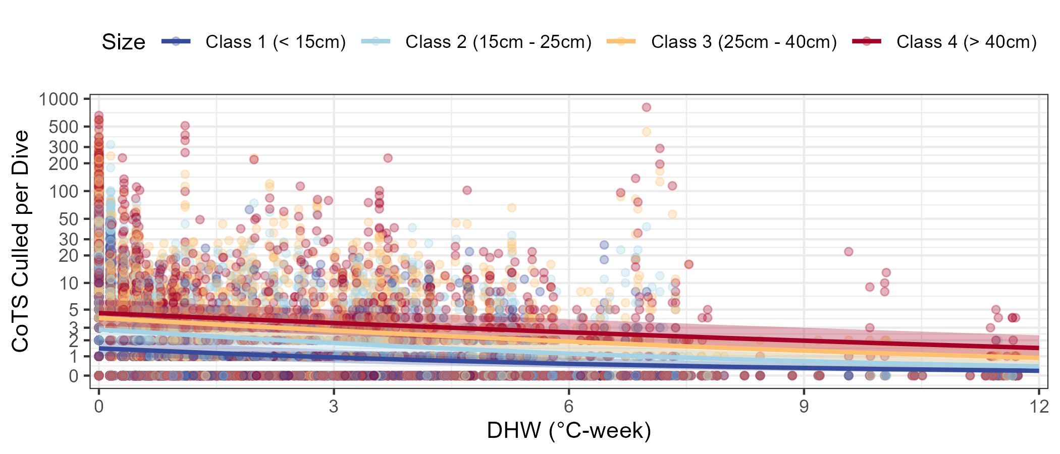
Figure S4.1: Model estimates (lines) with original data (coloured dots) on a log axis (top). DHARMa Residual analysis of normality (left) and homoscedasticity (right) for the hurdle model predicting COTS culled using DHW as the heat stress metric.

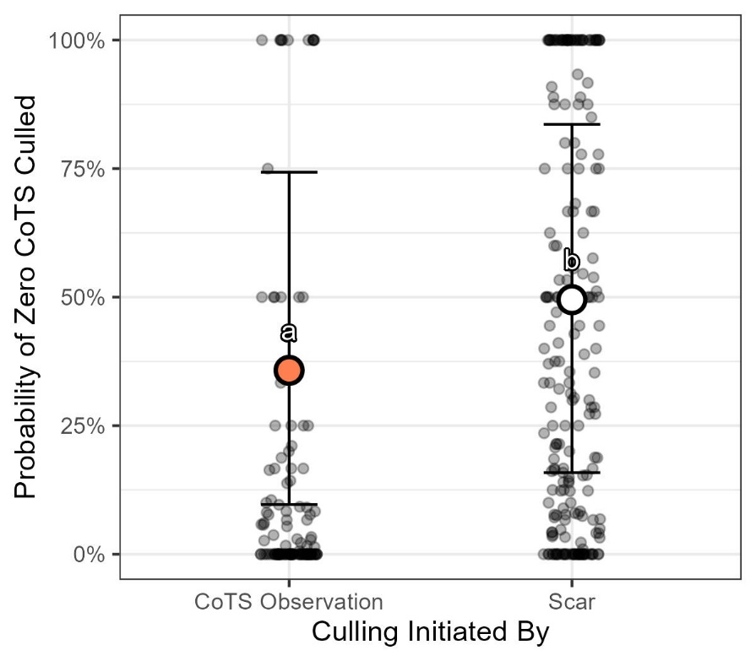
Figure S4.2: Model estimates (filled dots) with original data (coloured dots) of the probability of zero CoTS culled derived from the zero-inflation component of the hurdle model for each type of observation that can open the cull sites (CoTS observation vs. CoTS scar observation).
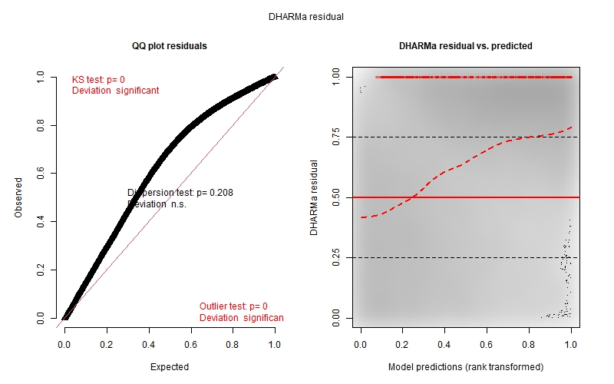
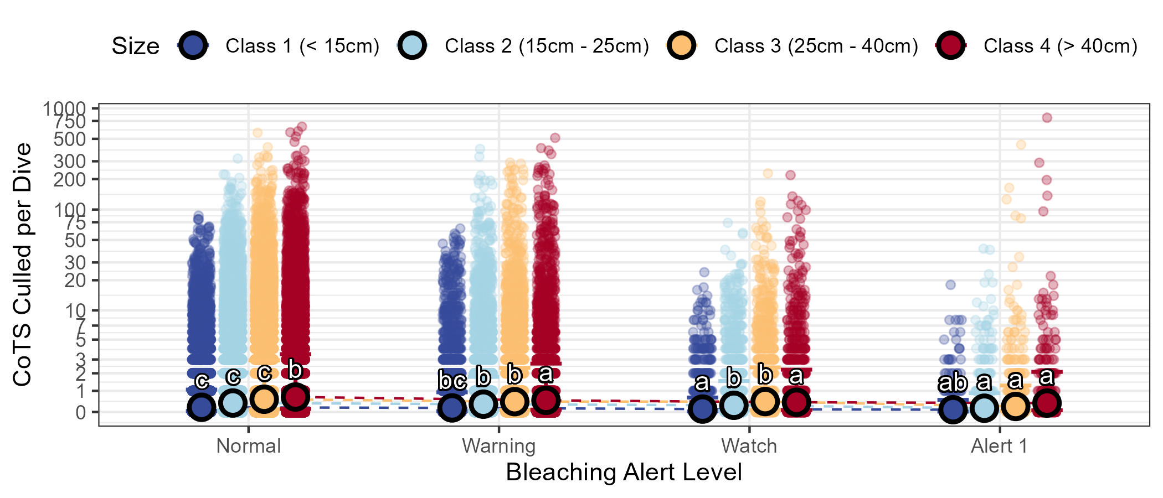
Figure S4.3: Model estimates (filled dots) with original data (coloured dots) on a log axis (top). DHARMa Residual analysis of normality (left) and homoscedasticity (right) for the hurdle model predicting COTS culled using BAA as the heat stress metric.

Section S5: GAM to investigate increasing annual heat stress severity alter the seasonal trajectory of CPUE?
Model structure for the predicting CPUE::
CPUE ~ s(DayofYear, bs = "cc", k = 12) + s(Hard Coral, bs = "re") +
SST + DHW + s(BAA, bs = "re") + s(Previous CPUE, k = 12) +
s(Season, bs = "re") + s(TowCullTimeDiff, k = 10) +
s(Bottom time) + s(Region, bs = "re") + s(Reef_ID, bs = "re"), family = tweedie
See Table S2 for variable details
Table S5. Average sample sizes for the random effects structure in each year of culling data. Reef is the smallest sampling unit included in the model. Cull Site is shown to provide context on the spatial extent of reef surveyed, although it was not explicitly included as a random effect.
Year | Reefs | Dives per Reef | Cull Sites per Reef
2018 | 16 | 12.88 | 6.69
2019 | 60 | 37.3 | 9.7
2020 | 92 | 19.26 | 7.95
2021 | 83 | 30.51 | 11.59
2022 | 115 | 20.61 | 9.82
2023 | 119 | 19.65 | 10.11
2024 | 147 | 15.66 | 8.16

Section 5.1: Use of GAM for Illustrative Seasonal Trends
The GAM used to investigate how increasing annual heat stress severity alters the seasonal trajectory of CPUE includes several random-effect smooths (bs = "re") for categorical variables such as Region, Reef_ID, Bleaching_Alert_Level, Season, and Hard_Coral. These terms serve an important role during model fitting: they absorb large variation arising from spatial and categorical differences that are not the focus of the seasonal CPUE patterns being illustrated. By doing so, they reduce bias in the estimated smooth for DayofYear and the environmental covariates (DHW, SST), which are central to the seasonal narrative.
When generating predicted seasonal trajectories for our stylised DHW/SST scenarios, we deliberately excluded these random-effect smooths from the prediction step. This ensured that the curves represent an “average” reef and region, rather than being anchored to any specific location, alert level, or categorical grouping. This approach produces a generic seasonal shape that can be overlaid with different stylised environmental trajectories without introducing site-specific noise.
We note that some covariates are included as coarse proxies. For example, recent culling pressure is represented as the number of CoTS removed in the last five culls on a reef, without accounting for variation in cull site location, spatial proximity, or elapsed time. Given that cull sites (∼10 ha) vary in number between reefs, and individual sites are nested within reefs, this variation is only partly accounted for via a random-effect spline for Reef_ID. While a more detailed treatment—such as a full GAMM with explicit effort quantification—may have been preferable for formal inference, the available data and the purpose of this exercise made the random-effect spline approach the most efficient and transparent way to illustrate the trends of interest. These simplifications mean the model cannot capture fine-scale operational dynamics or localised depletion patterns, and we assume culling pressure is approximately normally distributed across sites and reefs.
We acknowledge that this decision limits the model’s capacity for site-level prediction and that collinearity between DHW, SST, and DayofYear means the interpretation of the rigorous statistics may be confounded. The model has not been validated for inference, and predictions should not be interpreted as statistically rigorous forecasts. Instead, this model was developed solely to translate effect directions from our RQ1-3 analyses into a plausible, generalised seasonal context. It serves as a visual narrative tool to communicate how CPUE might vary throughout the year under different annual heat-stress conditions, not as a definitive predictive model.
Section 5.1: Model Diagnostics
No major violations of normality and homoscedasticity assumptions were observed for the linear components of the GAM (Fig S5). Significant deviations from uniformity, dispersion, and outlier tests reflect model simplifications (e.g., coarse culling pressure proxy, exclusion of certain interactions, and collinearity between seasonal covariates) (Fig S5). These diagnostics are expected given the model’s purpose as a descriptive seasonal narrative rather than a formal predictive or inferential tool.
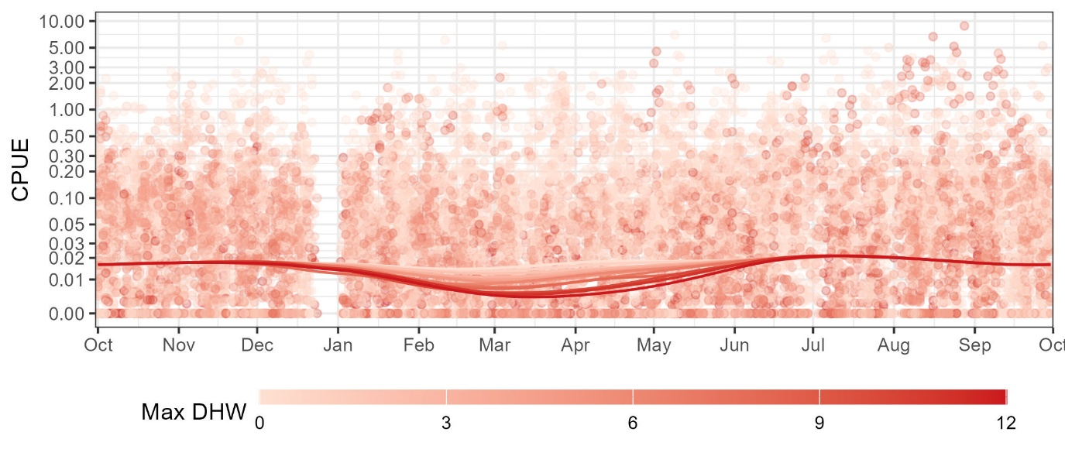
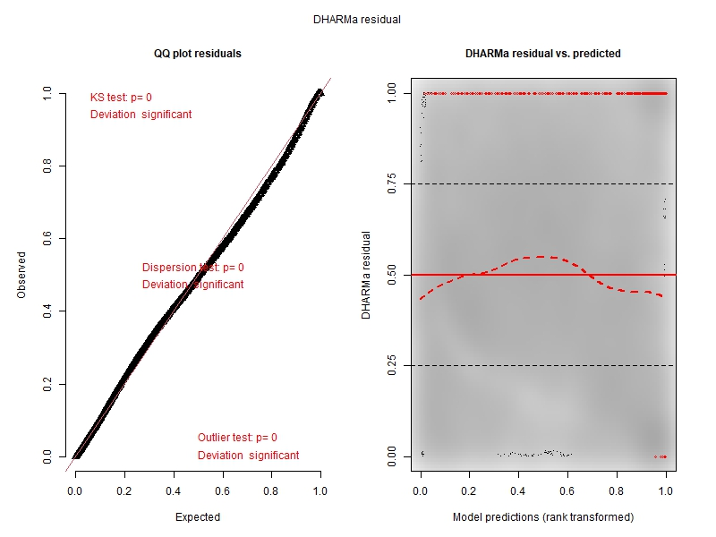
Fig. S5. Model estimates (lines) with original data (coloured dots) on a log axis (top). DHARMa residual analysis of normality (left) and homoscedasticity (right) of the seasonal CPUE GAM.

