Supplementary material
Supplementary Table 1: Comparison between the mean abdominal aortic aneurysm (AAA) diameter and volume values obtained from the mean of both readings of each observer.
Measurement | Observer | Time taken per scan | Average diameter (95% CI) | Average volume (95% CI)
Standard | Observer 1 | 7 minutes 40 seconds | 44.066 (43.574 –  44.557) | 89.188 (14.081 – 164.295)
Standard | Observer 2 | 8 minutes 0 seconds | 45.135 (44.574 – 45.697) | 85.087 (9.876 – 160.299)
Standard | Observer 3 | 4 minutes 5 seconds | 44.949 (44.421 – 45.478) | 94.949 (17.486 – 172.412)
AI | Observer 1 | 3 minutes 46 seconds | 43.5183 (42.969 – 44.112) | 96.761 (17.104 – 176.419)
AI | Observer 2 | 3 minutes 46 seconds | 43.5183 (42.969 – 44.112) | 96.761 (17.104 – 176.419)
AI | Observer 3 | 3 minutes 46 seconds | 43.5183 (42.969 – 44.112) | 96.761 (17.104 – 176.419)

Standard – Standard semi-automated segmentation method
AI – AI-assisted automated segmentation method

Supplementary Figure 1: Bland-Altman plot for intra-observer variability of diameter measurement using traditional segmentation software
- Observer 1
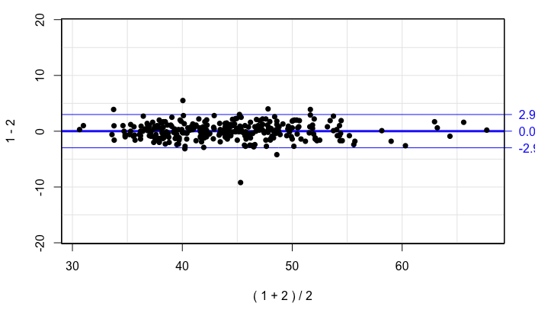

- Observer 2

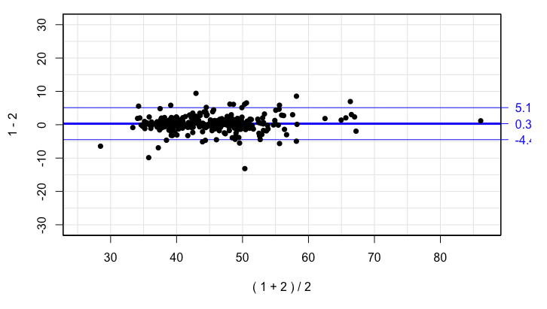

- Observer 3

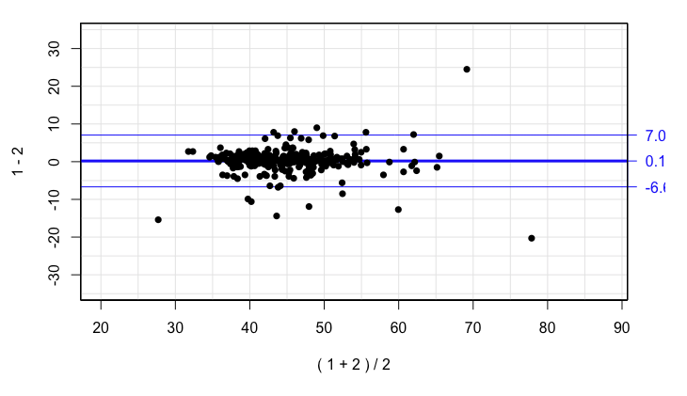

Supplementary Figure 2: Bland-Altman plot for inter-observer variability of diameter measurement for traditional segmentation software

- Observer 1 vs Observer 2

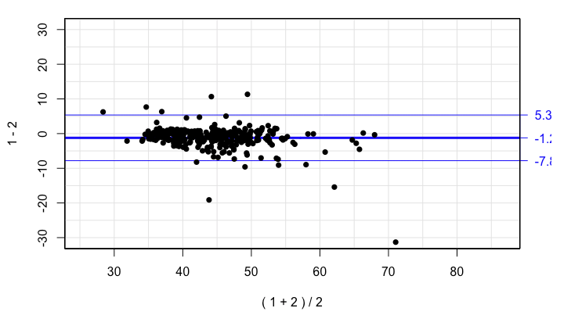

- Observer 1 vs Observer 3

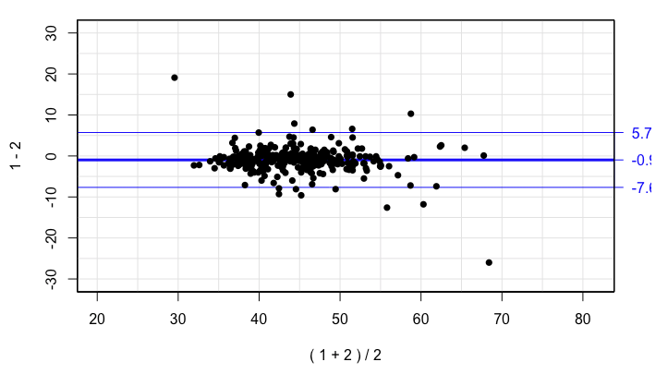

- Observer 2 vs Observer 3

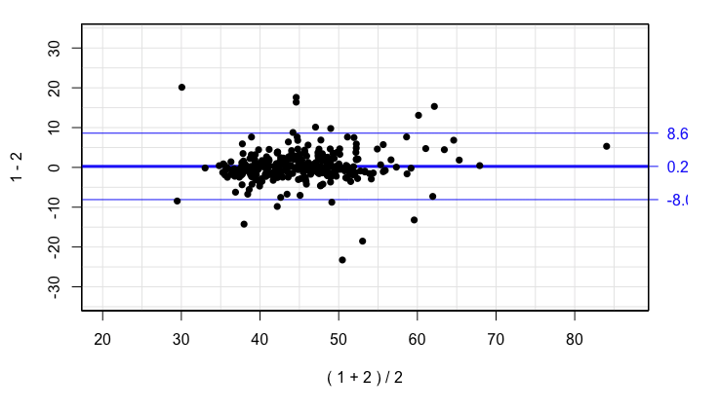

Supplementary Figure 3: Kaplan-Meier curve demonstrating 5 year freedom from surgical AAA repair
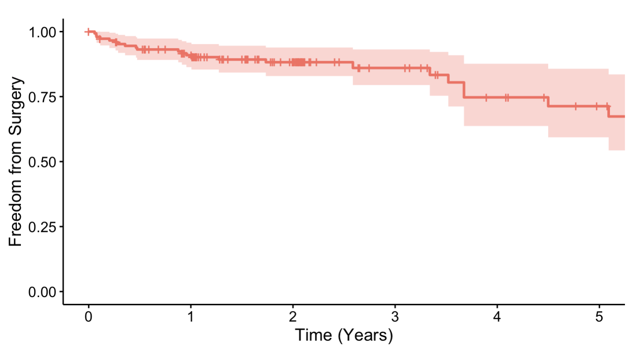
Red line: freedom from surgery
Pink band: 95% confidence interval

