Appendix 2: Appetite and Hunger Questionnaire
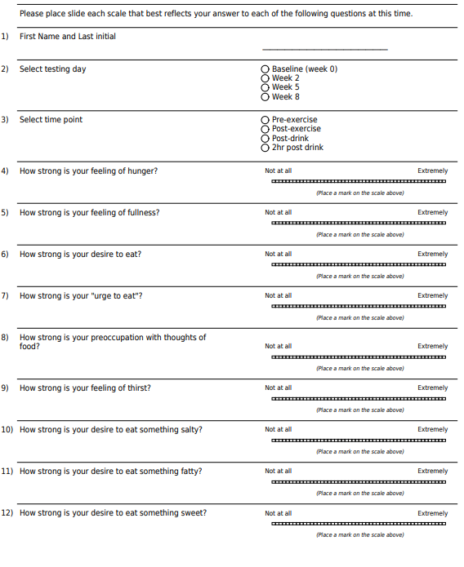

Appendix 3. Supplement Acceptability Questionnaire
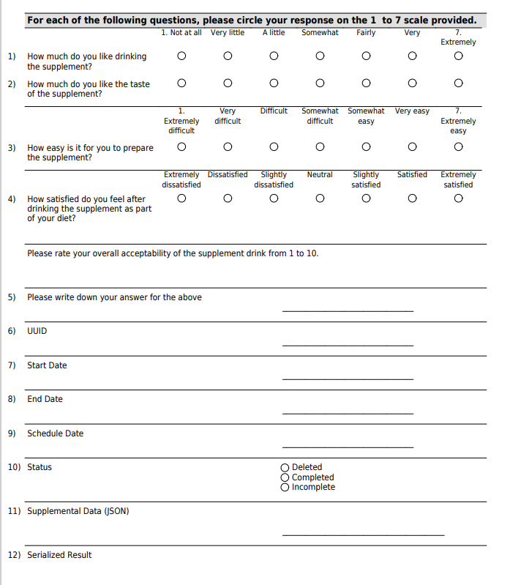
Appendix 4: Macronutrient and Energy Content of Almond Protein and Placebo Drinks
Dietary Component
Dietary Component | APP (daily) | APP (post-training) | Placebo (daily) | Placebo (post-training)
Energy (kJ) | 1127.6 | 1724.4 | 1115.6 | 1689.0
Protein (g) | 18.3 | 29.4 | 2.4 | 3.2
Carbohydrates (g) | 28.2 | 43.1 | 53.1 | 82.5
Fat (g) | 6.9 | 11.8 | 2.6 | 4.5
Fibre (g) | 8.2 | 13.0 | 2.1 | 3.0
NOTE: All daily drinks contained 20 g of chocolate powder and 250 ml of unsweetened almond milk (Coles brand). Post-training drinks contained 30 g of chocolate powder and 300 ml of unsweetened almond milk. Placebo drinks also included 37 g (daily) and 60 g (post-training) of maltodextrin (Bulk Nutrients).

APP almond protein powder, cals, calories, g grams, mg milligrams, kJ kilojoules
All values are sourced from manufacturer-reported nutrition information statements. Harris Woolf supplied almond protein powder on behalf of the Almond Board of California.

