Supplementary Information
A PointNet++-Based Deep Learning Approach Using Patient-Specific 3D Point Clouds for Personalized DBS Efficacy Prediction in Parkinson’s Disease
Yinghao Zhu,¹ Ru Wang,² Yuchun Wang,¹ Minyan Ge,¹ Bo Shen,³ Yimin Sun,³ Fengtao Liu,³ Jue Zhao,³ Jinling Wang,¹ Shugeng Chen,¹ Qianfeng Wang,¹ Narasimha M. Beeraka,⁴ Virak Sorn,⁵ Haiyin Wang,^{2,*} Vladimir N. Nikolenko,^{4,*} Nianhong Wang,^{1,*} Jianjun Wu,^{3,*} He Wang,^{1,6,*} Shumao Xu^{1,*}

¹Department of Rehabilitation Medicine, Huashan Hospital, Institute of Science and Technology for Brain-inspired Intelligence (ISTBI), Fudan University, Shanghai, 200040, China
²Shanghai Health Development Research Center (Shanghai Medical Information Center), Shanghai, 201100, China
³Department of Neurology and National Research Center for Aging and Medicine & National Center for Neurological Disorders, State Key Laboratory of Medical Neurobiology, Huashan Hospital, Fudan University, Shanghai, 200040, China
⁴Institute of Clinical Medicine N.V. Sklifosovsky, FSAEI HE I.M. Sechenov First Moscow State Medical University (Sechenov University), Moscow, 125009, Russia
⁵Faculty of Health Sciences & Biotechnology, University of Puthisastra, Phnom Penh, 12211, Cambodia
⁶Department of Radiology, Shanghai Fourth People's Hospital Affiliated to Tongji University School of Medicine, Shanghai, 200433, China
*Correspondence to: wanghaiyin@shdrc.org (H-Y.W.); vn.nikolenko@yandex.ru (V.N.); wnh@fudan.edu.cn (N.W.); wujianjun@fudan.edu.cn (J.W.); hewang@fudan.edu.cn (H.W.); shumaoxu@fudan.edu.cn (S.X.)

1) Baseline Machine Learning
1.1. Support Vector Regression (SVR)
Insensitive loss function (ε-insensitive loss):
$$L_{0.1}\left(y_{i},f\left(x_{i}\right)\right)=\left\{\begin{matrix}0 & if\left|y_{i}-f\left(x_{i}\right)\right|≤0.1, \\ \left|y_{i}-f\left(x_{i}\right)\right|-0.1 & if\left|y_{i}-f\left(x_{i}\right)\right|>0.1.\end{matrix}\right.$$
This means deviations smaller than 0.1 are ignored, while only errors larger than 0.1 are penalized.
Primal optimization problem:
$$\min_{w,b,ξ_{i},ξ_{i}^{*}}{ }\frac{1}{2}\left\|w‖^{2}+10\sum_{i=1}^{n}{(}ξ_{i}+ξ_{i}^{*}\right)$$
subject to
$$\left\{\begin{matrix}y_{i}-\left(w^{T}ϕ\left(x_{i}\right)+b\right)≤0.1+ξ_{i}, \\ \left(w^{T}ϕ\left(x_{i}\right)+b\right)-y_{i}≤0.1+ξ_{i}^{*}, \\ ξ_{i}≥0,ξ_{i}^{*}≥0\left(i=1,2,…,n\right)\end{matrix}\right.$$
Here:
w = model weight vector
b = bias term
ϕ(x_{i}) = mapping of input into high-dimensional feature space
ξ_{i}, ξ_{i}∗​ = slack variables, allowing tolerance for violations
- = regularization penalty controlling tradeoff between margin width and error tolerance

RBF (Radial Basis Function) kernel:
$$K\left(x_{i},x_{j}\right)=\exp\left(-γ‖x_{i}-x_{j}‖^{2}\right)\left(γ>0\right)$$
This kernel transforms data into a higher-dimensional space to handle non-linear relationships.

Dual optimization problem (Lagrangian form):
$$\max_{α_{i},α_{i}^{*}}{ }-\frac{1}{2}\sum_{i=1}^{n}{\sum_{j=1}^{n}{(}}α_{i}-α_{i}^{*})(α_{j}-α_{j}^{*})K(x_{i},x_{j})-0.1\sum_{i=1}^{n}{(}α_{i}+α_{i}^{*})+\sum_{i=1}^{n}{y_{i}}(α_{i}-α_{i}^{*})$$
Here:
α_{i},α_{i}∗​ = Lagrange multipliers
The dual form allows the kernel trick to avoid explicit computation in high-dimensional space

Prediction function:
$$f(x)=\sum_{i=1}^{n}{(}α_{i}^{*}-α_{i}^{**})K(x_{i},x)+b$$
This combines support vectors weighted by their multipliers.

1.2. Linear Regression (LR)
Model formulation:
$$y=Xβ+ε$$
Here:
y = response vector
X = design matrix of predictors
β= regression coefficients
ε= error term

Prediction function:
$${\hat{y}}_{new}=X_{new}\hat{β}$$

Loss function (least squares):
$$L(β)=‖y-\hat{y}‖^{2}=(y-Xβ)^{T}(y-Xβ)$$

Parameter solution (ordinary least squares estimator):
$$\hat{β}=(X^{T}X)^{-1}X^{T}y$$

1.3. Lasso Regression (L1-regularized linear regression)
The formulation introduces an additional L1 penalty to enforce sparsity in β:
$$\hat{β}=\arg{\min_{β}\left\{|y-Xβ|^{2}+λ|β|_{1}\right\}}​$$
Here:
λ= regularization strength
Encourages many coefficients to shrink exactly to zero → feature selection

1.4. Gradient Boosted Decision Trees (GBDT)
An ensemble method that builds trees sequentially. Each new tree fits the residual errors of the previous model:
Base learner: regression tree
Loss function: typically squared error for regression or log loss for classification
Update rule:
$$F_{m}\left(x\right)=F_{m-1}\left(x\right)+η⋅h_{m}\left(x\right)$$
where $h_{m}\left(x\right)$ is the new weak learner, and $η$ is the learning rate.

2) Mechanistic Mapping, Surgical Feasibility, and Comparative Validation
Additional analyses and justifications were considered to enhance the translational and mechanistic value of DeepPoint-DBS. First, a symptom-specific mapping was proposed to differentiate the subthalamic nucleus (STN) subregions and corresponding field gradients that mediate tremor, rigidity, and bradykinesia. Using diffusion tractography–based connectomic analysis, symptom improvements could be aligned with distinct motor network pathways. This would directly connect DeepPoint-DBS predictions to mechanistic neuroscience, thereby strengthening the overall impact of the study.
Second, several points were identified for integration into the discussion or limitation sections to address feasibility and clinical applicability. These included (1) demonstrating the feasibility of predicting effective stimulation parameters prior to the initial DBS programming session, showing that DeepPoint-DBS can reasonably predict the corresponding stimulation parameters' therapeutic efficacy, (2) demonstrating that surgeons could obtain effective stimulation parameter combinations from multiple predictions of therapeutic efficacy, and (3) proposing, as a long-term direction, integration into closed-loop DBS devices for automated adaptive programming. These points would emphasize both immediate translational potential and long-term clinical scalability. Finally, to highlight novelty and superiority, a head-to-head comparison with current state-of-the-art approaches was suggested. DeepPoint-DBS could be compared against volume of tissue activated (VTA) and field threshold models, atlas-based methods such as Lead-DBS pipelines, and convolutional neural network (CNN)–based predictive frameworks. Such comparisons would establish DeepPoint-DBS as an advancement over existing methodologies by demonstrating improved accuracy, mechanistic interpretability, and real-time clinical usability.

Supplementary Figures
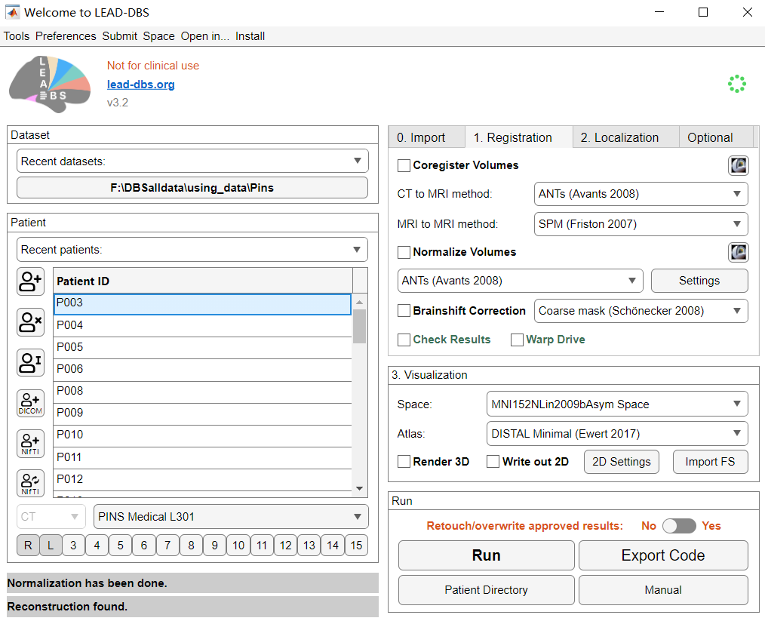
Supplementary Figure 1. GUI of lead-DBS.

Supplementary Figure 2. End-to-end PointNet++ Architecture for Predicting MDS-UPDRS III Scores in Parkinson’s Disease via 3D Point Cloud Processing. The network consists of a feature extraction stage with three Set Abstraction modules, followed by a fully connected regression head composed of three dense layers.

Supplementary Figure 3. Machine learning pipeline after feature engineering. Statistical features of spatial coordinates and electric field properties were extracted and used for model training.

