Kim et al. Seasonal and sexual variation in mRNA expression of selected adipokine genes affecting fat deposition and metabolism of the Emu (Dromaius novaehollandiae)

Supplemental Figure 1. Association of fat gain (kg) from April to June, from June to August, and from August to November, with mRNA expression level. (A). eFABP4. (B). SCD1. (C) eAdipoQ. (D) AdipoR1. (E). AdipoR2. (F) eLepr.

April to June June to August August to November
- eFABP4
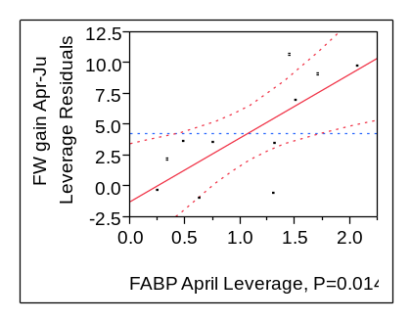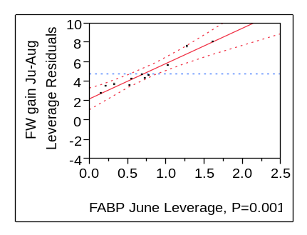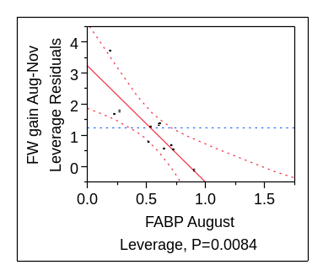
R²= 0.712

P=0.0015
R²= 0.94
P=0.015
R²= 0.64
- eSCD1
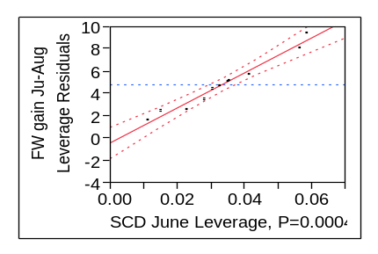
P=0.0004
R²= 0.97

- eAdipoQ
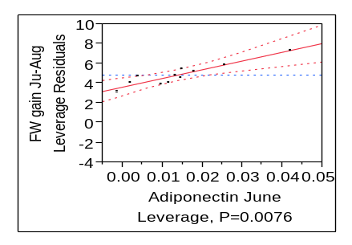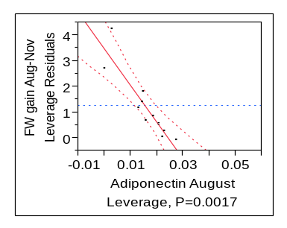
R²= 0.829

R²= 0.86

- eAdipoR1
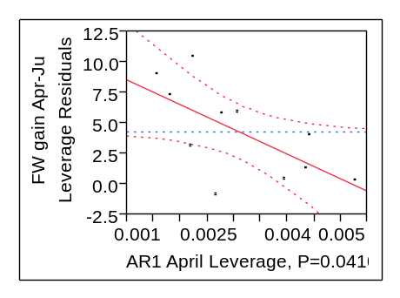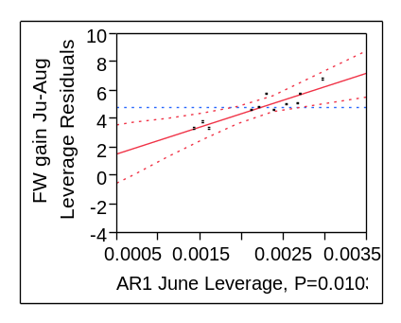
P=0.0103
R²= 0.92

P=0.023
R²= 0.55

- eAdipoR2
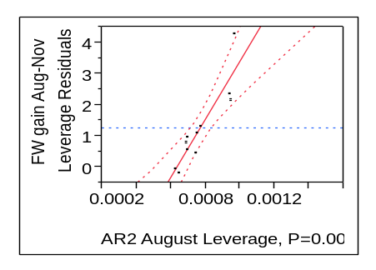
P=0.0018
R²= 0.825

- eLepR
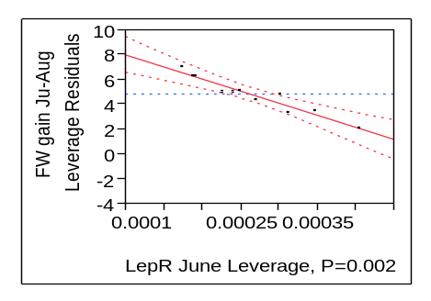
P=0.0026
R²= 0.92

