Supplementary Information

Overview of the J-Blue Credit scheme
J-Blue Credits (JBCs) are voluntary carbon credits issued exclusively for carbon dioxide removal (CDR) through blue carbon ecosystems. The scheme is developed and administered by the Japan Blue Economy Association (JBE). In 2020, the Japanese Ministry of Land, Infrastructure, Transport and Tourism approved the foundation of the JBE as a Collaborative Innovation Partnership. The ministry also decided to implement a carbon credit demonstration project in collaboration with JBE. However, JBE operates independently and does not rely on government subsidies.
The JBC scheme certifies credits only from marine vegetation-based CDR projects, specifically excluding credits from emission reduction or avoidance activities. The eligible quantity of CO₂ removed is defined as the net change relative to baseline, following the Before–After Control–Impact framework. All estimates are independently reviewed by a validation and verification body, and final authorized credit volumes are adjusted according to the level of uncertainty. Details of the carbon certification methodology—including the assessment of additionality, management of potential leakage, and verification that carbon credits are real, measurable, reportable, and verifiable—are provided in Reference 30 and the J-Blue Credit Guideline available online (https://www.blueeconomy.jp/wp-content/uploads/jbc2025/20250331_J-BlueCredit_Guidline_v.2.5.pdf)

Transaction mechanisms
Only domestic entities that possess a Japanese entity identification number and have their head office or principal place of business in Japan, including all legal entities such as corporations, non-profit organizations, and public entities, are eligible to serve as credit creators and credit purchasers. JBCs can be transacted through three public offering mechanisms, each allowing for different pricing and allocation strategies. In the Designated Unit Price Method, the money-based purchase amount, credit volume, and unit price (JPY per tCO₂) are fixed and disclosed prior to the public offering. Participating entities indicate the quantity of credits they wish to purchase under these predetermined conditions. Under the Total Allocation Method, each purchaser specifies a total payment amount in advance, and after the public offering closes, the final credit volume and unit price are allocated proportionally based on the relative value of each purchaser’s commitment. In the Multiple Price Method, purchasers submit both a total payment amount and a desired credit volume; credits are then allocated in descending order of stated unit price until the total available volume is exhausted. For both the Total Allocation Method and the Multiple Price Method, the mechanism is structured such that the resulting unit price rises as aggregate purchaser demand increases. The JBC scheme does not permit secondary trading; therefore, intermediaries cannot act as purchasers. This means that the offsetting of emissions will be conducted directly by the purchasers.

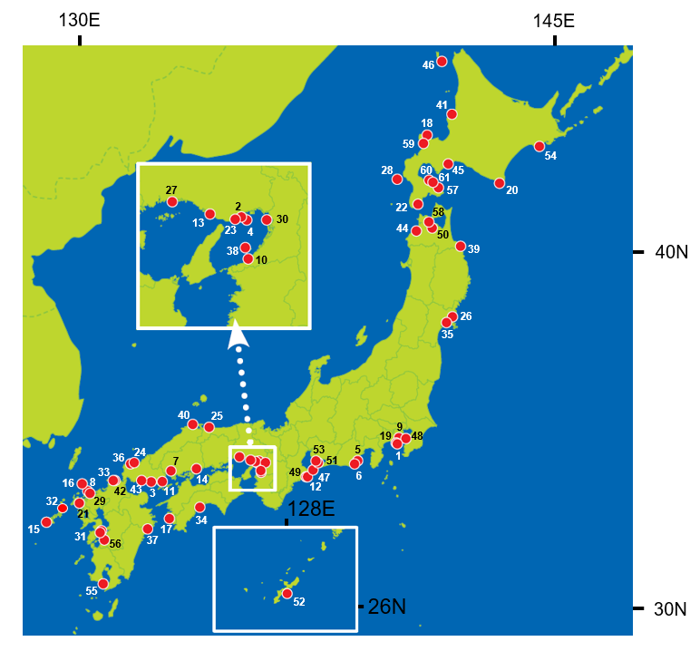
Supplementary Fig. 1 Locations of the 61 projects implemented under the J-Blue Credit scheme.

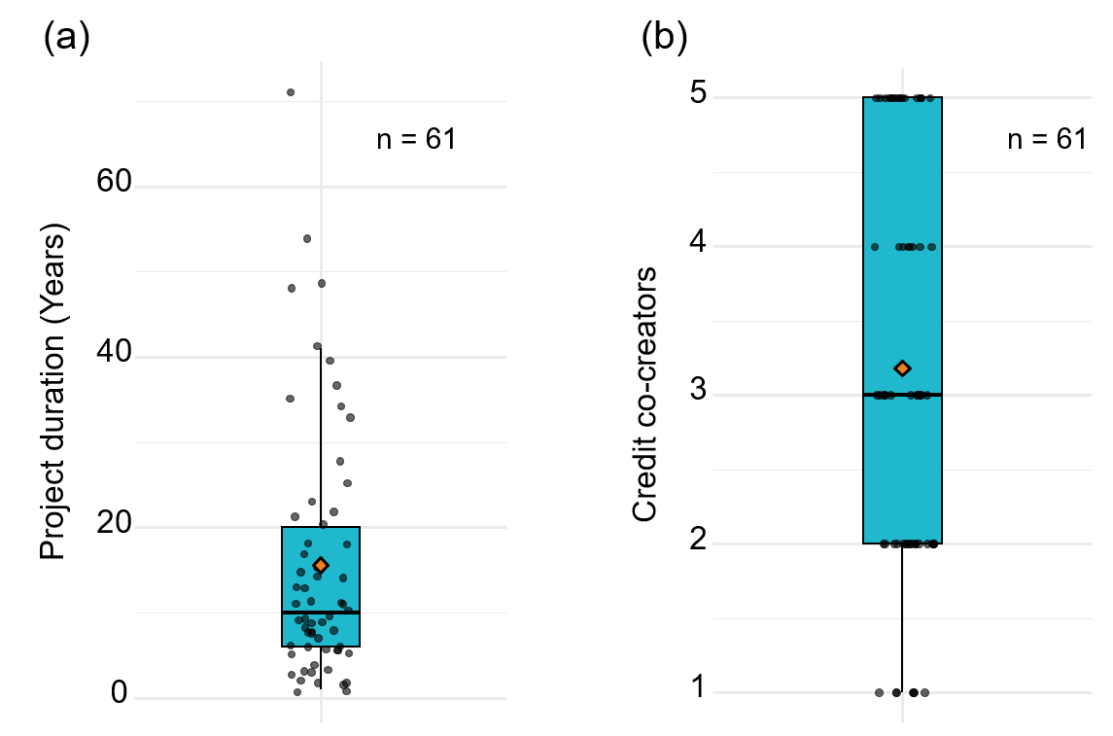

Supplementary Fig. 2 Boxplots of project durations in years (a) and numbers of credit co-creators (b).

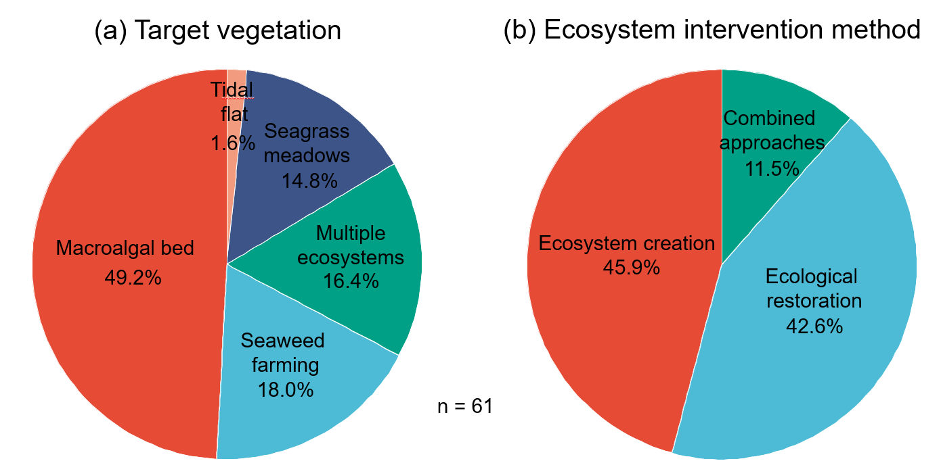

Supplementary Fig. 3 Pie charts showing the percentages of target vegetation types (a) and ecosystem intervention methods (b).

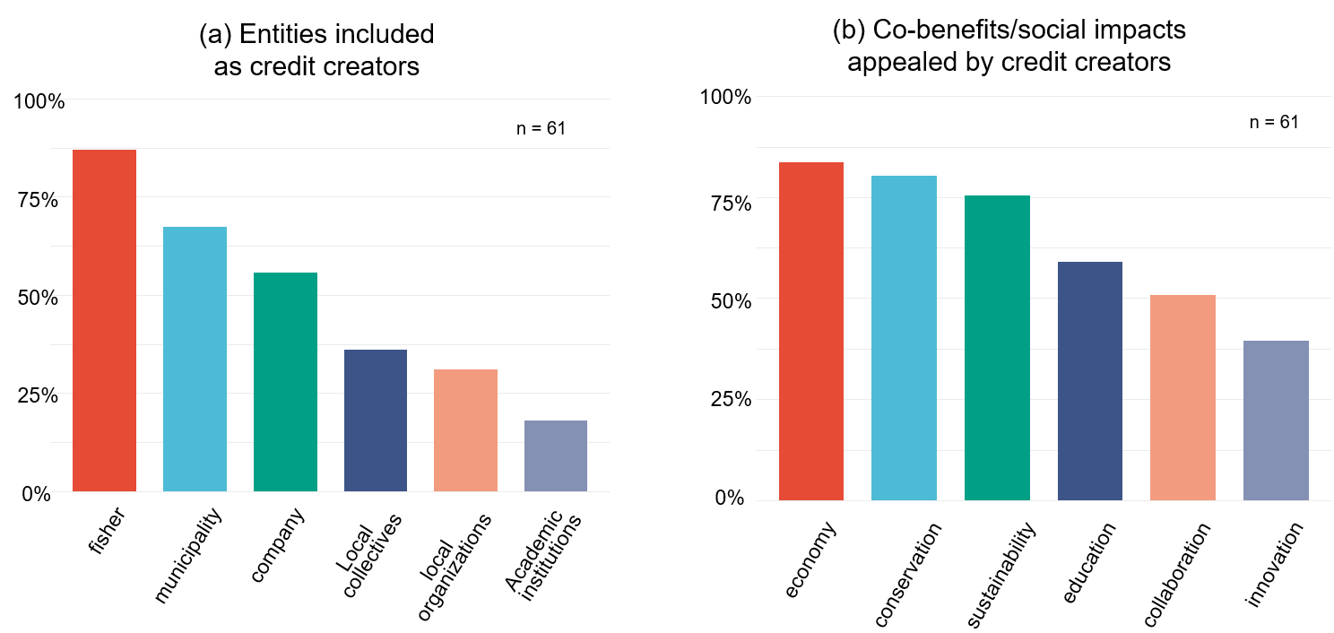

Supplementary Fig. 4 Bar charts showing the percentages of entity types included as credit creators (a) and the percentages of co-benefits and social impacts appealed by credit creators (b).

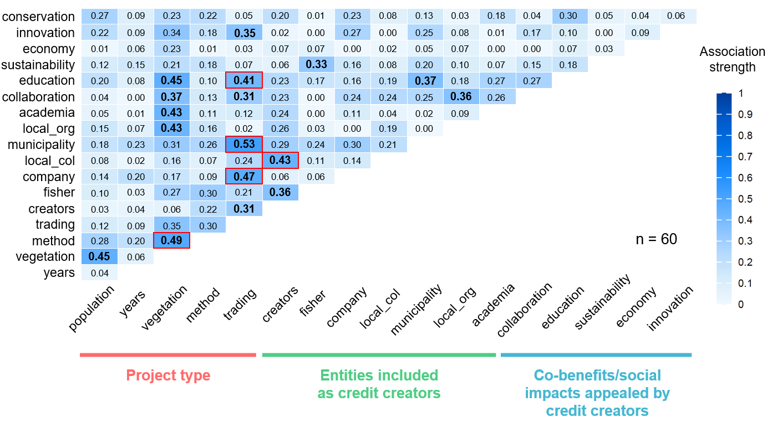
Supplementary Fig. 5 Heatmap showing the strength of associations among project characteristics. Statistically significant associations (association strength > 0.3 and FDR-adjusted q< 0.05) are outlined in red.

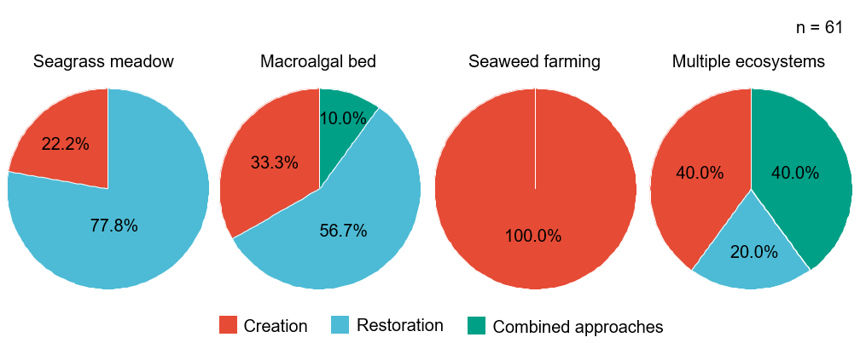

Supplementary Fig. 6 Pie charts showing the proportions of ecosystem intervention methods for each target vegetation type.

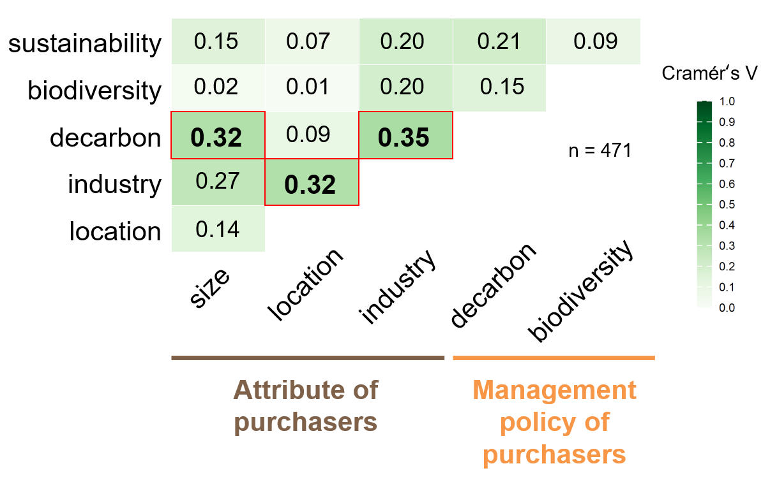
Supplementary Fig. 7 Heatmap showing the strength of associations among purchaser characteristics. Statistically significant associations (effect size > 0.3 and FDR-adjusted q < 0.05) are outlined in red.

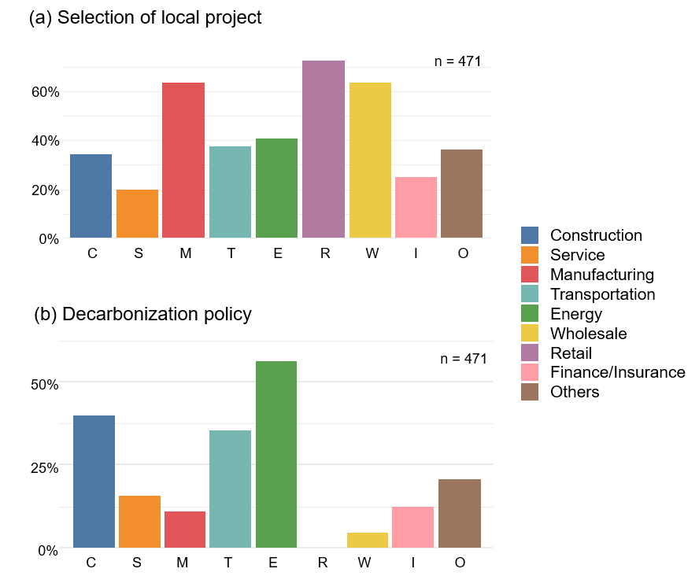

Supplementary Fig. 8 Bar charts showing the percentage of purchasers selecting local (i.e., same municipality) projects by industry sector (a), and the percentage of purchasers with a decarbonization policy by industry sector (b).

.
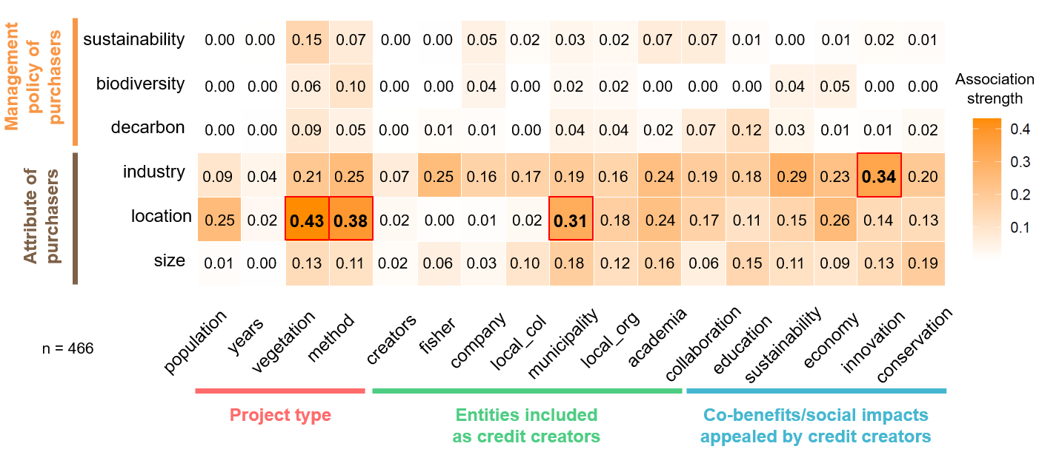
Supplementary Fig. 9 Heatmap showing the strength of associations between project characteristics and purchaser characteristics. Statistically significant associations (association strength > 0.3 and FDR-adjusted q < 0.05) are outlined in red.

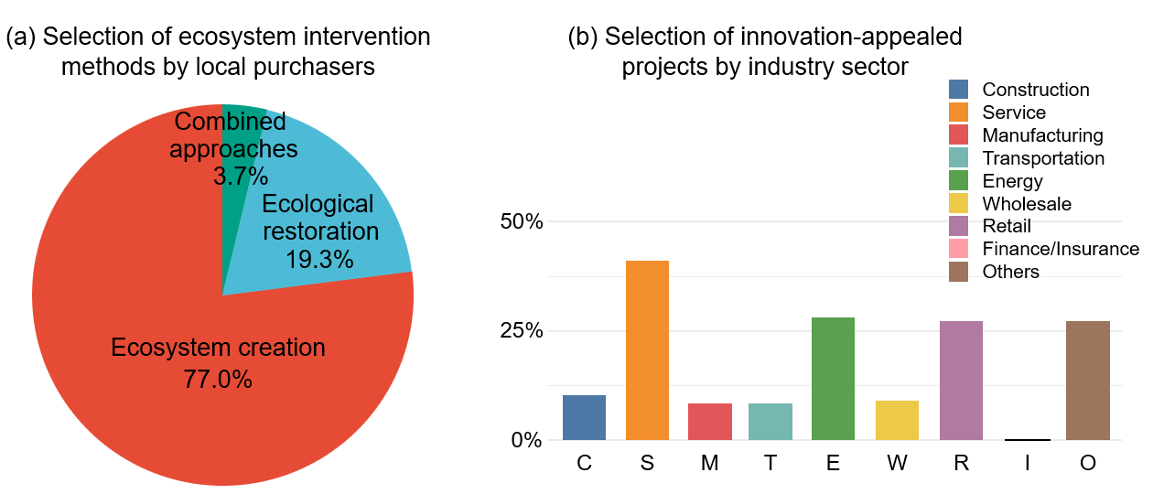

Supplementary Fig. 10 Pie charts showing the percentages of ecosystem intervention methods chosen by local purchasers (a), and bar charts showing the percentage of purchasers selecting innovation-appealed projects by industry sector (b).

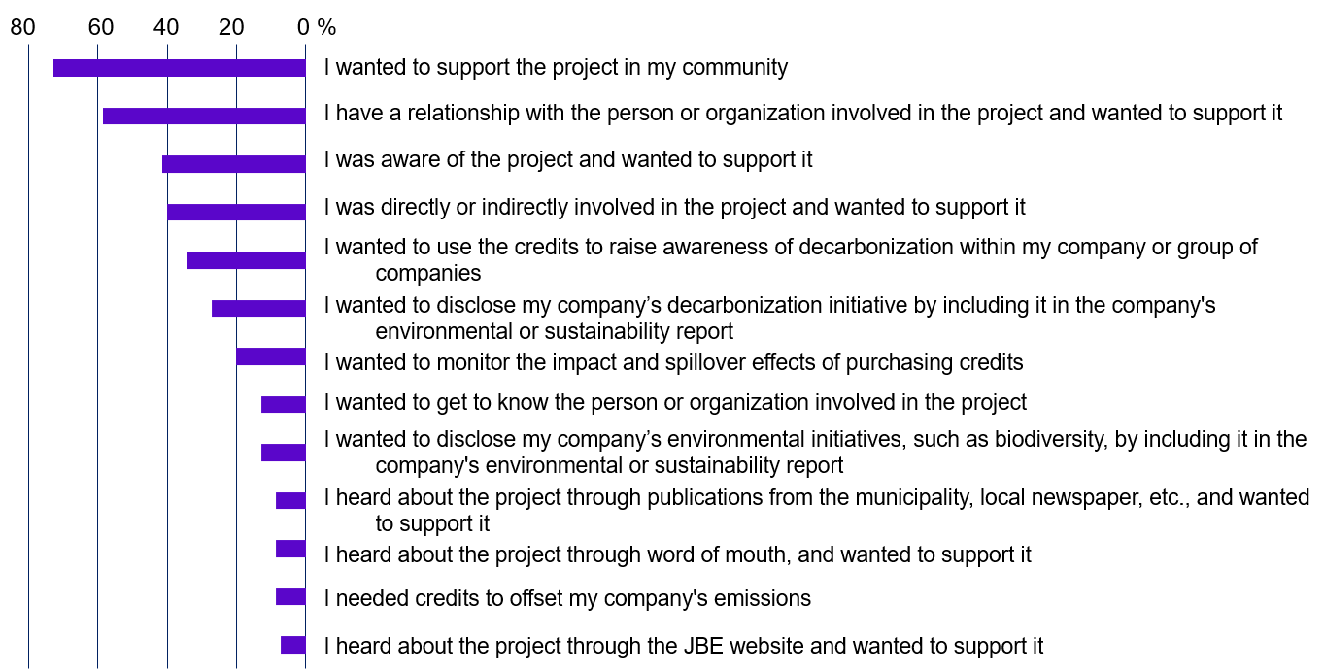
Supplementary Fig. 11 Results of a questionnaire examining the reasons for purchasing J-Blue Credits (multiple choice, n = 69). Source: Nishihara et al. (2025)⁴⁶

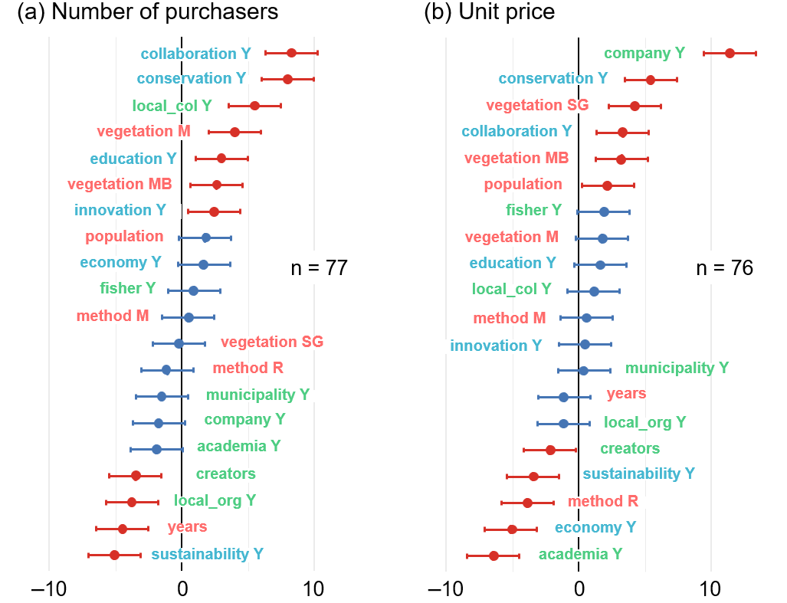

Supplementary Fig. 12 Results of linear mixed-effects models examining the relationship between project characteristics and two trading priorities: number of purchasers (a) and unit price (b) with transaction volume as an additional random intercept to the model shown in Figure 5.

Supplementary Table 1 Raw data used in the analyses of certified project characteristics and their associations.

Supplementary Table 2 Statistical results of the strength of associations among certified project characteristics.

Supplementary Table 3 Raw data used in the analyses of purchaser characteristics and their associations.

Supplementary Table 4 Statistical results of the strength of associations among purchaser characteristics.

Supplementary Table 5 Raw data used in the analyses of project-purchaser relationships and transaction outcomes.

Supplementary Table 6 Statistical results of the strength of associations between certified project characteristics and purchaser characteristics.

Supplementary Table 7 Statistical results of linear mixed-effects models examining the relationship between certified project characteristics and two trading priorities: number of purchasers (a) and unit price (b).

