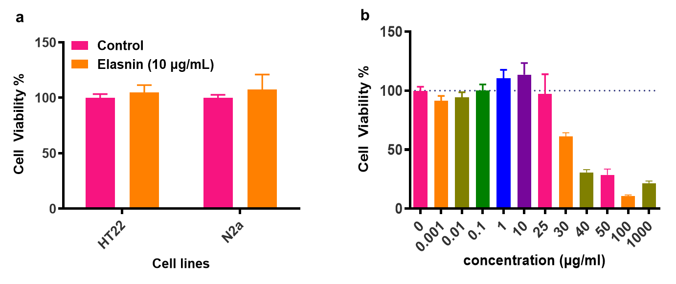
Fig. S1. Cytotoxicity of elasnin against nerve cells. a Cell viability of HT22 and Neuro2a upon treatment with 10 μg/mL of elasnin for 24 hours (n=8). b Cell viability of HT22 cells after treatment various concentrations of elasnin after 24 hours (n=6).

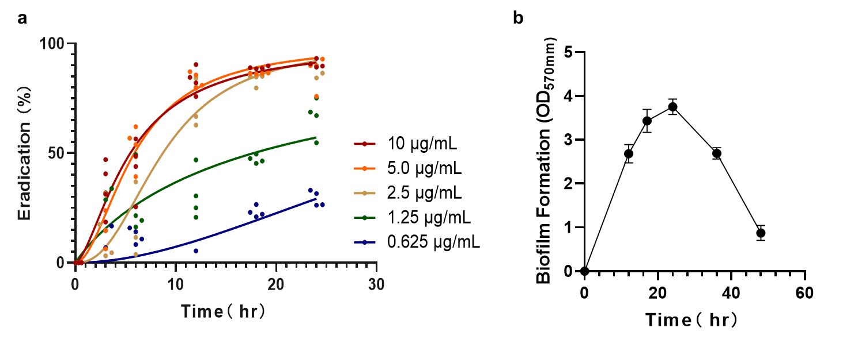
Fig. S2. a Time course of biofilm eradication by various concentrations of elasnin (n=4). b Time course of biofilm formation of MRSA ATCC 43300 (n=3).

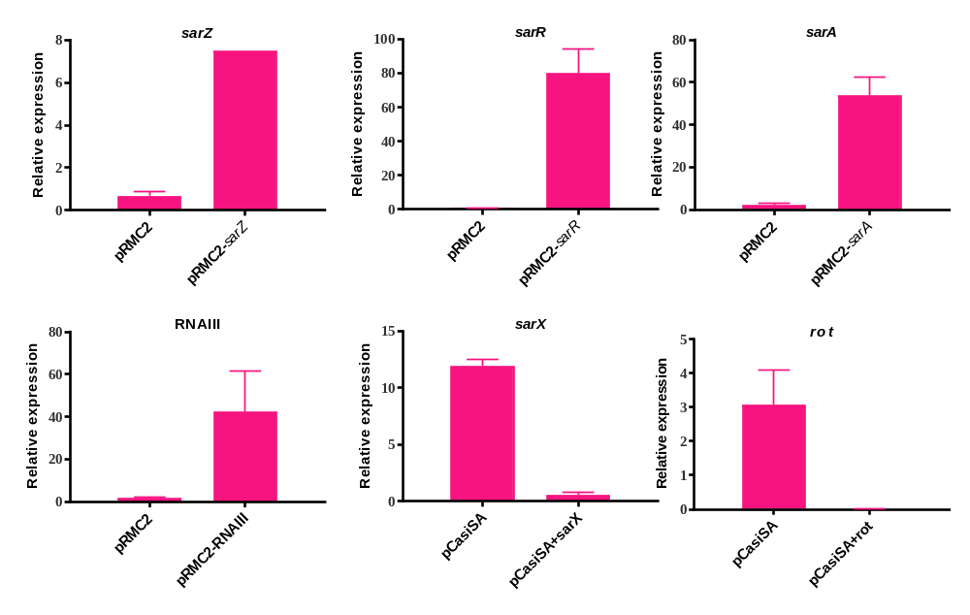
Fig. S3. Quantitative real-time PCR validation of gene expression in the mutants (n=6). Gene sarZ, sarR, sarA and RNA III was complemented using an expression vector pRMC2 while gene sarX and rot was transcriptionally inhibited by CRISPR/Cas9 transcription inhibition system pCasiSA. Relative expression levels of these genes were normalized to that of the reference gene gyrB.

Table S1. Biofilm inhibiting activities of elasnin against mutants.
Strain | MBIC₉₀ | Biofilm Inhibition  (5 μg/mL, %) | Biofilm formation (OD₅₇₀)
Wild Type | 1.25-2.5 | 96.91±3.72 | 1.96±0.79
pRMC2 | 1.25-2.5 | 96.60±1.25 | 2.48±0.54
pRMC2+sarA | 5-10 | 72.17±5.20 | 1.86±0.29
pRMC2+sarR | >10 | 30.22±9.67 | 0.46±0.10
pRMC2+RNAIII | >10 | 18.32±9.65 | 0.15±0.03
pRMC2+sarZ | >10 | -10.44±11.44 | 0.46±0.06
pCasiSA | 2.5-5.0 | 90.96±1.40 | 2.18±0.44
pCasiSA+rot | 5-10 | 75.66±4.25 | 1.43±0.44
pCasiSA+sarX | 5-10 | 40.56±18.58 | 0.98±0.17

Table S2. Media used in this study
Media | Formula
AM4 | Soybean Powder 20 g/L, Peptone Bacteriological 2 g/L, Glucose 20 g/L, Soluble starch 5 g/L, Yeast Extract 2 g/L, NaCl 4 g/L, K₂HPO₄ 0.5 g/L, MgSO₄ ·7H₂O 0.5 g/L, CaCO₃ 2 g/L, pH 7.8
AM5 | Malt extract 10 g/L, Yeast extract 4 g/L, Glucose 4 g/L
AM6 | Soluble starch 20 g/L, Glucose 10 g/L, Peptone Bacteriological 5 g/L, Yeast extracts 5 g/L, CaC0₃ 5 g/L, pH 7.2-7.5
GYM | Glucose 4.0 g, Yeast extract 4.0 g, Malt extract 10.0 g, CaCO3 2.0 g, Agar 12.0 g, Distilled water 1000.0 ml (Adjust pH to 7.2 before adding agar.)

Table S3. Plasmids and bacterial strains used in this study
Strains/plasmids | Description | Reference/Source
E. coli
DH5α | Host strain for plasmid | Invitrogen
Top10 | Host strain for plasmid | Invitrogen
MRSA
ATCC43300 | Wild-type methicillin-resistant S. aureus | ATCC
ATCC43300pRMC2 | ATCC43300 with empty pRMC2 | This study
ATCC43300pRMC2-sarA | ATCC43300 with pRMC2-sarA | This study
ATCC43300pRMC2-sarR | ATCC43300 with pRMC2-sarR | This study
ATCC43300pRMC2-sarZ | ATCC43300 with pRMC2-sarZ | This study
ATCC43300pRMC2-RNAIII | ATCC43300 with pRMC2-RNAIII | This study
ATCC43300pCasiSA | ATCC43300 with empty pCasiSA | This study
ATCC43300pCasiSA-rot | ATCC43300 with pCasiSA-rot | This study
ATCC43300pCasiSA-sarX | ATCC43300 with pCasiSA-sarX | This study
Plasmids
pRMC2 | Tetracycline-inducible expression vector | [83]
pRMC2-sarA | pRMC2 with sarA | This study
pRMC2-sarR | pRMC3 with sarR | This study
pRMC2-sarZ | pRMC4 with sarZ | This study
pRMC2-RNAIII | pRMC5 with RNAIII | This study
pCasiSA | transcription inhibition vector | [84]
pCasiSA-rot | pCasiSA with rot spacer | This study
pCasiSA-sarX | pCasiSA with sarX spacer | This study

Table S4. Primers used in this study
Name | Sequence | Description
pCasiF1 | CATGGATAAGAAATACTCAATAGGCTTAgctATCGGCA CAAATAGCGTCGG | pCasiSA construction
pCasiR1 | GTCTTTAAGGAAACTTTGTGGAACAATggcATCGACA TCATAATCACTTAAACG | pCasiSA construction
pCasiF2 | CGTTTAAGTGATTATGATGTCGATgccATTGTTCCACA AAGTTTCCTTAAAGAC | pCasiSA construction
pCasiR2 | cgattatgtcttttgcgcagtc | pCasiSA construction
pCasiF3 | cgcaccagcgaaaactggt | pCasiSA construction
pCasiR3 | CCGACGCTATTTGTGCCGATagcTAAGCCTATTGAGT ATTTCTTATCCATG | pCasiSA construction
pcasiSA-checkF | agaaaggcggacaggtatcc | For checking/ confirmation
pcasiSA-checkR | ccgatagctaagcctattgag | For checking/ confirmation
rot-spacer-F1 | GAAAgttgacgatgaaagaacagt | rot spacer for pCasiSA
rot-spacer-R1 | AAACactgttctttcatcgtcaac | rot spacer for pCasiSA
rot-spacer-F2 | GAAAagattaacgcagttactacg | rot spacer for pCasiSA
rot-spacer-R2 | AAACtacgttctagtacgcttata | rot spacer for pCasiSA
sarX-spacer-F1 | GAAAagcaatgtttctaatttctc | sarX spacer for pCasiSA
sarX-spacer-R1 | AAACgagaaattagaaacattgct | sarX spacer for pCasiSA
sarA-sacI-F | CGAGCTCaatagggaggttttaacc | Amplification of sarA fragment
sarA-kpnI-R | GGTACCCCttatagttcaatttcgt | Amplification of sarA fragment
sarA-kpnI-R1 | GGTACCttatagttcaatttcgt | Amplification of sarA fragment
RNAIII-sacI-F | CGAGCTCatcacagagatgtgatggaaaatagttg | Amplication of RNAIII fragment
RNAIII-kpnI-R | GGTACCCCaaaaaaggccgcgagctt | Amplication of RNAIII fragment
RNAIII-kpnI-R1 | GGTACCaaaaaaggccgcgagctt | Amplication of RNAIII fragment
sarR-sacI-F | CGAGCTCttgctacaacaagatgtgc | Amplification of sarR fragment
sarR-kpnI-R | GGTACCCCtcgttcaatgttattaaacgc | Amplification of sarR fragment
sarR-kpnI-R1 | GGTACCtcgttcaatgttattaaacgc | Amplification of sarR fragment
sarZ-sacI-F | CGAGCTCggagtgattggatgtatgtag | Amplification of sarZ fragment
sarZ-kpnI-R | GGTACCCCcccatcatcttatgataggga | Amplification of sarZ fragment
sarZ-kpnI-R1 | GGTACCcccatcatcttatgataggga | Amplification of sarZ fragment
pRMC2-F | aatcctgttaccagtggctg | For checking/ confirmation
pRMC2-R | gatacctgtccgcctttctc | For checking/ confirmation
pRMC2-Tet-R | ggcgagtttacgggttgtta | For checking/ confirmation
sarA-rt-F | ggtcacttatgctgacaaat | qRT-PCR
sarA-rt-R | gctttaacaacttgtggttg | qRT-PCR
sarR-rt-F | agtcaacgcaacatttcaag | qRT-PCR
sarR-rt-R | aaggtttgaactctgagcac | qRT-PCR
sarZ-rt-F | tcgaacacgtgaagagaaag | qRT-PCR
sarZ-rt-R | ctgatgcttctcgttctgaa | qRT-PCR
sarX-rt-F | tagaaacattgcttggcttc | qRT-PCR
sarX-rt-R | atctagctcatccattgcag | qRT-PCR
RNAIII-rt-F | aatggattatcgacacagtg | qRT-PCR
RNAIII-rt-R | agcaaatgttactcacttgc | qRT-PCR
rot-rt-F | ccgtataagcgtactagaac | qRT-PCR
rot-rt-R | cttgcaatcgcatcactgat | qRT-PCR
gyrB-rt-F | cgttaattgaagcaggctatgtg | qRT-PCR
gyrB-rt-R | tggtgttggattcaattcagatt | qRT-PCR

