Supporting Information for
Fast and direct diagnosis of states of health for the spent batteries
Minjeong Gong¹, Yoonjung Choi¹, Han Mo Yang², Sang Bok Ma², Dong-Hwa Seo*¹

Affiliation
- Department of Materials Science and Engineering, Korea Advanced Institute of Science and Technology (KAIST), 291 Daehak-ro, Yuseong-gu, Daejeon 34141, Republic of Korea
- Battery Tech Department, SK ecoplant, 19 Yulgok-ro 2-gil, Jongno-gu, Seoul 03143 Republic of Korea
* Corresponding to: dseo@kaist.ac.kr

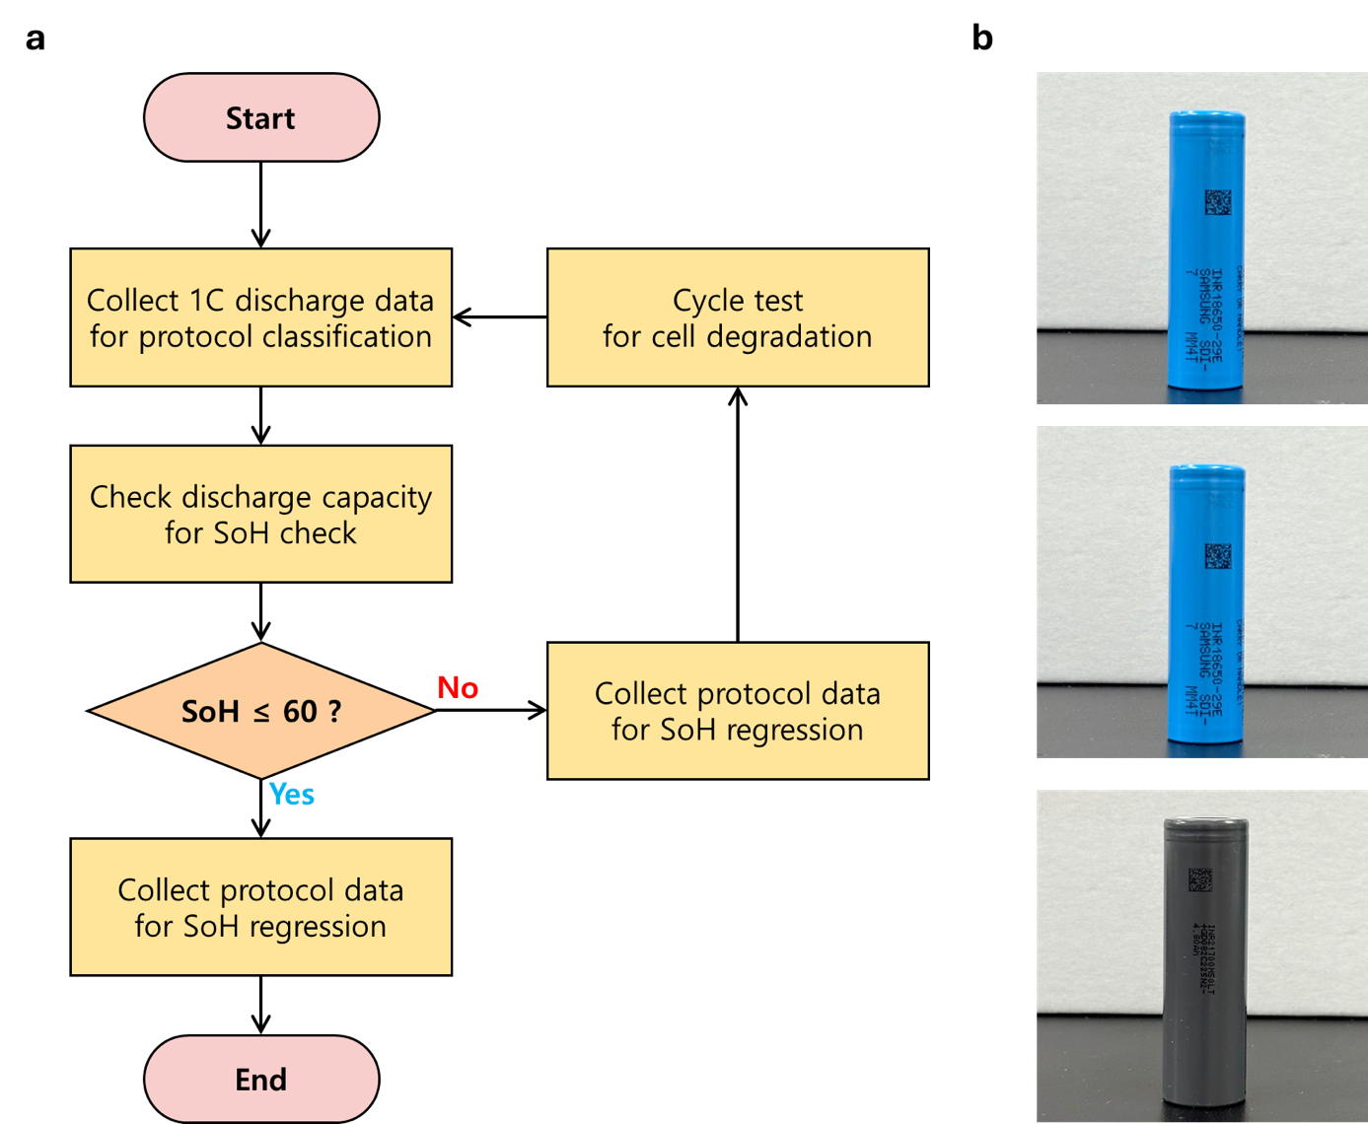
Supplementary Figure 1. Data collection (a) flow chart, (b) tested cylindrical cells (top: INR18650-29E, middle: INR21700-50E, and bottom: INR21700-M50LT)
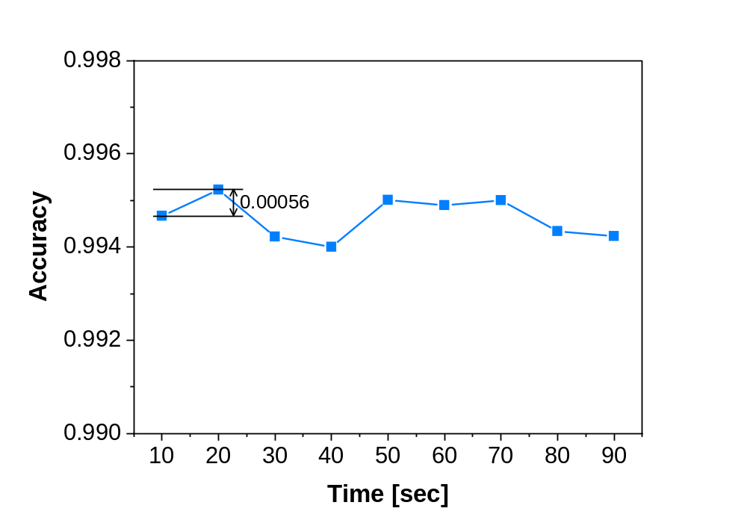
Supplementary Figure 2. Accuracy depending on the collection time of 1.0 C-rate discharge voltage

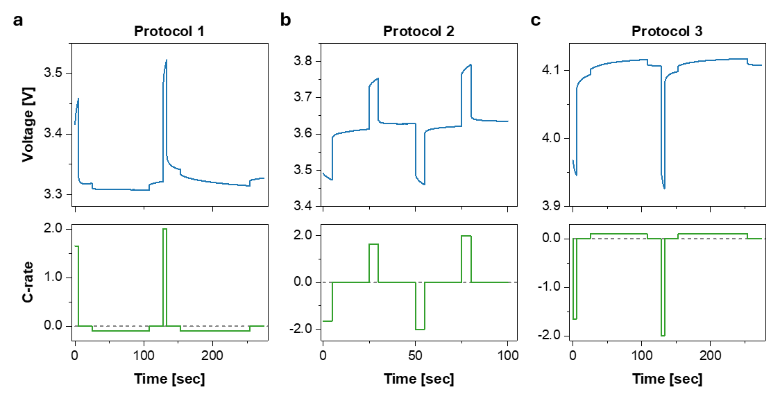
Supplementary Figure 3. Voltage profile according to the protocols (a) protocol 1, (b) protocol 2, and (c) protocol 3

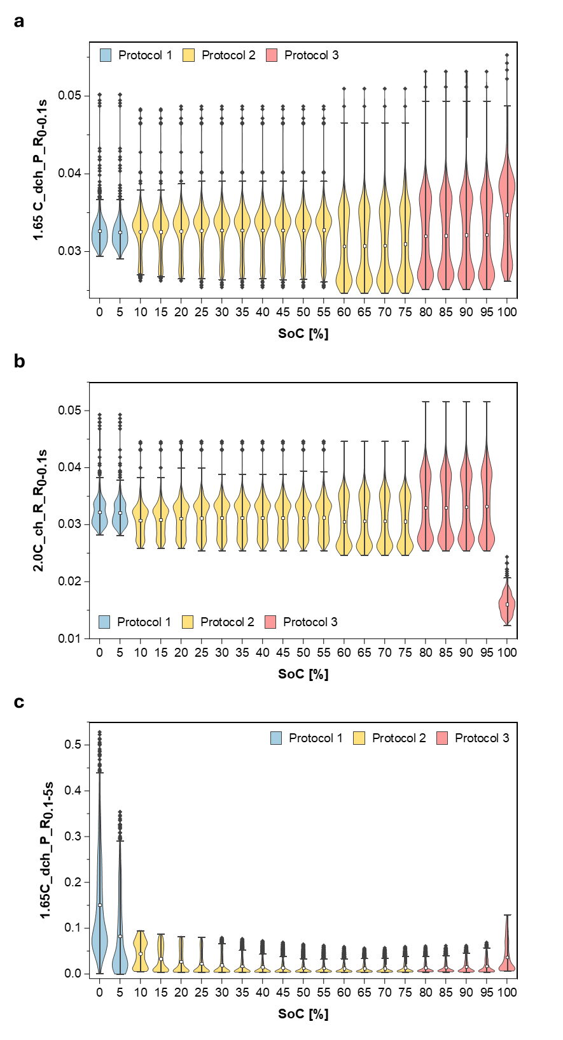
Supplementary Figure 4. Distribution of 3 features with highest mean absolute SHAP value (a) 1.65C_dch_P_R_{0-0.1s}, (b) 2.0C_ch_R_R_{0-0.1s}, and (c) 1.65C_dch_P_R_{0.1-5s}

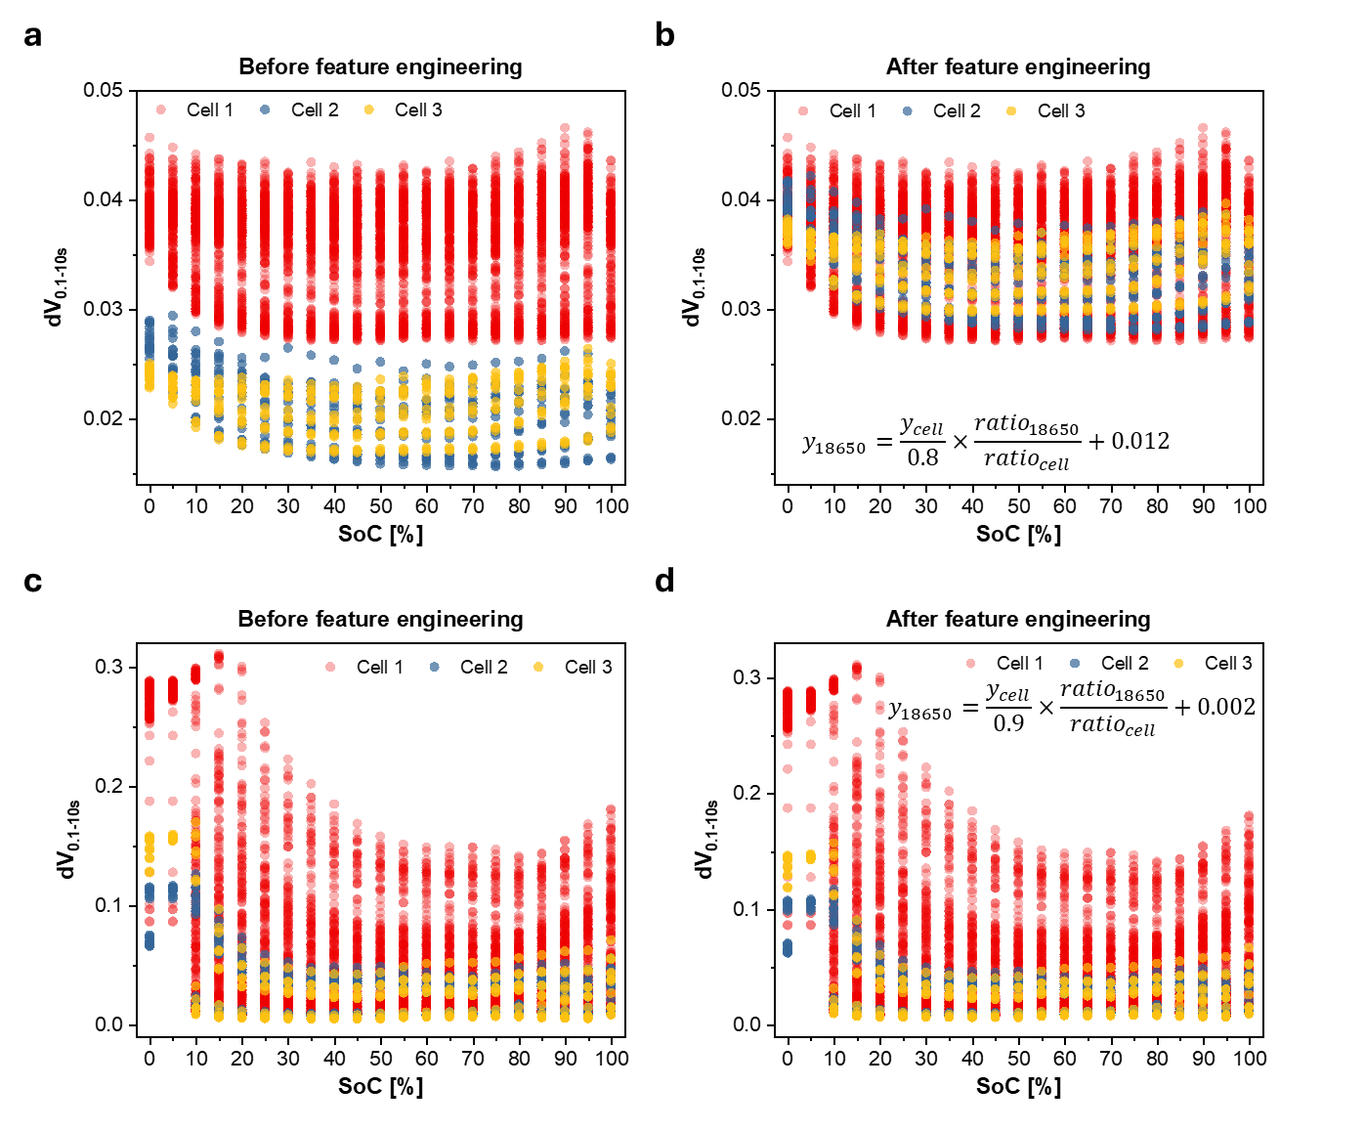
Supplementary Figure 5. Feature engineering for protocol classification. (a) before and (b) after feature engineering of dV_{0-0.1s}, (c) before and (d) after feature engineering of dV_{0.1-10s}

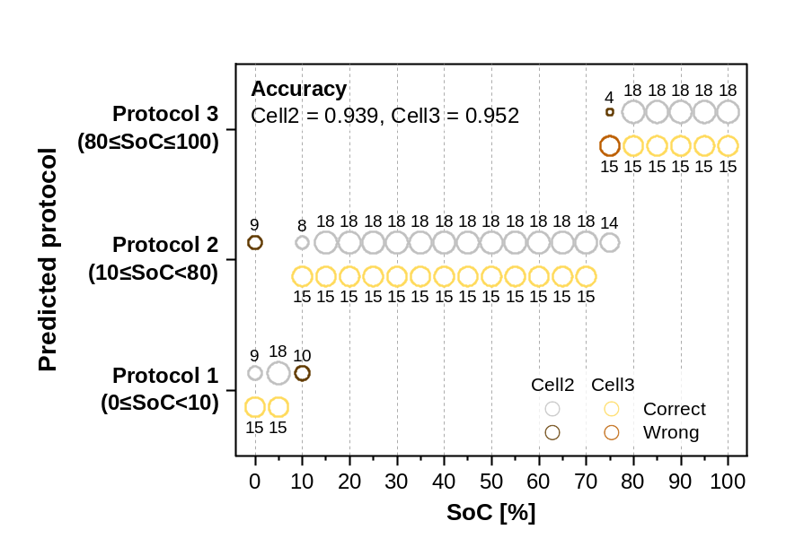

Supplementary Figure 6. Protocol classification results of other cells without any feature engineering

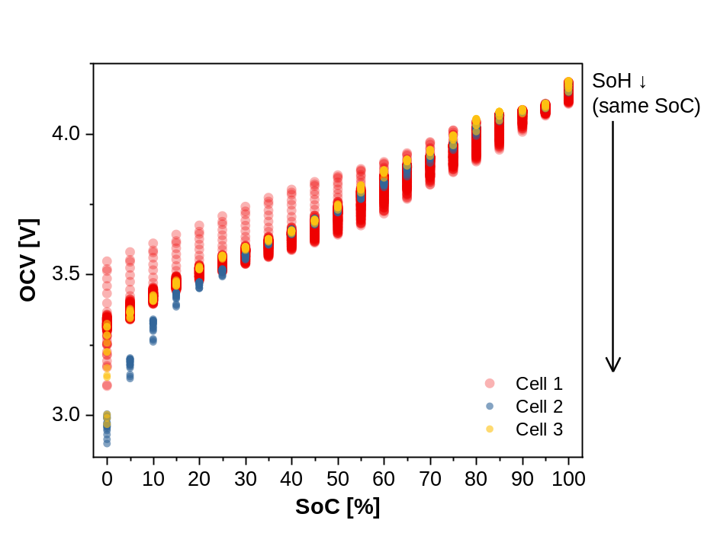
Supplementary Figure 7. OCV depending on the SoC of cell 1, 2 and 3

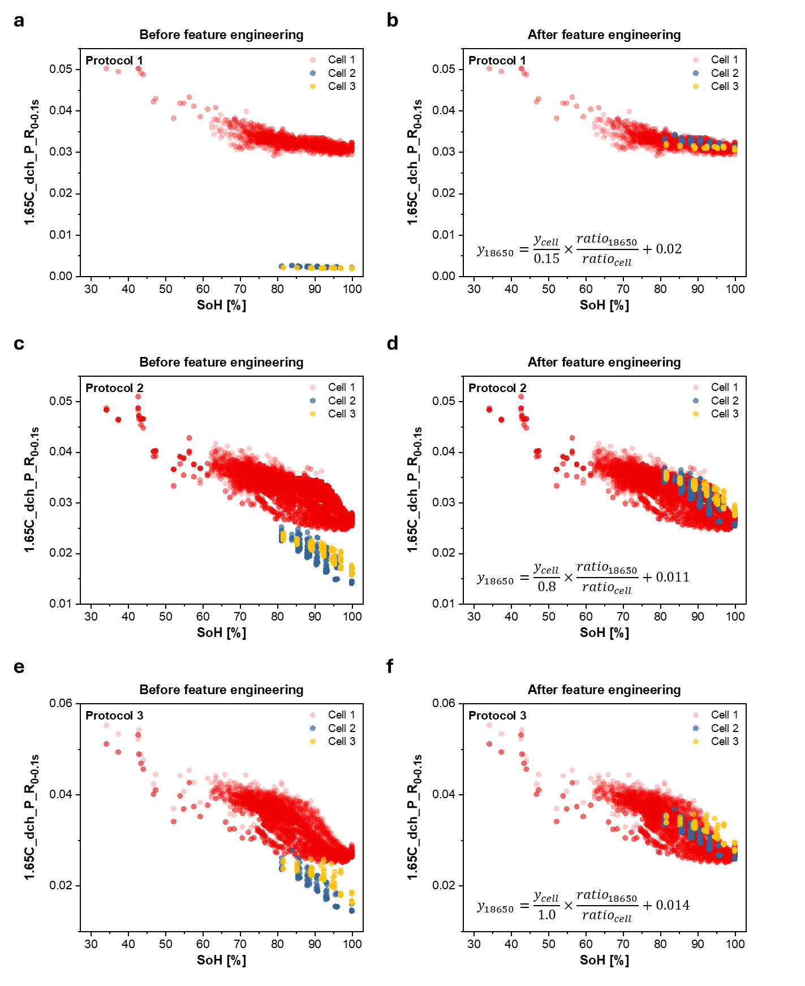
Supplementary Figure 8. Feature engineering of 1.65C_dch_P_R_{0-0.1s} for SoH regression model. (a) before and (b) after feature engineering for protocol 1, (c) before and (d) after feature engineering for protocol 2, (e) before and (f) after feature engineering for protocol 3

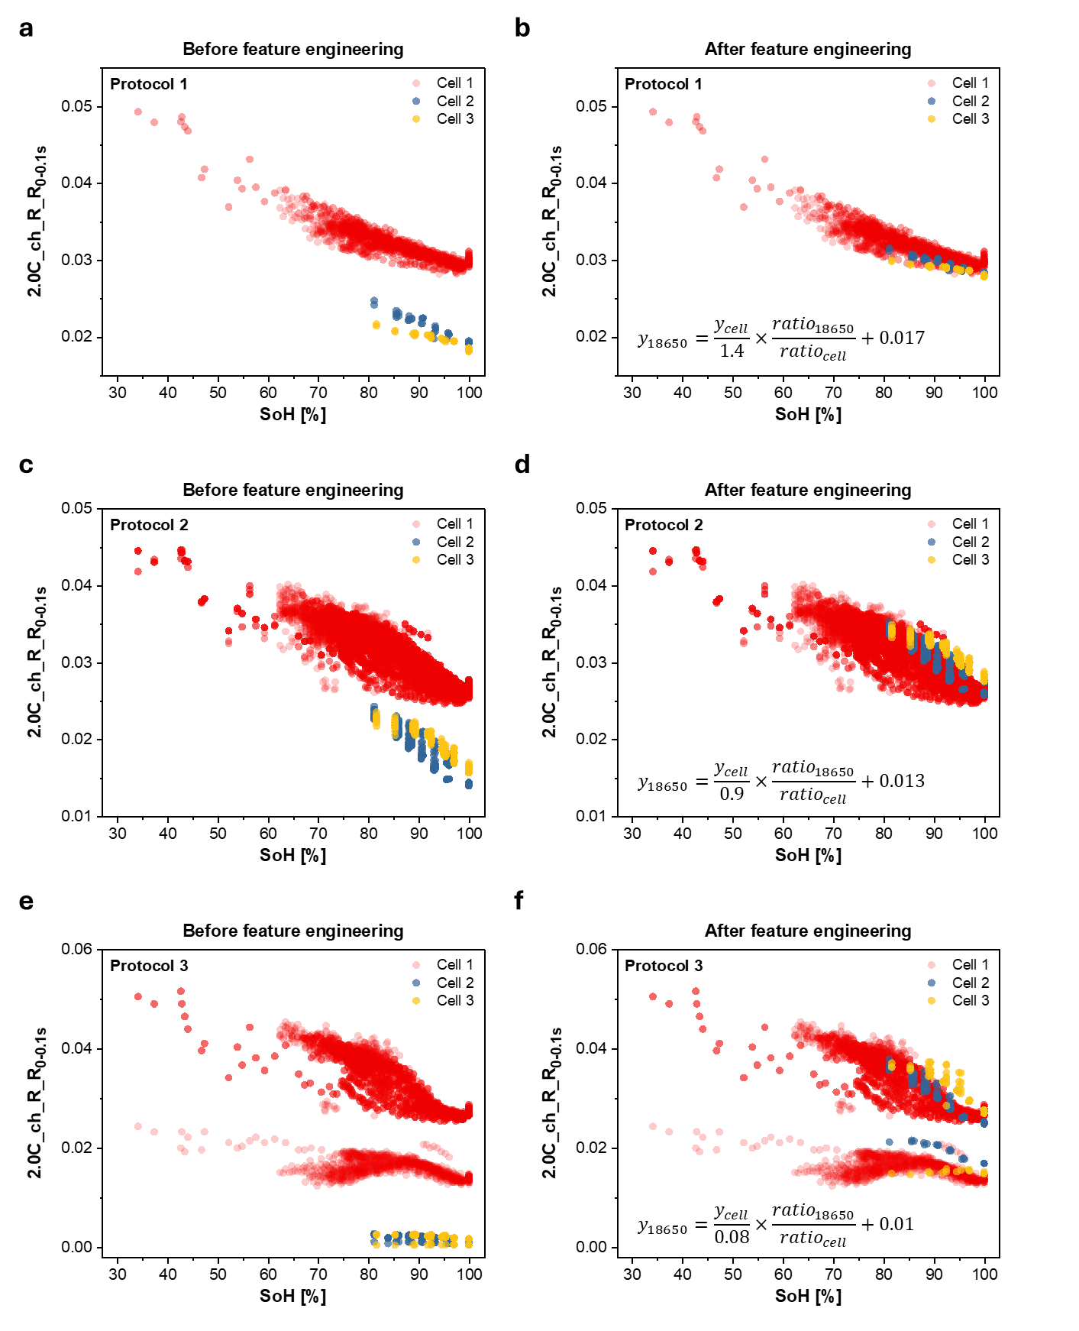
Supplementary Figure 9. Feature engineering of 2.0C_ch_R_R_{0-0.1s} for SoH regression model. (a) before and (b) after feature engineering for protocol 1, (c) before and (d) after feature engineering for protocol 2, (e) before and (f) after feature engineering for protocol 3

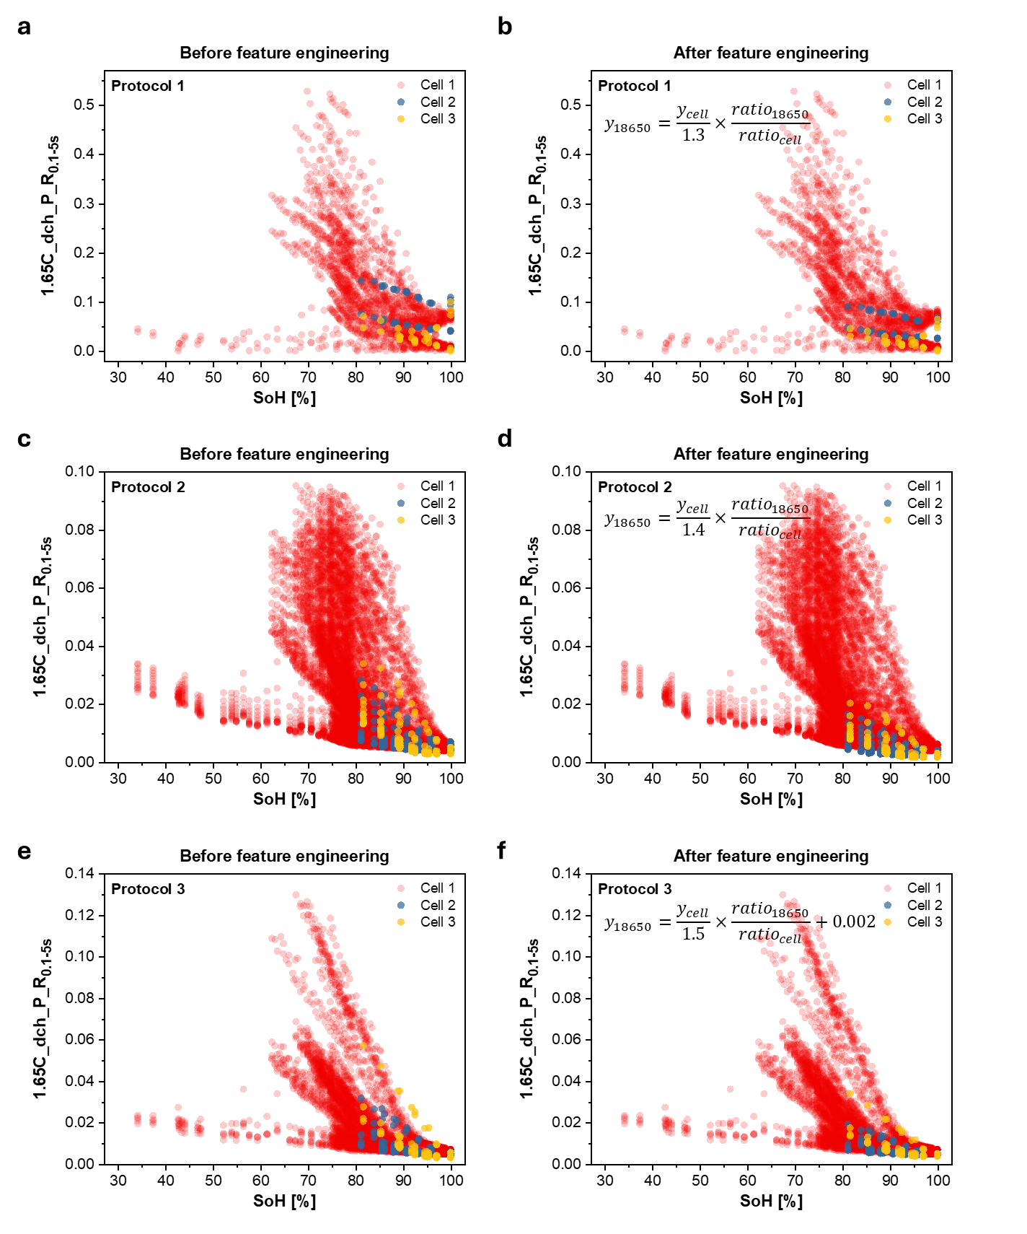
Supplementary Figure 10. Feature engineering of 1.65C_dch_P_R_{0.1-5s} for SoH regression model. (a) before and (b) after feature engineering for protocol 1, (c) before and (d) after feature engineering for protocol 2, (e) before and (f) after feature engineering for protocol 3

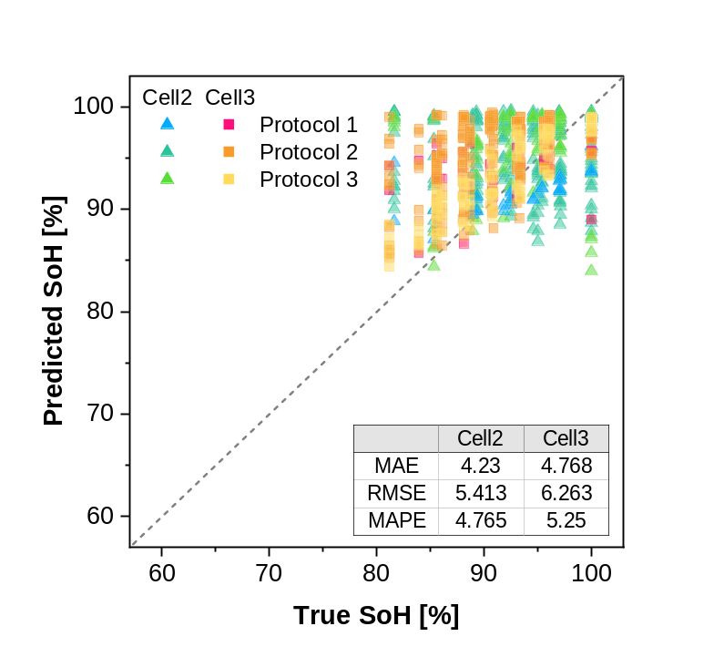
Supplementary Figure 11. SoH regression model results of other cells without any feature engineering

Supplementary Table 1. Cycle test conditions in INR18650-29E cells
Cycle test condition
Number (#) | Charge (CC/CV mode) | Discharge (CC mode)
1 | 0.5C-rate | 0.5C-rate
2 | 0.5C-rate | 1.0C-rate
3 | 0.5C-rate | 2.0C-rate
4 | 0.5C-rate | 4.0C-rate
5 | 1.0C-rate | 0.5C-rate
6 | 1.0C-rate | 1.0C-rate
7 | 1.0C-rate | 2.0C-rate
8 | 1.0C-rate | 4.0C-rate
9 | 2.0C-rate | 0.5C-rate
10 | 2.0C-rate | 1.0C-rate
11 | 2.0C-rate | 2.0C-rate
12 | 2.0C-rate | 4.0C-rate

Supplementary Table 2. The performance of protocol classifcaion according to the models
Model | Accuracy | Recall | Precision | TT
Light Gradient Boosting Machine | 0.9943 | 0.9943 | 0.9944 | 0.567
Extreme Gradient Boosting | 0.993 | 0.993 | 0.9931 | 0.175
Random Forest Classifier | 0.9923 | 0.9923 | 0.9924 | 0.156
Gradient Boosting Classifier | 0.992 | 0.992 | 0.9921 | 0.425
Decision Tree Classifier | 0.9907 | 0.9907 | 0.9908 | 0.014
K Neighbors Classifier | 0.986 | 0.986 | 0.9862 | 0.349
Quadratic Discriminant Analysis | 0.9576 | 0.9576 | 0.9599 | 0.011
Logistic Regression | 0.9566 | 0.9566 | 0.9563 | 0.728
Naive Bayes | 0.9556 | 0.9556 | 0.9588 | 0.013
SVM - Linear Kernel | 0.9243 | 0.9243 | 0.9237 | 0.02
Linear Discriminant Analysis | 0.9123 | 0.9123 | 0.9214 | 0.011
Ridge Classifier | 0.9109 | 0.9109 | 0.909 | 0.011
Ada Boost Classifier | 0.9093 | 0.9093 | 0.9159 | 0.068
Dummy Classifier | 0.6668 | 0.6668 | 0.4446 | 0.012
* TT: training time [sec]

Supplementary Table 3. The performance of SoH regression according to the models
Model | R² score | MAE | RMSE | MAPE | TT
Random Forest Regressor | 0.9749 | 0.988 | 1.5495 | 0.0123 | 5.1843
Extreme Gradient Boosting | 0.9746 | 1.0746 | 1.5591 | 0.0134 | 0.2271
Light Gradient Boosting Machine | 0.9674 | 1.262 | 1.765 | 0.0157 | 0.2671
K Neighbors Regressor | 0.9579 | 1.3104 | 2.0067 | 0.0164 | 0.06
Decision Tree Regressor | 0.9411 | 1.3296 | 2.3671 | 0.0164 | 0.0871
Gradient Boosting Regressor | 0.9271 | 1.924 | 2.6409 | 0.0239 | 1.53
Bayesian Ridge | 0.8184 | 3.1038 | 4.1686 | 0.0384 | 0.0243
Least Angle Regression | 0.8184 | 3.104 | 4.1686 | 0.0384 | 0.0143
Ridge Regression | 0.8184 | 3.1007 | 4.169 | 0.0383 | 0.2157
Linear Regression | 0.8184 | 3.1031 | 4.1679 | 0.0383 | 0.3871
AdaBoost Regressor | 0.8168 | 3.4474 | 4.1878 | 0.0411 | 0.44
Huber Regressor | 0.8103 | 3.0306 | 4.2613 | 0.0383 | 0.0886
Passive Aggressive Regressor | 0.7903 | 3.2349 | 4.4742 | 0.0407 | 0.0171
Orthogonal Matching Pursuit | 0.4191 | 5.5466 | 7.4612 | 0.0703 | 0.0157
Lasso Regression | 0.1762 | 7.1537 | 8.8862 | 0.0895 | 0.2943
Lasso Least Angle Regression | 0.1762 | 7.1537 | 8.8862 | 0.0895 | 0.0143
Elastic Net | 0.0863 | 7.6217 | 9.3577 | 0.0953 | 0.0129
Dummy Regressor | -0.0007 | 8.0442 | 9.793 | 0.1004 | 0.0143
* TT: training time [sec]

Supplementary Table 4. The selected features for SoH prediction model and Pearson correlation coefficients with SoH
 | Feature | Mean (|SHAP value|) | Pearson correlation coefficient with SoH
1 | 2.0C_ch_R_R_{0.1s} | 3.2578 | -0.6159
2 | 1.65C_dch_P_R_{0.1s} | 2.1699 | -0.8215
3 | 1.65C_dch_P_R_{5s} | 2.1128 | -0.6462
4 | 2.0C_P_hyst | 1.2655 | -0.3265
5 | 1.65C_dch_P_skew | 1.2499 | -0.3519
6 | 2.0C_ch_P_R_{5s} | 1.1445 | -0.3136
7 | 2.0C_ch_P_V_{f} | 0.6457 | -0.5039
8 | 1.65C_dch_R_skew | 0.4160 | -0.1712
9 | 2.0C_dch_P_V_{f} | 0.3704 | 0.5429
10 | 2.0C_ch_R_skew | 0.3402 | 0.4174
11 | 2.0C_ch_P_skew | 0.2777 | 0.3234
12 | 1.65C_R_R ratio | 0.1917 | -0.1945

