Supplemental Table 1. List of 54 myeloid neoplasm-relevant genes studied in targeted NGS sequencing
Gene name | Target region (exon) | Gene name | Target region (exon)
ABL | 4-6 | JAK3 | 13
ASXL1 | 12 | KDM6A | full
ATRX | 8-10, 17-31 | KIT | 2, 8-11, 13, 17
BCOR | full | KRAS | 2, 3
BCORL1 | full | MLL | 5-8
BRAF | 15 | MPL | 10
CALR | 9 | MYD88 | 3-5
CBL | 8, 9 | NOTCH1 | 26-28, 34
CBLB | 9, 10 | NPM1 | 12
CBLC | 9, 10 | NRAS | 2, 3
CDKN2A | full | PDGFRA | 12, 14, 18
CEBPA | full | PHF6 | Full
CSF3R | 14-17 | PTEN | 5, 7
CUX1 | full | PTPN11 | 3, 13
DNMT3A | full | RAD21 | Full
ETV6 | full | RUNX1 | Full
EZH2 | full | SETBP1 | 4 (partial)
FBXW7 | 9-11 | SF3B1 | 13-16
FLT3 | 14, 15, 20 | SMC1A | 2, 11, 16, 17
GATA1 | 2 | SMC3 | 10, 13, 19, 23, 25, 28
GATA2 | 2-6 | SRSF2 | 1
GNAS | 8, 9 | STAG2 | full
HRAS | 2, 3 | TET2 | 3-11
IDH1 | 4 | TP53 | 2-11
IDH2 | 4 | U2AF1 | 2, 6
IKZF1 | full | WT1 | 7, 9
JAK2 | 12, 14 | ZRSR2 | full

Supplemental Table 2. Comparison of genetic alterations between patients with high (>1.5) or low (≤1.5) lymphocyte/monocyte ratio
Clinical characters | Total  (n=554) | L/M ≤ 1.5  (n=206) | L/M > 1.5  (n=348) | P value
Epigenetics modifiers | 252 (45.5) | 93 (45.1) | 159 (45.7) | 0.930
DNA methylation | 148 (26.7) | 60 (29.1) | 88 (25.3) | 0.323
DNMT3A | 51 (9.2) | 20 (9.7) | 31 (8.9) | 0.753
TET2 | 86 (15.5) | 37 (18.0) | 49 (14.1) | 0.223
IDH1 | 3 (0.5) | 1 (0.5) | 2 (0.6) | >0.999
IDH2 | 23 (4.2) | 10 (4.9) | 13 (3.7) | 0.523
WT1 | 8 (1.4) | 2 (1.0) | 6 (1.7) | 0.716
Chromatin modifiers | 159 (28.7) | 55 (26.7) | 104 (29.9) | 0.439
ASXL1 | 118 (21.3) | 41 (19.9) | 77 (22.1) | 0.537
EZH2 | 25 (4.5) | 8 (3.9) | 17 (4.9) | 0.578
KMT2A | 12 (2.2) | 3 (1.5) | 9 (2.6) | 0.549
SETBP1 | 15 (2.7) | 4 (1.9) | 11 (3.2) | 0.589
BCOR | 28 (5.1) | 9 (4.4) | 19 (5.5) | 0.566
BCORL1 | 11 (2.0) | 2 (1.0) | 9 (2.6) | 0.225
PHF6 | 9 (1.6) | 2 (1.0) | 7 (2.0) | 0.495
Activated signaling | 59 (10.6) | 26 (12.6) | 33 (9.5) | 0.257
FLT3-ITD | 3 (0.5) | 2 (1.0) | 1 (0.3) | 0.559
FLT3-TKD | 2 (0.4) | 0 (0.0) | 2 (0.6) | 0.532
KIT | 4 (0.7) | 2 (1.0) | 2 (0.6) | 0.631
KRAS | 3 (0.5) | 1 (0.5) | 2 (0.6) | >0.999
NRAS | 18 (3.2) | 8 (3.9) | 10 (2.9) | 0.621
PTPN11 | 5 (0.9) | 3 (1.5) | 2 (0.6) | 0.366
JAK2 | 10 (1.8) | 5 (2.4) | 5 (1.4) | 0.512
CBL | 12 (2.2) | 8 (3.9) | 4 (1.2) | 0.065
GNAS | 2 (0.4) | 1 (0.5) | 1 (0.3) | >0.999
Transcription factor | 102 (18.4) | 38 (18.4) | 64 (18.4) | >0.999
CEBPA | 22 (4.0) | 8 (3.9) | 14 (4.0) | >0.999
RUNX1 | 68 (12.3) | 25 (12.1) | 43 (12.4) | >0.999
GATA2 | 6 (1.1) | 1 (0.5) | 5 (1.4) | 0.420
ETV6 | 13 (2.4) | 6 (2.9) | 7 (2.0) | 0.566
IKZF1 | 5 (0.9) | 2 (1.0) | 3 (0.9) | >0.999
Spliceosome-complex | 190 (34.3) | 78 (37.9) | 112 (32.2) | 0.195
U2AF1 | 42 (7.6) | 9 (4.4) | 33 (9.5) | 0.028
SRSF2 | 56 (10.1) | 23 (11.2) | 33 (9.5) | 0.526
ZRSR2 | 26 (4.7) | 12 (5.8) | 14 (4.0) | 0.332
SF3B1 | 77 (13.9) | 40 (19.4) | 37 (10.6) | 0.004
SF3B1^{5q} | 3 (0.5) | 1 (0.5) | 2 (0.6) | >0.999
SF3B1^{α} | 61 (11.0) | 32 (15.5) | 29 (8.3) | 0.009
SF3B1^{β} | 13 (2.3) | 7 (3.4) | 6 (1.7) | 0.208
Cohesin complex | 68 (12.3) | 15 (7.3) | 53 (15.2) | 0.007
RAD21 | 2 (0.4) | 0 (0.0) | 2 (0.6) | 0.532
SMC1A | 1 (0.2) | 0 (0.0) | 1 (0.3) | >0.999
SMC3 | 1 (0.2) | 1 (0.5) | 0 (0.0) | 0.372
STAG2 | 66 (11.9) | 15 (7.3) | 51 (14.7) | 0.009
Tumor suppressor | 63 (11.4) | 22 (10.7) | 41 (11.8) | 0.693
TP53 | 59 (10.6) | 19 (9.2) | 40 (11.5) | 0.402
CUX1 | 7 (1.3) | 4 (1.9) | 3 (0.9) | 0.433
Median number of mutations | 1 (0-8) | 1 (0-7) | 1 (0-8) | 0.800
P values of <0.05 are statistically significant.
Data are presented as n (%).
Abbreviations: L/M, lymphocyte/monocyte ratio
Note: Large insertion in FLT3-ITD and high GC content in CEBPA limited the detection and quantification by NGS.

Supplemental Table 3. Univariable Cox regression analysis for leukemia-free survival and overall survival
Variables | LFS |  | OS
Variables | HR (95% CI) | P value | HR (95% CI) | P value
Age* | 1.022 (1.014-1.030) | <0.001 | 1.025 (1.017-1.033) | <0.001
Female | 0.698 (0.542-0.899) | 0.005 | 0.677 (0.522-0.878) | 0.003
Ferritin* (X 10² ng/mL) | 1.001 (1.000-1.001) | 0.001 | 1.001 (1.000-1.001) | 0.012
L/M > 1.5 | 1.422 (1.107-1.827) | 0.006 | 1.401 (1.085-1.810) | 0.010
AMC (X 10⁷ /L)* | 1.003 (1.002-1.005) | <0.001 | 1.003 (1.001-1.005) | <0.001
WHO-2022 classification |  | <0.001 |  | <0.001
MDS-h, and SF3B1 | Reference | - | Reference | -
Low-risk MDS† | 1.314 (0.872-1.982) | 0.192 | 1.370 (0.906-2.072) | 0.135
High-risk MDS‡ | 4.314 (3.051-6.099) | <0.001 | 3.812 (2.679-5.424) | <0.001
MDS-biTP53 | 15.075 (9.348-24.311) | <0.001 | 17.686 (10.845-28.841) | <0.001
ICC
Low-risk MDS§ | Reference | - | Reference | -
MDS with EB | 2.952 (2.162-4.031) | <0.001 | 2.613 (1.900-3.593) | <0.001
MDS/AML¶ | 4.780 (3.482-6.562) | <0.001 | 3.924 (2.829-5.442) | <0.001
Mutated TP53# | 13.909 (9.332-20.730) | <0.001 | 16.642 (11.034-25.098) | <0.001
IPSS-M |  | <0.001 |  | <0.001
Very low/low | Reference | - | Reference | -
Moderate low | 1.695 (1.022-2.810) | 0.041 | 1.710 (1.031-2.835) | 0.038
Moderate high | 2.608 (1.651-4.118) | <0.001 | 2.281 (1.428-3.642) | 0.001
High | 4.101 (2.667-6.308) | <0.001 | 3.915 (2.538-6.040) | <0.001
Very high | 10.830 (7.290-16.090) | <0.001 | 9.411 (6.321-14.010) | <0.001
IPSS-R |  | <0.001 |  | <0.001
Very low/low | Reference | - | Reference | -
Intermediate | 1.709 (1.181-2.472) | 0.004 | 1.568 (1.076-2.285) | 0.019
High | 3.664 (2.591-5.181) | <0.001 | 3.234 (2.275-4.595) | <0.001
Very high | 6.662 (4.725-9.393) | <0.001 | 6.322 (4.470-8.941) | <0.001
HSCT | 0.862 (0.586-1.268) | 0.451 | 0.814 (0.551-1.203) | 0.301
HMA | 1.978 (1.546-2.526) | <0.001 | 1.745 (1.356-2.246) | <0.001
Note: Only 16 (2.9%) and 20 (3.6%) patients were categorized as very low-risk IPSS-M or IPSS-R respectively and there was no inter-group difference between IPSS-M or IPSS-R very low and low risk subgroups in both OS and LFS; accordingly, we put IPSS-M amd IPSS-R very low and low groups together.
P values of <0.05 are statistically significant.
*As continuous variables analysis.
†Low-risk MDS included MDS with del(5q), MDS-LB, MDS-LB and RS
‡High-risk MDS included MDS-IB1, MDS-IB2, MDS-f
§Low-risk MDS includes MDS with del(5q), MDS-SF3B1, and MDS, NOS with SLD or MLD.
¶MDS/AML includes MDS/AML with MDS-related gene mutations, MDS/AML with MDS-related cytogenetic abnormalities, or MDS/AML, not otherwise specified
#MDS or MDS/AML with mutated TP53
Abbreviations: AMC, absolute monocyte counts; ALC, absolute lymphocyte counts; CI, confidence interval; EB, excess blasts; HR, hazard ratio; HMA, hypomethylating agents; HSCT, allogeneic hematopoietic stem cell transplantation; h, hypoplastic; ICC, International Consensus Classification; IPSS-M, Molecular International Prognostic Scoring System; IPSS-R, Revised International Prognostic Scoring System; L/M, lymphocyte/monocyte ratio; LFS, leukemia-free survival; MDS, myelodysplastic syndrome/neoplasms; MDS/AML, myelodysplastic syndromes/acute myeloid leukemia; OS, overall survival.

Supplemental Table 4. Multivariable analysis Cox regression analysis of the impact of different variables on the leukemia-free survival and overall survival of patients with myelodysplastic syndromes/neoplasms
Variable | LFS |  | OS |  | LFS |  | OS
Variable | HR (95% CI) | P value | HR (95% CI) | P value | HR (95% CI) | P value | HR (95% CI) | P value
Age* | 1.027 (1.016-1.038) | <0.001 | 1.036 (1.024-1.048) | <0.001 | 1.027 (1.016-1.038) | <0.001 | 1.036 (1.024-1.048) | <0.001
Female | 1.150 (0.833-1.588) | 0.396 | 1.057 (0.763-1.463) | 0.739 | 1.155 (0.836-1.597) | 0.382 | 1.059 (0.763-1.468) | 0.733
Ferritin*(X 10² ng/mL) | 1.000 (1.000-1.001) | 0.037 | 1.000 (1.000-1.001) | 0.117 | 1.001 (1.000-1.001) | 0.021 | 1.000 (1.000-1.001) | 0.086
L/M > 1.5 | 1.404 (1.020-1.931) | 0.037 | 1.558 (1.128-2.151) | 0.007 | 1.440 (1.047-1.982) | 0.025 | 1.600 (1.158-2.211) | 0.004
AMC | 1.002 (1.000-1.005) | 0.060 | 1.002 (0.999-1.004) | 0.214 | 1.002 (0.999-1.004) | 0.123 | 1.001 (0.999-1.004) | 0.387
ICC |  | <0.001 |  | <0.001
Low-risk MDS† | Reference | - | Reference | -
MDS with EB | 1.616 (1.017-2.567) | <0.001 | 1.310 (0.816-2.104) | 0.364
MDS/AML‡ | 2.454 (1.467-4.101) | <0.001 | 1.920 (1.134-3.252) | 0.015
Mutated TP53§ | 4.712 (2.455-9.043) | 0.011 | 5.576 (2.838-10.953) | <0.001
WHO-2022 |  |  |  |  |  | <0.001 |  | <0.001
MDS-h, and SF3B1 |  |  |  |  | Reference | - | Reference | -
Low-risk MDS† |  |  |  |  | 0.947 (0.589-1.521) | 0.821 | 0.981 (0.609-1.579) | 0.936
High-risk MDS‡ |  |  |  |  | 1.726 (1.013-2.942) | 0.045 | 1.423 (0.828-2.446) | 0.202
MDS-biTP53 |  |  |  |  | 4.168 (2.035-8.535) | <0.001 | 4.729 (2.262-9.886) | <0.001
IPSS-M |  | <0.001 |  | <0.001 |  | <0.001 |  | <0.001
Very low/low | Reference | - | Reference |  | Reference | - | Reference | -
Moderate low | 1.630 (0.902-2.946) | 0.106 | 1.750 (0.970-3.157) | 0.063 | 1.644 (0.905-2.984) | 0.102 | 1.748 (0.964-3.169) | 0.066
Moderate high | 2.256 (1.301-3.911) | 0.004 | 2.065 (1.183-3.603) | 0.011 | 2.214 (1.259-3.892) | 0.006 | 2.004 (1.130-3.551) | 0.017
High | 2.817 (1.570-5.054) | 0.001 | 2.942 (1.636-5.292) | <0.001 | 2.931 (1.617-5.313) | <0.001 | 3.003 (1.650-5.466) | <0.001
Very high | 5.414 (2.961-9.901) | <0.001 | 4.847 (2.626-8.944) | <0.001 | 5.114 (3.336-11.206) | <0.001 | 5.532 (2.996-10.215) | <0.001
HMA | 0.885 (0.619-1.264) | 0.501 | 0.761 (0.524-1.105) | 0.152 | 1.007 (0.712-1.425) | 0.968 | 0.890 (0.619-1.279) | 0.528
HSCT | 0.647 (0.369-1.135) | 0.129 | 1.225 (0.734-2.044) | 0.437 | 0.600 (0.344-1.044) | 0.071 | 1.112 (0.673-1.835) | 0.679
P values of <0.05 are statistically significant.
*As continuous variables analysis.
†Low-risk MDS included MDS with del(5q), MDS-SF3B1, and MDS, NOS with SLD or MLD.
‡MDS/AML with MDS-related gene mutations, MDS-related cytogenetic abnormalities, or not otherwise specified
§MDS or MDS/AML with mutated TP53
Abbreviations: AMC, absolute monocyte count; CI, confidence interval; EB, excess blasts; HR, Hazard ratios; HMA, hypomethylating agents; HSCT, allogeneic hematopoietic stem cell transplantation; ICC, International Consensus Classification; IPSS-M, Molecular International Prognostic Scoring System; L/M, lymphocyte/monocyte ratio; LFS, leukemia-free survival; MDS, myelodysplastic syndromes/neoplasms; MDS/AML, myelodysplastic syndromes/acute myeloid leukemia; OS, overall survival.

Supplemental Table 5. Multivariable analysis Cox regression analysis of the impact of different variables on the leukemia-free survival and overall survival of patients with myelodysplastic syndromes/neoplasms
Variable | LFS |  | OS |  | LFS |  | OS
Variable | HR (95% CI) | P value | HR (95% CI) | P value | HR (95% CI) | P value | HR (95% CI) | P value
Age* | 1.025 (1.015-1.036) | <0.001 | 1.034 (1.022-1.046) | <0.001 | 1.025 (1.014-1.036) | <0.001 | 1.033 (1.022-1.045) | <0.001
Female | 1.233 (0.899-1.692) | 0.194 | 1.144 (0.830-1.576) | 0.410 | 1.249 (0.910-1.715) | 0.169 | 1.157 (0.839-1.595) | 0.374
Ferritin*(X 10² ng/mL) | 1.000 (1.000-1.001) | 0.062 | 1.000 (1.000-1.001) | 0.196 | 1.000 (1.000-1.001) | 0.040 | 1.000 (1.000-1.001) | 0.170
AMC | 1.002 (1.000-1.005) | 0.114 | 1.001 (0.998-1.004) | 0.387 | 1.002 (0.999-1.004) | 0.210 | 1.001 (0.998-1.004) | 0.604
ICC |  | <0.001 |  | <0.001
Low-risk MDS† | Reference | - | Reference | -
MDS with EB | 1.745 (1.114-2.734) | 0.015 | 1.475 (0.937-2.322) | 0.093
MDS/AML‡ | 2.603 (1.570-4.317) | <0.001 | 2.066 (1.231-3.467) | 0.006
Mutated TP53§ | 5.113 (2.701-9.680) | <0.001 | 6.183 (3.203-11.935) | <0.001
WHO-2022 |  |  |  |  |  | <0.001 |  | <0.001
MDS-h, and SF3B1 |  |  |  |  | Reference | - | Reference | -
Low-risk MDS† |  |  |  |  | 0.935 (0.582-1.503) | 0.783 | 0.976 (0.607-1.571) | 0.921
High-risk MDS‡ |  |  |  |  | 1.857 (1.101-3.133) | 0.020 | 1.597 (0.944-2.702) | 0.081
MDS-biTP53 |  |  |  |  | 4.333 (2.133-8.803) | <0.001 | 5.035 (2.439-10.392) | <0.001
IPSS-M |  | <0.001 |  | <0.001 |  | <0.001 |  | <0.001
Very low/low | Reference | - | Reference |  | Reference | - | Reference | -
Moderate low | 1.630 (0.902-2.945) | 0.105 | 1.756 (0.974-3.167) | 0.061 | 1.640 (0.904-2.974) | 0.103 | 1.748 (0.966-3.165) | 0.065
Moderate high | 2.343 (1.354-4.054) | 0.002 | 2.173 (1.248-3.783) | 0.006 | 2.309 (1.318-4.047) | 0.003 | 2.116 (1.199-3.734) | 0.010
High | 2.771 (1.556-4.935) | 0.001 | 2.856 (1.604-5.086) | <0.001 | 2.880 (1.600-5.184) | <0.001 | 2.894 (1.605-5.220) | <0.001
Very high | 5.250 (2.894-9.523) | <0.001 | 4.597 (2.516-8.399) | <0.001 | 5.977 (3.289-10.861) | <0.001 | 5.251 (2.878-9.581) | <0.001
HMA | 0.882 (0.619-1.259) | 0.490 | 0.756 (0.521-1.097) | 0.141 | 0.997 (0.705-1.412) | 0.988 | 0.868 (0.603-1.249) | 0.445
HSCT | 0.645 (0.368-1.132) | 0.126 | 1.186 (0.710-1.982) | 0.514 | 0.595 (0.342-1.037) | 0.067 | 1.078 (0.651-1.784) | 0.771
P values of <0.05 are statistically significant.
*As continuous variables analysis.
†Low-risk MDS included MDS with del(5q), MDS-SF3B1, and MDS, NOS with SLD or MLD.
‡MDS/AML with MDS-related gene mutations, MDS-related cytogenetic abnormalities, or not otherwise specified
§MDS or MDS/AML with mutated TP53
Abbreviations: AMC, absolute monocyte count; CI, confidence interval; EB, excess blasts; HR, Hazard ratios; HMA, hypomethylating agents; HSCT, allogeneic hematopoietic stem cell transplantation; ICC, International Consensus Classification; IPSS-M, Molecular International Prognostic Scoring System; LFS, leukemia-free survival; MDS, myelodysplastic syndromes/neoplasms; MDS/AML, myelodysplastic syndromes/acute myeloid leukemia; OS, overall survival.

Supplemental Figure 1. Distribution of revised International Prognostic Scoring System (IPSS-R) (A) and molecular IPSS (IPSS-M) (B) for patients with high (>1.5) or low (≤1.5) lymphocyte/monocyte (L/M) ratio
(a)
(b)
Note: P value < 0.05 is marked with *

Supplemental Figure 2. Kaplan-Meier curves for leukemia-free survival and overall survival in patients with myelodysplastic neoplasms/syndromes with or without allogeneic hematopoietic transplantation (HSCT) based on lymphocyte/monocyte (L/M) ratio,
(A) Leukemia-free survival, stratified by L/M ratio in patients not receiving HSCT
(B) Overall survival, stratified by L/M ratio in patients not receiving HSCT
(C) Leukemia-free survival, stratified by L/M ratio in patients receiving HSCT
(D) Overall survival, stratified by L/M ratio in patients receiving HSCT
(a) | (b)
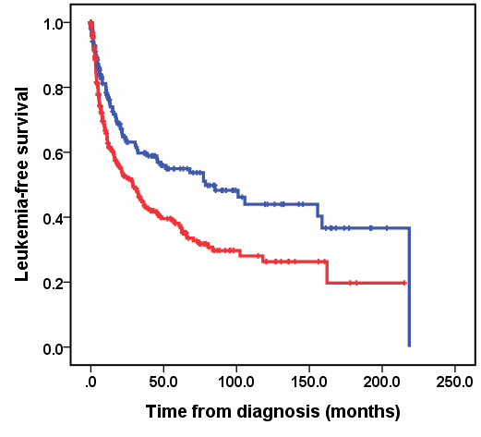  P = 0.001  L/M ≤ 1.5, n=175, Median LFS: 78.7 months  L/M > 1.5, n=286, Median LFS: 28.8 months | 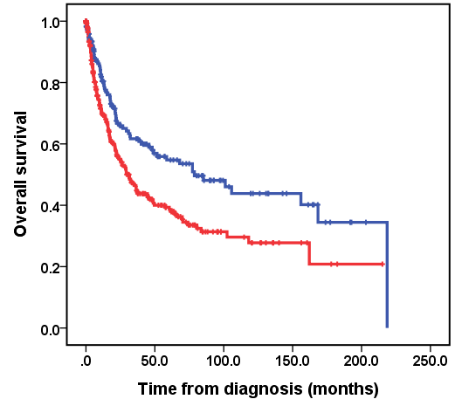  P = 0.001  L/M ≤ 1.5, n=175, Median OS: 78.7 months  L/M > 1.5, n=286, Median OS: 31.3 months
(c) | (d)
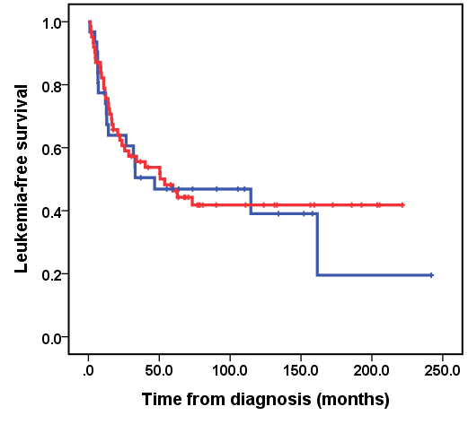  P = 0.755  L/M ≤ 1.5, n=31, Median LFS: 46.7 months  L/M > 1.5, n=62, Median LFS: 53.8 months | 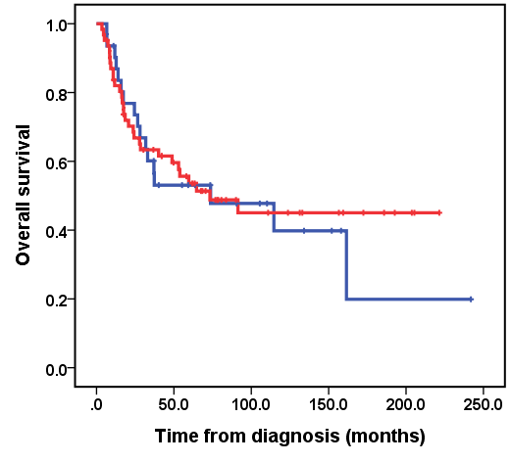  L/M ≤ 1.5, n=31, Median OS: 73.7 months  L/M > 1.5, n=62, Median OS: 73.3 months  P = 0.759

Supplemental Figure 3. Functional analysis of MDS patients with high versus low lymphocyte to monocyte ratio
