Supplementary Information for

Extraordinary Hall Effect in Freestanding Oxide Heterostructures
Z. S. Lim†, Z. Zhou†, K. Han, G. J. Omar, Z. Huang, S.W. Zeng, A. Ariando*
Department of Physics, National University of Singapore, Singapore 117551.
†These two authors contributed equally.
*Correspondence to: ariando@nus.edu.sg

In Fig. S1a, we illustrate a plausible scenario with an MTJ. Both ferromagnetic layers FM_{1,2} are assumed to have PMA, and the bottom FM₁ has larger H_{C} due to exchange enhancement by the adjacent antiferromagnetic (AFM) layer. Besides that, FM_{1,2} also have opposite signs of P_{S} – the majority-spin carriers in FM₁ (FM₂) are antiparallel (parallel) to the local magnetization (M). Hence, in the Fig. S1a, right panel, the mechanism of AHE is illustrated from an “imbalanced spin-polarization” analogue of the Spin Hall Effect (SHE)⁵⁴, following a simple Hamiltonian, $\tilde{H}=-α_{soc}\left(\vec{v}×\vec{E}\right)∙\hat{σ}$ where α_{soc} is the spin-orbit coupling coefficient, $\vec{v}$ is the electron’s velocity, $\vec{E}$ is the electric field from the cations, and $\hat{σ}$ is the free electron spin. This way, using the standard Hall bar connection, FM₁ would produce a negative-sign ρ_{AHE} loop, where net negative charges are deflected towards the positive-lead of Hall voltage at +M_{Z} (magnetization up) but towards the negative-lead at -M_{Z} (magnetization down). Vice versa, FM₂ produces a positive-sign ρ_{AHE} loop, where negative charges are deflected towards negative-lead at +M_{Z} but towards positive-lead at +M_{Z}. At the antiparallel (high resistance) state between FM_{1,2} (Fig. S1b, left panel), it is possible to observe hump features in Hall Effect (Fig. S1b, right panel) that also vanish at a large field, yet do not involve non-collinear magnetic textures.
In Fig. S1c, structure B indeed has more severe carrier localization compared to structure A, as evidenced by the slightly higher (overall) resistivity and low-temperature upturn. The ferromagnetic T_{C} indicated by a transition from linear ($ρ_{xx}∝T$) to Fermi-liquid ($ρ_{xx}∝T^{2}$) is also evident in structure A, but blurred in structure B. As shown in Fig. S1d left panel, reducing the SRO thickness (compared to structure A) would lead to an obvious positive AHE (instead of negative). Likewise, in Fig. S1d right panel, increasing SRO thickness (compared to structure B) would cause the expected positive AHE to be diminished by a competing negative AHE component at ~10 K.
To take a glimpse of the intermediate state prior to epitaxial lift-off, the structure “C_{f}–intermediate” is grown onto an STO(001) substrate pre-patterned with hall bar bordered by AlN (see methods), and is measured immediately after film growth to minimize the deterioration of SAO by atmospheric moisture’s attack. As seen in Fig. S3a-b and similar to the data of structure C_{f} in main text Fig. S3c, the Hall Effect humps also exist in structure C_{f}–intermediate up to 80 K together with dominant-negative AHE, but the humps are weirdly symmetrical at +/- magnetic fields, and are not understood at present.
In Fig. S5, the hysteretic behavior of topological charge density, $TCD=\hat{m}∙\left(\frac{∂\hat{m}}{∂x}×\frac{∂\hat{m}}{∂y}\right)$ is simulated via MUMAX3, using logical magnetic parameters of SRO at 80 K. These parameters are not extracted from the magnetometry of freestanding trilayer structure C_{f} due to extra signal from the proximity induced magnetism of iridate and oxygen vacancies. Instead, we use $J_{ex}=\frac{3k_{B}T_{c}}{2j(j+1)}$ to estimate the exchange constant, where j is the total angular momentum quantum number. 4d⁴ electronic configuration is arguably lying between the weak SOC (l-s coupling) and strong SOC (j-j coupling) regimes, with S=1, L=1, and J=L+S=1 because the two vectors are neither parallel nor antiparallel. Using bulk values, M_{sat} ~1.6 µ_{B}/Ru, j=1, T_{c}=160 K, J_{ex} = 3k_{B}T_{C}/4, hence A_{ex} = J_{ex}/a = 4.22 x 10⁻¹² J/m where a is the pseudocubic lattice parameter 3.93 Å. To account for weakened magnetism in the ultrathin regime, we assume T_{C} = 100 K and M_{sat}=1.0 µ_{B}/Ru at 0 K. Knowing that temperature-dependent magnetization usually takes the form of $M/M_{max}=tanh⁡\left(\frac{M/M_{max}}{T/T_{c}}\right)$ from the mean-field generalization to the Langevin’s paramagnetism, at 80 K, $T/T_{c}=\frac{M/M_{max}}{\tanh^{-1}\left(M/M_{max}\right)}=0.8$ can be obtained when $M/M_{max}=0.710412$, hence M_{sat} = 0.71 µ_{B}/Ru = 1.09x10⁵ A/m at 80 K, where M_{max} refers to M_{sat} at 0 K. Noting exchange length $l_{ex}=\sqrt{\frac{2A_{ex}}{µ_{o}{M_{sat}}^{2}}}$=23.86 nm, hence we use a cell size of 4 nm < $l_{ex}$. The uniaxial magnetic anisotropy, K_{u} is arbitrarily scaled down to 3.08x10⁴ J/m³. Gilbert damping constant is set to 0.1, while the backward/forward field sweep calculations are always initialized with m=Uniform(0,0,±1), so that the emergence of Skyrmions and TCD are always hysteretic. Combining with DMI D_{ind} = 4.5x10⁻⁴ J/m² induced at the SRO/SIO interface, we obtain a TCD variation within a field range that matches well with the observed Hall Effect hump features, i.e. it reaches the peak at µ_{o}H~±0.14 T and vanishes at µ_{o}H~±0.3 T. Subsequently the same parameters are used to generate the θ-dependent trend as shown in the main text Fig. 4c, at µ_{o}H_{peak,TCD} = 0.14 T, corresponding to Neel-type Skyrmions’ diameter of ~100 nm.

Supplementary Figures:
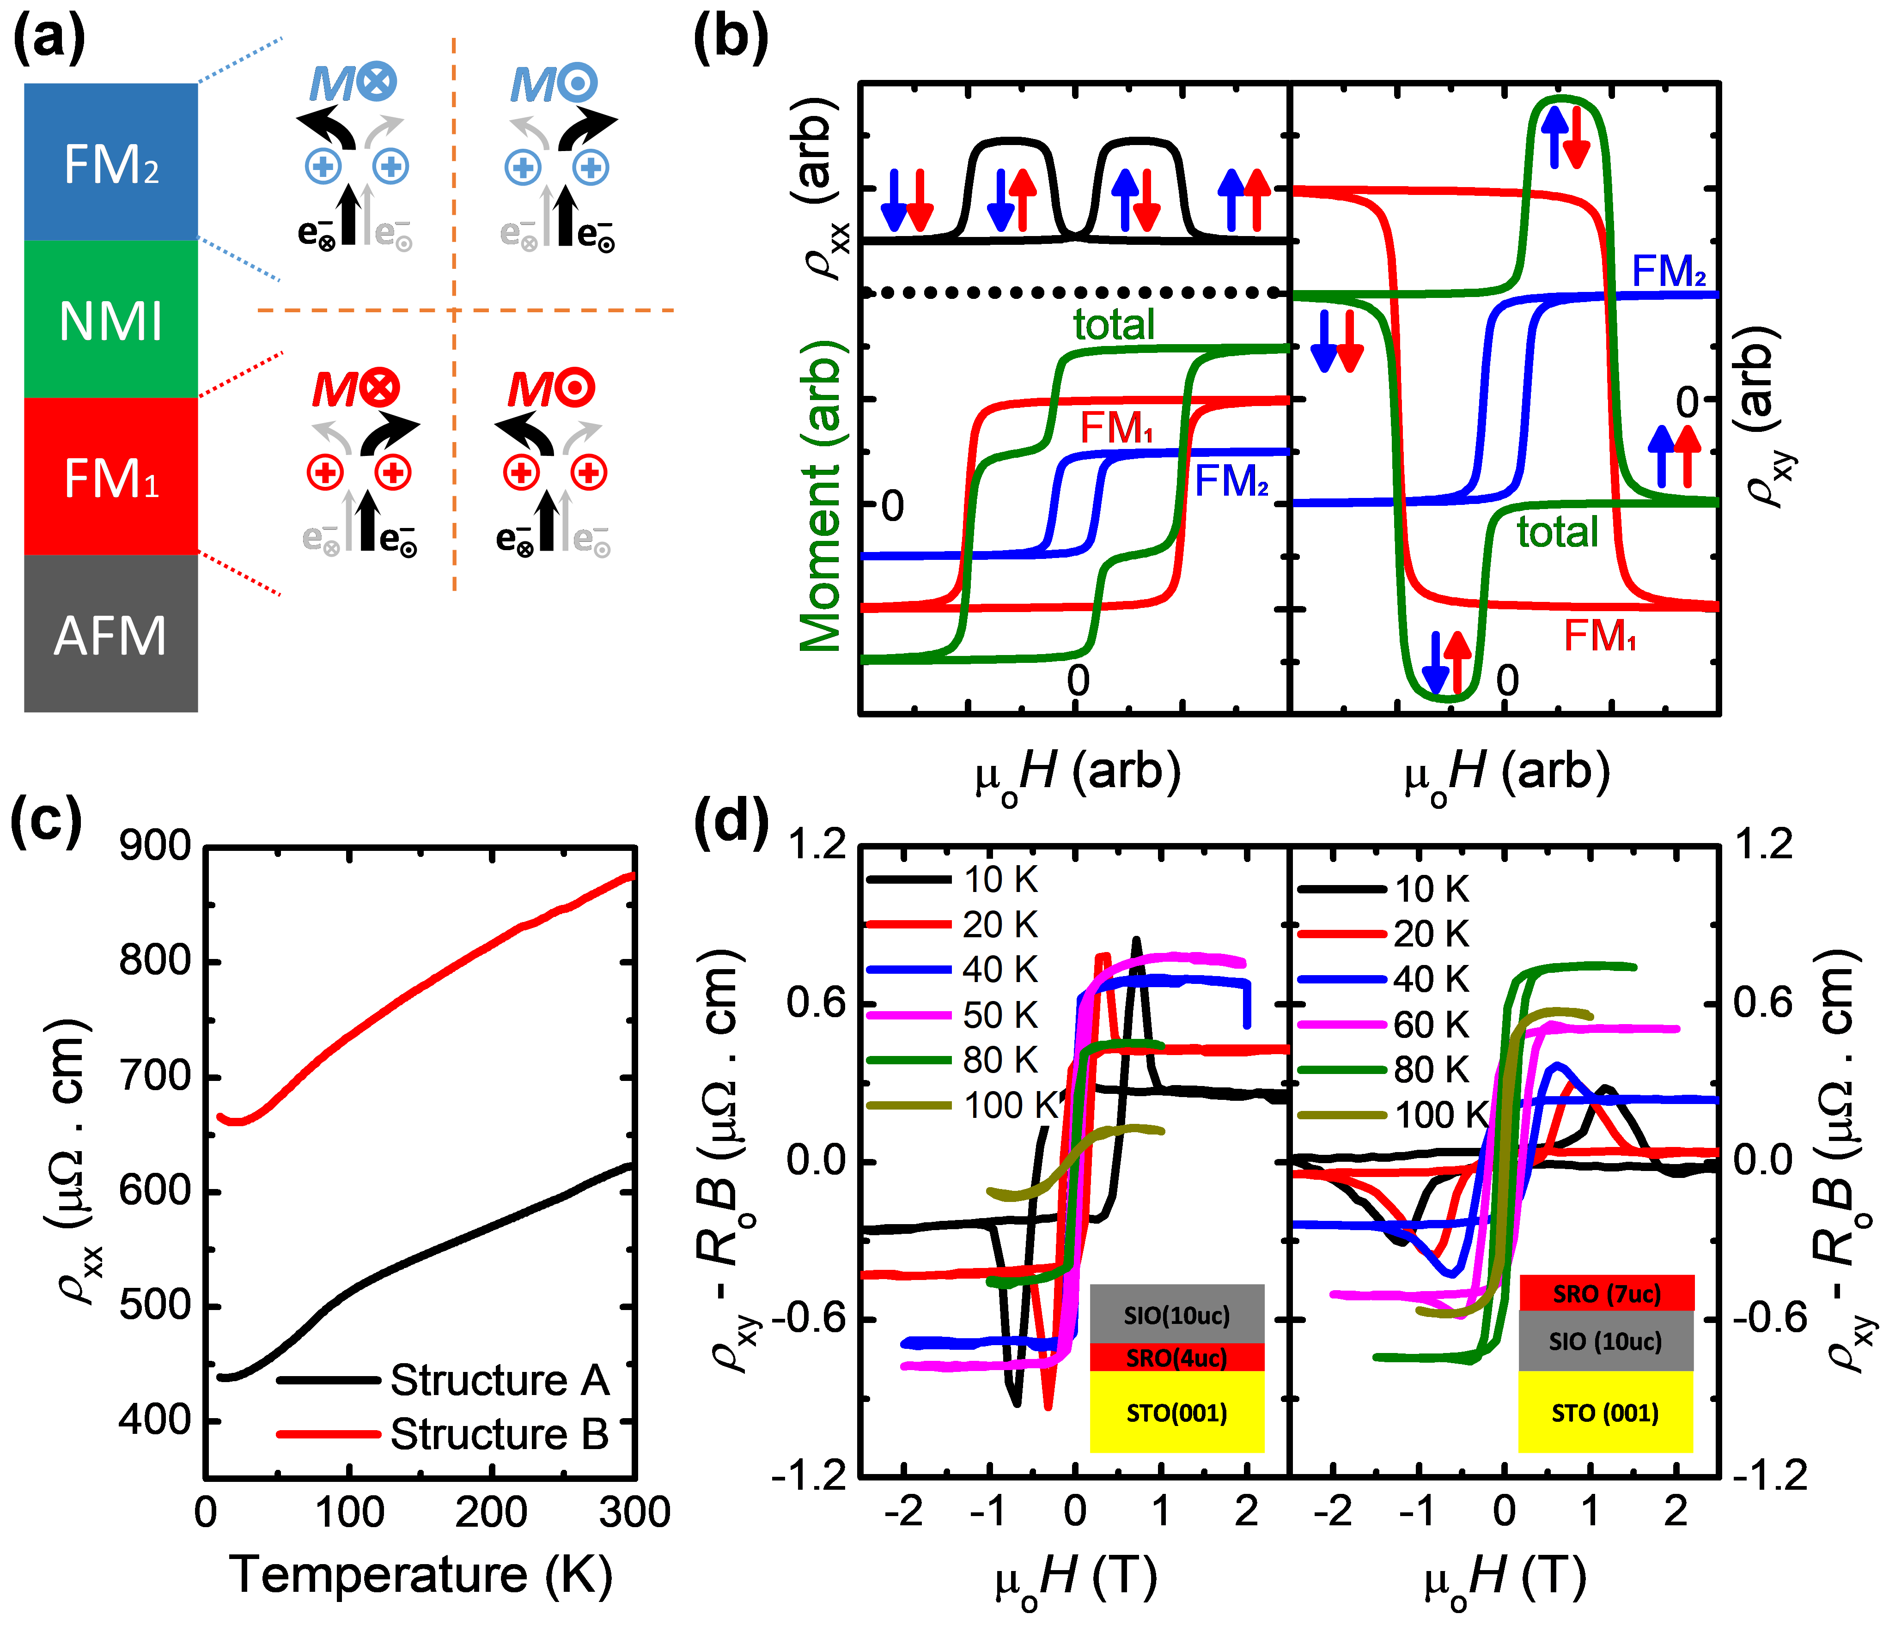
Supplementary Figure S1: (a) Left: structure of the conceptual MTJ, where “NMI” denotes the non-magnetic insulating tunneling barrier. Right: the mechanism of AHE, with symbols ⊗, ⦿ and ⨁ representing “into-plane (-M_{Z})”, “out-from-plane” (+M_{Z}) and positively-charged ions. (b) Sketches of expected data for linear resistivity (top left), magnetic moment (bottom left) and extraordinary Hall resistivity (right). (c) ρ_{xx}-T curves for structure A and B. (d) Extraordinary Hall Effect data from the modified structure A and B.
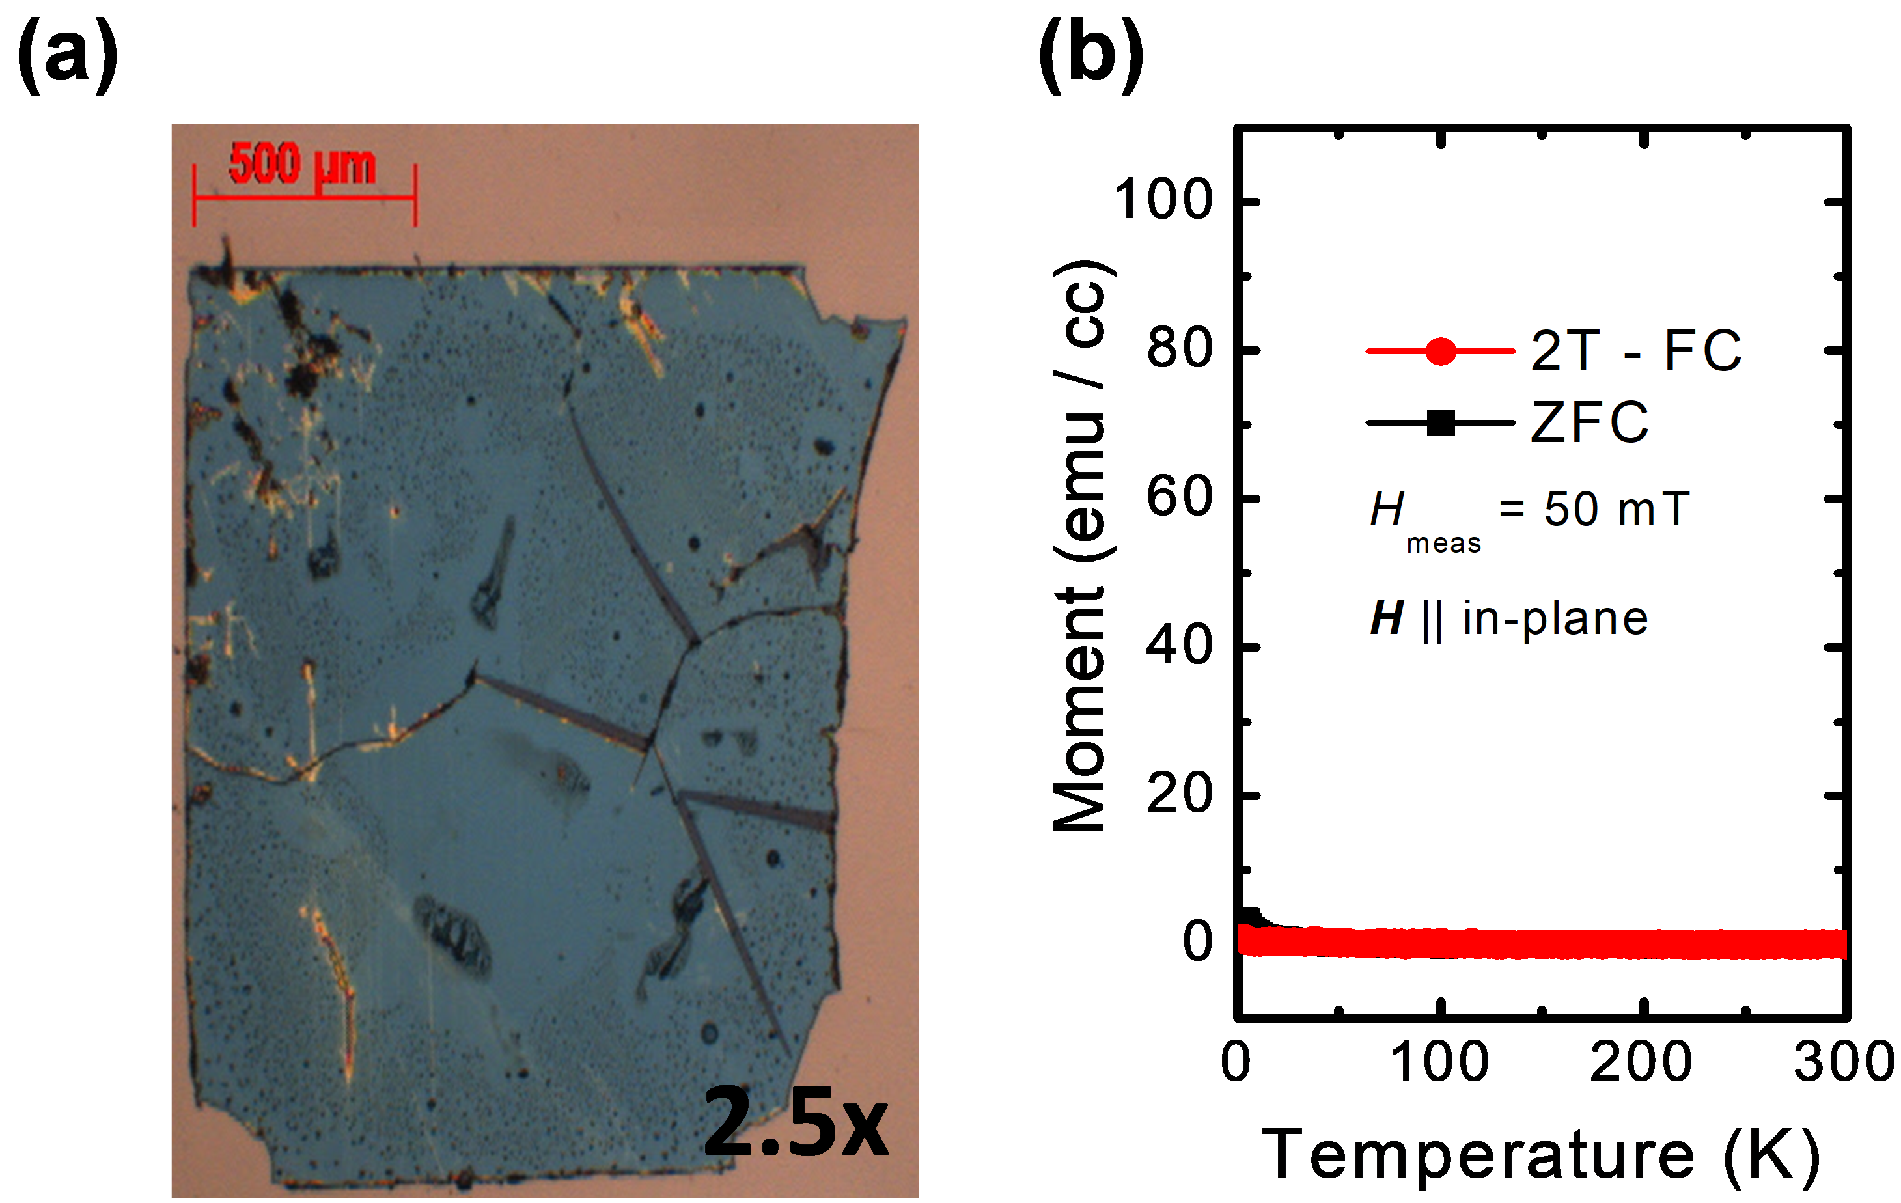
Supplementary Figure S2: (a) A large continuous flake floated with LSMO sacrificial layer and etched by an HCl+KI+H₂O solution, without any tape support. (b) No significant ferromagnetic moment can be measured from the large flake in (a).
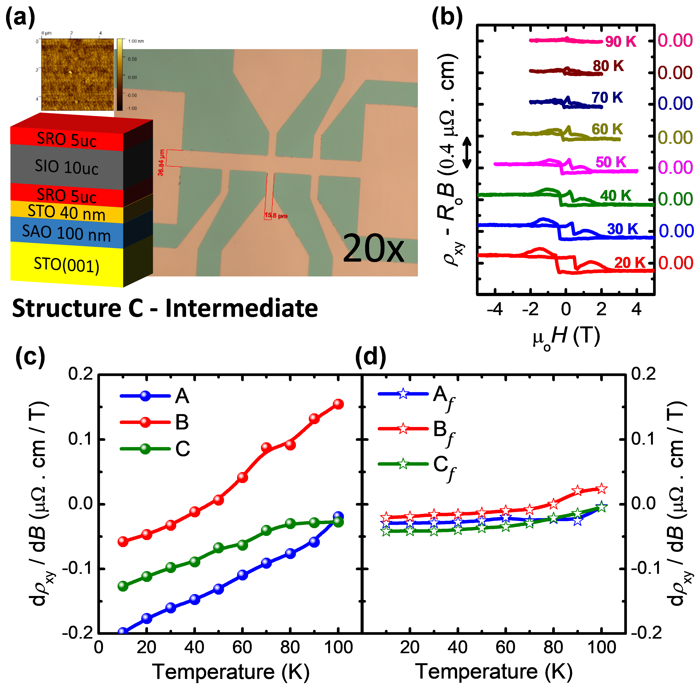
Supplementary Figure S3: (a) Schematic of structure C_{f}-Intermediate and the optical microscopy image of its Hall bar. (b) Extraordinary Hall Effect measured from structure C_{f}-Intermediate, with data shifted vertically for clarity. Ordinary Hall Effect high-field gradient extracted from (c) the epitaxial structures A, B and C and (d) their freestanding counterparts A_{f}, B_{f} and C_{f}.

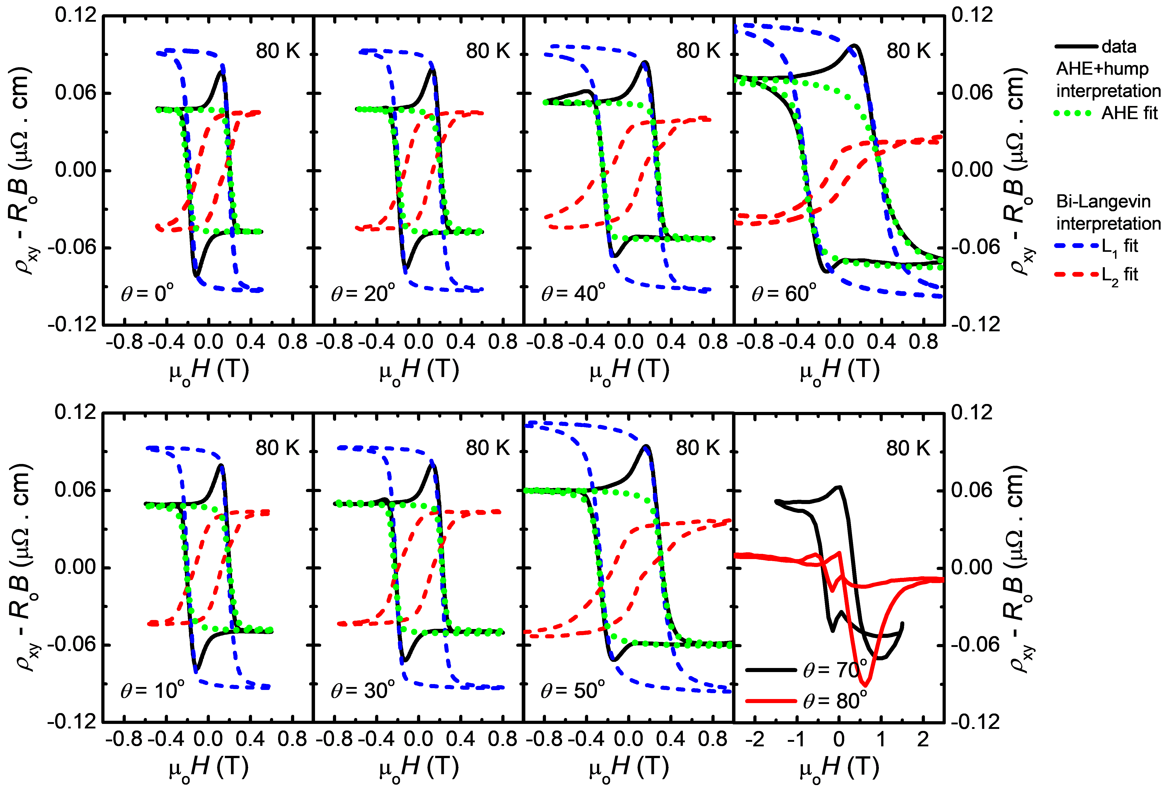
Supplementary Figure S4: The series of Extraordinary Hall Effect data of the structure C_{f} with a gradual increase of θ, measured at 80 K. The maximum field applied is gradually increased to account for the increasing H_{C, AHE} or H_{C1}. Humps (grey shading in Fig. 4) are not shown here. Data at θ=70º and 80º become too difficult to analyze.

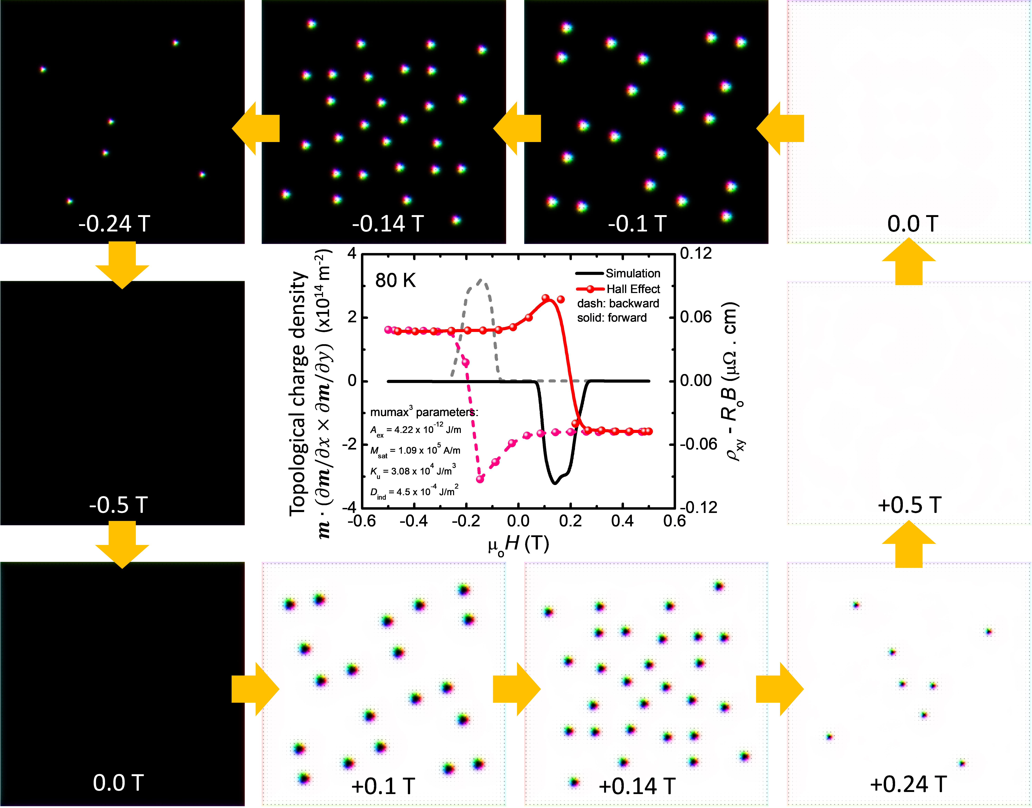
Supplementary Figure S5: Simulated field-sweep result of the TCD showing hysteretic behavior, overlapped with the experimental Hall Effect for comparison. The surrounding snapshots show the corresponding magnetic textures at various magnetic fields.

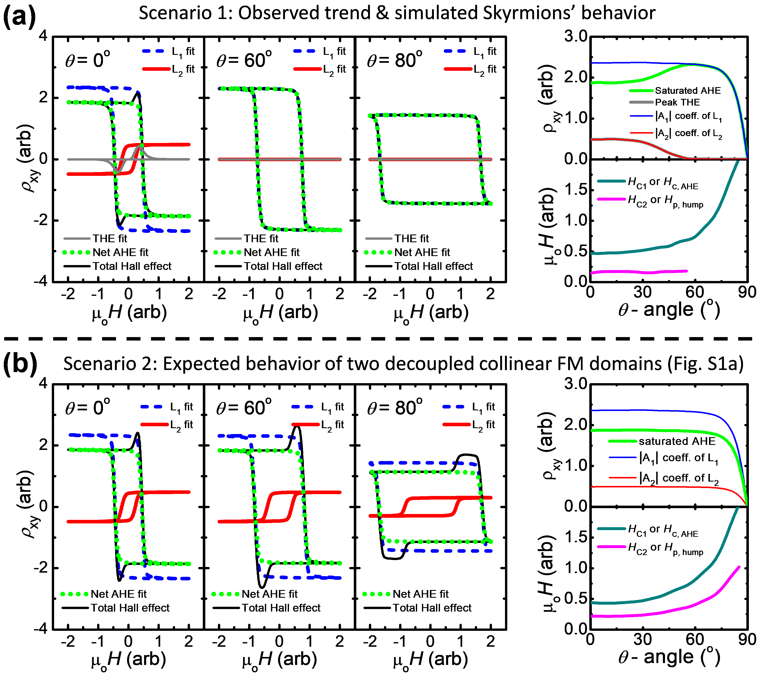
Supplementary Figure S6: Sketches of Hall Effects illustrating our understanding and expectation on the θ-dependent results, using arbitrary parameters. Left panels are the θ-dependent Hall Effect loops and their deconvolutions, while the right panels show the full trends of the θ- dependent absolute magnitudes and characteristic fields. The scenario in (a) corresponds to our observed trends as well as simulated Neel-type Skymions behavior, while the scenario in (b) corresponds to the description in Fig. S1a. Hence, we believe that Skyrmions exist in our samples (in favor of the AHE+THE interpretation), rather than two decoupled collinear ferromagnetic domains.

