Supplementary Material

Figure S1. Machine learning model workflow of this study.
Figure S2. Spatial distribution of Eh in surface sediments.
Figure S3. Spatial distribution of sediment microbial community α-diversity indices
Figure S4 Relative abundance of sediment microorganisms at the genus level across sampling sites.
Table S1. Content and detection rate of PAHs in surface sediments of Dianshan Lake.
Table S2. Topological parameters of Co-occurrence networks
Text S1. Random forest model.

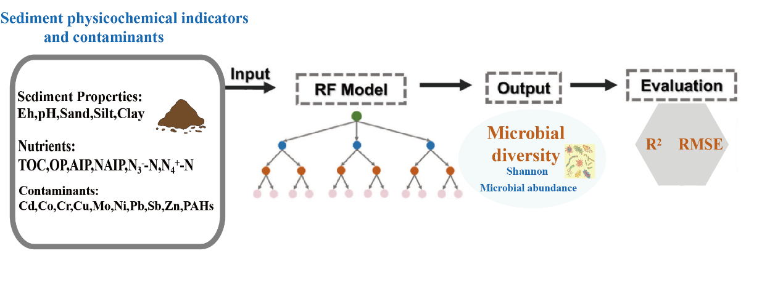Figure S1 Random Forest model workflow of this study.

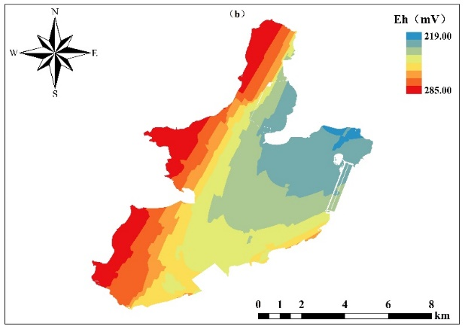
Figure S2. Spatial distribution of Eh in surface sediments

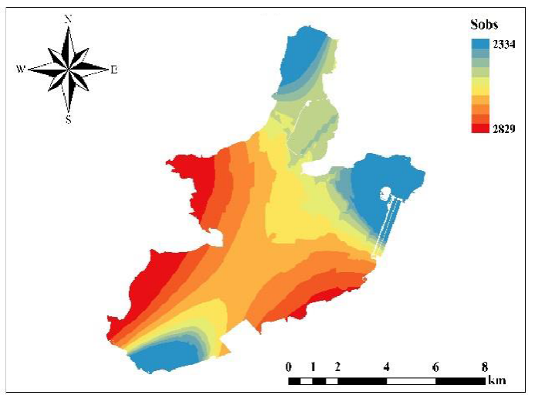 |  | 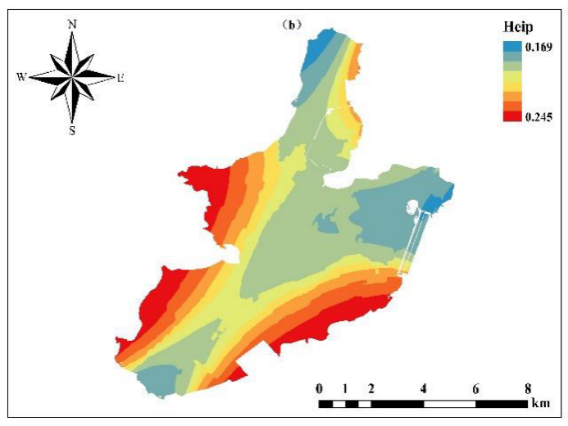
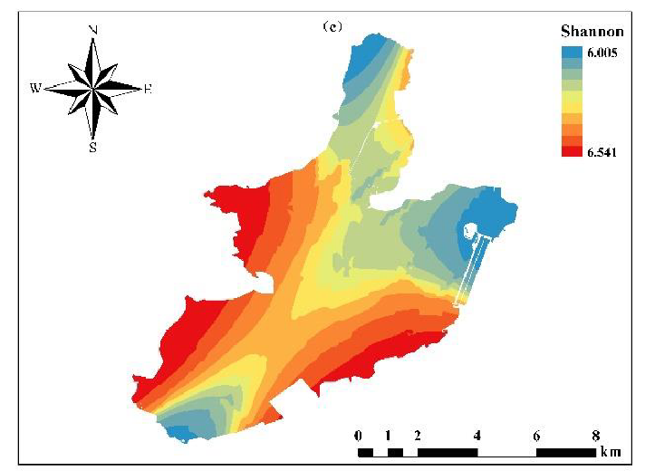 |  | 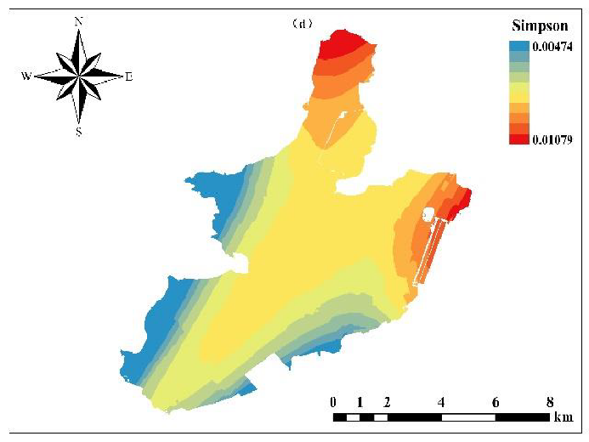
Figure S3 Spatial distribution of sediment microbial community α-diversity indices.

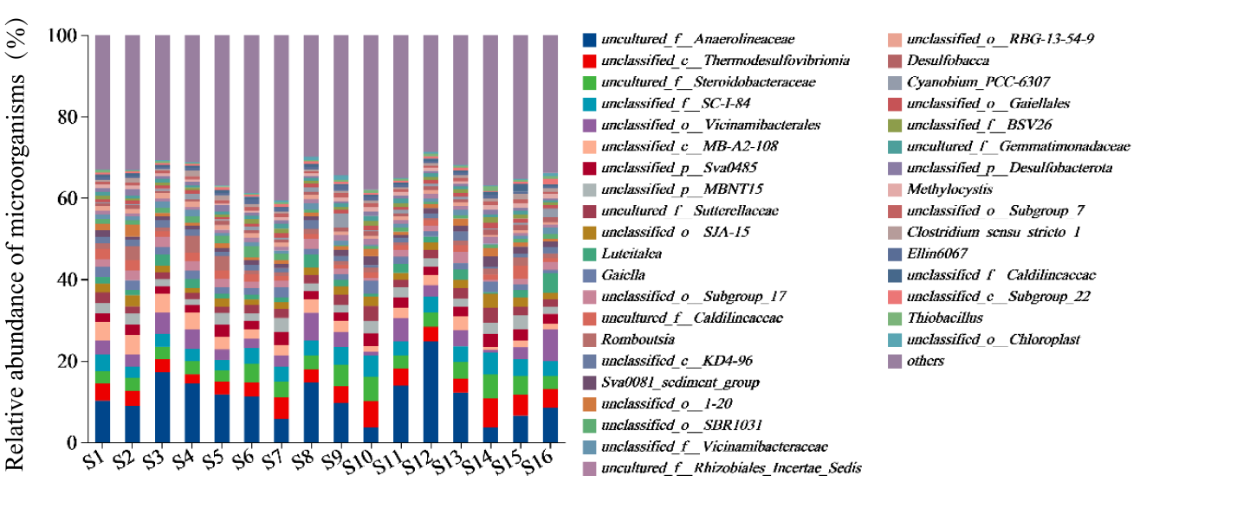
Figure S4 Relative abundance of sediment microorganisms at the genus level across sampling sites.

Table S1. Content and detection rate of PAHs in surface sediments of Dianshan Lake.
PAHs | Min(ng/g) | Max(ng/g) | Average(ng/g) | DR(%)
Nap | 0.00 | 3.14 | 1.00 | 62.50
Acy | 0.00 | 0.62 | 0.09 | 18.75
Ace | 0.00 | 0.79 | 0.21 | 62.50
Flu | 0.00 | 1.75 | 0.68 | 75.00
Phe | 1.06 | 12.88 | 3.60 | 100.00
Ant | 0.00 | 2.24 | 0.55 | 93.75
Flt | 1.13 | 17.44 | 5.47 | 100.00
Pyr | 1.04 | 19.19 | 5.30 | 100.00
BaA | 0.51 | 9.79 | 2.46 | 100.00
Chr | 0.69 | 14.54 | 3.15 | 100.00
BbF | 0.77 | 18.17 | 4.01 | 100.00
BkF | 0.16 | 10.93 | 1.73 | 100.00
BaP | 0.80 | 28.04 | 4.93 | 100.00
InP | 0.24 | 6.20 | 1.38 | 100.00
DahA | 0.00 | 1.27 | 0.20 | 62.50
BghiP | 0.00 | 4.95 | 1.54 | 93.75
Ʃ16PAHs | 7.54 | 128.94 | 36.32 | -

Table S2. Topological parameters of Co-occurrence networks.

Network index
Nodes | 50
Edges | 369
Number of positive connections | 199/53.9%
Number of negative connections | 170/46.1%
Average degree | 14.76
Average clustering coefficient | 0.612

Text S1. Random forest model.
Random forest model is a non-parametric machine learning method for classification and regression analysis proposed by Breiman in 2001^{[1]}. It can be applied to various data types and problems, including classification, regression and feature selection problems^{[2]}. The core of important feature selection using the RF model lies in calculating the importance of each feature on each tree within the random forest, and subsequently averaging these values for sorting^{[2, 3]}. The “scikit-learn” package was used to establish the RF model for this work. Regarding the parameters, only the number of decision trees (n_estimators) for RF is changed, with the value set to 2000. Other parameters adhere to the default values provided by the Scikit-learn library.

References:
[1] BREIMAN L. Random forests [J]. Machine learning, 2001, 45: 5-32.
[2] LI X, SHA J, WANG Z-L. Application of feature selection and regression models for chlorophyll-a prediction in a shallow lake [J]. Environmental Science and Pollution Research, 2018, 25: 19488-98.
[3] ZIEGLER A, KöNIG I R. Mining data with random forests: current options for real‐world applications [J]. Wiley Interdisciplinary Reviews: Data Mining and Knowledge Discovery, 2014, 4(1): 55-63.

