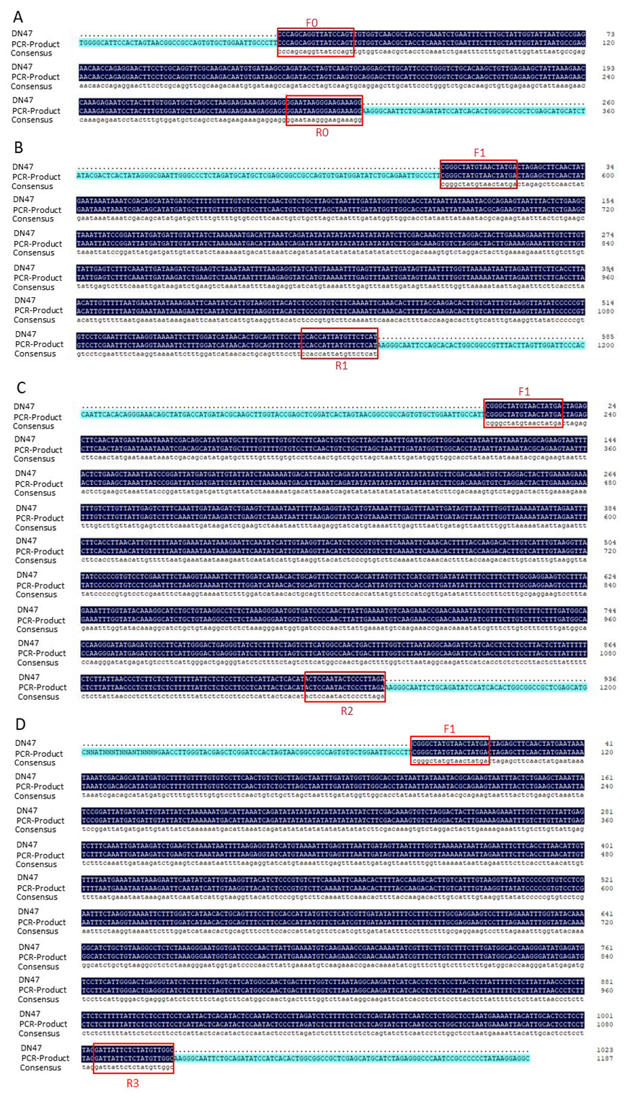
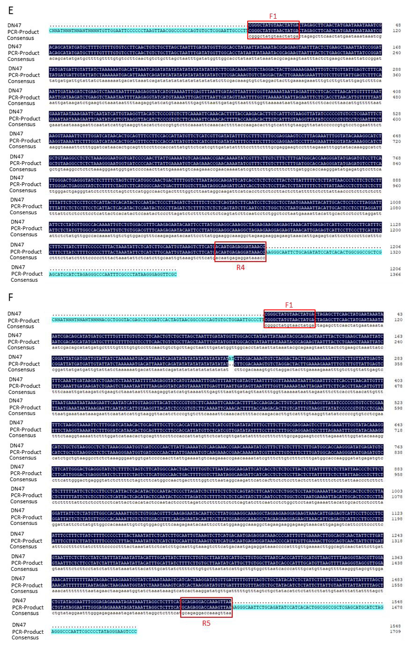

Supplementary Dataset 1. To confirm the co-transcribe between CG-α-1 and Linc-GmSTT1 gene, the amplified bands were cloned and sequenced, and the sequencing results were consistent with the target fragment sequences

