Supplementary Figure legends:

Figure S1.
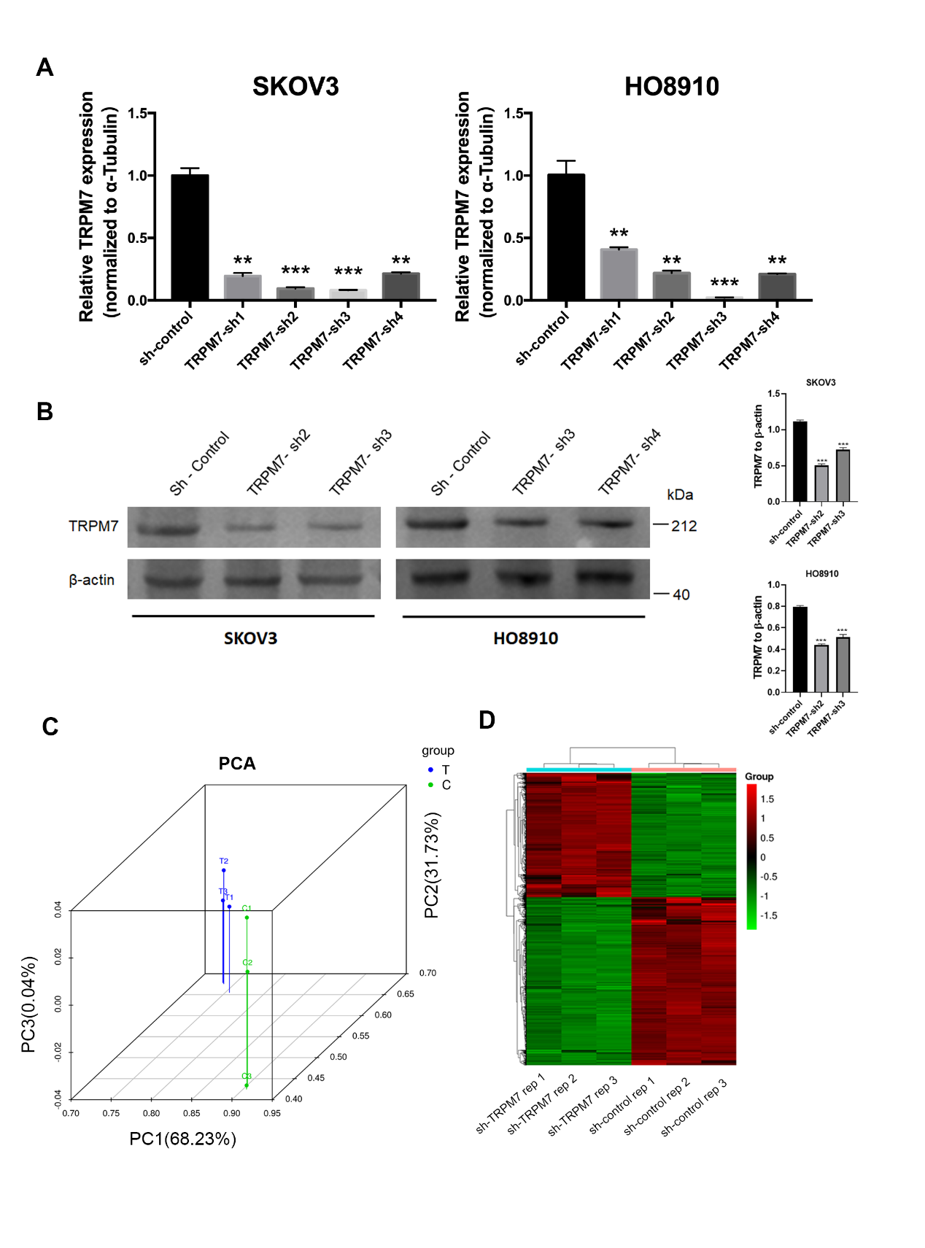
Figure S1. Verification of TRPM7 silencing in ovarian cancer cells.
SKOV3 and HO8910 cells were transduced with lentiviruses for expressing scramble sequence, TRPM7-sh1, TRPM7-sh2, TRPM7-sh3 or TRPM7-sh4, respectively. Four days later, the relative levels of TRPM7 expression in each group were quantified by qRT-PCR (A) and Western blot (B). (C) PCA score plot. (D) Heatmap displayed the DEGs between control and TRPM7 silencing SKOV3 cells.

Figure S2.
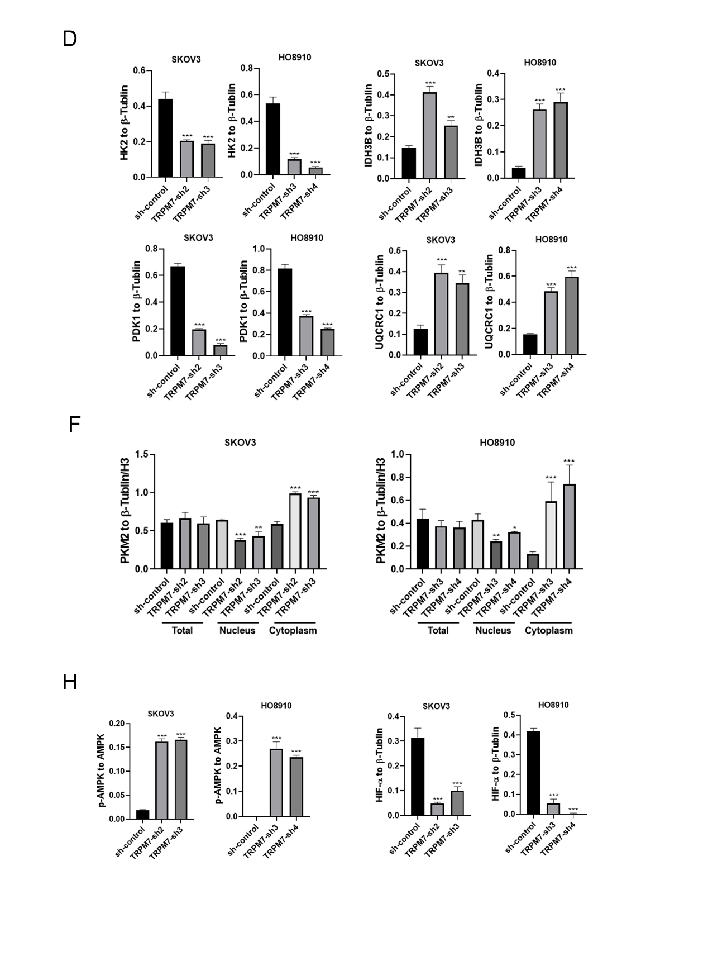
Figure S2.
The quantitative analysis of Western blot data in Figure 3

Figure S3.
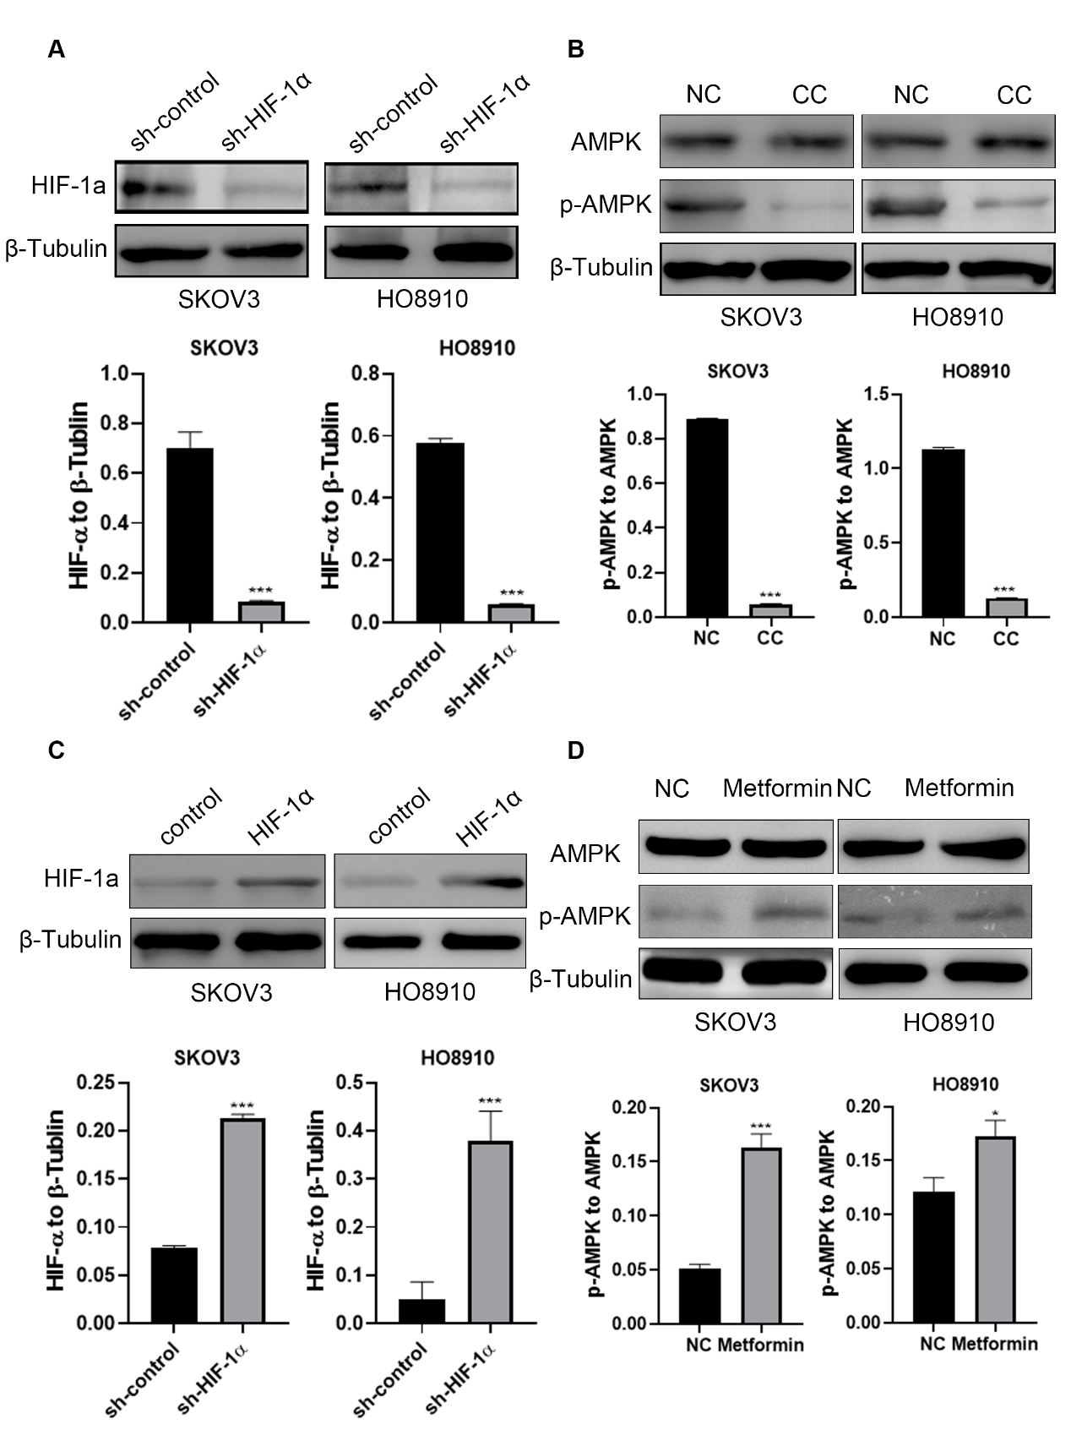
Figure S3. Verification of HIF-1α silencing and over-expression as well as modulating AMPK activation in ovarian cancer cells by Western blot.
(A) Western blot analysis of HIF-1α silencing in SKOV3 and HO8910 cells. (B) Treatment with CC attenuated AMPK activation in SKOV3 and HO8910 cells. (C) Western blot analysis of HIF-1α over-expression in SKOV3 and HO8910 cells. (D) Treatment with metformin enhanced AMPK activation in SKOV3 and HO8910 cells.

Figure S4.
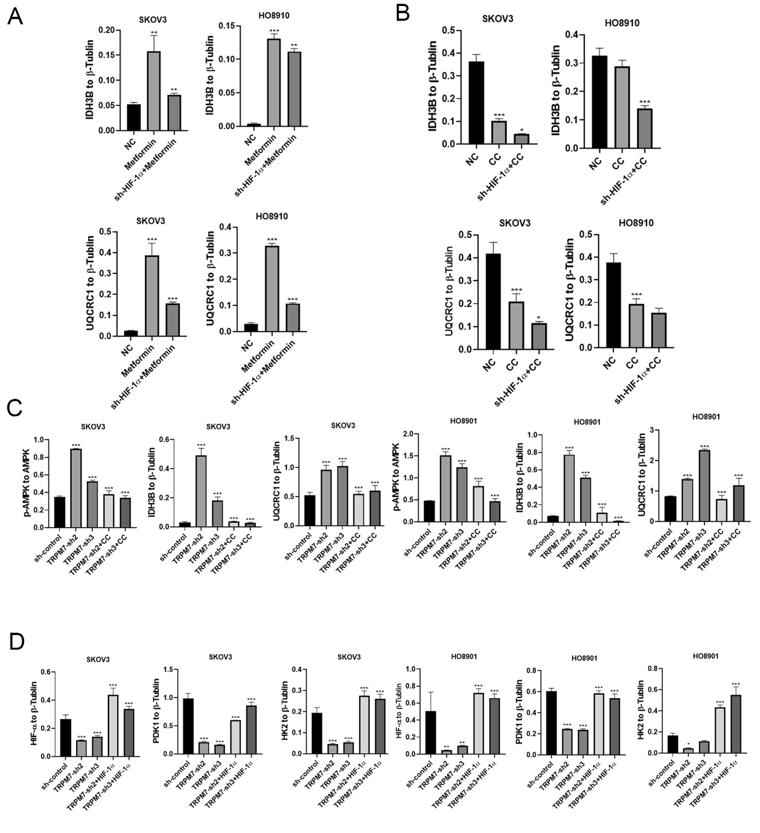
Figure S4.
The quantitative analysis of Western blot data in Figure 6.

Figure S5.
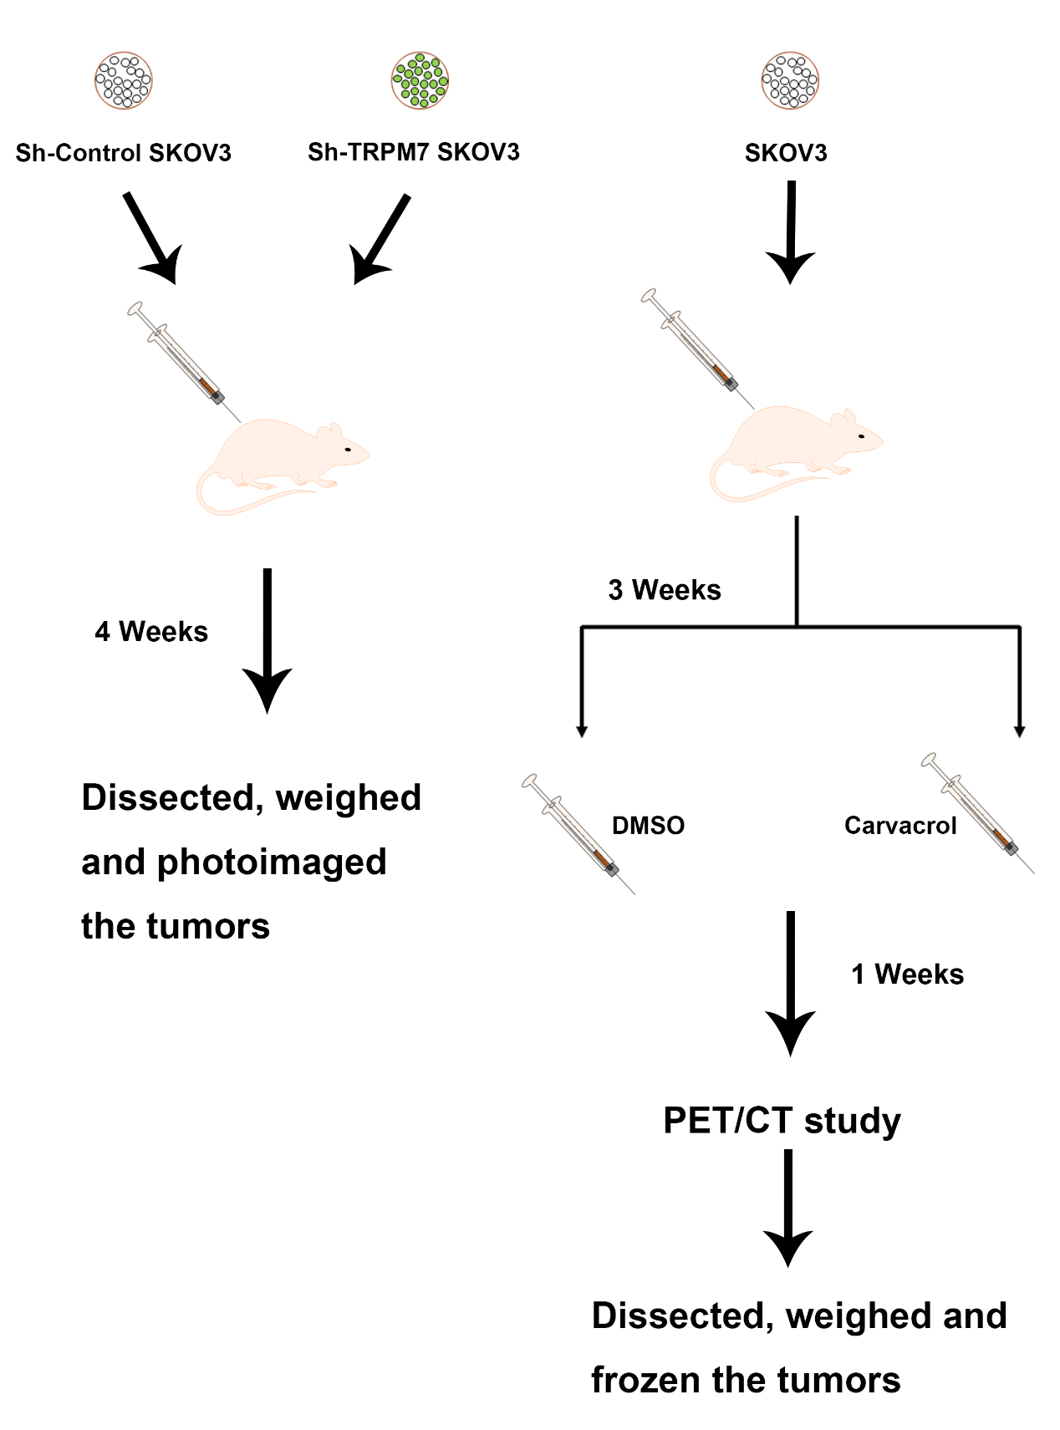
Figure S5.
The models of animal experiments and PET/CT study.

Table S1. The characteristics of the patients (n=60)
Characteristics | No. of patients
Ages  ≤60  >60 | 24  36
Histologic type  Serous  Mucinous  Endometrioid | 53  5  2
Pathological grade  1  2  3 | 14  20  26
FIGO stage  I-II  III-IV | 31  29
Pelvic metastasis  YES  NO | 43  17
Abbreviation, FIGO, International Federation of Gynecology and Obstetrics

Table S2. The target sequences of sh-TRPM7
Target Sequences Name | Sequences
TRPM7-shRNA1 | 5’-GGTGTTCCCAGAAAGGCAA-3’
TRPM7-shRNA2 | 5’-AACCGGAGGTCAGGTCGAAAT-3’
TRPM7-shRNA3 | 5’-AAGCAGAGTGACCTGGTAGAT-3’
TRPM7-shRNA4 | 5’-CAATATGTTCTACATTGTA-3’

Table S3. The sequences of primers
Primer name | Primer sequences
TRPM7 | forward 5'- TCCCGATAGATGGCTACAGG-3'  reverse 5'- CCTGACGAGTTGCTGACAAA-3'
HK2 | forward 5'-GACCAACTTCCGTGTGCTTT-3'  reverse 5'-TCCATGAAGTTAGCCAGGCA-3'
PDK1 | forward 5'-AGTTCATGTCACGCTGGGTA-3'  reverse 5'-CAGCTTCAGGTCTCCTTGGA-3'
IDH3B | forward 5'-ATGCTGCGGCATCTTAATCT-3'  reverse 5'-GCAATGACAGCCTCAGTGAA-3'
UQCRC1 | forward 5'- GGGCAAAAACATCCTCAGAA-3'  reverse 5'- ACGGATCCGGTTGTAGTCTG-3'
β-Tubulin | forward 5'- CTCTGAAGCTGACCACACCA-3'  reverse 5'- GCCAGGCATAAAGAAATGGA-3'

