Supporting Information for
Impacts of Ocean–Land–Atmosphere Interactions on Bay of Bengal Summer Monsoon Onset Anomalies via Modulating the Monsoon-Triggering Intraseasonal Oscillations
Weihao Sun¹, Guoxiong Wu^{2, 3}, Yimin Liu^{*2, 3}, Shaoyu Zhang⁴, Xiaolin Liu⁵
¹ East China Sea Forecasting and Disaster Reduction Center, Ministry of Natural Resources, Shanghai, China.
² Key Laboratory of Earth System Numerical Modeling and Application, Institute of Atmospheric Physics, Chinese Academy of Sciences, Beijing, China.
³ University of Chinese Academy of Sciences, Beijing, China.
⁴ National Climate Center, China Meteorological Administration, Beijing, China.
⁵ Merchant Marine College, Shanghai Maritime University, Shanghai, China.

*Corresponding author: Yimin Liu (lym@lasg.iap.ac.cn)

Contents of this file
Figure S1 to S6
Introduction
Supplementary materials provide BOBSM onset dates, bandpass-filtered (20–70 days) precipitation and OLR, as well as correlation, anomaly, and regression analyses of circulation and thermodynamic fields.
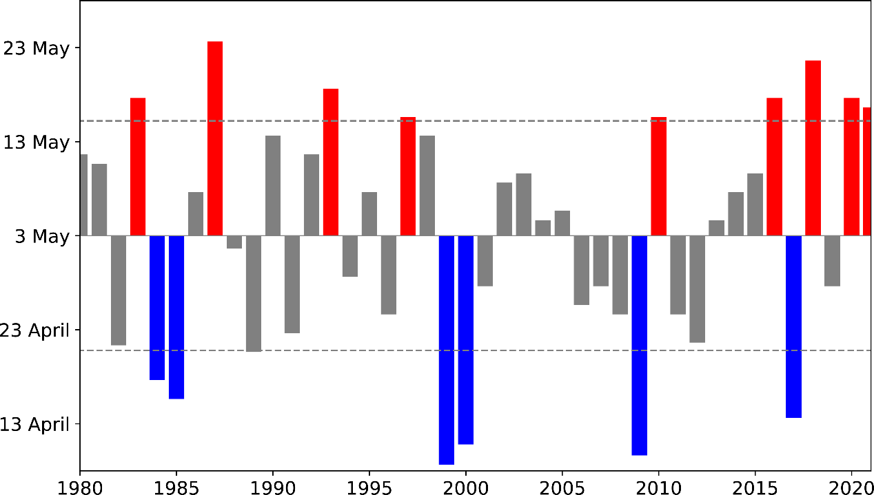
Figure S1. BOBSM onset dates for 1980-2021. Red columns indicate onset-late years while blue indicates early years. Criteria of selection is ±1 standard deviation from the average.

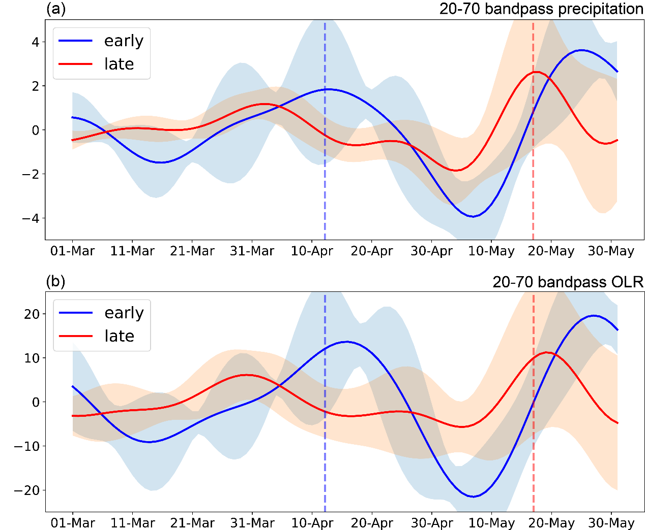
Figure S2. (a) Time series of 20-70-day bandpass filtered precipitation (unit: mm day⁻¹) over the Bay of Bengal (5°-15°N, 85°-100°E). Blue line indicates early-onset composite average, while red indicates late-onset result. Shading means ±1 deviation from the composite mean. (b) Same with (a), but for the Outward Longwave Radiation (OLR; unit: W m⁻²).

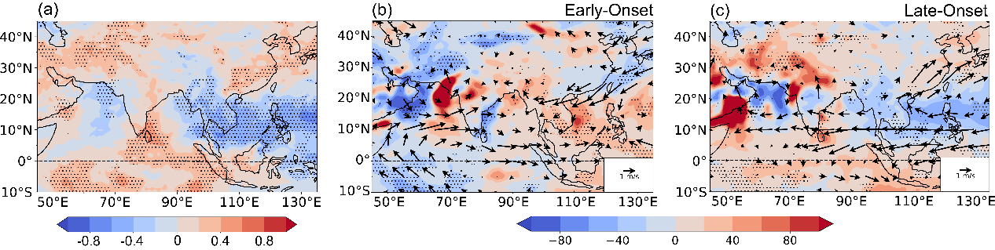
Figure S3. (a) Correlation between BOBSM onset dates and May precipitation during 1980–2021. (b) Anomalies of 850 hPa winds (m s⁻¹) and precipitation (unit: %) in May for early-onset years. (c) Same as (b), but for late-onset years. Stippling indicates regions significant at the 95% confidence level.

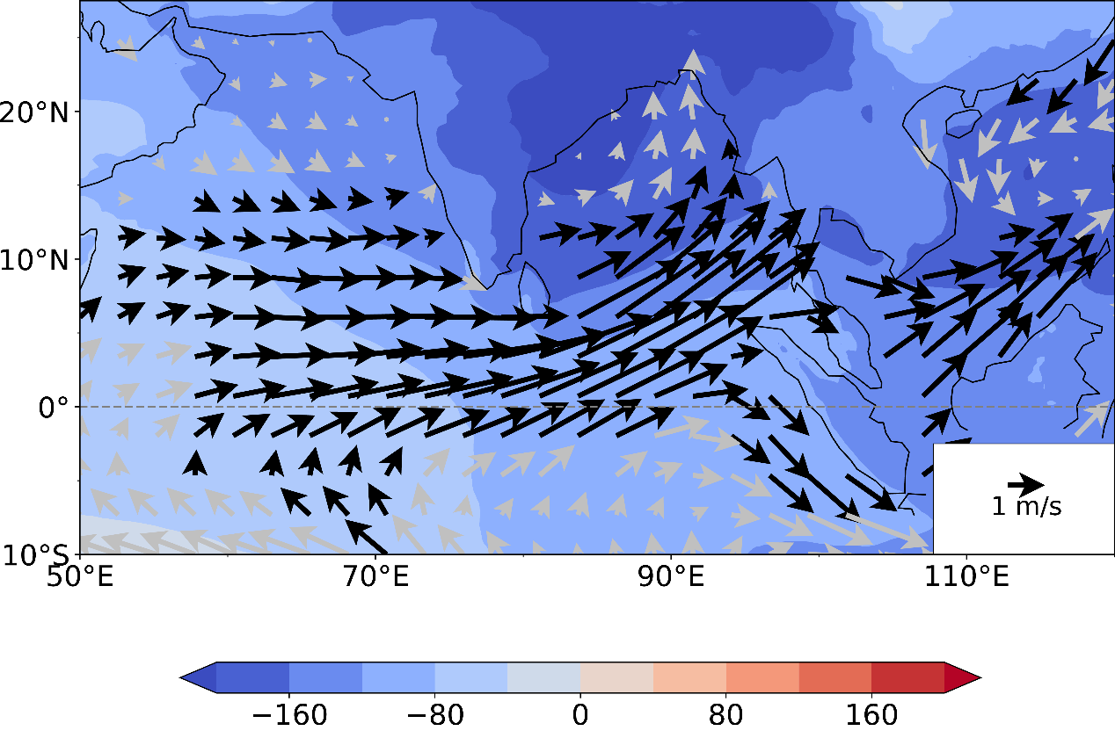
Figure S4. Composite difference in March-April 10 m wind (vectors; unit: m s⁻¹) and sea-level pressure (shading; unit: Pa) between early- and late-onset years. Black arrows indicate regions significant at the 95% confidence level based on the Student’s t-test.

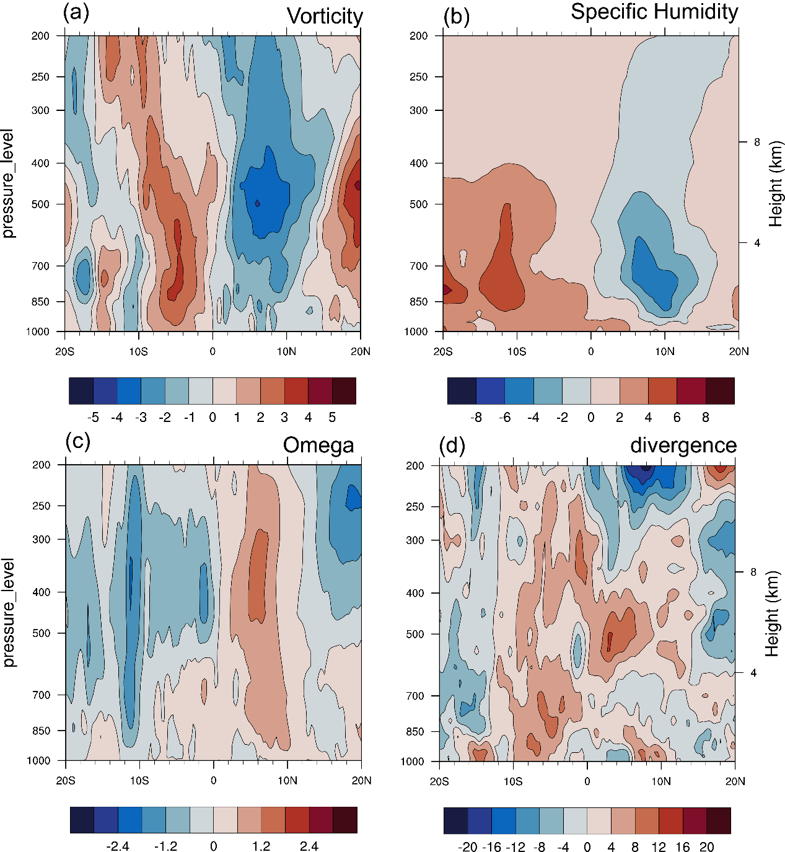
Figure S5. Latitude–vertical cross–section of pre–monsoon (March–April) anomalies over the Bay of Bengal (85°–100°E) for late–onset years for: (a) Relative vorticity (unit: 10⁻⁶ s^{–1}), (b) Specific humidity (unit: 10^{–4} kg/kg), (c) Omega (unit: 10^{–2} Pa s^{–1}), and (d) Divergence (unit: 10^{–7} s^{–1}).

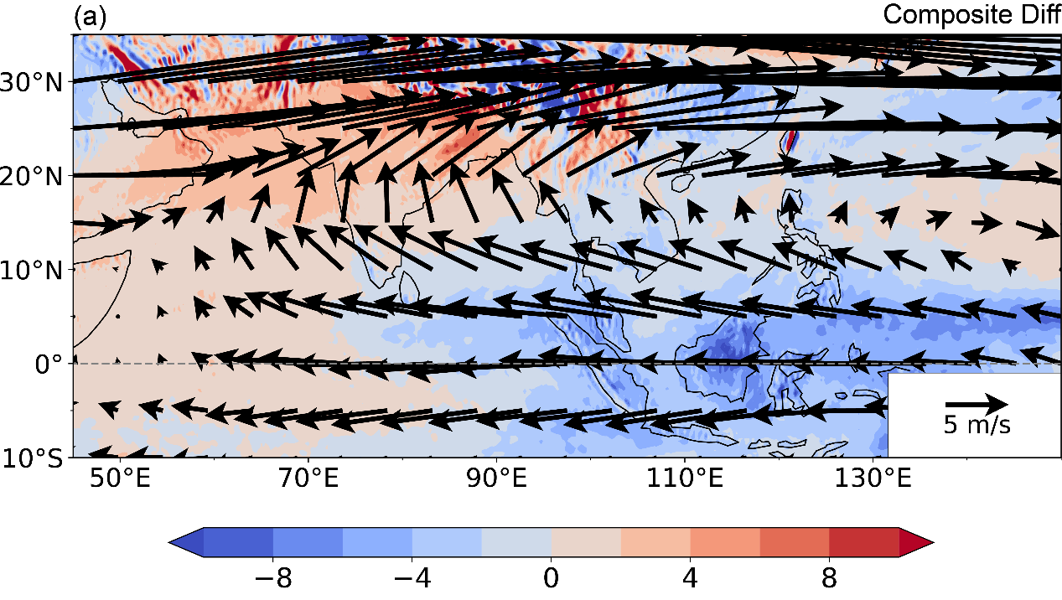
Figure S6. Composite difference in March-April 200 hPa wind (vectors) and 500 hPa Omega (shading; unit: 10^{–2} Pa s^{–1}) between early- and late-onset years.

