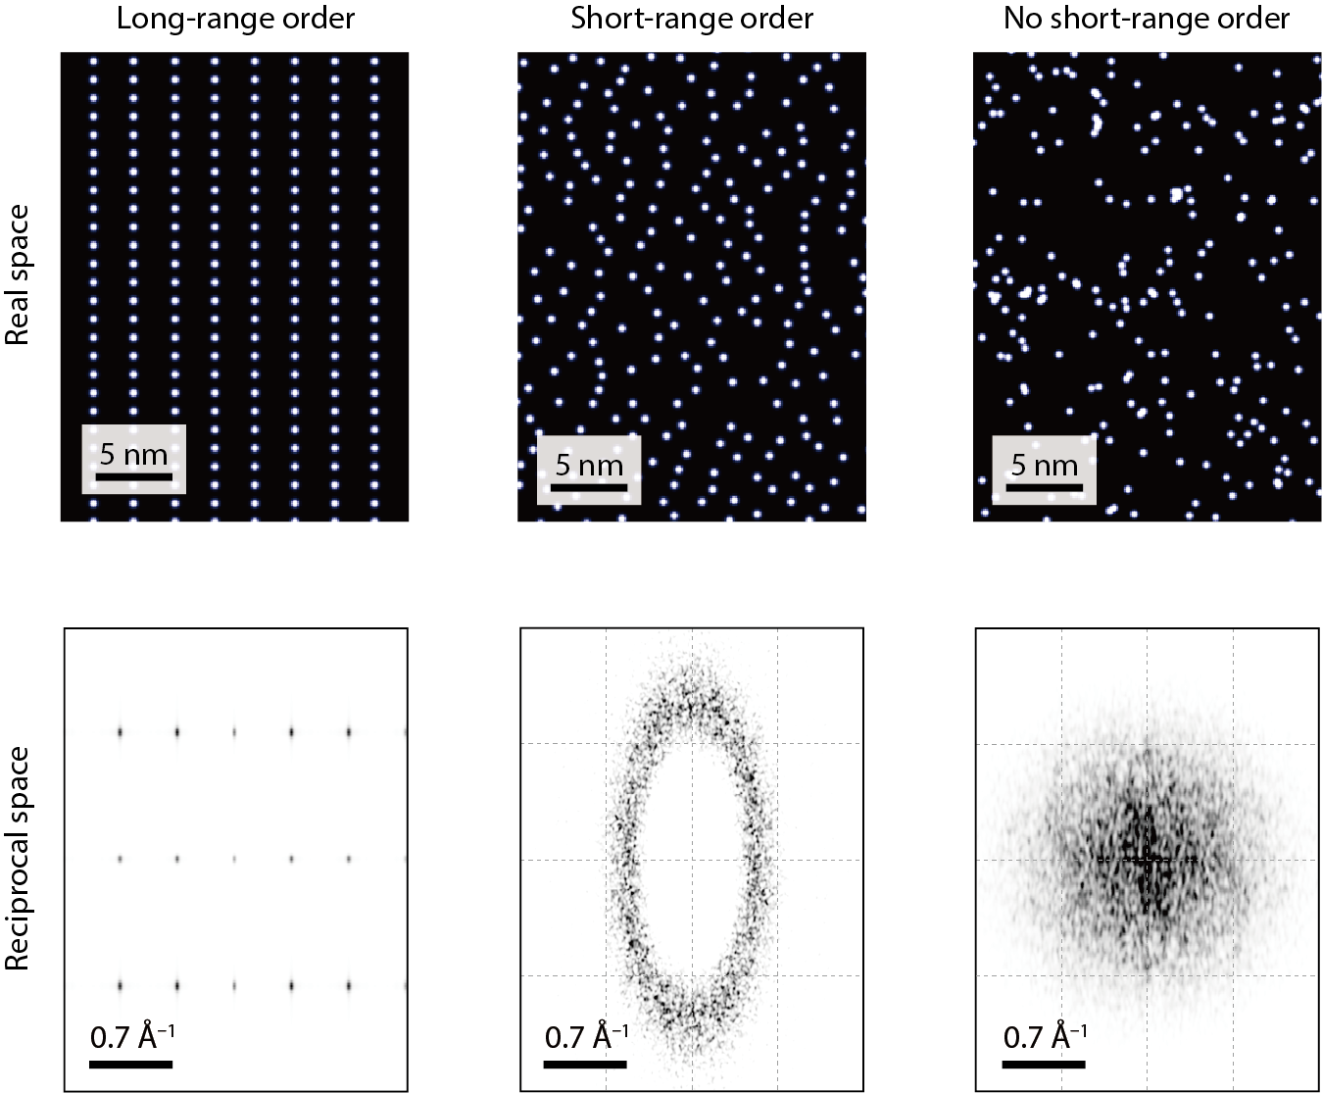

Extended Data Figure 1 | Structural simulations for the phase of solid, liquid, and gas. The real-space lattice structure of the liquid phase (middle) is simulated by the distribution of atoms (bright protrusions) with only short-range order (Methods). It is compared to the case of the perfect crystal with long-range order (left) and the fully random with no short-range order (right). Shown below of each panel are their corresponding Fourier-transform images. The liquid phase shows the oval-shape structure factor, which is the signature of short-range order^{27,28}, different from those of long-range order and no short-range order.

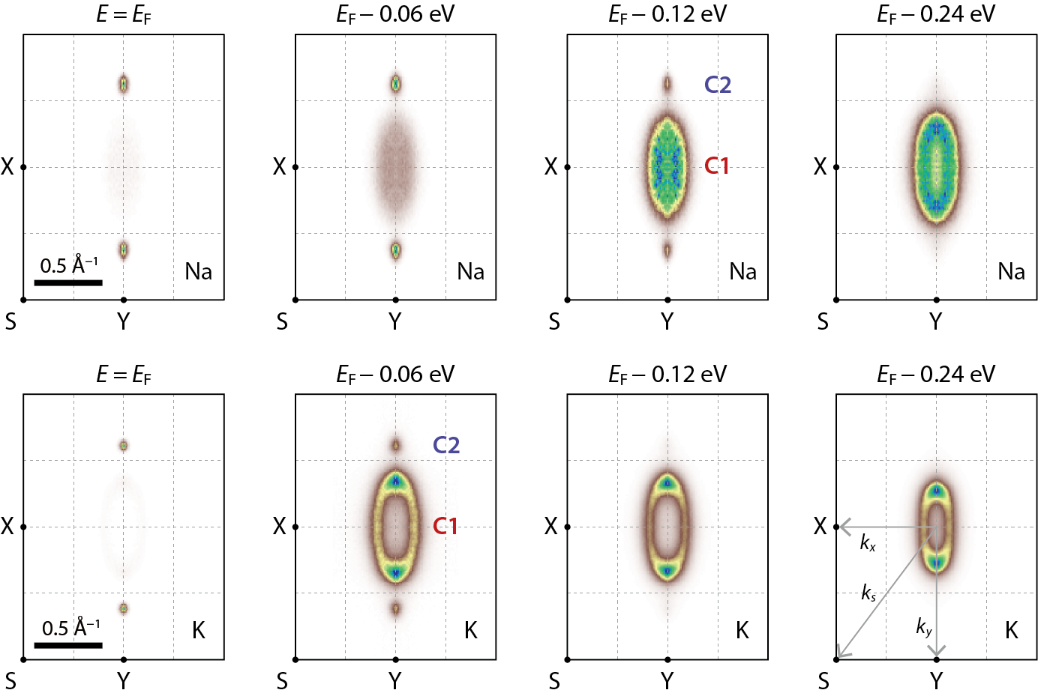

Extended Data Figure 2 | Constant-energy map of liquid metals on black phosphorus. ARPES intensity maps of black phosphorus doped by Na at n_{d} = 1.7 × 10¹⁴ cm⁻² (upper row) and K at n_{d} = 1.0 × 10¹⁴ cm⁻² (lower row). Data are plotted at the constant energy marked on top of each panel as a function of k_{x} and k_{y} in the surface Brillouin zone of black phosphorus. Unlike a pair of C2 bands that crosses E_{F}, the C1 band shows a clear signature of pseudogap with the magnitude of 235 meV for Na and 65 meV for K. This magnitude of pseudogap is found nearly isotropic with in-plane k directions. The size of area enclosed by the C1 contour of Na decreases towards E_{F}, which reflects the backward-bending band dispersion.

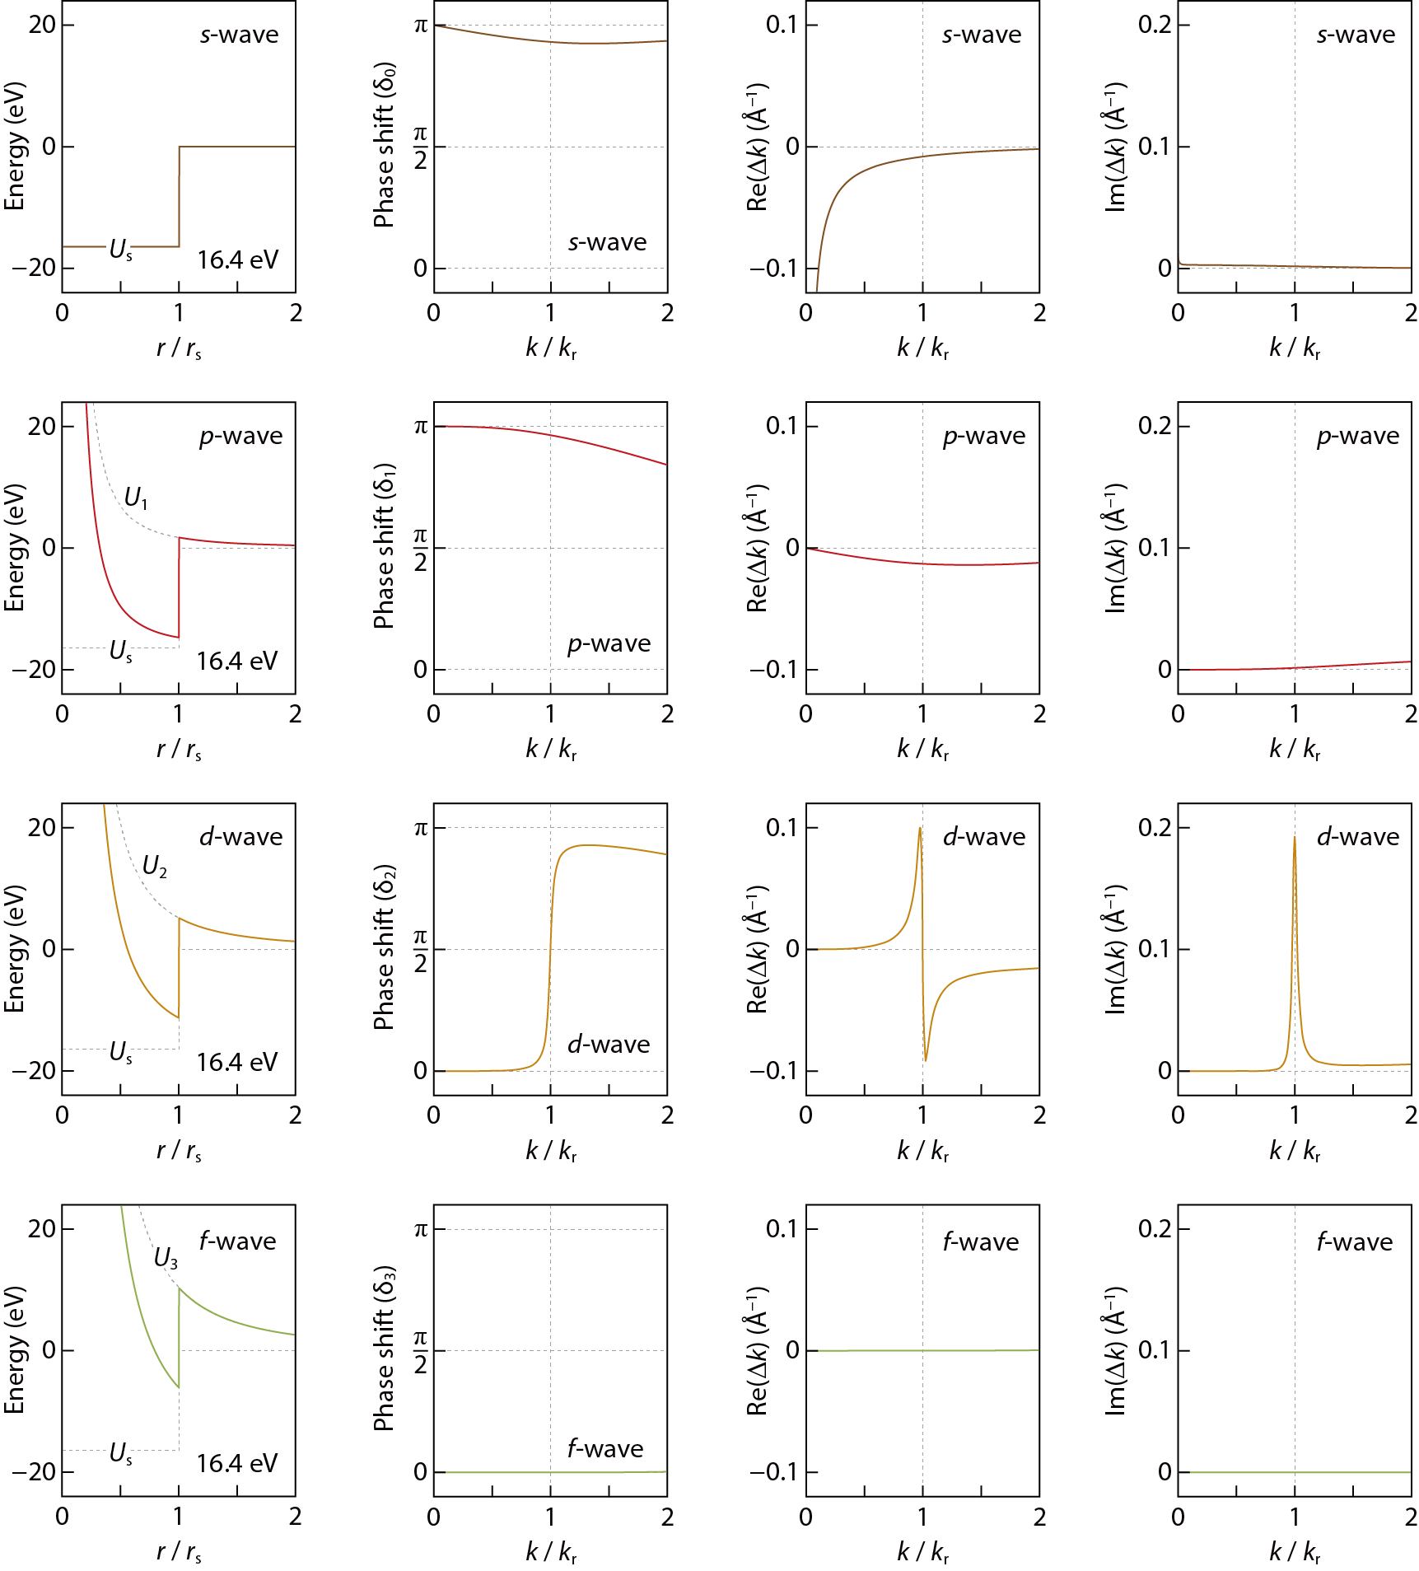

Extended Data Figure 3 | Model calculation for partial waves at d-wave resonance. A series of U_{l}, δ_{l}, Re(Δk), and Im(Δk) is calculated as described in Methods for the partial waves from l = 0 (top row) to l = 3 (bottom row). The depth of potential V₀ is set to 16.4 eV, which corresponds to d-wave resonance at k_{r} = 0.36 Å⁻¹, as shown in Fig. 4a. The d-wave resonance can be identified by δ₂ passing through π/2, which is accompanied by Re(Δk) and Im(Δk) taking the form of sin(2δ_{l})/k² and sin²(δ_{l})/k², respectively. For l = 0, there is no potential well, in which electron waves can be trapped, and it is impossible to have s-wave resonance.

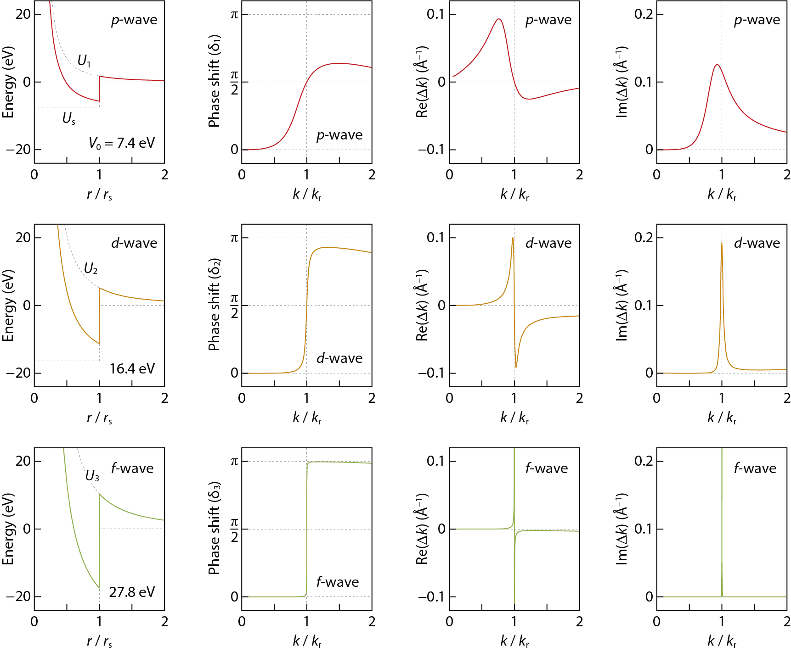

Extended Data Figure 4 | Comparison of Δk at p-wave, d-wave, and f-wave resonance. A series of U_{l}, δ_{l}, Re(Δk), and Im(Δk) is calculated for p-wave (top row), d-wave (middle row), and f-wave (bottom row) resonance (Methods). V₀ was set to 7.4 eV for p-wave, 16.4 eV for d-wave, 27.8 eV for f-wave resonance to have the same k_{r} of 0.36 Å⁻¹ (dotted line in Fig. 4a). The variation of δ_{l}, Re(Δk), and Im(Δk) is narrower in k or E width for the higher number of l, which accounts for the smaller magnitude of pseudogap in Fig. 5a.

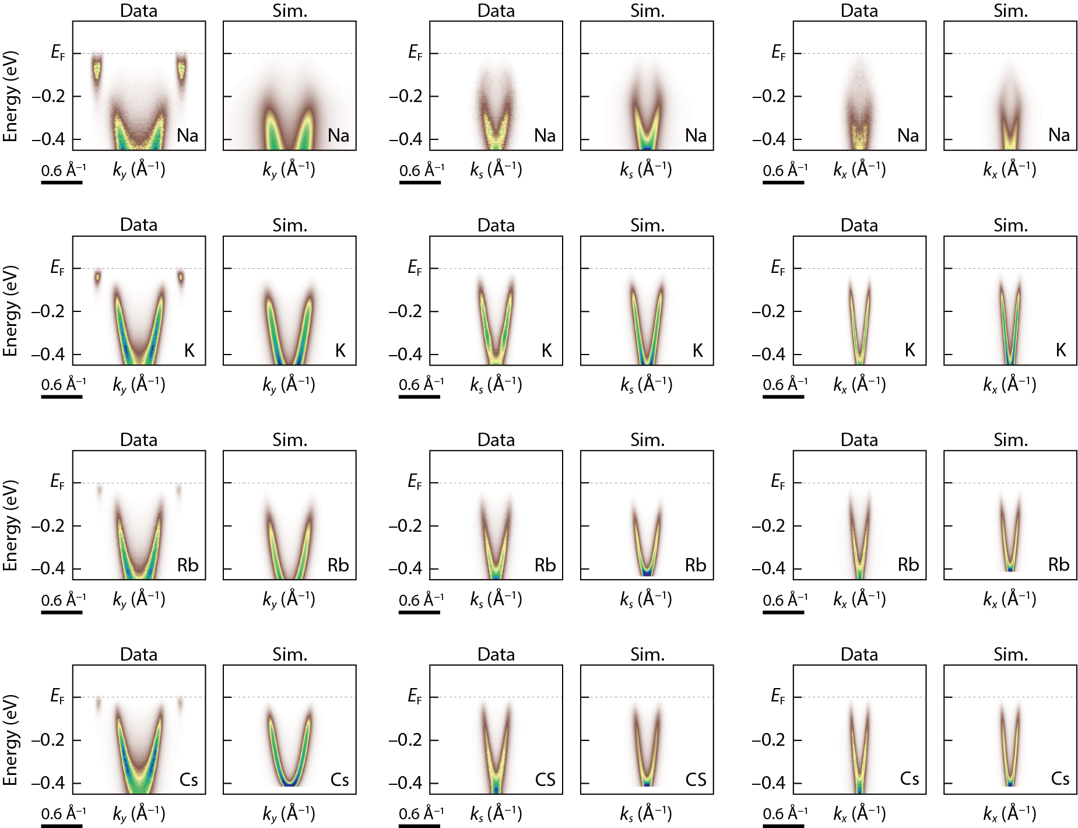

Extended Data Figure 5 | Spectral simulations compared to experimental ARPES data. The experimental band structure is taken from black phosphorus whose surface is doped by different kinds of alkali metal (Na, K, Rb, and Cs), as marked at the bottom right of each panel. This series of ARPES spectra was taken along k_{y} (left column), k_{s} (middle column), and k_{x} (right column). Each data is directly compared to corresponding spectral simulations at p-wave resonance for Na and d-wave resonance for K, Rb, and Cs (Methods).

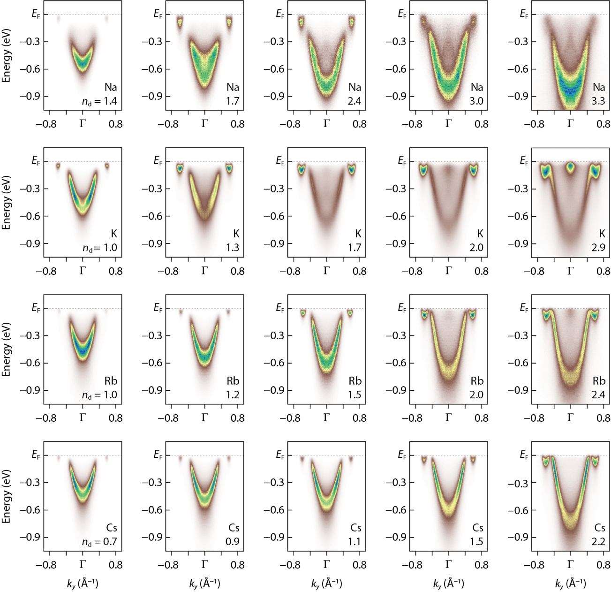

Extended Data Figure 6 | Evolution of pseudogap with surface doping. A doping series of APRES data is taken from black phosphorus whose surface is doped by Na, K, Rb, and Cs marked at the bottom right of each panel. Shown together in number is the dopant density n_{d} in units of 10¹⁴ cm⁻². It can be clearly seen that the magnitude of pseudogap progressively reduces down to zero with increasing n_{d}, as summarized in the phase diagram (Fig. 5b).

