Supporting Information
Table S1 Descriptive and comparative analyses of training and validation set.
Variable | Training Set  (N = 2584)  M±SD/n(%) | Validation Set  (N = 863)  M±SD/n(%) | χ²/z
PMS |  |  | 0.000
No | 1479 (57.2) | 494 (57.2)
Yes | 1105 (42.8) | 369 (42.8)
Demographic
Age (years) | 19.47±1.14 | 19.51 ± 1.17 | 0.532
BMI | 20.49 ± 2.66 | 20.42 ± 2.73 | 1.015
Family economy |  |  | 3.032
Insufficient | 397 (15.4) | 118 (13.7)
Sufficient for essentials | 1741 (67.4) | 577 (66.9)
More than sufficient | 446 (17.3) | 168 (19.5)
Diet |  |  | 2.431
Irregular | 252 (9.8) | 72 (8.3)
Basic regular | 1979 (76.6) | 660 (76.5)
Regular | 353 (13.7) | 131 (15.2)
Exercise |  |  | 2.223
Never | 282 (10.9) | 79 (9.2)
Occasionally | 2182 (84.4) | 741 (85.9)
Frequently | 120 (4.6) | 43 (5.0)
Smoking |  |  | 7.185
No | 2554 (98.8) | 842 (97.6)
Yes | 30 (1.2) | 21 (2.4)
Alcohol consumption |  |  | 2.821
No | 2264 (87.6) | 737 (85.4)
Yes | 320 (12.4) | 126 (14.6)
Menstrual Characteristics
Age of menarche (years) |  |  | 0.788
＜13 | 742 (28.7) | 238 (27.6)
13~16 | 1812 (70.1) | 617 (71.5)
＞16 | 30 (1.2) | 8 (0.9)
Menstrual regularity |  |  | 3.016
Irregular | 572 (22.1) | 167 (19.4)
Basic regular | 1703 (65.9) | 587 (68.0)
Regular | 309 (12.0) | 109 (12.6)
Days of menstruation |  |  | 0.169
≤3 | 223 (8.6) | 72 (8.3)
4~7 | 2247 (87.0) | 755 (87.5)
≥8 | 114 (4.4) | 36 (4.2)
Menstrual volume |  |  | 3.705
Small | 257 (9.9) | 69 (8.0)
Medium | 2121 (82.1) | 732 (84.8)
Large | 206 (8.0) | 62 (7.2)
History of dysmenorrhea |  |  | 1.034
Never | 336 (13.0) | 119 (13.8)
Occasionally | 1413 (54.7) | 455 (52.7)
Frequently | 835 (32.3) | 289 (33.5)
Use of analgesic |  |  | 3.207
Never | 1967 (76.1) | 633 (73.3)
Occasionally | 441 (17.1) | 170 (19.7)
Frequently | 176 (6.8) | 60 (7.0)
Socio-psychological Factors
Neuroticism | 2.69±0.69 | 2.67±0.68 | 0.362
Emotion regulation
Cognitive reappraisal | 28.02±6.95 | 27.93±7.15 | 0.063
Expressive suppression | 14.55±4.59 | 14.59±4.64 | 0.425
Mindfulness | 21.18±4.58 | 21.08±4.73 | 0.504
Childhood trauma
Emotional abuse | 6.85±2.80 | 6.85±2.65 | 0.411
Physical abuse | 5.73±2.31 | 5.76±2.31 | 0.457
Sexual abuse | 5.63±2.13 | 5.67±2.11 | 0.728
Emotional neglect | 9.87±4.96 | 9.68±4.79 | 0.776
Physical neglect | 7.95±3.32 | 7.81±3.22 | 0.722
Note. *＜0.05 **＜0.01***＜0.001

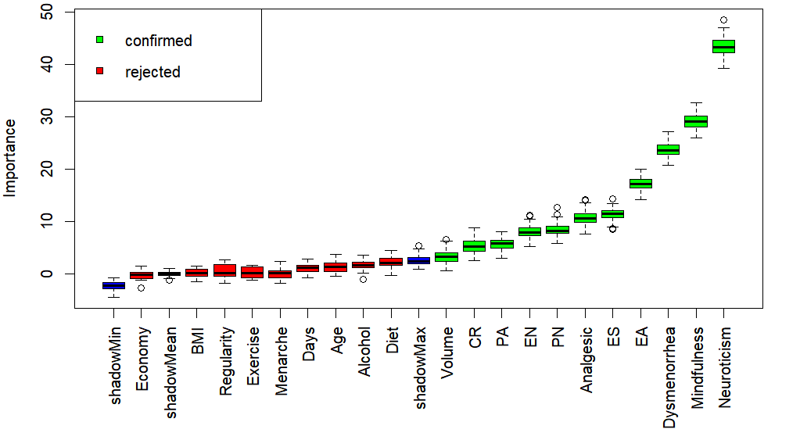
Fig. S1 Feature selection based on the Boruta algorithm.
Note. The x-axis is the name of each variable, and the y-axis is the Z value of each variable. The box plot shows the Z value of each variable during model calculation. The red and green boxes represent Z-scores that reject and confirm attributes, respectively, and the blue boxes represent the minimum, average, and maximum Z-values of the shadow property.

