Supporting information

Title:
Discovery of tricin as a novel ADAMTS1 inhibitor via molecular docking and ADMET predictions for inhibiting cancer metastasis
Ayushi Sharma, Chien-Huang Liao, Yung‑Wei Lin, Yu-Ching Wen, Shankar Gupta, Wei-Jiunn Lee, Yi-Chieh Yang, Min-Che Tung,* Ming-Hsien Chien*
*Correspondence to: Dr. Min-Che Tung (E-mail: tungminche@gmail.com) and Dr. Ming-Hsien Chien (E-mail: mhchien1976@gmail.com)

Supplementary figure
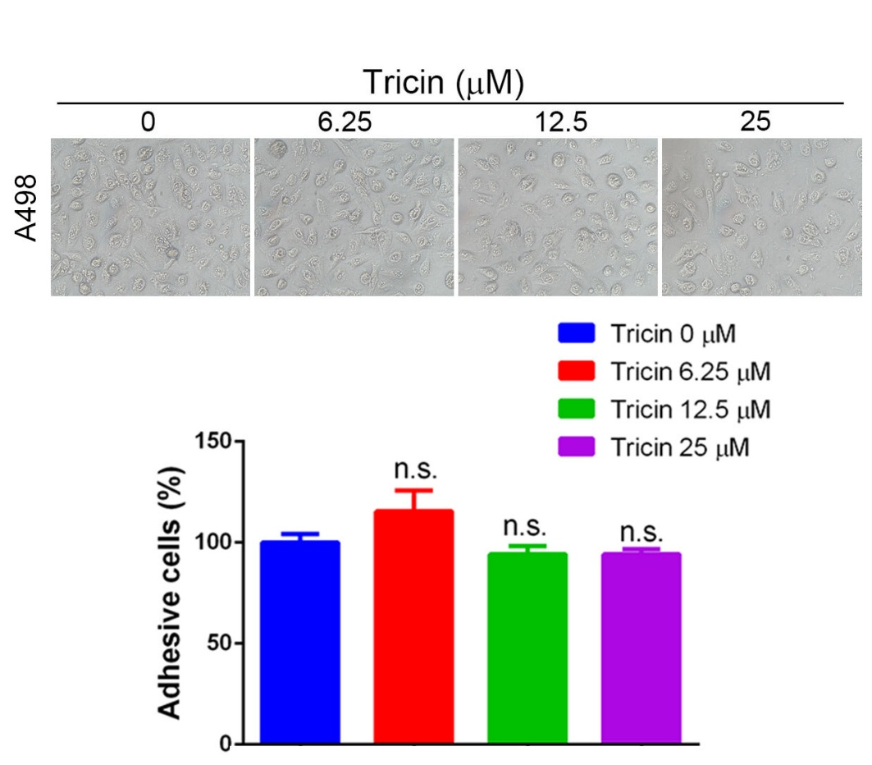
Figure S1. A498 cells were treated with various concentrations of tricin for 24 h and then subjected to an adhesion assay. Morphological changes in adherent cells were observed using phase-contrast microscopy (upper panel). The lower panel shows the quantification of adherent cells. Data are presented as the mean ± SD. n.s., not significant.

