Supplementary materials
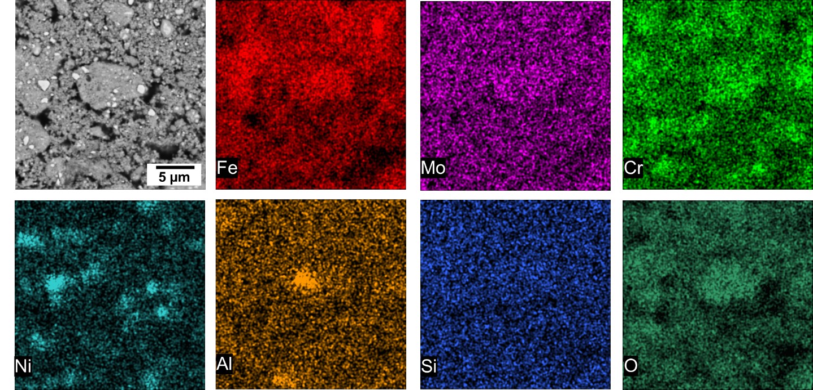
Fig. S1. Backscatter electron (BSE)-SEM micrograph of the powder mixture, along with the corresponding EDS elemental maps for Fe, Mo, Cr, Ni, Al, Si, and O. Imaging was taken at an accelerating voltage of 20 kV.
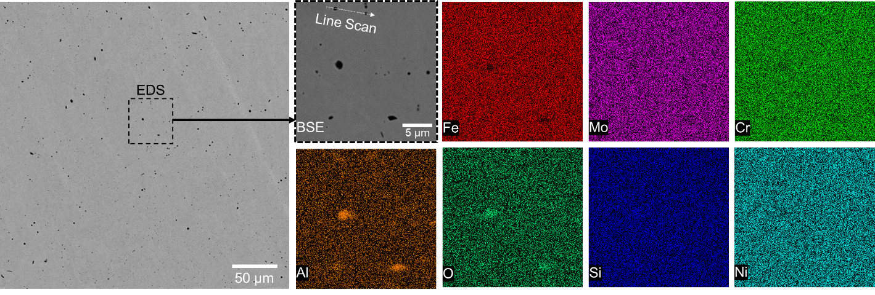
Fig. S2. BSE-SEM micrograph and EDS analysis of the cross-sectional area of the gel-cast specimen after H₂-based redox. Imaging was taken at an accelerating voltage of 20 kV, showing dense microstructure with coarse Al-rich inclusions (appearing as darker contrast particles).
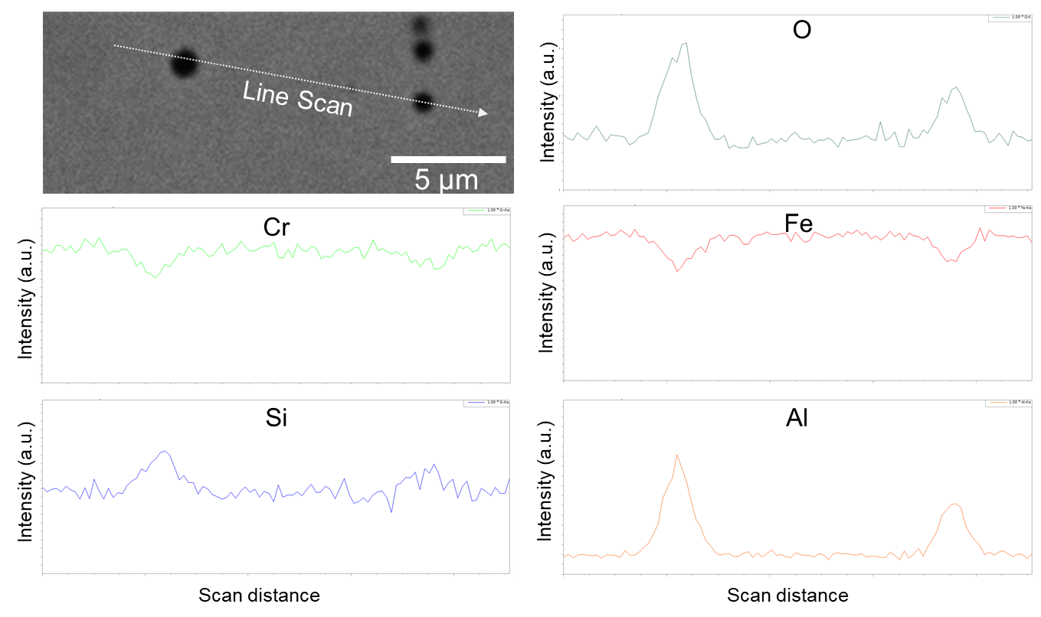
Fig. S3. EDS line scan across two submicron-sized inclusions, showing enrichment in Si, Al, and O, along with depletion of Fe and Cr, confirming their identity as gangue oxides ((Si,Al)Oₓ).

