Supplementary figure 1-6
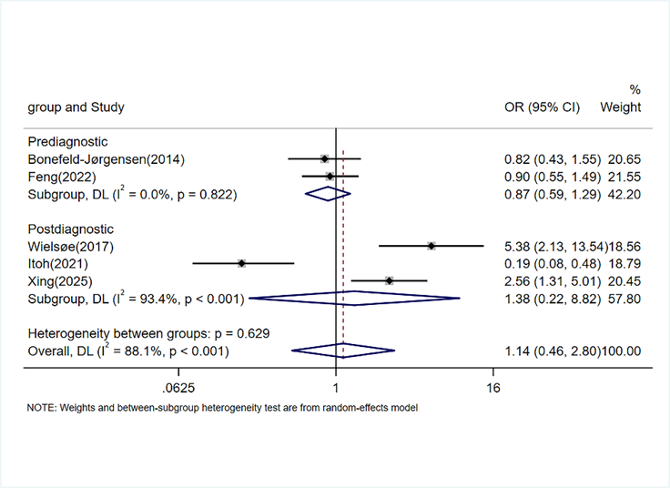
Figure S1. Odds ratios (ORs), 95% CI, and meta-analyses for comparing the highest versus lowest category of serum/plasma sumPFSA concentrations (ng/mL) and female reproductive system cancers risk, overall and by timing of blood sample collection.

Figure S2. Odds ratios (ORs), 95% CI, and meta-analyses for per-natural-log-unit increase in serum/plasma per- and polyfluoroalkyl substances (PFAS) concentrations (ng/mL) and female reproductive system cancers risk, overall and by timing of blood sample collection
Figure S3. Odds ratios (ORs), 95% CI, and meta-analyses for per-natural-log-unit increase in serum/plasma sumPFSA concentrations (ng/mL) and female reproductive system cancers risk, overall and by timing of blood sample collection.

Figure S4. Odds ratios (ORs), 95% CI, and meta-analyses for per natural log-unit increase in serum/plasma per- and polyfluoroalkyl substances (PFAS) concentrations (ng/mL) and female reproductive system cancers risk by menopausal status at diagnosis.
Figure S5. Odds ratios (ORs), 95% CI, and meta-analyses for per natural log-unit increase in serum/plasma per- and polyfluoroalkyl substances (PFAS) concentrations (ng/mL) and Cancer of male reproductive system.

Figure S6. Odds ratios (ORs), 95% CI, and meta-analyses for per natural log-unit increase in serum/plasma per- and polyfluoroalkyl substances (PFAS) concentrations (ng/mL) and Cancer of male reproductive system by Gleason score and tumor stage.

Supplementary Table 1. Search strategy
Database | Search strategy
Web of Science | (TS=(perfluorinated) OR TS= (perfluorooctanoic) OR TS=(perfluorooctane) OR TS=(perfluorohexane) OR TS=(PFOS) OR TS= (PFOA) OR TS= (PFHxS)) AND (TI= (Neoplasms) OR TI= (Tumor) OR TI=(Neoplasm) OR TI= (Tumors) OR TI= (Neoplasia) OR TI= (Neoplasias) OR TI=(Cancer) OR TI=(Cancers) OR TI=(Malignancy) OR TI=(Malignancies) OR TI= (malignant neoplasm))
PubMed | (((((((perfluorinated[Text Word]) OR (perfluorooctanoic[Text Word])) OR (perfluorooctane[Text Word])) OR (perfluorohexane[Text Word])) OR (PFOS[Text Word])) OR (PFOA[Text Word])) OR (PFHxS[Text Word])) AND (((((((((((Neoplasms[Text Word]) OR (Tumor[Text Word])) OR (Neoplasm[Text Word])) OR (Tumors[Text Word])) OR (Neoplasia[Text Word])) OR (Neoplasias[Text Word])) OR (Cancer[Text Word])) OR (Cancers[Text Word])) OR (Malignancy[Text Word])) OR (Malignancies[Text Word])) OR (malignant neoplasm[Text Word]))
Embase | (perfluorinated:ti,ab OR perfluorooctanoic:ti,ab OR perfluorooctane:ti,ab OR perfluorohexane:ti,ab OR PFOS:ti,ab OR PFOA:ti,ab OR PFHxS:ti,ab)  AND (neoplasms:ti,ab OR tumor:ti,ab OR tumors:ti,ab OR neoplasm:ti,ab OR neoplasia:ti,ab OR neoplasias:ti,ab OR cancer:ti,ab OR cancers:ti,ab OR malignancy:ti,ab OR malignancies:ti,ab OR "malignant neoplasm":ti,ab)
On August 10, 2025, a subsequent literature search was conducted using the previously specified keywords, encompassing publications from November 2024 to the present. A total of 1,725 articles were retrieved.

Supplementary Table 2. The use of the Newcastle-Ottawa Scale for assessing the quality of the included articles
Author | Country | Selection of cases and controls |  |  |  |  |  | Comparability | Exposure |  |  | Total score
Author | Country | Are the Case Definition and Diagnosis Adequate | Representativeness of the Cases | Selection of Controls |  | Definition of Controls |  | Comparability of Cases and Controls on the Basis of the Design or Analysis | Ascertainment of Exposure | Are the Investigation Methods the Same for Cases and Controls | Non-Response Rate | Total score
Bonefeld-Jorgensen (2014) and Ghisari (2017) | Denmark | 1 | 1 |  | 1 |  | 1 | 2 | 1 | 1 | 0 | 8
Wielsøe (2017) | Denmark | 1 | 1 |  | 0 |  | 1 | 1 | 1 | 1 | 0 | 6
Hurley (2018) | The US | 1 | 0 |  | 1 |  | 1 | 2 | 1 | 1 | 0 | 7
Mancini (2019) | France | 0 | 1 |  | 1 |  | 1 | 2 | 1 | 1 | 0 | 7
Tsai (2020) | China | 1 | 1 |  | 1 |  | 1 | 1 | 1 | 1 | 0 | 7
Itoh (2021) | Japan | 1 | 1 |  | 0 |  | 1 | 2 | 1 | 1 | 0 | 7
Feng (2022) | China | 1 | 0 |  | 1 |  | 1 | 2 | 1 | 1 | 0 | 7
Li (2022) | China | 1 | 1 |  | 0 |  | 1 | 1 | 1 | 1 | 0 | 6
Velarde (2022) | Philippines | 1 | 1 |  | 1 |  | 1 | 1 | 0 | 1 | 0 | 6
Chang (2023) | The US | 1 | 1 |  | 0 |  | 1 | 2 | 1 | 1 | 0 | 7
Winquist (2023) and Shahi (2025) | The US | 0 | 1 |  | 0 |  | 1 | 2 | 1 | 1 | 0 | 6
Dou (2024) | China | 1 | 1 |  | 1 |  | 1 | 2 | 1 | 1 | 0 | 8
Eriksen (2009) | Denmark | 1 | 1 |  | 0 |  | 1 | 1 | 1 | 1 | 0 | 6
Rhee (2023) | The US | 1 | 1 |  | 0 |  | 1 | 2 | 1 | 1 | 0 | 7
Purdue (2023) | The US | 1 | 0 |  | 1 |  | 1 | 2 | 1 | 1 | 0 | 7
Troeschel (2024) | The US | 1 | 1 |  | 1 |  | 1 | 2 | 1 | 1 | 0 | 8
Itoh (2025) | Brazil | 1 | 1 |  | 0 |  | 1 | 2 | 1 | 1 | 0 | 7
Xing (2025) | China | 1 | 1 |  | 1 |  | 1 | 2 | 1 | 1 | 0 | 8
Jones (2025) | The US | 1 | 1 |  | 0 |  | 1 | 2 | 1 | 1 | 0 | 7

Supplementary Table 3. A meta-regression analysis of PFAS exposure and female reproductive system cancers (P value)
Exposure | Comparison type | Publication year | Region | Sample size | Study design | Timing of blood collection | NOS score
PFOA | Highest vs. lowest | 0.582 | 0.772 | 0.992 | 0.716 | 0.867 | 0.537
 | Per ln-unit increase | 0.352 | 0.362 | 0.586 | 0.467 | 0.555 | 0.413
PFOS | Highest vs. lowest | 0.855 | 0.662 | 0.130 | 0.873 | 0.940 | 0.698
 | Per ln-unit increase | 0.766 | 0.828 | 0.123 | 0.872 | 0.560 | 0.916
PFHxS | Highest vs. lowest | 0.788 | 0.976 | 0.250 | 0.741 | 0.891 | 0.699
 | Per ln-unit increase | 0.623 | 0.939 | 0.435 | 0.616 | 0.884 | 0.967
PFNA | Highest vs. lowest | 0.880 | 0.765 | 0.683 | 0.988 | 0.671 | 0.948
 | Per ln-unit increase | 0.924 | 0.787 | 0.515 | 0.648 | 0.584 | 0.607
Publication year was categorized as before 2020 vs. 2020 or later; region as Western vs. Asian countries; sample size as <500 vs. ≥500; study design as case-control, nested case-control, or case-cohort; timing of blood collection as before vs. after diagnosis; and NOS score as <7 vs. ≥7. FOA, perfluorooctanoate; PFOS, perfluorooctane sulfonate; PFHxS, perfluorohexane sulfonate; PFNA, perfluorononanoate.

Supplementary Table 4. Sensitivity Analysis
 | Exposure | Comparison type | Pooled aOR (95%) | I-square (I²) | Number of Studies
First Sensitivity Analysis | PFOA | Highest vs. lowest | 1.01 (0.78,1.30) | 57.3% | 11
 |  | Per ln-unit increase | 0.97 (0.80,1.17) | 67.1% | 11
 | PFOS | Highest vs. lowest | 1.07 (0.78,1.46) | 70.2% | 11
 |  | Per ln-unit increase | 1.08 (0.90,1.30) | 69.0% | 11
 | PFHxS | Highest vs. lowest | 0.89 (0.58,1.35) | 79.7% | 9
 |  | Per ln-unit increase | 1.01 (0.83,1.23) | 83.1% | 9
 | PFNA | Highest vs. lowest | 1.14 (0.71,1.83) | 82.9% | 9
 |  | Per ln-unit increase | 0.97 (0.71,1.33) | 85.4% | 9
Second Sensitivity Analysis | PFOA | Highest vs. lowest | 1.17 (0.93,1.46) | 0.0% | 7
 |  | Per ln-unit increase | 1.06 (0.86,1.30) | 40.1% | 7
 | PFOS | Highest vs. lowest | 1.20 (0.94,1.55) | 14.6% | 7
 |  | Per ln-unit increase | 1.19 (0.99,1.43) | 38.5% | 7
 | PFHxS | Highest vs. lowest | 1.09 (0.58,2.05) | 79.1% | 5
 |  | Per ln-unit increase | 1.05 (0.78,1.42) | 84.5% | 5
 | PFNA | Highest vs. lowest | 1.65 (0.88,3.10) | 76.6% | 5
 |  | Per ln-unit increase | 1.39 (1.07,1.79) | 35.5% | 5
First Sensitivity Analysis, excluding studies with a NOS score below 7; Second Sensitivity Analysis: building on the first analysis and additionally excluding studies that collected blood samples after diagnosis. aOR, the adjusted odds ratios; PFOA, perfluorooctanoate; PFOS, perfluorooctane sulfonate; PFHxS, perfluorohexane sulfonate; PFNA, perfluorononanoate.

