Supplementary Figures
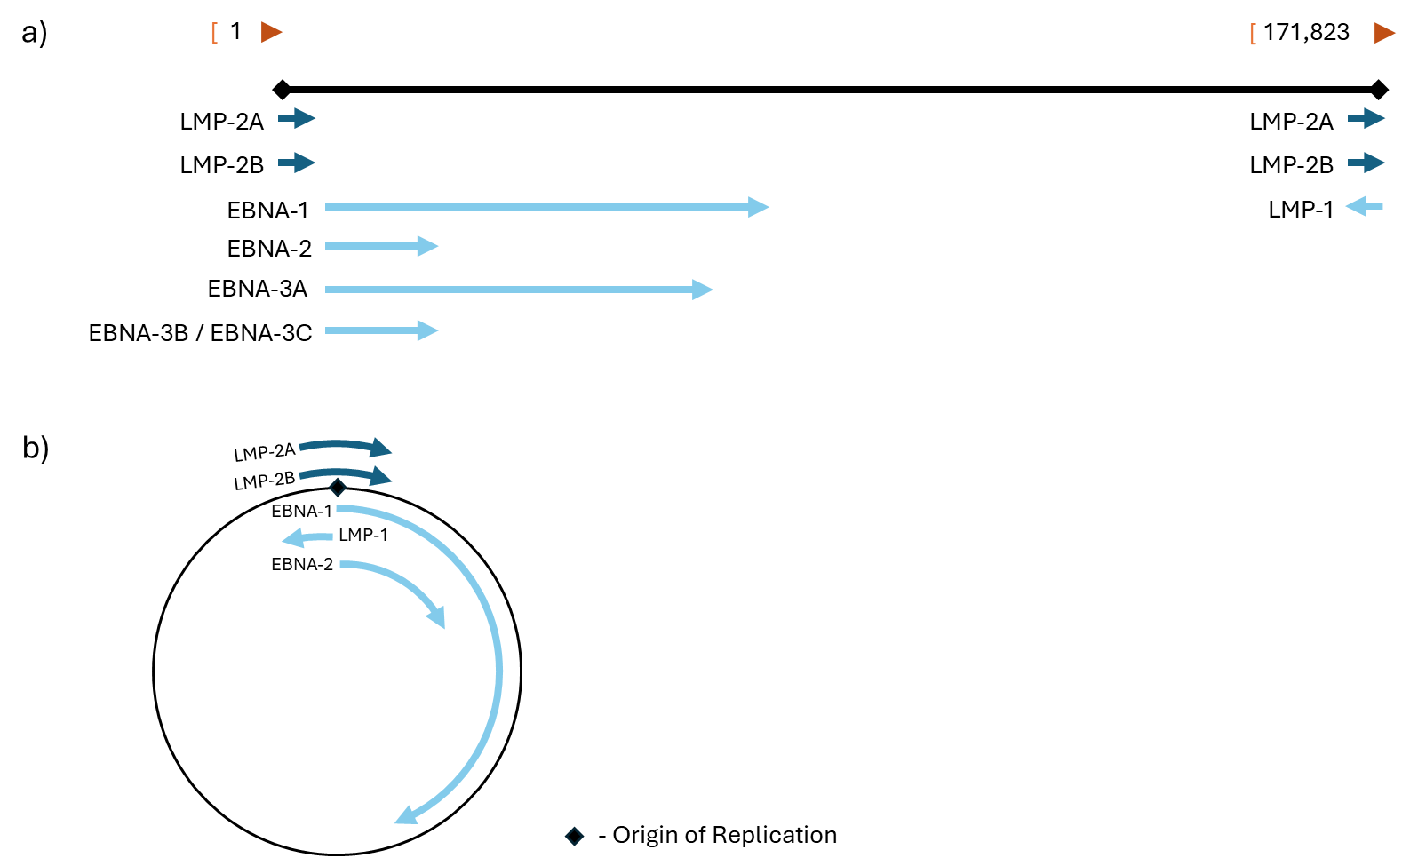
Supplementary Figure 1. A simplified depiction of the EBV genome. a) linear genomic form, and b) circular episomal form. LMP2A and LMP2B genes cross the origin of replication (denoted by a black diamond). Circularized genome correction is required for use with global alignment tools to avoid rejection of coding sequences which cross the starting base pair, as written in the FASTA sequence file. Data adapted from www.ncbi.nlm.nih.gov.
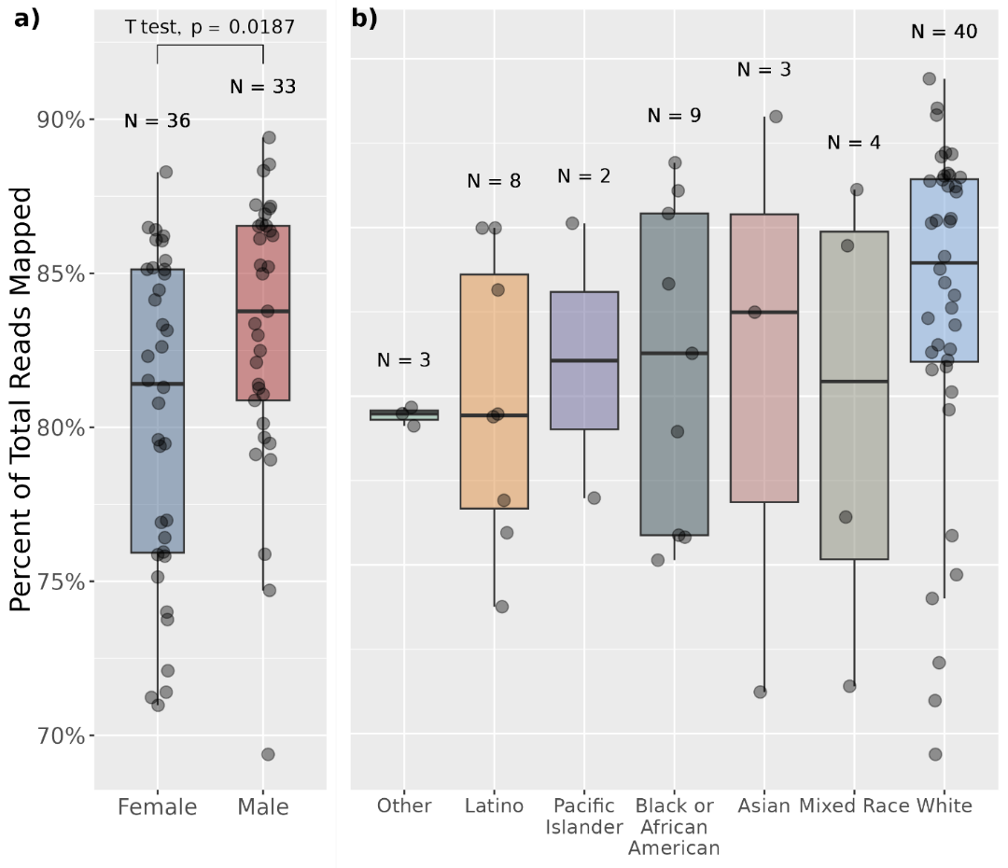
Supplementary Figure 2. Alignment distribution of total input RNA reads to human reference genome. Comparison is made between a) patient sex and b) patient race using student’s t-test.
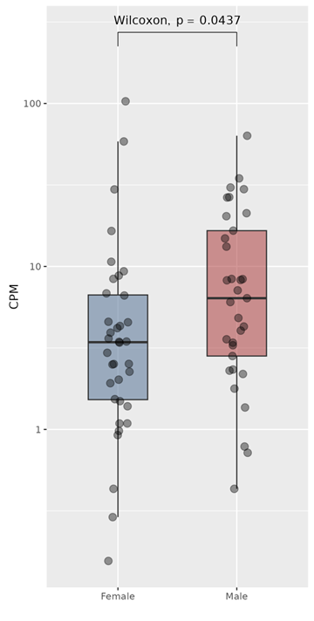
Supplementary Figure 3. Differences in HHV CPM in females versus males.
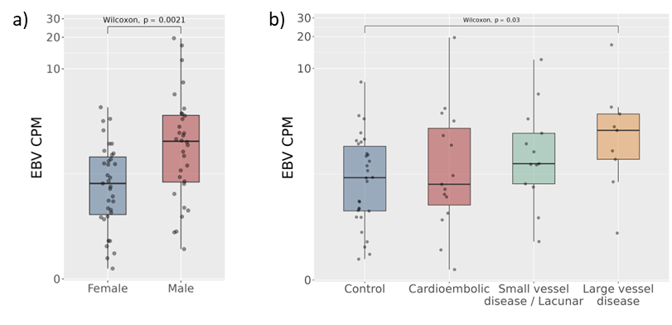
Supplementary Figure 4. EBV in blood of patients with ischemic stroke and controls. a) Males have higher mean EBV CPM compared to females. b) Stroke due to large vessel atherosclerosis have higher EBV CPM than non-stroke controls.
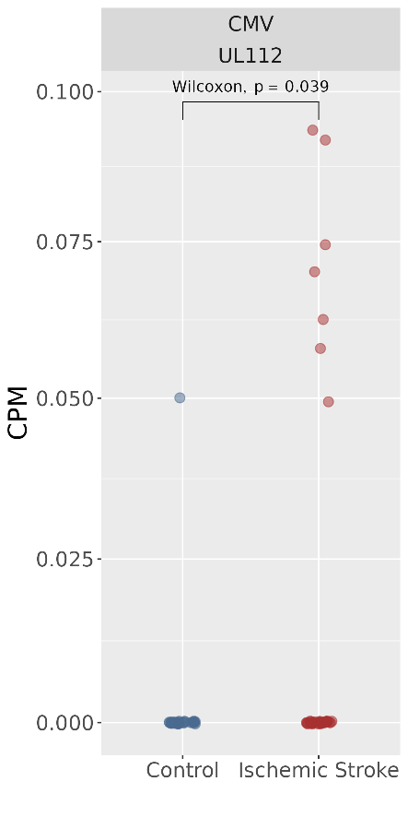
Supplementary Figure 5. Viral transcript counts in CPM for the CMV gene UL112 between IS and control.

Supplementary Tables
Supplementary Table 1. Complete viral genome database as compiled from the NCBI database of refseq and Genbank sequences.
Family | Genus | Species | Variant Count | Gene Count
Adenoviridae | Mastadenovirus | Human mastadenovirus A | 4 | 165
Adenoviridae | Mastadenovirus | Human mastadenovirus B | 229 | 10617
Adenoviridae | Mastadenovirus | Human mastadenovirus C | 77 | 3640
Adenoviridae | Mastadenovirus | Human mastadenovirus D | 156 | 6857
Adenoviridae | Mastadenovirus | Human mastadenovirus E | 69 | 3481
Adenoviridae | Mastadenovirus | Human mastadenovirus F | 16 | 571
Adenoviridae | Mastadenovirus | Human mastadenovirus G | 1 | 41
Anelloviridae | Alphatorquevirus | Alphatorquevirus cerco7 | 1 | 3
Anelloviridae | Alphatorquevirus | Alphatorquevirus homin1 | 19 | 77
Anelloviridae | Alphatorquevirus | Alphatorquevirus homin10 | 2 | 12
Anelloviridae | Alphatorquevirus | Alphatorquevirus homin2 | 1 | 2
Anelloviridae | Alphatorquevirus | Alphatorquevirus homin3 | 1 | 10
Anelloviridae | Alphatorquevirus | Alphatorquevirus homin6 | 1 | 6
Anelloviridae | Alphatorquevirus | Alphatorquevirus homin7 | 3 | 9
Anelloviridae | Alphatorquevirus | Torque teno virus 27 | 1 | 6
Anelloviridae | Betatorquevirus | Betatorquevirus homini1 | 1 | 3
Anelloviridae | Betatorquevirus | Betatorquevirus homini10 | 23 | 82
Anelloviridae | Betatorquevirus | Betatorquevirus homini16 | 1 | 2
Anelloviridae | Betatorquevirus | Betatorquevirus homini18 | 1 | 3
Anelloviridae | Betatorquevirus | Betatorquevirus homini2 | 1 | 3
Anelloviridae | Betatorquevirus | Betatorquevirus homini26 | 1 | 3
Anelloviridae | Betatorquevirus | Betatorquevirus homini27 | 1 | 3
Anelloviridae | Betatorquevirus | Betatorquevirus homini3 | 1 | 3
Anelloviridae | Betatorquevirus | Betatorquevirus homini5 | 1 | 3
Anelloviridae | Betatorquevirus | Betatorquevirus homini6 | 1 | 3
Anelloviridae | Betatorquevirus | Betatorquevirus homini8 | 1 | 2
Anelloviridae | Betatorquevirus | TTV-like mini virus | 17 | 52
Anelloviridae | Etatorquevirus | Etatorquevirus viver3 | 5 | 20
Anelloviridae | Gammatorquevirus | Gammatorquevirus homidi1 | 2 | 12
Anelloviridae | Gammatorquevirus | Gammatorquevirus homidi10 | 2 | 9
Anelloviridae | Gammatorquevirus | Gammatorquevirus homidi11 | 1 | 6
Anelloviridae | Gammatorquevirus | Gammatorquevirus homidi12 | 1 | 6
Anelloviridae | Gammatorquevirus | Gammatorquevirus homidi13 | 1 | 6
Anelloviridae | Gammatorquevirus | Gammatorquevirus homidi14 | 1 | 6
Anelloviridae | Gammatorquevirus | Gammatorquevirus homidi2 | 1 | 6
Anelloviridae | Gammatorquevirus | Gammatorquevirus homidi5 | 1 | 6
Anelloviridae | Gammatorquevirus | Gammatorquevirus homidi6 | 1 | 6
Anelloviridae | Gammatorquevirus | Gammatorquevirus homidi7 | 1 | 6
Anelloviridae | Gammatorquevirus | Gammatorquevirus homidi8 | 1 | 6
Anelloviridae | Gammatorquevirus | Gammatorquevirus homidi9 | 1 | 6
Anelloviridae | Gyrovirus | Gyrovirus chickenanemia | 254 | 759
Anelloviridae | Gyrovirus | Gyrovirus galga1 | 27 | 81
Anelloviridae | Gyrovirus | Gyrovirus homsa1 | 3 | 9
Anelloviridae | Gyrovirus | Gyrovirus homsa2 | 1 | 3
Anelloviridae | Gyrovirus | Gyrovirus homsa3 | 5 | 10
Anelloviridae | Gyrovirus | Gyrovirus homsa4 | 1 | 3
Anelloviridae | NA | Anelloviridae sp. | 22 | 48
Anelloviridae | NA | Small anellovirus | 2 | 8
Anelloviridae | NA | Torque teno virus | 70 | 219
Arenaviridae | Mammarenavirus | Mammarenavirus brazilense | 2 | 4
Arenaviridae | Mammarenavirus | Mammarenavirus choriomeningitidis | 2 | 4
Arenaviridae | Mammarenavirus | Mammarenavirus guanaritoense | 2 | 4
Arenaviridae | Mammarenavirus | Mammarenavirus juninense | 2 | 4
Arenaviridae | Mammarenavirus | Mammarenavirus lujoense | 2 | 4
Arenaviridae | Mammarenavirus | Mammarenavirus machupoense | 2 | 4
Astroviridae | Mamastrovirus | Burkina Faso astrovirus | 1 | 4
Astroviridae | Mamastrovirus | HMO Astrovirus A | 2 | 7
Astroviridae | Mamastrovirus | Mamastrovirus 1 | 49 | 146
Astroviridae | Mamastrovirus | Mamastrovirus 3 | 7 | 28
Astroviridae | Mamastrovirus | Mamastrovirus 4 | 2 | 8
Astroviridae | Mamastrovirus | Mamastrovirus 6 | 7 | 21
Astroviridae | Mamastrovirus | Mamastrovirus 9 | 4 | 16
Astroviridae | NA | Astrovirus MLB2 | 3 | 9
Astroviridae | NA | Astrovirus MLB3 | 1 | 3
Astroviridae | NA | Astrovirus VA3 | 1 | 3
Astroviridae | NA | Astrovirus VA4 | 1 | 3
Astroviridae | NA | Bastrovirus BAS-1 | 1 | 3
Astroviridae | NA | Human astrovirus | 9 | 25
Bornaviridae | Orthobornavirus | Orthobornavirus bornaense | 43 | 293
Bornaviridae | Orthobornavirus | Orthobornavirus sciuri | 25 | 153
Caliciviridae | Norovirus | Norwalk virus | 1330 | 3991
Caliciviridae | Sapovirus | Sapporo virus | 97 | 214
Caliciviridae | Vesivirus | Vesicular exanthema of swine virus | 6 | 17
Circoviridae | Circovirus | Circovirus eniyan | 1 | 2
Circoviridae | Circovirus | Circovirus porcine1 | 67 | 140
Circoviridae | Circovirus | Circovirus porcine2 | 2916 | 6413
Circoviridae | Circovirus | Human circovirus VS6600022 | 1 | 4
Circoviridae | Cyclovirus | Cyclovirus bashri | 1 | 3
Circoviridae | Cyclovirus | Cyclovirus homa | 1 | 2
Circoviridae | Cyclovirus | Cyclovirus humana | 4 | 8
Circoviridae | Cyclovirus | Cyclovirus insaan | 1 | 2
Circoviridae | Cyclovirus | Cyclovirus maanav | 1 | 2
Circoviridae | Cyclovirus | Cyclovirus manitan | 1 | 2
Circoviridae | Cyclovirus | Cyclovirus manukha | 1 | 2
Circoviridae | Cyclovirus | Cyclovirus manusyan | 1 | 3
Circoviridae | Cyclovirus | Cyclovirus mmadu | 1 | 2
Circoviridae | Cyclovirus | Cyclovirus munthu | 1 | 3
Circoviridae | Cyclovirus | Cyclovirus mutum | 1 | 2
Circoviridae | Cyclovirus | Cyclovirus nhanloai | 20 | 60
Circoviridae | NA | Circoviridae sp. | 1 | 2
Circoviridae | NA | Human PoSCV5-like circular virus | 1 | 2
Circoviridae | NA | Human fecal virus Jorvi2 | 1 | 5
Circoviridae | NA | Human fecal virus Jorvi3 | 1 | 2
Circoviridae | NA | Human fecal virus Jorvi4 | 1 | 2
Coronaviridae | Alphacoronavirus | Human coronavirus 229E | 69 | 563
Coronaviridae | Alphacoronavirus | Human coronavirus NL63 | 59 | 450
Coronaviridae | Betacoronavirus | Betacoronavirus 1 | 326 | 3250
Coronaviridae | Betacoronavirus | Human coronavirus HKU1 | 39 | 360
Coronaviridae | Betacoronavirus | Middle East respiratory syndrome-related coronavirus | 612 | 7207
Coronaviridae | Betacoronavirus | Severe acute respiratory syndrome-related coronavirus | 250 | 3571
Coronaviridae | Gammacoronavirus | Avian coronavirus | 423 | 4535
Flaviviridae | Hepacivirus | Hepacivirus hominis | 986 | 1651
Flaviviridae | Hepacivirus | Hepacivirus platyrrhini | 1 | 1
Flaviviridae | Orthoflavivirus | Orthoflavivirus aroaense | 4 | 4
Flaviviridae | Orthoflavivirus | Orthoflavivirus denguei | 4558 | 4558
Flaviviridae | Orthoflavivirus | Orthoflavivirus encephalitidis | 161 | 161
Flaviviridae | Orthoflavivirus | Orthoflavivirus flavi | 238 | 238
Flaviviridae | Orthoflavivirus | Orthoflavivirus ilheusense | 4 | 4
Flaviviridae | Orthoflavivirus | Orthoflavivirus japonicum | 303 | 308
Flaviviridae | Orthoflavivirus | Orthoflavivirus kyasanurense | 25 | 25
Flaviviridae | Orthoflavivirus | Orthoflavivirus langatense | 3 | 3
Flaviviridae | Orthoflavivirus | Orthoflavivirus louisense | 13 | 13
Flaviviridae | Orthoflavivirus | Orthoflavivirus loupingi | 26 | 26
Flaviviridae | Orthoflavivirus | Orthoflavivirus murrayense | 17 | 21
Flaviviridae | Orthoflavivirus | Orthoflavivirus nilense | 1692 | 3510
Flaviviridae | Orthoflavivirus | Orthoflavivirus omskense | 19 | 19
Flaviviridae | Orthoflavivirus | Orthoflavivirus powassanense | 17 | 17
Flaviviridae | Orthoflavivirus | Orthoflavivirus tembusu | 107 | 107
Flaviviridae | Orthoflavivirus | Orthoflavivirus usutuense | 150 | 150
Flaviviridae | Orthoflavivirus | Orthoflavivirus wesselsbronense | 6 | 6
Flaviviridae | Orthoflavivirus | Orthoflavivirus zikaense | 280 | 280
Flaviviridae | Orthoflavivirus | Spondweni virus | 2 | 2
Flaviviridae | Pegivirus | Pegivirus columbiaense | 4 | 4
Flaviviridae | Pegivirus | Pegivirus hominis | 46 | 46
Flaviviridae | Pegivirus | Pegivirus platyrrhini | 17 | 17
Flaviviridae | Pestivirus | Pestivirus bovis | 101 | 101
Flaviviridae | Pestivirus | Pestivirus tauri | 48 | 48
Genomoviridae | Gemycircularvirus | Gemycircularvirus HV-GcV1 | 1 | 4
Genomoviridae | Gemycircularvirus | Gemycircularvirus sp. | 5 | 14
Genomoviridae | Gemygorvirus | Gemygorvirus sewopo1 | 1 | 4
Genomoviridae | Gemykibivirus | Gemykibivirus humas1 | 2 | 8
Genomoviridae | Gemykibivirus | Gemykibivirus humas2 | 8 | 25
Genomoviridae | Gemykibivirus | Gemykibivirus humas3 | 1 | 3
Genomoviridae | Gemykibivirus | Gemykibivirus humas4 | 1 | 4
Genomoviridae | Gemykibivirus | Gemykibivirus humas5 | 1 | 3
Genomoviridae | Gemyvongvirus | Gemyvongvirus humas1 | 1 | 4
Hantaviridae | Orthohantavirus | Hantavirus Z10 | 3 | 3
Hantaviridae | Orthohantavirus | Orthohantavirus andesense | 2 | 2
Hantaviridae | Orthohantavirus | Orthohantavirus hantanense | 3 | 3
Hantaviridae | Orthohantavirus | Orthohantavirus sinnombreense | 1 | 1
Hantaviridae | Orthohantavirus | Orthohantavirus tulaense | 1 | 2
Hepadnaviridae | Orthohepadnavirus | Hepatitis B virus | 9087 | 69026
Hepeviridae | Paslahepevirus | Paslahepevirus balayani | 1 | 3
Hepeviridae | Rocahepevirus | Rocahepevirus ratti | 22 | 83
Iridoviridae | Megalocytivirus | Infectious spleen and kidney necrosis virus | 5 | 611
Kolmioviridae | Deltavirus | Hepatitis delta virus | 451 | 731
Matonaviridae | Rubivirus | Rubivirus rubellae | 84 | 168
Orthoherpesviridae | Cytomegalovirus | Cytomegalovirus humanbeta5 | 317 | 59132
Orthoherpesviridae | Lymphocryptovirus | Lymphocryptovirus humangamma4 | 301 | 17883
Orthoherpesviridae | Rhadinovirus | Rhadinovirus humangamma8 | 13 | 1307
Orthoherpesviridae | Roseolovirus | Roseolovirus humanbeta6a | 3 | 336
Orthoherpesviridae | Roseolovirus | Roseolovirus humanbeta6b | 5 | 492
Orthoherpesviridae | Roseolovirus | Roseolovirus humanbeta7 | 1 | 111
Orthoherpesviridae | Simplexvirus | Simplexvirus humanalpha1 | 48 | 4045
Orthoherpesviridae | Simplexvirus | Simplexvirus humanalpha2 | 13 | 1084
Orthoherpesviridae | Varicellovirus | Varicellovirus humanalpha3 | 146 | 10554
Orthomyxoviridae | Alphainfluenzavirus | Alphainfluenzavirus influenzae | 1542 | 2612
Orthomyxoviridae | Betainfluenzavirus | Betainfluenzavirus influenzae | 24 | 36
Papillomaviridae | Alphapapillomavirus | Alphapapillomavirus 1 | 27 | 188
Papillomaviridae | Alphapapillomavirus | Alphapapillomavirus 10 | 367 | 3292
Papillomaviridae | Alphapapillomavirus | Alphapapillomavirus 11 | 42 | 314
Papillomaviridae | Alphapapillomavirus | Alphapapillomavirus 13 | 18 | 125
Papillomaviridae | Alphapapillomavirus | Alphapapillomavirus 14 | 17 | 119
Papillomaviridae | Alphapapillomavirus | Alphapapillomavirus 2 | 2 | 15
Papillomaviridae | Alphapapillomavirus | Alphapapillomavirus 3 | 36 | 266
Papillomaviridae | Alphapapillomavirus | Alphapapillomavirus 4 | 11 | 75
Papillomaviridae | Alphapapillomavirus | Alphapapillomavirus 5 | 85 | 619
Papillomaviridae | Alphapapillomavirus | Alphapapillomavirus 6 | 119 | 840
Papillomaviridae | Alphapapillomavirus | Alphapapillomavirus 7 | 263 | 2055
Papillomaviridae | Alphapapillomavirus | Alphapapillomavirus 8 | 15 | 108
Papillomaviridae | Alphapapillomavirus | Alphapapillomavirus 9 | 1406 | 11222
Papillomaviridae | Betapapillomavirus | Betapapillomavirus 1 | 11 | 76
Papillomaviridae | Betapapillomavirus | Betapapillomavirus 2 | 16 | 111
Papillomaviridae | Betapapillomavirus | Betapapillomavirus 3 | 1 | 6
Papillomaviridae | Betapapillomavirus | Betapapillomavirus 4 | 3 | 21
Papillomaviridae | Betapapillomavirus | Betapapillomavirus 5 | 3 | 20
Papillomaviridae | Gammapapillomavirus | Gammapapillomavirus 1 | 2 | 17
Papillomaviridae | Gammapapillomavirus | Gammapapillomavirus 10 | 3 | 20
Papillomaviridae | Gammapapillomavirus | Gammapapillomavirus 11 | 7 | 48
Papillomaviridae | Gammapapillomavirus | Gammapapillomavirus 12 | 9 | 61
Papillomaviridae | Gammapapillomavirus | Gammapapillomavirus 13 | 4 | 28
Papillomaviridae | Gammapapillomavirus | Gammapapillomavirus 14 | 2 | 14
Papillomaviridae | Gammapapillomavirus | Gammapapillomavirus 15 | 7 | 47
Papillomaviridae | Gammapapillomavirus | Gammapapillomavirus 16 | 2 | 14
Papillomaviridae | Gammapapillomavirus | Gammapapillomavirus 17 | 1 | 7
Papillomaviridae | Gammapapillomavirus | Gammapapillomavirus 18 | 4 | 27
Papillomaviridae | Gammapapillomavirus | Gammapapillomavirus 19 | 4 | 26
Papillomaviridae | Gammapapillomavirus | Gammapapillomavirus 2 | 1 | 7
Papillomaviridae | Gammapapillomavirus | Gammapapillomavirus 20 | 2 | 12
Papillomaviridae | Gammapapillomavirus | Gammapapillomavirus 21 | 1 | 6
Papillomaviridae | Gammapapillomavirus | Gammapapillomavirus 22 | 11 | 77
Papillomaviridae | Gammapapillomavirus | Gammapapillomavirus 23 | 3 | 21
Papillomaviridae | Gammapapillomavirus | Gammapapillomavirus 24 | 7 | 49
Papillomaviridae | Gammapapillomavirus | Gammapapillomavirus 25 | 2 | 13
Papillomaviridae | Gammapapillomavirus | Gammapapillomavirus 26 | 1 | 6
Papillomaviridae | Gammapapillomavirus | Gammapapillomavirus 27 | 1 | 7
Papillomaviridae | Gammapapillomavirus | Gammapapillomavirus 3 | 2 | 13
Papillomaviridae | Gammapapillomavirus | Gammapapillomavirus 4 | 1 | 7
Papillomaviridae | Gammapapillomavirus | Gammapapillomavirus 5 | 2 | 14
Papillomaviridae | Gammapapillomavirus | Gammapapillomavirus 6 | 13 | 73
Papillomaviridae | Gammapapillomavirus | Gammapapillomavirus 7 | 11 | 74
Papillomaviridae | Gammapapillomavirus | Gammapapillomavirus 8 | 7 | 48
Papillomaviridae | Gammapapillomavirus | Gammapapillomavirus 9 | 6 | 42
Papillomaviridae | Gammapapillomavirus | Gammapapillomavirus sp. | 9 | 60
Papillomaviridae | Gammapapillomavirus | Human papillomavirus KC5 | 1 | 7
Papillomaviridae | Mupapillomavirus | Mupapillomavirus 1 | 1 | 7
Papillomaviridae | Mupapillomavirus | Mupapillomavirus 2 | 1 | 7
Papillomaviridae | Mupapillomavirus | Mupapillomavirus 3 | 1 | 7
Papillomaviridae | Nupapillomavirus | Nupapillomavirus 1 | 1 | 11
Papillomaviridae | NA | Human papillomavirus | 16 | 106
Papillomaviridae | NA | Human papillomavirus type 85 | 1 | 8
Paramyxoviridae | Henipavirus | Henipavirus hendraense | 4 | 36
Paramyxoviridae | Henipavirus | Henipavirus nipahense | 6 | 44
Paramyxoviridae | Morbillivirus | Morbillivirus caprinae | 88 | 633
Paramyxoviridae | Morbillivirus | Morbillivirus hominis | 274 | 2025
Paramyxoviridae | Orthorubulavirus | Orthorubulavirus hominis | 27 | 193
Paramyxoviridae | Orthorubulavirus | Orthorubulavirus laryngotracheitidis | 55 | 405
Paramyxoviridae | Orthorubulavirus | Orthorubulavirus mammalis | 13 | 100
Paramyxoviridae | Orthorubulavirus | Orthorubulavirus parotitidis | 620 | 5521
Paramyxoviridae | Pararubulavirus | Pararubulavirus sosugaense | 1 | 7
Paramyxoviridae | Respirovirus | Respirovirus laryngotracheitidis | 43 | 387
Paramyxoviridae | Respirovirus | Respirovirus pneumoniae | 347 | 2721
Parvoviridae | Bocaparvovirus | Bocaparvovirus primate1 | 30 | 192
Parvoviridae | Bocaparvovirus | Bocaparvovirus primate2 | 16 | 72
Parvoviridae | Dependoparvovirus | Adeno-associated virus | 75 | 652
Parvoviridae | Dependoparvovirus | Dependoparvovirus primate1 | 9 | 32
Parvoviridae | Erythroparvovirus | Erythroparvovirus primate1 | 18 | 79
Parvoviridae | Erythroparvovirus | Human erythrovirus V9 | 1 | 6
Parvoviridae | Tetraparvovirus | Tetraparvovirus primate1 | 8 | 20
Parvoviridae | NA | Parvovirus NIH-CQV | 5 | 16
Peribunyaviridae | Orthobunyavirus | Orthobunyavirus lacrosseense | 3 | 4
Peribunyaviridae | Orthobunyavirus | Orthobunyavirus oropoucheense | 2 | 3
Phenuiviridae | Bandavirus | Bandavirus dabieense | 3 | 4
Phenuiviridae | Phlebovirus | Phlebovirus candiruense | 3 | 4
Phenuiviridae | Phlebovirus | Phlebovirus riftense | 3 | 4
Phenuiviridae | Phlebovirus | Phlebovirus siciliaense | 3 | 4
Picornaviridae | Cardiovirus | Cardiovirus A | 32 | 34
Picornaviridae | Cardiovirus | Cardiovirus B | 26 | 33
Picornaviridae | Cardiovirus | Cardiovirus D | 1 | 1
Picornaviridae | Cosavirus | Cosavirus A | 1 | 1
Picornaviridae | Cosavirus | Cosavirus B | 1 | 1
Picornaviridae | Cosavirus | Cosavirus D | 2 | 2
Picornaviridae | Cosavirus | Cosavirus E | 1 | 1
Picornaviridae | Cosavirus | Cosavirus F | 1 | 1
Picornaviridae | Cosavirus | Cosavirus JMY-2014 | 1 | 1
Picornaviridae | Cosavirus | Human cosavirus | 2 | 2
Picornaviridae | Enterovirus | Enterovirus A | 2045 | 2045
Picornaviridae | Enterovirus | Enterovirus B | 404 | 404
Picornaviridae | Enterovirus | Enterovirus C | 734 | 734
Picornaviridae | Enterovirus | Enterovirus D | 606 | 606
Picornaviridae | Enterovirus | Enterovirus G | 83 | 83
Picornaviridae | Enterovirus | Enterovirus sp. | 3 | 3
Picornaviridae | Enterovirus | Rhinovirus A | 418 | 418
Picornaviridae | Enterovirus | Rhinovirus B | 84 | 84
Picornaviridae | Enterovirus | Rhinovirus C | 287 | 287
Picornaviridae | Hepatovirus | Hepatovirus A | 98 | 100
Picornaviridae | Kobuvirus | Kobuvirus aichi | 13 | 13
Picornaviridae | Kobuvirus | Kobuvirus bejaponia | 5 | 5
Picornaviridae | Parechovirus | Parechovirus A | 178 | 178
Picornaviridae | Rosavirus | Rosavirus A | 1 | 1
Picornaviridae | Salivirus | Salivirus A | 11 | 11
Picornaviridae | Salivirus | Salivirus FHB | 1 | 1
Picornaviridae | NA | Picornaviridae sp. | 1 | 1
Pneumoviridae | Metapneumovirus | Metapneumovirus hominis | 148 | 1323
Pneumoviridae | Orthopneumovirus | Orthopneumovirus bovis | 8 | 87
Pneumoviridae | Orthopneumovirus | Orthopneumovirus hominis | 2668 | 29074
Polyomaviridae | Alphapolyomavirus | Alphapolyomavirus nonihominis | 5 | 30
Polyomaviridae | Alphapolyomavirus | Alphapolyomavirus octihominis | 24 | 173
Polyomaviridae | Alphapolyomavirus | Alphapolyomavirus quardecihominis | 1 | 6
Polyomaviridae | Alphapolyomavirus | Alphapolyomavirus quintihominis | 52 | 273
Polyomaviridae | Alphapolyomavirus | Alphapolyomavirus terdecihominis | 1 | 9
Polyomaviridae | Betapolyomavirus | Betapolyomavirus hominis | 340 | 2368
Polyomaviridae | Betapolyomavirus | Betapolyomavirus macacae | 35 | 249
Polyomaviridae | Betapolyomavirus | Betapolyomavirus quartihominis | 151 | 907
Polyomaviridae | Betapolyomavirus | Betapolyomavirus secuhominis | 633 | 4425
Polyomaviridae | Betapolyomavirus | Betapolyomavirus tertihominis | 12 | 72
Polyomaviridae | Deltapolyomavirus | Deltapolyomavirus decihominis | 20 | 120
Polyomaviridae | Deltapolyomavirus | Deltapolyomavirus septihominis | 16 | 96
Polyomaviridae | Deltapolyomavirus | Deltapolyomavirus sextihominis | 17 | 101
Polyomaviridae | Deltapolyomavirus | Deltapolyomavirus undecihominis | 7 | 54
Redondoviridae | Torbevirus | Vientovirus | 1 | 3
Retroviridae | Betaretrovirus | Mouse mammary tumor virus | 1 | 8
Retroviridae | Betaretrovirus | Simian retrovirus 4 | 5 | 20
Retroviridae | Deltaretrovirus | Bovine leukemia virus | 82 | 984
Retroviridae | Deltaretrovirus | Human T-lymphotropic virus 4 | 2 | 16
Retroviridae | Deltaretrovirus | Primate T-lymphotropic virus 1 | 165 | 1461
Retroviridae | Deltaretrovirus | Primate T-lymphotropic virus 2 | 11 | 80
Retroviridae | Deltaretrovirus | Primate T-lymphotropic virus 3 | 7 | 56
Retroviridae | Gammaretrovirus | Baboon endogenous virus | 2 | 5
Retroviridae | Gammaretrovirus | Gibbon ape leukemia virus | 5 | 15
Retroviridae | Gammaretrovirus | Murine leukemia virus | 50 | 150
Retroviridae | Gammaretrovirus | Murine leukemia-related retroviruses | 6 | 17
Retroviridae | Gammaretrovirus | Porcine type-C oncovirus | 3 | 9
Retroviridae | Gammaretrovirus | RD114 retrovirus | 2 | 4
Retroviridae | Lentivirus | Human immunodeficiency virus 1 | 4696 | 50092
Retroviridae | Lentivirus | Human immunodeficiency virus 2 | 42 | 434
Retroviridae | Lentivirus | Simian immunodeficiency virus | 525 | 5678
Retroviridae | Simiispumavirus | Central cimpanzee simian foamy virus | 1 | 6
Retroviridae | Simiispumavirus | Eastern chimpanzee simian foamy virus | 1 | 5
Retroviridae | Simiispumavirus | Guenon simian foamy virus | 1 | 6
Retroviridae | Spumavirus | Simian foamy virus | 1 | 6
Retroviridae | NA | Human endogenous retrovirus K | 2 | 2
Sedoreoviridae | Orbivirus | Great Island virus | 9 | 10
Sedoreoviridae | Rotavirus | Rotavirus A | 11 | 12
Sedoreoviridae | Rotavirus | Rotavirus C | 1 | 1
Sedoreoviridae | Rotavirus | Rotavirus H | 11 | 11
Smacoviridae | Huchismacovirus | Human associated huchismacovirus 1 | 1 | 2
Smacoviridae | Huchismacovirus | Human associated huchismacovirus 2 | 1 | 2
Smacoviridae | Huchismacovirus | Human associated huchismacovirus 3 | 1 | 2
Smacoviridae | Huchismacovirus | Human smacovirus 1 | 13 | 26
Smacoviridae | Inpeasmacovirus | Inpeasmacovirus humas1 | 1 | 2
Smacoviridae | Porprismacovirus | Porprismacovirus humas3 | 3 | 6
Smacoviridae | Porprismacovirus | Porprismacovirus humas4 | 1 | 2
Spinareoviridae | Orthoreovirus | Mammalian orthoreovirus | 10 | 11
Spinareoviridae | Orthoreovirus | Pteropine orthoreovirus | 9 | 9
Tobaniviridae | Torovirus | Bovine torovirus | 6 | 38
Togaviridae | Alphavirus | Barmah Forest virus | 36 | 75
Togaviridae | Alphavirus | Chikungunya virus | 722 | 1819
Togaviridae | Alphavirus | Eastern equine encephalitis virus | 447 | 900
Togaviridae | Alphavirus | Madariaga virus | 32 | 64
Togaviridae | Alphavirus | Mayaro virus | 39 | 104
Togaviridae | Alphavirus | Onyong-nyong virus | 4 | 10
Togaviridae | Alphavirus | Ross River virus | 17 | 42
Togaviridae | Alphavirus | Semliki Forest virus | 9 | 20
Togaviridae | Alphavirus | Sindbis virus | 188 | 520
Togaviridae | Alphavirus | Venezuelan equine encephalitis virus | 123 | 249
Togaviridae | Alphavirus | Western equine encephalitis virus | 35 | 72
Totiviridae | NA | Trichomonas vaginalis virus | 1 | 3
NA | Husavirus | Husavirus sp. | 3 | 3
NA | NA | Circo-like virus-Brazil | 2 | 8
NA | NA | Circular ssDNA virus sp. | 20 | 31
NA | NA | Cressdnaviricota sp. | 2 | 4
NA | NA | Hudisavirus sp. | 7 | 14
NA | NA | Human DNA virus | 1 | 1
NA | NA | Human feces pecovirus | 1 | 2
NA | NA | uncultured virus | 1 | 2
Supplementary Table 2. All viruses detected by RNAseq protocol, including prevalence among the samples, total CPM and mean CPM. * denotes potential source from contamination.
Family | Genus | Species | Prevalence | Total CPM | Mean CPM
Adenoviridae | Mastadenovirus | Human mastadenovirus C | 38% | 129.96 | 5
Flaviviridae | Pegivirus | Pegivirus hominis | 9% | 0.52 | 0.09
Flaviviridae | Pestivirus | * Pestivirus bovis | 86% | 36.06 | 0.61
Orthoherpesviridae | Cytomegalovirus | Cytomegalovirus humanbeta5 | 91% | 228.72 | 3.63
Orthoherpesviridae | Lymphocryptovirus | Lymphocryptovirus humangamma4 | 97% | 146.76 | 2.19
Orthoherpesviridae | Rhadinovirus | Rhadinovirus humangamma8 | 28% | 86.76 | 4.57
Orthoherpesviridae | Roseolovirus | Roseolovirus humanbeta6b | 80% | 364.79 | 6.63
Orthoherpesviridae | Simplexvirus | Simplexvirus humanalpha1 | 25% | 110.54 | 6.5
Orthoherpesviridae | Simplexvirus | Simplexvirus humanalpha2 | 64% | 78.87 | 1.79
Orthoherpesviridae | Varicellovirus | Varicellovirus humanalpha3 | 3% | 0.34 | 0.17
Papillomaviridae | Alphapapillomavirus | Alphapapillomavirus 3 | 3% | 0.67 | 0.34
Papillomaviridae | Alphapapillomavirus | Alphapapillomavirus 5 | 6% | 11.87 | 2.97
Papillomaviridae | Betapapillomavirus | Betapapillomavirus 2 | 9% | 1.83 | 0.31
Papillomaviridae | Gammapapillomavirus | Gammapapillomavirus 7 | 22% | 1.53 | 0.1
Pneumoviridae | Orthopneumovirus | Orthopneumovirus hominis | 29% | 11.54 | 0.58
Retroviridae | Gammaretrovirus | * Murine leukemia virus | 3% | 4.31 | 2.16
Retroviridae | Lentivirus | * Human immunodeficiency virus 1 | 12% | 2.22 | 0.28
Retroviridae | Lentivirus | * Simian immunodeficiency virus | 3% | 33.7 | 16.85
Retroviridae | NA | Human endogenous retrovirus K | 67% | 140.74 | 3.06

