Supplementary materials:
Global and local knowledge networks spread regenerative agriculture in Europe
Corresponding author: Loekie Schreefel (loekie.schreefel@wur.nl)
Index
Supplementary Questionnaire 2
Supplementary Tables 3
Supplementary Figures 13
References 15

Supplementary Questionnaire

Part 1: general survey questions
- What is the name of your farm?
- What farming system best characterizes your farm (livestock, arable, mixed crop-livestock)?
- What is the size of your farm (hectares, cows, livestock units, employees)?
- Where is your farm located?
- How long have you been farming?
- Are you a full-time farmer?
  - If no, what is your off-farm occupations?
- Do you consider yourself a regenerative farmer?
- How long have you been considering yourself a regenerative farmer?

Part 2: SNA related survey questions
- What regenerative practices are you applying on your farm?
- List the specific sources you consult to acquire knowledge regarding your implemented regenerative practices (e.g. Gabe Brown, Commonland)?
- Describe the source of information (NGO, neighbouring farmer, agricultural adviser, book author, researcher, equipment supplier).
- What is the frequency of interaction with the knowledge source on a scale from 1 (low frequency) to 5 (high frequency)?
  - Very frequent: occurs at least once per week.
  - Frequent: occurs at least once per month but less than once per week.
  - Occasional: occurs at least twice per year but less than once per month.
  - Rare: occurs at most once per year.
- What is the level of trust you have in the information source on a scale from 1 (low trust) to 5 (high trust)?
  - Strong distrust: you strongly doubt the accuracy, reliability, or integrity of the source.
  - Moderate distrust: you have some reservations about the source's credibility.
  - Neutral: You neither actively trust nor distrust the source.
  - Moderate trust: you generally consider the source reliable but remain open to scrutiny.
  - Strong trust: you have high confidence in the source’s accuracy and reliability.

Supplementary Tables
Supplementary Table 1. Descriptive information reported by self-identified regenerative farmers, including the number of practices mentioned, the knowledge sources mentioned, and the average number of sources used per case country. Data were collected in Germany (DE), the Netherlands (NL), France (FR), Spain (ES), and Portugal (PT); EUR represents the average across the five case countries.
Country | Practices mentioned  (no.) | Knowledge sources mentioned (no.) | Average sources per farmer (no.)
DE | 36 | 148 | 6.4
NL | 45 | 338 | 11.3
FR | 32 | 209 | 11.6
ES | 40 | 191 | 4.2
PT | 26 | 65 | 5.9
EUR | 52 | 834 | 6.5

Supplementary Table 2. Information sources mentioned during farmer interviews, categorized by actor role. In-degree values represent the total in-degree per actor role in the European network, calculated after merging parallel edges. Parallel edges indicate distinct knowledge flows about different practices between the same farmer and knowledge source.
Actor roles | In-degree | Percentage (%)
Author | 267 | 19
Farmer(s) | 266 | 19
Research or education | 266 | 19
Advisory | 177 | 13
Online content and media | 129 | 9
NGOs | 109 | 8
Respondent farmer | 70* | 5
Value chain business | 67 | 5
Others | 15 | 1
Government agency | 14 | 1
*This number includes 12 edges (1%) where respondent farmers cited other respondent farmers, and 58 self-edges (auto-citations, 4%) where farmers cited themselves as sources of knowledge.
Supplementary Table 3. Top 100 knowledge sources mentioned
N° | Actors | Actor role | Country | Indegree | Degree | Betweenness
1 | Richard Perkins | Author | Sweden | 32 | 32 | 57946
2 | Allan Savory | Research or education | US | 29 | 29 | 72663
3 | Joel Salatin | Author | US | 28 | 28 | 56785
4 | Gabe Brown | Author | US | 16 | 16 | 41992
5 | Charles Dowding | Online content and media | UK | 16 | 16 | 8405
6 | Jean-Martin Fortier | Author | Canada | 15 | 15 | 18357
7 | Elaine Ingham | Research or education | US | 14 | 14 | 15041
8 | The Biggest Little Farm | Online Content and Media | US | 14 | 14 | 14926
9 | Dietmar Näser | Advisory | Germany | 12 | 12 | 21576
10 | Ernst Götsch | Research or education | Brazil | 12 | 12 | 15227
11 | Mark Shepard | Author | US | 10 | 10 | 16819
12 | John Kempf | Online Content and Media | US | 10 | 10 | 15526
13 | Kiss the Ground | Online Content and Media | US | 9 | 9 | 5640
14 | Masanobu Fukuoka | Farmer(s) | Japan | 8 | 8 | 12859
15 | Francesc Font | Farmer(s) | Spain | 8 | 8 | 8340
16 | Savory Institute | NGO | US | 8 | 8 | 7387
17 | Sepp Holzer | Author | Austria | 8 | 8 | 5519
18 | Darren J. Doherty | Author | Australia | 8 | 8 | 2520
19 | Bill Mollison | Author | Australia | 7 | 7 | 3322
20 | David Holmgren | Author | Australia | 7 | 7 | 3322
21 | Geoff Lawton | Research or education | Australia | 7 | 7 | 2500
22 | Climate Farmers | Advisory | Germany | 6 | 6 | 7457
23 | Friedrich Wenz | Advisory | Germany | 6 | 6 | 5778
24 | Jairo Restrepo Rivera | Research or education | Brazil | 6 | 6 | 5530
25 | Youngsang Cho | Farmer(s) | South Korea | 6 | 6 | 4815
26 | WUR | Research or education | The Netherlands | 6 | 6 | 2869
27 | We Are The Regeneration | NGO | The Netherlands | 6 | 6 | 2736
28 | Martin Crawford | Author | UK | 6 | 6 | 1566
29 | Ver de Terre Production | Research or education | France | 5 | 5 | 5805
30 | Pure Graze | Value Chain Business | The Netherlands | 5 | 5 | 3938
31 | Nova Crop Control | Advisory | The Netherlands | 5 | 5 | 3613
32 | Ferme du bec Hellouin | Research or education | France | 5 | 5 | 3459
33 | Sanne Beld | Advisory | The Netherlands | 5 | 5 | 2687
34 | Jaime Elizondo | Farmer(s) | US | 5 | 5 | 2306
35 | Wouter van Eck | Research or education | The Netherlands | 5 | 5 | 2279
36 | Taco Blom | Research or education | Belgium | 5 | 5 | 2036
37 | René Jochems | Advisory | The Netherlands | 5 | 5 | 1939
38 | Sonja Dreymann | Advisory | Germany | 5 | 5 | 1908
39 | Peter Vanhoof | Research or education | Poland | 5 | 5 | 1498
40 | Bodemzicht | Farmer(s) | The Netherlands | 5 | 5 | 1429
41 | Frédéric Thomas | Farmer(s) | France | 4 | 4 | 6543
42 | Claude et Lydia Bourguignon | Research or education | France | 4 | 4 | 6103
43 | Urs Mauk | Online Content and Media | Germany | 4 | 4 | 3206
44 | Rodale Institute | NGO | US | 4 | 4 | 2798
45 | WIJland | Advisory | The Netherlands | 4 | 4 | 2281
46 | Land van Ons | Online Content and Media | The Netherlands | 4 | 4 | 1623
47 | Jeff Lowenfels | Author | US | 4 | 4 | 1448
48 | Wayne Lewis | Author | US | 4 | 4 | 1448
49 | Theo Mulder | Advisory | The Netherlands | 4 | 4 | 1444
50 | Nicole Masters | Author | US | 4 | 4 | 1045
51 | P. Alfred Yeomans | Author | Australia | 4 | 4 | 918
52 | Warmonderhof | Research or education | The Netherlands | 4 | 4 | 499
53 | Onder Het Maaiveld | Online Content and Media | The Netherlands | 4 | 4 | 343
54 | No-till Growers | Online Content and Media | US | 4 | 4 | 170
55 | Jesse Frost | Online Content and Media | US | 4 | 4 | 67
56 | Schevichoven | Interviewed farmer | The Netherlands | 3 | 27 | 16370
57 | Peter Oosterhof | Interviewed farmer | The Netherlands | 3 | 17 | 7173
58 | Chambre d'agriculture | Government agency | France | 3 | 3 | 6102
59 | Christoff Fischer | Value Chain Business | Germany | 3 | 3 | 4426
60 | Johannes Storch | Online Content and Media | Germany | 3 | 3 | 4345
61 | Matt Powers | Author | US | 3 | 3 | 4045
62 | Regenerative Viticulture Foundation | NGO | UK | 3 | 3 | 3554
63 | Joseph Braun Freising | Farmer(s) | Germany | 3 | 3 | 2967
64 | Curtis Stone | Author | Canada | 3 | 3 | 2637
65 | Marc-André Selosse | Author | France | 3 | 3 | 2198
66 | Jordi Puig Roca | Research or education | Spain | 3 | 3 | 2004
67 | John D. Liu | Research or education | US | 3 | 3 | 1961
68 | Jesús Ignacio Simón Zamora | Research or education | Mexico | 3 | 3 | 1868
69 | Christoph Felgentreu | Advisory | Germany | 3 | 3 | 1794
70 | Vandana Shiva | Research or education | India | 3 | 3 | 1697
71 | Theo Nieuwenhuis | Advisory | The Netherlands | 3 | 3 | 1654
72 | Gérard Ducerf | Author | France | 3 | 3 | 1448
73 | André Voisin | Research or education | France | 3 | 3 | 1444
74 | IG Gesunder Boden | NGO | Germany | 3 | 3 | 1129
75 | Bij de Oorsprong | Value Chain Business | The Netherlands | 3 | 3 | 1095
76 | Pim Clotscher | Value Chain Business | The Netherlands | 3 | 3 | 784
77 | EARA | NGO | US | 3 | 3 | 549
78 | Eliot Coleman | Author | US | 3 | 3 | 495
79 | Anne Biklé | Author | US | 3 | 3 | 491
80 | David Montgomery | Author | US | 3 | 3 | 491
81 | Antonio Tucci | Farmer(s) | Spain | 3 | 3 | 474
82 | Paula Jarque | Farmer(s) | Spain | 3 | 3 | 474
83 | Toekomstboeren | NGO | The Netherlands | 3 | 3 | 471
84 | Commonland | NGO | The Netherlands | 3 | 3 | 409
85 | Peter Takens | Advisory | The Netherlands | 3 | 3 | 328
86 | Van Iersel | Value Chain Business | The Netherlands | 3 | 3 | 319
87 | Eugenio Gras | Farmer(s) | Spain | 3 | 3 | 268
88 | Daniel Mays | Author | US | 3 | 3 | 231
89 | Ketelbroek | Farmer(s) | The Netherlands | 3 | 3 | 195
90 | Velt | NGO | Belgium | 3 | 3 | 99
91 | Madelon Oostwoud | Farmer(s) | The Netherlands | 3 | 3 | 0
92 | Erve Kiekebos | Interviewed farmer | The Netherlands | 2 | 27 | 30934
93 | Gelukkige Groentes | Interviewed farmer | The Netherlands | 2 | 24 | 14208
94 | Pascal Boivin | Research or education | Switzerland | 2 | 2 | 12584
95 | Jammiekeshoeve | Interviewed farmer | The Netherlands | 2 | 20 | 10547
96 | Mathieu Archambeaud | Advisory | France | 2 | 2 | 7283
97 | Wijngaard Aan de Breede Beek | Interviewed farmer | The Netherlands | 2 | 17 | 7167
98 | SEO Birdlife | NGO | Spain | 2 | 2 | 6153
99 | KAIROS | Advisory | The Netherlands | 2 | 2 | 5280
100 | ISARA Lyon | Research or education | France | 2 | 2 | 4492

Supplementary Table 4. All meso-practices mentioned in which information was sourced.
Micro-practices | Count | Meso-practices | Count
RA in general | 360 | RA in general | 360
Agroforestry | 92 | Agroforestry and permaculture | 174
Food forest | 35 | Agroforestry and permaculture | 174
Permaculture | 28 | Agroforestry and permaculture | 174
Syntropic farming | 19 | Agroforestry and permaculture | 174
No tillage | 103 | Reduced/no tillage | 172
Reduced tillage | 57 | Reduced/no tillage | 172
Strip tillage | 11 | Reduced/no tillage | 172
Use a roller-crimper | 1 | Reduced/no tillage | 172
Composting | 77 | Composting | 114
Compost tea | 34 | Composting | 114
Vermicomposting | 2 | Composting | 114
Humanure composting | 1 | Composting | 114
Cover crops | 36 | Cover crops | 104
Maximum soil cover | 23 | Cover crops | 104
Catch crops | 18 | Cover crops | 104
Under sowing | 15 | Cover crops | 104
Vegetation cover | 10 | Cover crops | 104
Year-round soil cover | 2 | Cover crops | 104
Holistic grazing | 69 | Holistic grazing | 102
Rotational/strip grazing | 28 | Holistic grazing | 102
Voisin Rational Grazing | 5 | Holistic grazing | 102
Crop diversification | 32 | Crop diversity | 80
Intercropping | 16 | Crop diversity | 80
Strip cropping | 11 | Crop diversity | 80
Polyculture | 10 | Crop diversity | 80
Biointensive | 7 | Crop diversity | 80
Companion planting | 2 | Crop diversity | 80
Deep rooted species | 2 | Crop diversity | 80
Use organic fertilizers (e.g. animal manure) | 54 | Reduced/no artificial fertilizers | 79
Biofertilizer | 12 | Reduced/no artificial fertilizers | 79
No synthetic fertilizer | 7 | Reduced/no artificial fertilizers | 79
Foliar application | 2 | Reduced/no artificial fertilizers | 79
Reduce artificial fertilizers | 2 | Reduced/no artificial fertilizers | 79
Sheep wool fertilizer | 2 | Reduced/no artificial fertilizers | 79
Circular system | 19 | Reduced/no external inputs | 73
No synthetic inputs | 13 | Reduced/no external inputs | 73
Self-sufficiency | 11 | Reduced/no external inputs | 73
Minimize external inputs | 9 | Reduced/no external inputs | 73
Minimize synthetic inputs | 5 | Reduced/no external inputs | 73
No external inputs | 4 | Reduced/no external inputs | 73
Recycled/reused materials | 7 | Reduced/no external inputs | 73
No dependence on fossil fuel use | 2 | Reduced/no external inputs | 73
Input reduction | 3 | Reduced/no external inputs | 73
Effective microorganisms | 18 | Soil inoculation | 65
Bio stimulants | 16 | Soil inoculation | 65
Soil inoculation with microbiology | 13 | Soil inoculation | 65
Bio inoculants | 10 | Soil inoculation | 65
Organic-based preparations | 8 | Soil inoculation | 65
Conservation agriculture | 23 | Other approaches to farming | 65
Organic production | 18 | Other approaches to farming | 65
Market gardening | 6 | Other approaches to farming | 65
JADAM Organic Farming | 6 | Other approaches to farming | 65
Biodynamic agriculture | 5 | Other approaches to farming | 65
Micro-farming | 3 | Other approaches to farming | 65
Natural farming | 2 | Other approaches to farming | 65
Lean farming | 2 | Other approaches to farming | 65
Monitoring | 62 | Monitoring | 62
Biodiversity shelters (e.g. bushes) | 18 | Habitat provision | 61
Trees and hedges | 17 | Habitat provision | 61
Flower/herb/nature strips | 12 | Habitat provision | 61
Bushes and trees as wind borders | 3 | Habitat provision | 61
Insect hotels | 3 | Habitat provision | 61
Habitat provision | 3 | Habitat provision | 61
Bird and bat boxes | 2 | Habitat provision | 61
Riparian buffers | 2 | Habitat provision | 61
Natural buffer zones | 1 | Habitat provision | 61
Grass strips | 1 | Habitat provision | 61
Mulching | 56 | Mulching | 60
Wood chips | 4 | Mulching | 60
Natural water harvesting | 23 | Water storage | 55
Water reservoirs | 14 | Water storage | 55
Water buffers | 3 | Water storage | 55
Infiltration channels | 3 | Water storage | 55
Water filtration | 3 | Water storage | 55
Dikes | 3 | Water storage | 55
Pond | 3 | Water storage | 55
Swales | 3 | Water storage | 55
Soil Fertility Management | 44 | Soil fertility management | 51
Soil Management | 7 | Soil fertility management | 51
Integrated pest management | 19 | Reduced/no synthetic pesticides | 43
No synthetic pesticides | 12 | Reduced/no synthetic pesticides | 43
Natural pest management | 9 | Reduced/no synthetic pesticides | 43
No herbicides | 2 | Reduced/no synthetic pesticides | 43
Reduce synthetic pesticides | 1 | Reduced/no synthetic pesticides | 43
Green manure | 36 | Green manure | 36
Legumes | 34 | N-fixing plants | 34
Herb-rich grassland | 29 | Herb-rich grassland | 31
Grassland diversity | 2 | Herb-rich grassland | 31
Crop rotation | 30 | Crop rotation | 30
Direct seeding | 29 | Direct seeding | 29
Holistic management | 28 | Holistic management | 28
Crop - livestock integration | 23 | Crop-livestock integration | 26
Agro-silvo-pastoralism | 2 | Crop-livestock integration | 26
Polyface farming | 1 | Crop-livestock integration | 26
Local or native crop and animal species | 23 | Local or native crop and animal species | 23
Keyline design | 21 | Keyline design | 21
No heavy machinery | 12 | Reduce machinery | 17
Manual/low tech farming | 2 | Reduce machinery | 17
Minimize soil disturbance | 1 | Reduce machinery | 17
Reduce mechanization | 1 | Reduce machinery | 17
Reduce heavy machinery | 1 | Reduce machinery | 17
Animal welfare practices | 16 | Animal welfare practices | 16
Mobile chicken coops | 16 | Mobile chicken coops | 16
Financial resilience and sustainable business models | 14 | Sustainable farm income | 15
Financial diversification | 1 | Sustainable farm income | 15
Community involvement | 13 | Community involvement | 13
Animal diversity | 14 | Livestock diversification | 13
Double purpose cows | 2 | Livestock diversification | 13
Pruning | 3 | Other practices | 12
Other practices | 2 | Other practices | 12
Marine inputs | 2 | Other practices | 12
Create wetlands | 1 | Other practices | 12
No plastic | 1 | Other practices | 12
Free-range breeding system | 1 | Other practices | 12
Biochar | 12 | Biochar | 12
Extensive grazing | 12 | Extensive grazing | 12
Knowledge exchange & capacity Building | 11 | Knowledge exchange | 12
Provide training | 1 | Knowledge exchange | 12
Use perennials | 10 | Use perennials | 12
Perennial pastures | 2 | Use perennials | 12
Reduce concentrate feed | 5 | Reduce concentrate feed | 10
No concentrate feed | 5 | Reduce concentrate feed | 10
Short value chain | 9 | Locally produced | 9
Stone flower | 4 | Soil amendments | 8
Natural amendments | 3 | Soil amendments | 8
Zeolite | 1 | Soil amendments | 8
Permanent grassland | 7 | Permanent grassland | 7
Bokashi | 7 | Bokashi | 7
Pollinator integration | 3 | Pollinator integration | 7
Reduce water use | 6 | Minimize water use | 7
Drip irrigation | 1 | Minimize water use | 7
Controlled traffic lanes | 6 | Controlled traffic lanes | 6
Other | 8 | Other | 6
Keep living roots | 6 | Keep living roots | 6
High-tech practices | 5 | Mechanization | 5
More free time | 4 | More free time | 4
Avoid antibiotics | 3 | Avoid antibiotics | 3
Mechanical weeding | 1 | Weeding | 2
Integrated weed management | 1 | Weeding | 2
Certification | 2 | Certification | 2

Supplementary Table 5. Frequency of interaction of farmers with knowledge sources. The frequency of interactions represents the number of raw edges in the European network prior to merging parallel edges.
Frequency rate | Frequency of interaction (no.) | Percentage of total (%)
Very frequent | 422 | 19
Frequent | 592 | 27
Occasional | 273 | 12
Rare | 930 | 42
Total: | 2217 | 100%

Supplementary Table 6. Trust of farmers on their knowledge sources. The frequency rated represents the number of raw edges in the European network prior to merging parallel edges.
Trust rate | Frequency rated (no.) | Percentage of total (%)
Strong distrust | 3 | 0
Moderate distrust | 22 | 1
Neutral | 190 | 9
Moderate trust | 906 | 42
Strong trust | 1056 | 49
Total: | 2177* | 100%
*Trust scores were missing for 40 out of the 2217 edges. As trust was removed from subsequent analysis, results were not affected.

Supplementary Table 7. Farmers that accepted interviews in Germany (DE), the Netherlands (NL), France (FR), Spain (ES), Portugal (PT), and Europe as average of the five case-countries (EUR).
Country | Farmers identified | Farmer interviewed | Response rates
DE | 67 | 23 | 34
NL | 40 | 30 | 75
FR | 37 | 18 | 49
ES | 94 | 46 | 49
PT | 42 | 11 | 26
EUR | 280 | 128 | 46

Supplementary Table 8. Threshold values to determine actor sizes. Thresholds values were used to determine actor sizes following Schreefel et al. 1. These were sector specific and based on national inventories, ranging from very small to very large. Some clusters were adapted from the national inventories to maintain five ranges of actor sizes; these clusters are marked with an Asterix. Mixed (crop-livestock) farming systems, were too diverse to be benchmarked against national inventories. Their sizes were based on their dominant operations (arable or livestock) and clustered in a respective size category.
Cat. | Country |  | Unit |  | 1. Very small |  | 2. Small |  |  | 3. Medium |  | 4. Large |  | 5.Very large |  | Ref.
Arable | DE |  | Area (ha) |  | ≤10 |  | >10-50 |  |  | >50-100 |  | >100-200 |  | >200 |  | ²
Arable | NL |  | Area (ha) |  | ≤10 |  | >10-50 |  |  | >50-100 |  | >100-300 |  | >300 |  | ³
Arable | FR |  | Area (ha) |  | ≤10 |  | >10-50 |  |  | >50-100 |  | >100-200 |  | >200 |  | ⁴
Arable | ES |  | Area (ha) |  | ≤6 |  | >6-13 |  |  | >13-30 |  | >30-70 |  | >70 |  | ⁵
Arable | PT |  | Area (ha) |  | ≤1 |  | >1-5 |  |  | >5-20 |  | >20-100 |  | >100 |  | ⁶
Dairy | DE |  | Cows (n) |  | ≤20 |  | >20-50 |  |  | >50-100 |  | >100-200 |  | >200 |  | ⁷
Dairy | NL |  | Cows (n) |  | ≤50 |  | >50-100 |  |  | >100-150 |  | >150-250 |  | >250 |  | ⁸
Dairy | FR |  | Cows (n) |  | ≤40 |  | >40-60 |  |  | >60-80 |  | >80-150 |  | >150 |  | ⁹
Dairy | ES |  | Area (ha) |  | ≤4 |  | >4-12 |  |  | >12-29 |  | >29-81 |  | >81 |  | ¹⁰
Dairy | PT |  | LU |  | ≤10 |  | >10-50 |  |  | >50-100 |  | >100-300 |  | >300 |  | ⁶
Horticulture | DE |  | Area (ha) |  | ≤1 |  | >1-5 |  |  | >5-10 |  | >10-20 |  | >20 |  | ⁷
Horticulture | NL |  | Area (ha) |  | ≤1.25 |  | >1.25-2.5 |  |  | >2.5-5 |  | >5-10 |  | >10 |  | ¹¹
Horticulture | ES |  | Area (ha) |  | ≤0.8 |  | >0.8-1.2 |  |  | >1.2-2.0 |  | >2.0-4.6 |  | >4.6 |  | ¹⁰
Orchards | DE |  | Area (ha) |  | ≤2 |  | 2-5 |  |  | 5-10 |  | 10-20 |  | >20 |  | ¹²
Orchards | NL |  | Area (ha) |  | ≤1 |  | >1-5 |  |  | >5-10 |  | >10-20 |  | >20 |  | ¹³
Orchards | ES |  | Area (ha) |  | ≤0.7 |  | >0.7-1.6 |  |  | >1.6-3.8 |  | > 3.8-10.9 |  | >10.9 |  | ¹⁰
Private sector | DE |  | Employees (n) |  | ≤10 |  | 10-50 |  |  | 50-250 |  | 250-500 |  | >500 |  | ¹⁴
Private sector | NL |  | Employees (n)* |  | ≤5 |  | >5-10 |  |  | >10-50 |  | >50-100 |  | >100 |  | ¹⁵
Private sector | FR |  | Employees (n) |  | ≤1 |  | >2-10 |  |  | >10-50 |  | >50-200 |  | >201 |  | ¹⁶
Private sector | ES |  | Employees (n) |  | ≤9 |  | >9-20 |  |  | >20-50 |  | >50-250 |  | >250 |  | ¹⁷
Private sector | PT |  | Employees (n) |  | ≤1 |  | >2-10 |  |  | >10-50 |  | >50-100 |  | >100 |  | ⁶
Projects | DE |  | Capital (€ x 1,000) |  | ≤100 |  | >100-500 |  |  | >500-1,000 |  | >1,000-5,000 |  | >5,000 |  | Expert judgement
Projects | NL |  | Capital (€ x 1,000) |  | ≤100 |  | >100-500 |  |  | >500-1,000 |  | >1,000-5,000 |  | >5,000 |  | Expert judgement
Projects | FR |  | Capital (€ x 1,000) |  | ≤100 |  | >100-500 |  |  | >500-1,000 |  | >1,000-5,000 |  | >5,000 |  | Expert judgement
Projects | ES |  | Capital (€ x 1,000) |  | ≤100 |  | >100-500 |  |  | >500-1,000 |  | >1,000-5,000 |  | >5,000 |  | Expert judgement
Projects | PT |  | Capital (€ x 1,000) |  | ≤100 |  | >100-500 |  |  | >500-1,000 |  | >1,000-5,000 |  | >5,000 |  | Expert judgement
Cat. |  | Country |  | Unit |  | 1. Very small |  | 2. Small | 3. Medium |  | 4. Large |  | 5.Very large |  | Ref.
Pigs |  | DE |  | Pigs (n) |  | ≤100 |  | >100-400 | >400-1,000 |  | >1,000-2,000 |  | >2,000 |  | ⁷
 |  | NL |  | Pigs (n) |  | ≤500 |  | >500-1,500 | >1,500-3,000 |  | >3,000-7,500 |  | >7,500 |  | ¹⁸
Flowers |  | NL |  | Area (ha) |  | ≤25 |  | >25-50 | >50-100 |  | >100-150 |  | >150 |  | ¹⁹
Granivore farms |  | ES |  | Area (ha) |  | ≤2.2 |  | >2.2-7.9 | >7.9-20.6 |  | >20.6-55.4 |  | >55.4 |  | ⁵
Mixed livestock |  | ES |  | Area (ha) |  | ≤3.5 |  | >3.5-20.2 | >20.2-73.4 |  | > 73.4-213.4 |  | >213.4 |  | ⁵

Supplementary Table 9. Description of actor type used in the SNA.
Actor type | Description
Advisory | Services that concentrate on providing strategic guidance and advice on high-level business issues or specific problems and challenges (e.g., big international consultancy groups, or local self-employed farm advisory services).
Author | Actor identified as the originator of written or published content (e.g., books, or guides).
Farmer(s) | An individual farmer (e.g., a neighbouring livestock farmer) or a group of farmers (e.g., a farmer network), acting only as a source of knowledge (alter only) in the networks.
Government agency | Public institutions or administrative bodies at local, regional or national level (e.g., regional public services).
Respondent farmer | Self-identified regenerative farmers (ego and alter) interviewed as part of the study.
NGOs | Non-Governmental Organization and civil society entity (e.g., nature conservation groups)
Online content and media | Actors diffusing knowledge through online and media platforms (e.g., YouTube channels, blogs, podcasts, or TV shows).
Research or education | Actors engaged in research or educational activities (e.g., universities, research institutes, or educational programs).
Value chain business | Private-sector actor involved in agricultural value chain (e.g., processors, suppliers, distributors, or retailers).
Other actors | Other actor types not captured by the current classification (e.g., conference, agriculture certification, or quality label)

Supplementary Table 10. Classification of practices mentioned and aggregated into meso-clusters. The following list presents the top eight meso-practices adapted from Schreefel et al.¹, along with two additional categories: ‘Others’ and ‘Multiple Practices’.
Meso-practices | Micro-practices
Agroforestry and permaculture | Agroforestry; Food Forest; Syntropic farming; Permaculture
Reduced/no tillage | Reduced tillage; No tillage; Strip tillage; Use a roller-crimper
Composting | Composting; Humanure composting; Vermicomposting; Compost tea
Cover crops | Cover crops; Catch crops; Under sowing; Maximum soil cover; Vegetation cover; Year-round soil cover
Holistic grazing | Holistic grazing; Voisin Rational Grazing; Rotational/strip grazing
Crop diversity | Crop diversification; Polyculture; Intercropping; Companion planting; Biointensive; Strip cropping; Deep rooted species
Reduced/no artificial fertilizers | Reduce artificial fertilizers; No synthetic fertilizer; Use organic fertilizers (e.g. animal manure); Biofertilizer; Foliar application; Sheep wool fertilizer
Other practices | Agro-silvo-pastoralism; Animal diversity; Animal welfare practices; Avoid antibiotics; Bio inoculants; Biochar; Biodiversity shelters (e.g. bushes); Biodynamic agriculture; Bio stimulants; Bird and bat boxes; Bokashi; Bushes and trees as wind borders; Certification; Circular system; Community involvement; Conservation agriculture; Controlled traffic lanes; Create wetlands; Crop - livestock integration; Crop rotation; Dikes; Direct seeding; Double purpose cows; Drip irrigation; Effective microorganisms; Extensive grazing; Financial diversification; Financial resilience and sustainable business models; Flower/herb/nature strips; Free-range breeding system; Grass strips; Grassland diversity; Green manure; Habitat provision; Herb-rich grassland; High-tech practices; Holistic management; Infiltration channels; Input reduction; Insect hotels; Integrated pest management; Integrated weed management; JADAM; Organic Farming; Keep living roots; Keyline design; Knowledge exchange & capacity Building; Legumes; Local or native crop and animal species; Manual/low tech farming; Marine inputs; Market gardening; Mechanical weeding; Micro-farming; Minimize external inputs; Minimize soil disturbance; Minimize synthetic inputs; Mobile chicken coops; Monitoring; More free time; Mulching; Natural amendments; Natural buffer zones; Natural farming; Natural pest management; Natural water harvesting; No concentrate feed; No dependence on fossil fuel use; No external inputs; No heavy machinery; No herbicides; No plastic; No synthetic inputs; No synthetic pesticides; Organic production; Organic-based preparations; Other; Other practices; Perennial pastures; Permanent grassland; Pollinator integration; Polyface farming; Pond; Provide training; Pruning; Recycled/reused materials; Reduce concentrate feed; Reduce heavy machinery; Reduce mechanization; Reduce synthetic pesticides; Reduce water use; Riparian buffers; Self-sufficiency; Short value chain; Soil Fertility Management; Soil inoculation with microbiology; Soil Management; Stone flower; Swales; Trees and hedges; Use perennials; Water buffers; Water filtration; Water reservoirs; Wood chips; Zeolite
Regenerative practices in general | Regenerative practices in general (without mentioning any specific practices)
Multiple practices | All relations involving exchanges on more than one of the previous nine practice clusters (parallel edges)

Supplementary Table 11. Description of the network metrics used
Metric | Equation | Description
In-degree $(ID_{i})$ | $$k_{i}^{+}=\sum_{j=1}^{n}{aji∙}$$ | Number of edges leading to a node $i$, representing the number of times an actor was cited as a source of knowledge. Actors with a high in-degree are considered important knowledge sources.
Out-degree $(OD_{i})$ | $$k_{i}^{-}=\sum_{j=1}^{n}{aij∙}$$ | Number of edges emanating from a node$j,$ representing the number of sources cited by a farmer. Farmers with a high out-degree use many knowledge sources.
Betweenness centrality $(C_{B})$ | $$C_{B}(v)=\sum{\frac{g_{st}(v)}{g_{st}}}$$ | Extent to which a node $v$ lies on the shortest paths between other nodes. Shows actor’s potential to act as a broker or bridge in knowledge diffusion.
$v$represents each node, $e$ each edge, $j$ is the transmitter node of $e$(the respondent citing a source) $i$ is the receiving node of $e$ (the knowledge source being cited), $g_{st}(v)$ denotes the number of shortest paths from $s$ to $t$ that pass through node $v$, $g_{st}$ represents the total number of shortest paths (geodesics) connecting node s and t in the network.

Supplementary Figures

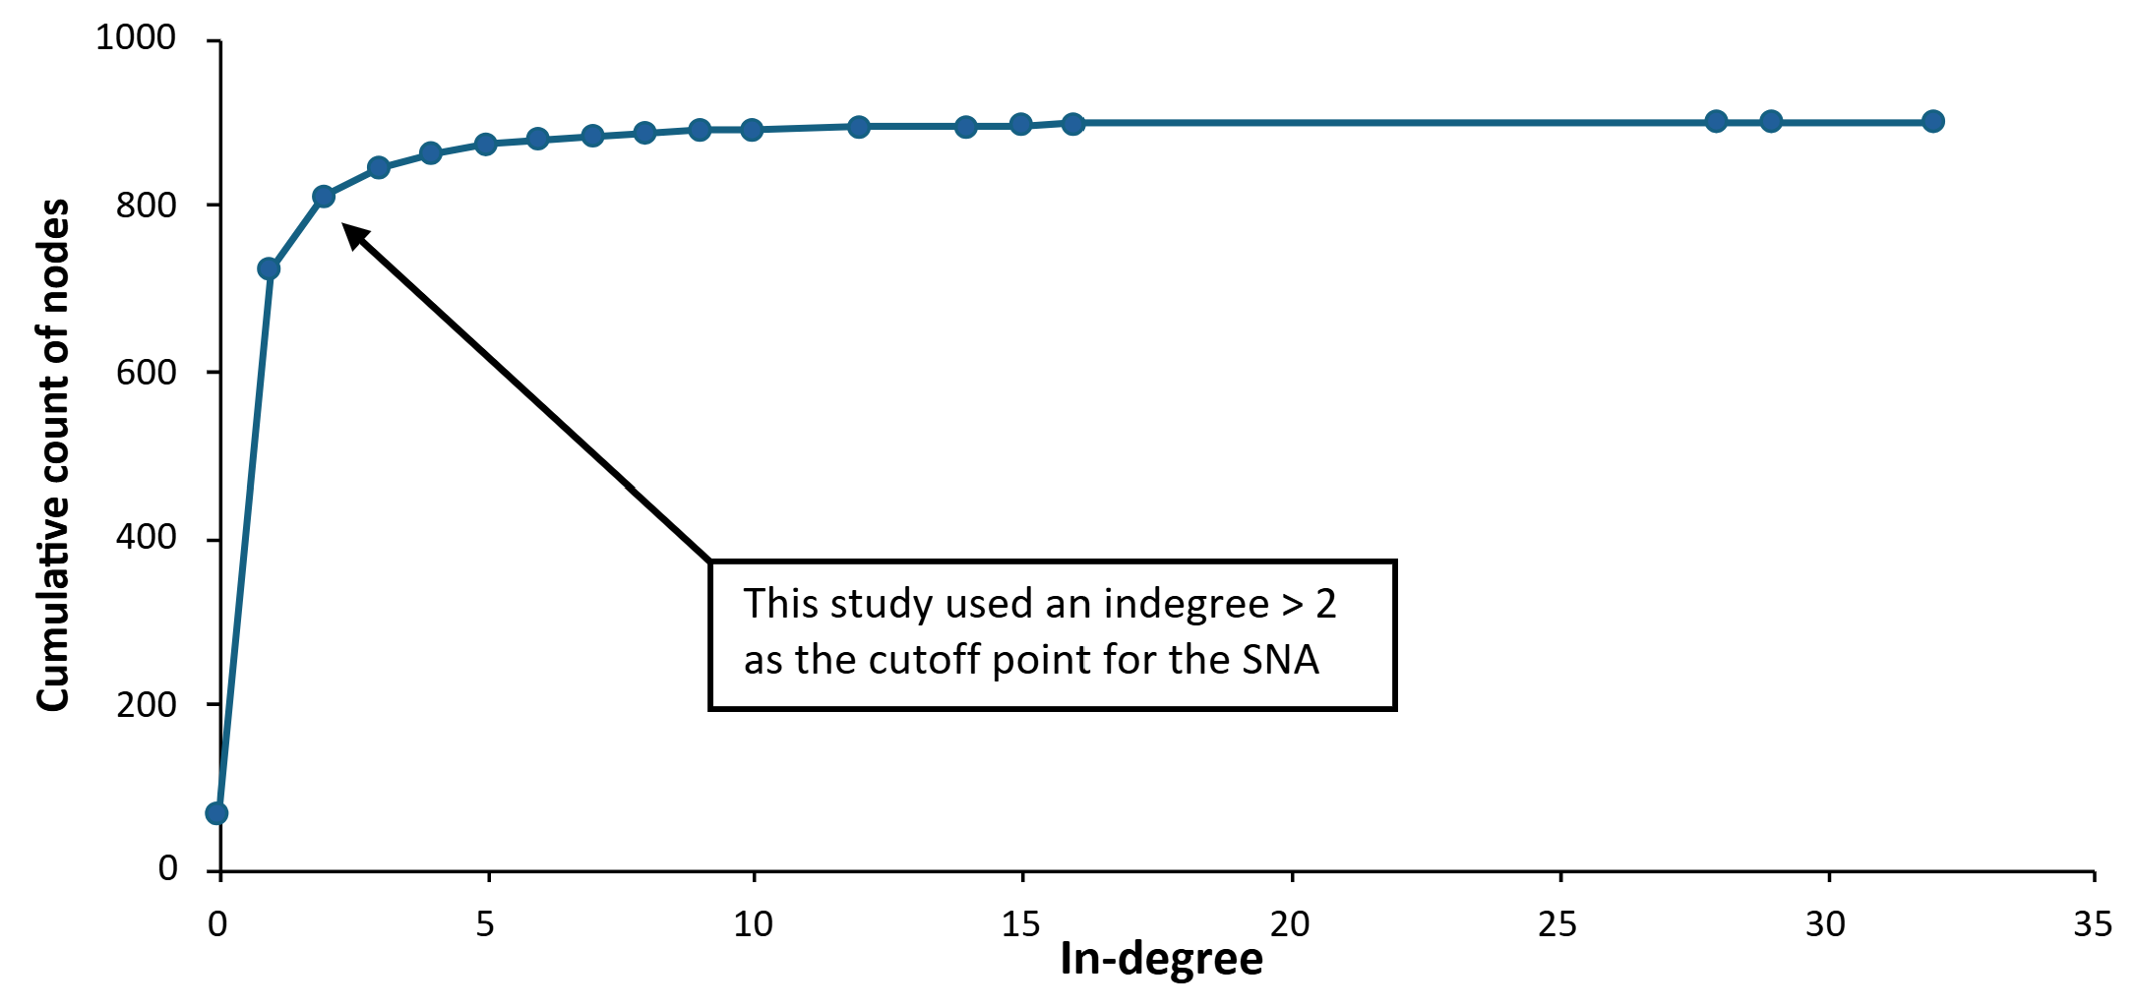
Supplementary Fig 1. Cumulative distribution of knowledge sources (nodes) with their frequency referenced (in-degree). This cutoff point is applied solely in the detailed network visualization (Figure 3b) of the main text to improve readability.
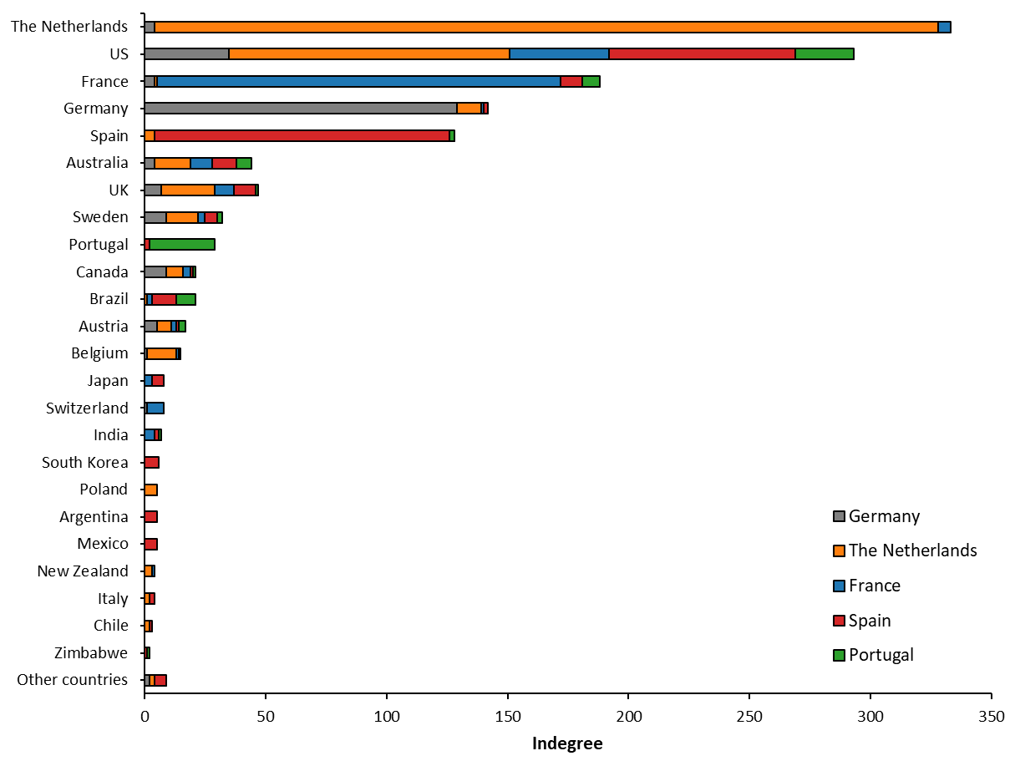
Supplementary Fig 2. Country specific information on the use of (inter) national knowledge sources. The category “Other countries” includes (by decreasing in-degree): Ireland, Thailand, Russia, Tasmania, Uruguay, Lebanon, Tanzania, Slovenia, and Hungary.

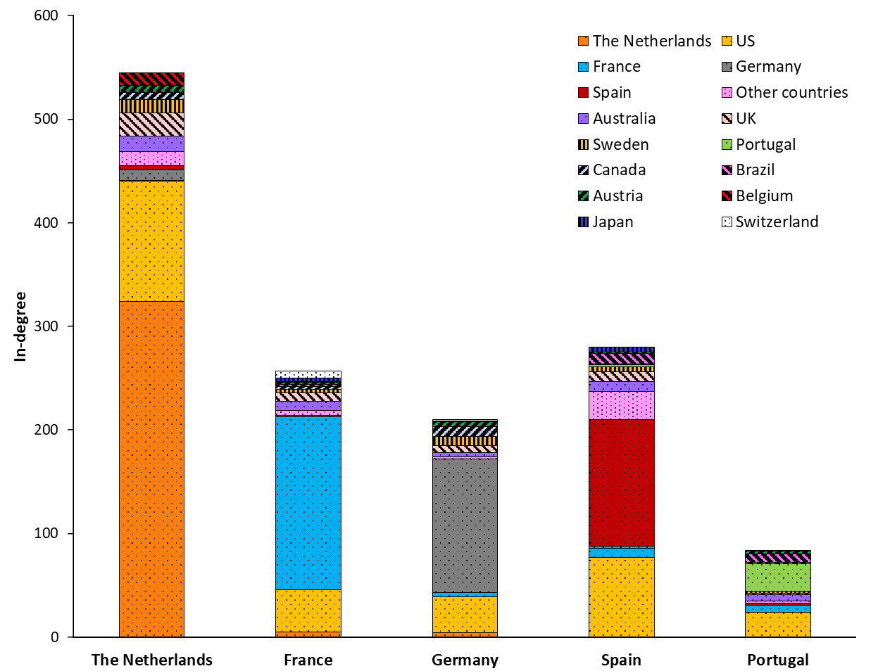
Supplementary Fig 3. In-degree by country of knowledge sources for each of the five case-study countries.

References
- Schreefel. Beyond the Buzz: analysing actors promoting regenerative agriculture in Europe. (2025).
- BMEL. Tabellen zur Landwirtschaft. https://www.bmel-statistik.de/landwirtschaft/tabellen-zur-landwirtschaft#c8262 (2023).
- CBS. Bedrijven met akkerbouw per grootteklasse, 2000-2018*. https://www.cbs.nl/nl-nl/maatwerk/2018/47/bedrijven-met-akkerbouw-per-grootteklasse-2000-2018- (2018).
- Statista. Nombre d’exploitations selon la Superficie Agricole Utilisée (SAU) en France en 2010 et 2020. https://fr-statista-com.ezproxy.library.wur.nl/statistiques/1294799/nombre-de-fermes-par-superficie-france/ (2025).
- INE. Agricultural Census 2020. https://ine.es/dyngs/INEbase/es/operacion.htm?c=Estadistica_C&cid=1254736176851&menu=resultados&idp=1254735727106#_tabs-1254736194955 (2020).
- INE. Farm Structure Survey 2016. file:///C:/Users/schre064/Downloads/IEEA_2016a_EN.pdf (2017).
- BMEL. Tabellen zur Landwirtschaft. https://www.bmel-statistik.de/landwirtschaft/tabellen-zur-landwirtschaft#c8266 (2020).
- Agrimatie. Schaalgrootte en inkomen melkveehouderij. https://agrimatie.nl/PublicatiePage.aspx?subpubID=2525&sectorID=2245&themaID=7458&indicatorID=7452 (2018).
- Agreste. Les Exploitations Bovines Laitières En France Métropolitaine En 2020. https://agreste.agriculture.gouv.fr/agreste-web/download/publication/publie/Dos2304/Dossiers2023-4_BovinsLait.pdf (2023).
- INE. Censo Agrario 2020. (2024).
- Agrimatie. Bedrijfsgrootte van glastuinbouwbedrijven. (2024).
- BMEL. Tabellen zur Landwirtschaft. https://www.bmel-statistik.de/landwirtschaft/tabellen-zur-landwirtschaft#c8264 (2022).
- LEI. Takverkenning Fruitteelt. https://edepot.wur.nl/266529 (1998).
- Statistisches Bundesamt. Rechtliche Einheiten und abhängig Beschäftigte nach Beschäftigtengrößenklassen und Wirtschaftsabschnitten. https://www.destatis.de/DE/Themen/Branchen-Unternehmen/Unternehmen/Unternehmensregister/Tabellen/unternehmen-beschaeftigtengroessenklassen-wz08.html?nn=208520 (2022).
- CBS. Aantal bedrijven naar sector en aantal werknemers, 2020. (2021).
- Microsoft. Company Size Codes. https://learn.microsoft.com/en-us/linkedin/shared/references/reference-tables/company-size-codes (2023).
- Eurostat. Enterprise statistics by size class and NACE Rev.2 activity (from 2021 onwards). https://ec.europa.eu/eurostat/databrowser/view/sbs_sc_ovw/default/table?lang=en&category=bsd.sbs.sbs_ovw (2022).
- Agrimatie. Schaalgrootte en inkomen varkensbedrijven. https://agrimatie.nl/PublicatiePage.aspx?subpubID=2525&sectorID=2255&themaID=7458&indicatorID=7452 (2018).
- Agrimatie. Bedrijfsgrootte van bloembollenbedrijven. https://agrimatie.nl/noord-holland/kerncijfers/bedrijfsgrootte-van-bloembollenbedrijven/ (2024).

