Supplement Information: Mechano-optically Co-designed Highly-scalable Silicon Photonic MEMS Switches with Buckling-free 2×2 Horizontal Adiabatic Directional Couplers

Section 1: Summary of the Reported Silicon Photonic MEMS switches.
As shown in Table S1, the HADC based MEMS switch shows excellent performance in excess loss (EL), crosstalk (CT), bandwidth, switching speed, durability, and scalability.
Table S1. Summary of the reported silicon photonic MEMS switches.
Ref. | Ref. of the maintext | Type | OFF state |  | ON state |  | Bandwidth  (nm) | Speed  (μs) | Durability  (billion) | Const-  ruction | Array | Digital  operation | Standard fabrication
Ref. | Ref. of the maintext | Type | EL | CT | EL | CT
1 | 15 | DC | 0.253 | –26 | 2.47 | –25 | 13 | 2.5 / 3.8 | – | 1 × 2 | 50 × 50  Cross-Bar  2,500 cells | No | Yes
2 | 16 | DC | 0.1 | –50.8 | 0.51 | –27.9 | 28.7 | 50 | – | 1 × 2 | 32 × 32  Cross-Bar  1,024 cells | No | Yes
3 | 17 | DC | 0.087 | –60 | 1.38 | –31 | 31.5 | 9.8 / 4.8 | – | 1 × 2 | 4 × 20  Cross-Bar  80 cells | No | Yes
4 | 18 | DC | – | –6.9 | 1 | – | – | 50 | – | 2 × 2 | 2 × 6  –  5 cells | No | Yes
5 | 19 | VADC | 0.026 | –60 | 0.47 | –18 | 120  (300) | 0.91 / 0.28 | > 10 | 1 × 2 | 64 × 64  Cross-Bar  4,096 | Yes | No
6 | 21 | VADC | 0.019 | –70 | 0.7 | – | 120 | 0.4 / 0.3 | – | 1 × 2 | 240 × 240  Cross-Bar  57,600 cells | Yes | No
7 | 22 | HADC | – | –20 | – | –25 | 25  (100) | 0.82 / 0.73 | – | SPDT | No array | Yes | Yes
8 | 23 | HADC | 0.52 | –25.5 | 0.92 | –11.9 | 108 | 36.7 / 21.4 | – | 1 × 2 | 8 × 8  Cross-Bar  64 cells | No | Yes
This  work |  | HADC | 0.35  (0.001) | –50.6  (–43.1) | 0.52  (0.027) | –12.6  (–22.7) | 180  (300) | 2.2 / 1.9 | > 7.2 | 2 × 2 | 64 × 64  Benes  352 cells | Yes | Yes
Note: data in the bracket represent the simulated results.
For the 1×2 VADC switch^{5, 6}, elementary switches have demonstrated impressive switch performance including low excess loss of <0.7 dB, high extinction ratio of >70 dB, large bandwidth of 300 nm and fast switching speed of 400 ns/300 ns. Leveraging the elementary switch with such high performance, a 240×240 switch array with Cross-Bar topology⁶ have been demonstrated. However, two silicon layers are required for the VADC design, which are not available in most standard silicon photonic foundry processes (SSPFPs). Consequently, complicated back-end processes are required, leading to high fabrication cost. Furthermore, the driving voltage of the elementary switch is as large as 60 V, which complicates the driving circuits due to the difficulties in implementing a multi-channel (100s or even 10,000s channels) voltage source with such high voltages.
For the 1×2 HADC switch⁸, a three-comb-drive device design and 8×8 Cross-Bar switch array have been implemented. However, the switch features excess loss of <4 dB, crosstalk of ~10 dB over the bandwidth of 108 nm and ON/OFF switching speed of 36.7 μs/21.4 μs in experiment, which might require further improvement for practical applications. Furthermore, the measured excess loss in the ON state varies up to ~1.7dB, depending on the ADC gap, which indicates slightly nonadiabatic coupling in the fabricated device.
For the single-pole double-throw (SPDT) switch based on HADC⁷, a unique switch design and fast ON/OFF switching speed of 0.82μs/0.73μs have been achieved. However, the excess loss difference between the two output ports is as high as ~5 dB and the bandwidth is only ~25 nm in experiment. In addition, each SPDT switch requires two, instead of one, electrical pads, which doubles the number of driving circuits and compromises scaling up switch arrays.
Furthermore, both the VADC- and HADC-based elementary switches feature 1×2 design, which is only compatible with Cross-Bar topology and incompatible with alternative widely-used topologies such as Benes, PI-Loss, Switch-and-Select etc. Note that all the array topologies have their own advantages and disadvantages. Therefore, flexible compatibility with various array topologies is critical for diverse applications.

Section 2: Design of the extra S-bends.
Theoretically, a larger S-bends enables lower bending loss and smaller waveguide buckling, while, the footprint and propagation loss will increase. To achieve low propagation and compact footprint, we choose w_{s} = 0.45 μm, L_{sbd} = 8.8 μm, d_{sbd} = 3.6 μm, and R_{s} = 3 μm. The simulated light propagation at 1550 nm and the transmission spectra of the extra S-bend are shown in Fig.S1, the excess loss of the extra S-bends is 0.01 – 0.06 dB over the broad bandwidth of 1.4 – 1.7 μm.
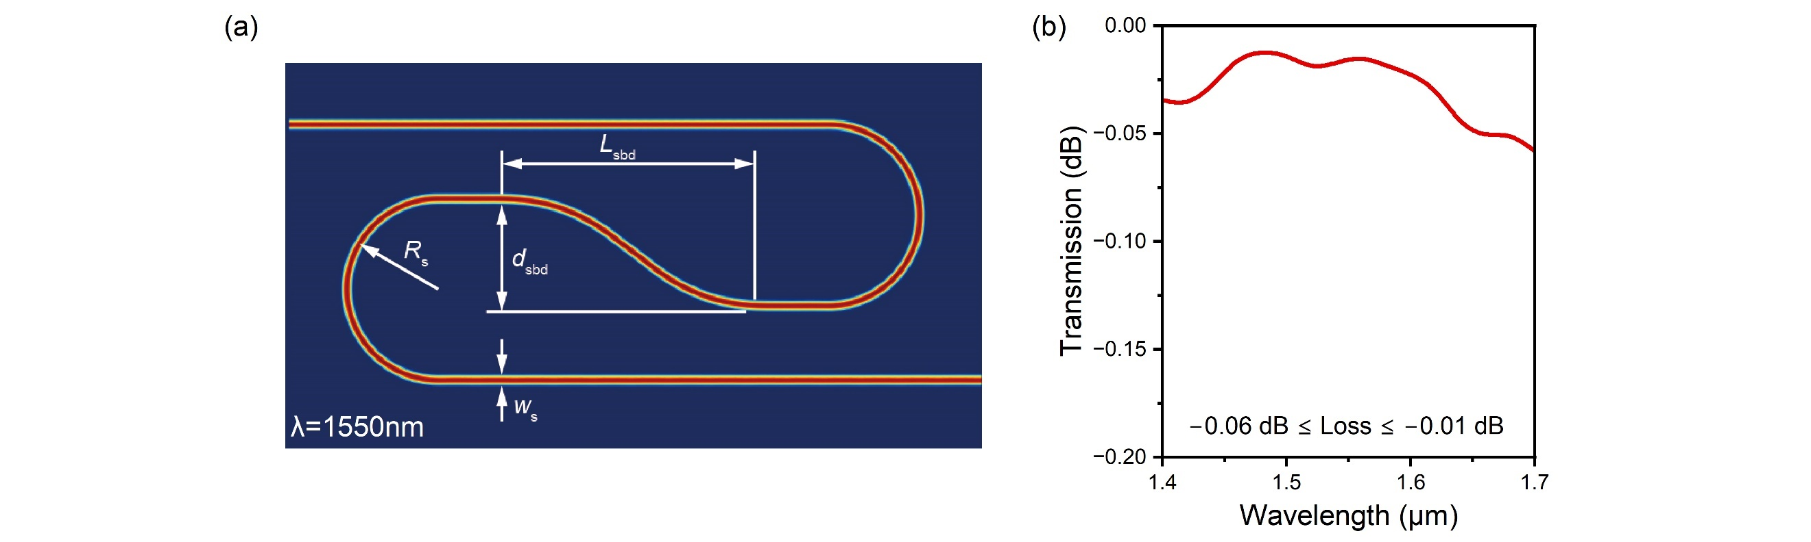
Fig.S1. Design of the extra S-bends. (a) Simulated light propagation of the extra S-bends. (b) Simulated transmission spectra of the extra S-bends.
The size of the extra S-bends is not increased further because the designed S-bend with low excess loss is already large enough to effectively reduce the waveguide buckling. Larger S-bend only reduces the buckling slightly, while at the price of larger footprint and higher propagation loss.

Section 3: Excess Loss Measurement of the Switch Components.
To measure the excess/propagation loss of the mode-converter pairs, the circular 90°-bends, the Euler S-bends, the ridge waveguide varied-width multimode interference (VWMMI) crossings, and the routing waveguides a series of testing structures are designed and fabricated, as shown in Fig.S2 (a) and (b).
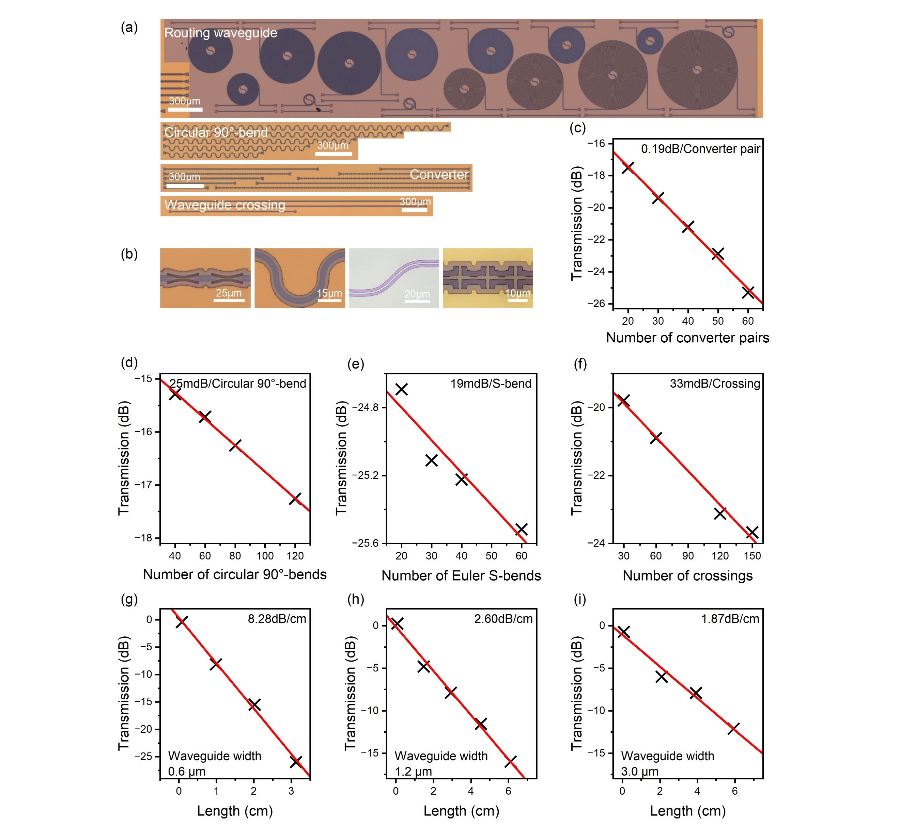
Fig.S2. Excess loss measurement of the switch components. (a) Optical microscope image of the passive optical test structures. (b) Close-up views of the mode converter pairs, the circular bends, the Euler S-bends and the ridge waveguide crossings. (c)–(i) Excess/propagation loss of the mode converter pairs, the circular bends, the Euler S-bends, the ridge waveguide crossings and the routing waveguides measured by cut-back methods.
From the linear fitting of the measurement results in Fig.S2 (c)–(i), the measured excess/propagation losses of the mode converter-pair, the circular 90°-bend, the Euler S-bend and the ridge waveguide VWMMI crossing are 0.19 dB, 25 mdB, 19 mdB and 33 mdB, respectively. The propagation loss of the routing waveguides with width of 600nm, 1.2μm, 3μm are 8.28 dB/cm, 2.60 dB/cm and 1.87 dB/cm respectively.

Section 4: Excess Loss Measurement of the Elementary Switch.
To measure the excess loss of the elementary switch in both OFF and ON state precisely, ten elementary switches are cascaded and characterized as shown in Fig.S3 (a).
When all the elementary switches are in OFF state (all-OFF state), as shown in Fig.S3 (b), the measured transmission spectra T₁₁ and T₂₂ are shown in Fig.S3 (d) and the excess loss of an elementary switch in OFF state can be averaged. Theoretically, the excess loss of T₁₁ in the OFF state should be extremely low because only waveguide propagation loss is included. However, the excess loss of T₁₁ in the OFF state is measured to be 0.11–0.43 dB, which can be attributed to the high excess loss of mode converter pairs and the extra scattering loss of the slab anchors introduced by overlay errors shown in Section 3. Besides, the excess loss of T₂₂ in the OFF state is measured to be 0.21–0.48 dB, which is higher than that of T₁₁. This can be attributed to the extra slab anchor and the meandering waveguides in the path of T₂₂.
When all the elementary switches are in ON state (all-ON state), as shown in Fig.S3 (c), the measured transmission spectra T₁₁ is shown in Fig.S3 (e) and the excess loss of an elementary switch in ON state can be averaged. The resonance in the measured transmission spectra T₁₁ is caused by some reflection and interference.
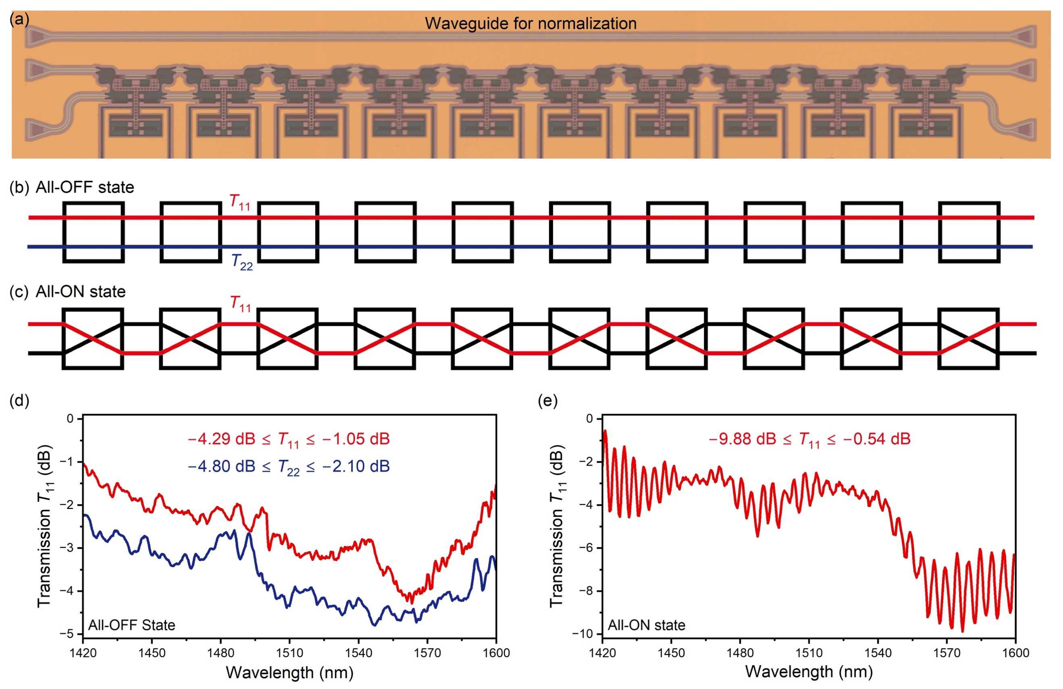
Fig.S3. Excess loss measurement of the elementary switch. (a) Optical microscope image of the cascaded elementary switches. (b) (c) Schematic diagram of the cascaded elementary switches in all OFF and all ON state respectively. (d) (e) The measured excess loss T₁₁ of the cascaded elementary switches in all OFF and all ON state respectively.
The transmission spectra of the elementary switch in OFF and ON state shown in Fig. 4f, g of the main text is averaged by the transmission spectra shown in Fig.S3 (d) and (e) respectively.

Section 5: Durability Measurement of the Device.
To demonstrate the durability of our switch, we operate it over 7.2 billion cycles with a square-wave voltage at 50 kHz in the over 40-hour experiment.

Fig.S4. Durability measurement of the device. The transmission T₁₂ of the device in OFF and ON states respectively.
The transmission spectra have been measured with realignment occasionally to compensate the drift of the alignment between the input/output fibers and the grating couplers in our measurement platform. The measured 10 groups of transmissions T₁₂ are shown in Fig.S4, which shows that the results are repeated perfectly and the discrepancies can be attributed to measurement errors.

Section 6: Excess loss Analysis of the Benes switch array.
In a Benes topology, input Port i (i = 1–64) is routed to the output Port i in the all-OFF state (labelled as ‘A-0’). Therefore, transmission of the 64 signal paths correspond to TA-0 i,j (i = j). To analyze the excess loss of the fabricated switch array in all-OFF state, we survey the numbers of transmission T₁₁ for switch cells (N₁), transmission T₂₂ for switch cells (N₂), ridge waveguide VWMMI crossings (N_{c}), circular 90°-bends (N_{b}), Euler S-bends (N_{s}) and the length of routing waveguides with width = 600 nm (L₁), 1.2μm (L₂) and 3 μm (L₃) included in different signal paths and the results are shown in Table S2. All the switch cells in the switch array are considered to have uniform excess loss of 0.2 dB (OFF) and 0.52 dB (ON) at 1550 nm according to the measurement results in Section 4. Here the estimated OFF-state excess loss of switch cell is slightly lower than the measurement data presented in Section 4 (~0.35 dB), resulting in a better agreement between the estimated and measured excess losses of all the array paths (as shown in Fig.S5). This discrepancy may be attributed to reduced overlay errors between slab waveguides and shallow-etched ridge waveguides, which reduces the excess loss of mode converters. Meanwhile, the measured results with well fitted linearity in Section 3 also shows that the excess loss of ridge waveguide VWMMI crossings, circular 90°-bends and Euler S-bends is uniform and can be considered as 33 mdB/crossing, 25 mdB/bend and 19 mdB/bend in the switch array. The excess loss at 1550 nm of different signal paths is estimated with the measured results mentioned above, as shown in Table S2. The measured excess loss at 1550 nm is listed in the table as well, which agrees well with the estimated results.
Table S2. Excess loss analysis of the Benes array in all-OFF state at 1550 nm
Path ID | N₁ | N₂ | N_{c} | N_{b} | N_{s} | L₁  (μm) | L₂  (μm) | L₃  (μm) | Estimated  Transmission  (dB) | Measured  Transmission (dB)
T_{1,1} | 0 | 11 | 0 | 44 | 0 | 1767 | 0 | 6334 | –5.02 | –6.86
T_{2,2} | 2 | 9 | 62 | 36 | 62 | 1631 | 4640 | 3678 | –7.62 | –8.13
T_{3,3} | 2 | 9 | 32 | 36 | 32 | 1631 | 2690 | 4422 | –6.24 | –6.79
T_{4,4} | 4 | 7 | 90 | 28 | 90 | 1496 | 6970 | 2156 | –8.69 | –9.18
T_{5,5} | 2 | 9 | 20 | 36 | 20 | 1631 | 2000 | 4540 | –5.68 | –7.02
T_{6,6} | 4 | 7 | 74 | 28 | 74 | 1496 | 6070 | 2344 | –7.95 | –7.82
T_{7,7} | 4 | 7 | 48 | 28 | 48 | 1496 | 4180 | 3328 | –6.77 | –7.09
T_{8,8} | 6 | 5 | 98 | 20 | 98 | 1361 | 8042 | 1202 | –8.83 | –8.42
T_{9,9} | 2 | 9 | 20 | 36 | 20 | 1631 | 2150 | 4220 | –5.66 | –6.27
T_{10,10} | 4 | 7 | 66 | 28 | 66 | 1496 | 5370 | 2610 | –7.55 | –7.55
T_{11,11} | 4 | 7 | 44 | 28 | 44 | 1496 | 4120 | 3080 | –6.57 | –6.59
T_{12,12} | 6 | 5 | 86 | 20 | 86 | 1361 | 7060 | 1610 | –8.27 | –8.21
T_{13,13} | 4 | 7 | 36 | 28 | 36 | 1496 | 3490 | 3444 | –6.20 | –7.14
T_{14,14} | 6 | 5 | 74 | 20 | 74 | 1361 | 6150 | 2114 | –7.72 | –8.10
T_{15,15} | 6 | 5 | 56 | 20 | 56 | 1361 | 5252 | 2376 | –6.90 | –7.28
T_{16,16} | 8 | 3 | 90 | 12 | 90 | 1226 | 7632 | 1186 | –8.25 | –7.90
T_{17,17} | 2 | 9 | 32 | 36 | 32 | 1631 | 3570 | 3196 | –6.20 | –7.14
T_{18,18} | 4 | 7 | 62 | 28 | 62 | 1496 | 5670 | 2146 | –7.36 | –7.53
T_{19,19} | 4 | 7 | 48 | 28 | 48 | 1496 | 4690 | 2622 | –6.73 | –7.27
T_{20,20} | 6 | 5 | 74 | 20 | 74 | 1361 | 6510 | 1712 | –7.70 | –7.83
T_{21,21} | 4 | 7 | 44 | 28 | 44 | 1496 | 4700 | 2490 | –6.56 | –7.19
T_{22,22} | 6 | 5 | 66 | 20 | 66 | 1361 | 6240 | 1720 | –7.36 | –7.68
T_{23,23} | 6 | 5 | 56 | 20 | 56 | 1361 | 5540 | 2060 | –6.91 | –7.23
T_{24,24} | 8 | 3 | 74 | 12 | 74 | 1226 | 6800 | 1430 | –7.52 | –7.47
T_{25,25} | 4 | 7 | 48 | 28 | 48 | 1496 | 4620 | 2720 | –6.71 | –7.27
T_{26,26} | 6 | 5 | 62 | 20 | 62 | 1361 | 5600 | 2230 | –7.15 | –7.71
T_{27,27} | 6 | 5 | 56 | 20 | 56 | 1361 | 5180 | 2434 | –6.88 | –7.61
T_{28,28} | 8 | 3 | 66 | 12 | 66 | 1226 | 5880 | 2084 | –7.13 | –6.27
T_{29,29} | 6 | 5 | 56 | 20 | 56 | 1361 | 5542 | 2066 | –6.87 | –7.49
T_{30,30} | 8 | 3 | 62 | 12 | 62 | 1226 | 5962 | 1856 | –6.95 | –6.90
T_{31,31} | 8 | 3 | 60 | 12 | 60 | 1226 | 5822 | 1924 | –6.85 | –7.16
T_{32,32} | 10 | 1 | 62 | 4 | 62 | 1091 | 5962 | 1854 | –6.74 | –6.53
T_{33,33} | 1 | 10 | 62 | 40 | 62 | 1699 | 5962 | 1854 | –7.64 | –8.55
T_{34,34} | 3 | 8 | 60 | 32 | 60 | 1564 | 5822 | 1924 | –7.35 | –7.75
T_{35,35} | 3 | 8 | 62 | 32 | 62 | 1564 | 5962 | 1856 | –7.45 | –8.48
T_{36,36} | 5 | 6 | 56 | 24 | 56 | 1429 | 5542 | 2066 | –6.97 | –7.22
T_{37,37} | 3 | 8 | 66 | 32 | 66 | 1564 | 5880 | 2084 | –7.63 | –8.19
T_{38,38} | 5 | 6 | 56 | 24 | 56 | 1429 | 5180 | 2434 | –6.98 | –6.91
T_{39,39} | 5 | 6 | 62 | 24 | 62 | 1429 | 5600 | 2230 | –7.25 | –7.90
T_{40,40} | 7 | 4 | 48 | 16 | 48 | 1293 | 4620 | 2720 | –6.41 | –15.05
T_{41,41} | 3 | 8 | 74 | 32 | 74 | 1564 | 6800 | 1430 | –8.02 | –8.22
T_{42,42} | 5 | 6 | 56 | 24 | 56 | 1429 | 5540 | 2060 | –7.01 | –7.17
T_{43,43} | 5 | 6 | 66 | 24 | 66 | 1429 | 6240 | 1720 | –7.46 | –7.71
T_{44,44} | 7 | 4 | 44 | 16 | 44 | 1293 | 4700 | 2490 | –6.26 | –6.21
T_{45,45} | 5 | 6 | 74 | 24 | 74 | 1429 | 6510 | 1712 | –7.80 | –7.81
T_{46,46} | 7 | 4 | 48 | 16 | 48 | 1293 | 4690 | 2622 | –6.43 | –6.07
T_{47,47} | 7 | 4 | 62 | 16 | 62 | 1293 | 5670 | 2146 | –7.06 | –6.84
T_{48,48} | 9 | 2 | 32 | 8 | 32 | 1158 | 3570 | 3196 | –5.50 | –5.20
T_{49,49} | 3 | 8 | 90 | 32 | 90 | 1564 | 7632 | 1186 | –8.75 | –9.73
T_{50,50} | 5 | 6 | 56 | 24 | 56 | 1429 | 5252 | 2376 | –7.00 | –7.15
T_{51,51} | 5 | 6 | 74 | 24 | 74 | 1429 | 6150 | 2114 | –7.82 | –7.80
T_{52,52} | 7 | 4 | 36 | 16 | 36 | 1293 | 3490 | 3444 | –5.90 | –6.20
T_{53,53} | 5 | 6 | 86 | 24 | 86 | 1429 | 7060 | 1610 | –8.37 | –8.88
T_{54,54} | 7 | 4 | 44 | 16 | 44 | 1293 | 4120 | 3080 | –6.27 | –6.18
T_{55,55} | 7 | 4 | 66 | 16 | 66 | 1293 | 5370 | 2610 | –7.25 | –7.03
T_{56,56} | 9 | 2 | 20 | 8 | 20 | 1158 | 2150 | 4220 | –4.96 | –4.68
T_{57,57} | 5 | 6 | 98 | 24 | 98 | 1429 | 8042 | 1202 | –8.93 | –8.54
T_{58,58} | 7 | 4 | 48 | 16 | 48 | 1293 | 4180 | 3328 | –6.47 | –5.85
T_{59,59} | 7 | 4 | 74 | 16 | 74 | 1293 | 6070 | 2344 | –7.65 | –7.09
T_{60,60} | 9 | 2 | 20 | 8 | 20 | 1158 | 2000 | 4540 | –4.98 | –4.95
T_{61,61} | 7 | 4 | 90 | 16 | 90 | 1293 | 6960 | 2156 | –8.39 | –7.62
T_{62,62} | 9 | 2 | 32 | 8 | 32 | 1158 | 2680 | 4422 | –5.54 | –5.28
T_{63,63} | 9 | 2 | 62 | 8 | 62 | 1158 | 4640 | 3678 | –6.92 | –5.87
T_{64,64} | 11 | 0 | 0 | 0 | 0 | 1023 | 0 | 6334 | –3.92 | –4.06
 |  |  |  |  |  |  |  | Max | –3.92 | –4.06
 |  |  |  |  |  |  |  | Min | –8.93 | –9.73
 |  |  |  |  |  |  |  | Ave | –7.00 | –7.20

The main contributors to the excess loss of the switch array include switch cell loss, waveguide transmission loss and VWMMI waveguide crossing loss. The propagation loss of ridge waveguide with 600-nm width can be reduced to 1.0 dB/cm or even smaller if standard silicon photonic foundry processes are used. Moreover, the excess losses of circular 90°-bend and Euler S-bend can also be reduced as the reduction of propagation loss. In our previous work, VWMMI waveguide crossings fabricated by standard silicon photonic foundry processes can achieve <10 mdB excess loss¹⁰. Therefore, if we retain the switch design in this paper and use improved fabrication processes, the excess loss for the 64×64 Benes switch array can be reduced to 2.4–5.8 dB (4.5 dB on average). When it is desired to scale the switch array up to 128×128, the excess loss would be approximately 2.8–9.6 dB (6.9 dB in average). It indicates that the bottleneck for scaling is the fabrication improvements.
Switch cells in the center stage of the 64×64 Benes switch array have been actuated to reconfigure the signal path TA-0 i,j (i = j = 1–64) as shown in Table S3. In a Benes topology, when the switch cells in the center stage are turned on (single-ON state, labelled as ‘S-1’), signal paths TA-0 i,j (i = j = 1–64) will be reconfigured to TS-1 i,j (i = 1–32, j = i+32; i = 33–64, j = i-32), which coincides with the left half of signal path TA-0 i,i and the right half of signal path TA-0 j,j . We turned on the switch cells in the center stage sequentially and the ON/OFF transmission spectra of the corresponding output ports are measured. The excess losses of the reconfigured signal paths TS-1 i,j at 1550 nm are listed in Table S3.
Table S3. Excess loss analysis of the Benes array in single-ON state at 1550 nm
Switch ID | Path ID | Estimated Transmission (dB) | Measured Transmission (dB)
1 | T_{1,33} | –6.65 | –6.45
2 | T_{2,34} | –7.81 | –7.15
3 | T_{3,35} | –7.17 | –7.12
4 | T_{4,36} | –8.15 | –7.96
5 | T_{5,37} | –6.97 | –6.99
6 | T_{6,38} | –7.78 | –7.32
7 | T_{7,39} | –7.33 | –6.94
8 | T_{8,40} | –7.94 | –7.31
9 | T_{9,41} | –7.16 | –7.14
10 | T_{10,42} | –7.60 | –7.33
11 | T_{11,43} | –7.33 | –7.02
12 | T_{12,44} | –7.59 | –6.99
13 | T_{13,45} | –7.32 | –7.19
14 | T_{14,46} | –7.39 | –7.41
15 | T_{15,47} | –7.30 | –6.85
16 | T_{16,48} | –7.19 | –6.14
17 | T_{17,49} | –7.79 | –8.75
18 | T_{18,50} | –7.50 | –7.21
19 | T_{19,51} | –7.59 | –7.41
20 | T_{20,52} | –7.12 | –7.78
21 | T_{21,53} | –7.79 | –7.80
22 | T_{22,54} | –7.13 | –6.86
23 | T_{23,55} | –7.40 | –6.94
24 | T_{24,56} | –6.56 | –6.44
25 | T_{25,57} | –8.14 | –8.26
26 | T_{26,58} | –7.13 | –7.40
27 | T_{27,59} | –7.58 | –8.04
28 | T_{28,60} | –6.37 | –5.91
29 | T_{29,61} | –7.95 | –8.13
30 | T_{30,62} | –6.57 | –6.25
31 | T_{31,63} | –7.21 | –7.14
32 | T_{32,64} | –5.65 | –7.28
1 | T_{33,1} | –6.65 | –6.99
2 | T_{34,2} | –7.81 | –6.97
3 | T_{35,3} | –7.17 | –6.55
4 | T_{36,4} | –8.15 | –8.52
5 | T_{37,5} | –6.97 | –7.33
6 | T_{38,6} | –7.78 | –7.51
7 | T_{39,7} | –7.33 | –6.76
8 | T_{40,8} | –7.94 | –15.46
9 | T_{41,9} | –7.16 | –6.80
10 | T_{42,10} | –7.60 | –6.93
11 | T_{43,11} | –7.33 | –6.29
12 | T_{44,12} | –7.59 | –7.01
13 | T_{45,13} | –7.32 | –6.70
14 | T_{46,14} | –7.39 | –7.48
15 | T_{47,15} | –7.30 | –7.05
16 | T_{48,16} | –7.19 | –6.12
17 | T_{49,17} | –7.79 | –7.00
18 | T_{50,18} | –7.50 | –6.90
19 | T_{51,19} | –7.59 | –7.20
20 | T_{52,20} | –7.12 | –7.27
21 | T_{53,21} | –7.79 | –7.12
22 | T_{54,22} | –7.13 | –6.54
23 | T_{55,23} | –7.40 | –6.62
24 | T_{56,24} | –6.56 | –6.13
25 | T_{57,25} | –8.14 | –6.91
26 | T_{58,26} | –7.13 | –6.29
27 | T_{59,27} | –7.58 | –6.69
28 | T_{60,28} | –6.37 | –5.34
29 | T_{61,29} | –7.95 | –7.58
30 | T_{62,30} | –6.57 | –5.67
31 | T_{63,31} | –7.21 | –6.09
32 | T_{64,32} | –5.65 | –5.31
 | Max | –5.65 | –5.31
 | Min | –8.15 | –8.75
 | Ave | –7.32 | –6.99
We quantified the discrepancy between estimated and measured losses by generating a scatter plot with measured values on the horizontal axis and estimated values on the vertical axis. The Root Mean Square Error (RMSE) between the data points and the ideal reference line y = x was calculated for both the all-OFF and single-ON states, as shown in Fig.S5 (a) and (b) respectively. RMSE below 0.60 suggests that the estimated values agree with the measured ones.
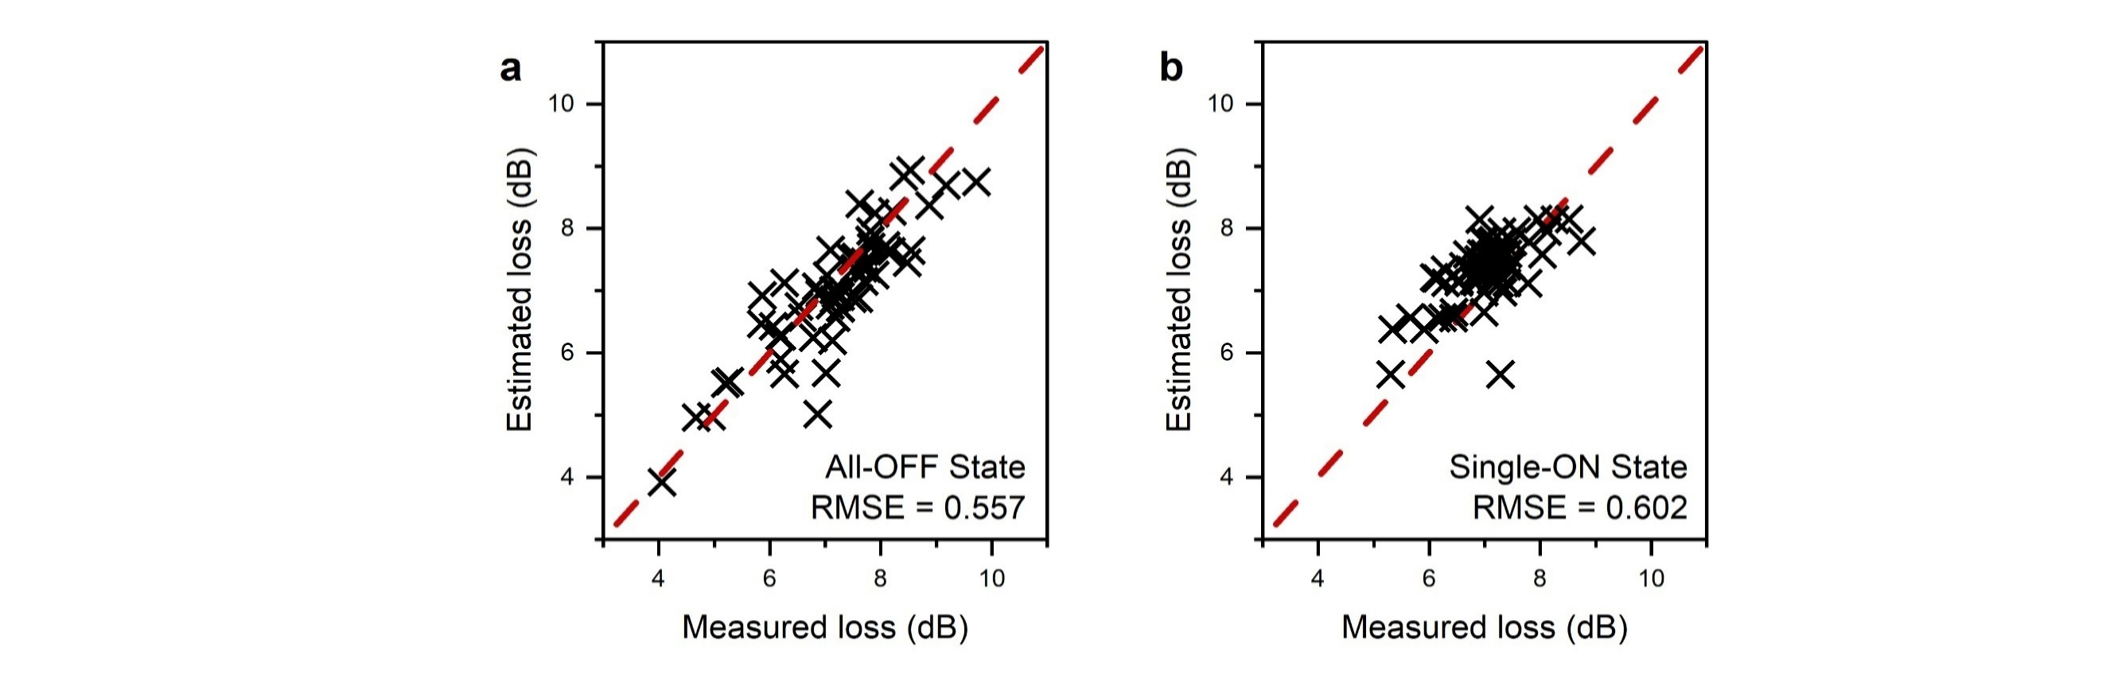
Fig.S5. Discrepancies between Estimated and Measured loss. (a) All-OFF state. (b) Single-ON state.

Section 7: Energy consumption of the proposed HADC switch.
To theoretically estimate the power consumption of the switch, we calculate the mechanical and electric potential energy of the device in the ON state. When the switch is turned on, a displacement of 900 nm occurs. With a spring constant of k_{y} = 0.36 N/m, the mechanical potential energy can be derived to be 146 fJ. For the electric potential energy, the simulated capacitance of the electrostatic combs is ~2.04 fF. With a drive voltage of 22 V, the electrical potential energy can be derived to be 494 fJ. Therefore, the theoretical total switching energy is then 640 fJ, equal to the sum of the mechanical and electrical potential energy. Moreover, the leakage current of the switch can be ignored according to our previous work⁹. As a result, assuming the maximum switching frequency of 100 kHz, the maximum power consumption is calculated to be 64 nW.

References
1. Han S, Seok TJ, Quack N, Yoo B-W, Wu MC. Large-scale silicon photonic switches with movable directional couplers. Optica 2015, 2(4): 370-375.
2. Han S, Béguelin J, Ochikubo L, Jacobs J, Seok TJ, Yu K, et al. 32 × 32 silicon photonic MEMS switch with gap-adjustable directional couplers fabricated in commercial CMOS foundry. Journal of Optical Microsystems 2021, 1.
3. Han S, Seok TJ, Kim C-K, Muller RS, Wu MC. Multicast silicon photonic MEMS switches with gap-adjustable directional couplers. Opt Express 2019, 27(13): 17561-17570.
4. Akihama Y, Hane K. Single and multiple optical switches that use freestanding silicon nanowire waveguide couplers. Light: Science & Applications 2012, 1(6): e16-e16.
5. Seok TJ, Quack N, Han S, Muller RS, Wu MC. Large-scale broadband digital silicon photonic switches with vertical adiabatic couplers. Optica 2016, 3(1): 64-70.
6. Seok TJ, Kwon K, Henriksson J, Luo J, Wu M. Wafer-scale silicon photonic switches beyond die size limit. Optica 2019, 6: 490.
7. Takabayashi AY, Sattari H, Edinger P, Verheyen P, Gylfason KB, Bogaerts W, et al. Broadband Compact Single-Pole Double-Throw Silicon Photonic MEMS Switch. Journal of Microelectromechanical Systems 2021, 30(2): 322-329.
8. Nagai T, Hane K. Silicon photonic microelectromechanical switch using lateral adiabatic waveguide couplers. Opt Express 2018, 26(26): 33906-33917.
9. Hu Y, Sun Y, Lu Y, Li H, Dai D. Silicon photonic MEMS switches based on split waveguide crossings. 2023. p. arXiv:2305.17366.
10. Peng Y, Li H, Dai D. Compact Silicon Photonic Waveguide Crossings with Sub- 10-mdB Loss. In: Chang-Hasnain CWASWSPSYLGEBERDD, Ma D, editors. Asia Communications and Photonics Conference 2021; 2021 2021/10/24; Shanghai: Optica Publishing Group; 2021. p. T4A.130.

